Software Requirements

Company Assessment Tool

Client: Oxford Innovation Services – Coaching 4 Growth

Date: 13th September 2017

Contents

1 Introduction 3

2 Design Concept 3

3 Roles 7

4 User Experience 8

5 Security and Data Management 14

6 Development Requirements 17

Appendix A – Example Question Sets 19

Appendix B – Question Types 21

Appendix C – Permissions Matrix 22

Appendix D – Glossary 23

Appendix E – Sample Data and Reporting 25

# Introduction

The Company Assessment Tool is a platform that is used to survey business leaders and key personnel within a company to identify the strengths and weaknesses of the business and areas to focus on to achieve a sustainable growing company.

From within each company participating in the service, a set of key respondents is identified and they are asked to complete an on-line assessment using the platform. The on-line assessment focusses on several key themes and each theme is associated with several questions within the assessment.

Once the respondents have completed the assessment, the data is processed to provide a set of data to be used for analysis/charting focussed on the key assessment themes. The data is used to produce a report summarising the respondents’ perception of the company; the report is used by a Business Coach as part of the Business support service. An administration function within the platform ensures that progress is easy to track and manage.

Multiple assessments types can co-exist on the same platform and it is possible for a customer to repeat an assessment or undertake multiple assessments to address different aspects of their business.

The platform is designed to operate as a self-contained flexible service which will allow a portfolio of different Streams to be created within the system, with branding and URLs to be applied to each Stream. Customers will be a given a license / permission to access the tool and the tool tracks progress and automatically generates a set of reports and usage data for each customer. It is anticipated that the solution will operate as a single-server solution.

# Design Concept

The following section describes a concept for the service; it is not prescriptive and alternative approaches are welcome.

## Core Process Flow

A process flow summarising the core software process is shown below.

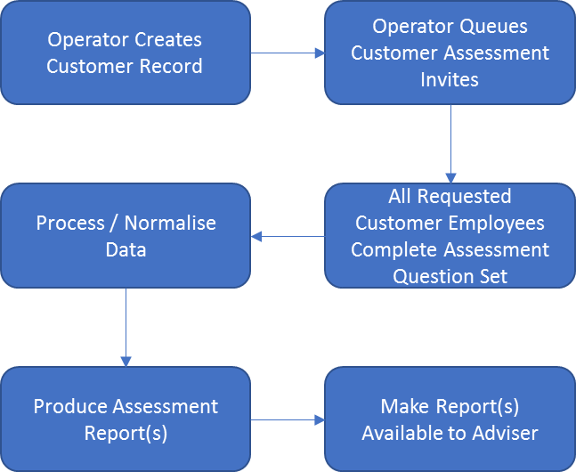

## Data Components

The tool requires key elements to work including Question Sets, Report Templates, Assessment Templates and Answer Sets from Respondents.

### Question Sets

A question set consists of up to 200 questions (each of up to 400 characters) and associated meta-data to define how the question should be presented (radio button, multiple choice etc.) and how the responses should be processed.

Each question can be associated with one or more Themes; there may be up to 50 Themes in a question set. Themes are used within the output report to present information focussed on Themes.

Example questions sets are included in Appendix A – Example Question Sets.

### Report Template

A Report Template defines a branded PDF report that the system will automatically populate with the Theme or raw scoring and associated information collected from the Respondents during an assessment. The report will identify the customer, the assessment name, dates and may contain any of the common reporting charts including tables, bar charts, spider diagrams, scatter charts etc. A Report is typically unique to a Stream as it will contain sector-targeted branding.

A Report may also be used to compare the Theme data from two identical previous assessments. This report can be used to contrast the position of the company before and after an engagement. These reports are not included in Assessment Templates as they report against historic data.

### Assessment Templates

Typically, each assessment will produce a report for the client and a different report for the Business Coach. An assessment template is a pairing of a question set with up to two reports (typically the client Report and the Business Coach Report).

A customer is assigned an Assessment to undertake based on the Assessment Template. Once all the Respondents have completed the assessment the reports identified in the Assessment Template are automatically produced.

Two or more Streams may use the same question set with different reports (often, the only difference between reports will be branding, which will be unique to each Stream).

The same report may be used with different question sets (e.g. where the original question set is revised to contain different wording or a different number of questions).

A special case of Assessment Template exists (referred to as an Evolution Template). It does not collect new assessment data but it allows for two previous sets of Respondent Data from the same Assessment Set to be compared to produce a then-and-now type report.

The following diagram illustrates the template concept.

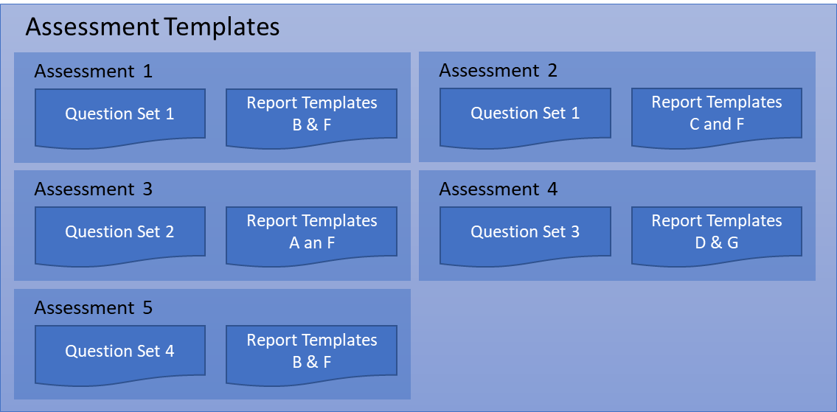

### Respondent Data

Respondent data falls into two categories; the raw data from respondents answering questions and the processed theme data for each company. It must be possible to associate the Respondent data with the Assessment.

Sample Respondent Data is included in Appendix E – Sample Data. The section also shows how respondent data should be processed to produce Theme based normalised and difference data.

## Outline Architecture

### Top Level Architecture

The main platform provides a framework within which different Streams can operate. Question Sets, Report Templates and Assessment Templates (pairings of questions and reports) can only be defined at a system level. All processing is performed at a system level. The definition and management of customers is managed within each Stream with multiple Streams defined within the platform. The following diagram illustrates the concept.

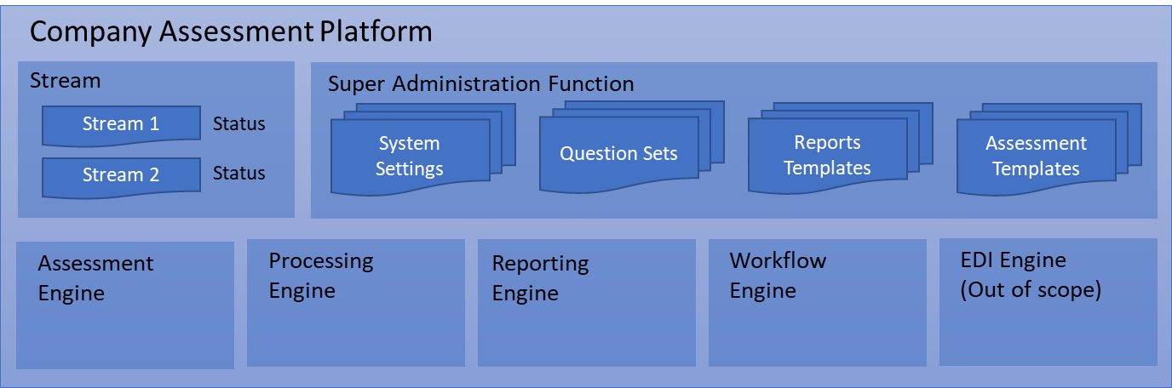

* Assessment Engine

The Assessment Engine presents the questions to the Respondents in the appropriate format for the question type and stores the responses in the Respondent Data. Once all company Respondents have completed the Assessment process the data is automatically made available for processing. The Assessment engine presents the questions in a randomised sequence.

* Processing and Normalising Engine

The processing and normalising function takes the raw Respondent Data and processes it to create company theme based data, normalised on a 0-10 scale, ready for display in a report as a company summary. This module will produce Theme based scores for the company and a scoring based on the consistency of Respondents’ answers within a Theme. The module must be expandable to support multiple answer formats which will predominantly be yes/no answers, but may also include rating answers (e.g. 1 – 10) and answers in combination (E.g. the answers from two questions may be combined to produce a reporting data point). It should also support then-and-now reporting comparing historic company theme data with recent company theme data. The system must be capable of automatically calculating corresponding scores and data depending on the responses.

* The Reporting Engine

The Reporting Engine takes the processed Theme and raw Respondent Data produced by the Processing and Normalising Engine and produces the reports identified in the Assessment set. The Reporting Engine will convert the data to produce Reports to show scoring and any associated text and graphical representation of the responses and scoring. The system will be expected to perform different types of calculations from the data for the reports, including summaries, totals, ranges and averages and other standard reporting formulae to allow flexibility for future question type development. Reports are produced in PDF format and they are stored on the server. A download link is e-mailed to the Business Coach associated with the company once the reports are available.

* The Workflow Engine

The Workflow Engine manages and monitors the progress of customer Assessments through the system and provides data for the dashboards.

### Stream Architecture

Customer data and associated Assessment Templates and Question Sets will be created at Stream level. It must be possible for identifiable customer data in each Stream to be kept independent of other each other with hierarchical access controls for different users. A Business Coach user must only be able to access customer data for his assigned customer(s), and for Business Coach Team Leaders must only be able to access customer data for customers assigned to their particular Stream.

Streams are created so that they may appear to have separate user interfaces with the capability for different URLs and security certificates to be used; branding and style of the portal is Stream specific.  These high-level activities can be managed by the Stream Administrator.

Assessment Templates and associated Reports are specific to each Stream and allocated to the Stream by a System Operator. Reporting branding is managed by defining report templates with appropriate branding to each stream.

A Stream is given access to run a pre-determined number of assessments. Access can be limited by both quantity of assessments and date.

Within the Stream, it is possible to create Customer and Respondent records and for Assessments to be queued for customers.

The diagram below illustrates an architectural model of a Stream.

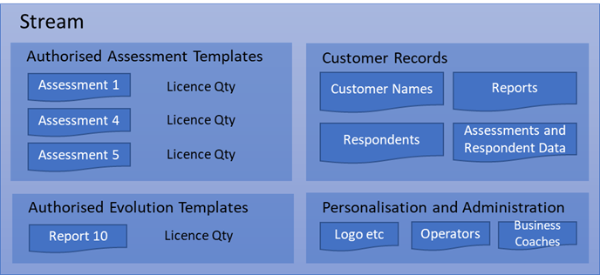

# Roles

The following section describes the roles of users in the system. Each role can exist multiple times. A permission matrix for the roles is summarised in Appendix C: Permissions Matrix.

## System Operator

The System Operator role manages the creation/suspension and deletion of Streams, Question Sets, Report Templates and Assessment Templates.

They do not have access to customer data within the Streams. If they need to directly support a customer in a Stream they can create a temporary Admin account within the relevant Stream.

They can monitor the tool from a customisable dashboard, giving them high-level visibility of all activity with streams (dashboards information defined further on).

## System Administrator

The System Administrator can perform the same tasks as the System Operator and they can monitor the tool from a dashboard and configure system wide settings.

The System Administrator can view all user accounts across the system and can view and edit their assigned roles as well as suspending accounts.

## Business Coach

A Business coaches operates within one or more defined Streams and are responsible for establishing Assessments for customers and will have access to both customer facing and Business Coach reports. The scope of their activities is restricted to the customers that they have assigned to them.

## Stream Operator

The Stream Operator can perform the same tasks as the Business Coach but they can perform the role for all customers. They can assign customers to Business Coaches and they can monitor via a dashboard the status of the Stream including the following:

* Business Coach Status
  + Assigned customer count and link to list
  + Assigned Assessments
  + Assessment utilisation
* Assessment Status
  + Live in-progress
  + Overdue (Respondents late or reports not downloaded)
  + Historical completions (per interval)

## Stream Administrator

The Stream Administrator can perform all tasks for all customers in the same manner as the Stream Operator. Additionally, they can view, edit, suspend and delete Operator and Business Coach accounts within the Stream. They are also able to personalise the Stream web pages with branding and style settings.

## Respondents

Respondents are people that are completing the survey on behalf of a customer. The Respondent can only complete assessments that are assigned to them.

# User Experience

## General

The application will present the users a graphical web interface using modern best practice to provide a coherent, responsive, low-click count, workflow orientated design with optional wizards for key operator processes. The interface should provide a responsive performance when operating over low bandwidth connections of between 250 and 500 kbps.

Within dashboards and where permissions allow, it should be possible to click through to underlying data and/or configuration screens.

The user must be able to cut and paste information into data fields. Where there is a significant data entry requirement across multiple fields, Administrators, Operators and Business Coaches should be given the option of reduced data entry requirements through the bulk import of data using industry standard formats or de facto standards such as CSV and Microsoft Excel. E.g. Question Sets and Customer records.

## Respondent

The interface must be designed for varying screen sizes and formats including PC, tablet and smart phone browsers. A mobile specific application is not required.

The Respondent’s task is very simple but it is very important that their experience of using the tool is good. Using best practice, the interface must be developed such they are presented with an intuitive, user-friendly interface that they can operate without any support or training.

The first experience of the system that a respondent has is when they receive a branded e-mail with a unique link inviting them to take part in the Assessment. The e-mail will contain template information and will indicate the company that the assessment is for, a username and temporary password and a Stream Administrator customisable helpline e-mail/number.

By clicking on the link, the Respondent is taken to a web page where they create a secure password for the account and log in. If a Respondent subsequently forgets their password, a reset option should exist on the login page to allow the Respondent to self-reset their password.

Once the Respondent has logged in, they are presented with a welcome page. The page has one menu that allows them to logout or change their password. In the main body of the page they are presented with a list of their incomplete assessments.

Each assessment link displays an assessment name and the name of the company that they are completing the assessments for. A progress indicator is shown and a completion date indicates when the assessments must be completed by. It is anticipated that a Respondent will only be presented with a maximum of two assessments at a time but should there be more, the screen should grow and scroll to support the additional assessment entries.

If a Respondent clicks on an assessment link, the Respondent is taken to the furthest point in the assessment that they have reached. They then can complete the assessment a page at a time or exit the assessment part complete. Each assessment page displays a progress indicator representing the percentage completion based on the number of questions saved. As they progress through each page the data is saved for each question. If the page is incomplete when the Respondent tries to move on to another page, a warning is displayed and the missing assessment responses are highlighted. Respondents may move backwards and forwards through the question set to make amendments until they finally commit the assessment.

The interfaces for smart phones and tablets may need to present fewer questions per page. The Respondent should be able to answer all questions within a page without scrolling vertically or horizontally.

Once the Respondent has completed the Assessment, it is removed from their list of Assessments.

If a Respondent has started but not completed the assessment a number of days prior to the due date, an automatic reminder e-mail is sent to them along with a link to the Assessment login page. The Business Coach is also notified when the e-mail is sent.

If a Respondent has not started the assessment a number of days prior to the due date, an automatic reminder e-mail is sent along with a new unique link for them to create a password. The Business Coach is also notified when the e-mail is sent.

The Stream Administrator can define the number of days before the reminder e-mails are sent to the Respondents.

If a respondent within a company fails to respond within the allotted time period, an operator or Business Coach must have the capability to either extend the timeline or generate the reports based on actual number of complete responses.

## System Administrator

The System Administrator should be an occasional user of the system primarily to configuring key elements of the system and to monitor and manage performance.

The System Administrator should be able to manage and monitor the status of the service using a dashboard. The home page of the System Administrator will present the same dashboard as the System Operator but certain functions will allow the administrator to control processes in line with their elevated permissions.

The interface should primarily be designed for PC browser access although tablet and phone access is desirable for the presentation of the user dashboard.

Critical events that prevent the service from functioning will be notified to the System Administrators and up to 5 nominated people via e-mail and/or SMS.

## System Operator

The interface should be designed for PC browser access although tablet and smart phone access is desirable for the presentation of key elements in the dashboard and for key tasks.

The System Operator should be an occasional user of the system with primary responsibility to create and configure Streams, branding for the Streams, Question Sets, Reports and Assessment Templates. They can also monitor System processes and performance using a dashboard.

### Dashboard

The Dashboard provides a summary status of the service and should provide enough information about the system for the Administrator and Operators to determine if intervention is required to address problems. The dashboard should present the status on refresh and may optionally provide continuous live updates. The layout of the dashboard should be configurable by the user. The following items should be presented in the dashboard.

* Key Process Status
  + There will be certain application and system processes that run continuously and which are critical to the operation of the service. The dashboard should identify the status of these processes both from an uptime and utilisation perspective.
* Summarised Stream data
  + Quantities of In-Progress Assessments
  + Quantities of completed assessments awaiting Report production
  + Quantities of Current Reports
* For each live Stream (Sort and filter by status) a summary showing:
  + - Stream status (live, suspended)
    - Batch RAG status (Red Amber Green) – % of customers who have completed assessments
    - It will be possible to drill into Streams to see underlying Stream data.

### Question Sets

The System Operator can create/edit/clone/delete Question Sets for future use. A wizard interface must be provided to ensure that Question Sets are easy for the Operator to define. As the System Operator may not be the author of the question set it should be possible for them to both import and export Question Sets using industry standard formats such as CSV, XML etc.

Where a Question Set has been assigned to an Assessment Template and the Assessment Template is in use within a Stream, it should not normally be edited because a change in wording may alter the responses of existing and in-progress assessments. The System Administrator can therefore not import data to over-write a live in-use question set. They can only edit live in-use question sets manually and they must click through a warning page regarding the risks of editing live in-use question sets (It is intended that edits should only be minor where they provide improved clarity or where a grammatical or spelling mistake has been made in a question.).

### Report Templates

The System Operator can create new or edit/clone/delete Report Templates for future use. It should be possible to run sample report templates for developments and approval purposes. This should normally only apply to future Report Templates, not current in-progress reports.

Where a Report Template is in-use with a Stream, it should not normally be edited. However, in cases where minor grammatical improvements or spelling mistakes need correcting in a live Report Template, the Operator must click through a warning page regarding the risks of editing live Report Templates.

### Assessment Templates

The System Operator can create new or edit/clone/delete Assessment Templates for future use. This should normally only apply to future Assessment Templates, not current in-progress Assessment Templates.

Where an Assessment Template is in-use within a Stream, it should not normally be edited other than in cases where minor grammatical improvements or spelling mistakes need correcting in a live Assessment Template, the Operator must click through a warning page regarding the risks of editing live Assessment Templates.

### Creation and Management of Streams

The System Operator can create new or edit/suspend/delete Streams. It must be made extremely difficult for a System Operator to suspend or delete a Stream by mistake; the Operator must click through warnings before a request is acted on. The user must also be given the option of exporting the Stream data before it is deleted.

A wizard process should be available to help a System Operator create or edit a Stream. The wizard should guide the System Operator through a series of stages to address:

* Stream Naming
* URLs and Security Certificates (Any site operating without SSL should be highlighted in System Operator dashboards.)
* E-mail configuration
* Stream Administrator accounts
* Stream batch management (option to skip)

When a Stream is Suspended, all Stream Users (Respondents, Business Coaches, Operators and Administrators) will be prevented from accessing the service until the suspension is cancelled.

### Creation of Batches

Streams will be assigned a specific batch of Assessments, with optional targets and dates assigned to the Stream. The System Operator workflows will allow for the creation, addition, suspension and removal of batch quantities from Streams.

A suspended batch prevents any further Assessments from being scheduled against the Stream until the suspension is revoked. Any in-progress Assessments will be allowed to be completed.

## Stream Operator

The interface should primarily be designed for PC browser access although tablet and smart phone access is desirable for the presentation of key elements in the dashboard.

The Stream Operator should be used as the main operational interface for all customers within a Stream. The interface should present a summary dashboard as the home page and provide the user with the option to use wizards to support the main workflow activities:

* Creation of a customer record and the assignment to a Business Coach. The workflow wizard should allow the operator to create the Respondent records and create an Assessment request using one of the Business Coaches authorised Assessment types. The workflow wizard notifies the Business Coach of new customer creation and new assessments via e-mail (unless configured not to be notified).
* From an assessment summary page, it should be possible to identify the status of responses and add/remove/edit Respondents to allow an assessment to complete. It should also be possible to reset passwords and re-trigger invitations from the same summary page.
* Starting with a Business Coach name or a company name, identify reports to re-run or to download.

### Dashboard

The Stream Operator is provided with a dashboard that shows a summary of the current service status:

* Available Assessment Stream batches
  + Stream batch Name (click on to see view set and report)
  + Batch Quantity
  + Target Date
  + Batch Quantity utilised (links to list of companies and / or Business Coaches including dates and status)
* In-Progress Assessments (sortable list with RAG on due date)
  + Company Name, Due Date, Business Coach Name, Respondent Qty and progress
* Recently completed Assessments (sortable list)
  + Company Name, Completion Date, Business Coach Name, Respondent Qty, Report Count
  + Total of above
* Reports Awaiting Production (link to list of Company Name, Completion Date, Business Coach Name, Respondent Qty)
  + Company Name, Completion Date, Business Coach Name, Respondent Qty
  + Total of above

## Stream Administrator

The interface should primarily be designed for PC browser access although tablet and smart phone access is desirable for the presentation of key elements in the dashboard.

The Stream Administrator should provide the same interface experience as the System Operator. However, the Administrator has additional activities for the administration of branding of the Stream and Operator/Business Coach accounts within the Stream.

### Branding and Stream Specific Content

The configuration of the branding should be managed through a wizard interface to ensure that all aspects of the user web pages and dynamic content are defined before the service is taken live.

It should be possible for the Stream Administrator to also create/edit the individual elements outside of the wizard.

It must be possible to configure the branding to allow multiple logos to display in the Reports and Customer Assessment Interface. The option to display at least 5 logos per Stream, displayed in full colour with customisable size / position on the Reports and Customer Interface is required, with reporting information presented under each Theme.

### Accounts Administration

The Stream Administrator must be able to create, edit, suspend and delete user accounts:

* Stream Operators
* Stream Business Coaches

It must be possible for the administrator to identify, report and export a list of all companies assigned to live, suspended or deleted Business Coaches accounts. The list must identify whether the account has any in-progress assessments, due dates and the date of their last complete assessment.

The system must warn the Stream Operator if they are about to suspend or delete a Business Coach with assigned customers. The Stream Operator should be presented with the option to use a wizard that simplifies the customer re-assignment process for all affected customers.

The Stream Administrator can decide which event notifications a Business Coach should be sent; the default is that all event notifications are sent.

### Stream Business Coach

The interface must be designed for varying screen sizes and formats including PC browser, tablet and smart phone access. Using best practice, the interface must be developed such they are presented with an intuitive interface that they can operate with minimal support or training

The Stream Business Coach has a role that only allows them to manage and view record of customers that are assigned to them by the Stream Operator.

The Stream Operator is provided with a dashboard when they login. The Dashboard displays a list of the Current Assessments and the companies which are participating along with the status of the Assessments, e.g. in-progress Assessments, Assessments awaiting report), etc. Each Assessment record identifies the Company, the number of Respondents, the Assessment name, a unique assessment identifier, the due date and the percentage of completion.

The Stream Operator can click on an Assessment entry to see the details of the assessment including the Respondent details and, where the Assessment is complete, the output reports. The Business Coach can choose to re-run reports

The Business Coach can choose to select one of his customers from a filterable list and then view current and historic Assessments records for the company. The Business Coach can schedule then-and-now comparison reports to see how the company has progressed.

# Security and Data Management

The system must be written to ensure that vulnerabilities are minimised and malicious code is not included. Connections to the system must be secure and steps taken to ensure that malicious and unauthorised access is prevented.

Data must be managed securely to ensure that Stream data is not shared with roles that do not have appropriate permission.

## Security

### SSL

The system must support SSL on all interfaces. The system must be able to support multiple domain URLs for the Streams.

### Password Strength

The system must ensure that strong passwords are enforced for all non-Respondent users to include case, number and non-alphabetical symbols.

Respondents may choose and re-use passwords with a lower strength although a minimum standard should be enforced where letters and numbers are used.

User passwords must not be stored in clear text.

### Respondents Accounts

Respondents are uniquely identified within a Stream. A Respondent may be assigned more than one Assessment within a Stream; the same username and password will be used to access all allocated Assessments.

### Operational User (non Respondent) Accounts

All Operational and Administration users are identified for authentication using their e-mail address. A single user may be assigned one or more roles within a Stream and they may hold roles in more than one Stream. A user may also perform a System Operator Role.

A user will log on to the last role that they used. They can switch to any of their other roles (e.g. to switch Streams) at any time. If data will be lost by switching roles they must be warned and given the option to return to save data. When they swap roles the screen must refresh and the user be presented with the initial default screen.

It must always be apparent to the user when logged into the system, the role they are currently performing and which Stream they are supporting. The roles displayed should be summarised as follows:

* System Administrator
* <User name> - System Operator
* <User name> - <Stream Name> - Administrator
* <User name > - <Stream Name> - Operator
* <User name> - <Stream Name> - Business Coach

### Two Factor Authentication

It must be possible to enable two-factor authentication for all non-Respondent roles using third party services such as Google Authenticator.

## User Data

The following data must be available for each key record type, with the option to make certain fields mandatory.

### Company Records

* Company Name
* Address
* System Generated Reference /Unique Identifier
* Company Registration Number/NI Number
* Incorporation Date
* Company Turnover
* Employee Count
* Up to 5 Stream Administrator defined fields

A company may have records created in more than one Stream. Each company should be treated as an individual record.

### Respondent Records

* First Name
* Surname
* Role
* Respondent e-mail
* Company
* Other Stream Administrator fields

### Stream

* Stream Name
* Key Contact First Name
* Key Contact Surname
* Key Contact e-mail
* Up to 5 Stream Administrator defined fields

### System Administrator

* First Name
* Surname
* e-mail address

### All users except for Respondents and System Administrator

* First Name
* Surname
* e-mail address
* Roles

## Transaction Logging

It is important that transaction logging is in place to ensure an audit trail for all changes and to maintain confidence in the security of the platform and the ability of the users to manage the system properly.

The transaction log should make it possible for the Stream Administrators to see changes made to their Stream and for the System administrator to see all changes in the system. In-page icon buttons should allow an appropriately filtered transaction log data set to be presented to the Administrators. (e.g. when looking at reports the administrator should be able to see who triggered the creation of a report and any previous creations).

Log data should include:

* The Stream (where appropriate)
* The identity of the account used to effect the change
* The data component changed
* The new data value/setting
* The date and time of the change.

When viewing the log it should be possible to filter events using category and user filters:

* The Stream (System administrator only)
* System Changes
* User Accounts and Permissions
* Company and Respondent Records
* Assessments
* Reports
* Users effecting changes (including system)

## Data Export, Anonymising of Data and Data Deletion

Stream data can be anonymised, exported and deleted by the Stream Administrator.

### Anonymising of Data

Data may be required for long term use outside of the programme. For this reason, it must be possible to anonymise data through the removal of identifying data. When data is anonymised, a new data set is created where the company name and company number are replaced by a sequence number that is unique to the anonymised data set. Respondent Data and identifying information will be removed, Except for Theme titles and the Theme summary values.

### Data Export

It must be possible to bulk export customer Assessment data for all customers using the same Assessment Set or Question Set.

Export Data will include summary information to identify the Question Set, Completion Dates, Themes and for each customer the Core Customer Record data and calculated theme values. Data should be exportable in industry standard formats such as CSV, XML etc. Anonymised data can also be exported.

There should be options to filter the data selected for export (it should be possible to filter such that only records for customers with more than one assessment are exported).

### Data Deletion

It must be possible to delete all records associated with Assessment Sets. It must also be possible to delete anonymised data sets.

Suitable warnings must be given to users and it must only be possible to delete record sets if there are no active Assessments associated with the record set.

## Assessment Set Batches

Batches are assigned to each stream with optional numerical targets and expiry dates. Batch usage can be tracked in the dashboard.

## Operational Reporting

A reporting function must also be available within the system to export dashboard and dashboard supporting information at Stream and System level – including number of customers / per status / coach / stream, limited by date range, with other fields as required.

Reporting must support for industry standard formats such as PDF, Excel, CSV, XML etc.

# Development Requirements

## Intellectual Property

The service must be developed using either Open Source or commercially supported applications. To allow us to assess any potential IPR issues, the Supplier should provide full details of any Open Source software used as the underlying platform. It will be a condition of the contract that the chosen provider warrants that it will not use open source software in the delivery of the project, save where the customer has consented to such use and the supplier:

* has notified the customer in advance of its intention to use open source software and has provided details of the relevant open source licences in writing;
* will only use open source content approved by the customer; and,
* warrants that the use of any open source content will not have any negative impact on the customer, including without limitation full use and development of the product as required during this project.

Uncompiled script based code may be used within the service if it’s use is clear, well-structured and commented.

Oxford Innovation Services will retain the Intellectual Property Rights and Usage Rights for all software and scripts developed as a part of this contract and will have full, unrestricted access to the development after completion.

The service must be developed using either Open Source or commercially supported applications. Uncompiled script based code may be used within the service if it’s use is clear, well-structured and commented.

Oxford Innovation Services will retain the Intellectual Property Rights and Usage Rights for all software and scripts developed as a part of this contract and will have full, unrestricted access to the development after completion.

## Future Evolution

It is anticipated that the platform will evolve over time to support additional questioning formats and processing algorithms (e.g. multiple choice and where two questions are scored in combination). Using the concept model, it is anticipated that developments will affect the following components:

* Question Sets
* Assessment Engine
* Processing and Normalising Engine
* The Reporting Engine
* Export Requirements

It is therefore important that the system is developed to accommodate such changes without major re-development work.

## Equality and Diversity

Whilst the initial development is only required in English, the platform should be designed to provide international language support if required. The skin, alerts and warnings, and questions must be supported in multiple languages.

## Compatibility

The Respondent interface must be responsive in the following device formats:

* PC browser
* Tablet browser
* Smart phone browser

The web interface must support the following browsers - and Java where used (all code versions available for download since 1st January 2016):

* Google Chrome
* Internet Explorer/Microsoft Edge
* Firefox
* Safari

Customer Reports must be rendered as PDFs in mobile compatible format.

## Disability Access

It must be possible for all pages in the site to be adjusted for disabled accessibility. Legal minimum standards should be adhered to and where possible the development should meet Level AA of the Web Content Accessibility Guidelines (WCAG) 2.0.

# Appendix A – Example Question Sets

In the following example, there are two question sets, one with 15 questions and the other with 22. In both sets. Each question is associated with one or more Themes; one question applies to both Finance and Cash Themes. All questions are presented as Yes/No questions and they are scored as a 1 for Yes and a 0 for No.

|  |  |  |  |  |
| --- | --- | --- | --- | --- |
| **Question Set** | **Question Number** | **Theme** | **Question Words** | **Question Type** |
| S1 | 1 | Change | Question Words 1 | YN |
| S1 | 2 | Strategy | Question Words 2 | YN |
| S1 | 3 | Operations | Question Words 3 | YN |
| S1 | 4 | Change | Question Words 4 | YN |
| S1 | 5 | Finance, Cash | Question Words 5 | YN |
| S1 | 6 | Finance | Question Words 6 | YN |
| S1 | 7 | Change | Question Words 7 | YN |
| S1 | 8 | Operations | Question Words 8 | YN |
| S1 | 9 | Change | Question Words 9 | YN |
| S1 | 10 | Cash | Question Words 10 | YN |
| S1 | 11 | Strategy | Question Words 11 | YN |
| S1 | 12 | Finance | Question Words 12 | YN |
| S1 | 13 | Change | Question Words 13 | YN |
| S1 | 14 | Operations | Question Words 14 | YN |
| S1 | 15 | Cash | Question Words 15 | YN |
| S2 | 1 | Change | Question Words 1 | YN |
| S2 | 2 | Strategy | Question Words 2 | YN |
| S2 | 3 | Operations | Question Words 3 | YN |
| S2 | 4 | Change | Question Words 4 | YN |
| S2 | 5 | Finance | Question Words 5 | YN |
| S2 | 6 | Cash | Question Words 6 | YN |
| S2 | 7 | Change | Question Words 7 | YN |
| S2 | 8 | Operations | Question Words 8 | YN |
| S2 | 9 | Change | Question Words 9 | YN |
| S2 | 10 | Cash | Question Words 10 | YN |
| S2 | 11 | Strategy | Question Words 11 | YN |
| S2 | 12 | Finance | Question Words 12 | YN |
| S2 | 13 | Change | Question Words 13 | YN |
| S2 | 14 | Operations | Question Words 14 | YN |
| S2 | 15 | Cash | Question Words 15 | YN |
| S2 | 9 | Leadership | Question Words 16 | YN |
| S2 | 10 | Marketing & Sales | Question Words 17 | YN |
| S2 | 11 | Marketing & Sales | Question Words 18 | YN |
| S2 | 12 | Finance, Cash | Question Words 19 | YN |
| S2 | 13 | Leadership | Question Words 20 | YN |
| S2 | 14 | Operations | Question Words 21 | YN |
| S2 | 15 | Cash | Question Words 22 | YN |

For each question set the themes and question quantities are shown below.

|  |  |  |
| --- | --- | --- |
| **Theme** | **Question Set** | |
|  | S1 | S2 |
| Cash | 3 | 5 |
| Change | 5 | 5 |
| Finance | 3 | 3 |
| Operations | 3 | 4 |
| Strategy | 2 | 2 |
| Leadership |  | 2 |
| Marketing & Sales |  | 2 |

# **Appendix B – Question Types**

|  |  |  |  |
| --- | --- | --- | --- |
| Question Type | Themes | Processing 1 | Processing 2 |
| Yes/No | 1 or more | Each yes represents a value of one and each no a value of zero. For all respondents and all questions in a theme, the respondent values are averaged and normalised to provide a score between 0 and 10. | Each yes represents a value of one and each no a value of zero.  For each Respondent, for all questions in a theme, the respondent values are averaged and normalised to provide a score between 0 and 10.  Within each theme, the difference between the highest and lowest individual normalised averages is calculated to provide an indication of largest agreement/ disagreement between Respondents. |
| Yes/No/Not Applicable | 1 or more | Each yes represents a value of one and each no a value of zero. Questions answered Not Applicable are not processed.  For all Respondents and all answered questions in a theme, the respondent values are averaged and normalised to provide a score between 0 and 10. | Each yes represents a value of one and each no a value of zero. Questions answered Not Applicable are not processed.  Within each theme, the difference between the highest and lowest individual normalised averages is calculated to provide an indication of largest agreement/ disagreement between Respondents. |
| Comment | No | No processing – the text is available for display in the report in raw form. | None |
| Multi-dimension Yes/No | 1 or more | Two linked yes/no questions are asked. The outputs form a 2x2 matrix; no-no,no-yes,yes-no, yes-yes. Each of the matrix positions is represented by NN, NY, YN, YY. The count of each letter pair within a theme is normalised to produce four results between 0 and 10. | None |

# Appendix C **–** Permissions Matrix



Key: X = Permission / O = No permission

# Appendix D – Glossary

**Assessment Template:**

An Assessment Template defines a pairing of Question Set with Report Templates. The Assessment Template allows one Question Set to be re-used in Stream specific Report Templates.

**Current Assessment:**

A current Assessment is one for which meets any of the following criteria:

* the due date falls in the future but the assessment has not completed.
* the assessment has completed but the adviser has not downloaded the reports.

**Processing Engine:**

**A software module that takes in Respondent data and produces company reporting data sets for use by the Reporting Engine.**

**Question Set:**

A set of questions with associated metadata defining how the question is presented and the respondent data should be processed. Each question within the Question Set can be associated with one or more Themes; there may be up to 50 Themes in a question set. Themes are used within the output report to present information focussed on Themes.

**Reporting Engine**

**A software module that takes company reporting data (processed Respondent data) and produces PDF reports for use by Business Coaches when coaching customers.**

**Respondents:**

Respondents are employees of companies that are being assessed. There are normally several Respondents for each company and they complete web based questionnaires.

**Stream:**

**A Stream is a defined group of customers that fall into a particular sector or target category e**.g. Software Development, Digital Technology, Manufacturing. A Stream may have its own Branding specific to the sector, assessment targets and may use a separate URL for customers to access the service.

**Theme:**

A Theme defines a question grouping / categorisation focussed on a particular area of a business. Themes might be Strategy, Leadership, Innovation etc. Several questions will be asked for each Theme and a question may be associated with one or more Themes. Themes are used within the output report to present information focussed on Themes.

**Report Template:**

A Report Template is a branded PDF report that can be populated with information collected from the Respondents during an assessment. The report will identify the customer, the assessment name, dates and common reporting charts.

# Appendix E – Sample Data and Reporting

The following sheet shows sample questions and answers from 6 respondents to questions on 7 themes:

|  |  |  |  |  |  |  |  |  |
| --- | --- | --- | --- | --- | --- | --- | --- | --- |
| **Question #** | **Question** | **Theme** | **Respondent** | | | | | |
| **A** | **B** | **C** | **D** | **E** | **F** |
| 1 | Question Words 1 | Change | Y | N | Y | Y | N | Y |
| 2 | Question Words 2 | Strategy | Y | N | Y | Y | Y | N |
| 3 | Question Words 3 | Operations | Y | Y | Y | N | Y | Y |
| 4 | Question Words 4 | Change | Y | N | N | Y | N | N |
| 5 | Question Words 5 | Finance | N | Y | Y | N | Y | Y |
| 6 | Question Words 6 | Cash | Y | N | Y | Y | Y | N |
| 7 | Question Words 7 | Change | N | Y | Y | N | Y | N |
| 8 | Question Words 8 | Operations | N | Y | Y | N | N | Y |
| 9 | Question Words 9 | Change | Y | Y | N | Y | Y | N |
| 10 | Question Words 10 | Cash | N | N | N | N | N | Y |
| 11 | Question Words 11 | Strategy | N | N | N | N | N | Y |
| 12 | Question Words 12 | Finance | N | N | N | N | N | N |
| 13 | Question Words 13 | Change | Y | Y | Y | Y | Y | Y |
| 14 | Question Words 14 | Operations | Y | Y | Y | Y | Y | Y |
| 15 | Question Words 15 | Cash | N | Y | N | N | Y | N |
| 16 | Question Words 16 | Leadership | N | N | N | N | N | N |
| 17 | Question Words 17 | Marketing & Sales | Y | N | Y | Y | N | Y |
| 18 | Question Words 18 | Marketing & Sales | Y | Y | Y | Y | Y | Y |
| 19 | Question Words 19 | Finance, Cash | Y | Y | Y | Y | Y | Y |
| 20 | Question Words 20 | Leadership | Y | N | Y | Y | N | Y |
| 21 | Question Words 21 | Operations | N | N | N | N | N | N |
| 22 | Question Words 22 | Cash | Y | Y | Y | Y | Y | Y |

The table below shows for each Theme in the question set above, the numbers of questions, the total of all Y answers and the normalised score.

|  |  |  |  |
| --- | --- | --- | --- |
| **Theme** | **Qs** | **Score** | **Normalised** |
| Change | 5 | 19 | 6.33 |
| Strategy | 2 | 5 | 4.17 |
| Operations | 4 | 14 | 5.83 |
| Finance | 3 | 10 | 5.56 |
| Cash | 5 | 19 | 6.33 |
| Leadership | 2 | 4 | 3.33 |
| Marketing & Sales | 2 | 10 | 8.33 |

The following table identifies the difference between the highest and lowest score for each Respondent in each Theme

|  |  |  |  |  |  |  |  |
| --- | --- | --- | --- | --- | --- | --- | --- |
| **Theme** | **A** | **B** | **C** | **D** | **E** | **F** | **Max-Min** |
| Change | 4 | 3 | 3 | 4 | 3 | 2 | 2 |
| Strategy | 1 | 0 | 1 | 1 | 1 | 1 | 1 |
| Operations | 2 | 3 | 3 | 1 | 2 | 3 | 2 |
| Finance | 1 | 2 | 2 | 1 | 2 | 2 | 1 |
| Cash | 3 | 3 | 3 | 3 | 4 | 3 | 1 |
| Leadership | 1 | 0 | 1 | 1 | 0 | 1 | 1 |
| Marketing & Sales | 2 | 1 | 2 | 2 | 1 | 2 | 1 |

The diagram below represents how the Theme based normalised data may be represented in a spider diagram for a client company report.

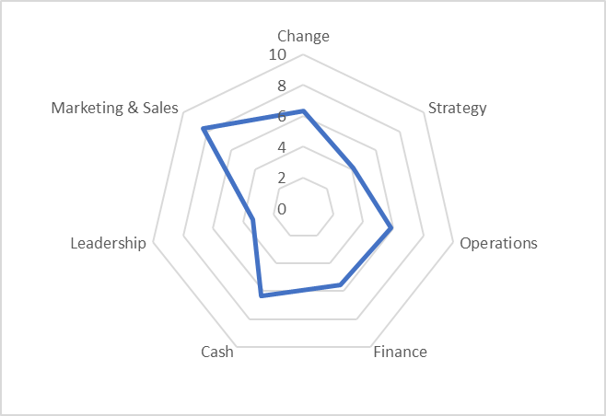

The diagram below illustrates how the difference between the highest and lowest score for each Respondent in each Theme may be represented in a client report to show discrepancy of views (A higher number of questions may result in larger discrepancy).

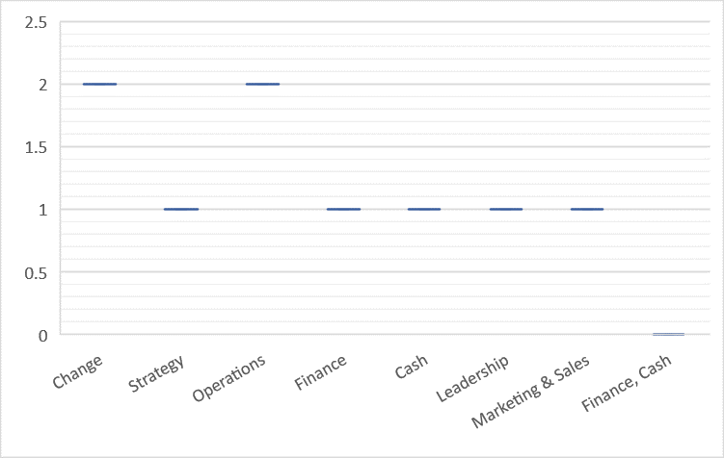

**The Business Coach Report may contain the following raw data table so that the Business Coach can understand each respondent complete the questionnaire and drill into areas requiring support. Note that question 19 is repeated in two Themes.**

|  |  |  |  |  |  |  |  |  |
| --- | --- | --- | --- | --- | --- | --- | --- | --- |
| **Question #** | **Question** | **Theme** | **Respondent** | | | | | |
| **A** | **B** | **C** | **D** | **E** | **F** |
| 6 | Question Words 6 | Cash | Y | N | Y | Y | Y | N |
| 10 | Question Words 10 | Cash | N | N | N | N | N | Y |
| 15 | Question Words 15 | Cash | N | Y | N | N | Y | N |
| 22 | Question Words 15 | Cash | Y | Y | Y | Y | Y | Y |
| 19 | Question Words 12 | Cash | Y | Y | Y | Y | Y | Y |
| 1 | Question Words 1 | Change | Y | N | Y | Y | N | Y |
| 4 | Question Words 4 | Change | Y | N | N | Y | N | N |
| 7 | Question Words 7 | Change | N | Y | Y | N | Y | N |
| 9 | Question Words 9 | Change | Y | Y | N | Y | Y | N |
| 13 | Question Words 13 | Change | Y | Y | Y | Y | Y | Y |
| 5 | Question Words 5 | Finance | N | Y | Y | N | Y | Y |
| 12 | Question Words 12 | Finance | N | N | N | N | N | N |
| 19 | Question Words 12 | Finance | Y | Y | Y | Y | Y | Y |
| 16 | Question Words 9 | Leadership | N | N | N | N | N | N |
| 20 | Question Words 13 | Leadership | Y | N | Y | Y | N | Y |
| 17 | Question Words 10 | Marketing & Sales | Y | N | Y | Y | N | Y |
| 18 | Question Words 11 | Marketing & Sales | Y | Y | Y | Y | Y | Y |
| 3 | Question Words 3 | Operations | Y | Y | Y | N | Y | Y |
| 8 | Question Words 8 | Operations | N | Y | Y | N | N | Y |
| 14 | Question Words 14 | Operations | Y | Y | Y | Y | Y | Y |
| 21 | Question Words 14 | Operations | N | N | N | N | N | N |
| 2 | Question Words 2 | Strategy | Y | N | Y | Y | Y | N |
| 11 | Question Words 11 | Strategy | N | N | N | N | N | Y |