Schedule 1 - Definitions of Contract

Articles means the Contractor Deliverables (goods and/or the services), including Packaging (and Certificate(s) of Conformity and supplied in accordance with any QA requirements if specified) which the Contractor is required to provide under the Contract in accordance with Schedule 2 (Schedule of Requirements), but excluding incidentals outside Schedule 2 (Schedule of Requirements) such as progress reports. (This definition only applies when DEFCONs are added to these Conditions);

Authority means the Secretary of State for Defence acting on behalf of the Crown;

Authority’s Representative(s) shall be those person(s) defined in Schedule 3 (Contract Data
Sheet) who will act as the Authority’s Representative(s) in connection with the Contract. Where the term “Authority’s Representative(s)” in the Conditions is immediately followed by a functional description in brackets, the appropriate Authority’s Representative(s) shall be the designated person(s) for the purposes of condition 7; For the purposes of clause 26. a. the Authority Representative shall be IRMProcurementSupport@babcockinternational.com

Business Day means 09:00 to 17:00 Monday to Friday, excluding public and statutory holidays;

Central Government Body a body listed in one of the following sub-categories of the Central
Government classification of the Public Sector Classification Guide, as published and amended from time to time by the Office for National Statistics:
- Government Department;
- Non-Departmental Public Body or Assembly Sponsored Public Body (advisory, executive, or tribunal);
- Non-Ministerial Department; or
- Executive Agency;

Collect means pick up the Contractor Deliverables from the Consignor. This shall include loading, and any other specific arrangements, agreed in accordance with clause 28.c and Collected and Collection shall be construed accordingly;

Commercial Packaging means commercial Packaging for military use as described in Def
Stan 81-041 (Part 1)

Conditions means the terms and conditions set out in this document;

Consignee means that part of the Authority identified in Schedule 3 (Contract Data Sheet) to whom the Contractor Deliverables are to be Delivered or on whose behalf they are to be Collected at the address specified in Schedule 3 (Contract Data Sheet) or such other part of the Authority as may be instructed by the Authority by means of a Diversion Order;

Consignor means the name and address specified in Schedule 3 (Contract Data Sheet) from whom the Contractor Deliverables will be dispatched or Collected;

Contract means the Contract including its Schedules and any amendments agreed by the Parties in accordance with condition 6 (Formal Amendments to the Contract);

Contract Price means the amount set out in Schedule 2 (Schedule of Requirements) to be paid (inclusive of Packaging and exclusive of any applicable VAT) by the Authority to the Contractor, for the full and proper performance by the Contractor of its obligations under the Contract.
Contractor means the person who, by the Contract, undertakes to supply the Contractor Deliverables, for the Authority as is provided by the Contract. Where the Contractor is an individual or a partnership, the expression shall include the personal representatives of the individual or of the partners, as the case may be, and the expression shall also include any person to whom the benefit of the Contract may be assigned by the Contractor with the consent of the Authority;

Contractor Commercially means the Information listed in the completed Schedule 5
Sensitive Information (Contractor’s Commercially Sensitive Information Form), which is
Information notified by the Contractor to the Authority, which is acknowledged by the Authority as being commercially sensitive;

Contractor Deliverables means the goods and/or the services, including Packaging (and
Certificate(s) of Conformity and supplied in accordance with any QA requirements if specified) which the Contractor is required to provide under the Contract;

Control means the power of a person to secure that the affairs of the Contractor are conducted in accordance with the wishes of that person:
- by means of the holding of shares, or the possession of voting powers in, or in relation to, the Contractor; or
- by virtue of any powers conferred by the constitutional or corporate documents, or any other document, regulating the Contractor;
and a change of Control occurs if a person who Controls the Contractor ceases to do so or if another person acquires Control of the Contractor;

CPET means the UK Government’s Central Point of Expertise on Timber, which provides a free telephone helpline and website to support implementation of the UK Government timber procurement policy

Crown Use in relation to a patent means the doing of anything by virtue of Sections 55 to 57 of the Patents Act 1977 which otherwise would be an infringement of the patent and in relation to a Registered Design has the meaning given in paragraph 2A(6) of the First Schedule to the Registered Designs Act 1949;

Dangerous Goods means those substances, preparations and articles that are
capable of posing a risk to health, safety, property or the environment which are prohibited by regulation, or classified and authorised only under the conditions prescribed by the:
- Carriage of Dangerous Goods and Use of Transportable Pressure Equipment Regulations 2009 (CDG) (as amended 2011);
- European Agreement Concerning the International Carriage of Dangerous Goods by Road (ADR);
- Regulations Concerning the International Carriage of Dangerous Goods by Rail (RID);
- International Maritime Dangerous Goods (IMDG) Code;
- International Civil Aviation Organisation (ICAO) Technical Instructions for the Safe Transport of Dangerous Goods by Air;
- International Air Transport Association (IATA) Dangerous Goods Regulations.

DBS Finance means Defence Business Services Finance, at the address stated in Schedule 3 (Contract Data Sheet);

DEFFORM means the MOD DEFFORM series which can be found at https://www.aof.mod.uk;

DEF STAN means Defence Standards which can be accessed at
https://www.dstan.mod.uk;

Deliver means hand over the Contractor Deliverables to the Consignee.
This shall include unloading, and any other specific arrangements, agreed in accordance with condition 28 and Delivered and Delivery shall be construed accordingly;

Delivery Date means the date as specified in Schedule 2 (Schedule of Requirements) on which the Contractor Deliverables or the relevant portion of them are to be Delivered or made available for Collection;

Denomination of Quantity means the quantity or measure by which an item of material is
(D of Q) managed;

Design Right(s) has the meaning ascribed to it by Section 213 of the Copyright,
Designs and Patents Act 1988;

Diversion Order means the Authority’s written instruction (typically given by MOD
Form 199) for urgent Delivery of specified quantities of Contractor Deliverables to a Consignee other than the Consignee stated in Schedule 3 (Contract Data Sheet);

Effective Date of Contract means the date specified on the Authority’s acceptance letter;

Evidence means either:
- an invoice or delivery note from the timber supplier or Subcontractor to the Contractor specifying that the product supplied to the Authority is FSC or PEFC certified; or
- other robust Evidence of sustainability or FLEGT licensed origin, as advised by CPET;

Firm Price means a price (excluding VAT) which is not subject to variation;

FLEGT means the Forest Law Enforcement, Governance and Trade initiative by the European Union to use the power of timber- consuming countries to reduce the extent of illegal logging;

Government Furnished is a generic term for any MOD asset such as equipment,
Assets (GFA) information or resources issued or made available to the Contractor in connection with the Contract by or on behalf of the Authority;

Hazardous Contractor means a Contractor Deliverable or a component of a Contractor
Deliverable Deliverable that is itself a hazardous material or substance or that may in the course of its use, maintenance, disposal, or in the event of an accident, release one or more hazardous materials or substances and each material or substance that may be so released;

Independent Verification means that an evaluation is undertaken and reported by an
individual or body whose organisation, systems and procedures conform to “ISO Guide 65:1996 (EN 45011:1998) General requirements for bodies operating product certification systems or equivalent”, and who is accredited to audit against forest management standards by a body whose organisation, systems and procedures conform to “ISO 17011: 2004 General Requirements for Providing Assessment and Accreditation of Conformity Assessment Bodies or equivalent”;

Information means any Information in any written or other tangible form disclosed to one Party by or on behalf of the other Party under or in connection with the Contract;

Issued Property means any item of Government Furnished Assets (GFA), including
any materiel issued or otherwise furnished to the Contractor in connection with the Contract by or on behalf of the Authority;

Legal and Sustainable means production and process methods, also referred to as timber
production standards, as defined by the document titled “UK Government Timber Production Policy: Definition of legal and sustainable for timber procurement". The edition current on the day the Contract documents are issued by the Authority shall apply;

Legislation means in relation to the United Kingdom any Act of Parliament, any subordinate legislation within the meaning of section 21 of the Interpretation Act 1978, any exercise of Royal Prerogative;

Military Level Packaging (MLP) means Packaging that provides enhanced protection in
accordance with Def Stan 81-041 (Part 1), beyond that which Commercial Packaging normally provides for the military supply chain;

Military Packager is a MOD sponsored scheme to certify military Packaging
Approval Scheme (MPAS) designers and register organisations, as capable of producing
acceptable Services Packaging Instruction Sheet (SPIS) designs in accordance with Defence Standard (Def Stan) 81-041 (Part 4);

Military Packaging Level (MPL) shall have the meaning described in Def Stan 81-041 (Part 1);

MPAS Registered Organisation is a packaging organisation having one or more MPAS Certificated
Designers capable of Military Level designs. A company capable of both Military Level and commercial Packaging designs including MOD labelling requirements;

MPAS Certificated Designer shall mean an experienced Packaging designer trained and
certified to MPAS requirements;

NATO means the North Atlantic Treaty Organisation which is an inter- governmental military alliance based on the North Atlantic Treaty which was signed on 4 April 1949;

Notices shall mean all Notices, orders, or other forms of communication required to be given in writing under or in connection with the Contract;

Overseas shall mean non UK or foreign;

Packaging Verb. The operations involved in the preparation of materiel for; transportation, handling, storage and Delivery to the user;
Noun. The materials and components used for the preparation of the Contractor Deliverables for transportation and storage in accordance with the Contract;

Packaging Design Authority shall mean the organisation that is responsible for the original
(PDA) design of the Packaging except where transferred by agreement.
The PDA shall be identified in the Contract, see Annex A to Schedule 3 (Appendix – Addresses and Other Information), Box 3;

Parties means the Contractor and the Authority, and Party shall be construed accordingly;

Primary Packaging Quantity means the quantity of an item of material to be contained in an
(PPQ) individual package, which has been selected as being the most suitable for issue(s) to the ultimate user, as described in Def Stan 81-041 (Part 1);

Publishable Performance Information
means any of the Information in Schedule 9 (KPI Data Report) as it relates to Key Performance Indicator where it is expressed as publishable in the table in Schedule 9 which shall not contain any Information which is exempt from disclosure which shall be determined by the Authority; and which shall not constitute Sensitive Information;

Recycled Timber means recovered wood that prior to being supplied to the Authority
had an end use as a standalone object or as part of a structure. Recycled Timber covers:
- pre-consumer reclaimed wood and wood fibre and industrial by-products;
- post-consumer reclaimed wood and wood fibre, and driftwood;
- reclaimed timber abandoned or confiscated at least ten years previously;
it excludes sawmill co-products;

Safety Data Sheet has the meaning as defined in the Registration, Evaluation,
Authorisation and Restriction of Chemicals (REACH) Regulations 2007 (as amended);

Schedule of Requirements means Schedule 2 (Schedule of Requirements), which identifies,
either directly or by reference, Contractor Deliverables to be provided, the quantities and dates involved and the price or pricing terms in relation to each Contractor Deliverable;

Sensitive Information means the Information listed in the completed Schedule 5 (Contractors Sensitive Information), which is Information notified by the Contractor to the Authority, which is acknowledged by the Authority as being sensitive, at the point at which the Contract is entered into or amended (as relevant) and remain sensitive information at the time of publication;

Short-Rotation Coppice means a specific management regime whereby the poles of trees
are cut every one to two years and which is aimed at producing biomass for energy. It is exempt from the UK Government timber procurement policy. For avoidance of doubt, Short-Rotation Coppice is not conventional coppice, which is subject to the timber policy;

Specification means the description of the Contractor Deliverables, including any specifications, drawings, samples and / or patterns, and shall include any document or item which, individually or collectively is referred to in Schedule 2 (Schedule of Requirements). The Specification forms part of the Contract and all Contractor Deliverables to be supplied under the Contract shall conform in all respects with the Specification;

STANAG 4329 means the publication NATO Standard Bar Code Symbologies which can be sourced at https://www.dstan.mod.uk/faqs.html;

Subcontractor means any subcontractor engaged by the Contractor or by any other subcontractor of the Contractor at any level of subcontracting to provide Contractor Deliverables wholly or substantially for the purpose of performing (or contributing to the performance of) the whole or any part of this Contract and ‘Subcontract’ shall be interpreted accordingly;

Timber and Wood-Derived means timber (including Recycled Timber and Virgin Timber but
Products excluding Short-Rotation Coppice) and any products that contain wood or wood fibre derived from those timbers. Such products range from solid wood to those where the manufacturing processes obscure the wood element;

Transparency Information means the content of this Contract in its entirety, except for (i) any Information which is exempt from disclosure in accordance with the provisions of the Freedom of Information Act 2000 (FOIA) or the Environmental Information Regulations 2004 (EIR), which shall be determined by the Authority, and (ii) any Sensitive Information;

Virgin Timber means Timber and Wood-Derived Products that do not include Recycled Timber.

Annex A to Schedule 1 – Additional Definitions of Contract iaw. Conditions 45 - 46 (Additional Conditions)

Agent means Babcock Land Defence Limited of 33 Wigmore Street, London, W1U 1QX c/o I&RM, B15, Donnington, Telford, TF2 8JT or such other person as notified by the Authority to the Contractor.

Allied Quality Assurance Publications means standards for Quality Assurance Systems that
(AQAP) have been developed by NATO for Defence products
Army Equipment Support Publications means technical information concerning Army
(AESP) Equipment for parties involved with operational use, maintenance or repair of said equipment.

Beyond Economic Repair (BER) means when the cost of repairing an item would more costly than replacing it. (If it costs more than 80% of the replacement value)

Deficiencies/Discrepancies means a failing, defect or variation of equipment delivered or collected for the fulfilment of the Contract Requirement.

Deliverable Quality Plan means a document, prepared by a supplier, and agreed with the project/repair manager setting out the specific quality practices, resources and sequence of activities relevant to a particular product, project or contract.

Disposal means method of dealing with surplus or defunct MoD equipment

Equipment Build Standard means the required standard for repairs/remanufacture or production of Army Equipment

Key Performance Indicator (KPI) means a key performance measurement to evaluate the success of a contract and the activities in which it engages.

Local Equipment/Commercial Review means a specific, recurring meeting held
meeting to discuss progress toward set objectives.

NATO Stock Number (NSN) means a 13 digit numeric code identified all the standardised material items of supply as recognised by all NATO Countries that has come to be used in all treaty countries.

Nomenclature means the body or system of terms used in a particular specialist field.

Non Codified means material items of supply that are not arranged into a systemised code.

Non-Conformance means a failure to comply to accepted standards

Novation means the substitution of a new contract in place of an old one.

Obsolescent is when a Contractor Deliverable subject to this agreement:-
- is or is intended to be, no longer produced by the original equipment manufacturer; or
- is or is planned to be, no longer supported by the original equipment manufacturer.

Obsolete means any Contractor Deliverable that has become Obsolescent.

Purchase Order (PO) means a buyer-generated document that authorised a purchase transaction.

Remedies means the extent of damages generally intended to compensate one party to a contract for any failure of another party to said contract to comply with their contractual obligations in a timely manner.

Statement of Work (SOW) means a document that defines project-specific activities, deliverables and timelines for the contract.

Surge means a potential unforeseen increase in requirements (e.g. in times of war)

Turnaround Time (TAT) means a period of time for completing a process cycle (such as repair or replacement of a component or equipment), commonly expressed as an average of previous such periods.

Warranty means a written guarantee, issued to the purchaser, of an article of equipment or component of such, by its manufacturer/supplier, promising to repair or replace if it is necessary within a specified period of time.

Schedule 2 - Schedule of Requirements for Contract No:

For IRM19/7393

For The Repair of Hydraulic and Pneumatic assemblies and the provision of output specifications

Contractor Deliverables
Item Number | MOD Stock Reference No. | Part No. (where applicable) | Specification | Consignee Address Code (full address is detailed in  DEFFORM 96) | Packaging Requirements inc. PPQ and DofQ (as detailed in DEFFORM 96) | Delivery Date | Total Qty | Price (£) Ex VAT
 |  |  |  |  |  |  |  | Per Item | Total inc. Packaging (and Delivery if specified in Schedule 3 (Contract Data Sheet) )
1 | As per the attached pricing sheet – Annex B to Schedule 2 |  | The Repair of Hydraulic Assemblies (Category A) | As stated on each Purchase Order | As stated within Statement of Work at Annex A to Schedule 2 & Pricing Document at Annex B to Schedule 2 | In accordance with the Lead-time agreed at Annex B to Schedule 2 | As Required |  | Pricing shall be in accordance with Annex B to Schedule 2.
2 | As per the attached pricing sheet – Annex B to Schedule 2 |  | The Provision of Output Specifications for Hydraulic Assemblies (Category A) | As stated on each Purchase Order | As stated within Statement of Work at Annex A to Schedule 2 & Pricing Document at Annex B to Schedule 2 & Data Item Description at Annex C to Schedule 2 | In accordance with the Lead-time agreed at Annex B to Schedule 2 | As Required |  | Pricing shall be in accordance with Annex B to Schedule 2.
3 | As per the attached pricing sheet – Annex B to Schedule 2 |  | The Repair of Hydraulic Assemblies (Category B) | As stated on each Purchase Order | As stated within Statement of Work at Annex A to Schedule 2 & Pricing Document at Annex B to Schedule 2 | In accordance with the Lead-time agreed at Annex B to Schedule 2 | As Required |  | Pricing shall be in accordance with Annex B to Schedule 2.
4 | As per the attached pricing sheet – Annex B to Schedule 2 |  | The Provision of Output Specifications for Hydraulic Assemblies (Category B) | As stated on each Purchase Order | As stated within Statement of Work at Annex A to Schedule 2 & Pricing Document at Annex B to Schedule 2 & Data Item Description at Annex C to Schedule 2 | In accordance with the Lead-time agreed at Annex B to Schedule 2 | As Required |  | Pricing shall be in accordance with Annex B to Schedule 2.
5 | As per the attached pricing sheet – Annex B to Schedule 2 |  | The Repair of Pneumatic Assemblies | As stated on each Purchase Order | As stated within Statement of Work at Annex A to Schedule 2 & Pricing Document at Annex B to Schedule 2 | In accordance with the Lead-time agreed at Annex B to Schedule 2 | As Required |  | Pricing shall be in accordance with Annex B to Schedule 2.
6 | As per the attached pricing sheet – Annex B to Schedule 2 |  | The Provision of Output Specifications for Pneumatic Assemblies | As stated on each Purchase Order | As stated within Statement of Work at Annex A to Schedule 2 & Pricing Document at Annex B to Schedule 2 & Data Item Description at Annex C to Schedule 2 | In accordance with the Lead-time agreed at Annex B to Schedule 2 | As Required |  | Pricing shall be in accordance with Annex B to Schedule 2.
Total Price

Item Number | Consignee Address (XY code only)

Airports | Communications | Defence | Education | Emergency Services | Energy | Mining and Construction | Property | Rail | Training
STATEMENT OF WORK FOR THE REPAIR AND OVERHAUL OF VARIOUS HYDRAULICS AND PNEUMATICS UNDER CONTRACT IRM19/7393
The contents of this specification must not be communicated to a third party or used for any other work than that for which the specification is issued without the written agreement of the Babcock Land Defence Repair Manager

Contents

Cover Sheet
1
Contents 2
List of Tables 2
Amendment Record 3
1.0 Introduction 5
2.0 Publications 6
3.0 Documentation 8
4.0 Repair Policy 9
5.0 Repair Requirement 10
6.0 Performance and Test Acceptance 12
7.0 Preservation, Packing & Labelling 12

List of Tables
Table 1 – Equipment Details 4
Table 2 – Support Publications 5
Table 3 - Equipment Modification Equipment……..………………………………………………………………8

Amendment Record

Issue/  Amdt  No | Identification of Change  Page & Para No | Date  Entered | Date  Effective | Authorisation

- Introduction
1.1 The equipment covered by this Statement of Work (SoW) are managed by the Vehicle Support Team and provide Engine, Transmissions and Ancillaries for the Challenger, Warrior, Titan/Trojan and Terrier vehicles; this equipment is listed in Table 1; any previous versions of these items will be repaired and returned as the latest standard unless otherwise instructed.

Table 1 – Equipment Details

Lot 1 & 2
NSN | DESCRIPTION | PLATFORM
4320992553274 | PUMP,ROTARY | WARRIOR
2540994960005 | MOTOR,HYDRAULIC | WARRIOR
4320991532089 | PUMP UNIT,ROTARY | AS90
4320999381930 | RAM,HYDRAULIC | AS90
4320011112277 | PUMP,CENTRIFUGAL | AS90
4320997983422 | PUMP,HYDRAULIC | WARRIOR
4320993014761 | PUMP UNIT | CR2
2530998263978 | CYLINDER,HYDRAU BRAKE... | CR2
2530123392226 | CYLINDER ASSY | BRV
2590997452697 | MAIN CYLINDER | BRV
2530123424145 | ACCUMULATOR,HYDRAULIC | BRV
3040123422994 | ACCUMULATOR,HYDRAULIC | BRV
4320991333824 | PUMP UNIT,HYDRAULIC | TROJAN/TITAN
4320990755528 | PUMP | AS90
4320996600939 | RAM,HYDRAULIC | AS90
2590990831662 | ACCUMULATOR,PNEUMATIC | AS90
4320123179276 | MOTOR,HYDRAULIC | CRARRV
2540998395311 | MOTOR,HYDRAULIC | BULLDOG
2510995170590 | SHOCK ABSOBR LH | CRV(T)
2590997751527 | TRACK ADJUSTER ASSY,LH | BULLDOG
2530997960387 | ADJUSTER,TRACK | BULLDOG
2590999393388 | MOTOR ELECTRIC | WARRIOR
2530991478539 | MODULATOR,BRK | PINZGAUER
Lot 3 & 4
NSN | DESCRIPTION | PLATFORM
3040999798724 | CYLINDER ASSY,ACT,LINEAR | TROJAN/TITAN
4320999685632 | PUMP,ROTARY | TROJAN/TITAN
3040999117167 | CYLINDER ASSEMBLY,ACTUAT | VIKING
3040991555598 | CYLINDER ASSY | VIKING
2530992345128 | CYLINDER,STEERING | VIKING
2530992160239 | CYLINDER ASSY,HYDRAULIC | VIKING
4320999931039 | PUMP,HYDRAULIC | VIKING
2540993486083 | MOTOR,HYDRAULIC | VIKING
4730993348461 | MANIFOLD,HYDRAULIC SYSTE | FOXHOUND
2530993986893 | VALVE, ROTATING PISTON | PINZGAUER
4730332093145 | MANIFOLD ASSY,HYDRAULIC | FOXHOUND
2590993002155 | CYL,ACTUATING,LINEAR | AS90
4320998991048 | PUMP | PINZGAUER
3040999580680 | CYLINDER ASSEMBLY,ACTUAT | TROJAN/TITAN
4820993888272 | VALVE,SPOOL | TROJAN/TITAN
4320992137444 | PUMP,HYDRAULIC | TERRIER
4730991719852 | SWIVEL JOINT,HYDRAULIC | TITAN/TROJAN
4933992563928 | PUMP,HAND | AS90
Lot 5 & 6
NSN | DESCRIPTION | PLATFORM
4310995514573 | COMPRESSOR ASSEMBLY | CRARRV
4310992447627 | COMPRESSOR | PINZGAUER
4310993567470 | COMPRESSOR UNIT | AVRE TRAILER
2590995308371 | COMPRESSOR UNIT | CR2
4310996678186 | COMPRESSOR,AIR | TROJAN/TITAN
4130997248233 | COMPRESSOR | CR2
4310993198040 | MOTOR,HYDRAULIC | CRARRV
4810661522661 | VALVE ASSEMBLY,MANIFOLD | ESCAPADE
4310992133345 | COMPRESSOR UNIT,RCPCTNG | WARRIOR
4310996145838 | COMPRESSOR UNIT,RECIPROC | FOXHOUND
4310991318627 | COMPRESSOR ASSEMBLY | WARRIOR
4320993113064 | PUMP,ROTARY | AS90

  - This document is intended as an outline specification detailing the engineering requirement to support the Repairer in applying appropriate expertise to produce a compliant product that meets the in-service user requirements, which shall be acceptable to the Authority and for which a warranty shall be provided. The performance of overhauled assemblies shall meet the Output Specification and reliability that of the original equipment manufacturers (OEM) specification and any additional criteria contained within this specification. Should any discrepancies exist between the OEM and MoD specifications, either in build or performance test criteria, the MoD will generally take precedence. Clarification shall always be sought from the appropriate Babcock Land Defence Limited (BLDL) Repair Manager.
  - The demanding operational role of Armed Service equipment can be significantly different to that of equivalent commercial equipment. It is therefore essential to ensure that this equipment proves reliable when used and that the end User has the necessary confidence that it will survive the rigours of the in-service application.
  - MoD only place contracts with Suppliers who can demonstrate that they have a Quality Management System (QMS) appropriate for the products or services being acquired. When stated, appropriate Certification shall also be required and is defined as the ‘Right Standard’ – a recognised European [Euro Norm - EN] QMS standard e.g. ISO 9001:2015. The ‘Right Scope’ registered scope of work on the certificate covers intended acquisition. The ‘Right Issuing Body’ – certification issued by a Certification Body holding suitable accreditation, with the right scope, from a National Accreditation Body who is a signatory of the International Accreditation Forum (IAF) or IAF Accredited Regional Multi-Lateral Agreements.
  - For the products or services being acquired within this SoW, the contractor and any significant sub-contractor, shall refer to Table 2 (Support Publication Requirements) below.
  - Occasionally there may be circumstances, such as urgent operational requirements (UOR) where it will be to the Authority’s benefit to accept delivery of products that do not fully conform to contract requirements. As detailed in Defence Standard 05-61 (Part 1) (Concessions), there must be a clear and demonstrable benefit to the Authority and approval must be given by the Babcock Land Defence Limited Repair Manager, (in writing), before this takes place.
  - Any quantities referred to shall be considered as estimated quantities only. The Authority may order more or less than those referred to. Any figures are for guidance only and no guarantee can be given that any specific quantities of repairable items will become available.

- Publications
2.1 Contractors are responsible for obtaining the latest OEM publications, parts lists and supersession lists for the equipment.
  - Publications produced by the MoD for service use are generally based upon the commercial publications, but the format is specific to the service User.
Table 2 – Support Publications
Publication | Title
DLF | Defence Logistics Framework
Primary Quality Requirement AQAP 2110- Edition D | NATO Quality Assurance requirement for Design, Development and Production
DEFCON 602A / AQAP2105 Edition C version 1 | Deliverable Quality Plan
DEF STAN: 05-057 | Configuration Management of Defence Materiel
DEF STAN: 05-099 | Managing Government Furnished Equipment in Industry – Part 1 Provides end to end view of MOD requirements for the management of GFE in Industry.
DEF STAN: 05-061 | Quality Assurance Procedural Requirements - Concessions
DEF STAN:00-056 | Safety Management Requirements for Defence Systems
DEF STAN: 05-135 | Avoidance of Counterfeit Material
DEF STAN: 81-041 | Packaging of Defence Material Military Packaging Accreditation Scheme (MPAS) Approval  Introduction to Defence Packaging Requirements  Logistics and labelling and barcode type No Spaces in the Barcode
AESP 2350-P-102-Octad | CHALLENGER 2 (CR2)
AESP 2350-T-200-Octad | WARRIOR (WR) 9MCV
AESP 2355-E-100-Octad | FOXHOUND
AESP 2350-L-200-Octad | AS90
AESP 2350-T-270-Octad | VIKING
AESP 2320-D-400-Octad | PINZGAUER
AESP 2350-F-100-Octad | TITAN and TROJAN (T2)
AESP 2350-K-200-Octad | BRV
AESP 2350-P-120-Octad | CRARRV
AESP 2350-T-256-Octad | BULLDOG
Data Item Description | Output Specifications
- Documentation
  - A contract specific draft quality plan (QP) will be required at the Invitation to Tender (ITT) stage to demonstrate how equipment is to be managed. The QP should identify all risk areas and detail how they will be mitigated and managed throughout the duration of the contract. The QP shall reference procedures, developed in accordance with the Contractors Quality Registration, which detail how control of the repair relating to the Company Quality Assurance processes will be achieved. Inspection and test points shall be clearly indicated. Documentation relating to critical or safety related items and assemblies shall be highlighted.

  - The Contractor is required to submit a strip and survey report to the Babcock Land Defence Repair Manager detailing the level of repair (e.g. NFF, Low, Medium and High) and prior to repair or within two weeks of completion of the repair. The strip and survey report shall fully identify all work relating to the assembly, including costs and as a minimum include:
    - Whether an Equipment Failure Report (EFR) was provided with the assembly.
    - All faults found on the assembly including those on key ancillaries, during inspection.
    - PR number.
    - Serial No.
    - Any ‘on condition’ parts that are deemed Beyond Repair (BR). P2 applications shall be required for all crankcases, crankshafts and cylinder heads declared BR – the P2 application shall detail the engine number, PR number and contain a good quality photograph of the damage.
    - Any ‘on condition’ parts that are deemed Beyond Repair (BR). P2 applications shall be required for all crankcases, crankshafts and cylinder heads declared BR – the P2 application shall detail the engine number, PR number and contain a good quality photograph of the damage.

  - At the commencement of the Contract, and thereafter at reasonable intervals depending upon need arising and priorities, the Babcock Land Defence Repair Manager and Contractor shall agree a "production plan/delivery schedule" for the repair. The Contractor shall provide a monthly report on the progress of the repair work against the plan to the Babcock Land Defence Repair Manager. This report must include expected delivery dates, financial accrual information and any mitigating factors to support repair and/or delivery variations.
  - Records, comprising repair, calibration, inspection, spares and test reports as applicable and defined in this specification, shall be maintained by the Contractor. Additionally, the Contractor is to keep records of all visits/survey reports, approvals and costs incurred in the repair/manufacture of the Contractor deliverables. Where there is a legislative requirement, documents are to be kept for the period specified in that legal requirement. All records must be made available to the Authority as required
- Repair Policy
  - Repair. Assemblies submitted for repair will have been removed from service for a multitude of reasons. This specification is not to be considered as comprehensive for the work requirement and is not to be used as a reason to limit any work on the assembly. The Contractor shall be solely responsible for the development, maintenance, management and the provision of the output specifications created under this Contract, this includes incorporating learning from experience and any concession amendments made to the output specifications throughout the duration of the Contract. As per clause (46.8) within the contract. It is the Contractor's responsibility to produce a comprehensive repair specification for each item and to ensure that the quality of the assembly returned after refurbishment / repair shall meet the requirements.
  - This acquisition may be further supported by a series of additional quality assurance activities including the requirement for the supplier to provide a project specific quality plan and a First Article Inspection regime (FAI). There may also be the requirement for a post contract award meeting to provide additional assurance that the quality contractual requirements are fully understood and will be met. The supplier may also be required to provide proof of a suitable factory acceptance regime in advance of any production/manufacture.

  - Beyond Economical repair (BER). Fully priced estimates shall be required for any assembly not considered by the repairer as economic to repair. These must be submitted at the survey stage (before work commences) and not be a result of back stripping or cannibalisation. The Authority will only agree Beyond Economic Repair (BER) classification where the Contractor has been able to demonstrate that their cost to repair is greater than the eighty percent of new cost as supplied to the MoD. If an item is considered BER due to the cost of the repair exceeding 80% of the new price, the authority may request the repair agent to submit a quote for the additional cost up to 95% of the new price and supply a revised delivery schedule. This will generally occur when limited E0 stock is available or demand exceeds available supply chain stock. Once BER has been agreed the Authority will issue disposal instructions for the scrapped carcass accordingly.
  - Replacement Parts. Procurement of all replacement parts used in the repair shall be the responsibility of the Contractor. All parts shall meet the OEM specification and shall be purchased from approved suppliers. Certificates of conformity (COC) shall be obtained for all parts which have not been sourced through the OEM and shall be made available to the Babcock Land Defence Repair Manager or a nominated representative when requested.
  - The following items are to be considered as routine replacements.
    - All seals and gaskets.

    - All flexible hoses
    - All seal “O” Rings and gaskets
    - Nuts, bolts and washers.
    - All flexible hoses
    - All throw away locking devices, tab washers, nylon insert style nuts, split pins, retaining rings and locking wire
  - Safety. The Contractor has an obligation towards safety. Any failures or incidents in relation to the equipment which affects safety shall be reported to the Babcock Land Defence Repair Manager without delay. The Babcock Land Defence Repair Manager shall be entitled to require action to be taken to correct the failure and to prevent reoccurrence.
  - Concessions. All deviations from the drawings shall be advised to the MoD and a concession applied for. The Contractor shall not deviate from the drawings or technical specification without MoD approval in accordance with Def Stan 05-061.
  - Modifications. All modifications approved by the OEM & MoD as defined in the latest technical documentation shall be incorporated as part of the repair. Unauthorised modifications shall not be incorporated.
- Repair Requirement
  - Repair Inspection. Assemblies received for repair are to be checked for correct nomenclature and part number and a report produced detailing the modification status (if applicable), serial number, any significant damage and/or missing item.
  - MoD Form 445 (Discrepancy Report). Any discrepancies in the items delivered should be reported using MoD Form 445 revised 02/16 (Discrepancy Report). These reports shall be completed in accordance with the criteria laid down in Defence Logistics Framework and distributed as required by the Contract with two copies to the issuing depot email LEIDOS-KNGD-DRTEAM@teamleidos.mod.uk.
  - Disassembly. A detailed inspection of all components shall be carried out, with a full survey report raised to establish any significant cause of failure and the extent of the work requirements. The survey report shall be sent to the Babcock Land Defence Repair Manager for repair approval as per para 3.2.
  - Repair Requirement. The scope of the repairs to be carried out shall be determined from the initial assessment report or (Strip survey) prior to repair and or against the OEM specification. The scope of the repairs for this requirement is agreed levels of repair; these are, No Fault Found, Beyond Economic Repair (BER), Low, Medium and high. A full repair survey report in soft copy shall be submitted before commencement for approval to proceed. Pricing will be (Firm cost, Fixed or levels of repair and what constitutes a specific repair level) and whether a strip survey is included scope of the repairs.
  - Repair Levels. The requirement on this contract will be priced on a level of repair basis as follows:
    - Level 1- Strip Survey / NFF – No fault found following diagnostics / S&S. Minor aesthetic repairs (e.g. repainting) to ensure item is at A1 standard, according to OEM specification. Certificate of conformity to be included inside the package as defined in SoW Section 6.0.
    - Level 2 - Low level repair- Minor Repair - all mandatory replacement parts in accordance with SoW (Section 4 - Replacement Parts). Will typically involve no more than a partial strip down and little or no complex components. Normally cosmetic in their nature, basic replacement of minor components and a minimum amount of re-manufacture required. All repairs and tests must be In accordance with OEM specification to A1 standard. Certificate of conformity to be included inside the package as defined in SoW Section 6.0.
    - Level 3 – Medium level repair- Medium Repair - includes Level 2 (minor repair). Repair is more complex than a minor repair. It may require sub-assembly testing and repair. It will also involve further re-manufacture or replacement of components. All repairs and tests must be In accordance with OEM specification to A1 standard. Certificate of conformity to be included inside the package as defined in SoW Section 6.0..
    - Level 4 – High level repair- This level of repair includes all of the work from 5.5.1 to 5.5.3 will also and extensive rework. Major Repair / Catastrophic Failure (e.g. drowned/fire damaged vehicle) - Includes Level 3 (medium repair). Replacement of high value/volume complex components. Requires replacement of all wearing and lifed parts unless still within manufacturer's tolerance. Full reconditioning and complete overhaul of the equipment. Includes final testing In accordance with OEM specification. All repairs and tests must be In accordance with OEM specification to A1 standard. Certificate of conformity to be included inside the package as defined in SoW Section 6.0.
    - BER- Beyond Economic Repair (BER) - Includes administration costs, presentation of P2 form, disposal costs or cost to return the NSN to depot, as well as costs associated with salvage and storage of any subcomponents. Fully priced estimates shall be required for any assembly not considered by the repairer as economic to repair. These must be submitted at the survey stage (before work commences) and not be a result of back stripping or cannibalisation. The Authority will only agree Beyond Economic Repair (BER) classification where the Contractor has been able to demonstrate that their cost to repair is greater than the eighty percent of new cost as supplied to the MoD. If an item is considered BER due to the cost of the repair exceeding 80% of the new price, the authority may request the repair agent to submit a quote for the additional cost up to 95% of the new price and supply a revised delivery schedule. This will generally occur when limited E0 stock is available or demand exceeds available supply chain stock. Once BER has been agreed the Authority will issue disposal instructions for the scrapped carcass accordingly. In accordance with SoW Section 4 (Repair Policy).

  - At this stage, components being replaced are to be disposed of using Contractor’s formal quality control procedures. All remaining components shall be inspected to establish their suitability for re-use or reclamation. Those found not suitable are to be disposed of by the Contractor once approval for the repair has been given by the Authority / Babcock Land Defence Repair Manager.

  - Rebuild. Assemblies are to be rebuilt in accordance with the latest OEM specification using reclaimed and new components, incorporating all approved modifications where applicable.
  - Identification and Marking. The Contractor shall permanently fix an identification plate to the assembly indicating that they have been subject to repair. The plate shall record.
    - Assembly Serial Number (if applicable).
    - PR Number
    - NATO Stock Number (NSN)

- Performance and Test Acceptance
  - On completion of repair the assembly shall be subjected to suitable static and dynamic testing and acceptance by the Contractor
  - Final testing of all assemblies shall be carried out in accordance with OEM/MoD procedures and standards and is to be accompanied with a traceable Certificate or Conformities (C of C).These should be clearly identified on the packaging and a copies included within the packaging and attached to the equipment. Where discrepancy exists between the OEM and MoD test specification the MoD specification will generally take precedence, but the Contractor shall ultimately seek clarification from the Authority / Babcock Land Defence Repair Manager. It is the responsibility of the Contractor to ensure that all test equipment is maintained and calibrated.

  - Inspection/test records shall be retained for all assemblies for a period of four years in accordance with DEFCON 609 and in accordance with contract condition 18 made available for the Babcock Land Defence Repair Manager or nominated representatives of the Authority upon request.

  - The Contractor is to ensure its Quality and Assurance processes are open to audit.

  - At the time of packing a (electronic delivery note) and signed Certificate of Conformity shall accompany every completed repair. A copy of each document shall be packed alongside the completed unit and a soft copy of each shall be available and emailed to Babcock Land Defence Repair Manager on request.

7.0 Preservation, Packing & Labelling
7.1 Completed assemblies shall be internally & externally preserved in accordance with DEF STAN 81-061 and packed in accordance with DEF STAN 81-041; consisting six parts. More than one part may apply to any one packaging requirement and it is essential that all parts are used where appropriate. Labelling and marking where appropriate shall comply with the requirements of DEF STAN 81-041 (Part 6).
7.2 Where appropriate, completed assemblies shall be packed in accordance with the relevant Service Packaging Instruction Sheet (SPIS) and to the Military Packaging Level (MPL) shown in the contract or order. All MPL material and services to be carried out by suppliers accredited to Military Packaging Accreditation Scheme (MPAS).
7.3 Any replacement wood used in packaging shall be ISPM 15 compliant and carry the Forestry Commission, Heat Treated, mark (see below) (DEFCON 129 refers).

BLDL Repair Manager
Email:

Annex B to Schedule 2 – Pricing

Please see attached Excel file “Annex B to Schedule 2 - Pricing Schedule for IRM19 7393”

Babcock Land Defence reserve the right to add items of a similar nature.

Annex C to Schedule 2 - Data Item Description (DID)

DATA ITEM DESCRIPTION (DID)
1. Reference  DID_Output_Spec | 2. Issue  1.12 |  | 3. Date of Issue:  **/**/2021
4. Title
Output Specifications – Data Item Description
5. Equipment/Equipment Sub-System  5.1 Assembly part number:  5.2 Identified Key Sub-assembly part numbers*:  *See ref 8.4 |  | 6. Contract Reference  MOD Contract Number:  Supplier Name:
7. Specification
7.1 T&C of the contract IRM19/7393 refer, IPR Conditions DEFCON 703, Def Form 315 and Def Form 177 if sub-contracted.
8. Description and Purpose

- The purpose of the Output Specification Data Item Description is to provide a defined standard and guidance against which suppliers are contracted to deliver output specifications. Suppliers are expected to review the DID guidance for each section and adjust the submission for each NSN’s Output Specification submission.

- The purpose of the Output Specification is to provide the Authority with a quantitative specification, detailing the NSN’s designed functional and physical performance characteristics and permissible tolerances following repair activities.

- The equipment’s Output Specifications provides the quantifiable standard, against which each NSN must be assessed, to enable that NSN to be set at a Safe and Fit for Issue Condition (A1), before being allowed to re-enter into the Authority’s premises, following repair. A1 items are defined as being fit for issue without qualification (routine or pre-issue checks or tests excepted).

- The Output Specification must detail the test and inspection criteria for both: 1) The fully assembled NSN and 2) Any identified key sub-assembly requiring test and inspection prior to assembly.
*An Identified Key Sub-assembly is defined as a sub-assembly which requires test and inspection at the sub-assembly level prior to its inclusion in the assembly of the parent system, as its performance cannot be quantifiably verified when testing the fully assembled system.

- The Output Specification Template provided on the last page of this DID, must be populated by the supplier in accordance with the format and detail specified in this DID. A separate Output Specification must be supplied for each NSN as detailed in the Contract Schedule.

- The Output Specification shall detail:
  - The general characteristics and functions assessed to allow the assembly to be identified as Condition A1 i.e. safe and fit for issue.
  - The critical characteristics & functions, test methodology and tolerances by which assemblies have been judged to be Condition A1 i.e. Safe and Fit for Issue.
  - Where a component or sub-assembly requires test prior to incorporation in a higher-level assembly (section 8.4 refers) the functional & critical characteristics, test methodology and tolerances by which it is assessed shall be provided.
  - Where specialist test equipment, test rigs, test fixtures or facilities are required to enable the asset to be assessed as A1, the associated drawings, diagrams, and specifications for this support equipment shall be provided or referenced.
  - Where specific standards or specifications (e.g. ISO or BSI) are applicable to the assessment of the repaired equipment, their details must be included.
  - Photographs of the repaired asset should be included in the output specification pack for reference purposes. An example of a completed photographs pack has been attached to the end of this DID.

9. Delivery Date
Initial issue of the Output Specification to be provided prior to the acceptance and delivery of the first off repair for each NSN.

10. Updates/Further Submissions
Final issue of the Output Specification, incorporating any updates, learnings & concessions captured through the duration of the contract to be provided by the supplier 6 months prior to the contract end date or within 3 months of notification from the Authority.

11. Distribution & Media
- Electronic:
  - 1 x MS Word & 1 x Adobe PDF of the completed DID template
  - 1 x MS Word & 1 x Adobe PDF of the completed Photographs template
- The files shall be named in the following convention:
  - [NSN]_Output_Specification_[Draft/Final]_[yyyymmdd]
  - [NSN]_Photo_[Draft/Final]_[yyyymmdd]
Four electronic copies of the document (2 x MS Word & 2 x Adobe PFD) to be provided to the repair management team at Babcock Land Defence Ltd. No paper copies are required to be delivered.
- Content & Composition – The following section is provided to give suppliers an indication of the required content and composition of the Output Specification deliverable, and to aid completion of the template. The detail listed in this secion is not exhaustive, and suppliers are expected to use their professional judgement to identify any additional areas that are relevant to the specific NSN:
  - Scope – This section shall detail:
  - Item Information, this shall detail the NSN, part number and title description.
  - General Description of the equipment, detailing the assemblies’ purpose and general characteristics.
  - The main hierarchical content of the assembly detailing the hardware and software system, sub-system, and major sub-assemblies applicable to the Output Specification.
  - Figures & drawings of the equipment to support the general description and hierarchy of hardware components and software functions.
  - Associated processes and tests required for the validation of the equipment’s Output Specifications, detailing the function/data/logic/signal message interfaces between the equipment and its sub-assemblies/components.

  - Repair Level Definitions (if applicable) – If the asset is deemed complex and may undergo different levels of complexity of repair depending on the damage, please detail how many different categories or “cost bands” there may be, based on the cost of repair (e.g. 4 levels: cosmetic repairs, repair of minor sub-assemblies/components, repair of some major and minor sub-assemblies/components, repair of many major sub-assemblies/components). Please provide a high-level guidance definition for each level of repair (aim for 4-5 lines per level per NSN). This is not meant to dictate everything that may be repaired within that cost band, but rather give an indication of what may be expected to be repaired within that cost band. We expect assets to require between 1 and 4 levels of repair. Each level of repair should have an increase in repair cost (based on time, skill, or spare parts) from the last repair level and would therefore be a more expensive repair than the last one. For each level of repair, please identify the number of minor or major components that would make the asset fall into that level of repair, and examples of what you deem to be “major” and “minor” components/sub-assemblies for the asset. You can use a combination of expected cost, complexity of repair, difficulty to obtain components, and cost of spares to classify an item as major or minor. Please also include references to any painting, testing standards, repair specifications or other relevant information that may allow an Authority repair manager to differentiate each repair level for this asset.

  - Testing Facilities & Equipment – This section shall detail any facilities, infrastructure, or test equipment required as part of the associated processes and tests used in the validation of the item’s Output Specifications. Where any facilities or equipment identified are specialist or bespoke the provision of, drawings and related data must be provided.

  - Quality Management – This shall summarise the quality management system used in the production of the Output Specification and quality conformance of the test equipment used in the validation of item’s Output Specifications. This includes access and sight of records related to any:
  - Audits/Inspections performed on test equipment to ensure that the results obtained can be replicated on other assets, to provide confidence in the Output Specification.
  - Results of tests performed on test instruments, software, and associated function outputs, including the prime software configuration used in the testing methods.

  - Item Performance Characteristics – This shall detail the performance characteristics for the repaired asset and any identified key components and sub-assemblies, which can be verified during test and may include:
    - The Mechanical performance specification and permissible tolerances.
- Consumption data (e.g. fuel, air, oil)
- Performance data of the repaired asset, key components, and sub-assemblies (e.g. torque, speed, power, flow, pressure, force, temperature)
- Mechanical characteristics of the repaired asset, key components, and sub-assemblies (e.g. mechanical ratios, torque conversion ratios, compression pressures, fluid capacities, load capacities)
- Pressure, flow and temperature measurements by component and sub assembly
- Combustion characteristics
- Damping rates
- Spring rates and deflections
- Emissions measurements
- Noise measurements
- Vibration measurements
    - The Electro-Mechanical performance specification and permissible tolerances.
- Voltage, nominal and permissible range
- Frequency nominal and permissible range
- Power consumption and tolerances
- Switch and sensor settings and tolerances
- Safety devices, settings and cut out tolerances
- Insulation and resistance properties
- Electro-magnetic tolerances
    - The Optical performance specification and permissible tolerances.
    - The Optical-Sight performance specification and permissible tolerances.
    - The performance specifications and permissible tolerances against Electronic Counter Measure (ECM) thresholds.
    - Function software specifications detailing the permissible output signals in relation to any digital/electronic test equipment required to test the electronic architecture & performance of the equipment.

  - Item Physical Characteristics – This shall detail the equipment’s physical specifications related to the material and the condition of the assembly and any identified key sub-assemblies against:
  - External Surfaces must be clean, dry, and free from debris, with no signs of burrs, corrosion, cracking, chafing, or overheating.
  - Internal Surfaces and joints, including alignment tolerances and torque settings of screws and fixings.
  - Painted surfaces against blistering, peeling, flaking.
  - Alignment and sealing of item components and special sealing compounds.
  - Components must not be distorted or misshapen (e.g. cross threaded or bent screws).
  - Fixings and Brackets aligned with appropriate clearances
  - Bonding Integrity
  - Bore Stroke
  - Additives
  - Weight Tolerances
  - Blast Protection and Survivability Integrity
  - Human Factors Integration (HFI) Tolerances
  - All required markings must be detailed, clear and correct. In the case of modification and identification plates, the markings must be correct for that assembly and modification status.

  - Environmental Performance Characteristics – This shall detail the assembly and any identified key sub-assembly’s performance, characteristics, and tolerances when subjected to environmental stresses against:
  - Noise and Vibration thresholds and the series of vibration tests that were performed to qualify the equipment.
  - Temperature thresholds and the series of tests that were performed between extreme cold and extreme heat to quality the equipment.
  - Humidity
  - Item Integrity thresholds against drop tests, pressure tests, leakage, and soakage.
  - Emission Characteristics This includes the series of tests performed to qualify the equipment against environmental pressures for the validation of the Output Specification for no acceptable loss of equipment integrity and its components and functions.

  - Risks & Observations – This shall detail observed risks associated with sustaining the repair capability of the equipment against the Output Specification due to obsolescence, emergent issues with components, facilities, or test infrastructure availability. This includes recommendations to ensure the continued availability in the depth service for sentencing the equipment at A1 condition.

  - Supplementary Evidence (if applicable) – Where available any supplementary evidence in support of the Output Specification should be provided. This may include Original Equipment Manufacturer (OEM) specifications, and technical drawings.

  - Performance Reports (if applicable) – This shall detail any applicable reports and tests records which quantify the Item at A1 condition, section 8.6 refers.

  - Applicable Standards – This shall detail any applicable industry/national/international standards or specifications, section 8.6.e refers.

  - Hazards & Warnings – This shall detail hazards and warnings associated with the equipment being handled and transported in the Authority’s support chain and in the equipment’s safe disposal, to meet current health, safety, and environmental legislation.

  - Photographs – Photographs of the repaired asset should be saved in a separate word and PDF file, as per the template below. As a guide, we would expect between 5 and 15 photographs for each asset depending on the complexity of the asset. The photographs should capture the asset from different angles, getting close to the asset to focus on key areas that may require repairs. Please photograph the asset against a plain background (e.g. a wall) to ensure the photos do not capture any commercially sensitive items/documents you may have in the room. Take pictures of the asset in a well-lighted room or use your camera’s flash if needed. Ensure that every picture includes the NSN number of the asset within the picture itself. For example, you can print out the NSN number on an A4 piece of paper and place it next to the asset so that it is visible even if the picture is taken out of the DID document. Please include an extended measuring tape next to the assets, to give a sense of the size/scale of the asset. If possible, please also provide pictures of the test equipment used when testing the asset. Please provide descriptive text under each photograph if it helps contextualise it. The photographs should be of a high enough resolution to be useful for a repair contractor to use, although the resolution can be decreased when adding them if it substantially increases the file size. This can be done by clicking on the picture, then going to the menu bar at the top of Word and clicking on Picture Format > Compress Picture and then unticking the “apply only to this picture” checkbox, selecting the “Delete cropped areas of pictures”, selecting “Web (150ppi)” and clicking “OK”. Please find below an example of how a good picture might look.

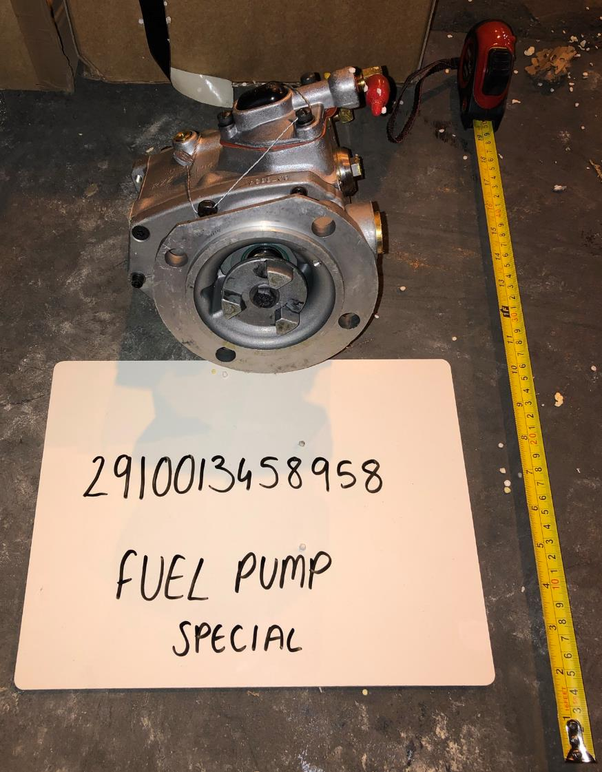

Schedule 3 – Contract Data Sheet IRM19/7393

General Conditions
Condition 2 – Duration of Contract:

The Effective Date of Contract is the date of Contract signature by both parties and the contract shall expire on 1 December 2029

Condition 4 – Governing Law:

Contract to be governed and construed in accordance with: English Law
Scots Law clause 4.d shall apply (one must be chosen)

Solicitors or other persons based in England and Wales (or Scotland if Scots Law applies) irrevocably appointed for Contractors without a place of business in England (or Scotland, if Scots Law applies) in accordance with clause 4.g (if applicable) are as follows:
Condition 7 – Authority’s Representatives:

The Authority’s Representatives for the Contract are as follows: Commercial: (as per DEFFORM 111)
Project Manager: (as per DEFFORM 111)
Condition 18 – Notices:

Notices served under the Contract shall be sent to the following address: Authority: (as per DEFFORM 111)
Contractor:

Notices can be sent by electronic mail? (tick as appropriate)
Condition 19.a – Progress Meetings:

The Contractor shall be required to attend the following meetings:
Quarterly LERC (Local Equipment Repair Committee)
Condition 19.b – Progress Reports:

The Contractor is required to submit the following Reports:
Contract Status Reports – The Contractor shall provide a monthly report on the progress of the repair work against the plan to the Babcock I&RM Repair Manager and ~DSG.GRPBabcockRepairOrderbook@babcockinternational.com within 5 workings days of receipt. This shall also include financial accrual data.

Frequency: Monthly and within 5 working days of receipt.
Content: In accordance with Schedule 14

Method of Delivery: Email

As detailed at Box 2 of the most recently issued DEFFORM 111 and DSG.GRPBabcockRepairOrderbook@babcockinternational.com

Reports shall be Delivered to the following address:
As detailed at Box 2 of the most recently issued DEFFORM 111 and DSG.GRPBabcockRepairOrderbook@babcockinternational.com

Supply of Contractor Deliverables
Condition 20 – Quality Assurance:

Is a Deliverable Quality Plan required for this Contract? (tick as appropriate)

The Agreed Quality Plan - Quality Plan QP 19-7393 Issue A is at Schedule 16 of the Contract. The Contractor shall remain at all times solely responsible for the accuracy, suitability and applicability of the Agreed Quality Plan.

Other Quality Assurance Requirements:
AQAP 2110 Edition D Version 1 NATO Quality Assurance Requirements for Design, Development and
Production.
AQAP 2105 Edition C Version 1 NATO Requirements for Quality Plans
AQAP 2070 Edition B Version 3
DEF STAN 05-061 Part 1 Issue 6 - Quality Assurance Procedural Requirements – Concessions
DEF STAN 05-061 Part 4 Issue 3 - Quality Assurance Procedural Requirements – Contractor Working
Parties
DEF STAN 05-061 Part 9 Issue 5 - Quality Assurance Procedural Requirements - Independent Inspection
Requirements for Safety Critical Items.
DEFSTAN 05-57 – Issue No 6 dated 07.03.2014 - Configuration Management of Defence Materiel
DEFSTAN 05-099 – Managing Government Furnished Equipment
DEF STAN 05-135 Issue 2 - Avoidance of Counterfeit Material
DEF Stan 81-41 – Return of stores to the Defence Fulfillment Centre (DFC). Part 1 and Part 6 guiding principles DEF CON 129 Logistics Labelling & Barcodes
ISO 9001:2015 Certification is to be mandatory

Condition 21 – Marking of Contractor Deliverables:

Special Marking requirements:
Condition 23 - Supply of Data for Hazardous Contractor Deliverables, Materials and Substances:

A completed Schedule 6 (Hazardous Contractor Deliverables, Materials or Substance Statement), and if applicable, Safety Data Sheet(s) are to be provided by e-mail with attachments in Adobe PDF or MS WORD format to:

- The Authority’s Representative (Commercial)

- Defence Safety Authority – DESTECH-QSEPEnv-HSISMulti@mod.gov.uk

to be Delivered no later than one (1) month prior to the Delivery Date for the Contract Deliverable or by the following date:
Condition 24 – Timber and Wood-Derived Products:

A completed Schedule 7 (Timber and Wood-Derived Products Supplied under the Contract: Data Requirements) is to be provided by e-mail with attachments in Adobe PDF or MS WORD format to the Authority’s Representative (Commercial)

Condition 25 – Certificate of Conformity:

Is a Certificate of Conformity required for this Contract? (tick as appropriate)

Applicable to Line Items:

If required, does the Contractor Deliverables require traceability throughout the supply chain?
(tick as appropriate)

Applicable to Line Items:

Condition 27.b – Delivery by the Contractor:

The following Line Items are to be Delivered by the Contractor: ALL

Special Delivery Instructions:
The Contractor shall (or procure that any of its subcontractors shall) comply with the requirements set out in the Logistics Commodities Services Transformation Authority Managed Material Supplier Manual (Version 2 – LDOC/CMO/V2.0 dated 28 June 2019) issued by the Authority and published on the Authority's Knowledge in Defence (KiD) system (as amended from time to time) (the “LCST Supplier Manual”) in respect of all Articles which are:
- supplied by the Contractor or any of its subcontractors under this Contract; and
- which are to be delivered to depots which are managed and/or operated by Leidos Europe Ltd or its subcontractors pursuant to the Logistics Commodities and Services (Transformation) contract (Contract No. LCST/0001) (“LCS(T) Managed Depots”).

Please note that until otherwise instructed, Barcode Labelling shall be in accordance with Issue 9 of Def Stan 81-041 Part 6
In the event that the Contractor does not adhere to the time of delivery notified by Babcock Land Defence Limited - DSG, Babcock Land Defence Limited shall not be held responsible for any subsequent claim by the Contractor, nor be held liable to meet any additional charges incurred by the Contractor through failure to deliver on the due date at the appointed time

Each consignment is to be accompanied by a delivery note.
Condition 27.c - Collection by the Authority:

The following Line Items are to be Collected by the Authority:

Special Delivery Instructions:

Each consignment is to be accompanied by a delivery note. Consignor details (in accordance with 27.c.(4)):

Line Items: Address:

Line Items: Address:

Consignee details (in accordance with condition 22): Line Items: Address:
Line Items: Address:
Condition 29 – Rejection:

The default time limit for rejection of the Contractor Deliverables is thirty (30) days unless otherwise specified here:

The time limit for rejection shall be thirty (30) Business Days.
Condition 31 – Self-to-Self Delivery:

Self-to-Self Delivery required? (tick as appropriate)

If required, Delivery address applicable:

Pricing and Payment
Condition 34 – Contract Price:
All Schedule 2 line items shall be FIRM Price other than those stated below: Line Items ALL Clause 45.5 refers

Termination
Condition 41 – Termination for Convenience:
The Notice period for terminating the Contract shall be twenty (20) days unless otherwise specified here: The Notice period for termination shall be twenty (20) Business Days

Other Addresses and Other Information (forms and publications addresses and official use information)
See Annex A to Schedule 3 (DEFFORM 111)

Schedule 3 Annex A |  | DEFFORM 111 (Edn 07/21)  Appendix - Addresses and Other Information
 | 1. Commercial Officer |  | 8. Public Accounting Authority  - Returns under DEFCON 694 (or SC equivalent) should be sent to DBS Finance ADMT – Assets In Industry 1, Level 4 Piccadilly Gate, Store Street, Manchester, M1 2WD   44 (0) 161 233 5397  DBSFin-FAADMT-AiiTeam@mod.gov.uk  - For all other enquiries contact DES Fin FA-AMET Policy, Level 4 Piccadilly Gate, Store Street, Manchester, M1 2WD   44 (0) 161 233 5394
 | Name:
 | Address:
 | Email: Being employees of Babcock Land Defence Limited acting as agent to the Authority
 | 2. Project Manager, Equipment Support Manager or PT Leader  (from whom technical information is available) Name:  Address Email: |  | 9. Consignment Instructions  The items are to be consigned as follows:
 | 3. Packaging Design Authority |  | 10. Transport. The appropriate Ministry of Defence Transport Offices are:  A. DSCOM, DE&S, DSCOM, MoD Abbey Wood, Cedar 3c, Mail Point 3351, BRISTOL BS34 8JH  Air Freight Centre  IMPORTS  030 679 81113 / 81114 Fax 0117 913 8943  EXPORTS  030 679 81113 / 81114 Fax 0117 913 8943  Surface Freight Centre  IMPORTS  030 679 81129 / 81133 / 81138 Fax 0117  913 8946  EXPORTS  030 679 81129 / 81133 / 81138 Fax 0117 913 8946
 | Organisation & point of contact:
 | (Where no address is shown please contact the Project Team in Box 2)
 | 4. (a) Supply / Support Management Branch or Order Manager: Branch/Name:  Tel No:  (b) U.I.N. |  | B. JSCS
JSCS Helpdesk No. 01869 256052 (select option 2, then option 3)
JSCS Fax No. 01869 256837
Users requiring an account to use the MoD Freight Collection Service should contact UKStratCom-DefSp-RAMP@mod.gov.uk in the first instance
 | 5. Drawings/Specifications are available from |  | 11. The Invoice Paying Authority  Babcock Land Defence Limited - DSG  1000 Lakeside, North Harbour, Western Road, Portsmouth, PO6 3EN  Email: SSC.AP.2470@babcockinternational.com
 | 6. INTENTIONALLY BLANK |  | 12. Forms and Documentation are available through *: Ministry of Defence, Forms and Pubs Commodity Management PO Box 2, Building C16, C Site  Lower Arncott  Bicester, OX25 1LP (Tel. 01869 256197 Fax: 01869 256824)  Applications via fax or email: Leidos-FormsandPublication@teamleidos.mod.uk
 | 7. Quality Assurance Representative: |  | *NOTE  - Many DEFCONs and DEFFORMs can be obtained from the MOD Internet Site: https://www.aof.mod.uk/aofcontent/tactical/toolkit/index.htm  2. If the required forms or documentation are not available on the MOD Internet site requests should be submitted through the Commercial Officer named in Section 1.
 | Commercial staff are reminded that all Quality Assurance requirements should be listed under the General Contract Conditions.
 | AQAPS and DEF STANs are available from UK Defence Standardization, for access to the documents and details of the helpdesk visit http://dstan.gateway.isg-r.r.mil.uk/index.html [intranet] or https://www.dstan.mod.uk/ [extranet, registration needed].

Schedule 4 - Contract Change Control Procedure (i.a.w. clause 6.d) for Contract No: IRM19/7393

Authority Changes
- The Authority shall be entitled to propose any change to the Contract (a " Change") or (subject to Clause 2) Changes in accordance with this Schedule 4.
- Nothing in the Schedule shall operate to prevent the Authority from specifying more than one Change in any single proposal, provided that such changes are related to the same or similar matter or matters.

Notice of Change
- If the Authority wishes to propose a Change or Changes, it shall serve a written notice (an "Authority Notice of Change") on the Contractor.
- The Authority Notice of Change shall set out the change(s) proposed by the Authority in sufficient detail to enable the Contractor to provide a written proposal (a "Contractor Change Proposal") in accordance with clause 7 to 9 (inclusive).

The Contractor may only refuse to implement a Change or Changes proposed by the Authority, if such change(s):

Would, if implemented, require the Contractor to deliver any Contractor Deliverables under the Contract in a manner that infringes any applicable law relevant to such delivery; and/or

Would, if implemented, cause any existing consent obtained by or on behalf of the Contractor in connection with their obligations under the Contract to be revoked (or would required a new necessary consent to be obtained to implement the Change(s) which, after using reasonable efforts, the Contractor has been unable to obtain or procure and reasonably believes it will be unable to obtain or procure using reasonable efforts); and/or

Would, if implemented, materially change the nature and scope of the requirement (including its risk profile) under the Contract; and

The Contractor notifies the Authority within 10 (ten) Business Days (or such longer period as shall have been agreed in writing by the parties) after the date of the Authority Notice of Change that the relevant proposed Change or Changes is/are a Changes(s) falling within the scope of clauses 5.a, 5.b and/or 5.c providing written evidence for the Contractor’s reasoning on the matter; and

Further to such notification:

Either the Authority notifies the Contractor in writing that the Authority agrees, or (where the Authority (acting reasonably) notifies the Contractor that the Authority disputes the Contractor’s notice under clause 5.d) it is determined in accordance with Condition 39 (Dispute Resolution), that the relevant Change(s) is/are a Change(s) falling within the scope of clauses 5.a, 5.b, and/or 5.c; and

(where the Authority either agrees or it is so determined that the relevant Change(s) is/are a Change(s) falling within the scope of Clauses 5.a, 5.b and/or 5.c) the Authority fails to make sufficient adjustments to the relevant Authority Notice of Change (and issue a revised Authority Notice of Change) to remove the Contractor’s grounds for refusing to implement the relevant Change under Clauses 5.a, 5.b and/or 5.c within 10 (ten) Business Days (or such longer period as shall have been agreed in writing by the parties) after:

The date on which the Authority notifies in writing the Contractor that the Authority agrees that the relevant Change(s) is/are a Change(s) falling within the scope of clauses 5.a, 5.b and/or 5.c; or

The date of such determination

The Contractor shall at all times act reasonably, and shall not seek to raise unreasonable objections, in respect of any such adjustment.

Contractor Change Proposal
- As soon as practicable, and in any event within:
    - (where the Contractor has not notified the Authority that the relevant Change or Changes is/are a Change(s) falling within the scope of Clauses 5.a, 5.b and/or 5.c in accordance with Clause 5) fifteen (15) Business Days (or such other period as the Parties may agree (acting reasonably) having regard to the nature of the Change(s)) after the date on which the Contract shall have received the Authority Notice of Change; or
    - (where the Contractor has notified the Authority that the relevant Change or Changes is/are a Change(s) falling within the scope of Clauses 5.a, 5.b and/or 5.c in accordance with Clause 5 and:
        - the Authority has agreed with the Contractor’s conclusion so notified or it is determined under Condition 39 (Dispute Resolution) that the relevant Changes(s) is/are a Changes(s) falling within the scope of Clauses 5.a, 5.b and/or 5.c and the Authority has made sufficient adjustments to the relevant Authority Notice of Change (and issued a revised Authority Notice of Changes(s)) to remove the Contractor’s grounds for refusing to implement the relevant Changes(s) under Clauses 5.a, 5.b and/or 5.c fifteen (15) Business Days (or such other period as the parties shall have agreed (both partied acting reasonably) having regard to the nature of the Change(s) after the date on which the Contractor shall have received such revised Authority Notice of Change; or
        - the Authority has disputed such conclusion and it has been determined in accordance with Condition 39 (Dispute Resolution) that the relevant Change(s) is/are not a Change(s) falling within the scope of Clauses 5.a, 5.b and/or 5.c) fifteen (15) Business Days (or such other period as the parties shall have agreed (both parties acting reasonable) having regard to the nature of the Change(s)) after the date of such determination,
the Contractor shall deliver to the Authority a Contractor Change Proposal. For the avoidance of doubt, the Contractor shall not be obliged to deliver to the Authority a Contractor Change Proposal where the Contractor notifies the Authority, and the Authority agrees or it is determined further to such notification in accordance with Clause 5, that the relevant Change or Changes is/are a Change(s) falling within the scope of Clauses 5.a, 5.b and/or 5.c.
- The Contractor Change Proposal shall comprise in respect of each and all Change(s) proposed:
    - the effect of the Change(s) on the Contractor’s obligations under the Contract;
    - a detailed breakdown of any costs which result from the Change(s);
    - the programme for implementing the Change(s);
    - any amendment required to this Contract as a result of the Change(s), including, where appropriate, to the Contract Price; and
    - such other information as the Authority may reasonably require.
- The price for any Change(s) shall be based on the prices (including all rates) already agreed for the Contract and shall include, without double recovery, only such charges that are fairly and properly attributable to the Change(s).

Contractor Change Proposal – Process and Implementation
- As soon as practicable after the Authority receives a Contractor Change Proposal, the Authority shall:
    - evaluate the Contractor Change Proposal; and
    - where necessary, discuss with the Contractor any issues arising (and (in relation to a Change(s) proposed by the Authority) following such discussions the Authority may modify the Authority Notice of Change) and the Contractor shall as soon as practicable, and in any event not more than ten (10) Business Days (or such other period as the Parties shall have agreed in writing) after receipt of such modification, submit an amended Contractor Change Proposal.
- As soon as practicable after the Authority has evaluated the Contractor Change Proposal (amended as necessary) the Authority shall:
    - Either indicate its acceptance of the Change Proposal by issuing an amendment to the Contract in accordance with Condition 6 (Formal Amendments to the Contract), whereupon the Contractor shall promptly issue to the Authority the Contractor’s DEFFORM 10B indicating their unqualified acceptance of such amendment in accordance with, and otherwise discharge their obligation under, such Condition and implement the relevant Changes(s) in accordance with such proposal; or
    - serve Notice on the Contractor rejecting the Contractor Change Proposal and withdrawing (where issued in relation to a Change proposed by the Authority) the Authority Notice of Change (in which case such notice of change shall have no further effect)
- If the Authority rejects the Contractor Change Proposal it shall not be obliged to give its reasons for such rejection.
- The Authority shall not be liable to the Contractor for any additional work undertaken or expense incurred in connection with the implementation of the any Change(s), unless a Contractor Change Proposal has been accepted by the Authority in accordance with Clause 11.a and then only to the terms of the Contractor Change proposal so accepted.

Contractor Changes
14. If the Contractor wishes to propose a Change or Changes, they shall serve a Contractor Change Proposal on the Authority. Such proposal shall be prepared and reviewed in accordance with and otherwise be subject to the provisions of Clauses 8 to 13 (inclusive).

Schedule 5 - Contractor’s Sensitive Information Form (i.a.w. condition 12) for Contract No: IRM19/7393
Contract No: IRM19/7393
Description of Contractor’s Commercially Sensitive Information:

Cross Reference(s) to location of sensitive information:.
Explanation of Sensitivity:
Details of potential harm resulting from disclosure:
Period of Confidence (if applicable):
Contact Details for Transparency / Freedom of Information matters:
Name:
Position:
Address:

Schedule 6 - Hazardous Contractor Deliverables, Materials or Substances Supplied under the Contract: Data Requirements for Contract No: IRM19/7393

Hazardous Contractor Deliverables, Materials or Substances Statement by the Contractor

Contract Number: IRM19/7393

Contract Title: The Repair of Hydraulics and Pneumatic Assemblies & Associated Items

Contractor:

Date of Contract:

* To the best of our knowledge there are no hazardous Articles, Deliverables, materials or substances to be supplied

* To the best of our knowledge the hazards associated with Articles, Deliverables, materials or substances to be supplied under the Contract are identified in the Safety Data Sheets (Qty:) attached in accordance with either:

DEFCON 68 ; or

Condition 9 of Standardised Contract 1A/B Conditions ;

Contractor’s Signature:

Name:

Job Title:
Date:

* check box() as appropriate

To be completed by the Authority Domestic Management Code (DMC): NATO Stock Number:
Contact Name:

Contact Address:

Copy to be forwarded to:

Hazardous Stores Information System (HSIS) Defence Safety Authority (DSA)
Movement Transport Safety Regulator (MTSR) Hazel Building Level 1, #H019
MOD Abbey Wood (North) Bristol BS34 8QW

Schedule 7 - Timber and Wood- Derived Products Supplied under the Contract: Data Requirements for Contract No: IRM19/7393

The following information is provided in respect of condition 24 (Timber and Wood-Derived Products):

Schedule of Requirements item and timber product type | Volume of timber Delivered to the Authority with FSC, PEFC or equivalent  evidence | Volume of timber Delivered to the Authority with other evidence | Volume (as Delivered to the Authority) of timber without evidence of compliance with Government Timber Procurement Policy | Total volume of timber Delivered to the Authority under the Contract

Schedule 8 - Acceptance Procedure (i.a.w. condition 28) for Contract No: IRM19/7393

Schedule 9 – Publishable Performance Information – Key Performance Indicator Data Report (i.a.w. Condition 12) for Contract No: IRM19/7393

KPI Description* | Rating Thresholds | Frequency of Measurement | Quarter and Year* | Average for Reporting Period | Rating* | Comment*
Delivery Performance  100% within 5 working days of the agreed Delivery Plan. | Good*: 100% | Quarterly
 | Approaching Target: 99.9% - 96%
 | Requires Improvement: 95.9% - 93%
 | Inadequate: <92.9%
Social Value KPI (if applicable) | Good*:
 | Approaching Target:
 | Requires Improvement:
 | Inadequate:
*Publishable fields. Please note, of the four Rating Thresholds, only the ‘Good’ threshold is published.

Schedule 10 – Purchase Order Template –Sample (For Information Only)

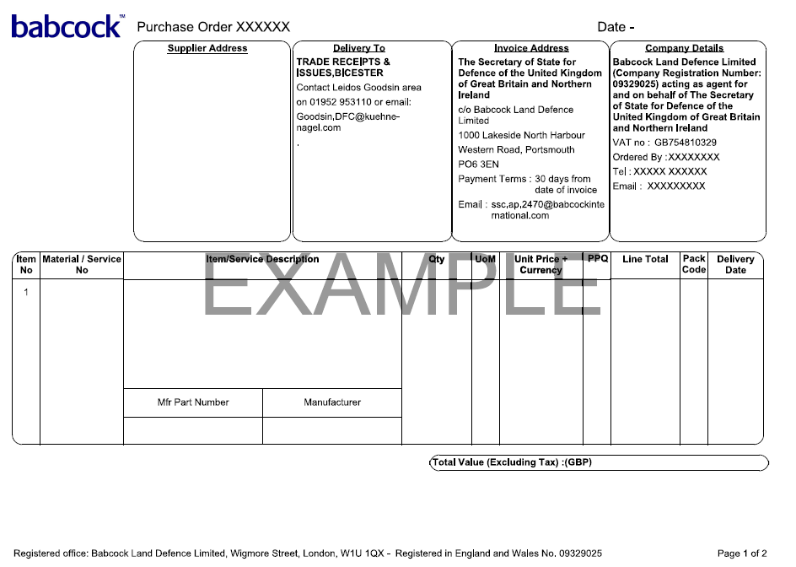

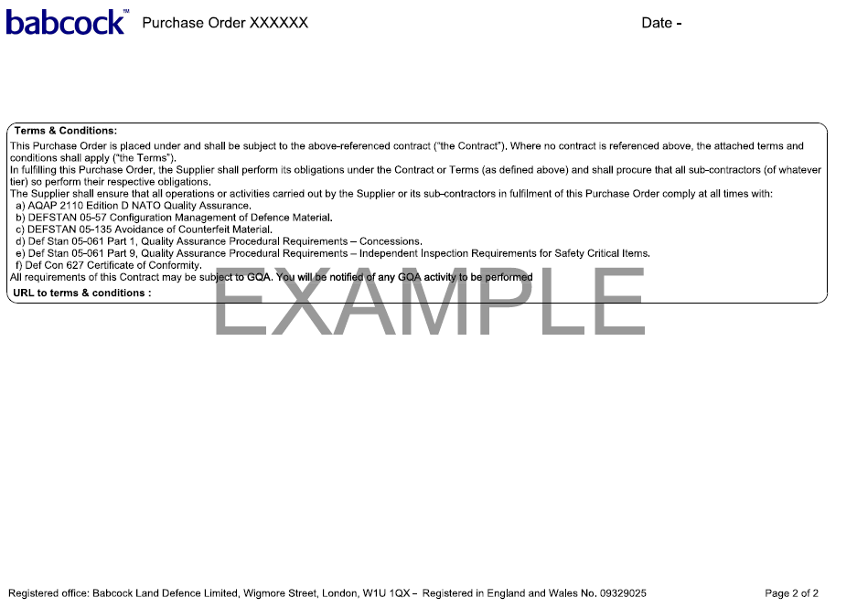

Schedule 11 – Discrepancy Report – Sample (For Information Only)

Copies of the Discrepancy Report MOD Form 445, in pads of 100, can be obtained from the Forms and Publications address on the Contract.

This form should be used for reporting discrepancies in consignments of goods sent to the Contractor for repair.

Triplicate copies of the form should be completed in manuscript or typescript. Copies 1 & 2 should be sent to the Consignor, with copy 3 being retained by the Contractor.
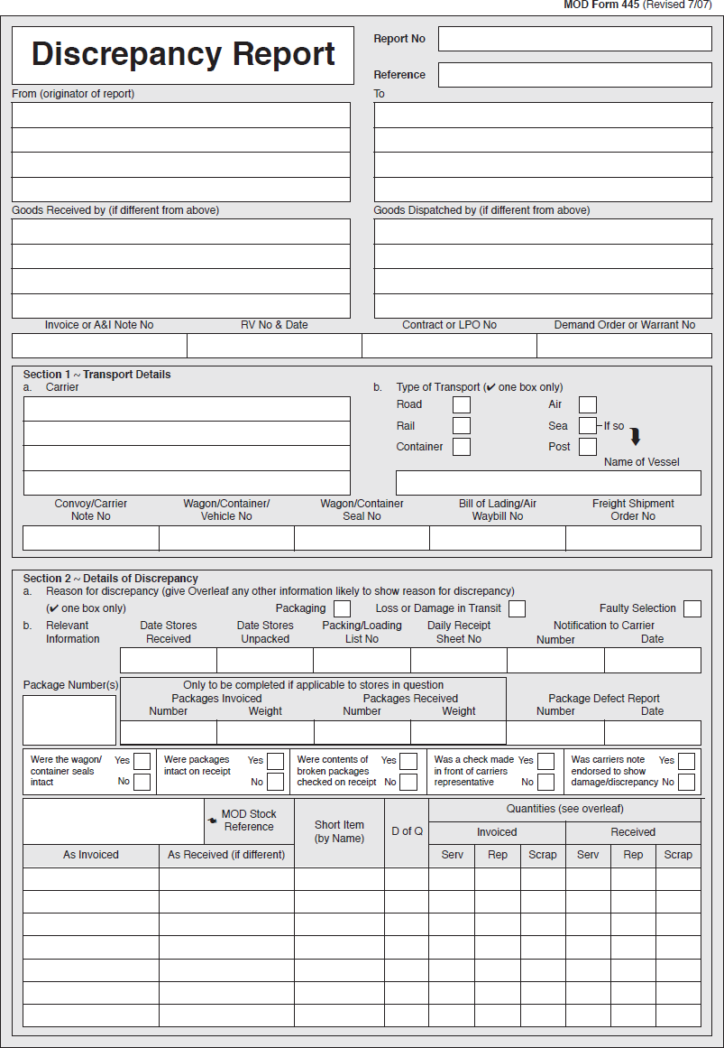

Schedule 12 – Strip and Survey Report – Sample (For Information Only)

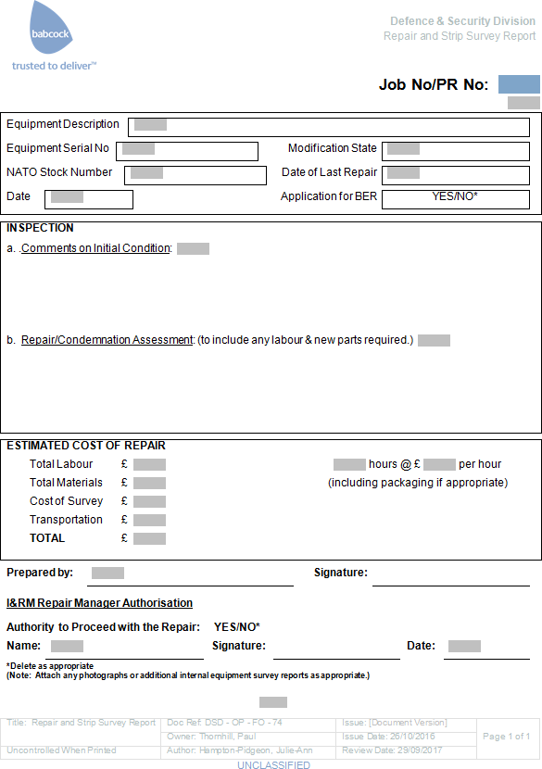

Schedule 13 – Application to dispose of BR/BER Equipment

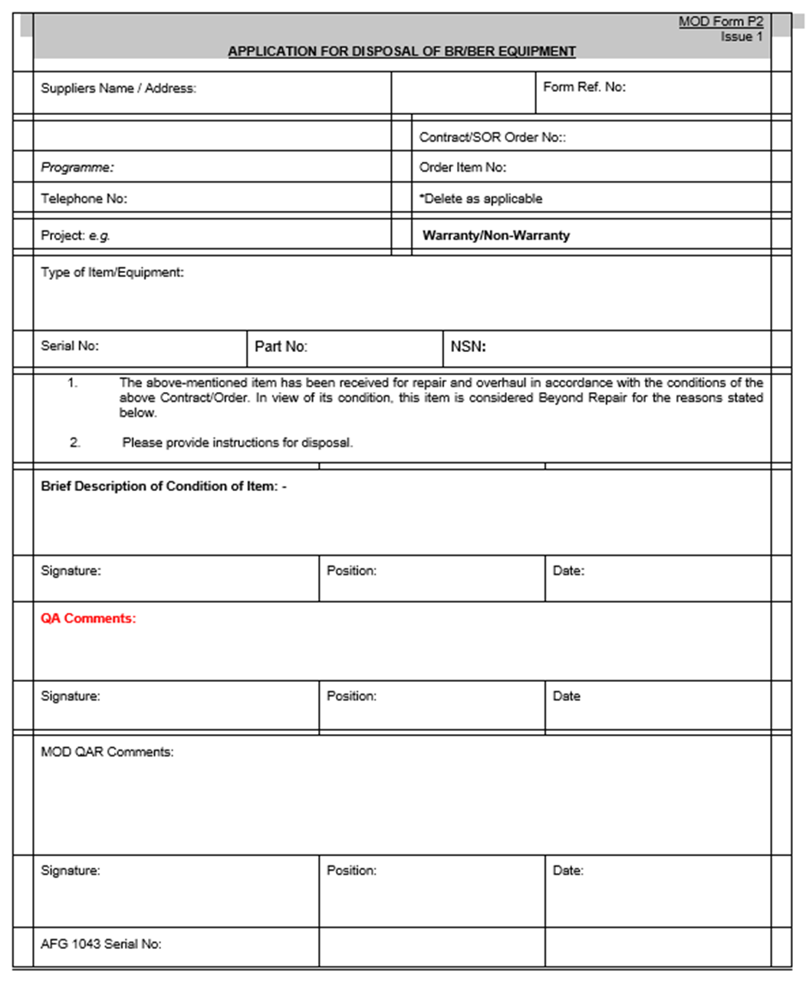

Schedule 14: Contract Status Report

This report is for information purposes only. A monthly report will be generated and issued to Contractors. This should always be completed in accordance with the accompanying email instruction.

Contract Number: IRM19/7393

Supplier Name | Cont. Ref | PR  Number | NSN | Description | Purchase Order | Position Number | Sequence Number | Outstanding Qty | Updated Repair  Price (Each) | Most Likely Delivery Date  Max | Confirmed  Delivery Date (DD/MM/YYYY) | Supplier Comments | WIP

Schedule 15 – Sample Agreement to Novate a Contract (For information purposes only)
(Will only need to be signed and agreed in the event that the Contract is novated.)

DATED

------------

AGREEMENT TO NOVATE A CONTRACT

between

CONTINUING PARTY

and

[SECRETARY OF STATE FOR DEFENCE]

and

[BABCOCK LAND DEFENCE LIMITED]

THIS AGREEMENT is dated [DATE]

PARTIES
[FULL COMPANY NAME] incorporated and registered in England and Wales with company number [NUMBER] whose registered office is at [REGISTERED OFFICE ADDRESS] (Continuing Party).
[SECRETARY OF STATE FOR DEFENCE] (MoD).
[BABCOCK LAND DEFENCE LIMITED] incorporated and registered in England and Wales with company number [NUMBER] whose registered office is at [REGISTERED OFFICE ADDRESS] (Babcock).
BACKGROUND
The Continuing Party and the MoD are party to a contract for [DESCRIBE CONTRACT] dated [DATE] (the

Contract).
The MoD and Babcock entered into a Land Equipment Service Provision and Transformation Contract dated 31 March 2015 (the SPC) in respect of which certain services transfer, on a phased basis, from the MoD to Babcock. The MoD wishes to transfer its rights and obligations under the Contract to Babcock as part of the transfer of services under the SPC.
The MoD shall continue to be liable for any failure by it to perform its obligations under the Contract before the Effective Date, with Babcock assuming responsibility for all other liabilities so arising in the MoD's place.
The parties have therefore agreed to novate the MoD's rights, obligations and liabilities under the Contract to Babcock on the terms of this agreement with effect from [DATE] (Effective Date).
AGREED TERMS

NOVATION

With effect from the Effective Date, the MoD transfers all its rights and obligations under the Contract to Babcock. Babcock shall enjoy all the rights and benefits of the MoD under the Contract, and all references to the MoD in the Contract shall be read and construed as references to Babcock.

Babcock agrees to perform the Contract and be bound by its terms in every way as if it were the original party to it in place of the MoD.

The Continuing Party agrees to perform the Contract and be bound by its terms in every way as if Babcock were the original party to it in place of the MoD.

RELEASE OF OBLIGATIONS AND LIABILITIES

The Continuing Party and the MoD release each other from all future obligations to the other under the Contract.

Nothing in this agreement shall affect or prejudice any claim or demand that the Continuing Party or the MoD may have against the other under or in connection with the Contract arising before the Effective Date.

GOVERNING LAW

This agreement and any dispute or claim (including non-contractual disputes or claims) arising out of or in connection with it or its subject matter or formation shall be governed by and construed in accordance with the law of England and Wales.

JURISDICTION

Each party irrevocably agrees that the courts of England and Wales shall have exclusive jurisdiction to settle any dispute or claim (including non-contractual disputes or claims) arising out of or in connection with this agreement or its subject matter or formation.

Signed .....................................................

for and on behalf of [SECRETARY OF STATE FOR DEFENCE]
Date ........................................................
Signed ................................................................

for and on behalf of [BABCOCK LAND DEFENCE LIMITED]
Date ........................................................
Signed .....................................................

for and on behalf of [CONTINUING PARTY]
Date ....................................................

Schedule 16 –Agreed Quality Plan for Contract No: IRM19/7393
(In accordance with condition 20 (where applicable):

The Deliverable Quality Plan must be set out as defined in AQAP 2105 Edition C Version 1 January 2019 and delivered to the Authority (Quality) at ITT stage. Once agreed by the Authority the Quality Plan shall be incorporated into the Contract. The Contractor shall remain at all times solely responsible for the accuracy, suitability and applicability of the Deliverable Quality Plan

Schedule 17 - Government Furnished Equipment (GFE)

The following NSNs are included in the GFE agreement in relation to contract number IRM19/7393;
Item No. | DMC | NSN | Description
1
2
3
4
5
6
7
8
9
10

Schedule 18: DEFFORM 315 – Contract Data Requirement

CONTRACT DATA REQUIREMENT

1. ITT/Contract Number  IRM19/7393 | 2. CDR Number  1 | 3. Data Category  Maintenance/Repair/Reconditioning | 4. Contract Delivery Date  TBC
5. Equipment/Equipment Subsystem Description  All articles listed by NSN on Schedule 2 - for IRM19/7393 |  | 6. General Description of Data Deliverable  Output Specifications for each article listed on Annex A and Annex B to Schedule 2 - Pricing Schedule for IRM19/7393 in accordance with Annex C to Schedule 2
7. Purpose for which data is required  Competitive contrating for Maintenance/Repair/Reconditioning |  | 8. Intellectual Property Rights  a. Applicable DEFCONs  DEFCON 16 (Edn 06/21) Repair And Maintenance Information  DEFCON 21 (Edn 06/21) Retention of Records  DEFCON 703 (Edn 06/21) Intellectual Property Rights – Vesting In the Authority  b. Special IP Conditions  Condition 46.8
9. Update/Further Submission Requirements

As required.

10. Medium of Delivery  Email |  | 11. Number of Copies  Subject to the Authority discretion

Schedule 19: TRANSFER REGULATIONS, EMPLOYEE TRANSFER ARRANGEMENTS ON EXIT

Contract No: IRM19/7393
- Definitions
  - In this Schedule 19, save where otherwise provided, words and terms defined in Schedule 1 (Definitions) of the Contract shall have the meaning ascribed to them in Schedule 1 (Definitions) of the Contract.
  - Without prejudice to Schedule 1 (Definitions) of the Contract unless the context otherwise requires:
“Data protection legislation” means all applicable data protection and privacy legislation in force from time to time in the UK, including but not limited to:
(i) the General Data Protection Regulation ((EU) 2016/679) as retained in UK law by the EU (Withdrawal) Act 2018 and the Data Protection, Privacy and Electronic Communications (Amendments etc) (EU Exit) Regulations 2019 (the "UK General Data Protection Regulation" or “UK GDPR”);
(ii) the Data Protection Act 2018;
(iii) the Privacy and Electronic Communications Directive 2002/58/EC (as updated by Directive 2009/136/EC) and the Privacy and Electronic Communications Regulations 2003 (SI 2003/2426) as amended; and
(iv) all applicable legislation and regulatory requirements in force from time to time which apply to a party relating to the processing of personal data and privacy and the guidance and codes of practice issued by the Information Commissioner’s Office which apply to a party;

"Employee Liability Information" has the same meaning as in Regulation 11(2) of the Transfer Regulations;

"Employing Sub-Contractor" means any sub-contractor of the Contractor providing all or any part of the Services who employs or engages any person in providing the Services;

"New Provider" means any replacement service provider or providers engaged to provide the Services (or part thereof) or substantially similar services or the Authority itself where the Services or substantially similar services or part thereof continue to be provided by the Authority after partial termination, termination or expiry of this Contract;

"Relevant Transfer" means a transfer of the employment of Transferring Employees from the Contractor or any Employing Sub-Contractor to a New Provider or the Authority under the Transfer Regulations;

"Transfer Date" means the date on which the transfer of a Transferring Employee takes place under the Transfer Regulations;
"Transferring Employee" means an employee wholly or mainly employed or otherwise assigned to the Services (or in respect of partial termination, the relevant part of the Services) whose employment transfers under the Transfer Regulations from the Contractor or any Employing Sub-Contractor to a New Provider;
"Transfer Regulations" means the Transfer of Undertakings (Protection of Employment) Regulations 2006 as amended from time to and/or the Service Provision Change (Protection of Employment) Regulations (Northern Ireland) 2006 (as amended from time to time), as appropriate.
- EMPLOYMENT
  - Information on Re-tender, Partial Termination, Termination or Expiry
    - No earlier than two years preceding the termination, partial termination or Expiry of this Contract or a potential Transfer Date or at any time after the service of a notice to terminate this Contract or the provision of any of the Services (whether in whole or part) or on receipt of a written request by the Authority, the Contractor shall (and shall procure that any Employing Sub-Contractor shall):
      - supply to the Authority such information as the Authority may reasonably require in order to consider the applicaton of the Transfer Regulations on the termination, partial termination or expiry of this Contract;
      - supply to the Authority such full and accurate and up-to-date information as may be requested by the Authority including the information listed in Appendix 1 to this Schedule 19 relating to the employees who are wholly or mainly employed, assigned or engaged in providing the Services or part of the Services under this Contract who may be subject to a Relevant Transfer;
      - provide the information promptly and in any event not later than three months from the date when a request for such information is made and at no cost to the Authority;
      - acknowledge that the Authority will use the information for informing any prospective New Provider for any services which are substantially the same as the Services or part of the Services provided pursuant to this Contract;
      - inform the Authority of any changes to the information provided under paragraph 2.1.1(a) or 2.1.1(b) up to the Transfer Date as soon as reasonably practicable.
    - Three months preceding the termination, partial termination or expiry of this Contract or on receipt of a written request from the Authority the Contractor shall:
      - ensure that Employee Liability Information and such information listed in Part A of Appendix 2 of this Schedule 19 (Personnel Information) relating to the Transferring Employees is provided to the Authority and/or any New Provider;
      - inform the Authority and/or any New Provider of any changes to the information provided under this Paragraph 2.1.2 up to any Transfer Date as soon as reasonably practicable;
      - enable and assist the Authority and/or any New Provider or any sub-contractor of a New Provider to communicate with and meet those employees and their trade union or other employee representatives.
    - No later than 28 days prior to the Transfer Date the Contractor shall provide the Authority and/or any New Provider with a final list of the Transferring Employees together with the information listed in Part B of Appendix 2 of this Schedule 19 (Personnel Information) relating to the Transferring Employees. The Contractor shall inform the Authority and/or New Provider of any changes to this list or information up to the Transfer Date.
    - Within 14 days following the relevant Transfer Date the Contractor shall provide to the Authority and/or any New Provider the information set out in Part C of Appendix 2 of this Schedule 19 in respect of Transferring Employees.
    - Paragraphs 2.1.1 and 2.1.2 of this Appendix are subject to the Contractor's obligations in respect of the Data Protection Legislation and the Contractor shall use its best endeavours to obtain the consent of its employees (and shall procure that its Sub-Contractors use their best endeavours to obtain the consent of their employees) to the extent necessary under the Data Protection Legislation or provide the data in an anonymous form in order to enable disclosure of the information required under paragraphs 2.1.1 and 2.1.2. Notwithstanding this paragraph 2.1.4, the Contractor acknowledges (and shall procure that its Sub-Contractors acknowledge) that they are required to provide sufficient information to the Authority to enable the Authority to determine the nature of the activities being undertaken by employees engaged in providing the Services, to assess whether there is an organised grouping for the purposes of the Transfer Regulations and to assess who is assigned to such organised grouping. To the extent that anonymous data has been provided by the Contractor pursuant to its obligations under Paragraph 2.1.1 or 2.1.2 above, the Contractor shall provide full data to the Authority no later than 28 days prior to the Transfer Date.
    - On notification to the Contractor by the Authority of a New Provider or within the period of six months prior to the Termination Date or after service of a notice to terminate this Contract (whether in whole or in part), whichever is earlier and in any event on receipt of a written request by the Authority, the Contractor shall not and shall procure that an Employing Sub-Contractor shall not:
      - materially amend or promise to amend the rates of remuneration or other terms and conditions of employment of any person wholly or mainly employed or engaged in providing the Services under this Contract; or
      - replace or re-deploy from the Services any person wholly or mainly employed or engaged in providing the Services, or materially increase or decrease the number of persons performing the Services under this Contract or the working time spent on the Services (or any part thereof); or
      - reorganise any working methods or assign to any person wholly or mainly employed or engaged in providing the Services (or any part thereof) any duties unconnected with the Services (or any part thereof) under this Contract; or
      - terminate or give notice to terminate the employment of any person wholly or mainly employed or engaged in providing the Services (or any part thereof) under this Contract other than in the case of serious misconduct or for poor performance,
save in the ordinary course of business and with the prior written consent of the Authority (not to be unreasonably withheld or delayed) and the Contractor shall indemnify and keep indemnified the Authority in respect of any reasonable costs (including reasonable legal costs), losses and expenses and all damages, compensation, fines and liabilities arising out of or in connection with any breach of paragraphs 2.1.1, 2.1.2, 2.1.3, 2.1.4 or 2.1.6 of this Schedule 19.
    - The Authority may at any time prior to the period set out in paragraph 2.1.5 of this Schedule 19 request from the Contractor any of the information in sections 1(a) to (d) of Appendix 1 and the Contractor shall and shall procure any Sub-Contractor will provide the information requested within 28 days of receipt of that request.
  - Obligations in Respect of Transferring Employees
    - To the extent that the Transfer Regulations apply on expiry, termination or partial termination of this contract, the Contractor shall and shall procure any Employing Sub-Contractor shall and the Authority shall and shall procure that a New Provider shall in such circumstances:
      - before and in relation to the Transfer Date liaise with each other and shall co-operate with each other in order to implement effectively the smooth transfer of the Transferring Employees to the Authority and/or a New Provider; and
      - comply with their respective obligations under the Transfer Regulations including their obligations to inform and consult under Regulation 13 of the Transfer Regulations.
  - Unexpected Transferring Employees
    - If a claim or allegation is made by an employee or former employee of the Contractor or any Employing Sub-Contractor who is not named on the list of Transferring Employees provided under paragraph 2.1.3 (an "Unexpected Transferring Employee") that he has or should have transferred to the Authority and/or New Provider by virtue of the Transfer Regulations, the Party receiving the claim or allegation shall notify the other Party (or the Contractor shall notify the Authority on the Sub-Contractor’s behalf and the Authority shall notify the Contractor on the New Provider’s behalf) in writing as soon as reasonably practicable and no later than ten Business Days after receiving notification of the Unexpected Transferring Employee's claim or allegation, whereupon:
      - the Contractor shall (or shall procure that the Employing Sub-Contractor shall), as soon as reasonably practicable, offer and/or confirm continued employment to the Unexpected Transferring Employee or take such other steps so as to effect a written withdrawal of the claim or allegation; and
      - if the Unexpected Transferring Employee's claim or allegation is not withdrawn or resolved the Contractor shall notify the Authority (who will notify any New Provider who is a party to such claim or allegation), and the Authority (insofar as it is permitted) and/or New Provider (as appropriate) shall employ the Unexpected Transferring Employee or as soon as reasonably practicable, (subject to compliance with its obligations at paragraph 2.3.1(c)(iii)), serve notice to terminate the Unexpected Transferring Employee's employment in accordance with his contract of employment; and
      - the Contractor shall indemnify the Authority against all reasonable costs (including reasonable legal costs) losses and expenses and all damages, compensation, fines and liabilities arising out of or in connection with any of the following liabilities incurred by the Authority or New Provider in dealing with or disposing of the Unexpected Transferring Employee's claim or allegation:
        - any additional costs of employing the Unexpected Transferring Employee up to the date of dismissal where the Unexpected Transferring Employee has been dismissed in accordance with paragraph 2.3.1(b);
        - any liabilities acquired by virtue of the Transfer Regulations in relation to the Unexpected Transferring Employee;
        - any liabilities relating to the termination of the Unexpected Transferring Employee's employment but excluding such proportion or amount of any liability for unfair dismissal, breach of contract or discrimination attributable:
- to a failure by the Authority or a New Provider to act reasonably to mitigate the costs of dismissing such person);
- directly or indirectly to the procedure followed by the Authority or a New Provider in dismissing the Unexpected Transferee; or
- to the acts/omissions of the Authority or a New Provider not wholly connected to the dismissal of that person;
        - any liabilities incurred under a settlement of the Unexpected Transferring Employee's claim which was reached with the express permission of the Contractor (not to be unreasonably withheld or delayed);
        - reasonable administrative costs incurred by the Authority or New Provider in dealing with the Unexpected Transferring Employee's claim or allegation, subject to a cap per Unexpected Transferring Employee of £5,000; and
        - legal and other professional costs reasonably incurred;
    - the Authority shall be deemed to have waived its right to an indemnity under paragraph 2.3.1(c) if it fails without reasonable cause to take, or fails to procure any New Provider takes, any action in accordance with any of the timescales referred to in this paragraph 2.3.
  - Indemnities on transfer under the Transfer Regulations on Partial Termination, Termination or Expiry of the Contract
    - If on the expiry, termination or partial termination of the Contract there is a Relevant Transfer, the Contractor shall indemnify the Authority and any New Provider against all reasonable costs (including reasonable legal costs) losses and expenses and all damages, compensation, fines and liabilities arising out of or in connection with any claim by any employee or trade union representative or employee representative arising whether before or after the Transfer Date out of any failure by the Contractor or any Sub-Contractor to comply with their obligations under Regulation 13 of the Transfer Regulations in relation to any Transferring Employee or any other employee of the Contractor or any Sub-Contractor affected by the Relevant Transfer (as defined by Regulation 13 of the Transfer Regulations), save to the extent that all reasonable costs (including reasonable legal costs), losses and expenses and all damages, compensation, fines and liabilities are a result of the act or omission of the Authority or the New Provider.
    - If there is a Relevant Transfer, the Authority shall indemnify the Contractor against all reasonable costs (including reasonable legal costs) losses and expenses and all damages, compensation, fines and liabilities arising out of, or in connection with:
      - any claim or claims by a Transferring Employee at any time on or after the Transfer Date which arise as a result of an act or omission of the Authority or a New Provider or a sub-contractor of a New Provider during the period from and including the Transfer Date;
      - subject to paragraph 2.4.1 any claim by any employee or trade union representative or employee representative arising whether before or after the Transfer Date out of any failure by the Authority or a New Provider or a sub-contractor of a New Provider to comply with their obligations under Regulation 13 of the Transfer Regulations in relation to any Transferring Employee or any other employee engaged wholly or mainly in connection with the Services by the New Provider or any other employee of the Authority or any New Provider affected by the Relevant Transfer effected by this Contract (as defined by Regulation 13 of the Transfer Regulations),
save to the extent that all reasonable costs (including reasonable legal costs), losses and expenses and all damages, compensation, fines and liabilities are a result of the act or omission of the Contractor or any Employing Sub-Contractor.
    - In the event of a Relevant Transfer, the Authority shall indemnify the Contractor in respect of all reasonable costs (including reasonable legal costs), losses and expenses and all damages, compensation, fines and other liabilities arising out of or in connection with or as a result of a substantial change by the Authority [or a New Provider or any sub-contractor of a New Provider] on or after the Transfer Date to the working conditions of any Transferring Employee to the material detriment of any such Transferring Employee. For the purposes of this paragraph 2.4.3, the expressions "substantial change" and "material detriment" shall have the meanings as are ascribed to them for the purposes of Regulation 4(9) of the Transfer Regulations.
  - Contracts (Rights of Third Parties) Act 1999
    - A New Provider may enforce the terms of paragraph 2.3 and 2.4 against the Contractor in accordance with the Contracts (Rights of Third Parties) Act 1999.
    - The consent of a New Provider (save where the New Provider is the Authority) is not required to rescind, vary or terminate this Contract.
    - Nothing in this paragraph 2.5 shall affect the accrued rights of the New Provider prior to the rescission, variation, expiry or termination of this Contract.
  - General
    - The Contractor shall not recover any Costs and/or other losses under this Schedule 19 where such Costs and/or losses are recoverable by the Contractor elsewhere in this Contract and/or are recoverable under the Transfer Regulations or otherwise.

Appendix 1

CONTRACTOR PERSONNEL-RELATED INFORMATION TO BE RELEASED UPON RE-TENDERING WHERE THE TRANSFER REGULATIONS APPLIES

1. Pursuant to paragraph 2.1.1(b) of this Schedule 19, the following information will be provided:
a) The total number of individual employees (including any employees of Sub-Contractors) that are currently engaged, assigned or employed in providing the Services and who may therefore be transferred. Alternatively the Contractor should provide information why any of their employees or those of their Sub-Contractors will not transfer;
b) The total number of posts or proportion of posts expressed as a full-time equivalent value that currently undertakes the work that is to transfer;
c) The preceding 12 months total pay costs – (Pay, benefits employee/employer national insurance contributions and overtime);
d) Total redundancy liability including any enhanced contractual payments;

2. In respect of those employees included in the total at 1(a), the following information:
a) Age (not date of Birth);
b) Employment Status (i.e. Fixed Term, Casual, Permanent);
c) Length of current period of continuous employment (in years, months) and notice entitlement;
d) Weekly conditioned hours of attendance (gross);
e) Standard Annual Holiday Entitlement (not "in year" holiday entitlement that may contain carry over or deficit from previous leave years);
f) Pension Scheme Membership:
g) Pension and redundancy liability information;
h) Annual Salary;
i) Details of any regular overtime commitments (these may be weekly, monthly or annual commitments for which staff may receive an overtime payment);
j) Details of attendance patterns that attract enhanced rates of pay or allowances;
k) Regular/recurring allowances;
l) Outstanding financial claims arising from employment (i.e. season ticket loans, transfer grants);

3. The information to be provided under this Appendix 1 should not identify an individual employee by name or other unique personal identifier unless such information is being provided 28 days prior to the Transfer Date.

4. The Contractor will provide (and will procure that the Sub-Contractors provide) the Authority/tenderers with access to the Contractor's and Sub-Contractor’s general employment terms and conditions applicable to those employees identified at paragraph 1(a) of this Appendix 1.

Appendix 2

PERSONNEL INFORMATION TO BE RELEASED PURSUANT TO THIS CONTRACT

Part A

- Pursuant to paragraph 2.1.2 of this Schedule 19, the written statement of employment particulars as required by section 1 of the Employment Rights Act 1996 together with the following information (save where that information is included within that statement) which will be provided to the extent it is not included within the written statement of employment particulars:
  - Personal, Employment and Career
a) Age;
b) Security Vetting Clearance;
c) Job title;
d) Work location;
e) Conditioned hours of work;
f) Employment Status;
g) Details of training and operating licensing required for Statutory and Health and Safety reasons;
h) Details of training or sponsorship commitments;
i) Standard Annual leave entitlement and current leave year entitlement and record;
j) Annual leave reckonable service date;
k) Details of disciplinary or grievance proceedings taken by or against transferring employees in the last two years;
l) Information of any legal proceedings between employees and their employer within the previous two years or such proceedings that the transferor has reasonable grounds to believe that an employee may bring against the transferee arising out of their employment with the transferor;
m) Issue of Uniform/Protective Clothing;
n) Working Time Directive opt-out forms; and
o) Date from which the latest period of continuous employment began.

  - Superannuation and Pay
a) Maternity leave or other long-term leave of absence (meaning more than 4 weeks) planned or taken during the last two years;
b) Annual salary and rates of pay band/grade;
c) Shifts, unsociable hours or other premium rates of pay;
d) Overtime history for the preceding twelve-month period;
e) Allowances and bonuses for the preceding twelve-month period;
f) Details of outstanding loan, advances on salary or debts;
g) Pension Scheme Membership;
h) For pension purposes, the notional reckonable service date;
i) Pensionable pay history for three years to date of transfer;
j) Percentage of any pay currently contributed under additional voluntary contribution arrangements; and
k) Percentage of pay currently contributed under any added years arrangements.

  - Medical
a) Details of any period of sickness absence of 3 months or more in the preceding period of 12 months; and
b) Details of any active restoring efficiency case for health purposes.

  - Disciplinary
a) Details of any active restoring efficiency case for reasons of performance; and
b) Details of any active disciplinary cases where corrective action is on going.

  - Further information
a) Information about specific adjustments that have been made for an individual under the Equality Act 2010;
b) Short term variations to attendance hours to accommodate a domestic situation;
c) Individuals that are members of the Reserves, or staff that may have been granted special leave for public duties such as a School Governor; and;

d) Information about any current or expected maternity or other statutory leave or other absence from work.

Part B

  - Information to be provided 28 days prior to the Transfer Date:
a) Employee's full name;
b) Date of Birth
c) Home address;
d) Bank/building society account details for payroll purposes Tax Code.
PART C
  - Information to be provided within 14 days following a Transfer Date:
    - Performance Appraisal
The current year's Performance Appraisal;
Current year’s training plan (if it exists); and
Performance Pay Recommendations (PPR) forms completed in the current reporting year, or where relevant, any bonus entitlements;
Superannuation and Pay
Cumulative pay for tax and pension purposes;
Cumulative tax paid;
National Insurance Number;
National Insurance contribution rate;
Other payments or deductions being made for statutory reasons;
Any other voluntary deductions from pay;

In consideration of equipment being added post contract award a review / assessment of the Statement of Work (SoW) is to be carried out and amended in the table above to reflect the new requirements.
Publication requirements referenced are subject to edition changes. In consideration of above, Suppliers shall make themselves fully aware of the issue and amendment status of all related documents, particularly when replying to any invitation to tender or contract. Responsibility for the correct application of standards/specifications rests with the Supplier and/or their significant sub-contractors.
Information Quality Assurance Standards - For guidance on the application and interpretation of AQAPs, refer to the appropriate AQAP Standards Related Documents (SRD). Where Government Quality Assurance (GQA) is performed against the contract it will be in accordance with AQAP 2070 Edition B.
Requirement for delivery of Output Specifications for each equipment type.
This is the general guide criteria, however, due to the age of some of the equipment, complexity and obsolescence, there may be issues inherent within this SoW for equipment listed in Equipment Detail table 1. The Contractor shall identify those parts which are obsolete and submit their findings via a strip and survey report and P2 form for Disposal of BR/ BER Equipment to the Babcock Land Defence Repair Manager. This will be submitted to the Authority for consideration, the Babcock Land Defence Repair Manager. This will be submitted to the Authority for consideration, the Babcock Land Defence Repair Manager will advise in all BER requests.
Subject to contract agreement it is obligatory to replace consumable items should the integrity become degraded, damaged or compromised during repair or inspection. There may be instances were parts are replaced on condition this is dependent upon the equipment which is to be agreed between Babcock Repair Manager and the Supplier.
Traceable Certificate of Conformity (CofC) - a document, signed by the Supplier, which states that the product conforms in all aspect with contractual requirements and specifications. Where failure of an item or component could lead to loss of equipment, performance or life then it is mandatory to maintain full traceability back to source.

