\

Tenterden

Needs Analysis

2019
Prepared by: Ian Brooks and Sheila Jones

Contents
Section 1: Introduction 4
Section 2: People 5
2.1 Gender 5
2.2 Age 5
2.3 Households 8
2.4 Ethnic group 9
2.5 Passports and Country of Birth 10
2.6 Religion 11
Section 3: Transport 11
Section 4: Crime 12
Section 5: Housing 12
5.1 Household Status 12
5.2 Housing 13
Section 6: Economic Statistics 15
Section 7: Education and Training 18
Section 8: Rural Issues 18
Section 9: Leisure Facilities 19
Section 10: Other Views and Input 20
10.1 County Councellors 20
10.2 Other Agencies 20
Daniel Smith – Youth Engagement Officer, Kent Police 20
V. English – Designated Safeguarding Lead, Homewood School & Sixth Form Centre 20
Sally Baldock – High Halden – Parish Councillor 20
10.3 Views of Local Young People 21
10.4 History of Consultation of young people through surveys 22
Survey 1: 400 young people took part in the survey (210 Males and 230 Females) covering hobbies and interests. 22
Survey 2: Carried out by the Police and the Safety Unit 23
Survey 3: Completed by Carol (ABC), Jo (Community warden) and Ian Brooks (KCC) with support from Homewood School, Highworth School and Knatchbull School. 23
Section 11: Conclusions 24
11.1 Aims and Priorities: 25
11.2 Summary of key findings 26
Appendix 27
Appendix A – Bus Routes 27
Appendix B – G – Crime Statistics 28
Appendix B – April 2018 28
Appendix C – May 2018 28
Appendix D – June 2018 29
Appendix E – August 2018 29
Appendix F – September 2018 30
Appendix G – October 2018 30
Appendix H – Education 31
Appendix I – Rural Isolation 33
Distances from Tenterden: 33
Appendix J – Leisure Facilities 34
Appendix K – Michael Hill OBE Letter………………………………………………………………….37
Appendix L – Community Warden Letter…………………………………………………….……….38

Section 1: Introduction
This profile has been written for the Town Council to understand the Tenterden community and the development of issues for and around young people in the area. It provides a variety of information about the people and/or organisations based on their geographical location. It includes information around the age, gender, ethnicity, employment status and access to private/public transport of the population. The information included in this report covers the four wards of Tenterden: West, St Michaels, North and South.
This profile brings together quantitative data for the area to help with decision making regarding actions and priorities for young people as well as bringing together the views and opinions of local stakeholders.

Section 2: People

2.1 Gender
The ratio of male to female in each of the Tenterden Wards is relatively equal. The exception to this statement being the Tenterden North ward which has significantly more females than males, as well as a significantly higher total population.

2.2 Age

17% of the total population in Tenterden are young people, under the age of 16. This is significant, at almost one fifth of the population. Across the Tenterden borough there are 574 young people aged between 0 and 9 years old, and 758 aged between 10 and 19 years old.
Figure 1
Figure 2

When these statistics are narrowed down to the under 18 age groups within each ward, the results are shown below. There is a similar number of 0-3 year old young people in all four of the wards. There are between 100 and 200 young people aged between four and ten years old with the St Michaels and Tenterden South wards having the highest portions at 200 and 170 respectively. The St Michaels ward also has the highest proportion of 11 to 18 year old young people at 240, closely followed by the Rolvenden and Tenterden West ward which currently has 210 young people aged between 11 and 18.

Figure 3

2.3 Households
Th highest proportion of households with one married family are in the Tenterden North ward, with the other three wards all having around 200 of this type of household. The Tenterden North ward also has the highest number of one family (cohabiting) and one family (lone parent). There are almost 50 lone parent households in each of the wards.

Figure 4

2.4 Ethnic group
An overwhelming majority at 98% of the population of Tenterden are White British. This could potentially depict a difficulty for Ethnic groups to settle in Tenterden shown by the very small minority living in the area. However, in both social and educational settings there is evidence of community support being available to young people trying to integrate.

Figure 5

2.5 Passports and Country of Birth
Over three quarters of the Tenterden population have a UK passport at 80% and and overwhelming majority were born in the UK.
Figure 6

Figure 7

2.6 Religion
As shown below, the most prominent religion in Tenterden is Christianity. Support for all religions in the area is good, with freedom to worship, with Homewood providing a faith room for young people to use. Zion Baptist Church also provide some youth provision with the opportunity for support and worship. Within Tenterden, there are no reported issues around the area of religion.

Figure 8

Section 3: Transport
Many rural communities including Tenterden act as ‘commuter villages’, providing a higher quality of life for residents who commute to urban areas for work (although there can also be large numbers of people working from home). There are typically fewer jobs in these rural areas than urban, and those local jobs are often lower paid than their urban counterparts. Therefore, for those residents with independent means to travel, they have access to a much wider range of work and facilities whilst those who are vulnerable, or on lower incomes are much more restricted in their choices of work and facilities.
These communities also often highlight a lack of good public transport as a real barrier in accessing public services such as post-16 education, leisure and sport services, youth provisions, health, employment, financial services and training.
Transport links in more rural areas can be limited (see our public transport list for the Tenterden area in Appendix A). This can especially impact on young people seeking access to education, work and leisure opportunities in neighbouring towns like Ashford and Maidstone.

Section 4: Crime
Included in appendix B-G are crime statistics for Tenterden from April to October 2018. As shown, violent crime covers an average of 31.5% of crime in Tenterden. This is closely followed by criminal damage and assault in every month except August 2018, accounting for an average of 13.8% of crimes in the area. These are also the main areas, alongside ASB in which young people are mainly involved. These numbers are proportionately quite low but are key areas that require consideration and support. These issues can trace back to health, housing in areas of social needs and educational issues.

Section 5: Housing

5.1 Household Status
Having breakdown of the structures of local households can assist in decisions around priorities in the area. Taken from the most recent data from the Office for National statistics, research shows that the total population covering all four wards is 7,735. This highest concentration of this population is in the town centre area.

The graph shows the number of people and households in the individual wards along with groups who may be particularly vulnerable. For example, lone parents (approximately 200) and older people living alone (approximately 820).

Many local rural communities highlight that younger groups, particularly families, are moving out of the area. This is often due to a lack of affordable housing, not having suitable employment or training opportunities or access to local provisions.

Figure 9

5.2 Housing
The most common housing in the area includes Detached, Semi-detached, Terraced and Social Housing. There are a limited number of flats and apartments within the Tenterden area. There is also a limited amount of affordable housing, driven from the very high house prices in the area, as shown in figure 10 below. This makes it less likely that young people are able to afford to stay in the area and make a start on the housing ladder. There is a higher number of retired people as well as a high number of individuals living on their own, with over 1000 in the Tenterden Town ward area alone.

Figure 10

Figure 11

Section 6: Economic Statistics
Many rural communities have been affected by the recent economic downturns, with unemployment levels rising even in areas that have had very few people out of work in the past. This is particularly relevant to young people in a more rural environment. The state of the economy can have a detrimental effect on the number and types of opportunities for young people.

It is interesting that the statistics below in figure 12, demonstrate that much of the population covering all wards are retired people showing the higher proportion being the older generation residing in the area. However, there are still a significant number of students and looked after children needing support in each of the four wards.

Figure 12

The number of families with Looked After Children is very high and as shown in figure 13 below, families on Child Benefit highest in the 5-10 and 11-15 age range in every ward. The highest numbers of these can be seen in the St Michaels and Tenterden South.

Figure 13

The Children in Poverty for under 16 year old figures show a number of 180 across the four wards. The highest number comes from the Tenterden South ward. These statistics indicate a strong need for support of this type with a relatively large number for a small area.

Figure 14

Employment statistics as demonstrated below for the Tenterden area, unemployment is low at an average of 2.5% across the four wards. However, combined with the Poverty levels in the area, this would suggest a high number of low income families.

Figure 15

Section 7: Education and Training
Appendix H demonstrates the range of primary and secondary education facilities available to children and young people in the Tenterden area and beyond including Homewood School and Sixth Form Centre. All the schools in the area have been rated as Good in their Ofsted inspections.

Section 8: Rural Issues
Tenterden is surrounded by small villages with the nearest towns being Ashford, Rye, Hastings and Maidstone (as demonstrated in appendix I). There isn’t a train service and generally the last bus time is around 6pm. This creates rural isolation across the generations. This in turn means that access to any social or recreation venues is almost impossible for the young people in these areas. Therefore, the young people are limited as to what they can do and be engaged outside of the area.

As opportunities to access social and recreational activities are limited, there is always the issue of young people becoming inactive, bored and potentially engaging in disruptive or anti-social behavior. This also impacts on the older generation due to the limited activities and support young people can access during the daytime, but during the evening these are further restricted unless they have access to private transport.

Mental health issues are being highlighted increasingly frequently in the press at this time and those living in a rural community like Tenterden can be even more vulnerable to becoming isolated and possibly suffering from mental health issues. Therefore providing opportunities to reduce isolation and supporting and meeting their needs wherever possible is vital.

For young people, providing a place to access affordable physical activities, meet with friends and gain access to health, relationship, emotional, educational and work guidance and support can address many of these issues which are enhanced by isolation. In turn, this can reduce the problems which can arise when young people have little to do.

Section 9: Leisure Facilities
Tenterden Leisure Centre is the main recreational venue for Tenterden and surrounding areas. They offer a large range of activities with sports halls and a leisure pool with flumes. They also offer classes and spa treatments.

The Leisure Centre also offer a reduced rate for the gym to young people under the age of 16 years old. However, there are no other activities specifically for young people.

There are some other groups and clubs that young people could gain access to such as:
- After school activities, for example, the farm at Homewood
- 2nd Tenterden Scouts – Beavers, Cubs, Scouts and Explorer Scouts
- Guides and Brownies
- Boxing
- Fencing
- Next Generation Youth Café
- Kestral Gymnastics Academy
- Tenterden Tigers Football Club
The local churches have had some youth provisions in the past, but we have not been advised of any taking place at this moment in time.

Further details of these activities can be found in Appendix J.

Most of the above activities have an associated cost and some are not exclusively for young people and therefore do not necessarily offer the support network required by the young people of Tenterden and surrounding villages.

Section 10: Other Views and Input

10.1 County Councellors
A statement from Michael Hill is included in Appendix K.

10.2 Other Agencies

Daniel Smith – Youth Engagement Officer, Kent Police
“A Youth Worker in Tenterden would be a very positive addition for the town. Working out of the new café will allow a local point of contact for the local youth and will make the centre more accessible. From my work with young people I feel there is a major positive to having a familiar face in the community who they can relate to and this would be what Tenterden needs as it is a remote community and an established Youth Worker will compliment the good work other agencies are already offering such as the Next Generation Youth Café and Homewood School.”

V. English – Designated Safeguarding Lead, Homewood School & Sixth Form Centre
“Our initial thoughts were for the Youth Hub to offer groups to support both students and parents on issues such as ADHD/ASD support, managing children with challenging behavior and online safety advice and guidance. For students, access to sexual education (Get it cards), anti-social behavior consequences, drug awareness and anger management.”

Sally Baldock – High Halden – Parish Councillor
“As someone working with adolescents and a rural parish Councillor in the Tenterden area I fully believe there is a paramount need for proactive youth provision. Young People have few or no advocates for them in the local community; often their needs are not heard or are reflected by people who presume to understand their wishes and feelings. In and around the Tenterden area I have heard young people asking for things to do, things that could engage and safeguard them, but all to no avail. A designated youth worker could listen, be advocate, build relationships and be a consistent figure to enable a safe and thriving teenage community.
A contribution from Jo Voss, Community Warden is included in Appendix L

10.3 Views of Local Young People
Having spoken to young people in the Tenterden area, they expressed the issue of rural isolation and how it impacts on their social and leisure time. They feel that they can be mis-understood and mis-represented in the community and that they find their own ‘entertainment’ most of the time. They agreed that this can cause some to get involved in anti-social trouble within the community, i.e. disruptive and anti-social behavior and shoplifting. However, this is a small representation.

We undertook a meeting asking what key issues young people encounter in the area and what they would like to see for young people in the town and surrounding areas.

They felt that the transport links were a major issue with the bus timetables being very limited for accessing the nearby towns for the Cinema, Food Outlets, Activities and Shopping. Also, the cost of transport can have a detrimental effect.

The Next Generation Youth café was a positive factor in the discussion where the young people had access to a safe space, somewhere to meet and relax with their friends and have access to support around several youth issues. These include school/work issues, health advice, relationship and home issues and problems within the community. The young people can access this group twice a week after school and have somewhere to relax with friends and seek support before getting their buses to the villages. It also provides young people with a voice in the community.

These are the main things they would like access to in the Town but on a more regular basis, since at present the group is only open for two afternoon/ evening sessions per week. An increase in this sort of provision was suggested.

On a positive note, the group were also pleased to be involved in discussion groups for the re-generation of the recreation ground and particularly the new Youth hub and Skateboard park. They said they felt included in the community and would like this to continue.

The group felt that the age range at a Youth Hub should be 11 year old and above and that if it remained a free facility and there was more availability it would encourage a larger group of young people to attend. They would also like it to stay open later some evenings for the older age group.

The group also said that other than some attending the gym at the Tenterden Leisure Centre, the Youth Hub was the only accessible place for young people, and they felt there should be more activities, trips and events focused on the young people of the area.

10.4 History of Consultation of young people through surveys
Over the past years, the young people of Tenterden have been involved in a range of questionnaires to look at their needs. They have attended local meetings, Town council meetings and consultations. Below is the results from three different surveys with up to 440 young people involved.

Survey 1: 400 young people took part in the survey (210 Males and 230 Females) covering hobbies and interests.

Top facilities for Tenterden:
Skate Park: 170
Cinema: 140
Shopping Centre: 55

Is a Skate Park a good idea?
Yes: 68%
No: 29%

Would you use the skate park?
Yes: 45%
No: 55%

Survey 2: Carried out by the Police and the Safety Unit

Would you be in favour of a small skate park in Tenterden to keep the skate boarders off the street and in a set area?
Castweazle: 32 Yes 2 No
Caxton: 4 Yes 0 No
West Cross Mews: 1 Yes 0 No
Shurbote: 26 Yes 1 No
Priory Way: 7 Yes 0 No
South Gate Road, Abbot Way, Kiln Field 15 yes 6 No

Total 85 Yes 9 No

89.5% in favour of a skate park.

Do you think more should be done for the young people of Tenterden?
Castweazle: 30 Yes 3 No
Caxton: 4 Yes 0 No
West Cross Mews: 1 Yes 0 No
Shurbote: 27 Yes 1 No
Priory Way: 7 Yes 5 No
South Gate Road, Abbot Way, Kiln Field 15 yes 6 No

Total 84 Yes 15 No

84% believe more should be done for the young people of Tenterden.

Survey 3: Completed by Carol (ABC), Jo (Community warden) and Ian Brooks (KCC) with support from Homewood School, Highworth School and Knatchbull School.
If they were available, which of the following facilities or equipment would you use?
Skate Park: 41
Adventure Park: 85
Sheltered area: 40
Youth Café: 74
Indoor Skate Park: 36
Indoor Gym: 58

If they were available, which of the following facilities or equipment would you use?
Skate Park and BMX Park: 110
Adventure Park: 190
Sheltered area: 120
Youth Café: 162
Indoor Gym: 145
Indoor Skate Park: 82

- This is the important information in a nut shell, helping to show the need for facilities in Tenterden.
- There is an outdoor adventure park provided by the Town Council on the recreation ground.
- Sheltered areas are provided on the recreation ground which would be good to build on.
- Youth Café is running at Highbury Hall, but a new purpose built centre would be a great idea and will provide them with their own safe environment to be proud of.
- Indoor Gym is now provided at the sports centre with special times for young people.
- Designs for a skate park are in progress.

Section 11: Conclusions
We have carried out a potential needs analysis of the community in the Tenterden area which reviews the common issues for young people, in order to identify the strengths and areas in which they are currently experiencing difficulties. We have used a range of creative approaches carried out with young people and members of the community to develop a potential and needs analysis.
Whilst carrying out this needs analysis, we have ensured that the process is sensitive to the individual differences of young people and members of the community i.e. age, culture, gender, sexual orientation, marital status, family status, disability, ethnic background, members of the traveller community and religious beliefs.

11.1 Aims and Priorities:
The youth workers aims are to meet the needs of the young people through ‘Youth Work’. Youth work is a method of working with young people who choose to engage with the work or are referred. It is a developmental process and is based on addressing the personal, social, educational, developmental needs of individuals and groups of young people.
Ultimately, community youth work is dedicated to supporting the most vulnerable young people with the highest levels of need to ensure they succeed in the transition to adulthood. This requires the drive of ‘Youth Workers’ in innovative ways to ensure a high performance in meeting the needs of young people.

An important focus of this new youth work will be value for money and outcomes and development of young people. Developing funding and a diverse customer base over the next few years are key priorities for the service as it seeks to ensure a sustainable financial model in the context of challenging funding settlements.

The new model of youth work is focused around increasing young people’s employability through economic, social and community outcomes. This is achieved through the development of health, wellbeing, skills abilities and personal attributes. To enable this, the ‘youth work’ will include but is not limited to:
• High quality open access Youth Work
• Targeted programmes such as Drugs & Alcohol
• Early help preventative work, including 1:1 support for referred young people
• Peer lead social education programmes

We recognise the importance of listening to feedback from young people and importantly, acting upon that feedback. Over the past few months young people have been asked about their needs and concerns in a number of ways including Consultation workshops, discussion, Questionnaires and observation. Once reviewed, the feedback of young people and those who work with them in Tenterden showed various common themes identified below.

• Facilities for young people including new café area, Skate park adventure area, Muga and safe areas.
• Drugs and alcohol issues have been identified in the community
• Emotional and mental health concerns are increasing, issue such as isolation, self-harm, self-image and bullying.
• Some young people say that the only place they get sympathetic reaction to their concerns is from youth workers.
• Young people feel that coming to the youth centre helps give them a safe learning environment where they can come and feel free to be themselves.
• The majority of young people have said there are no barriers to them accessing provision (which is currently limited). Those who identified barriers have highlighted that transport, isolation and school work are the main barriers.

11.2 Summary of key findings
There are 12 NEETS in the area.
From the most up to date Government Statistics across the four wards, there are:
- 180 people living in poverty
- 1345 young people living in low income households
- 195 Lone Parent families

Over the last six months, 12% of crime was linked to anti-social behavior.
There are very limited areas that young people can go to be in their own free space in a safe environment.
Identify a need for a skate park that the young people have been working for and raising money towards the build cost.
There is a crucial need to improve the level of access of the provision for young people in Tenterden.

Appendix

Appendix A – Bus Routes
Tenterden – Ashford – Number 2 Bus
First Bus: 6.42 arrives 7.30
Last Bus: 20.55 arrives 21.29

Ashford – Tenterden
First Bus: 7.51 arrives 8.38
Last Bus: 20.05 arrives 20.49
Cost - £5.70 Return £8.60

Tenterden – Rye – Number 312 Bus
First Bus: 7.55 arrives 8.22
Last Bus: 18.05 arrives 18.31

Rye – Tenterden
First Bus: 6.55 arrives 7.21
Last Bus: 18.05 arrives 18.31
Cost - £4.20 Return £6.30

Tenterden - Maidstone
First Bus: 6.07 arrives 7.05
Last Bus: 22.15 arrives 22.58
Cost - £11.90 Return £17.90

Tenterden – Woodchurch – Number 2a
First Bus: 6.52 arrives 7.06
Last Bus: 19.55 arrives 20.08

Appendix B – G – Crime Statistics

Appendix B – April 2018

Appendix C – May 2018

Appendix D – June 2018

Appendix E – August 2018

Appendix F – September 2018

Appendix G – October 2018

Appendix H – Education
Rolvenden Primary School
Address: Hastings Road, Cranbrook, TN17 4LS
Primary School
School type: Maintained School
Ofsted Ratin: 2 Good (last inspection 7th March 2017)

Benenden Church of England Primary School
Address: The Green, Cranbrook, TN17 4DN
Primary School
School Type: Maintained School
Ofsted rating: 2 Good (Last Inspection: 14th December 2016)

Tenterden Church of England Junior School
Address: Recreation Ground Road, Tenterden, TN30 6RA
Primary School
School Type: Academy
Multi-academy Trust/Sponsor: Tenterden School Trust
Ofsted Rating: 2 Good (Last inspection: 11th December 2018)

Tenterden Infant School
Address: Recreation Ground Road, Tenterden, TN30 6RA
Primary School
School Type: Academy
Multi-academy Trust/Sponsor: Tenterden School Trust
Ofsted Rating: 2 Good (Last inspection: 5th February 2019)

St Michael’s Church of England Primary School
Address: Ashford Road, Tenterden, TN30 6PU
Primary School
School Type: Academy
Multi-academy Trust/Sponsor: Tenterden School Trust
Ofsted Rating: 2 Good (Last inspection: 12th December 2018)
Homewood School and Sixth Form Centre
Address: Ashford Road, Tenterden, TN30 6LT
Secondary and 16-18
School Type: Academy
Multi-academy Trust/Sponsor: Tenterden School Trust
Ofsted Rating: 2 Good (Last inspection: 23rd May 2017)

Little Acorns School
Address: London Beach Farm, Tenterden, TN30 6SR
School Type: Special School
Ofsted Rating: No Ofsted Assessment

High Halden Church of England Primary School
Address: Church Hill, Ashford, TN26 3JB
Primary
School Type: Maintained School
Ofsted Rating: 2 Good (Last Inspection: 17th January 2017)

Greenfield School
Address: Tenterden Road, Ashford, TN27 8BE
Primary and Secondary
School Type: Special School
Ofsted Rating: No Ofsted Inspection

Appendix I – Rural Isolation

Distances from Tenterden:
Major Towns:
Ashford 12.5 miles
Rye 12.4 miles
Hastings 19.8 miles
Royal Tunbridge Wells 22.4 miles
Maidstone 18.4 miles
Local Villages:
Shadoxhurst 7.8 miles
Woodchurch 4.3 miles
Appledore 5.9 miles
Wittersham 5.6 miles
Stone in Oxney 6.9 miles
Rolvenden 3.1 miles
Cranbrook 8.2 miles
Biddenden 4.9 miles
Headcorn 9.4 miles
High Halden 3.0 miles
Bethersden 6.1 miles
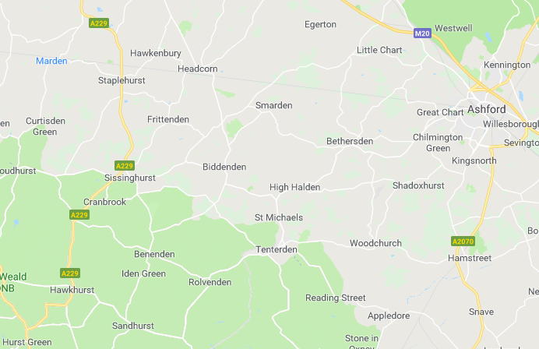

Appendix J – Leisure Facilities
Tenterden Leisure Centre
Modern sports venue with leisure pool with flumes and sports halls, plus classes and spa treatments.
Address: Recreation Ground Road, Tenterden, TN30 6RA
Hours:
Monday: 6.30am-9pm
Tuesday: 6.30am-9pm
Wednesday: 6.30am-9pm
Thursday: 6.30am-9pm
Friday: 6.30am-9pm
Saturday: 8am-9pm
Sunday: 8am-8pm

Phone: 01580 765987

Scouts
2nd Tenterden Scouts
Address: The Scout Hut, Bells lane, Tenterden, Kent, TN30 6EX
This is part of the Ashford District.
Beavers Ages 6-8
Cubs Ages 8-10.5
Scouts Ages 10.5-14
Explorer Scouts Ages 14-18

Boxing
Tenterden Amateur Boxing Club

Address: 53A High Street, Tenterden TN30 6BD
Phone: 07719882408/07815155913
An ABA accredited amateur boxing club based in the heart of Tenterden Town. Currently hold classes twice a week for people aged 7 and up. The club has a friendly and relaxed environment and encourage beginners and people of all abilities to come and try out our classes.
Contact:
Head Coach: 07719882408
Alternative Contact: 07815155913

Fencing
Tenterden Swords Fencing Club
Phone: 07714439385

For ages and skill sets.
We meet every Thursday night (including school holidays) in St Michaels Village hall in Grange Road, St Michaels, Tenterden. The Under 16s session starts at 7pm, and the Adult session starts at 8pm. The younger children usually finish at around 8pm. The evening finishes around 10pm.

We have been established since 1976 and are proud of our warm and friendly atmosphere. We have a skilled and highly respected coach, Peter Huggins, who offers individual lessons, we run an annual competition, The Invicta Open.

The first session is free for everyone, whether you are new to the sport or just new to the club. If you’ve never fenced before please come along in loose jogging bottoms and trainers. We have all the kit so you don’t have to worry.

Tenterden Youth Cafe (Next Generation)
Address: Highbury Hall, Highbury Lane, Tenterden, TN30 6LE
Phone: 07989435168
Open Mondays and Wednesdays 4.30pm-7pm for ages 11+

The Next Generation Youth Café meets on Mondays and Wednesdays for 48 weeks of the year from 4.30-7pm. Chill out zone, pool, table tennis, Wii, Café service for hot food and refreshments. Youth support services such as sexual health/exploitation, alcohol, drugs and smoking. Qualified youth workers on duty.

Tenterden Youth Club was founded in 1966 with the aim of helping and educating youth through their leisure time activities so to develop their physical, mental and spiritual capabilities that they may grow to full maturity as individuals and members of society and that their conditions of life may be improved. Today we carry on this work at Highbury Hall with the Youth Café, a drop-in centre for young people aged 11 onwards. The service is available to all young people in Tenterden and the wider area.

Tenterden Tigers Football Club
Contact: Graham Smith
Phone: 07768610643
Basic Training at Tenterden Recreation Ground Mondays from
5pm year 1
6pm years 2 and 3
7pm years 4 and 5
Website: tenterdentigersfc.com

Appendix K – Letter from Michael Hill
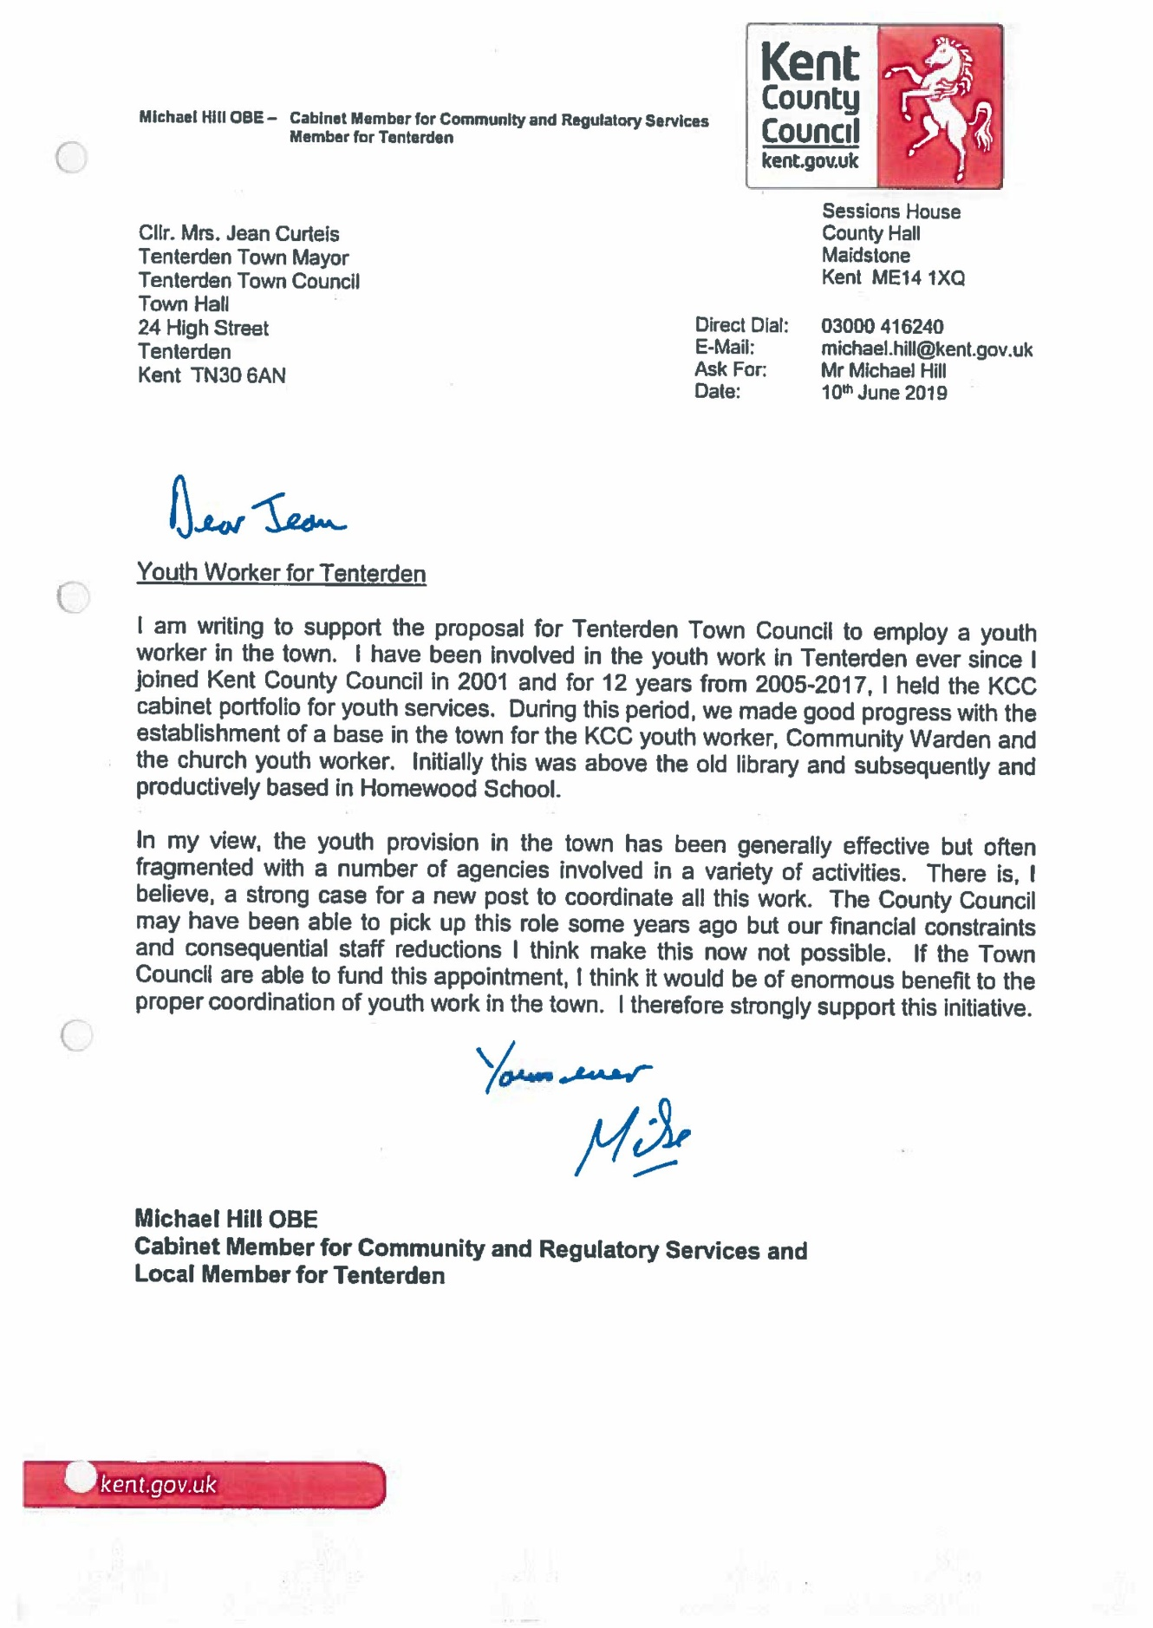
Appendix - L
CONTRIBUTION FROM JO VOSS – COMMUNITY WARDEN, TENTERDEN AREA.

I am the Community Warden for Tenterden and surrounding villages. I work closely with all age groups and currently help at the existing Youth Café. The young people who attend have various needs and issues which I feel could be met by a dedicated Youth Worker. The current provision is only accessible for a few hours, twice a week, which means young people are left to their own devices the rest of the time. Due to the rural area having poor transport links and the cost implications, young people living in the area are not able to access facilities in Ashford.

I feel a dedicated Youth Worker would be able to facilitate access to advice and information and provide support and a trusted person for young people to speak to. I think there is more anti-social behaviour in the area when young people have nothing to do and nowhere to go. There is also an increase in teenagers dabbling in drugs and I am aware that gangs from big cities are pushing into the rural areas and finding vulnerable young people, hooking them into dangerous behaviour. Having greater support and guidance for young people would be a positive addition to their well-being and safety.

Jo Voss
Community Warden
Tenterden and Surrounding Villages.

