FOR SALE:
2007 Volvo B7RLE Single Decker Bus
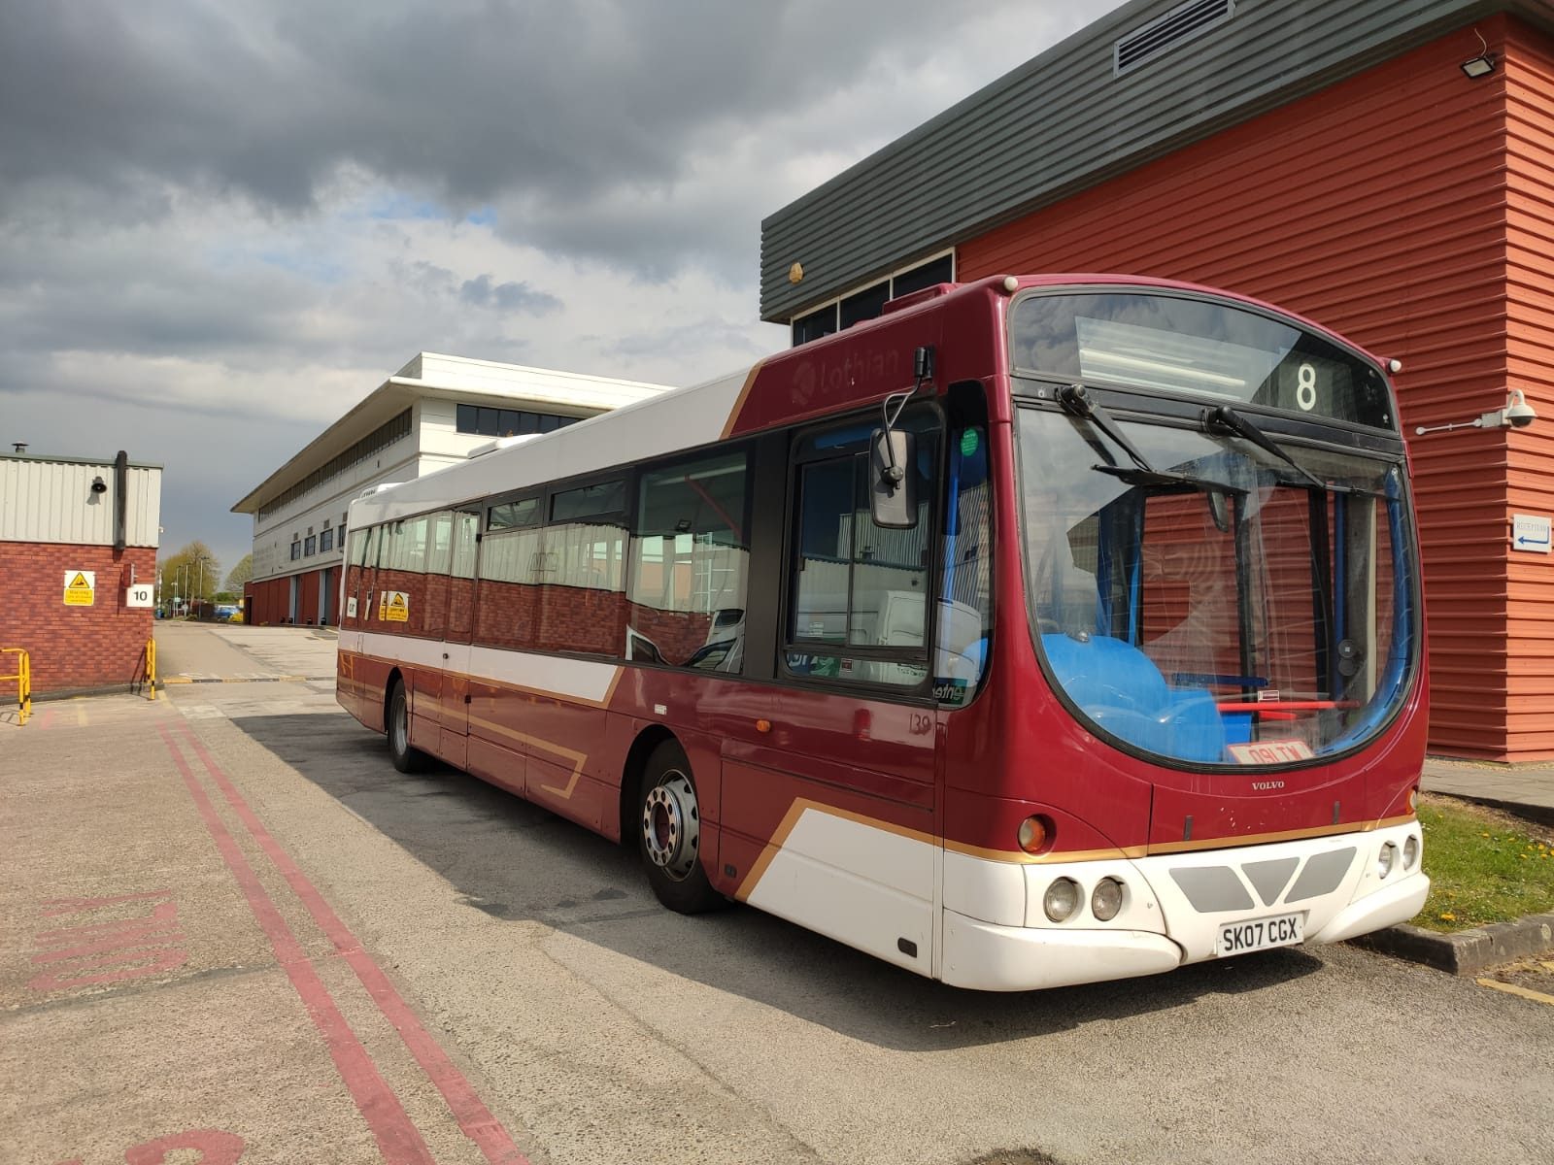
Details
Can be viewed and collected from: Ricardo Midlands Technical Centre, Southam Road, Radford Semele, Leamington Spa, Warwickshire, CV31 1FQ.
Please contact Richard Saady for viewing details on 01926 319319.
All sealed bids must be emailed to Jon Collyns at jon.collyns@cambridgeshire.gov.uk before 31st July and submitted in pounds and pence.
Please Note that the vehicle is SOLD AS SEEN and that the seller shall accept no liability after the sale has been made.

Make | Volvo | Model | B7RLE
Colour | Red and White | Year | 2007
Engine Size | Volvo D7C | Length/Width | 12 x 2.55m
Number of Seats | 38 | Drive Side | Right
Fuel | Diesel | MOT and Road tax | Expired 25/04/22

