

www.gov.uk/naturalengland

Request for Quotation

**Developing and facilitating workshops for Relevant Factor Diagrams for the Health, Wellbeing, Nature and Sustainability decision-support tool for Local Authorities in England**

**July 2022**

## 

## Request for Quotation

You are invited, to submit a quotation for the requirement described in the specification below.

Please confirm, by email, receipt of these documents and whether you intend to submit a quote.

Your response should be returned to the following email address by:

Email: [patrick.shannon-hughes@naturalengland.org.uk](mailto:Thomas.mainwaring-evans@naturalengland.org.uk)

Date: 9/9/2022

Time: COP

Ensure you state the reference number and ‘Final Submission’ in the subject field to make it clear that it is your response.

**Contact Details and Timeline**

Patrick Shannon-Hughes will be your contact for any questions linked to the content of the quote pack or the process. Please submit any questions by email and note that, unless commercially sensitive, both the question and the response will be circulated to all tenderers.

|  |  |
| --- | --- |
| Action | Date |
| Date of issue of RFQ | 5/8/2022 at 12:00 BST |
| Deadline for clarifications questions | 26/8/2022 at 17:00 BST |
| Deadline for receipt of Quotation | 9/9/2022 at 17:00 BST |
| Intended date of Contract Award | 30/9/2022 |
| Intended Contract Start Date | 5/10/2022 |
| Intended Delivery Date / Contract Duration | 28/2/2023 |

### Glossary

Unless the context otherwise requires the following words and expressions used within this Request for Quotation shall have the following meanings (to be interpreted in the singular or plural as the context requires):

|  |  |
| --- | --- |
| “Authority” | Means the Department for Environment, Food and Rural Affairs acting as part of Natural England |
| “RFQ” | Means this Request for Quotation and all related documents published by the Authority and made available to suppliers |
| “Contract” | Means the contract to be entered into by the Authority and the successful supplier. |

### 

### Conditions applying to the RFQ

You should examine your response to the RFQ and related documents ensuring it is complete prior to submitting your completed quotation.

Your quotation must contain sufficient information to enable the Authority to evaluate it fairly and effectively. You should ensure that you have prepared your quotation fully and accurately and that prices quoted are arithmetically correct for the units stated.

The supplier by submitting a quotation is deemed to accept the terms and conditions in the RFQ. Failure to comply with the instructions set out in the RTQ may result in the supplier’s exclusion from this procurement.

**Acceptance of Quotations**

By issuing this RFQ the Authority does not bind itself to accept any quotation and reserves the right not to award a contract to any supplier who submits a quotation.

#### Costs

The Authority will not reimburse you for any costs and expenses which you incur preparing and submitting your quotation, even if the Authority amends or terminates the procurement process.

#### Mandatory Requirements

The RFQ includes mandatory requirements and, if you do not comply with them, your quotation will not be evaluated. All mandatory requirements are set out in Bravo.

#### Clarifications

The Authority reserves the right to discuss, confidentially, any aspect of your quotation with you prior to any award of Contract to clarify matters.

#### Amendments

The Authority may amend the RFQ at any time prior to the deadline for receipt. If it amends the RFQ the Authority will notify you in writing and may extend the deadline for receipt in order to give you a reasonable time in which to take the amendment into account.

#### Conditions of Contract

The terms and conditions attached Condensed Terms and Conditions will be included in any contract awarded as a result of this RFQ process. The Authority will not accept any material changes to these terms and conditions proposed by a supplier.

#### Specification

1. **Background to Natural England**

Natural England is the government’s adviser for the natural environment in England. Its ambition is not just to improve nature, but to see it thriving everywhere. This is because Natural England recognises that a healthy natural environment is fundamental to everyone’s wealth, health and happiness.

Our mission is building partnerships for nature’s recovery. This reflects the need for us to work with and through a wide range of people and also the need for rapid action to re-build sustainable ecosystems and thereby protect and restore habitats, species and landscapes.

Further information about the Authority can be found at: [Natural England](http://www.naturalengland.org.uk/)

1. **Background to the specific Natural England work area relevant to this purchase**

Health, Wellbeing, Nature and Sustainability (HWNS) are the basis for thriving local areas. Nevertheless, they are often given insufficient consideration in strategic planning. We believe that a user-friendly tool that provides validated insights on what matters for these outcomes is needed. This will help shape local strategies and planning so that they help people and nature thrive and contribute to global sustainable development.

Natural England is working with partners to develop such a HWNS tool. These partners are the Environment Agency, UK Health Security Agency, Department of Health and Social Care, What Works Wellbeing, University of Exeter, Liverpool City Region Combined Authority, Norfolk County Council, Sandwell Metropolitan Borough Council and Surrey County Council.

The tool will be designed for key decision makers involved in the development of strategies for local and combined authorities. This contract is to develop user profiles and user journeys for the persons specified.

This is a time-sensitive contract as it will inform future work packages to develop the HWNS tool. Contract outputs need to be delivered within the specified timescales.

Suppliers can deliver the contract either on their own or together with subcontractors. Subcontractors must be selected by the suppliers. A joint application must be submitted. The requirements set out in this document apply to suppliers and any subcontractors.

1. **Requirements/Scope**

This section sets out the contract requirements. Suppliers must explain how they will deliver the required outputs within the specified timeframe and to budget. They must further demonstrate that they have the required skills and experience. Information on how this will be evaluated can be found below under Quotation Submission.

**Background on the HWNS tool.**

The HWNS tool will have two parts: a dashboard and Relevant Factor diagrams. The dashboard provides users with information on how they are doing in terms of health, wellbeing, nature, and sustainability. There are three Relevant Factor diagrams, one for Nature, one for Sustainability and a joint one for Health and Wellbeing. The Relevant Factor Diagrams will show users what factors matter for these outcomes. The diagrams will also show how factors relate to each other and the outcomes. Figure 1 shows what a Relevant Factor diagram for Sustainability currently looks like.

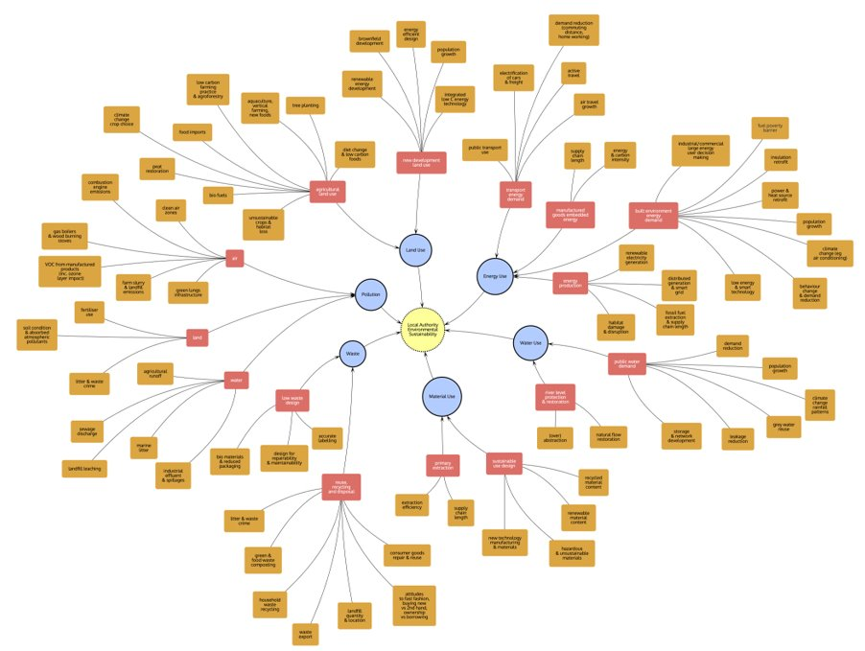

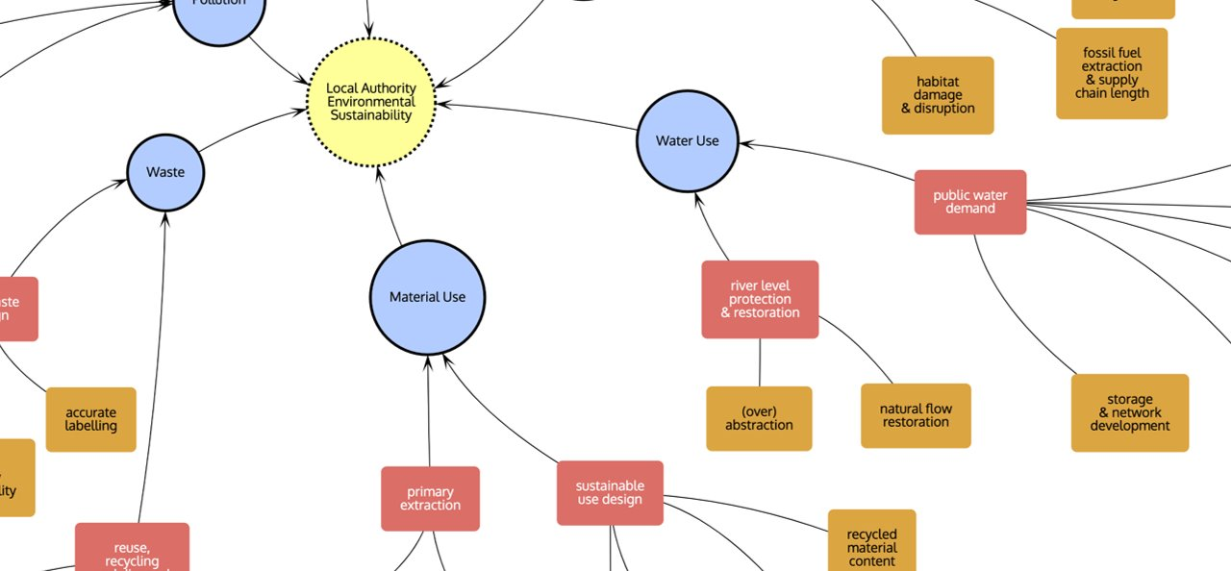

Figure 1 Relevant Factor diagram for Sustainability.

**Details on required outputs and skills.**

The Relevant Factor Diagrams have been developed through several workshops with a wide audience of stakeholders who identified the main relevant factors which underpin each of the outcomes. Each of the factor diagrams have captured three levels of factors which have been colour coded. Blue, red then orange.

The next step for the development of the RFDs is to introduce and test them with the targeted audience. To do this we plan to hold a half-day in person workshop with the four LA partner authorities; Liverpool Combined Authority, Norfolk County Council, Sandwell Metropolitan Council and Surrey County Council. The primary aims of these workshops are:

* To further enhance the pilot’s awareness and understanding of HWNS, how they can use the tool and what benefits they can gain from it.
* To gather learning and feedback on how useful the current HWNS tool is for progressing strategic decision making around HWNS at an LA/CA using a real-world example

Additionally, we also hope that these workshops can assist with the following aims:

* To gain an initial insight into the current processes and systems used within LA/CAs for strategic planning around HWNS
* To gather insight into the needs of the different audiences that would use the HWNS tool – gaining insight into who will use the tool? In what ways will they use it? When and how often they will use it?

In each workshop we plan to use a real-world example from the respective authority to apply the RFDs to.

The expected attendees of the workshop are:

* Facilitator
* HWNS SRO
* HWNS project manager
* 1-2 HWNS project partners
* 1 member of NE AT staff
* Potentially the Evaluation contractor?
* Up to 10 LA/CA staff:
  + Senior decision makers
  + Senior support staff with relevant expertise in HWNS

**Required outputs**:

* Develop a workshop plan for each authority alongside NE staff with some input from the Evaluation contractor
  + This could include the development of resources to aid the workshop such as specific dashboards and/or large printouts of RFD's, or finding a list of relevant drives and pressures of change
* Facilitate each workshop in person with the assistance of NE staff
* Attend post-workshop meeting to discuss what went well and what could be improved for the next workshop
* Complete a report on the finding from the workshop

**Required skills**

* Expertise and experience in developing workshop
* Expertise in facilitating workshops
* Understanding of systems thinking and concepts of Health, Wellbeing, Nature and Sustainability
* Excellent organisational skills.
* Excellent time management and project management skills to deliver the contract on time and to a high quality so that it can inform the following work package

1. **Contract Management**

The project will be managed by Patrick Shannon-Hughes with the involvement of a project steering group. Proposed timescales are as follows:

* Kick-off meeting w/c 5th September 2022.
* Fortnightly check-ins thereafter to update Natural England Project Officer on progress, with steering group participation if required. Progress statements/ drafts, where appropriate, to be provided 24 hours before the meeting.
* Full outputs by week commencing 27th February 2023.

We will raise purchase orders to cover the cost of the services and will issue to the awarded supplier following contract award. Natural England proposes to make payment on satisfactory completion of the project.

1. **Contract Period**

It is anticipated that this contract will be awarded for five months. Prices will remain fixed for the duration of the contract award period. We may at our sole discretion extend this contract to include related or further work. Any extension shall be agreed in advance of any work commencing and may be subject to further competition.

1. **Sustainability**

As a delivery partner, the successful contractor is expected to pursue sustainability in their operations, thereby ensuring Natural England is not contracting with a supplier whose operational outputs run contrary to Natural England’s objectives. The successful contractor will need to approach the project with a focus on the entire life cycle of the project. The successful contractor is likely to be able to provide a copy of their environmental policy and any environmental accreditation schemes such as ISO 14001 or EMAS which they have been awarded or are working towards.

**Prices**

Prices must be submitted in £ sterling, inclusive of VAT.

**Quotation Submission**

We will award this contract in line with the most economically advantageous tender. Suppliers will be scored on price and quality:

* Price: 30% weighting
* Quality: 70% weighting

The contract will be awarded to the Supplier with the highest overall score.

**Price**

Price will be assessed on the total for delivering the project. The total price submitted by the supplier will be scored according to the following mechanism.

The weighting and maximum marks available for this part of the request for quotation is 30% and will be awarded to the supplier with the lowest total price. The remaining suppliers will receive marks on a pro rata basis from the lowest to the highest price.

The calculation used is the following:

$$Supplier Score= \left({Lowest Total Price}/{Total Price}\right)×50$$

For example, if three Supplier Responses are received and Supplier A has quoted £3,000 as their total price, Supplier B has quoted £5,000 and Supplier C has quoted £6,000 then the calculation will be as follows:

* Supplier A Score = £3000/£3000 x 50 (Maximum available marks) = 50
* Supplier B Score = £3000/£5000 x 50 (Maximum available marks) = 30
* Supplier C Score = £3000/£6000 x 50 (Maximum available marks) = 25

The following quality criteria are weighted in accordance with the importance and relevance attached to each one.

|  |  |  |
| --- | --- | --- |
| **Criteria** | **Weighting** | **Description** |
| **Contract outputs** | **24%**  **(100 points available, minimum score of 50 required)** | Confirmation that your quotation proposal meets our specification.  Suppliers must explain how they will deliver the required outputs within the specified timeframe and to budget (as detailed above under Specification). Please highlight any differences or provide alternatives with reasons/benefits of using those alternatives.  Please ensure your response is clear and well presented.  Your response must be a maximum of 4 sides of A4, font size 10 (excluding CVs). |
| **Skills and experience** | **24%**  **(100 points available, minimum score of 50 required)** | Adequate staff resources devoted to the project and with an appropriate expertise.  Suppliers must demonstrate they have the required skills and experience to deliver the required outputs within the specified timeframe and to budget (as detailed above under Specification). This includes project qualifications and experience of similar projects  Please show clearly which key staff will be assigned to each of the tasks and outputs of the project and the number of days each will provide.  Please submit CVs of named staff who will work on the project (maximum of 1 side of A4, font size 10pt Arial per staff) that highlights most relevant publications and current or previous work experience.    Your response must be a maximum of 4 sides of A4, font size 10 (excluding CVs). |
| **Project and risk management** | 14%  (100 points available, minimum score of 50 required) | Suppliers must demonstrate they have suitable project management capabilities within their project team to deliver the contract outputs within the specified timescales and to budget.  Please submit a GANNT plan for delivering the required outputs (as detailed above under Specification).  Please also provide a summary of what you believe to be the main risks and areas of uncertainty, their potential impact on the project and how significant they are, and how you would act to minimise and manage them. This should include contingency plans to cover the unexpected unavailability of staff.  Your response must be a maximum of 4 sides of A4, font size 10 (excluding GANNT plan). |
| **Ethics** | 8% | Suppliers must explain how they will meet our ethical research guidelines (Annex d)).  Your response must be a maximum of 1 side of A4, font size 10. |
| **Sustainability** | Pass/fail | Please provide a copy of a sustainability statement for your organisation, or a brief statement of how you consider sustainability in projects.  The sustainability statement must be a maximum of 1 side of A4, font size 10. |

Quotation responses to each question will be evaluated and scored against the following score criteria:

|  |  |
| --- | --- |
| **Score** | **Justification** |
| For a score of hundred (100): | Excellent - Response is completely relevant and excellent overall.  The response is comprehensive, unambiguous and demonstrates a thorough understanding of the requirement and provides details of how the requirement will be met in full. |
| For a score of seventy (70): | Good - Response is relevant and good.  The response demonstrates a good understanding and provides details on how the requirements will be fulfilled. |
| For a score of fifty (50): | Acceptable - Response is relevant and acceptable.  The response provides sufficient evidence to fulfil basic requirements. |
| For a score of twenty (20): | Poor - Response is partially relevant and/or poor.  The response addresses some elements of the requirements but contains insufficient / limited detail or explanation to demonstrate how the requirement will be fulfilled. |
| For a score of zero (0): | Unacceptable - Nil or inadequate response.  Fails to demonstrate an ability to meet the requirement. |

### Disclosure

All Central Government Departments, their Executive Agencies and Non Departmental Public Bodies are subject to control and reporting within Government. In particular, they report to the Cabinet Office and HM Treasury for all expenditure. Further the Cabinet Office has a cross-Government role delivering overall Government policy on public procurement, including ensuring value for money and related aspects of good procurement practice.

For these purposes, the Authority may disclose within Government any details contained in your quotation. The information will not be disclosed outside Government during the procurement.

In addition, the Authority is subject to the Freedom of Information Act 2000 and the Environmental Information Regulations 2004, which provide a public right of access to information held by public bodies. In accordance with these two statutes, the Authority may be required to disclose information contained in your quotation to any person who submits a request for information pursuant to those statutes.

By submitting a quotation you consent to these terms as part of the procurement.

### Disclaimers

Whilst the information in this RFQ and any supporting information referred to herein or provided to you by the Authority have been prepared in good faith the Authority does not warrant that this information is comprehensive or that it has been independently verified.

The Authority does not:

* make any representation or warranty (express or implied) as to the accuracy, reasonableness or completeness of the RFQ;
* accept any liability for the information contained in the RFQ or for the fairness, accuracy or completeness of that information; or
* accept any liability for any loss or damage (other than in respect of fraudulent misrepresentation or any other liability which cannot lawfully be excluded) arising as a result of reliance on such information or any subsequent communication.

Any supplier considering entering into contractual relationships with the Authority following receipt of the RFQ should make its own investigations and independent assessment of the Authority and its requirements for the goods and/or services and should seek its own professional financial and legal advice.

**Protection of Personal Data**

In order to comply with the General Data Protection Regulations 2018 the contractor must agree to the following:

* You must only process any personal data in strict accordance with instructions from the Authority
* You must ensure that all the personal data that we disclose to you or you collect on our behalf under this agreement are kept confidential.
* You must take reasonable steps to ensure the reliability of employees who have access to personal data.
* Only employees who may be required to assist in meeting the obligations under this agreement may have access to the personal data.
* Any disclosure of personal data must be made in confidence and extend only so far as that which is specifically necessary for the purposes of this agreement.
* You must ensure that there are appropriate security measures in place to safeguard against any unauthorised access or unlawful processing or accidental loss, destruction or damage or disclosure of the personal data.
* On termination of this agreement, for whatever reason, the personal data must be returned to us promptly and safely, together with all copies in your possession or control.

**General Data Protection Regulations 2018**

For the purposes of the Regulations the Authority is the data processor.

The personal information that we have asked you provide on individuals (data subjects) that will be working for you on this contract will be used in compiling the tender list and in assessing your offer. If you are unsuccessful the information will be **held and destroyed within two years** of the award of contracts. If you are awarded a contract it will be retained for the duration of the contract and destroyed within **seven years** of the contract’s expiry.

We may monitor the performance of the individuals during the execution of the contract, and the results of our monitoring, together with the information that you have provided, will be used in determining what work is allocated under the contract, and in any renewal of the contract or in the award of future contracts of a similar nature. The information will not be disclosed to anyone outside the Authority without the consent of the data subject, unless the Authority is required by law to make such disclosures.

#### Annex

1. **What is the HWNS tool?**

**Background**

Local Authorities are grappling with a challenging range of interlocking issues, from nature and climate emergencies to health and well-being crises. Yet they have inherited a 20th century strategic planning system which proceeds sequentially through economy, spatial planning and transport. Health, well-being, nature and sustainability come in at a later stage and may even be seen as constraints in the planning process. 21st Century challenges, however, require a different approach, grounded in systems thinking, which focuses on health, well-being, nature and sustainability as final outcomes. The planning tools Local and Combined Authorities have inherited are sub-optimal because they are discipline specific and do not take sufficient account of interactions between disciplines. Many alternative metrics and dashboards have been proposed, but these do not provide a convincing account of the complex relationships underpinning the outcomes.

That is why we are developing a tool to provide Local and Combined Authorities with validated insights on what matters for HWNS. The tool will enable those responsible for strategic planning to make evidence-based decisions which will help people and nature to thrive and contribute to global sustainable development. The tool will be user friendly and free to use.

**How will the tool work?**

The tool focuses on four main outcomes - Health, Wellbeing, Nature and Sustainability – and includes a dashboard and diagrams showing relevant factors.

The dashboard will provide a selective snapshot of how authorities are doing in terms of HWNS outcome indicators:

* Health: Focusing on Healthy Life Expectancy
* Wellbeing: Focussing on the Office of National Statistics (ONS) measures of wellbeing: Anxiety, Happiness, Life Satisfaction and Worthwhile.
* Nature: Presenting the current state of nature
* Sustainability: Presenting the current environmental impacts of the area and showing how these relate to local, national and global targets.

The relevant factor diagrams (Figure 1) will show users what factors matter for HWNS outcomes and how these relate to each other and the outcomes. This will help Local and Combined Authorities to understand both trade-offs and complementarities as well as enable them to design integrated strategies that take these into account.

The final product will allow users to visualise and quickly be aware of which factors are relevant to achieving the final outcomes and to what degree of influence these factors have. Finally, the evidence and data provided will be able to inform Local and Combined Authorities on an evaluation of their progress and provide a starting point for project-based cases which improve the natural environment.

### Figure 1: An example of a section of a Relevant Factor Diagram from the first stage of development (16/03/22).

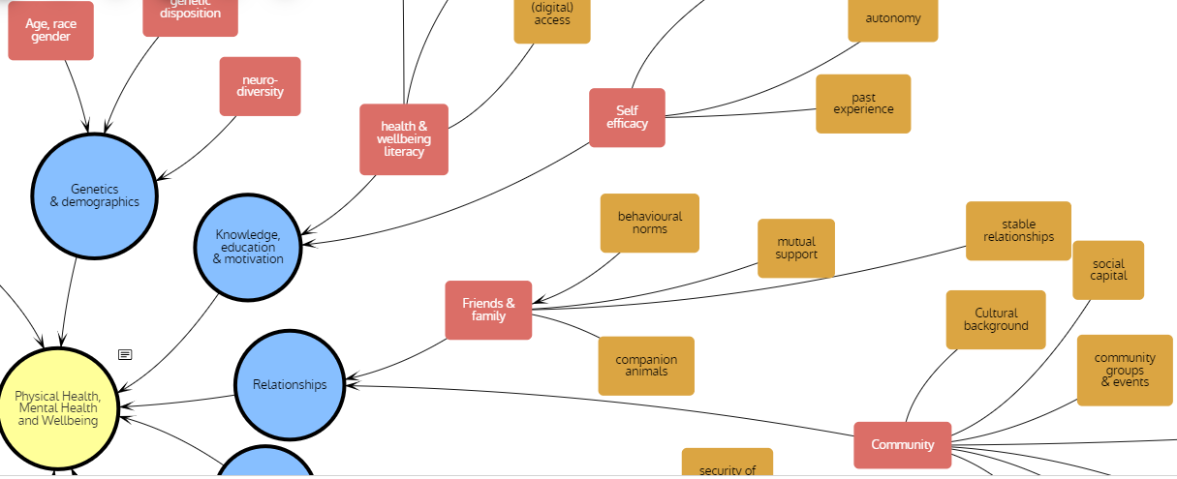

**Who is involved?**

We are working in partnership with a variety of organisations specialising in HWNS across the UK. We have four Local and Combined Authorities piloting the tool (see Figure 2).

Our pilot authorities will begin to trial early versions of the tool in 2023. These trials will help us to iteratively develop the tool through user-feedback and ensure that a more comprehensive final product is produced.

Figure 2: Participating Organisations to date

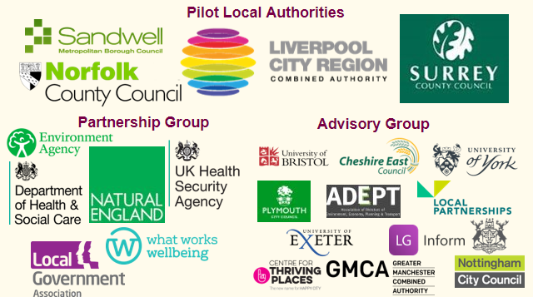

1. **Ethical research principles**

All Natural England staff commissioning or conducting (social) research where people are the subjects and/or participants have a responsibility to uphold five key ethical principles:

1. **Sound research methods and appropriate dissemination and utilisation of the findings.** Ensuring the research meets a clear organisational need, doesn’t place any unnecessary burden on respondents, and is based on sound methods that ensure evidence is robust, usable and accessible
2. **Participation based on valid informed consent** – it is clearly voluntary and participants have sufficient information to decide whether to take part
3. **Enabling participation** through method and sample design, with consideration given to likely barriers to participation and reasonable steps taken to address these
4. **Avoidance of personal and social harm** including avoidance of undue stress
5. **Non-disclosure of identity and personal information** ensuring confidentiality and data protection and that participants are not identified or identifiable in research outputs.

More detail about the principles can be found [here](https://www.gov.uk/government/publications/ethical-assurance-guidance-for-social-research-in-government).