Programme/Course:  Conflict & Disengagements | Time/Duration:  3hour Update
Previous Knowledge:
- All delegates will have attended the full day induction course, and possibly also previous further annual updates, so no knowledge should be new on the update.
Aim of Session:
By the end of the session staff will be able to:
- Staff to adopt appropriate values, attitude, and language.
- Staff to understand how to approach conflict and keep themselves safe.
- Staff to understand how we all react in crisis (assault cycle) and adopt de-escalation where appropriate.
- To be able to safely demonstrate disengagements and the rationale when to be used.
Outcomes of Session  - Adopt positive values and attitudes, as reflected in the language used and  behaviour during the course  - Accept and adopt appropriate theoretical concepts, approaches and  strategies (e.g. rights-based approaches, person-centred care)  - Describe (all) and evaluate (some) a range of primary interventions  - Understand the legal and ethical implications of using restrictive intervention  - Clearly articulate rationale for the use of RDaSH restrictive interventions |  | Assessment Methods  - Class discussion.  - Small group discussions and feedback to wider group.  - Engagement in communication games.  - Group poster work.  - Picture scenario work in small groups and feedback.  - Observation and demonstration of disengagement techniques.
Planned differentiation:
The scenarios provided to the group will be tailored to job roles of staff attending the course.
The course taught differently from an induction to an update.

Links to next session
- This is a stand-alone session.

Timing/Outcome | Resources | Learner Activities | Teacher Activities | Assessment
5 minutes | Slides 1 to 5 | Housekeeping, Inductions, Learning outcomes. | Explain housekeeping, location of equipment/ facilities.  Explain learning outcomes.  Complete introductions – as part of delegate introductions as them to explain what their role/ where their work will be based (helps inform the personal safety discussion) | Delegate engagement in introductions.
10 minutes | Slides 6&7  Whiteboards  Whiteboard markers | Slide 6 –  As a group activity delegates to write on whiteboards (or trainer can get delegates to shout out some answers) asking the following question:  - What is conflict, where they can find it, what forms can it take?  In the group feedback mentioning the following:  - Disagreements  - Values, believes, culture  - Communication  - Difference of opinion  - Different states of emotions  - Internal conflict  Slide 7 –  As the delegates have fed back, show slide 7 and show the different areas that conflict could develop.  In group feedback mention how, there could be a controlled conflict (sports image) and it could be a positive conflict.  As a shout out activity what is a positive conflict?  Group feedback should mention the following:  - Workplace meetings (e.g. MDT, team meetings etc) | Slide 6 -  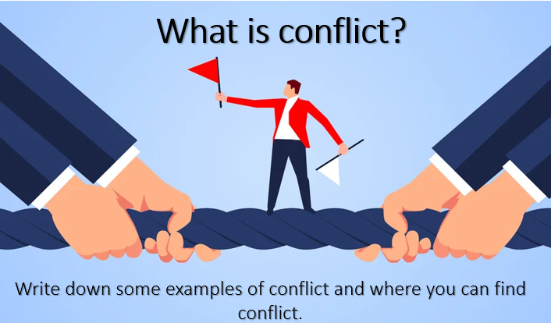  Slide 7 -   | Group discussion and feedback  Group discussion and feedback
20 minutes  15 mins  5 mins | Slide 8, 9 &10  Whiteboards, card headings (if needed) | Slide 8 –  As a group work activity on communication barriers using whiteboards. Asking the following question:  - Give some examples under each communication barrier how it can affect communication (for example: masks would come under a physical barrier, abbreviations would come under language.)  In the group feedback mention the following:  - Culture – difference in religion values, beliefs etc  - Language – different languages, interpreters, abbreviations etc  - Physical – deafness, learning difficulties, environment etc  - Gender – job roles, religion (women with same sex staff) etc  - Interpersonal – ways of speaking to different ages, upbringing etc  - Perceptual – way you see things etc  - Emotional – different emotions can affect how you communicate.  - Link trauma could link to all communication barriers and how it can affect communication.  Slide 9 –  Facilitators to lead communication games (whispers, drawing game, charades)  After the activity ask the group the following question:  - Why did we do this activity, how does it link to your work?  - How could we of made this better for communication?  - Could this happen in real life especially when doing the whispers activity?  - What is communication made up off?  In group feedback mention the following:  - In reply to question 4 – should get back verbal and non-verbal.  - Linking back to conflict, that poor communication and understanding barriers can cause that conflict.  Slide 10 –  In the previous group activity we spoke about verbal & non-verbal communication. Facilitator to support the group to break it down to three headings (body language, tone of voice & words) ask delegates to do a pie chart given the headings and random percentages and see what delegates think is right.  In group feedback:  - Ask delegates why they given the answers.  - Link back to the games and which section of pie chart was took out of the communication games previously done.  Show answer slide; reflect with group why BL is the greatest percentage and words the smallest (i.e. it’s not what we say, but the way that we communicate the message) | Slides 8 -  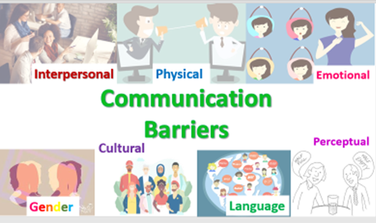  Slide 9 –  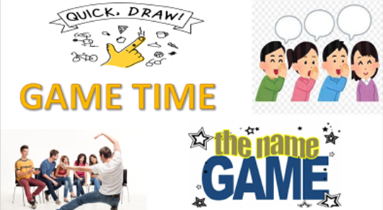  Slide 10 –  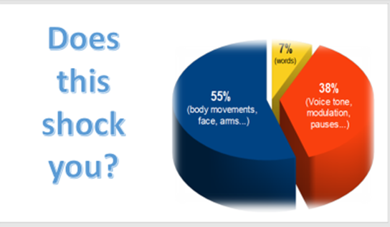  Explain that this is Albert Mehrabian’s model of communication: During the 1960s and 1970s, Albert Mehrabian’s work on spoken communication led to the conclusions outlined in the pie chart – figures which are widely quoted in recruitment and business contexts | Group is split into smaller groups, depending on numbers, to work as a group and be able to feed back as many communication barriers as they can for their heading.  Delegates to engage in communication games with a positive attitude, and join in group discussion.  Delegates to complete their own pie chart and rationale for their choices.
5 minutes | Slides 11 | Slide 11 –  As a group discussion, facilitator to go through the cycle of Betari’s box and explain how that can relate to conflict, communication and morale.  (e.g. having someone negative in the team – what does it do to the team morale?) – our own behaviour influences everyone else.  Explain we all have the ability to make someone’s day better or worse, depending how we act ourselves. | Slides 11 –  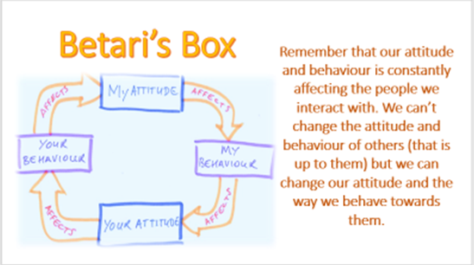 | Ask delegates to reflect on themselves and being self aware when supporting others.
10 minutes  5 mins | Slides 12&13  Whiteboards and/ or worksheets (can differentiate depending on experience of the group). | Slide 12 –  Remind group of the assault cycle  In a group using slide 12 mention the following:  - Baseline - explain that we do this naturally to keep us on a baseline (primary strategies).  - Trigger –explain we all have triggers that can cause our behaviour to change.  - Escalation – this shows we have secondary strategies to prevent us becoming to the crisis point.  - Crisis – explain that some people have coping strategies however some people do not have this. Explain for example when we are at our angriest, we are at our stupidest, due to our cognitive functions (this can relate to any emotional state – i.e. upset, depressed etc). However, that crisis can go up and down over a period.  - De-escalation – things we do to bring back down to baseline.  - Post event depression – explain how if someone has been at their angriest that they will go below the baseline and explain we need time to come back up to baseline. (People may feel drained, different emotions with what they experienced)  Slide 13 –  As a shout out activity (or trainer can use whiteboards for delegates to write notes) asking the following questions:  - What is an external trigger?  - What is an internal trigger?  Group feedback mention the following:  - Internal is some could be personal to yourself for example: trauma, smell, pain, thought and feelings, tiredness etc.  - External is something in the environment for example: hot or cold, time of year, people, noise etc.  - That if external and internal come across the same path/ collide that the trigger will appear. | Slide 12-  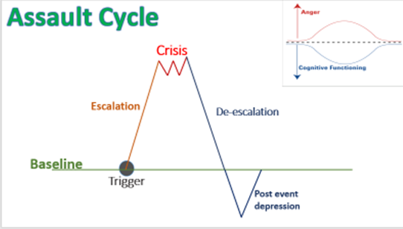  Slide 13 -  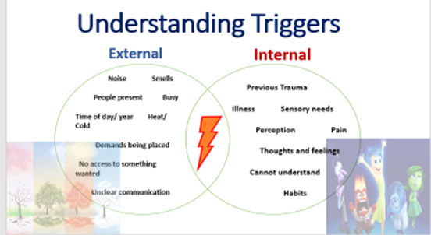 | Group discussion
5 min | Slides 14 - 18 | As a shout out activity, trainer ask the following:  - Do we stereotype and why?  Group discussion mention the following:  - It’s a natural instinct for us to do and way of protecting ourselves.  - The downside is that we can pre-judge/ get it wrong (i.e. don’t judge a book by its cover)  The Facilitator can choose from either the stereotyping images OR the written case studies  For images: Group discussion delegates to shout out what they see.  (Disclose it is a safe space to say what they see – we want delegates to stereotype as they naturally would!) | 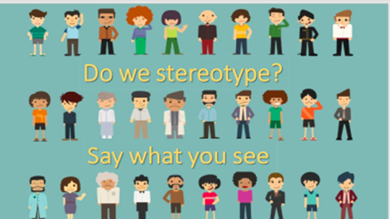  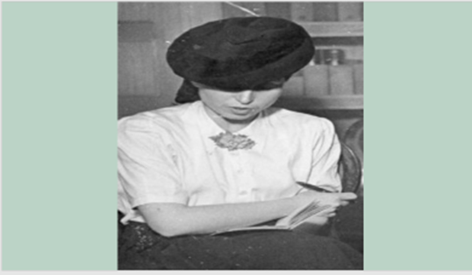  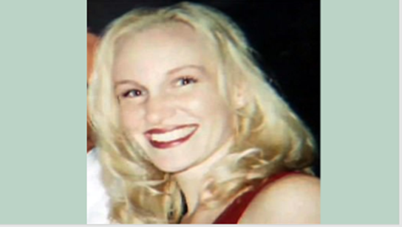  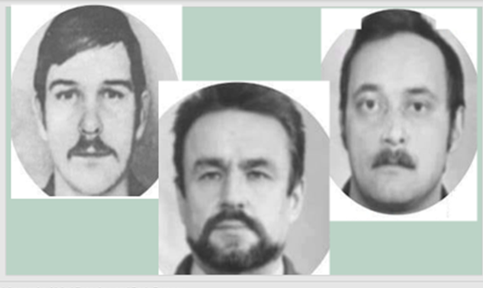  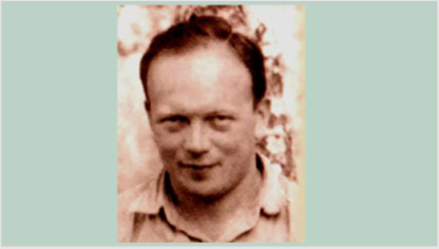 | Group discussion  Shout out activity
5 min | Slides 19 - 23 | 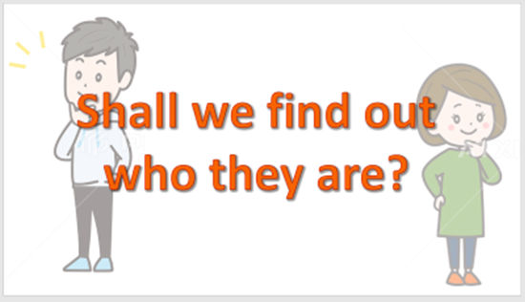  Trainer to disclose stories behind the people may be upsetting.  Group discussion to mention:  - How we do not judge until you know someone but also can be a good thing to judge to protect ourselves.  - Link it to personal safety and lone working. | 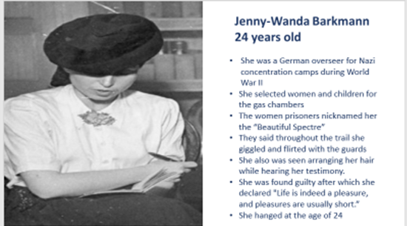  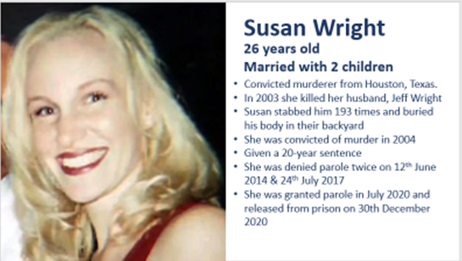  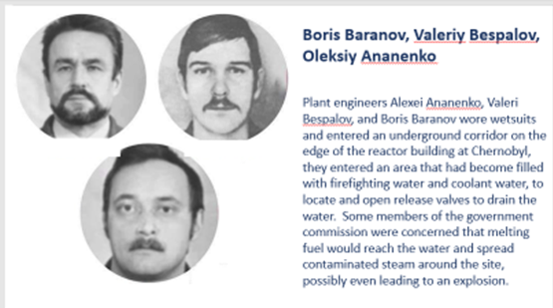  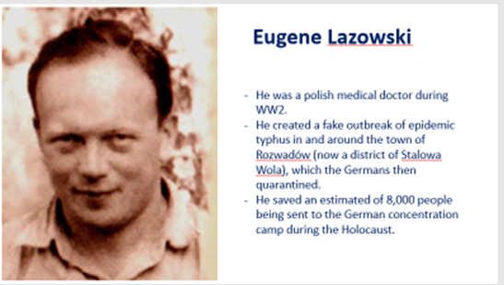 | Assessing staff sensitivity to the people and their stories, staff to engage in self-reflection, consider again why we stereotype, and that our first impressions are vital but not always right.
10 min | Slides 24 - 30 | Introduce slide 24:  In tables/ groups delegates are to decide individually who they would rather care for you, and who they would rather support.  Tables do not need to agree, but they need to discuss what leads them to choose who they choose (i.e. based on previous experience, perception, how they feel they may gel with that person)  Tally up A, B, C and 1, 2, 3 as a whole room.  Then use slides 24-30 to show delegates who they have chosen.  Discuss that some colleagues in the room may receive written information about a patient prior to meeting that person, again we draw judgements about that person.  If we had written down the worst thing everyone in the room had done, would we all still want to be sat together?!  Explain about the balance of knowing risks associated with a person vs. reflecting how accurately the information we receive now reflects who that person is. | 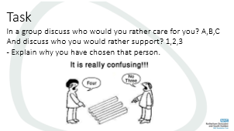  In summary, stereotyping can help us (keeping ourselves safe), but it can also impact on our judgement and responses. | Staff to engage in the activity and group discussions that follow.
5 mins | Slide 37 - Lone Working | Slide 40 –  As a shout question to the group, ask the following:  - What do you know about the Lone working policy?  - Ask staff to raise their hands if they think they are a ‘lone worker’.  - Ask staff to tell you what a ‘lone worker’ is? Assess the groups understanding around the heading. | 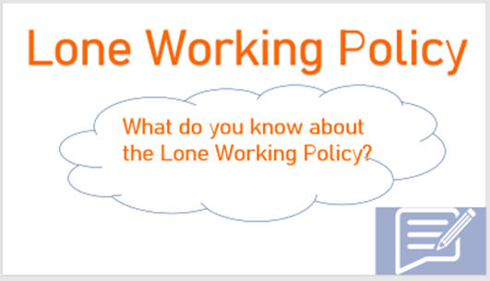  If inductees do not know if they are a lone worker, get them to locate the Lone Working policy via the internet – they can “google” this.  Also share key points of the policy – i.e. appendices relating to initial home visit risk assessments & personal safety risk assessment (see also next slide) | Assess staff’s understanding of whether they are a lone worker and why this is importance in terms of their job roles.
10 mins | Slide 36 | Initially explain what impact factors are – i.e. the things we consider when completing a dynamic risk assessment in terms of our safety. (“What things might make our alarm bells ring?”)  Explain there are 3 areas we consider:  - People – size, build, age, group/individual etc.  - Objects – mention; potential weapons, drug & alcohol items, pets etc.  - Places - places, building layout, areas, time of day and year etc.  Can be completed as a shout out activity or as a group activity producing posters for each of the three areas to consider. | 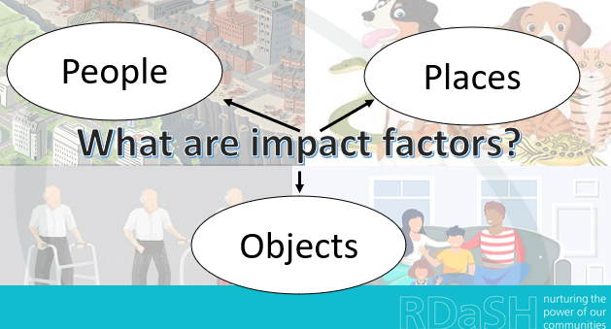 | Group discussions/ posters and feedback.
10 mins | Picture images | Share the picture images of various locations around the room.  Ask delegates to imagine they are completing a visit to that location, and to dynamically risk ass the image pulling out the impact factors. | Select images relevant to the staff’s role within the group | Group discussion and feed back.
15 mins | Slide 39: Personal Safety | As a group exercise (or trainer to do a shout out answer exercise) using whiteboards, ask the following:  Tell us the things you do to stay safe at work.  Answers may include but not limited to:  Safe storage of kit/ personal possessions  Not allowing selves to be locked in  Not taking shoes off during a visit  Use of safe words/ phrases  Mobile phones and their functionality  How to keep in touch with colleagues  Ensuring pets/ animals are moved out of the room  Knowing your exits and escape routes  Use of building/ personal alarm systems  The wearing (or not) of lanyards and uniforms  Checking people’s identity  Checking for tailgaters | 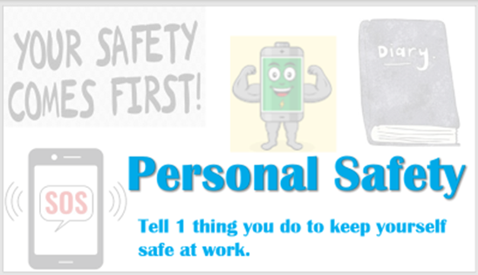 | Group feedback, sharing good practice
45 mins  Disengagement techniques:  The Law  Non-Confrontational  Safe Stance  Reactionary gap and spatial awareness  Wrist Grips, Clothing Grabs, Strangles  Hair pulls  Distractors  Punches & Kick  Acid Attacks  Bites | Empty room – ensure room is free from trip hazards etc.  Discussion and/ or slides  Ensure participants are dressed appropriately and health declarations have been completed. | Observe and Practice techniques  Engage in discussion regarding the law (understand actions needs to be justified, proportionate and necessary)  Understand our disengagement techniques are built on the principles of ‘flight’ – i.e. getting yourself away safely.  When introducing topic, focus on spatial awareness (i.e. get delegates to stand toe-to-toe/ step back).  Safe stance – gently push partner with feet together and then to adjust stance to see the difference. | If delegates are struggling to understand use case studies from the media (i.e. Tony Martin and Richard Osborn Brooks) to help explain justified, proportionate and necessary actions.  Demonstrate Techniques and  facilitate practice. Demonstrate and discuss techniques work on speed, surprise, and technique.  Lead a discussion on The Law, bringing in and relating back to duty of care and Health and Safety at Work Act.  Remind of stance and stepping back, throughout the activity. | Time to practice techniques, feedback through group discussion.
10 mins | Slides 45, 46 | Delegates have the opportunity to ask any questions.  Delegates to complete QR code feedback.  Delegates to sign out, informing us they have not been injured (in the event of any injury to complete an IR1) | 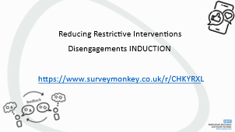
TOTAL TIME: 3 hours

