Notice for Expressions of Interest, for alteration and conversion works of an existing rooms - three classrooms located in the Technology Block (Block C) require conversion into a Science Lab, Design Technology Room and Food Technology Room for Grove House School, Sawyers Hall Lane, Brentwood, Essex, CM15 9DA.

The Grove House School is seeking a suitable contractor to carry out internal minor alteration and refurbishment works of the existing building

Address of Site: Grove House School - Technology block, Sawyers Hall Lane, Brentwood, Essex, CM15 9DA
The Technology block is situated within Grove House school boundary behind the main building.
The technology block previously develop during Phase 1. The block currently houses the September 2016 intake of pupils and requires alteration and conversion works into a Science Lab, Design Technology Room and Food Technology Room.
The site currently occupied by the students, reception staff and act as waiting area for visitor.

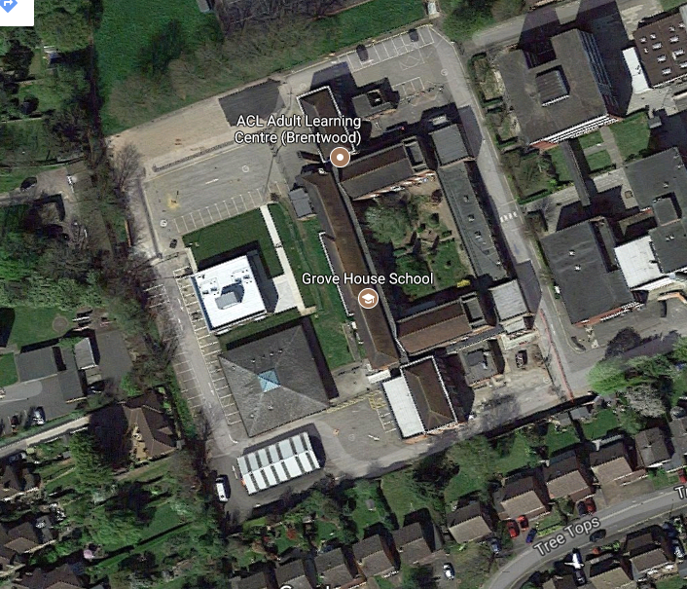
Three existing classrooms are to be converted into 1) a Science Lab (with access to a Science Prep Room), 2) Design Technology Room, and 3) Food Technology Room.
The works in each room require alteration to comply with the ESFA Facilities Output Specification, with the majority of works and costs related to the installation of services into each teaching area

The works also includes the supply and installation of FF&E as specified by the client. (Supporting documents will be included as part of ITT, please note they are for design intend purposes only)
Contractors wishing to be considered for this opportunity must express their interest by sending an email to Andrew.wong@macegroup.com by noon Wednesday 27.09.2017 to receive an invitation to tender. The buildings must be ready for occupation including all fit out of fixed and loose FF & E by the deadline 23rd March 2018 or earlier if possible.

Industry – Construction and Real Estate

Location of contract – CM15 9DA

Value of contract – £186,000

Published date – 14.09.2017

Closing date – 27.09.2017

Contract start date – 31.10.2017

Contract end date – 23.02.2018

Supporting information

The Science Lab will have a floor area of 57.4m2, and will include refurbishment works such as replacing the carpet with a vinyl floor, application of moisture resistant paint to walls, and M&E works with installation of gas, power and data to each work station, installation of an extraction / ventilation system and installation of fire alarm.
The Science Preparation Room will have a floor area of 15m2, and will include refurbishment works such as replacement of carpets to a new vinyl floor, decorating walls and ceilings with moisture resistant paint, and M&E works such as the supply and installation of additional power, reinstatement of water heater to sink, allowance for extraction / ventilation system and installation of fire alarm.
The Food Technology room will have a floor area of 64.7m2, and will include refurbishment works such as replacing the carpet with a new vinyl floor, installation of a moisture resistant ceilings, walls and woodwork, and M&E works will include installing pipe works for sinks, supply and install of electric cookers, connection of electrical hobs, radiator relocation, fire alarm installation, installation of an extraction / ventilation system.
The Design Technology room will have a floor area of 57.4m2, and will include replacement of carpet to a vinyl floor and M&E works such as supply and installation of additional power & data, fire alarm services and water.

