G- Cloud Customer Benefits Record
Customer Information

 | 1. Organisation Name:
 | Department for Education
 | 2. Contact Name: |  |  | 3. Email Address: |  |  | 4. Telephone Number
 | Angela Bains |  |  | Angela.bains@education.gov.uk |  |  | 02476 660110
Successful Supplier Information

 | 5. Company Name:
 | Parity Consultancy Solutions
 | 6. Contact Person: |  |  | 7. Email Address: |  |  | 8. Telephone Number/s:
 | Andrew Ogg |  |  | a.ogg@parity.net |  |  | 07771911659
Order Information

 | 9. Lot/Service Description & Service ID Number:
Lot 3 - Cloud support - (Service ID
2515 9975 0221 035)

 | 10. Order Date: |  |  | 11. Order Terms (0 - 24months): |  | 12. Price & Unit measure
 | 12/01/2018 |  |  | 12 months |  | Approx £4,000,000 (but this will be used via a call off arrangement)

13. Previous Service Spend/Budget: |  |  | 14. Forecast Spend following Award(Contract Value):
N/A |  |  | N/A

 | 15. Payment Term: |  | 16. Commencement Date: |  | 17. First Invoice Date:
 | 30 days after receipt of invoice of acceptance of deliverables |  | 15 January 2018 |  | n/a
18. Additional Information - Please provide below all prices for the short listed services together with supplier name and indicate which supplier/price resulted in contract award

Supplier Name | Service ID | Service Cost
Parity Consultancy Solutions | Service ID 2515 9975 0221 035 | £4,000,000

19. Submission - Once complete, please email a copy to: gcloud-benefits@crowncommercial.gov.uk

Guidance Notes For Completion

Customer Information.
- Please enter your name your organisations name.
- Please enter your name.
- Please enter your corporate email address.
- Please enter your corporate contact number and mobile phone number if applicable.
Successful Supplier Information.
- Please enter the successful Suppliers name.
- Please enter the name of your contact point / contract manager within the supplier’s organisation.
- Please enter a telephone number for your contact point.
- Please enter the email address for your supplier contact point.
Other Information.
- Please enter the Lot/Service Description & Service ID Number
- Please enter the order date
- Please enter the order term
- Please enter the Price & Unit measure
- Please enter the Previous Service Spend (if known)
- Please enter the Forecast spend following award (contract value)
- Please enter the payment term
- Please enter the commencement date of the contract
- Please enter the first invoice date
- Additional Information - Please provide all the prices for the short listed services together with supplier name and indicate which supplier/price resulted in contract award.
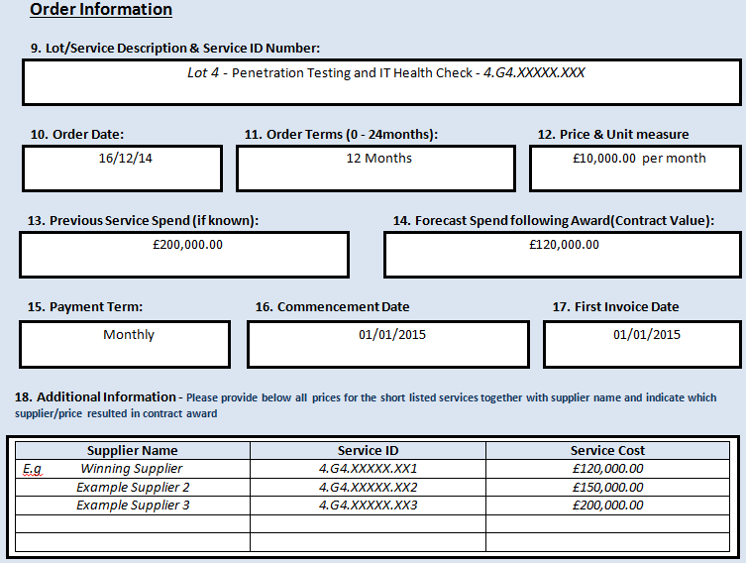
Example 9 - 18

