4.2.2.1 TIGHTEN OR REPLACE SCREWS AND BOLTS AND RE-TENSION ROAD RESTRAINT SYSTEM REQUIRING RE-TENSIONING.
RRS - TENSIONED CORRUGATED BEAM (INCLUDES BARRIER LENGTH, TRANSITIONS, AND TERMINALS)
The Contractor shall agree with the Service Manager a programme of ‘cyclic’ activities to ensure that the inspection and re-tensioning frequencies as stated in GM701-ADAMR.

All Road Restraint Systems, shall be as defined in the BS EN 1317(both part 1 and 2), CE marked, shall conform to DMRB TD19/06 and Series 400 of MHCW Volume 1.

maintenance requirements
- All vehicle restraint systems and pedestrian restraint systems within the affected property, including vehicle safety barriers, safety barrier gates, crash cushions, terminals, transitions, pedestrian guard rails, vehicle parapets, combined vehicle and pedestrian parapets and pedestrian parapets on bridges and other structures, arrester beds and cattle grids. (GM 701 – PG62)

- Road restraint systems (vehicle and pedestrian) are managed and maintained to function in accordance with their intended design and performance requirements.

- Prepare and instruct the implementation of the maintenance requirements plan (MRP) with regards to road restraint systems maintenance requirements.

- Record asset data as defined in the ADMM [Ref 1.N].

- Maintain barrier tension in accordance with manufacturer's recommendations, or, in the absence of manufacturer's recommendations (e.g. on non-proprietary safety barrier systems), in accordance with BS 7669-3 [Ref 45.N]. Replace all post screws when re-tensioning tension corrugated beam (TCB) safety barriers.

472AR Tensioned Corrugated Beam Safety Barrier
- 1 Tensioned Corrugated Beam Safety Fence shall be re-tensioned in accordance with BS 7669: Part 3, Section 2.1 and to the frequencies stated in GM701-ADAMR .

- At other times the Service Manager shall instruct the Contractor of each length where the slack shall be required to be removed.

- Tensioning between any two limits shall not proceed until each limit shall be anchored sufficiently securely to resist the load effects due to tensioning.

- At the boundaries of the Affected Property, retensioning shall be to the nearest adjuster or anchorage assembly outside of the Affected Property boundary.

- Tensioning shall be undertaken only when the ambient temperature shall be between 25°C and -5°C.

- Adjuster assemblies shall be located not more than 70.5 metres apart and each installation shall incorporate at least one adjuster assembly.

On completion of tensioning, the centre of each screw securing beams to posts shall not be closer than 25 mm ±2 mm to the end of the slotted hole in the beam. (M&RC-SPEC PG19)

UNIT / MEASUREMENT / ITEMISATION
- Check all road restraint systems and tighten or replace screw bolts and re-tension barrier requiring re-tensioning 191386.13 linear metre. (MOM Schd. B Issue 7 PG13)

- The measurement of check all road restraint systems and tighten or replace screws and bolts and re-tension barrier requiring re-tensioning shall be the length along the centre line of the beams for single sided road restraint systems. If the road restraint system is double sided the measurement shall be the length of one side for the entire length of each road restraint system subject to the limitations on lengths instructed by the Service Manager. Transitions and terminals shall be included in lengths measured where applicable. (MOM Schd. B Issue 7 PG13)

- Separate items shall be provided for tighten or replace screws and bolts and re-tension barrier requiring re-tensioning and check all road restraint systems and Treatment of weeds, remove scattered aggregate from carriageway and reprofile gravel bed of arrester beds in accordance with Chapter II paragraphs 3 and 4 and the following:
Group Feature
I 1 Sub-Asset Type.
II 1 Item.
(MOM Schd. B Issue 7 PG13)

additional information
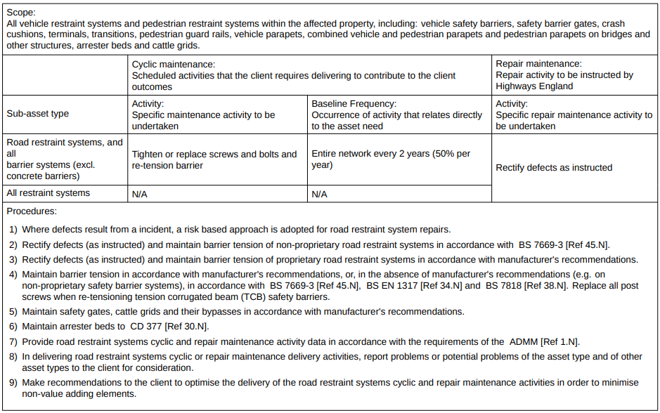
(GM 701 – PG62)

