|  |
| --- |
| **Invitation To Tender (ITT)** |
| Lead Generation for Inward Investment to Cornwall, UK.  December 2023 – March 2025 |
| Date 1/11/23  Cornwall Trade and Investment  Economy and Skills |
| Sustainable Growth and Development  Cornwall Council |
|  |
|  |

1. **Cornwall** **Council Directorate of Sustainable Growth and Development**

**1.1** Our role is to maximise the potential for the economic growth and development of Cornwall as we take forward delivery of the strategic economic plan and adoption of the Local Plan and ensure that our housing meets current and future needs. We also work closely with the Council’s Chief Operating Officer (the Council’s section 151 Officer) to ensure that the financial gap faced by Cornwall Council is reduced through Council tax growth and business rates. We work in partnership with the Local Enterprise Partnership (LEP), our local communities, businesses and stakeholders to grow Cornwall’s economy together, ensuring that we understand and reflect their needs and ambitions in our actions and our approach.

**1.2** Economy and Skills Service within the Directorate of Sustainable Growth and Development. We work alongside Cornwall and Isles of Scilly Local Enterprise Partnership (LEP) to maximise the sustainable economic development of Cornwall. Our Service Director is the Chief Executive Officer of the LEP and we collectively support the LEP Board to create and implement the Cornwall and Isles of Scilly Strategic Economic Plan. The plan encompasses a culture strategy to inform planning and development decisions for Cornwall and the Isles of Scilly (CIOS), alongside a £1bn investment programme to contribute towards overall growth and employment.

**2. Background**

**2.1** [Cornwall Trade and Investment](http://www.cornwallti.com) (CTI) is a function within Cornwall Council’s Economy and Skills service. CTI’s remit is to promote CIOS as a business destination, generate inward investment, encourage trade activity, and foster increased job creation. Through its extensive international networks, CTI’s activity presents Cornwall on a global scale – acting as the front door to decision makers, business owners, British Embassy staff and other stakeholders.

**2.2** As part of the UK Government’s Levelling Up agenda, CIOS been allocated £132million to spend on local investment through the [Shared Prosperity Fund.](https://www.gov.uk/government/publications/uk-shared-prosperity-fund-prospectus/uk-shared-prosperity-fund-prospectus) With a focus on green and inclusive growth, Cornwall will use their funding to achieve good growth for CIOS, providing opportunities for communities and businesses and giving residents access to new jobs and training. CTI has been allocated funding through Shared Prosperity Fund (SPF) under Strand 2- *Support for Local Business: Low productivity is a challenge for businesses in CIOS. Our Good Growth model will improve local opportunities by investing in infrastructure, industry and training.*

SPF specific outcomes for CTI are as follows:

* E23 - Strengthening local entrepreneurial ecosystems and supporting businesses at all stages of their development to start, sustain, grow and innovate, including through local networks.
* E25 - Grants to help places bid for and host international business events and conferences that support wider local growth sectors.
* E27 - Funding to develop angel investor networks nationwide.

**This tender is to support outcome E23 by increasing inward investment. Targets for CTI under SPF include engaging with 13 potential businesses, with 6 landed inward investors within the lifetime of the project which ends 28 February 2025.**

**2.3 Inward Investment for CTI**

Inward investment in CIOS refers to the process of attracting businesses, capital and resources from outside the region or country to invest in various economic activities within CIOS. It is investment as capital or the creation of a new enterprise within CIOS or a foreign enterprise acquiring a business. The goal of inward investment is to stimulate economic growth, create jobs and enhance the overall development of the region.

**2.4**  **Key Sectors**

CTI will support a wide range of industries, in accordance with demand, strategic fit and to compliment sector development activity.

CIOS’s strategic sectors are:

* + Clean Energy
  + Data and Space
  + Agri-food
  + Geo-resources
  + Visitor Economy

The following diagram demonstrates CTI’s strategy for attracting inward investment relevant to the strategic sectors:

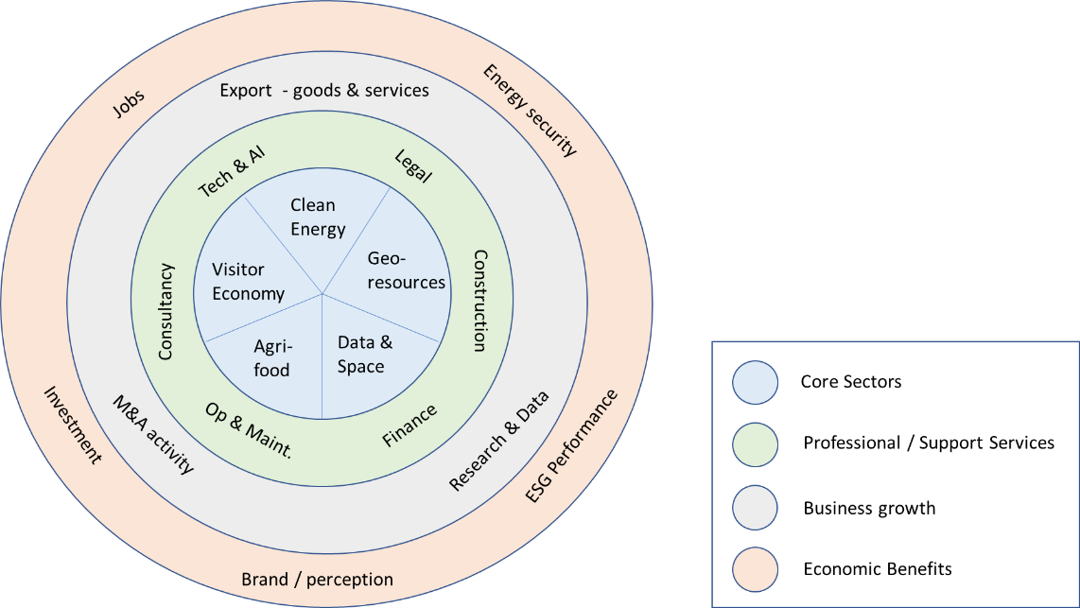

A focus on CIOS’ core sector opportunities is to drive increase growth of businesses directly related to those sectors and the associated professional and support services required to support their growth. In turn, export levels will increase, research and data opportunities will grow, and the opportunities for merger and acquisition transactions will result. The accumulative economic benefits of this growth will benefit and drive economic and social drivers positively.

**2.6 Past performance and data:**

Since 2018, CTI has supported 55 new businesses to locate into the region and ONS data shows a 69% increase in foreign businesses.

CTI has an existing pipeline of 40 leads held on a central CRM system, prioritised depending on timescales, strategic fit, probability of landing and economic impact.

Sources of current leads:

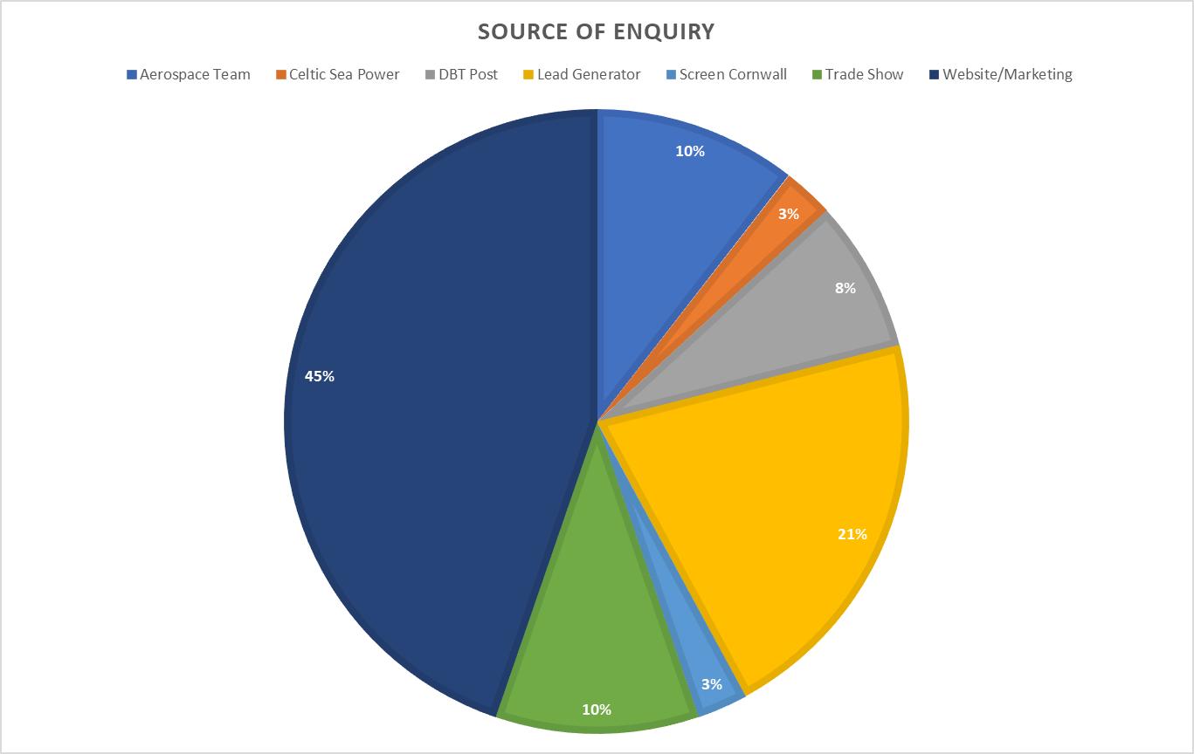

Strategic partnerships in key markets are an important source of inward investor enquiries, which are currently as follows:

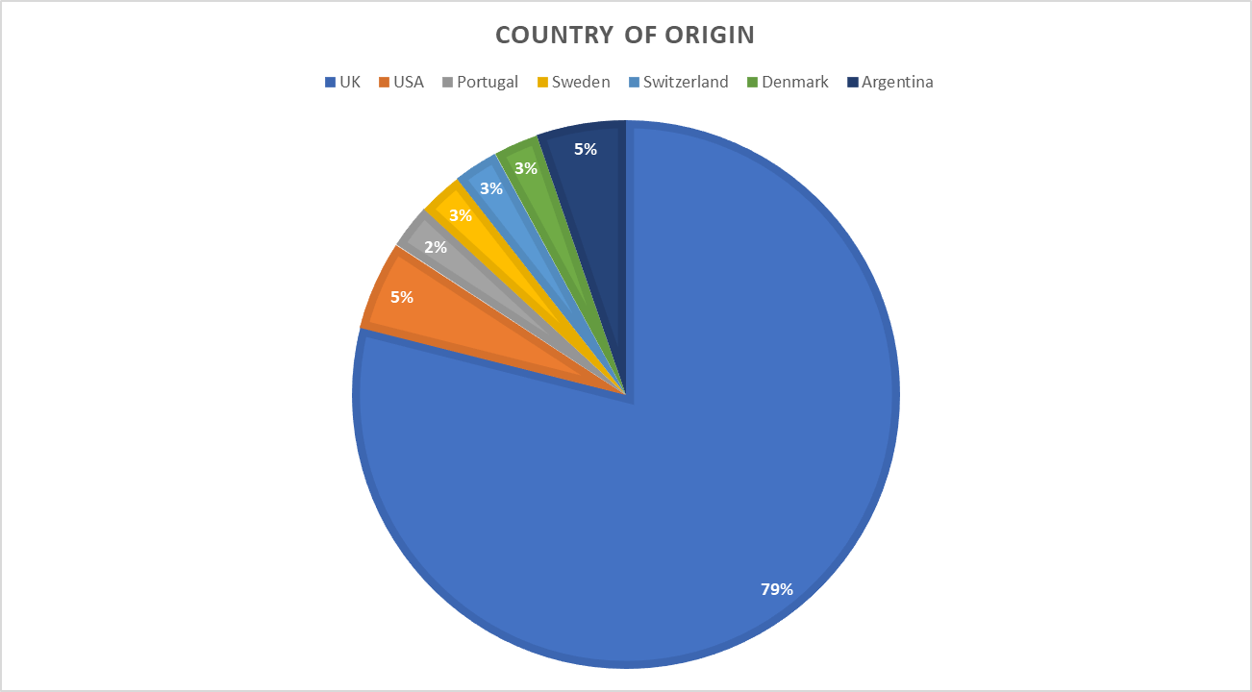

Inward investor leads attracted to CIOS are apportioned to the following industries and contribute to defining CTI’s prioritisation:

**2.7 Securing an inward investment**

Each prospective inward investor will be provided with a dedicated Trade & Investment Manager from the CTI team.

CTI’s client management includes the following:

* + 1. Understanding the client’s business, strategy and drivers
    2. Understanding the nature of the respective industry
    3. Establishing appropriate ‘fit’ in CIOS and business credibility
    4. Understanding competition from other UK or international regions
    5. Working with British Embassy and Department for Business and Trade (DBT) staff from country of origin to form clear pitch to the business
    6. Working with local network in CIOS to:
       1. assist with infrastructure and property requirements / queries
       2. providing a series of useful introductions (e.g. local government, industry organisations, business peers, potential collaboration partners, local supply chain businesses, local education providers, research organisations etc)
       3. propose potential funding opportunities, including local angel networks, investment funds, R&D funding, and grant funding opportunities
       4. establishing availability of local talent
       5. anything else which may assist with decision to locate, past examples include personal property searches, introductions to assist with business owner partner finding employment, local knowledge, information regarding local schools, etc!
    7. Assessing and verifying inward investment
    8. Aftercare to improve the likelihood of retention, productivity, and job creation

**3. Requirement for Lead Generation**

**3.1 CTI’s Lead generation approach**

CTI has always taken a targeted approach to lead generation, and the majority of leads have historically come from trade mission/DBT contacts overseas and procured lead generators.

Leads will be generated by the following activity:

1. Lead generator
2. Events
3. Marketing

**A: Lead generator:** The procured lead generator will be vital in securing high quality leads in key target sectors. They will be expected to work closely with the CTI team, providing additionality to other lead generation activities. (see requirement below)

**B: Events**: CTI will be attending international events and trade missions as part of ongoing organic lead generation.

C: **Marketing:** CTI will build on current campaigns and bespoke marketing activity. With contribution from the lead generator, CTI will define a clear inward investment offer, building on the years of successful support and utilizing strengths within the team, whilst also looking for new innovative ways of working. CTI will share all relevant information with the lead generation agency as part of ongoing collaboration.

**4. Requirement**

**The requirement is for the provision of lead generation services:**

* 1. Following appointment, compile a detailed lead generation proposal. This will follow a briefing from CTI, to include the tenderer’s approach, example client journey and lead quality matrix and scoring criteria (with advice from CTI and adhering to the criteria mentioned in [SPF output guidance](https://www.gov.uk/guidance/uk-shared-prosperity-fund-outputs-and-outcomes-definitions-2))
  2. Inward Investment – to quality check leads against CTI’s criteria and targets, make 2/3 initial introductions per month, with the inward investment work front loaded until October 2024.
  3. To provide 13 strong inward investor leads who could fulfil the [E23 output criteria.](https://www.gov.uk/guidance/uk-shared-prosperity-fund-outputs-and-outcomes-definitions-2)
  4. To have referred at least 6 inward investors who establish a base in CIOS, and have a credible strategy for growth and resulting job creation.
  5. Other key performance indicators will be agreed with the supplier during contracting stage and will be used to monitor the performance of the Contract.

**5. Budget**

The total maximum budget available for this commission is £70,000 (exc VAT) inclusive of all expenses.

**Responses that exceed the total budget will not be considered.**

The budget will be reviewed as part of the ITT evaluation detailed in Section 10 and will reflect the degree to which there is a saving on the maximum budget.

**6. ITT and commission timetable**

The timescale of the programme is from the date of signing the contract until the 28th February 2025. The timetable for submission of the response, completion of the programme are set out below in 6.1, with the timetable for the project set out in 6.2.

**6.1** Timetable for submission of the tender response

|  |  |
| --- | --- |
| **Milestone** | **Date** |
| Publication of ITT | 1 November 2023 |
| Final date for receipt of clarifications | 1700: 9 November 2023 |
| Final date for response to clarifications | 13 November 2023 |
| Deadline to return the Tender response to Cornwall Council | 1700: 22 November 2023 |
| Evaluation of Tender responses by CTI team | 23 – 24 November 2023 |
| Successful and unsuccessful tenders notified | Week commencing 27 November 2023 |
| Contract Issued | Week commencing 4 December 2023 |

**6.2** Timescale of Project

|  |  |
| --- | --- |
| **Milestone** | **Date** |
| Contract signed and project inception meeting | Week commencing 4December 2023 |
| Knowledge building of Cornwall’s inward investment offer and CTI service | December/January 2023/4 |
| First leads delivered to CTI | February 2024 |
| 75% of all leads delivered to CTI | October 2024 |
| Final 25% of all leads delivered to CTI | December 2024 |
| Project wrap up – share all information, current lead pipeline for Cornwall, and key stats. | January 2025 |
| End of Project | 28 February 2025 |

**7. General conditions**

* 1. Equality and Diversity (see also Enclosure 1)

Cornwall Council is committed to providing services in a way that promotes equality of opportunity. It is expected that the successful supplier will be equally committed to equality and diversity in its service provision and will ensure compliance with all anti-discrimination legislation. The supplier will be required to provide a copy of their Equality and Diversity Policies/Practices if successful in securing this contract.

* 1. Environmental Policy (see also Enclosure 1)

Cornwall Council is committed to sustainable development and the promotion of good environmental management. It is expected that the successful supplier will be committed to a process of improvement with regard to environmental issues. The supplier will be required to provide a copy of their Environmental Policies/Practices if successful in securing this contract.

* 1. Data Protection (see also Enclosure 1)

The contractor will comply with its obligations under Data Protection Legislation (DPL), being the UK Data Protection Legislation and the General Data Protection Regulation (GDPR) and any other directly applicable European Union legislation relating to privacy.

The supplier will be required to provide a copy of their Data Protection policy and privacy statement if successful in securing this contract

* 1. Conflict of Interest. Suppliers must provide a clear statement with regard to potential conflicts of interests. Therefore, please confirm within your ITT submission whether, to the best of your knowledge, there is any conflict of interest between your organisation and Cornwall Council that is likely to influence the outcome of this procurement either directly or indirectly through financial, economic or other personal interest which might be perceived to compromise the impartiality and independence of any party in the context of this procurement procedure.

Receipt of this statement will permit Cornwall Council to ensure that, in the event of a conflict of interest being notified or noticed, appropriate steps are taken to ensure that the evaluation of any submission will be undertaken by an independent and impartial panel.

* 1. Publicity – as a Shared Prosperity Funding project the tenderer needs to comply with all brand and publicity requirements as set out here: <https://www.gov.uk/guidance/uk-shared-prosperity-fund-branding-and-publicity-6>

**8. ITT submission requirements**

Please include the following information in your ITT submission.

**8.1** Covering letter (two sides of A4 maximum) to include:

1. A single point of contact for all contact between the supplier and Cornwall Council during the ITT selection process, and for further correspondence
2. Confirmation that the supplier has the resources available to meet the requirements outlined in this brief and its timelines.
3. Confirmation that the supplier has Equality and Diversity, Environmental and Data Protections policies are in place and, if successful, supporting documentation will be provided as evidence
4. Confirmation that the supplier holds current valid insurance policies as set out in Enclosure 1, if successful, supporting documentation will be provided as evidence
5. Conflict of interest statement
6. If you are the successful supplier you agree to the terms and conditions in Cornwall Council’s standard consultancy agreement/terms and conditions by signing the agreement/terms and conditions. (Enclosure 1)

**8.2** Response required to meet Section 4. The tenderer should provide a detailed proposal outlining the following:

1. Agency Overview: Provide an overview of your agency's experience and expertise in lead generation.
2. Strategy and Approach: Outline your proposed strategy and approach for Lead Generation for CTI, in line with our requirements and strategy as set out within this specification.
3. Team and Resources: Describe the key team members who will be dedicated to this project and their relevant experience. Also, highlight any additional resources, partnerships or subcontracting arrangements that will support the successful execution of the project.
4. Case Study: Provide 2 case studies of a similar project you have undertaken, highlighting the strategies employed, outcomes achieved, lessons learned and any references. (Max 1000 words per example (links ONLY to websites relevant to the case studies will be considered)
   1. Budget

**9. ITT clarifications**

Any clarification queries arising from this ITT which may have a bearing on the offer should be raised by email to: [info@cornwallti.com](mailto:info@cornwallti.com) in accordance with the ITT and Commission Timetable in section 6.1.

Responses to clarifications will be anonymised and uploaded to Contracts Finder in accordance with the ITT Timetable.

No representation by way of explanation or otherwise to persons or corporations tendering or desirous of tendering as to the meaning of the ITT, contract or other ITT documents or as to any other matter or thing to be done under the proposed contract shall bind Cornwall Council unless such representation is in writing and duly signed by a Director/Partner of the supplier. All such correspondence shall be returned with the ITT Documents and shall form part of the contract.

**10. ITT evaluation methodology**

Each ITT response will be checked for completeness and compliance with all requirements of the ITT. ITT responses will be evaluated to determine the most economically advantageous offer taking into consideration the award criteria.

**ITT returns will be assessed on the basis of the following ITT award criteria**

|  |  |
| --- | --- |
| Ref 8.1 Covering Letter |  |
| Acceptable covering letter including confirmation of the requirements detailed at 8.1. | Pass/ Fail |
| Ref 8.2 Proposal | Marks |
| Proposal – To meet section 8.2 Sections a,b,c,d will all be scored out of 20 available marks per section. (totalling 80). | 80 |
| Ref 8.3 Budget | Marks |
| A **fixed fee** for this work (exc. VAT) including travel and other expenses.  The lowest bid will be awarded the full 60marks. Other bids will be awarded a mark that is proportionate to the level of their bid in comparison to the lowest bid i.e., Marks awarded = 20 x lowest bid/bid. | 20 |

**11. Assessment of the ITT**

The reviewer will award the marks depending upon their assessment of the applicant’s ITT submission using the following scoring to assess the response:

|  |  |  |
| --- | --- | --- |
| **Scoring Matrix for Award Criteria** | | |
| Score | Judgement | Interpretation |
| 100% | Excellent | Exceptional demonstration of the relevant ability, understanding, experience, skills, resource and/or quality measures required to provide the goods/works/services. Full evidence provided where required to support the response. |
| 80% | Good | Above average demonstration of the relevant ability, understanding, experience, skills, resource and/or quality measures required to provide the goods/works/services. Majority evidence provided to support the response. |
| 60% | Acceptable | Demonstration of the relevant ability, understanding, experience, skills, resource and/or quality measures required to provide the goods/works/services, with some evidence to support the response. |
| 40% | Minor Reservations | Some minor reservations of the relevant ability, understanding, experience, skills, resource and/or quality measures required to provide the goods/works/services, with little or no evidence to support the response. |
| 20% | Serious Reservations | Considerable reservations of the relevant ability, understanding, experience, skills, resource and/or quality measures required to provide the goods/works/services, with little or no evidence to support the response. |
| 0% | Unacceptable | Does not comply and/or insufficient information provided to demonstrate that there is the ability, understanding, experience, skills, resource and/or quality measures required to provide the goods/works/services, with little or no evidence to support the response. |

During the ITT assessment period, Cornwall Council reserves the right to seek clarification in writing from the suppliers, to assist it in its consideration of the ITT. ITTs will be evaluated to determine the most economically advantageous offer taking into consideration the award criteria weightings in the table above.

Cornwall Council is not bound to accept the lowest price or any ITT response. Cornwall Council will not reimburse any expense incurred in preparing ITT responses. Any contract award will be conditional on the Contract being approved in accordance with Cornwall Council’s internal procedures and Cornwall Council being able to proceed.

**12. Award**

Any contract awarded as a result of this ITT process will be in accordance with the attached Cornwall Council standard terms and conditions (see Enclosure 1).

**13. ITT returns**

Please submit the ITT response in accordance Section 6.1 by email to

[gpi@cornwall.gov.uk](mailto:gpi@cornwall.gov.uk)

with the following wording in the subject box:

“ITT response to Lead Generation Tender -[enter your company name here] Strictly Confidential”

Suppliers are advised to request an acknowledgement of receipt when submitting by email.

**14. Disclaimer**

The issue of this documentation does not commit Cornwall Council to award any contract pursuant to the ITT process or enter into a contractual relationship with any provider of the service. Nothing in the documentation or in any other communications made between Cornwall Council or its agents and any other party, or any part thereof, shall be taken as constituting a contract, agreement or representation between Cornwall Council and any other party (save for a formal award of contract made in writing by or on behalf of Cornwall Council).

Suppliers must obtain for themselves, at their own responsibility and expense, all information necessary for the preparation of their ITT responses. Information supplied to the suppliers by Cornwall Council or any information contained in Cornwall Council ’s publications is supplied only for general guidance in the preparation of the ITT response. Suppliers must satisfy themselves by their own investigations as to the accuracy of any such information and no responsibility is accepted by Cornwall Council for any loss or damage of whatever kind and howsoever caused arising from the use by suppliers of such information.

Cornwall Council reserves the right to vary or change all or any part of the basis of the procedures for the procurement process at any time or not to proceed with the proposed procurement at all.

Cancellation of the procurement process (at any time) under any circumstances will not render Cornwall Council liable for any costs or expenses incurred by suppliers during the procurement process.

**15. Enclosures**

1. Cornwall Council’s standard consultancy agreement/terms and conditions.