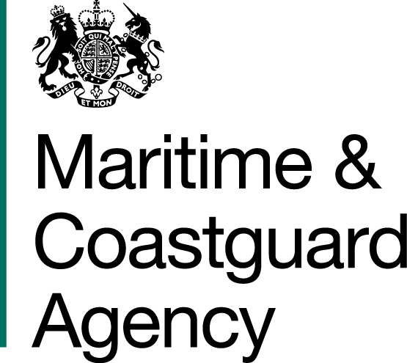 |  |  | Bay 3/21  Spring Place  105 Commercial Road  Southampton  SO15 1EG
 | To whom it may  Concern, |  | Tel:  E-mail: | +44 (0)20 381 72173  contracts@mcga.gov.uk
 |  |  | Your ref:  Our ref: |  | TCA 3/7/706
 |  |  | 8th December 2017

INVITATION TO TENDER FOR Contract for the Storage, Maintenance and Deployment of the United Kingdom’s Counter Pollution Equipment Stockpile

You are invited by the Secretary of State for Transport (from now on referred to as "the Authority") to submit a tender for the above contract.

One original and one copy (so marked) of your tender and proposals, including any covering letter, will be required. Your Tender Price should be entered onto the Price Schedule included within the documentation.

Tenders must be delivered by 11.00 hours on 13th February 2018

Late tenders will not be accepted and it is your responsibility to ensure that your tender is received on time.

A site visit to view the equipment at our Barnsley base will be a available on the 5th January 2018 if you would like to attend please contact contract@mcga.gov.uk by the 3rd January 2018.

Tenderers are welcome to ask questions about any aspect of the procurement process. Such queries should be addressed to the Procurement Team at contracts@mcga.gov.uk, and should contain the reference number or title of the contract. The deadline for submission of queries is 17:00 31st January 2018.

As part of your tender you should supply the following:-

- The MCA’s Form of Tender, signed and dated by an authorised representative of the tendering organisation;
- The MCA’s provided Price Schedule;
- An outline description of how the tenderer will meet the requirements of the MCA.

SHOULD YOU BE SUCCESSFUL, THESE DOCUMENTS AND ANY SUBSEQUENT CORRESPONDENCE BETWEEN YOU AND THE DEPARTMENT WILL FORM A BINDING CONTRACT BETWEEN YOU AND THE AUTHORITY.

Please read all the documents listed in the Form of Tender. To ensure that all tenderers have access to the same information you can only obtain further information about contractual issues and Technical Information from me (The Contract Officer). All requests must be submitted in writing to me at the above e-mail address.

Yours sincerely,

Richard Skeats MCIPS
MCA Procurement Team

