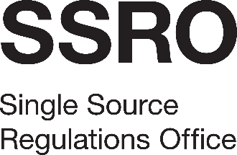

Structure review support
Appendix 5: Statement of Conduct
[Name of Bidder]

To the SSRO:
On behalf of [Name of Bidder], of [Address] (“the Bidder”) –
    - We recognise that the essence of competitive tendering is that the SSRO receives bona fide competitive tenders from all persons tendering. We therefore certify that this is a bona fide tender and that we have not fixed or adjusted the amount of the tender or our price by or in accordance with any agreement or arrangement with any other person.
    - We certify that the we have not done and undertakes not to do at any time before the deadline for the return of this tender any of the following acts:
      - communicate to any person other than the SSRO the amount or approximate amount of our proposed tender, except where the disclosure, in confidence, of the approximate amount is necessary to obtain any insurance premium quotation required for the preparation of the tender;
      - enter into any agreement or arrangement with any other person that he or she shall refrain from submitting a tender or as to the amount included in the tender; or
      - offered to pay or given or agreed to pay or give any sum of money, inducement or valuable consideration directly or indirectly to any person doing or having done or causing or having caused to be done, in relation to any other actual or proposed tender for the contract any act, omission or thing of the kind described above.
    - We certify that we, including any of our team, have not committed any offence or engaged in any conduct such as would disqualify us from being awarded a contract under the Public Contracts Regulations 2015.
    - In this certificate, the word “person” shall include any person, body or association, corporate or unincorporated; and “any agreement or arrangement” includes any such information, formal or informal, whether legally binding or not.

……………………………………………........
Signature (duly authorised to sign tenders on behalf of the Bidder)
Print name:
Date:

