

**STATEMENT OF SERVICE REQUIREMENTS FOR **** Capital Purchase via competitive tender process of a replacement autoclave (stem sterilizer)**

**1. NAME OF DIRECTORATE/DIVISION - SCIENCE DIVISION**

The Health and Safety Executive (HSE) is a Crown non-departmental public body with specific statutory functions in relation to health and safety. It is appointed by the Secretary of State for Work and Pensions and employs around 3500 staff including policy advisers, inspectors, technologists and scientific and medical advisers. HSE’s job is to prevent people being killed, injured or made ill by work.

HSE consists of a governing Board comprising of a Chair and nine non-executive members, all of whom are appointed by the Secretary of State for Work and Pensions after consultation with organisations representing employers, employees, local authorities and others, as appropriate. HSE comprises various directorates and groups and is led by a senior management team. HSE`s Science & Research Centre is part of HSE`s Science Division. HSE works from over 30 locations throughout Great Britain.

The Science and Research Centre is Britain's leading industrial & occupational health and safety research facility. Science Division supports HSE’s mission to protect the health and safety of the national workforce by ensuring risks in the workplace are adequately controlled.

Science Division employs circa 420 people including scientists, engineers, psychologists, social scientists, health professionals and technical specialists. Its capabilities encompass a wide range of topics including: fire, explosion and process safety; human factors and risk assessment; occupational and environmental health; safety engineering; work environment; and specialist photographic and technical services.

Services Include:

* Research and development
* Specialist advice and consultancy
* Forensic investigation into the causes of accidents
* Environmental and biological monitoring
* Assessment of levels of risk and investigation of their control
* Establishing realistic requirements for standards, and processes or meeting those standards
* Validation and certification
* Training

1.5 To deliver these services Science Division has advanced facilities that range from high power computers for modeling and analysis, well equipped laboratories covering biomedical, occupational hygiene and environmental work to unique facilities for large scale experiments in the areas of engineering, fires, explosions and process safety.

1.6 More information is available from our website: [www.hsl.gov.uk](http://www.hsl.gov.uk)

**2. BACKGROUND TO THE PROJECT**

The Biohazards team at HSE’s laboratory in Buxton, Derbyshire need to replace a 22 year old floor standing autoclave that has recently been decommissioned and is no longer fit for purpose.

The replacement item is required for the sterilization of ‘clean’ instruments and liquid culture media for sterile microbiological procedures. In addition, it is a regulatory requirement that the team autoclave biohazardous waste - for safety reasons - and this autoclave – one of two at the site - provides an important backup to the larger main autoclave, and for when work generates more biohazardous waste than one autoclave can reasonably handle.

The new autoclave will require delivery and installation by the supplier and will be located in the HSE Buxton laboratory block (autoclave room, L.2.24). The equipment will need to be delivered directly to that room by the supplier on an agreed date for installation.

The delivery will require contractor engineering input for installation purposes (to be included in quotation) and will also require HSE’s on-site Interserve Facilities Management engineering assistance/oversight to ensure that building services are available and appropriate for the item to be plumbed in to water supply and drainage etc. These utilities should already be available as the old autoclave also required similar connectivity.

The autoclave must meet all UK pressure vessel and electrical safety standards and because HSE Buxton must treat hazard group 3 microbiological waste **the autoclave must be capable of routinely treating bagged biohazard waste at 131oC for up to 1 hour.**

**3. SCOPE OF THE SERVICES REQUIRED**

The purchased item must be a floor standing autoclave (steam sterilization) system that will be located in a dedicated wash/autoclave room at HSE, Buxton, Derbyshire (SK17 9JN). Space within the autoclave room is limited, requiring the installation of a compact system (see images of system to be replaced, below; this is also where the new system will be located). Steam/odour extraction is already in place above the system and the **maximum** available footprint for this floor standing system beneath the LEV is likely to be: 1.0 m x 1.25 m.

**NB. This includes any space required to the side of the autoclave to permit lid opening if a top loading, swing open lid is present.**

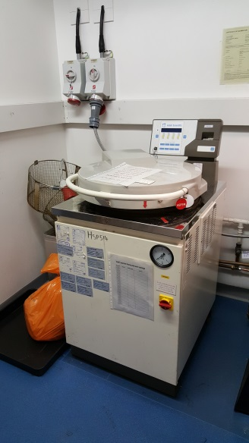 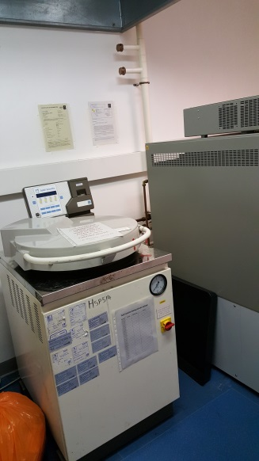

In addition:

1. The internal (pressure vessel volume) of the autoclave needs to be of the following minimum dimensions in order to accommodate existing autoclave bins that we use for standard waste processing in both our current autoclaves:

* Steam chamber width (if rectangular/square) or diameter (if cylidrical) - needs to be at least 45 cm wide
* Steam chamber depth - needs to be at least 58 cm deep

1. The supplied autoclave MUST have a vacuum facility to ensure treatments of bagged/packaged items.
2. The supplied autoclave must be able to treat hazard group 3 microbiological waste so the autoclave must be capable of routinely treating bagged biohazard waste at 131oC for up to 1 hour to satisfy our on-sire requirements in this respect.
3. The autoclave will fall under pressure vessel regulations and will therefore require routine independent checks from new (thereafter usually annually as a minimum). Manufacturer conformity certification must be provided at the point of installation to allow us to satisfy pressure vessel regulations.
4. The autoclave must be CE approved for electical use within the UK and be able to run from an appropriate UK power supply (the old autoclave runs on a 3-phase, 415v supply).
5. The autoclave must be capable of thermal load validation and must have a printout capability to record the temperatures of each treatment cycle (as a minimum); we apppreciate that some modern systems have USB connectivity for thermal cycle data download but this is not essential.
6. The machine must be capable of at least two load treatments during an avaerage 8 hr shift period (including cooling time).
7. The delivery will require contractor engineering input for installation purposes (to be included in quotation); liaising with on-site facility provider IFM.
8. Is the potential supplier able to take our old Astell autoclave (1997; model ASA260) as a traded in / part exchange, to include its removal from site?
9. If no part exchange arrangement is available, could the supplier dispose of the old autoclave? (Please provide a price if a charge is made for this).
10. Please include in your submission information about the steam capture/drainage provision for the system, in particular with regards microbiological safety. This is important since this autoclave will be used as a backup to process infectious microbiological waste.
11. Can the supplier please provide a price for years 2 and 3 for an on-site parts and labour maintenance contract, as this will be required going forwards - we assume year 1 will be covered by a full manufacturer parts and labour warranty.
12. Some instruction will be required for HSE users to allow them to use the installed equipment safely – please ensure the quotation includes this.
13. **For budgetary reasons the system must be delivered and installed on site at HSE Buxton by 31st March 2020.**

4. **GOVERNANCE AND PERFORMANCE MANAGEMENT ARRANGEMENTS**

**Management Information (MI)**

Detail HSE’s MI requirements, include: the range of information required, the format(s) in which it is required; the frequency at which it must be provided and the timeframe(s) for its provision i.e. within five working days of the end of each calendar month.

**For budgetary reasons the system must be delivered and installed on site at HSE Buxton by 31st March 2020. This is essential and none negotiable.**

**Service levels and Key Performance Indicators**

Consider whether it is appropriate to implement a Service Level (SL) and/or Key Performance Indicator (KPI) regime and detail any SLs or KPIs which will be applied to the contract and used to evaluate successful delivery. Include details of the proposed monitoring and ‘penalty’ regimes.

The autoclave must be provided with a minimum of 1 year full manufacturer parts and labour warranty.

Can the supplier please also provide a price for years 2 and 3 cover for an on-site parts and labour maintenance contract, as this will be required going forwards

**Issue and complaint resolution**

Autoclaves do break down and we require clear process instructions please for who to speak to if this occurs; also an indication of typical response time for maintenance engineers to attend site in Buxton.

**5. QUESTION SET AND EVALUATION CRITERIA**

Please also refer to the Scope of Services Required section.

Bidders should provide the following details within their tender submission:-

* Full specification of the proposed machine, along with details of the on-board control system (where relevant).
* Details of the design and dimensions of the machine (e.g. lid opening type, pressure vessel shape, power/steam/water connectivity requirements) and any accessories included in the price, along with the required maintenance level and frequency.
* Please confirm that the machine can be delivered to HSE’s Science Division in Buxton, HSE Science and Research Centre, Harpur Hill Business Park, Harpur Hill, Buxton, Derbyshire, SK17 9JN
* Please provide details of any assistance that may be required on the delivery of the machine;
* Anticipated delivery dates or required lead in time;
* Options for additional warranty periods i.e. on-site maintenance cover (e.g. gold/silver/bronze and the difefernces between them).
* Preference will be given to UK suppliers.
* Please provide details of the user training package, along with details of the supplier’s staff that will undertake the training.
* Details of the size of the machine and confirmation that it will fit in the space that HSE has – 1.0 m x 1.25 m
* Full costings, broken down to show:-
* Machine costs (to include vacuum air removal facility);
* Delivery costs;
* Installation costs; and
* On-site training costs (and duration of training provided).
* Any other expected costs that will contribute to the overall price

As stated in the Introduction the information provided in this document will be used by PU to develop a question set and the evaluation criteria. However as the contract owner you are likely to have a greater understanding of what is important in terms of delivery and you will be required to articulate this to inform the process. Provide details below of what you consider to be important in the context of this contract.

**6. ADDITIONAL INFORMATION AND CONSIDERATIONS**

**Contract period**

**For budgetary reasons the system must be delivered and installed on site at HSE Buxton by 31st March 2020.**

One year parts and labour one year warranty required as a minumum + price please for years two and three for similar cover (with alternative levels of cover and respective prices if available).

When do you want the contract to start?

Detail how long you wish to put the contract in place for, including any proposed extension options.

Do you require any specific contract termination provisions to be built in?

Provide details of the budget allocated for the proposed work, or an indication of the anticipated spend.