December 2021

Dear Sir or Madam,

**Re: Planned Works to South Lodge and Mess room on behalf of Chorleywood Parish Council.**

Please find enclosed the Tender documentation for the above project:

1. The Schedule Of Works
2. The Ecal schedule of works for services
3. Current planning drawings
4. Form Of Tender

The tender return date is 24th January 2022 at 12pm and is to be returned by post with the enclosed envelope to the clerk of the council at:

Clerk of the Council

South Lodge,

Rickmansworth Rd,

Chorleywood,

Rickmansworth

WD3 5SL

To arrange access, please contact Yvonne Merritt on 01923 285594. Please note that failure to return the tender at the prescribed time and date will preclude you from the tendering process.

Should you have any queries regarding the works schedule, please contact me on 07821060668 from 4th January 2022 onwards.

Yours sincerely

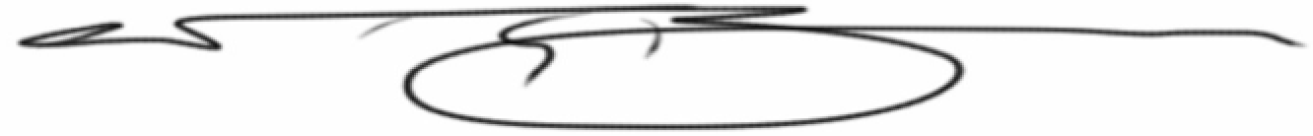

Nicholas Brown BSc (Hons) FRICS

Ashridge Surveyors Ltd