

**HINTON PARISH COUNCIL**

**C/O 9 new Street**

**Newtown**

**Berkeley**

**Glos GL13 9NN**

**Tender Invitation**

Tenders are invited from suitable experienced companies for the replacement or refurbishment half pipe at the play are, Oldminster rd. Sharpness, GL3 9NA. What three words Adventure.snipe.skills

**Location- Hinton is a Parish in the Berkeley Vale**, consisiting of Sharpness, Hinton & Purton. It is approx 8 miles from Junction 14 M5

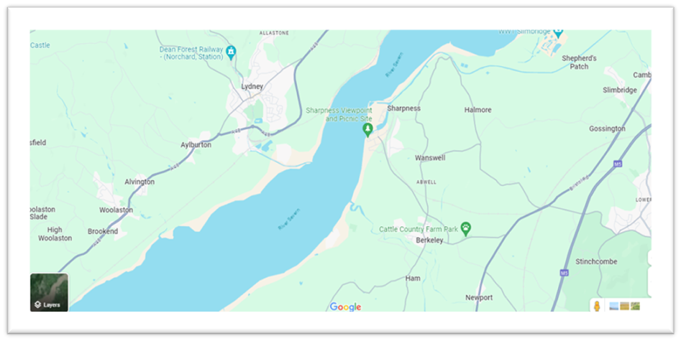

**Introduction**- Hinton Parish Council are seeking tenders for the installation of a new or refurbishment of the half pipe unit at their play area in Oldminster Rd, Sharpness GL13 9NA. The current surface of the play area is tarmac.

**Budget**- The Council has a small amount of funds in reserves and has sort funding through other bodies resulting in a total of £25,000 - £30,000 (Ex VAT) for the project. All pricing should be exclusive of VAT and in GBP (£). Pricing should be valid for a minimum of 90 days from the due date of the response. Prices will be fixed for the duration of the contract.

**The scope-** of this project is to install a new or refurbished halfpipe unit, to replace the original on like for like in size. All works should comply to the British and European Standard for playground equipment BS EN 1176. The contractor will be responsible for organising an independent post-installation inspection and rectifying any issues identified at their own cost. Bidders are allowed to submit a maximum of two different options to allow for design variations

**Specification** - The new OR refurbished half pipe should meet the following specifications:

* Unit to meet BS EN 1176
* Unit will not contain any toxic materials or contain any chemicals that could leak out in contact with children
* The unit height will not exceed the highest point of the original half pipe
* Cost to include removal and disposal of old halfpipe
* All damages will be paid for by the contractor

**Scoring**- Scoring Bidder responses will be scored against the following criteria:

* Price 40%
* Material/Life Span 30%
* Play value & compliance with the brief 30%

**Insurance** -The preferred Bidder must provide evidence of Public Liability Insurance of no less than £5 Million, Employers Liability Insurance of no less than £5 million and Professional Indemnity insurance of no less than £5 million to the Parish Council within the response.

**Tender Timescales**-

* Tender Live: July 18th 2024
* Tender Returns: August 20th 2024 12pm
* Preferred Bidder Announcement: Tuesday 27th August 2024

Work to be completed as soon as possible, subject to lead in time for delivery on Half pipe unit. Bidders must provide a suitable Point of Contact (PoC) for clarification questions during the period between the Tender Return and Preferred Bidder Date; and bidders must also provide a PoC for the preferred Bidder announcement if different.

Clarifications & queries must be addressed to: Parish Clerk [clerk@hinton-pc.gov.uk](mailto:clerk@hinton-pc.gov.uk)

Bidder tender returns should be emailed to [clerk@hinton-pc.gov.uk](mailto:clerk@hinton-pc.gov.uk)

**Site Meetings** If you would like to arrange a site meeting with a member of the Parish Council, please email clerk@hinton-pc.gov.uk

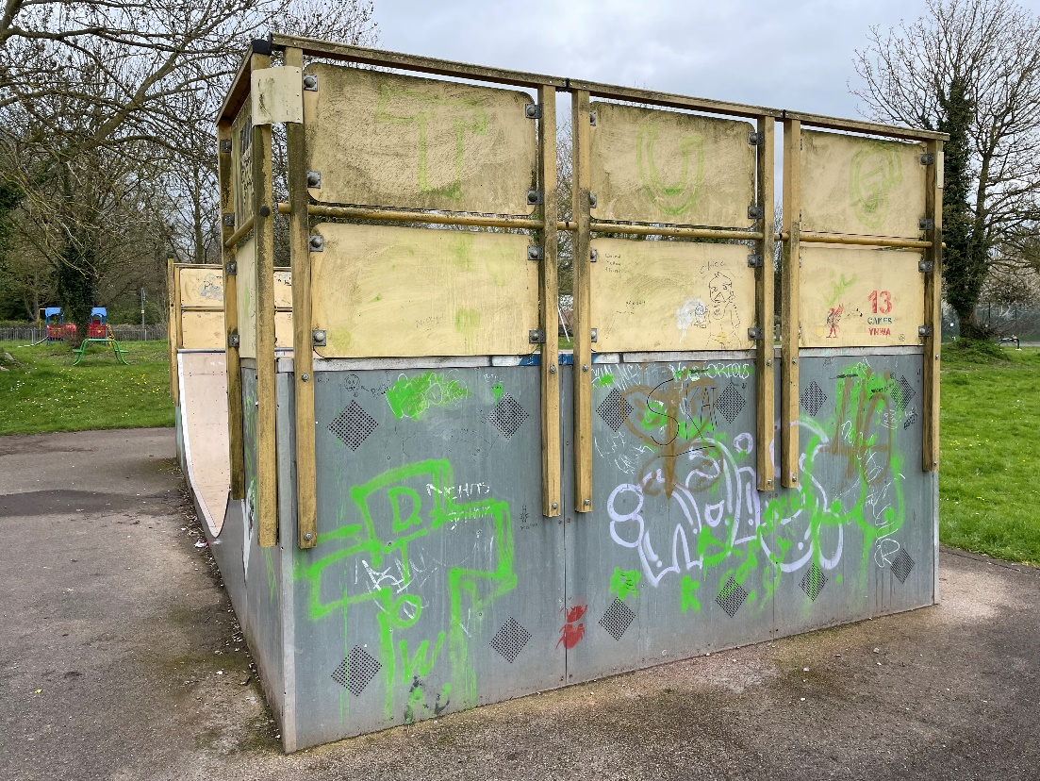

**H 2700mm**

**W 3700mm**

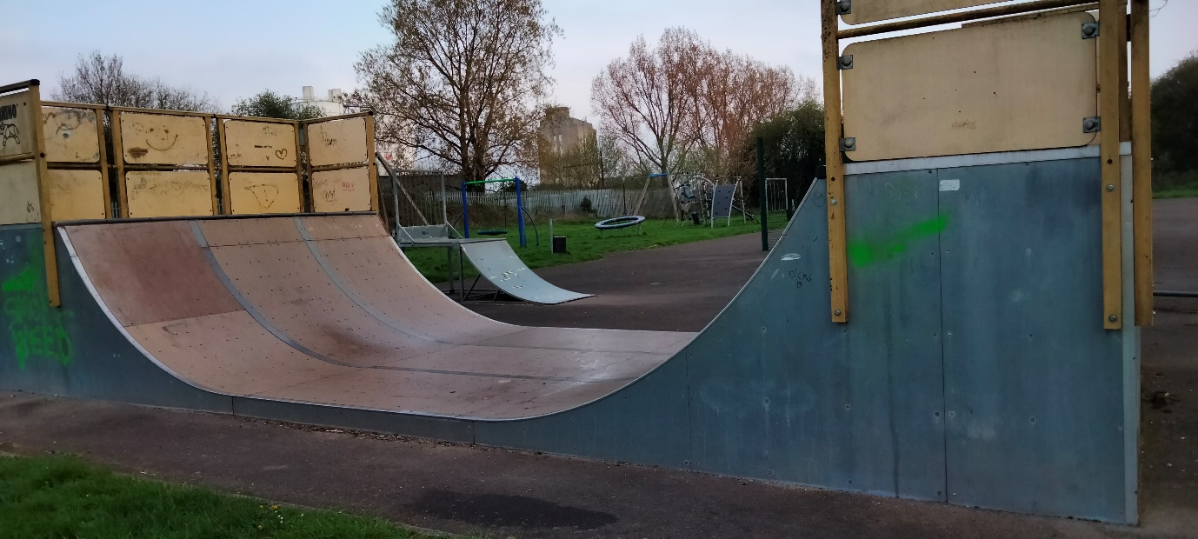

**L 9000mm**