

**INVITATION TO TENDER [ITT]**

**Version 4 [09 Oct 2023]**

**PROPOSED SERVICES – to supply; deliver and commission two Thermal Stores for a decarbonisation project at Shuttleworth College; Old Warden Park; Biggleswade; Bedfordshire; SG18 9DX**

**1.0 Introduction**

Bedford College is seeking a **fixed price tender** to supply; deliver and commissioning two thermal Stores.

Tender should include the following.

1. Provide two Thermal Stores in accordance with specification/drawing [PANDA CE; see files – 02-15 M-DE-03 P00 Thermal stores & 02-15 SPC-M-THST T00 Thermal stores
2. Deliver the units to Shuttleworth College; Old Warden Park; Biggleswade; Bedfordshire; SG18 9DX [see location plan below]. **Please note – all deliveries must be made via the Shuttleworth Access Road from the B658**

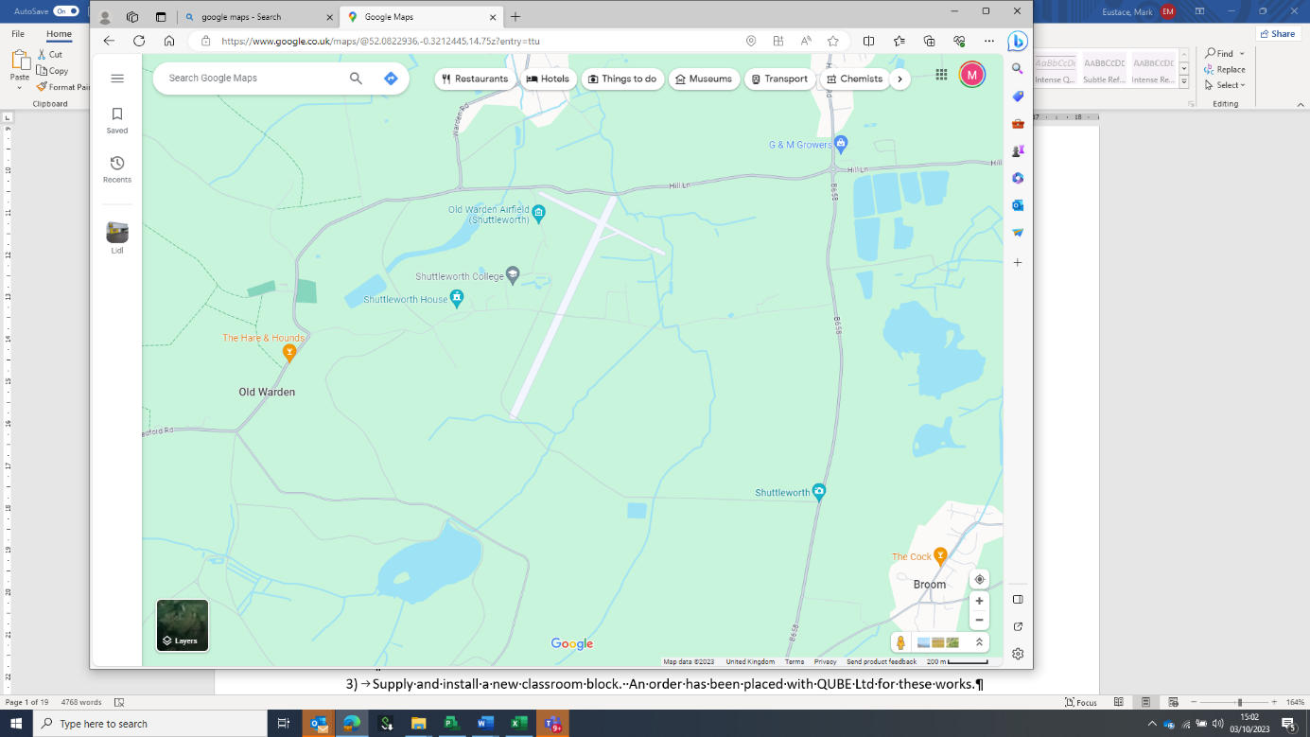

Access to Shuttleworth College from B658

Delivery Location

Location Plan

1. Provide O&M information.

The project is fully funded and supported via a government SALIX grant.

The College campus and Shuttleworth estate will be fully operational for the entire duration of the project. Learners will be present in buildings and land adjacent to the site area during the works. Shuttleworth College is live work area that provides facilities for animal management; horticulture and agricultural studies.

Bedford College have appointed a team of consultants [see V3 PROJECT DIRECTORY 03 Oct 2023] who are delivering the project up to the handover to the turnkey contractor. The consultant team are working on the project under the employment of Bedford College.

Mark Eustace [Capital Works Project Manager - CWPM] will be the main point of contact and the sole source for answering questions and queries during the tender [**via email only** - [*meustace@bedford.ac.uk*](mailto:meustace@bedford.ac.uk)*]*

The key dates for the project are set out below in Table A.

|  |  |
| --- | --- |
| *Project Milestone* | *Key Date/Duration* |
| Release tender information – | Tuesday 10 Oct 2023. |
| Tender period | 3 weeks |
| Return the second stage tender | *12:00 on Monday 31 Oct 2023*  ***NOTE: the tender return shall be via email only*** *to tenders@bedford.ac.uk* |
| Tender award | Monday 06 November 2023. |
| Delivery | Monday 01 April 2024 |

Table A – *Key Project Milestones*

Please note that Bedford College is seeking a project specific equipment supply submission that takes full account of the project information and the nature of the client. Generic bid submissions that take no account of the ITT will be ruled invalid.

Any quote for the supply of the equipment will be deemed to include supply; delivery & commissioning in line with agree timetable [see Table A].

**2.0 Tender Information.**

The specification for the tender is set out in *02-15 SPC-M-THST T00 Thermal stores*

The quote [unless agreed by Bedford College] shall be in full accordance with the specification

**3.0 Health and Safety & Asbestos**

All delivery staff shall always wear steel toe cap boots or shoes and clean branded hi-vis vests/jackets. The use of site hats will be subject to the method statement and RAMS.

Smoking will only be permitted in pre-agreed areas outside of the working area. The workforce shall not interact at any time with customers; members of the public, Willow Place staff, or visitors.

**See Appendix 1**- Pre-Construction Client Information [In accordance with the CDM Regulations 2015]

**4.0 Pricing Schedule & tender return**

Please include the following information in your offer letter on headed paper.

1. Prices in accordance with the Contract Sum Analysis *see below* [excluding VAT]. Please include the CSA table.
2. Delivery charge
3. Documentation
4. Delivery date from receipt of order
5. Warranty period
6. Payment terms

**Contract Sum Analysis**

|  |  |  |
| --- | --- | --- |
| *Item* | *Notes & Comments* | *Cost* |
| Supply 2nr. – Thermal Stores | See specification/Drawing - 02-15 M-DE-03 P00 Thermal stores & 02-15 SPC-M-THST T00 Thermal stores |  |
| Delivery to Shuttleworth College | Lifting and unloading by others |  |
| O&M manuals and | Allow to supply 2 hardcopies |  |
| Warranty | State period of coverage |  |

**5.0 Tender Instructions & validity**

1. Tenders must be returned via email to [tenders@bedford.ac.uk](mailto:tenders@bedford.ac.uk). **[See note 4 below]**
2. The tender offer shall be presented on headed paper.
3. Please ensure you allow sufficient time to submit the documents/quote/CSA prior to the deadline of 12:00 on Monday 31 October 2023
4. Late tenders [or quotes sent to the wrong email address] shall be excluded from consideration.
5. All queries during the tender process shall be submitted in writing [via email] to Mark Eustace meustace@bedford.ac.uk
6. The proposal shall remain in force for a minimum of 30 days from the date fixed for the submission.
7. In submitting the proposal, the contractor shall undertake that, in the event of the submission being accepted by the College, within 30 days of being called upon to do so by the Principal or Authorised Officer on behalf of the College, the contractor will execute a formal contract.
8. Proposals shall only be submitted on the basis that they are bona fide competitive submissions.

a) shall have offered or given or agreed to give any officer or member of the College staff any gift or consideration of any kind as an inducement or bribe to influence its decision.

b) shall have communicated to any other person than the College the amount or approximate amount of the proposed submission other than in confidence in order to obtain quotations necessary for the preparation of the submission, or for insurance purposes, or

c) shall have entered into any agreement or arrangement with any person as to the amount of any proposed submission or that person shall refrain from submitting.

1. The College will exclude bidders at any time throughout the tender process should the grounds of exclusion pursuant to Public Contracts Regulations 2015 as amended be found to apply.

Please note that tenders should not be copied or submitted to any other email address. The College reserves the right to exclude any tenders that are not submitted in line with the ITT.

**6.0 Acceptance of Submission**

1. The College shall not be under any obligation to accept any proposal.
2. The College shall not be under any obligation to accept the lowest proposal.
3. The College reserves the right to cancel the entire or parts of the tender, without such an action conferring any right to compensation on the contractors.
4. At no time should the contractor, prior to submitting or following the bid submission, communicate with any person within the College in the first instance other than Mark Eustace. Failure to abide by this ruling could disqualify the contractor’s proposal from being considered.
5. The submission must be based upon the terms, conditions and specification(s) set out in these documents, otherwise it may be rejected because of being unsuitable and non-compliant.  The Form of Tender may not be modified in anyway.
6. Contractors will be notified of the outcome of their submission at the earliest possible time.
7. No submission will be deemed to have been accepted unless such acceptance has been notified to the contractor in writing.
8. In case a submission is abnormally low or high in relation to the services to be provided, the College will request a clarification in writing and/or explanation concerning its elements.  The College reserves the right to exclude a submission, if after a verification process based on the explanations and evidence received it concludes that the submission is abnormally low or high.

**7.0 Payment Terms**

Bedford College terms are that each month’s invoices will normally be settled within 28 days. All invoices should be submitted electronically to the finance department using the email address *finance@bedford.ac.uk* quoting a valid purchase order number. Should any offer vary from the standard College payment terms then this must be agreed in writing by the Capital Works Project Manager prior to the purchase order being issued.

**8.0 Project Team**

The core project team members are identified below.

|  |  |  |  |
| --- | --- | --- | --- |
| Diane Gamble | Bedford College | Director of Estates and Facilities | [dgamble@bedford.ac.uk](mailto:dgamble@bedford.ac.uk) |
| Mark Eustace | Project Management Solutions | Capital Works Project Manager | [meustace@bedford.ac.uk](mailto:meustace@bedford.ac.uk) |
| Stuart Devonshire | Devonshire Architects | Principal Designer; design team leader and Architect | stuart@devonshirearchitects.co.uk |
| John Paul Cain | Panda CE | Mechanical & Electrical consultant | [jp@pandaces.co.uk](mailto:jp@pandaces.co.uk) |

**9.0 Tender Scoring**

Bedford College and the project team will be applying a technical/financial evaluation to determine the tender.

The tender evaluation will determine the most compliant, comprehensive and cost-effective offer.

The consultant team will review the priced schedule to determine the basis of each tender. In some cases, this may result in the request for clarification or further information to satisfy the client team that the cost is offered on a full “like for like “basis.

**APPENDIX 1**

Pre-Construction Client Information – Shuttleworth College; Old Warden Park; Biggleswade; Bedfordshire; SG18 9DX.

Pre-Construction Client Information [In accordance with the CDM Regulations 2015]

|  |  |
| --- | --- |
| Version | 6.0 |
| Date | 03 Oct 2023 |
| Author | Mark Eustace |
| Checked By: | Diane Gamble |

|  |  |
| --- | --- |
| Description of the project | Site address – Shuttleworth College; Old Warden Park; Biggleswade; Bedfordshire; SG18 9DX  The works will comprise of the supply and commissioning of two ASHP. |
| [Key dates](http://www.designingbuildings.co.uk/wiki/Key_dates). | Works are planned to be carried out between 01/04/24 and 10/06/24. |
| Contact details [and roles] for the key college team | *College Project Manager [Primary Contact]*  Mark Eustace  [meustace@bedford.ac.uk](mailto:meustace@bedford.ac.uk)  07977 123039  *On Site Contact on behalf of Bedford College*  Chris Jones  [Cjones@bedford.ac.uk](mailto:Cjones@bedford.ac.uk)  Shuttleworth College Facilities Co-Ordinator |
| Principal Contractor; supervision and the operation of the works. | Bedford College will be fulfilling the role of Client/Employer for the project.  The contractor shall fulfil the role of Principal Contractor [PC].  Bedford College shall appoint a suitably experienced full-time non-working Senior Site Manger [SSM] for the duration of the site works.  The CWPM shall be the main point of contact for the College during the defect’s liability period. |
| The Project Team | Bedford College has appointed Project Management Solutions as Employers Agent.  The current project team structure is set out below.  The design team is being led and coordinated by Architect & Lead Designer – Stuart Devonshire [Devonshire Architects]  Mechanical & Electrical Design – JP Cain [PANDA CE]  M&E Clerk of the Works – Iain Hodkinson [PANDA CE]  Structural & Civil Engineering Consultant - Sanjay Dhanani [Waldeck] |
| The extent and location of existing information. | *The following information will be supplied in advance of the works:*  ITT plus specification [02-15 SPC-M-ASHP T00] |
| Project arrangements: | Working hours are as follows:  07:00– 17:00 [no weekend working]  Smoking is only permitted on site in a pre-agreed location.  No access will be permitted to other parts of the college estate without prior agreement. |
| Planning and managing the construction work | The ASHP supplier shall name and appoint a named supervisor for the works.  A full set of RAMS will be supplied to the College for comment/approval  A qualified non-working first aider will be supplied by the contractor at all times.  The movement of all site traffic outside of the site boundary will be subject to a maximum speed of 10 mph. |
| Communication and liaison | All communication during the works will be via Mark Eustace [Capital Works Project Manager].  The works contractor shall allow for meeting with the CWPM for a coordination meeting one a Wednesday [weekly] during the project. |
| Security; access and egress for other residents/tenants. | The contractor shall take all reasonable steps to protect the works.  No work shall be left over night in an unsafe state.  In co-operation with the CWPM, the contractor shall prepare and agree a Construction Management Plan [CMP] to ensure that all of the students; staff and visitors at Bletchley campus and occupiers of the adjacent properties continue have quiet and safe enjoyment of their demise all-times. |
| Site transport | Strict 20 mph rules are in place on the main service road. The supplier shall exercise extreme care when exiting the site.  Extreme care must be exercised during access; egress and manoeuvring on campus and in the circulation areas.  All deliveries shall be banked and adhere to the speed restrictions.  Any failure comply will result in the permanent explosion from site of the driver and vehicle. |
| Emergency procedures | For the duration of the works, the supplier will maintain effective communication with Bedford College Facilities Team. |
| Safety hazards and adjacent land uses | The college will be using a variety of vehicles on site. Extreme caution shall always be exercised.  For the entire duration of the project, leaners; staff and visitors will be present but not within the site works.  The site works will be very close to a working campus and machinery. |
| Temporary Works | The supplier shall exercise extreme care to prevent any collapse or damage to the sub strata. |
| Site Operative Health & Safety | PPE The supplier will provide fully serviced PPE for operatives or their supervisors.  All operatives must enter the site in full; clean and fully operational PPE.  Minimum PPE will be as follows:   * Safety hard hat conforming to BS EN 397, less than three years old and in good condition. * High visibility vest conforming to BS EN 471 * Steel protected footwear [to protect the toes and foot bed] to EN20345 S1-P SRC safety rating * Gloves - Life gear Green Latex Grip Builders Gloves [OSA]   Behaviour & dress  All site personnel are expected to conduct themselves in a professional manner at all times whilst on site, especially given that the site is within a busy shopping area. This includes the use of appropriate language and dress. Shorts, hooded garments and vests will not be allowed on site without prior permission. |
| Site Accommodation | Not applicable |
| Restrictions on deliveries, waste collection or storage. | Not applicable |
| COVID Rules | Not applicable |
| Existing services. | Not applicable |
| R&D [Asbestos](http://www.designingbuildings.co.uk/wiki/Asbestos) [Survey](http://www.designingbuildings.co.uk/wiki/Contaminated_land) | Not applicable |
| [Client](http://www.designingbuildings.co.uk/wiki/Client)’s activities | Bedford College operate Shuttleworth College as a live teaching site.  Learners; staff and visitors who are totally unconnected with the project will be located adjacent to works site. Extreme care should be exercised to limit any contact or disturbance during the works. |
| CCS | CCS registration is not required |
| Storage of hazardous materials | Not applicable |

**Appendix 2 Conflict of Interest Declaration**

I/We warrant that:

* 1. There **would be no** conflict or perceived conflict of interest in relation to the personnel or type of work involved in this contract.

Signed:

Position/Status:

Company Name:

Address:

Date signed:

I / We warrant that:

* 1. There could be a possible conflict or perceived conflict of interest in relation to the personnel or type of work involved in this contract.

Please explain what the possible conflict or perceived conflict of interest may be and who it relates to and how it could have an adverse effect on this contract.

|  |
| --- |
|  |

Signed:

Position/Status:

Company Name:

Address:

Date signed: