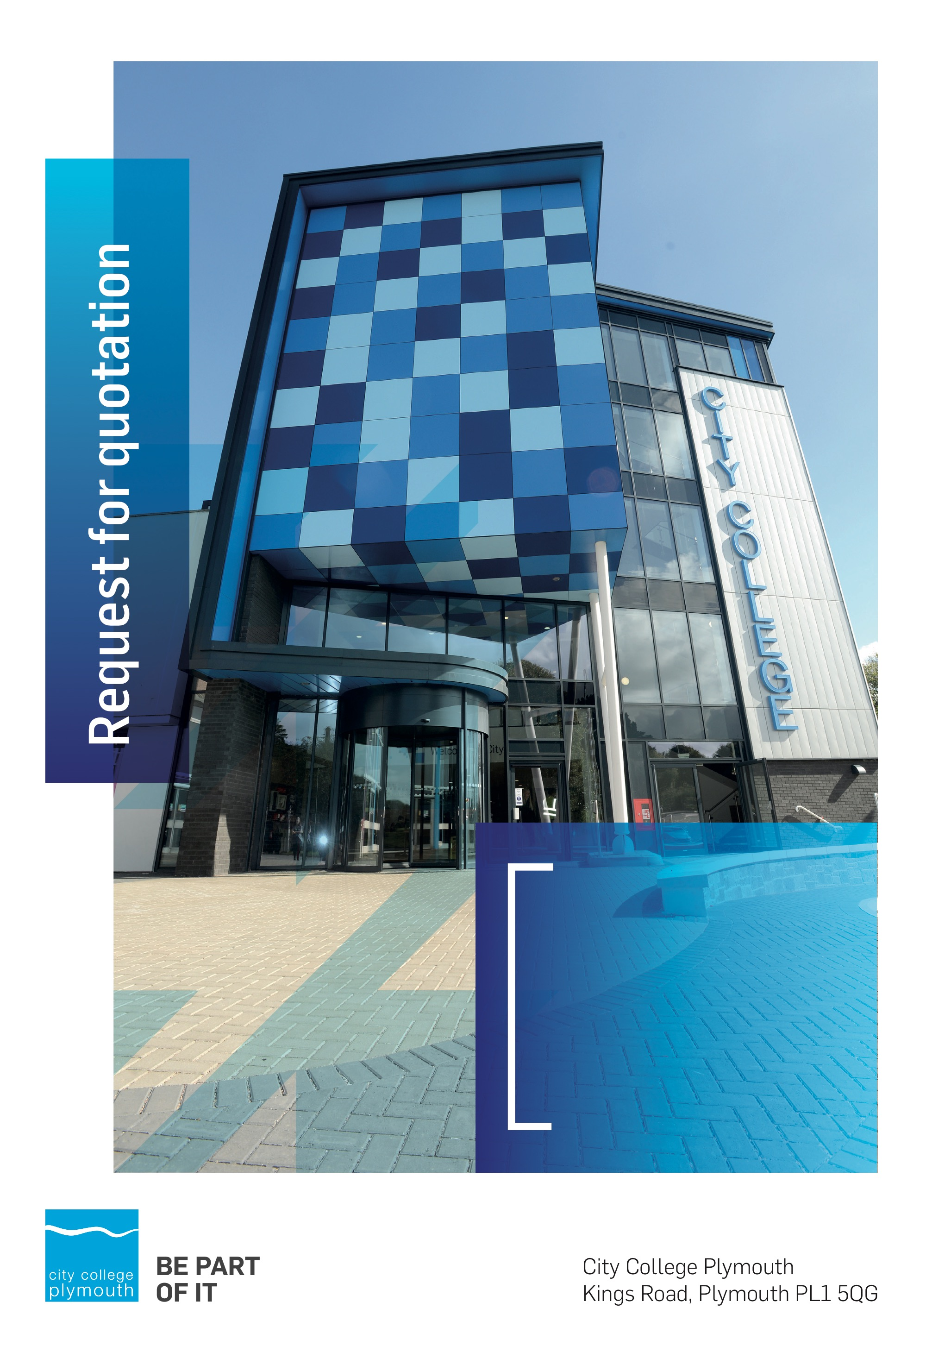

**Request for Quotation**

**RFQ188**

**Construction T-Level improvements**

**Issued 09/03/2022**

# Table of Contents

Table of Contents 2

Confidentiality Statement 4

Open Procedure 4

Submission Details 4

Submission Deadlines 4

Submission Delivery Address 5

Submission Questions and Clarifications 5

Electronic Submissions 5

Introduction and Executive Summary 6

Business Overview & Background 6

Our Guiding principle 7

Our Vision 7

Our Core values 7

Our Culture 7

The Way Forward - our Priorities 7

Detailed Requirement 8

Security 8

Tender Timescales 9

Written submission 9

Pricing 10

Terms and Conditions 10

Validity 10

Selection Criteria 10

Award Price 11

Scoring 11

Assessment of Quotations 12

Freedom of Information Act 2000 12

general data protection Regulation (GDPR) 2018 12

Agreement Conditions Acceptance and Declaration 12

Supporting Documentation 12

# Confidentiality Statement

This document, and any attachments thereto, regardless of form or medium, is intended only for use by the addressee(s) and may contain legally privileged and/or confidential, copyrighted, trademarked, patented or otherwise restricted information viewable by the intended recipient only. If you are not the intended recipient of this document (or the person responsible for delivering this document to the intended recipient), you are hereby notified that any dissemination, distribution, printing or copying of this document, and any attachment thereto, is strictly prohibited and violation of this condition may infringe upon copyright, trademark, patent, or other laws protecting proprietary and, or, intellectual property. In no event shall this document be delivered to anyone other than the intended recipient or original sender and violation may be considered a breach of law fully punishable by various domestic and international courts. If you have received this document in error, please respond to the originator of this message or email him/her at the address below and permanently delete and/or shred the original and any copies and any electronic form this document, and any attachments thereto and do not disseminate further.

Thank you for your consideration, City College Plymouth.

Where no notice is given, all information contained herein is Copyright 2022 City College Plymouth.

# Open Procedure

The College fully adheres to the requirements of the Public Contracts Regulations 2015, including for opportunities which are under threshold amounts.

Any Contractor who directly or indirectly canvasses any Member or Officer of the Institution, or advisor concerning the award of the contract for the provision of the services, or who directly or indirectly obtains or attempts to obtain information from any such member or Officer concerning any Tender or proposed Tender for the service will be disqualified from having his/her Tender considered.

# Submission Details

## Submission Deadlines

All submissions for responding to this Request for Quote must be submitted via email as stated below, no later than:

**Friday 1st April 2022**

**12:00 Noon**

Any submissions received after this date will not be considered.

## Submission Delivery Address

All submissions should be submitted electronically as below.

## Submission Questions and Clarifications

You may contact the following person if you have any questions or require clarification on any topics covered in this Request for Quotation, by Friday 26th March 2022.

**Adam Baker**

Procurement Officer

City College Plymouth

Phone: 01752 305313

Email: tenders@cityplym.ac.uk

All correspondence during the Tender should be channeled via the Procurement Officer using the above details only. Bidders found to have gained an unfair advantage shall be disqualified from the current opportunity and future opportunities with the College for a minimum of three (3) years.

## Electronic Submissions

Electronic submissions in response to this Request for Quotation must meet the following criteria:

Sent via email to: [tenders@cityplym.ac.uk](mailto:tenders@cityplym.ac.uk) quoting reference RFQ188

Document standards:

* Text must be in Microsoft Word format;
* Price tables must be in Microsoft Excel format (using pricing schedule in **Appendix A**);
* Supportive evidence may additionally be submitted in PDF format;
* Images, Designs, and other supporting evidence may be in either JPEG or PDF format
* Completed **Appendix C** Suitability Assessment & Selection Questionnaire (Including Mandatory & Discretionary Exclusions) Parts 1, 2 and 3. - *Please note this suitability assessment will not be viewed unless you are shortlisted for the presentation stage. Failure at this stage may prevent the contract from being awarded.*
* Signed Agreement Acceptance and Declaration **Appendix D**

*Please note that the College is able to accept submissions sent in a compressed or “.zip” file format, so long as the files contained meet the standards described above.*

**WARRANTY**:

By submitting your tender bid, you are warrantying to the College that you have not breached our canvassing or soliciting clause.

If any successful tenderer awarded a contract is found to have provided an inaccurate warranty, then the College reserves the right to terminate the awarded contract with immediate effect and re-tender the contract from which the successful tenderer will be excluded from re-bidding and shall be disqualified from any future opportunities for a period of four years.

# Introduction and Executive Summary

City College Plymouth have been successful in a bid for funding to refurbish a space to deliver a new construction T Level qualification. .

The College is seeking a contractor to carry out an interior and external refurbishment of a portion of the existing construction building to facilitate this.

The anticipated value of the supply contract will exceed £25,000, therefore, as per the Public Contracts Regulations 2015 the opportunity will be advertised on the Government portal ‘Contracts Finder’

# Business Overview & Background

City College Plymouth has a learning environment and organisational culture that impacts positively on the health, wellbeing and sustainability of our community and enables all of our students and staff to achieve their full potential.

City College Plymouth is one of the largest providers of innovative, technical and professional, education in the South West with a national reputation for promoting enterprise, employability and science, technology, engineering and mathematics (STEM). The College plays a central role in the educational, cultural and economic life of the region and works with strategic partners to facilitate growth, raise aspirations and foster wealth creation.

The College was awarded the Teaching Excellence Framework (TEF) Gold award for its university-level provision and its most recent Ofsted inspection confirmed that the College continues to be ‘Good’ with many outstanding features. The College was rated first in the South West and second nationally for student satisfaction in the latest FE Choices student satisfaction survey.

City College Plymouth is also one of the first Institutes of technology in the UK Working in collaboration with education providers and employers across the South West to improve the training in science, technology, engineering and maths in order to address skills gaps within these industries and support regional growth.

City College supports the region’s employers with their award-winning Apprenticeship provision, as well as providing a range of courses and bespoke training programmes which enable employees to upskill or retrain to better support their business’ requirements.

The College operates on two main sites within the city, serving 12,500 students and employing over 650 staff. The College operates year round, with opening times from 0800-2100 on some days.

## Our Guiding principle

City College Plymouth has a learning environment and organisational culture that impacts positively on the health, wellbeing and sustainability of our community and enables all of our students and staff to achieve their full potential.

## Our Vision

To be the learning destination of choice

## Our Core values

Respect, ownership, integrity for all

## Our Culture

Nurturing a passion for teaching and learning

Enriching our community through knowledge, experience and skills

Enabling every student to be the best that they can be

## The Way Forward - our Priorities

• Staff - our most important investment

• Students - our purpose

• Community - making a difference

• Achievement - reputation for success

• Wellbeing - infusing health into every day

# Detailed Requirement

The anticipated cost of the works is £425,000 net

City College Plymouth is looking for a contractor to carry our refurbishment works to a section of the construction building in preparation for the delivery of the new construction T-Level.

Kendall Kingscott have were appointed by City College Plymouth as design consultants and they have produced for us detailed Pre contract Information (Appendix E ), Contract specification (Appendix F) and multiple drawings (Appendix G ). These are to be used to ascertain the scope and extent of the project and to enable pricing of the works within Appendix A. All accompanying documents are available from the drop box link here;

https://www.dropbox.com/sh/gz65bhclfsx7kan/AAC20-pMjhAhY-ZeteXDdhLza?dl=0

A site visit is **strongly recommended,** the premises manager, Dom Jennings, can be contacted on 01752 305740/ [djennings@cityplym.ac.uk](mailto:djennings@cityplym.ac.uk) to arrange a visit within the tender period. .

All prospective contractors will be required to complete the suitability assessment questionnaire (Appendix C).

## Security

The College requires that all contractors, prior to undertaking work on the College site, will have been subject to a (DBS) English Disclosure Barring and Services check. This requirement may be suspended where works are undertaken during the college holiday breaks or outside of the main school week, providing the College is satisfied any risk to students who may be on site for revision or taster sessions is adequately managed.

All staff on site will be required to comply with health and safety requirements at all times and to wear appropriate identification.

All staff will be required to sign in and sign out when on College premises.

## Tender Timescales

Please see below an outline of the tender timescales.

|  |  |
| --- | --- |
| **Action** | **Date** |
| Tender Issued | 09/03/2022 |
| Site Visit | To be arranged |
| Deadline for Clarification | 25/03/2022 |
| Tender Response Date | 01/04/2022 |
| Analysis of tender | 04/04/22-11/04/22 |
| Formal appointment of contract | 13th April 2022 |
| Works commencement date | 27th April 2022 |
| Works to be completed by | 2nd September 2022 |

# Written submission

You are required to submit a brief written document that outlines how you will meet our requirements and how you intend to work with the College, with particular regard to the following:

* Experience of previous works in a further education setting during term time.
* Project management arrangements and proposed plan of works.
* Capacity to meet given timescales
* Please indicate how the award of any resulting contract to your organisation would support City College Plymouth students in their development and learning and indicate any added value you could offer (social value). Please also state is you have a sustainability/environmental policy.

You should also confirm your understanding of our DBS requirements and that you will be able to comply.

You are also required to complete a suitability and assessment questionnaire, attached at **Appendix C**. This document is not used during the selection process, but will be viewed if you are the shortlisted contractor.

Your document will be scored in accordance with the table on page 11.

# Pricing

Bidders should provide their pricing in Appendix A against all the elements on the different tabs.

# Terms and Conditions

The College’s normal business terms 30 days from the date of invoice. Payment will become due subject to the above upon the College’s full acceptance of the goods/services/works. This Request for Quotation and any resulting purchase order will be subject to JCT Minor Works Building Contract with Contractor's Design 2016 Edition.

# Validity

Bidder’s offers should be open and valid for acceptance for a period of no less than ninety [90] days from the date of submission.

# Selection Criteria

The successful supplier will have provided the Most Economically Advantageous Tender (MEAT) to the college. It should be noted that the bidder with the lowest submitted prices will not necessarily be down-selected. All bidders will be notified via email of the results of the outcome no later than ninety [90] days form the date of submission. The date of contract award will be provided within that email.

The marking criteria are described in the table below:

|  |  |
| --- | --- |
| **Category** | **Weighting** |
| Price | 75% |
| Programming of works and contract management | 10% |
| Experience of working in further education | 10% |
| Social Value and sustainability | 5% |

Please see table below for more details on the scoring method.

## Award Price

Lowest quote price divided by quote price multiplied by 100.

## Scoring

|  |  |  |
| --- | --- | --- |
| **Assessment** | **Score** | **Interpretation** |
| **Excellent** | 4 | *Comprehensive response supported by examples*  *Description fully supported by details that demonstrate the applicant’s ability to provide the required services.* |
| **Good** | 3 | *Broad response supported by relevant examples.*  *Description well supported by details that demonstrate the applicant’s ability to provide the required services.* |
| **Satisfactory** | 2 | *Reasonable response supported by some evidence.*  *Description adequately supported by details that demonstrate the applicant’s ability to provide the required services.* |
| **Poor** | 1 | *Limited response not well supported by evidence.*  *Description inadequately supported by details that demonstrate the applicant’s ability to provide the required services.* |
| **Unacceptable** | 0 | *No response or insufficient information provided.* |

# Assessment of Quotations

Bidders must ensure that their quotation fully addresses all information requested within this RFQ document. Bidders must ensure that any quotation fully meets the specification required. The College reserves the right to discount any quotation which does not fully meet the specification.

The College reserves the right to seek clarification with bidders upon receipt of quotations.

# Freedom of Information Act 2000

Under the Freedom of Information Act 2000 the College cannot guarantee that information provided by bidders during the course of this RFQ procedure or any resulting contract will be held a confidential. The College will not routinely release information to interested parties unless required to do so in order to meet our statutory obligations.

# general data protection Regulation (GDPR) 2018

All bidders must comply with the General Data Protection Regulation (GDPR) 2018 in respect of using and processing personal information. Bidders must have in place technical and organisational safeguards to protect personal data from unauthorised use, disclosure or loss.

The College reserves the right to request a copy of your privacy statement if you are the successful bidder.

# Agreement Conditions Acceptance and Declaration

Bidders are required to sign and return the attached Agreement Conditions Acceptance and Declaration, **Appendix D**.

# Supporting Documentation

Appendix A Pricing Schedule.

Appendix B Standard Terms and Conditions

Appendix C Suitability Assessment & Selection Questionnaire (Including Mandatory & Discretionary Exclusions) Parts 1, 2 and 3.

Appendix D Agreement Conditions Acceptance and Declaration.

Appendix E Pre-Contract Information

Appendix F Contract Specification

Appendix G Drawings

All of the above are available from the link below due to document size restraints.

<https://www.dropbox.com/sh/gz65bhclfsx7kan/AAC20-pMjhAhY-ZeteXDdhLza?dl=0>