BLYTH TOWN COUNCIL

INVITATION TO TENDER

REPLACEMENT WATER SYSTEM

BOLAM AVE ALLOTMENT SITE

FEBRUARY 27 2024

1. Introduction

  - Blyth Town Council propose to install a new water system on its Bolam Avenue allotment site. The successful contractor can programme this work as soon as possible as can be shown in Section 16 of this document. This project is to replace the existing system currently on site which will include the installation of isolation valves on each lane. The current system is some 50 years old and is now subject to water leaks etc.

The Bolam Site is in the Cowpen area of the town. (Post Code NE24 5BN)

  - Within this invitation to tender, there is the opportunity for interested companies to submit a price for this project as outlined.

2. Bolam Ave Allotments

The water system is to be installed at the locations shown below on page 2

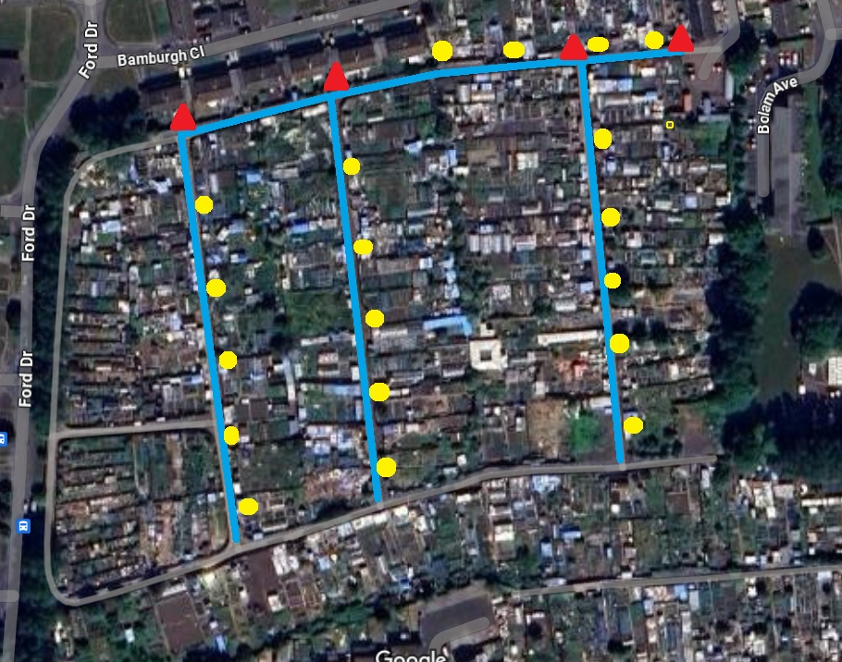

The blue lines indicate the pipework (645 metres)
The red triangles indicate stop cocks (4)
The yellow circles indicate taps (19)

Work Specification

The installation of approximately 645 metres of 25mm blue mdpe water pipe to replace the existing line, will be buried in 100mm of sand to a minimum depth of 750mm with marker tape above and backfilled with excavate materials.

Within the installation process we also require 4 inline stopcocks to enable the supply to the individual lanes to be isolated in the event that they ever need to be turned off. These need to be installed inside a sealed chamber with a concrete surround.

The 19 taps that are indicated on the plan in yellow dots we require the taps and associated fittings to be installed to Northumbria Water’s specification as shown below page 3.

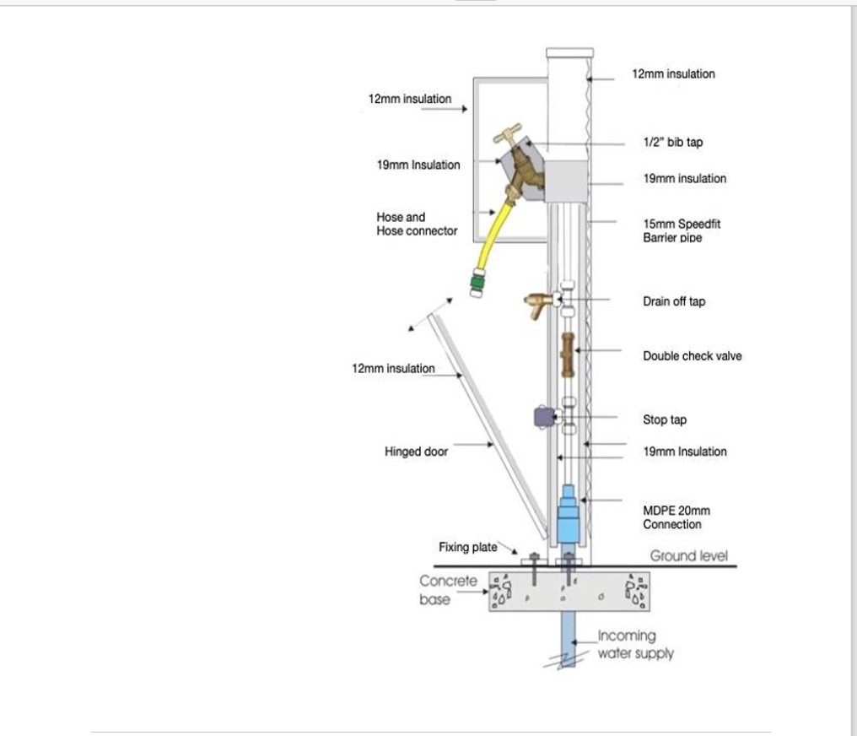

3. General Information

3.1 At this stage we would like all of the works agreed to be started as soon as practicable in the financial year 2024/25. The Council would hope that these discussions to agree a date could commence when we hope to notify the successful contractor in April 2024.

3.2 This document is designed to allow a potential supplier to apply a degree of flexibility with regard to the proposed design. The detail of eg the tap housing should be contained within the tender documentation which should be to current Water Regulations and Standards and to the aims of the Council.

3.3 The design for the water supply is on the basis that it is adequate to supply the needs of the allotment tenants and Council.

3.4 Potential Contractors should ensure that they have sufficient information to submit a quotation. The information provided should be used as the basis of the submitted price, but if there are any queries whatsoever, please contact the Town Council.

3.5 The purpose of this brief is to obtain competitive tenders and to form the basis of the relevant appointment. However, the Council reserves the right to add to, omit from, or amend the brief in any way prior to the appointment of the supplier and execution of the works. Changes that materially affect the provision of services described herein and cause a change in the price then such altered services are agreed between the Council and the appointed Company.

3.6 Any solicitation and/or relationship to Town Councillors will preclude a quotation being submitted.

3.7 Any contract awarded will be in accordance with JCT Standards and Water Regulation Standards.

3.8 The Allotment site is under the land ownership of Blyth Town Council and the appropriate approvals for this work have been given.

4. Assumptions and Constraints

4.1 Local Authority contracting, tendering and seeking quotations is strictly governed by the Standing Orders of the Town Council. It is fully transparent and is based on fair and genuine competition.

4.2 The contractor will provide a tender for a completion price, detailing costs as requested in Section 16 of this form.

4.3 The contractor shall hold, and provide, copies of the required insurance and public liability cover to a minimum of £5million.

4.4 The Town Council is committed to equal opportunities in all respects of its operation and encourages contractors to implement similar policies.

4.5 The contractor will comply with the latest Health and Safety at Work Act and shall hold the relevant Health and Safety certificates, including those specific to the job.

4.6 The contractor will hold in place a relevant written Health and Safety Policy and shall complete a risk assessment for the tasks to be undertaken.

4.7 The Contractor shall comply with the Control of Waste regulations.

5. General Requirements

5.1 The contractor shall be legally authorised to perform all aspects of the work quoted for.

5.2 The contractor should own or have legal access to the appropriate equipment to undertake the work quoted for.

5.3 The contractor must provide copies to the Town Council, of appropriate personal and public liability insurance cover, appropriate licenses and risk assessments within the tender submission. All such documents shall be current.

6. Change Management

6.1 Any alteration to the specifications agreed in the works order may be subject to the following change management procedures. A change management schedule will be signed by both parties in every instance.

6.2 Any changes to the specifications, where the tender price is reduced, will be with the express consent of the Town Clerk, and as agreed with the contractor.

6.3 Any changes to the specifications, where the agreed price is increased by under £500, will be with the express consent of the Town Clerk, and as agreed by the contractor. Any changes to the specifications, where the agreed price is increased by over £500, will be with the express consent of the Town Council, and as agreed by the contractor.

6.4 The contractor shall not instigate any changes to the schedule out with the change management procedures. Should the contractor do so then all costs will be borne by them and not from any contingency sum included in the submission or contract. They may also be required to rectify any changes that have been undertaken.

6.5 Any invoices issued for work that has not been authorised through the above procedure will be rejected.

7. Instructions to Contractors

7.1 It is the responsibility of the Contractor to obtain for themselves, at their own expense, any additional information necessary for the preparation of their tender.

7.2 All tenderers are required to satisfy themselves that they are in possession of sufficient information to prepare a detailed and fixed price offer. If any errors are made due to failure to obtain such information, the responsibility therein lies with the tenderer.

7.3 All information provided by Blyth Town Council in connection with this tender shall be treated as confidential by the Contractors, except where such information may be disclosed for the purpose of obtaining sureties and quotations necessary for the preparation and submission of the price.

7.4 All information submitted to the Town Council may need to be disclosed and/or published under the Freedom of Information Act. If the tenderer considers that any information included in the tender submission is commercially sensitive, it will need to be identified and an explanation in broad terms of what harm might result from disclosure provided. However, this information may still be disclosed should the Town Council be required to do so under the current legislation, even if this information is marked “confidential” or the equivalent.

7.5 Any questions relating to this invitation to tender must be raised no later than the date shown on the schedule. Any questions raised within the scheduled timescales provided, together with the answers provided by the Council, will be circulated to all parties who have notified us that they may be submitting a quotation. Council staff should only be contacted, if necessary, to assist potential Contractors in clarifying any queries in line with their tender submission, and not to encourage or support their tender outside the prescribed process.

7.6 Any organisation wishing to tender for this work must present their submission in full by the required closing date and time. Any quotation received after this date and time will not be considered.

7.7 Should the Contractor wish to arrange an accompanied site visit in conjunction with current guidelines, please contact the Council by email at info@blythtowncouncil.org.uk or telephone 01670 361668.

7.8 The contractor should indicate in Section 16 their anticipated start date.

7.9 The Town Council has provided the Terms and Conditions of the proposed contract and these are expected to be met.

7.10 If any questions relating to the Terms and Conditions of the work needs to be raised, they must be done according to the schedule. Any questions relating to the Terms and Conditions, or any other item within this quotation, which are sent to the Town Council after the required date will be considered at the sole discretion of the Town Council.

8. Tender Process

8.1 All tenders must be submitted to the Council as follows; section 7 also refers:

1. Tenders are sent to tenders@blythtowncouncil.org.uk.
IN THE SUBJECT HEADING PLEASE QUOTE TENDER FOR WATER
SYSTEM AT BOLAM ALLOTMENTS
2. An automated reply is sent to the sender on its receipt, confirming submission. The message also states that they are welcome to repeat if they need to send additional documents.
3. Tender Applications are stored in a secure account that remains locked until the set time.
4. At the time required for the opening of tenders, the e/mail account and documents shall then be available and shared to all Staff/councillors involved in the process with email tracking options active (read receipt/email delivery) to ensure all access is monitored.

8.2 All submissions will be opened at the appointed time, ie the closing date and time in the presence of the Town Clerk. Changes to working practices, in the event of eg, further guidelines re Covid19, may require the need for virtual meetings.

8.3 The quotations will be assessed on a number of criteria including:
- Quality of design
- Maintainability
- Safety
- Value
- References
- After sales care

8.4 The Clerk will follow up reference information provided by all shortlisted contractors.

8.5 The Council may need to clarify issues with the shortlisted contractors and relevant information subsequently obtained.

8.6 Contractors should contact the Council prior to the closing date to inform that documents have been sent, in the event of no receipt confirmation having been received as outlined in 8.1.2.

9. Timescales

Action | Date
Issue of brief for proposed Bolam Allotment Water System Replacement | Tuesday 27 February 2024
Closing date for questions relating to proposals | 25 March 2024
Responses to questions provided back to all interested parties by | 2 April 2024
Closing time and date for return of prices | Monday 8 April 2024  12.00 noon
Opening of Tenders | 9 April 2024
References requested | 9 April 2024
Closing date for reference returns | 16 April 2024
Officer Evaluation by | 16 April 2024
Review of shortlist and recommended Contractor by | Special Env Committee to be arranged.
Contractors notified of decision | Subject to the above, but shortly thereafter.

Please note that should any of the above dates be changed you will be notified.

10. Contractor Form

The Town Council requires to know details of any individual organisation or partnership with whom it may enter into a contract. This will enable it to demonstrate safeguarding of public funds and that there will be no conflict of interest in awarding this contract.

Any false information knowingly provided will immediately deem the tender submission invalid.

Company Details

Name of Company in whose name business is to be transacted
Registered Address
Principal Contact
Telephone – mobile number preferred
Email address
Please indicate membership of any professional or trade bodies
Please indicate how many years this company has traded
Company number (if relevant)
Staffing levels | Permanent | Casual

11. Legal Information and Professional Conduct

What is the legal status of your organisation (e.g. sole trader, private limited company, partnership etc)
VAT Registration Number
If this is a partnership please supply the full names of all partners on a separate sheet if necessary
Has your organisation been convicted (or has any outstanding actions) of a criminal nature relating to the conduct of its business or profession?  If yes please provide details on a separate sheet | Yes/No
Has your organisation failed to fulfil its obligations relating to the payment of contributions or taxes under the law of any part of the United Kingdom.  If yes please provide details on a separate sheet | Yes/No
Has your organisation had a contract cancelled, or not renewed, for failure to perform to the terms of that contract?  If yes please provide details on a separate sheet | Yes/No
By Law (RIDDOR), you must report certain injuries, diseases and dangerous occurrences to the Health and Safety Executive. Has your organisation had to make any such reports under RIDDOR in the past five years?  If yes please provide details on a separate sheet | Yes/No
In the past five years have you or your organisation, or any of your employees, been served with a prohibition or improvement notice, or been convicted of any offence in law, enforced by the Health and Safety Executive, Local Authority, Police or the Department of Transport?  If yes please provide details on a separate sheet | Yes/No

12. Financial Details

Please indicate the annual turnover of your organisation over the last three years

£ | Year:
£ | Year:
£ | Year:

The Town Council may carry out a financial assessment on all applicants. Sets of accounts are not required at this stage but may be requested prior to awarding the contract.

Please provide details of your bankers. They may be, should you be shortlisted, required to provide you with a reference

Please note that all payments will be made by bank transfer.

13. Health and Safety

All applicants undertaking works under this tender must satisfy the Town Council of their competency regarding Health and Safety.

Please enclose details of your current Health and Safety Policy and any relevant certificates pertinent to this tender, together with the name of the person responsible for the management of health and safety in your organisation.

14. Insurances

Please provide details of your organisation’s insurance protection in relation to employer’s liability and public liability.

Policy | Insurer | Value £
Employer’s Liability
Public Liability

Please enclose a copy of the insurance certificates, which must be current.

15. References

Please provide two references for work carried out in the past three years; one of the references must be either a current contract or one that has completed within the last twelve months (no earlier than April 2022). The referees should not be related to any member of your company. To speed up the assessment process it would be advantageous to be able to contact referees via email – please provide a relevant email address for each reference. Please inform your referees that we may contact them in order to allow a speedier response and of the date we require references by.

Reference 1

Contact name
Contact phone & email
Full postal Address
Brief description of works, their value and the date the work was carried out
Please confirm this referee is aware and that you authorise the Council to contact the referee at the Council’s discretion

Reference 2

Contact name
Contact phone & email
Full postal Address
Brief description of works, their value and the date the work was carried out
Please confirm this referee is aware and that you authorise the Council to contact the referee at the Council’s discretion

16. Tender and Price Contract

I believe that the company, as detailed in Section 12 of the Tender Form, meets the entire requirements outlined in this brief and that I and my company are qualified to undertake the works described. I will comply with the requirements for a contractor performing the work stated as set out in invitation to quote and JCT Minor Works Building Contract 2016.

I agree to the terms and conditions as set out in these documents.

To carry out the works detailed in the schedule of works, the company, as detailed in Section 12 of the Tender Form, will charge, where applicable:

£ …………….. Bolam Ave Allotment Water System Replacement

Please detail below the guarantees in relation to the above:

I anticipate commencing the necessary works and completion of works, subject to agreement, on:

Project | Commencement Date | Completion Date
Bolam Allotment Water System Replacement

I agree that this sum will/may be paid over interim payments on the production of suitable evidence as agreed by the Town Clerk. This can be further discussed on award of Contract.

Any contract variation, whether affecting the contract sum or not, shall be agreed prior to the specific addition/deletion carried out.

Signature ………………………………………………. Date…………….

Name ………………………………………………..

Company Name ……………………………………………………………

