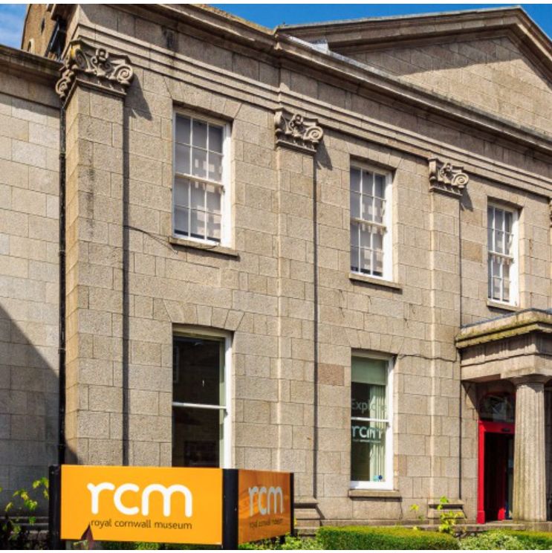
Design and Build Tender
Our Past, Our Future: Royal Institution of Cornwall
Volume 2 (Part B) – Applicants Offer
This document must be completed and returned in the published format. Failure to comply with this instruction may result in your Submission being discounted.
December 2023
Closing time/date for return of submission: 12:00 (Noon) 19/02/2024
Name of Applicant:
Please return electronically to: jackie@jackiegeorge.co.uk
Contents

Section 1 – General Notes 3
Section 2 Applicants Response to Tender 4

Section 1 – General Notes
- This document should be read in conjunction with the supporting information contained within Volume 1 “Invitation to Tender - Background Information, Instructions and Conditions of Tender” and associated documents also referenced.
- This document and associated documents will form the basis of the Applicants formal tender response. Care should be taken to ensure that it is completed accurately, and all information required to submit a compliant tender is done ahead of submitting any final response.
- There is a word count for the responses – Please ensure that for each method statement that the response is no more than 750 words on 2 A4 pages at a font no smaller than Aerial 11.
- Appendices are only permitted to illustrate detail as set out in the method statement, not to add in more detail. Where appendices are used to avoid word count or are not succinct then they will not be evaluated.

Section 2 Applicants Response to Tender
- Section 3 to be completed by all Applicants looking to submit a formal response to this Tender.
- Please note, in completion of the bid submission around quality questions, we would be expecting to see the tenderer bring out the detail of the whole core team (irrespective of level of input anticipated and their roles, experiences and capabilities, and what they would bring to support in the delivery of this project – but with a clear focus on the key members of the proposed team that would be engaged.
- The below are pass fail questions, and in the event that you answer “no” to any of the questions then we will not evaluate your tender any further and will not be able to contract with you.
Ref | PASS / FAIL QUESTIONS – Confirmation that Tender is submitted on the following understanding: | Please delete as appropriate
1 | For the design element of the work you will have (and will maintain for the duration of the Contract) suitable trading / accredited body status (or equivalent)  Please state below which apply: | Yes / No
2 | You will be contracting under the stated terms of Contract. | Yes / No
3 | You will act as Principal Designer for the duration of the works. | Yes / No

Method Statement Topic Areas - Understanding the brief, including methodology and approach
Requirements for the Applicant’s response to this Method Statement:
The Invitation to Tender documents provides details of the services required. Importantly the context and setting in which those services are to be provided and the support which is required to be provided by the Royal Institution of Cornwall.
As part of the Supplier’s response the Royal Institution of Cornwall would be seeking a submission that outlines the method and approach to be adopted in response to the accompanying brief and how this would contribute to successfully meeting the objective and required outcomes as set out.
Please provide in your response your understanding of the aims of the project set out in the statement of requirements and the role that you would be expected to perform.
We would be looking for you to highlight procedures, major issues, constraints, risks etc., and demonstrate your approach to achieving the objectives and importantly your understanding of the key principles to support a successful outcome.
This should be in the form of a method statement for each phase that includes the approach and methodology to be applied in that phase and including the tools, techniques and processes you intend to follow.
Please include an outline programme plan setting out your indicative support over the various stages.
To meet the agreed timetable of progress reporting and other activity to be confirmed but as a minimum, a monthly written progress report to be provided to the Royal Institution of Cornwall for presentation to the monthly project meetings. In addition, Programme Managers will be expected to provide verbal updates on significant developments or issues.
Please include a succinct methodology and outline plan /programme noting the word limit indicated
WHAT DOES A STRONG RESPONSE LOOK LIKE?
A strong response would clearly evidence you understand the role and support which the appointed a core team would be expected to undertake, the scope and complexity of the overall scheme, the engagement with other partners as required outcomes.
A strong response would include the submission of a methodology for undertaking the work which should include the following elements;
- How individual consultants will work efficiently together with their team and others, identifying who is the lead consultant managing the day to day work;
- What you see as the main risks to the project success and how you will contribute to mitigate and manage them;
- What are the key objectives and elements of work and expertise you bring to them;
- Clear details on the methods and approach which you would undertake and confidence that the method and approach would be able to deliver quality outcomes to the satisfaction of the Royal Institution of Cornwall within the timeframe required.
- The tools, techniques and processes to be undertaken must be appropriately applied, proportional for the required delivery of the Contract and proven in delivering the outcomes required in this tender.
A strong response would also indicate an understanding of the proportional nature of the support required and how resources would be flexed appropriately to manage periods of more intense support versus other periods during the scheme duration where little or no active resource input would be needed. In short, a strong response would demonstrate you fully understand what is required and know how you would go about your role in this project.
A strong response would clearly indicate an understanding of the requirements as set out within the Brief and what is necessary to deliver high quality outcomes. It will clearly set out how each of the identified themes will be approached and met by the bidder and provide confidence that both the design elements and the build elements are able to be fulfilled within the allocated budget.
A strong response would clearly set out a structured approach to ensure that the Contract is delivered in a timely, orderly and professional manner, with particular emphasis around the design element and the build elements.
It would also clearly outline through the delivery of the contract how the objectives of the Brief would be achieved and provide a high degree of confidence that the core team would be able to perform the Contract in line with the expectations set out by the Royal Institution of Cornwall.
A strong response would clearly indicate an understanding of the requirements as set out and what is necessary at the respective stages of the overall programme. It will clearly set out the approach to be taken in the respective stages including both sign off from the Royal Institution of Cornwall at key stages and wider effective engagement with key stakeholders.
A strong response would include an indicative programme and timeline which is credible in relation to the wider expectations of the different phased of activity from design to the build. In addition, the response would provide clarity on expectations around response and delivery timescales for the services provided, as well as details on how issues would be escalated and resolved. It would set out key milestones with anticipated dates. Any variations with the submitted programme should be explained.
A strong response would include details and examples of how you propose to show you will complete the project to all deadlines as set in the agreed timetable.as well as how you would provide verbal updates on significant developments or issues between formal reports.
A succinct methodology and outline plan / programme would be integral to this response, coupled with concept sketch designs or interpretations on the proposed options which the interior / exhibition design would look to explore further with the client.
PLEASE ADD RESPONSE BELOW (response is no more than 750 words on 2 A4 pages at a font no smaller than Aerial 11.):

Method Statement Topic Areas - Quality and Past Experience and how this would be used:
Requirements for the Applicant’s response to this Method Statement:
As noted in the accompanying documents, this tender is seeking a partner to undertake the full design of phases 1 and 2 (UK Landscape Institute’s stage A-Feasibility to E-Detail Proposals to enable planning application to be submitted) but only the installation of Phase 1 to Stage L- Completion. at the Royal Cornwall Museum.
It is important to highlight the Grade 2 Listed Building status of the Royal Cornwall Museum and as part of this response would provide details of your experience in similar settings and how this would be beneficial to the works required in this tender.
To deliver the outcomes of this tender, it will require a range of different, but core experience, skills and capabilities are set out in the accompanying Brief.
The above would also be complimented by excellent communication and stakeholder engagement skills.
By very nature of the work required, it will be assembling a competent, diverse and talented design team and as such that will need to be drawn out in the response.
The Supplier would be able to provide core team who have proven capability in delivery of support and advice on similar projects ideally in similar settings or contexts.
Your response should provide strong evidence that you are able to assemble and bring the key experience, skills and capabilities to deliver the high-end quality outcomes required by the museum.
To support the work, it would be highly desirable for the consultant(s) to have knowledge, experience and skills in respect of working with the public sector, ideally local government, along with a strong understanding of engagement within and across diverse communities.
Provide the name and contact details of sub contractors.
WHAT DOES A STRONG RESPONSE LOOK LIKE?
A strong response would show that the Supplier would be able to demonstrate they can provide the necessary core skills across a diverse team.
A strong response would provide clear assurance that the Supplier would be delivering the Contract with resources with relevant core experience, skills and capabilities required to deliver the outcomes set out in the Tender Brief in a manner that provides confidence and assurance around capacity and continuity of the team.
A strong response would have set out the core team and the necessary supporting evidence that the team has all of the required core experience, skills and capabilities to ensure a high-end quality outcome.
A strong response would clearly indicate that the proposed team has the right blend of core experience, skills and capabilities required to work on such a high profile, complex project. The response would clearly indicate the roles which the individual team members would bring to the project and how this project would benefit from their experience, knowledge and expertise.
This experience, knowledge and expertise would also look to demonstrate a clear connection to work on similar projects of similar scale and profile, ideally within a Grade 2 Listed Building settings.
This could also include details on how staff are inducted and how they are trained and supported to be effective within all they do, and the assurance that they have the right and relevant skills and experience to undertake the roles required.
A strong response would provide details of the key individuals of the teams CV’s and / or organisational biographies which demonstration through this that they have the right professional experience, knowledge and expertise, and that this is transferable and relevant to this project. This would include details of projects that they have been involved in and the role that they played. The individuals indicated should be those that will work on the project.
Where roles are not yet determined at time of tender then the response should provide details around how you would select and appoint partner organisations or resources, to take into account assurances on high end quality outcomes.
Where relevant, details of trade bodies, accreditation bodies and / or professional organisations would also be included in the response to this requirement.
PLEASE ADD RESPONSE BELOW: (response is no more than 750 words on 2 A4 pages at a font no smaller than Aerial 11.):

Method Statement Topic Area - PARTNERING AND COLLABORATION:
Requirements for the Applicant’s response to this Method Statement:
In order to fulfil any resulting contract, the Royal Institution of Cornwall is looking to complete both the necessary design and build. As such the Royal Institution of Cornwall will be looking to contract with a lead partner and for the lead partner to assemble the necessary core team to deliver the overall project, from detailed design through to construction and final contract stage.
As noted elsewhere in this tender pack, any resulting Contract will be for support over a period of time, with a range of partner organisations, individuals or a number of different contractors undertaking specific projects on the overall scheme.
Accordingly successful progress on the project will need to build upon the ability to build and maintain a long-term arrangement across partners, to deliver the overall vision and objectives.
The appointed lead partner will play a critical part in supporting the Royal Institution of Cornwall to achieve the intended outcomes. As with all such projects it is vital to ensure the right partners who both share the ethos but also understand how to work with other stakeholders in a matrix team setting and advance the project in a way that effectively balances and takes account of the individual stakeholder needs and expectations.
Please provide details of your partnering ethos and experience and how you would look to bring your experience of working on complex / matrix collaborative projects to this project.
WHAT DOES A STRONG RESPONSE LOOK LIKE?
A strong response would be clear on the overall structure of partners and the lead contractor. It would provide details on how the core team members would work with both the Royal Institution of Cornwall and as well with each other and key stakeholders / other contractors.
A strong response would provide details on the approach they would adopt and the experience and credentials they have elsewhere which they would bring to this project to make it a success.
A strong response would include also an indication of a strong track record regarding successful contract and project management and working collaboratively with key stakeholders. It would provide confidence on how this track record could successfully be applied in relation to this actual Contract and the expertise which the team would bring to delivery of this in any awarded Contract.
A strong response would provide examples of how, where and when you have implemented and delivered a successful complex project in an environment with a number of stakeholders.

PLEASE ADD RESPONSE BELOW: (response is no more than 750 words on 2 A4 pages at a font no smaller than Aerial 11.):

METHOD STATEMENT - Social Value Considerations
The Applicant shall provide a Method Statement which details how their organisation aligns with the social value principles of that of The Royal Institute of Cornwall.
For the purposes of the consideration and application of this Tender, Social Value is defined as the additional added value or extra benefits able to be attributed to Social Value outcomes beyond the core requirements related to the spend. More details on the Social Value Act itself can be found here:
https://www.gov.uk/government/publications/social-value-act-information-and-resources/social-value-act-information-and-resources
The Royal Institute of Cornwall requirements for the Applicant’s response to this Method Statement: is for the Applicant to provide a detailed method statement that focuses on how they would approach supporting Social Value considerations as part of the delivery of the Contract emphasising those that the applicant has as an organisation and how these interrelate with those of The Royal Institute of Cornwall.
In relation to this contract the Royal Institute of Cornwall sees the following as being areas where, through the delivery of the Services, positive outcomes to Social, Economic and / Environmental outcomes could be achieved, such as:
- Within the workforce this could be supporting apprenticeships, local employment, or contribution to the Local economy as a direct result of this Contract for instance through the supply chain.
- Supporting environmental outcomes (including reduction of use of products / material that are harmful to the environment or working practices that minimise environmental damage), as well as making a positive contribution to the Royal Institute of Cornwall’s pledge around removing use of “single use plastics”. Details should be given in the tender response which highlight the measures which the tenderer will be taking to reduce its use of single use plastics wherever possible. More information can be found at: https://www.sas.org.uk/about-the-movement/
- Supporting environmental outcomes in relation to re-use/ repair/ recycle.
Social outcomes may also include details on how the Supplier would look to support community initiatives and / or work to make a positive outcome within the wider community. The above list is not exclusive or exhaustive but an indication on what are deemed to be relevant and proportional areas for Social Value consideration to this contract.
WHAT DOES A STRONG RESPONSE LOOK LIKE?
A strong response would outline clearly what would be done to contribute towards added Social Value if awarded the Contract, actually how the Supplier would go about doing this, and what tangible outcomes the Royal Institute of Cornwall could expect as a result.
Linkages to how this would also support the Royal Institute of Cornwall’s wider aspirations would also be made clear.
A strong response would demonstrate commitment to deliver on the stated outcomes not simply be aspirational.
PLEASE ADD RESPONSE BELOW: (response is no more than 750 words on 2 A4 pages at a font no smaller than Aerial 11.):

