TENDER DOCUMENT

FROM

Central Region Schools Trust



For Fencing Works and Controlled Gate Installation Works

at

Gospel Oak School

23 December 2022

Ref: CRST/ESTATE/GO/2022-2

Table of Contents
Section 1 Introduction 3
Section 2 Tender Specification 8
Section 3 Information Required from the Supplier 10
Section 4 Pricing Schedule 11
Section 5 Evaluation 13
Appendix A FORM OF TENDER 14
Appendix B DECLARATION OF BONA FIDE TENDER 15
Appendix C CONFLICTS OF INTEREST DECLARATION 16
FREEDOM OF INFORMATION ACT 17

Section 1 Introduction

- About the Trust

Our Trust was founded in September 2012, when Arrow Vale Community High School became a Sponsored Academy. The Trust was originally named Redditch RSA Academies Trust, and has now been renamed as Central Region Schools Trust
The Governors at Arrow Vale made the decision to become an RSA Academy, recognising the huge benefits the school would gain by being so closely affiliated to the Royal Society for the Encouragement of Arts, Manufactures and Commerce (more widely known as the Royal Society of Arts).
The school, in doing so, joined a small family of academies, the RSA Family of Academies in an umbrella trust, with The RSA Academy, Tipton and Whitley Academy – an RSA Academy, being the other members. All of our schools are improving in reputation, popularity, and quality of education.
The MAT expanded to four schools in March 2016, when the other middle school in the Arrow Vale pyramid in Redditch, Church Hill Middle School, along with one of its two First schools, sharing the same site, Abbeywood First School, chose to join the Trust. The Trust now had seamless curriculum delivery in the Redditch Pyramid from aged 9-19, and for the pupils at Abbeywood, from Early Years all through to 19 years of age. The two schools on the Church Hill site were led by one Executive Headteacher, Di Smith, with one Local Academy Governing Board holding to account the leadership across the two schools. The Trust was the first to have primary provision within the wider RSA Family of Academies.
In September 2021 CRSAAT was renamed Central Region Schools Trust (CRST). RSA Academy was renamed Gospel Oak School. January 2022 saw the Trust strengthened by the addition of Holyhead school, a mixed secondary school and sixth form located in Handsworth area of Birmingham.
Trust is comprised of 11 Schools:
- Abbeywood First RSA Academy
- Arrow Valley First RSA Academy
- Gospel Oak School
- Oldbury Park Primary RSA Academy
- Sutton Park Primary RSA Academy
- Arrow Vale RSA Academy
- Church Hill Middle RSA Academy
- Ipsley CE RSA Academy
- St Stephens CE RSA Academy
- Waseley Hill High School
- Holyhead High school

- About this Tender

The Trust member school Gospel Oak is seeking a single supplier that can remove and install new fencing at the school along the main walkway and boundary. Also, to supply and install controlled pedestrian and main gates. The work needs to be carried out in summer half term.

The specifications can be found in section 2. In order to prepare a proposal a site visit has also been arranged. To arrange a site visit, call the school office 0121 5561351 or email to Premises and Health and Safety Manager Matt Clapham MClapham@gospeloakschool.co.uk

- Tender Objective

  - The objective of this tender is to identify the most economically advantageous offer. Your proposal will be evaluated in accordance with the assessment criteria and absolute percentage weightings set out within this document.

  - Original documents must not be included, as the Trust does not accept responsibility for returning them.

- Tender Timeline

Issue of Tender | 23 December 2022
Site Address | Gospel Oak School  Bilston Road  Tipton  DY4 0BZ  T: 0121 5561351  For site visit - call the school office or email to School Premises and Health and Safety Manager Matt Clapham MClapham@gospeloakschool.co.uk
Last date for Clarification | By 17:00 pm on 27 January 2023
Tender Submission | By 17:00 pm on 27 January 2023
Contract Awarded | 3 February 2023
Work to be carried out | Between 3 -14 April 2023

- Instructions to Tenderers

  - All enquiries and communication relating to this tender must be forwarded in writing at tenders@crst.org.uk

  - Completed tender documents must be returned at us via email tenders@crst.org.uk by 17:00 on 27 January 2023. Late submissions will not be considered.

  - The proposal shall be submitted on the basis that the offer in it shall remain in force for a minimum of six months from the date fixed for the submissions.

  - In submitting the proposal, the supplier shall undertake that, in the event of the submission being accepted by the Central Region Schools Trust, within fourteen days of being called upon to do so by the Central Region Schools Trust representative, the supplier will execute a formal contract consisting of the contract documentation and until such date as the contract is executed this submission, together with the formal written acceptance of it by the Principal or Authorised Officer on behalf of the Central Region Schools Trust, will form a binding agreement between the Central Region Schools Trust and the supplier.

  - Failure by the successful supplier to execute a formal contract within the time specified above will render the contract voidable at the option of the Central Region Schools Trust at any time.
  - Tenderers must complete and return the Form of Tender, Declaration of Bona Fide Tender and Conflicts of Interest Declaration.

  - During the evaluation period, the Institution reserves the right to seek clarification from any or all of the Tenderers, to assist it in its consideration of their Tenders.

  - All bidders for this contract opportunity are hereby notified that in the event of any merger or acquisition taking place during the term of this contract that results in additional business being awarded to the selected supplier in accordance with Regulation 72 of the Public Contracts Regulations 2015

  - You will also need to provide with your quotation submission a contact within your organisation to ensure that should we need to consult on a Freedom of Information request we can do this promptly. If we are unable to contact anyone to consult, we may have to release the information to ensure that we remain within the 20 working days deadline.

- Acceptance of Submission

  - The Central Region Schools Trust shall not be under any obligation to accept any proposal.

  - The Central Region Schools Trust shall not be under any obligation to accept the lowest proposal.

  - Supplier must provide responses using the Tender Response Form. The Institution reserves the right to disqualify you if you do not submit your tender in a manner consistent with the provisions set out in Instructions to Tenderers, Specification, Terms and Conditions and the Tender Response Form.

  - The Central Region Schools Trust reserves the right to cancel the mini tender process at any point. The CRST is not liable for any costs resulting from any cancellation of this tender process nor for any other costs incurred by those tendering for this Contract.

  - At no time should the supplier, prior to submitting or following the bid submission, communicate with any person within the Central Region Schools Trust in the first instance. Failure to abide by this ruling could disqualify the supplier’s proposal from being considered.

  - The Central Region Schools Trust has no liability to settle any cost incurred by the supplier as a result of the tender procedure.

  - Suppliers will be notified of the outcome of their submission at the earliest possible time.

  - In case a submission appears to be abnormally low in relation to the services to be provided, the Central Region Schools Trust will request a clarification in writing and/or explanation concerning its elements. The Central Region Schools Trust reserves the right to exclude a submission, if after a verification process based on the explanations and evidence received it comes to the conclusion that the submission is abnormally low.

- Pricing

  - Tenderers must complete the Pricing Schedule to provide all of the obligations under the Contract. No claim for additional payment will be considered for items that have not been specified.

  - All Prices shall be stated in pounds sterling and exclusive of VAT.

  - If the Central Region Schools Trust suspects that there has been an error in pricing of the proposal, the Central Region Schools Trust reserves the right to seek clarification as it considers necessary from that supplier only.

- Submission of Proposals

  - In completing the submission documentation, the supplier shall prepare and submit its proposal giving due consideration to the entire submission package. The requirements for submission of proposals are that the supplier shall:

- Complete and return the SUPPLIER INFORMATION (See Section 3).
- Comple and return the PRICING SCHDEULE (Appendix D).
- Complete, sign and return the FORM OF TENDER (See Appendix A).
- Complete and return the DECLARATION OF BONA FIDE TENDER (See Appendix B).
- Complete and return the CONFLICT-OF-INTEREST DECLARATION FORM (See Appendix C).

  - Any further supporting information you wish to provide should be provided in separate sections or appendices along with the following.
- Copy insurance documentation demonstrating at least £5 million Employers Liability cover and £5 million Public Liability cover.

- Use of Submission Documents

  - Invitations to submit a proposal must be treated as private and confidential. Suppliers must not disclose that they have been invited to submit a proposal or release details of the submission documents, other than on an “in confidence” basis to those who have a legitimate need to know, or to those professional advisers whom the supplier needs to consult for the purposes of preparing the submission.

  - Any information given to the supplier by way of guide quantities, or any plan is only given as a guide. The supplier warrants that it has ascertained for itself the accuracy of the information. No claim against the Central Region Schools Trust shall be allowed whether in contract or in tort or under the Misrepresentation Act 1967 or otherwise on the ground of inaccuracy.

- Freedom of Information

Suppliers are requested to specify with reasons if any information contained in its submission is confidential. The Central Region Schools Trust will use reasonable endeavours to keep such information confidential but does not guarantee to do so if it is obliged to disclose such information pursuant to its duties under the Freedom of Information Act 2000.

Section 2 Tender Specification

- Fencing Internal Boundary

Supply and install 8/6/8 ‘Twinwire’ Welded Mesh fencing all to the following specification all to match the existing boundary fencing.

Height 2.40 Metres (Actual 2430mm) overall x up to 230 Metres.

Part | Specification
Panels | 2506mm wide x 2430mm 8/6/8 mesh to standard specification with  200 x 50 apertures, twin 8mm horizontal wires and single 6mm vertical wire.
Posts | 60 x 60 x RHS steel with factory fitted threaded inserts, posts set at max 2.52 Metre c/c.
Fixings | M8 x 35 security headed bolts c/w individual clips.
Finish | Panels and posts Polyester Powder Coated RAL 6005 Green.

- Access Controlled Pedestrian Gate with Manual Hydraulic Closer Gate Furthest Away

Manufacture, supply and install 1 off manually operated single leaf gate, 2400mm high overall x 1.20 m wide between posts, infilled with 868 mesh to match fencing welded to frames, framed 50 x 50 SHS with 80 x 80 SHS gate posts.

Finish. Gate Frame & Posts - Galvanised BS 1461 & Polyester Powder Coated RAL 6005 Green.

For Single Leaf gate complete with the following.

- ‘Maglock’ electronic release system.
- Best quality Hydraulic return arm. Eg. ‘Lockinox’ Samson 2
- ‘Salto’ compatible intercom, stainless steel vandal resistant, single button to enable
- Academy Reception - desk mounted handset.
- Connection to desk mounted handset at Academy Reception.
- Cabling and connection from suitable 240 volt power supply to maglock and fob/free to exit button.
- Free Exit Button/fob mounted on stand-alone post.

- Access Controlled Pedestrian Gate with Manual Hydraulic Closer

Manufacture, supply and install 2 off manually operated single leaf gates, 2400mm high overall x 1.20 m wide between posts, infilled with 868 mesh to match fencing welded to frames, framed 50 x 50 SHS with 80 x 80 SHS gate posts.
Finish. Gate Frame & Posts - Galvanised BS 1461 & Polyester Powder Coated RAL 6005 Green.

Single Leaf gates complete with the following.

- ‘Maglock’ electronic release system.
- Best quality ‘Lockinox’ Samson 2 Hydraulic return arm.
- ‘Salto’ compatible Code / Fob Reader compatible with existing ‘Salto’ system (NO INTERCOM)
- Cabling and connection from suitable 240 volt power supply to maglock and free to exit button. Power provided by yourselves.
- Free Exit Button/fob reader mounted on standalone post.

- Sliding Gate – 6.30 Metre Clear Opening.

Supply and install 1 off Automated sliding Cantilever type vehicle access gate, Approx. Overall Height 2.40M x 6.30 Metres opening comprising one single Leaf infilled with 868 twin wire mesh. BS EN 12453 compliant.

Finish – Polyester Powder Coated RAL 6005 Green Sliding Gate is complete with the following.

- 5 off Cat 3 live safety edges per gate leaf.
- Emergency Stop Button
- Live monitored dual height photocells.
- Dead man key switch operation.
- Flashing warning light.
- Motor, gearbox and control panel housed within inbuilt IP rated enclosure.
- Weatherproof warning signage fitted both sides of gate.
- Concrete footings to mount gate and associated components.
- Documentation, instructions and check sheets applicable to operation.
- Intercom mounting posts.
- ‘Salto’ compatible intercom only, stainless steel vandal resistant, single button to enable to calls to Academy Reception.
- Desk mounted handset.
- Cabling and connection from suitable 240 volt power supply to gate. Power provided by yourselves.
- Loop detection cables to allow free exit.
- Test and commission to check operation by our electrical contractor.

- Additional Requirements.

- Supply and lay 2 off plastic ducting tubes from all gates to Academy reception external wall. Backfill trench, re lay uplifted grass and re instate disturbed path and roadways with like for like tarmac surface, environmentally dispose of arising away from site.

- Dig out by mechanical means a section of a minimum of 1.50 metres wide through the existing soil bank to allow the sliding gate item 4 and cage item 7 to be fitted in the proposed position. Environmentally dispose of arising.

Ensure safety compliance a protective fence needs to be fitted around the sliding gate. This should be mandatory to ensure compliance with the machinery act 1974 to which these mechanical devices fall under.

- Supply and install 358 Flat Panel Mesh fencing to form a three sided compound. All to the following specification. Height 2400mm overall (2430mm actual) x up to 25.84 Metres in total length including a return one end to the external fencing and a return on the opposite end to the sliding gate support post.

Part | Specification
Panels | 2515mm wide x 2430mm 358 flat mesh to standard specification With 76.2 x 12.7 apertures, single 4mm horizontal wires and single 4mm  Vertical wire. Panels overlapped at posts.
Posts | 60 x 60 x 2600 long RHS steel posts at max 2.44 Metre c/c into concrete bases, posts drilled through for security bolts
Fixings | M8 x 35 Security headed bolts c/w full length clamp bar.
Finish | Panels and posts Polyester Powder Coated RAL 6005 Green.

- Supply and install 2 off additional corner posts to suit.

- Fencing External Boundary

Supply and install 8/6/8 ‘Twinwire’ Welded Mesh fencing all to the following specification all to match the existing boundary fencing .

Height 2.40 Metres (Actual 2430mm) overall x up to 165 Metres.

Part | Specification
Panels | 2506mm wide x 2430mm 8/6/8 mesh to standard specification with  200 x 50 apertures, twin 8mm horizontal wires and single 6mm vertical wire.
Posts | 60 x 60 x RHS steel with factory fitted threaded inserts, posts set at max 2.52 Metre c/c.
Fixings | M8 x 35 security headed bolts c/w individual clips.
Finish | Panels and posts Polyester Powder Coated RAL 6005 Green.

Picture 1 – Indicating Start of fence run and example of existing fencing | 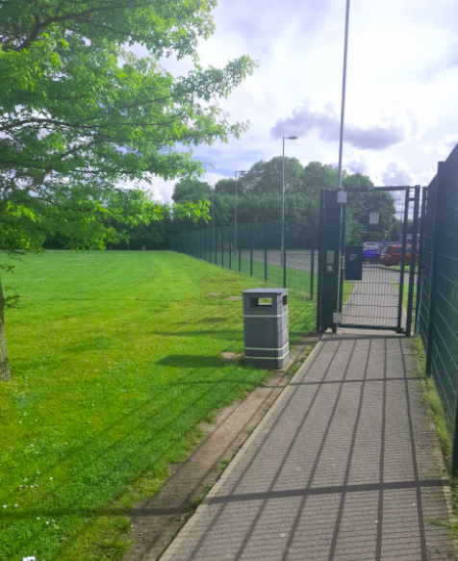
Picture 2 – Indicates second part of fence run and first path crossing where pedestrian gate 1 is to be located | 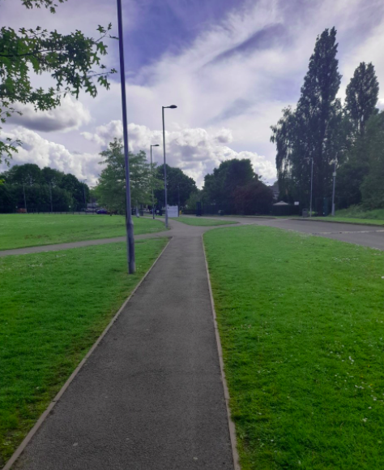
Picture 3 – Continuation of fence run to third pedestrian gate (by white car) | 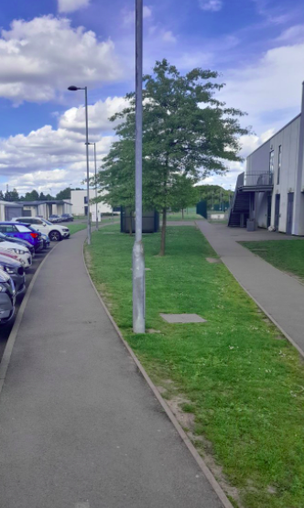
Picture 4 – indicates continuation of fence run and second pedestrian gate (Left hand path) | 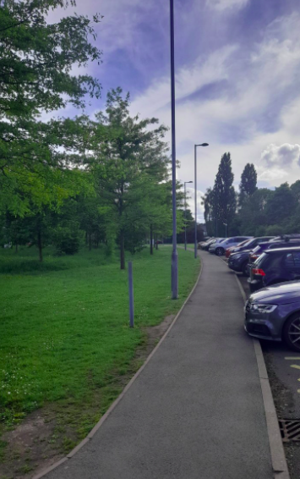
Picture 6 – indicates location of additional fencing to boundary line (over the grass bank area) | 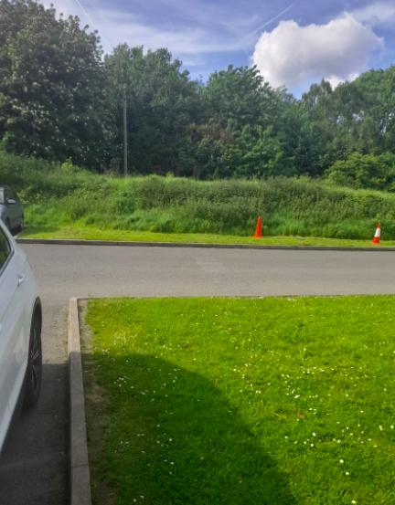
Picture 6 – indicates location of additional fencing to boundary line (over the grass bank area) | 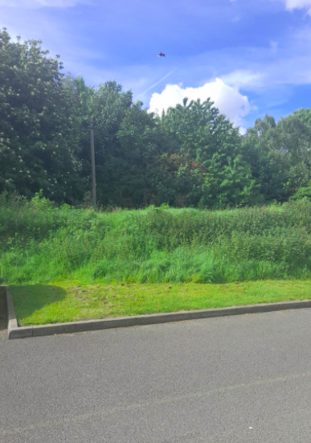
Picture 7 – Indicates return run for option C – internal fence boundary | 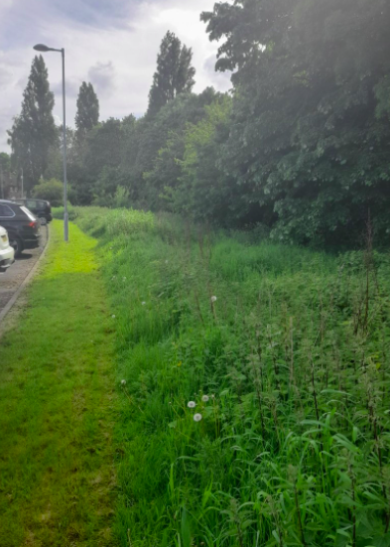
Picture 8 – Indicates return run for internal boundary fence Option C | 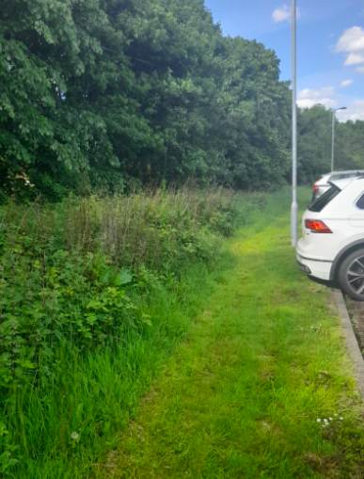

Internal pathway fencing (no external boundary fencing)

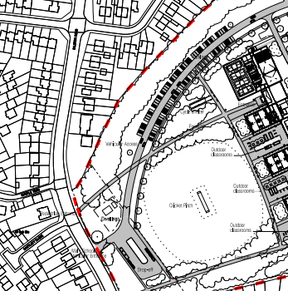

Section 3 Information Required from the Supplier

Provide us Contact Details of the person responsible for carrying out the work

- Main Contact

Name
Position
Company Name
Address
Telephone - Main
Telephone – Direct
Mobile
Fax
Email
Website

- Additional Contact

Name
Position
Company Name
Address
Telephone - Main
Telephone – Direct
Mobile
Fax
Email

Section 4 Pricing Schedule

All suppliers are required to complete the pricing table below -

S.No. | Item Description |  | Material |  | Cost | Delivery Schedule
 | Total Cost |  |  |  | £0.00
*Removal of all waste from site in line with waste policy
**Fees should be exclusive of VAT but inclusive of expenses and disbursements

Section 5 Evaluation

This tender will be scored using the following award criteria:

Criteria | Score
Price (75%) | 75
Quality/Delivery/Installation (25%) | 25

SCORING METHDOLOGY

Pricing

- The submitted Total Contract Cost (based on our requirements) using the rates submitted in the pricing schedule will be ranked and points allocated in ascending order from a maximum of 75% of the overall score. The lowest contract cost submitted will be set as the maximum score from which we will calculate the relative percentage scores of all other tenderers’ bids.

- In case a tender appears to be abnormally low in relation to the services to be provided, Central Regions Schools Trust will request a clarification in writing and/or explanation concerning its elements. Central Regions Schools Trust reserves the right to exclude a tender, if after a verification process based on the explanations and evidence received it comes to the conclusion that the tender is abnormally low.

Non-Technical
Scores under each Quality criteria will be awarded on the following basis:

Scoring Methodology | Scoring
Excellent: Fully meets requirements. Provided a clear & comprehensive response and evidence of expertise, experience and/or capabilities to the benefit of the institution. | 4
Good: Meets most requirements. Provided a response which evidenced most of the requirements relating to expertise, experience and/or capabilities to the benefit of the institution. | 3
Marginal: Meets some requirements. Provided a response which evidenced some of the requirements relating to expertise, experience and/or capabilities to the benefit of the institution. | 2
Unsatisfactory: Meets few requirements. The response did not demonstrate adequate levels of expertise, experience and/or capabilities and or no benefit for the Institution | 1
No Response | 0

Appendix A FORM OF TENDER

To: Central Region Schools Trust

Dear Sirs
- I/we have read the information provided in your Invitation to Tender and, subject to and upon the terms and conditions contained therein, I/we offer to supply the services described in the said tender documents in such manner as may be required.

- Terms and Conditions: I/we agree that this tender and any contract which may result there from shall be based upon those included in the Invitation to Tender Pack.

- The prices quoted in this Tender are valid for acceptance for 180 days from the final day for submission of Tenders and I/we confirm that the terms of the Tender will remain binding upon me/us and may be accepted by you at any time before that date.

- Law: I/we agree that the construction, validity, performance and execution of any contract that may result from this Tender shall be governed by and interpreted in accordance with English Law and shall be subject to the exclusive jurisdiction of the Courts of England and Wales.

- I/we agree to bear all costs incurred by me/us in connection with the preparation and submission of this Tender and to bear any further costs incurred by me/us prior to the award of any contract.

- I/we agree that any other terms or conditions of the agreement or any general reservation which may be printed on any correspondence emanating from me/us in connection with this tender, shall not be applicable to this Tender or Contract.

Signature:

Print Full Name:

Date:

In the capacity of:
(Please state official position, e.g., Director, Sales Manager, etc.)

being a person duly authorised to sign tenders on behalf of:

Company Name:

Address:

Appendix B DECLARATION OF BONA FIDE TENDER

1. We certify that this is a bona fide tender, and that we have not fixed or adjusted the amount of the tender by or under or in accordance with any agreement or arrangement with any other person. We also certify that we have not done, and we undertake that we will not do at any time before the hour and date specified for the return of this tender any of the following acts:

a) Communicate to a person other than the person calling for those tenders the amount or approximate amount of the proposed tender, except where the disclosure, in confidence, of the approximate amount of the tender was necessary to obtain insurance premium quotations required for the preparation of the tender.

b) Enter into any agreement or arrangement with any other person that they shall refrain from tendering or as to the amount of any tender to be submitted.

c) Offer or pay or give or agree to pay or give any sum of money or valuable consideration directly or indirectly to any person for doing or having done or causing or having caused to any other tender or proposed tender for the said work any act or thing of the sort described above.

2. We further certify that the principles described in paragraph 1 above have been, or will be, brought to the attention of all sub-contractors, suppliers and associate companies providing services or materials connected with the tender, and any contract entered into with the sub-contractors, suppliers or associated companies will be made on the basis of compliance with the above principles by all parties.

3. In this certificate, the word “person” includes any persons and anybody or association, corporate or otherwise; and “any agreement or arrangement” includes any such transaction, formal or informal, and whether legally binding or not.

4. I confirm that I accept any breach of the conditions of this Declaration of Bona Fide Tender will inevitably lead to the termination of the agreement.
Signature:

Print Full Name:

Date:

In the capacity of:
(Please state official position, e.g., Director, Sales Manager, etc.)

being a person duly authorised to sign tenders on behalf of:

Company Name:

Address:

Appendix C CONFLICTS OF INTEREST DECLARATION

Please complete Section A or B as appropriate
Section A

I/We warrant that:

  - There would be no conflict or perceived conflict of interest arising from any existing relationship that I/We might have, and the members of staff involved in the conduct of the procurement procedure*. If in doubt, please declare. I/We acknowledge that a failure by us to declare a potential conflict of interest, which I/We should have reasonably known about, may result in our disqualification from the tender process or a termination of any contract awarded as a result of this tender process.
Name:

Position/Status:

Company Name:

Address:

Date:

Section B
I / We warrant that:

  - There could be a possible conflict or perceived conflict arising from any existing relationship that I/We might have, and the members of staff involved in the conduct of the procurement procedure*
Please explain what the possible conflict or perceived conflict of interest may be and who it relates to and how it could have an adverse effect on this contract.

Name:

Position/Status:

Company Name:

Date:

*Means staff members of the Institution, or of a procurement service provider acting on behalf of the Institution, who are involved in the conduct of the procurement procedure or may influence the outcome of that procedure.

FREEDOM OF INFORMATION ACT

The Institution adheres to the Government’s Code of Practice on Access to Government Information, commonly known as Open Government. Under the Code of Practice, the Institution is obliged to provide details, upon request, regarding the expenditure of public money.

This may include, amongst other things, the disclosure of a winning tender price, the nature of the goods or services provided standards of service or performance and the tender evaluation criteria. If you wish your tender details to remain confidential, please signify on your tender return. (Subject to the public interest test)

For further information on the Freedom of Information Act 2000 please refer to the following guidance notes issued by the Information Commissioner, www.informationcommissioner.gov.uk

FOIA Guidance Note 2 – Information provided in confidence
FOIA Guidance Note 3 – The Public Interest Test
FOIA Guidance Note 5 – Commercial

