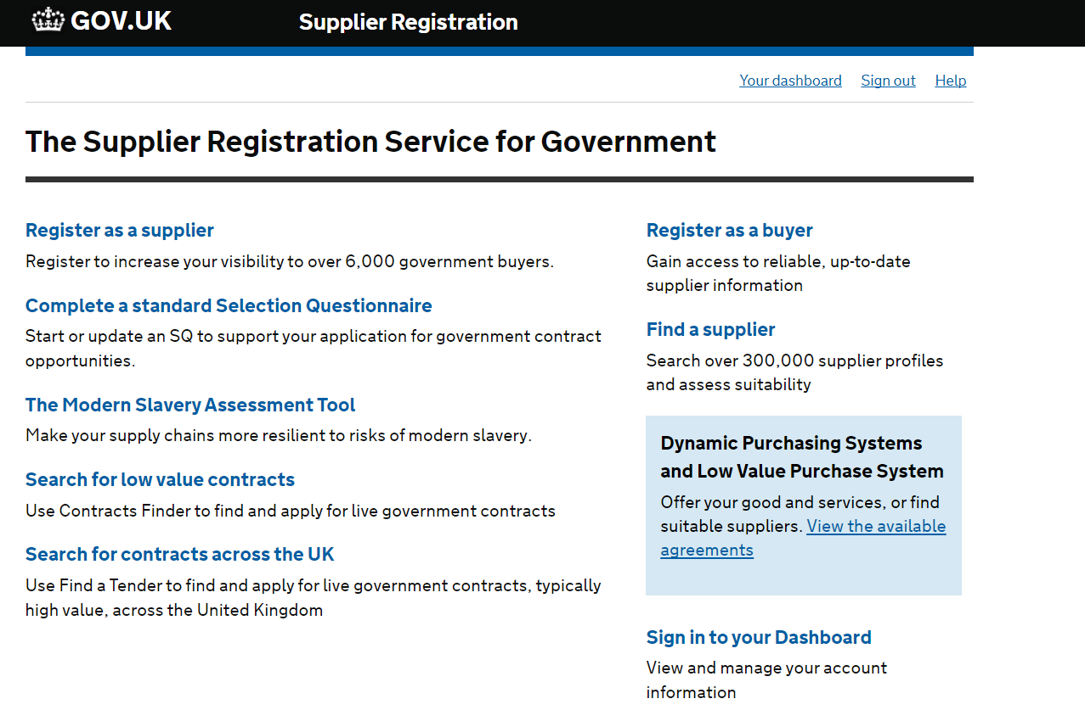

**Step 1:**

**Select ‘View the available agreements’**

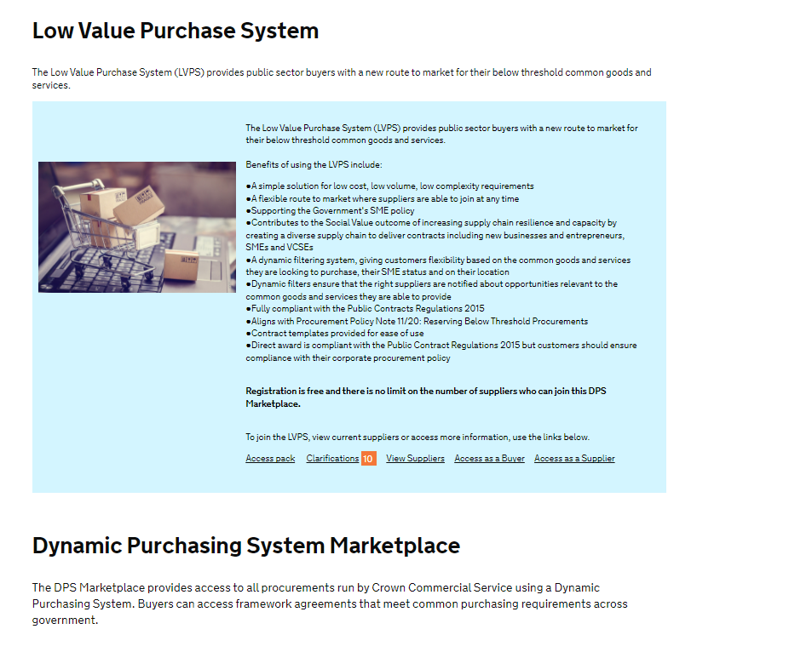

**Step 2:**

**Scroll down to ‘Construction’ link**

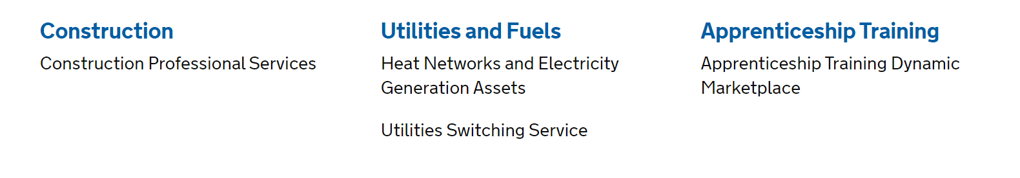

**Step 3:**

**Select ‘Construction’**

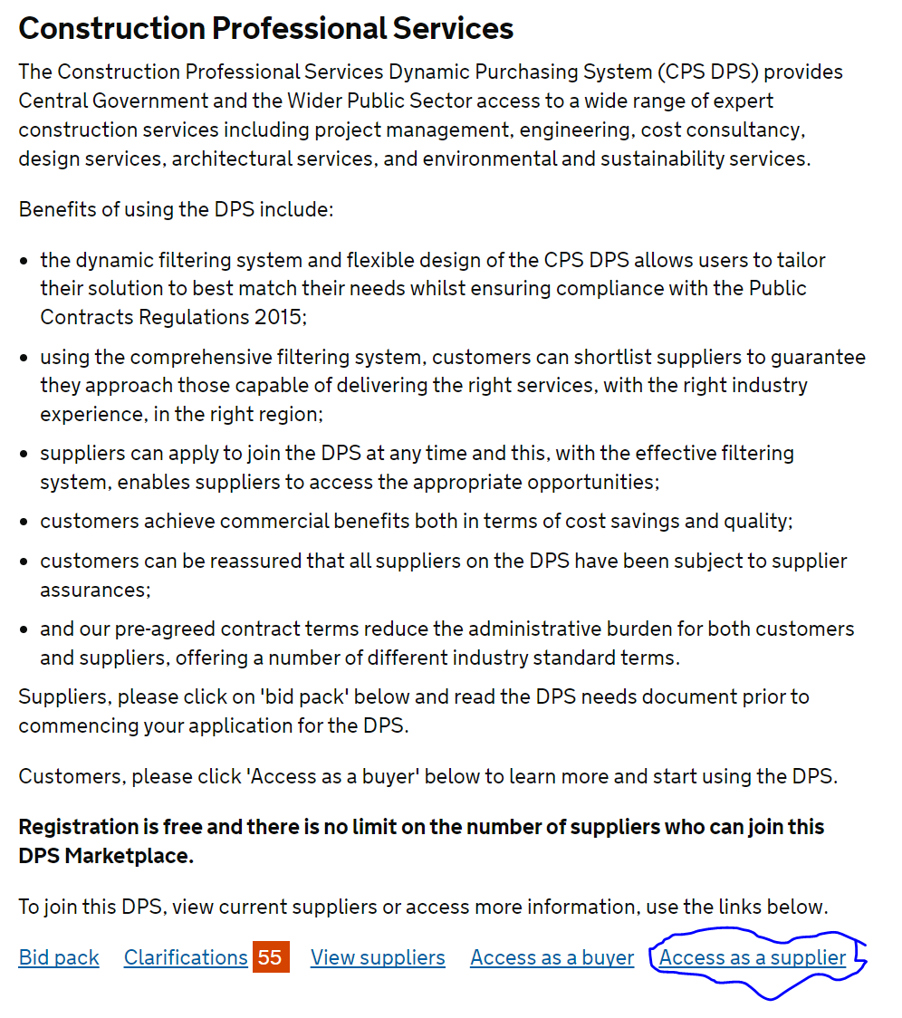

**Step 4:**

**Select ‘Access as a Supplier”**

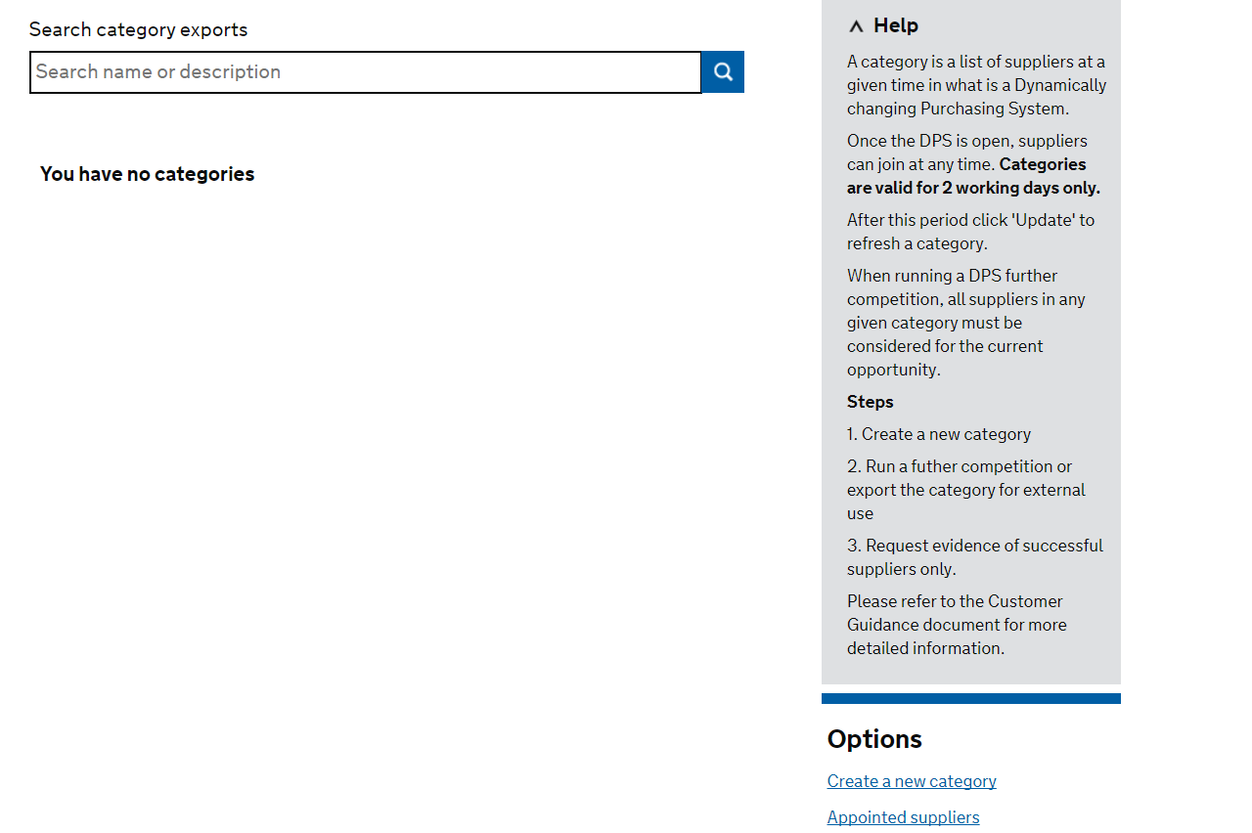

**Step 5:**

**Select ‘Create a new category’ –** this is an **example** and from the “Buyers” perspective. Supplier’s should have “update categories” section instead.

**Step 6:**

**Please click and add the following categories:**

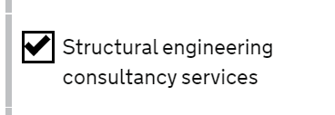

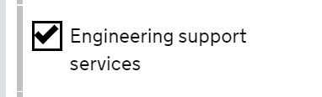

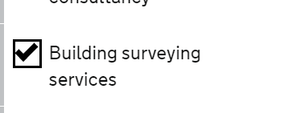

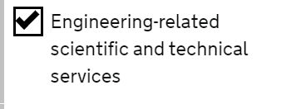

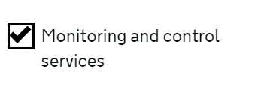

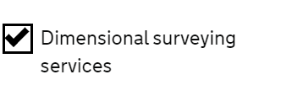

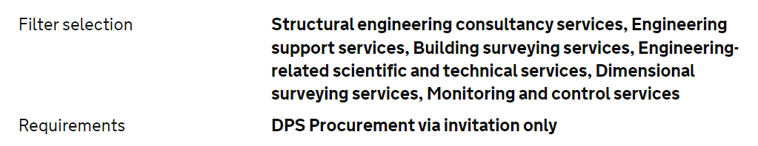

**Step 7:**

Save your categories.