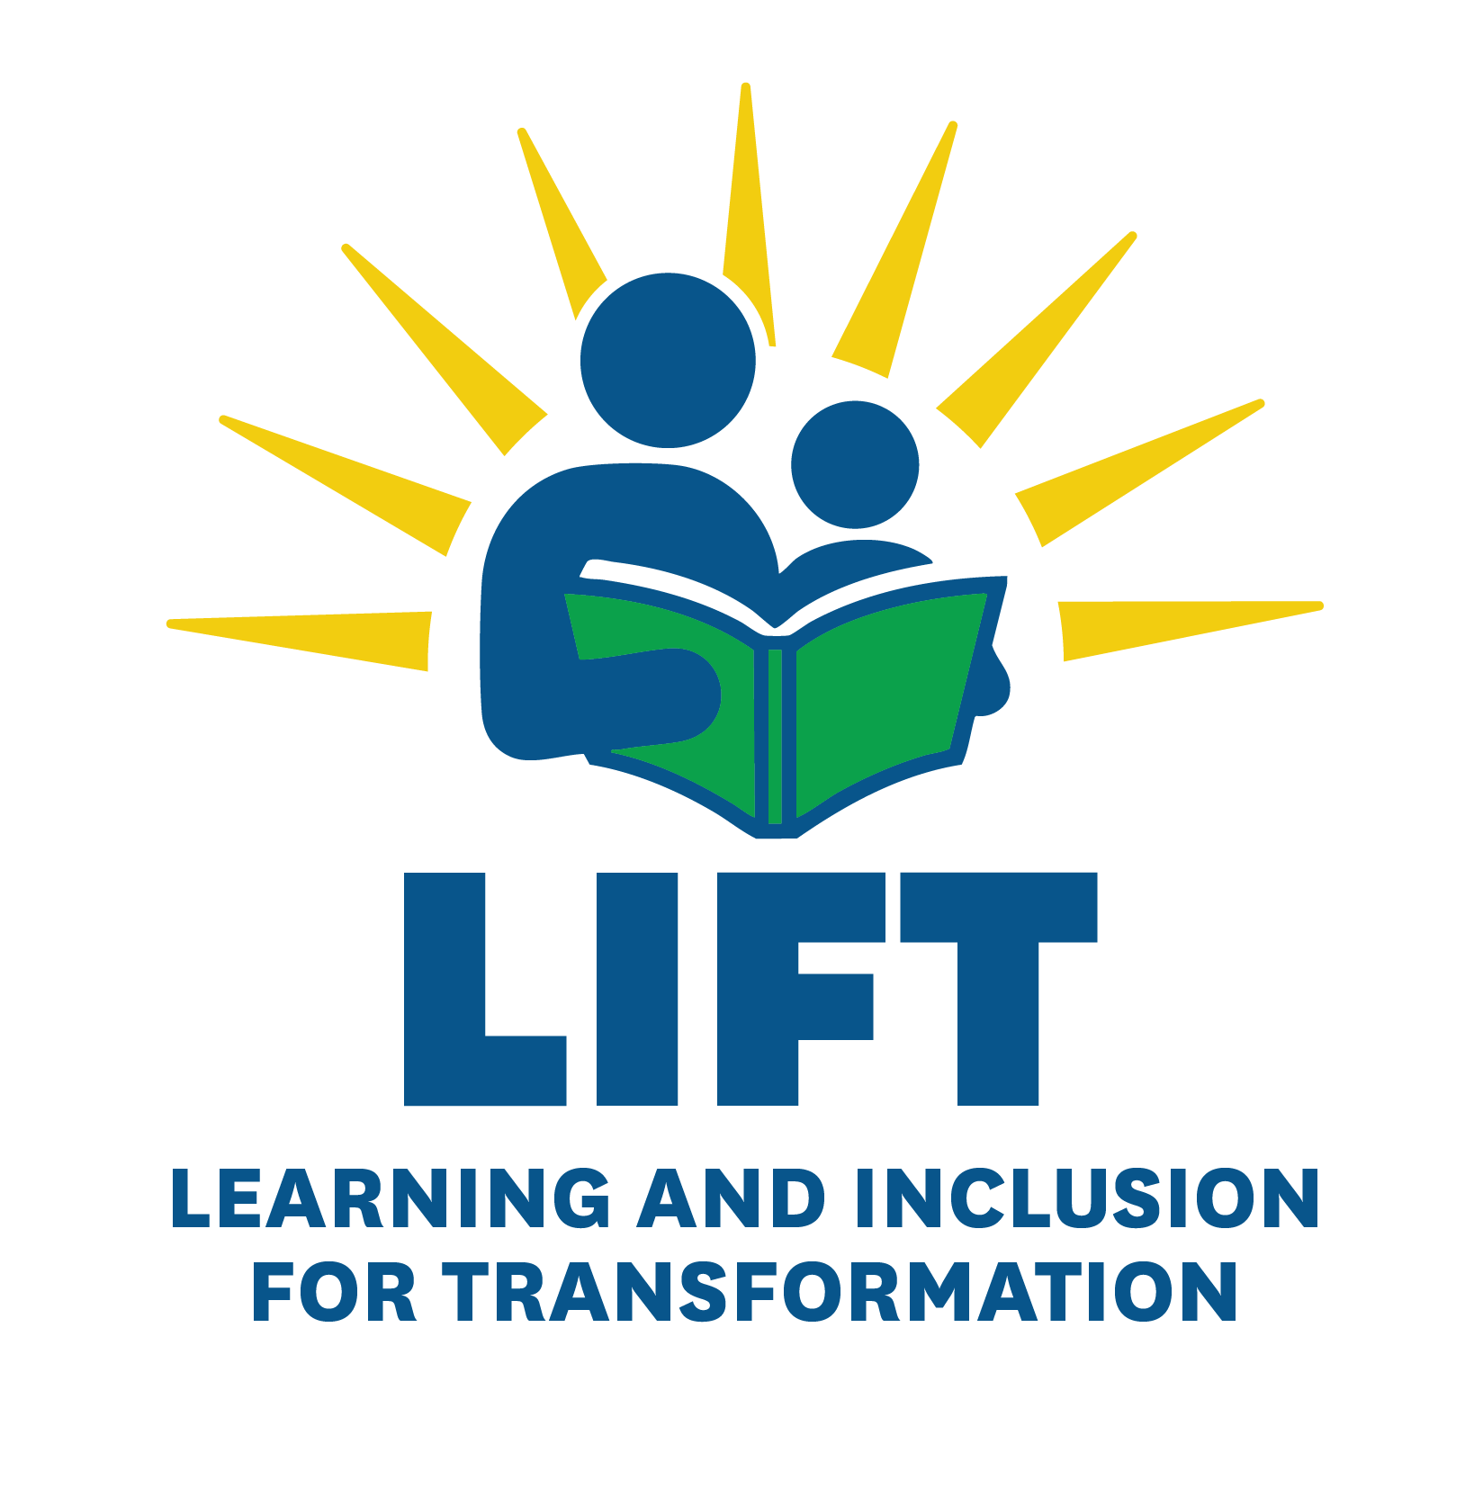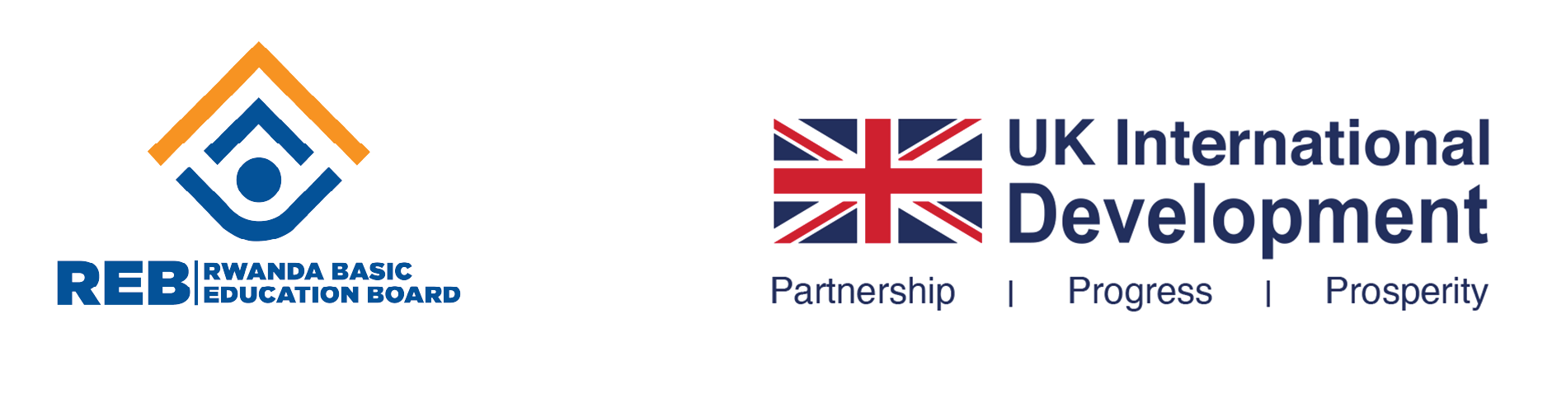

## **Rationale**

Learning and Inclusion for Transformation (LIFT) is a programme of the Ministry of Education that is funded by the UK Government through FCDO and aims to improve foundational learning outcomes for P1-P3 children in English and mathematics in Rwanda’s primary schools. LIFT supports adolescents aged 12-17 to return to formal education or access alternative education pathways and enables access to education for children with disabilities.

Focusing on those most at risk of not completing basic education, LIFT is removing barriers to learning, creating safe school environments and developing partnerships for equitable education, so every child has the opportunity to thrive.

The programme will run until 2030. It is implemented by a consortium of partners UNICEF, Cambridge Education/ Mott MacDonald and TETRATECH.

Cambridge Education (CE) will deliver its interventions across two components, with the following aims:

1. to improve learning outcomes in English and maths for both girls and boys in lower primary (P1-P3). (Foundational Learning component)
2. to support 28,000 out of schoolgirls and boys to either return to school or access alternative learning pathways (Out-Of-School component)

Across both areas, LIFT will focus on technical assistance and advocacy to the government around foundational learning and out-of-school girls and boys, to ensure approaches are scaled and evidence from the programme feeds into policy and programming in the sector.

The intended impact of LIFT is for children and adolescents, including the most disadvantaged, to have the knowledge and skills to achieve their potential and contribute to Rwanda’s economic development.

There is little evidence on issues around safety and violence in schools in Rwanda. This study would aim at exploring how safe students feel in school currently, why and how to improve this.

## **Objectives**

The main objective of this study is to better understand the current issues around violence and safety in schools including corporal punishment in Rwanda.

The study will generate critical evidence on:

* The types of violence perpetrated by both school staff and peers present in formal schools, including psychological, physical/corporal punishment, and sexual violence.
* How students and staff perceive safety within and around school environments.
* The effectiveness of existing reporting mechanisms and response systems at the school, community, and district levels.

This evidence will inform and support:

* **Our LIFT programming**: Helping us adapt our interventions to more effectively address the identified challenges.
* **Our influencing efforts**: Using the findings to engage with decision-makers at both central and decentralized levels to advocate for meaningful change.
* **The work of OOS Fund grantees**: Enabling them to refine their programming as they support Back-to-School (BTS) pathways.

## **Research questions**

1. What are the features of psychological, physical and sexual violence in Rwandan formal schools? who are the perpetrators? who are the victims/ survivors?
2. What is the frequency, trends, and effects of corporal punishment in formal schools?
3. How safe do students and school staff feel in and around school? Are safety risks perceived to be different for different groups (boys/girls, pregnant learners, CwD, etc)?
4. Do students and school staff understand what constitutes violence in school and know the potential mechanisms to report it?
5. What do students or school staff do when they feel unsafe or witness incidences of violence?
6. What are the mechanisms that districts, sectors, communities and schools have in place for preventing violence, identifying potential safety concerns, responding to reports of violence in and around school? What do schools do when violence occurs? Does it vary depending on perpetrators or victims?

## **Research framework**

|  |  |
| --- | --- |
| **Research question** | **Breakdown** |
| What are the features of psychological, physical and sexual violence in Rwandan formal schools? | How is violence perpetrated in primary schools? Against students? Against school staff?  Who are the perpetrators?  who are the victims/ survivors? Are specific groups more targeted/ more vulnerable? |
| How safe do students and school staff feel in and around school? | Are safety risks perceived to be different for different groups (boys/girls, pregnant learners, CwD, etc)?  Where in school and around school do students feel safe and not safe? Why? |
| Do students and school staff understand what constitutes violence in school and know the potential mechanisms to report it? | Are students and school staff able to identify what violence is and is not?  Do they know how to report violence when they witness it/ experience it? |
| What do students or school staff do when they feel unsafe or witness incidences of violence? | Do students or school staff report violence if they experience it or witness it? if not, why not?  What other response mechanisms do they use? |
| What are the mechanisms that districts, sectors, communities and schools have in place for preventing violence, identifying potential safety concerns, and responding to reports of violence in and around school? | What are the mechanisms put in place by communities, districts, sectors and schools to prevent violence in school, including raising awareness, training etc?  How do schools, districts, sectors and communities identify potential safety concerns in school/on the way to school, if at all?  What do schools, districts, sectors and communities do when violence occurs?  What do they do when a formal report is made?  Does the response vary depending on perpetrators or victims? |

## **Methodology**

This study will adopt a mixed-methods approach, combining quantitative and qualitative data collection and analysis to provide a comprehensive understanding of safety and violence in Rwandan basic education system. The design ensures both breadth (through a nationally representative quantitative approach) and depth (through participatory and narrative methods), with a strong emphasis on ethical, inclusive, and child-friendly practices.

The target population includes 12 years basic education schools with children from P1 to S6, teachers, headteachers, and parents. To engage students, the study will utilize participatory techniques designed for children and adolescents. Examples include mapping exercises where children identify safe and unsafe areas within their school environment, and creative methods such as visual storytelling or role-play to facilitate them expressing their experiences in non-verbal and age-appropriate ways.

**Quantitative methods**

These will include a structured survey administered to students and teachers. The survey will consist primarily of closed-ended questions to allow for standardized data collection and statistical analysis. For students specifically, the structured survey could be administered through child-friendly approaches, suitable for this type of sensitive topics. This approach will help quantify the prevalence and patterns of safety-related issues across schools.

**Qualitative methods**

Qualitative methods will be used to complement the survey data and gather insights and recommendations from system actors and students on how to enhance safety in schools. These methods aim at exploring perceptions, lived experiences, and contextual factors in greater depth. The study will employ a range of approaches including:

***Key Informant Interviews (KIIs):*** These will be conducted with school leaders to understand institutional perspectives and experiences on school safety, reporting mechanisms, and existing challenges.

***Focus Group Discussions (FGDs):***FGDs will be held with caregivers and teachers to explore community-level views and experiences on safety in and around schools. These discussions will be designed to encourage open dialogue and shared experiences.

***Participative activities with primary school students:*** Primary school students can be very young and will need to be encouraged to share experiences through participative and child-friendly approaches such as drawing, games, etc, as opposed to formal FGDs. The consultant will propose in their methodology child-friendly participative activities to understand learner-specific perceptions and experiences around violence. These discussions will be conducted in gender-segregated groups by an enumerator of the same gender to ensure comfort and openness.

Consultancy firms could look at the following resources for information on child-friendly participatory methods but are also free to propose whatever methods they feel are most suitable:

* [River of Life](https://oercollective.caul.edu.au/qualitative-research/chapter/__unknown__-18/) (used in the Girls Education Challenge, for example)
* [Mapping of safe and unsafe areas in school](https://assets.publishing.service.gov.uk/media/57a08ce1ed915d622c001645/paper54.pdf) (link to comprehensive research conducted for DFID in several sub-Saharan countries using different participatory methods)

In each school, the following activities will be completed:

***Quantitative****:*

* Questionnaire administered to teachers
* Questionnaire administered to students (through child-friendly approaches)

***Qualitative****:*

* KII with school leaders
* FGD with teachers
* FGD with parents of students attending the school
* Participatory activity with female students
* Participatory activity with male students

We assume enumerators will need to work in pairs and spend one full day in each school they visit.

**Sampling strategy**:

The quantitative survey will be nationally representative and needs to allow for presentation of results by rural and urban areas, by education level (lower/upper primary and lower/upper secondary), and by gender for students and teachers.

The qualitative data collection does not need to be nationally representative and can be done with a much smaller number of schools. It will focus specifically on the most vulnerable children, including a focus on how children with disabilities experience violence in school, and other groups of vulnerable students such as pregnant learners and overaged children.

We are open to either both methods (quantitative and qualitative) being used at the same time, or for a sequential approach, with quantitative survey being implemented first, and the qualitative research used to deepen some of the findings.

## **Research ethics and safeguarding**

Safeguarding is a fundamental commitment to the LIFT programme. It refers to the responsibility to prevent and respond to any form of harm, including abuse, violence, exploitation, or neglect, particularly when perpetrated by LIFT staff or representatives against children and adults at risk.

All staff and consultants engaged in the Safe Schools Study are required to uphold the highest standards of ethical conduct and safeguarding throughout the research process. This includes ensuring that all research activities, especially those involving direct engagement with individuals (children), communities, and other stakeholders, are conducted in a manner that protects the safety, rights, and dignity of all participants.

Specifically, consultants must:

* Conduct a comprehensive assessment of potential risks and benefits associated with the research, considering the diverse backgrounds and vulnerabilities of participants, and adjust methodologies accordingly to minimise harm. This might involve having psychosocial support available for respondents as we are asking them to discuss difficult topics.
* Adhere to established ethical research principles, including obtaining informed consent, ensuring confidentiality and anonymity, and implementing appropriate measures to protect both participants and researchers from harm.
* Fully comply with the LIFT Safeguarding Policy and Code of Conduct and promptly report any safeguarding concerns in accordance with established procedures.

## **Purpose of the consultant**

To design and execute a comprehensive data collection exercise that captures the reality of safety and violence across Rwandan schools. This will be achieved through a structured research design and the development of appropriate tools, training of the data collection team, and systematic data collection and cleaning. The findings will be analysed and compiled into a comprehensive report to inform programming, advocacy and policy influence, and partner interventions.

## **Responsibilities for the consultant**

The selected consultancy firm is expected to perform the following activities:

1. **Develop a work plan**

This entails developing a detailed plan outlining how the study will be conducted, including what activities will take place, who will be responsible for each task, when they will occur, and the overall timeline. The workplan will be approved by CE.

1. **Research Design and Tools**

This involves defining the study’s scope, methodology, and instruments.

Key activities include:

* In collaboration with CE, the consultant will review and finalize the research questions and objectives to ensure alignment with the study’s overall purpose.
* Work with CE to select appropriate methodologies—such as qualitative approaches (e.g., participatory activities and storytelling that reflect diverse realities), quantitative surveys, or mixed methods—suited to the research context.
* In collaboration with CE, agree on the appropriate sampling techniques to ensure national representativeness and alignment with the study objectives.
* Co-design data collection tools with CE that are age appropriate and contextually relevant —such as structured questionnaires, interview guides, and observation checklists—tailored to capture psychological, physical, and sexual violence, as well as perceptions of safety.
* Programming of tools into the digital data collection platform

1. **Training of Data Collection Team**

This ensures high-quality, ethical, and consistent data collection. It includes:

* Recruiting qualified enumerators and supervisors with experience in child protection or education research.
* Conducting training workshops that cover research ethics, child safeguarding, data collection techniques and tool administration, and the use of digital data collection platforms (where applicable).
* Simulating field scenarios to build enumerators’ confidence and ensure consistency in data collection practices.
* Before full deployment, pilot the data collection tools in selected schools to ensure clarity and cultural relevance, gather feedback, and adjust instruments accordingly.

1. **Data Collection and Cleaning**

This involves gathering and preparing data for analysis:

* Deploying trained teams to selected schools and communities across Rwanda.
* Collecting data through interviews, surveys, and observations, ensuring informed consent, confidentiality, and anonymity in line with ethical standards.
* Monitoring data quality in real-time, using digital tools where possible.
* Implement data cleaning procedures by checking for completeness, consistency, and accuracy, and addressing any anomalies or errors to ensure the dataset is ready for in-depth analysis.
* Provide a comprehensive clean dataset accompanied by detailed documentation

1. **Data Analysis**

This involves a combination of descriptive, quantitative, and qualitative techniques, transforming raw data into meaningful insights that support evidence-based decision-making.

* **Descriptive analysis** to summarize key characteristics of the data, providing an overview of respondent demographics and general trends.
* **Quantitative analysis** using statistical software to identify patterns, trends, and correlations—such as the prevalence of different types of violence and variations by region, gender, or school type.
* **Qualitative analysis** of interview and focus group data to explore nuanced perceptions, lived experiences, and contextual factors influencing safety and violence in schools.
* **Triangulation of findings** from multiple data sources to enhance the credibility, validity, and reliability of the results.

1. **Report Writing**

This involves synthesizing the study’s findings into a clear, actionable report that effectively communicates insights and supports decision-making. CE and the consultant will agree on the report structure. Key activities include:

* Structuring the report to include essential components such as background, methodology, key findings, and practical recommendations.
* Visualizing data using charts, graphs, and infographics to enhance clarity and engagement.
* Tailoring recommendations to meet the needs of various audiences, including LIFT programme, policymakers, and grantees.

## **Responsibilities for Cambridge Education**

* Provide strategic oversight and contextual guidance throughout the evaluation process.
* Review and provide timely feedback and approval on all draft deliverables listed under the contractor’s responsibilities.
* The consultancy firm is responsible for managing their own logistics and administrative arrangements; CE will offer guidance and support as needed.
* Coordinate and arrange necessary meetings for the consultancy firm at the start of the evaluation process.
* Provide office space as needed for progress review meetings and presentations.

## **Timeline**

This is a suggested timeline, to be further detailed by the Consultant:

|  |  |
| --- | --- |
| **Activity** | **Duration** |
| Inception and design | 2 weeks |
| Workplan development |
| Training of data collectors and instruments pilot | 1 week |
| Data collection and cleaning | 2 to 4 weeks |
| Data analysis | 2 weeks |
| Report writing and PPT presentation of findings | 2 weeks |

## **Deliverables**

* Research framework including research tools, training content, and ethics / safeguarding protocol.
* Documented processes and evidence of completed training, piloting, and field data collection activities.
* Full and clean datasets for both quantitative and qualitative data collection
* Approved Report (structure of the report to be approved previously by LIFT team)
* PPT presentation for dissemination

## **Requirements and Evaluation criteria**

The selection of the consultant will be determined based on the following criteria: previous experience, skills of the proposed consultancy firm team members, technical proposal, and financial proposal.

|  |  |
| --- | --- |
| Criteria | Weighting |
| Technical proposal | **80%** |
| * Similar previous experience of the consultant (provision of examples of similar past work in Rwanda showing at least 10 years of cumulative experience) | 20% |
| * Proposed methodology and coherence of the approach | 40% |
| * Skillset of the team members (provide CVs of main team members including the field supervisors) * Lead researchers must have solid experience conducting similar research, and a diploma in a relevant field (education, social studies, sociology, psychology, etc) * The lead consultant should have 10 years of experience in inclusion and/or Gender-based violence and/or violence in school. * The team must include a statistician/data analyst with at least 7 years of experience | 20% |
| Financial proposal | **20%** |
| Total | **100%** |

## **Eligibility**

Eligible vendors must meet the following criteria, and their submission must be documented in this order:

* Technical proposal
* Financial proposal
* Evidence of Company Registration/ Incorporation (if applicable)
* Evidence of Public Liability Insurance, Professional Indemnity Insurance and Employee Liability Insurance (if applicable, depending on the base country)
* Evidence of Tax Compliance for 2023/2024 Financial Year of the Revenue Authority of the country the supplier is registered
* Postal address and verifiable contact telephone / cell phone numbers
* Any relevant accreditations or quality certificate(s) such as ISO standards, etc.
* Any other relevant information such as ethics policy, anti-slavery policy, code of conduct etc.
* Bids must be valid for 60 days from date of submission of the bids

## **Submission**

Any questions relating to this invitation should be forwarded during official working hours and no latter than 24th July 2025 to Anca.Savu@camb-ed.com and to [Chloe.Gonthier@mottmac.com](mailto:Chloe.Gonthier@mottmac.com)

All bids should read the following in the subject line: “Invitation for bids for safe school study Rwanda” No: IFB/MML/RW/2025. All bids should be submitted electronically by email ONLY to: Anca.Savu@camb-ed.com keeping in cc’d Chloe.Gonthier@mottmac.com

The deadline for submission is 23:59 Rwanda time on Wednesday 6th August 2025. Late submissions shall not be considered.

All bids should be addressed to: **Anca Savu**

Cambridge Education

22 Station Road

Cambridge CB1 2JD

United Kingdom