

|  |  |
| --- | --- |
| **Report subject** | Mill Meadows adventure playground – consultation results |
| **Committee name** | Adventure Playground Working Group |
| **Committee meeting date** | 29th September 2023 |
| **Report author** | Sheridan Jacklin-Edward, Town Clerk |
| **Report contact details** | clerk@henleytowncouncil.gov.uk / 07595 608577 |

1. **Executive summary**
   1. To summarise the results of the Mill Meadows adventure playground consultation and to make recommendations on the specification for the playground refurbishment.

**2. Background information**

* 1. The adventure playground at Mill Meadows was installed in 2009 and has been deteriorating in recent years, with a number of items of play equipment no out of use.
  2. A site visit was undertaken on 15th August 2023 with Cllrs Hinton and Dodds, the Town Clerk, Estates Manager, Parks Manager, and a Park Warden.
  3. Following this, a public consultation was held between 1st and 15th September 2023, consisting of an online survey, which was advertised on notices around the adventure playground and on social media.

**3. Detailed consideration**

**Respondent demographics**

* 1. 185 responses were received to the public consultation.
  2. Below are the results of the questions regarding the characteristics of the respondents. The most frequent respondents were female Henley residents between the age of 31-50, most likely parents / carers of children using the playground, responding on behalf of the child(ren).
  3. There was also a strong response from neighbours of Mill Meadows (27 in total).

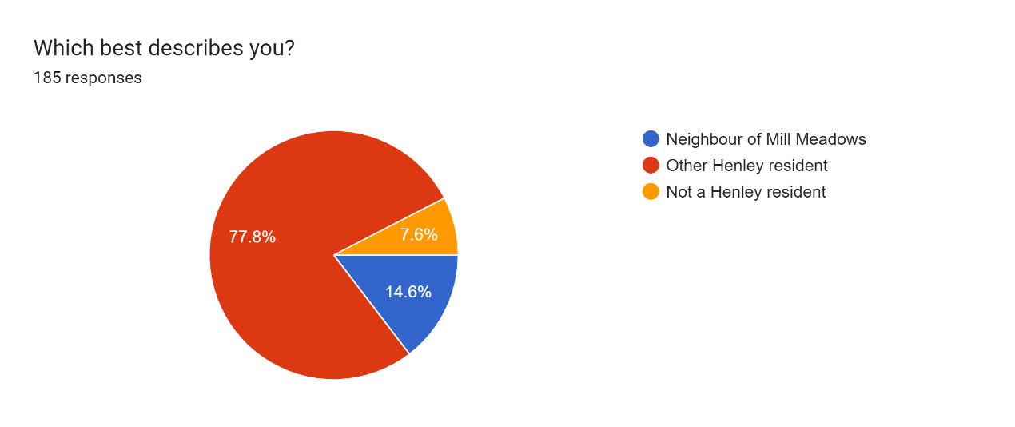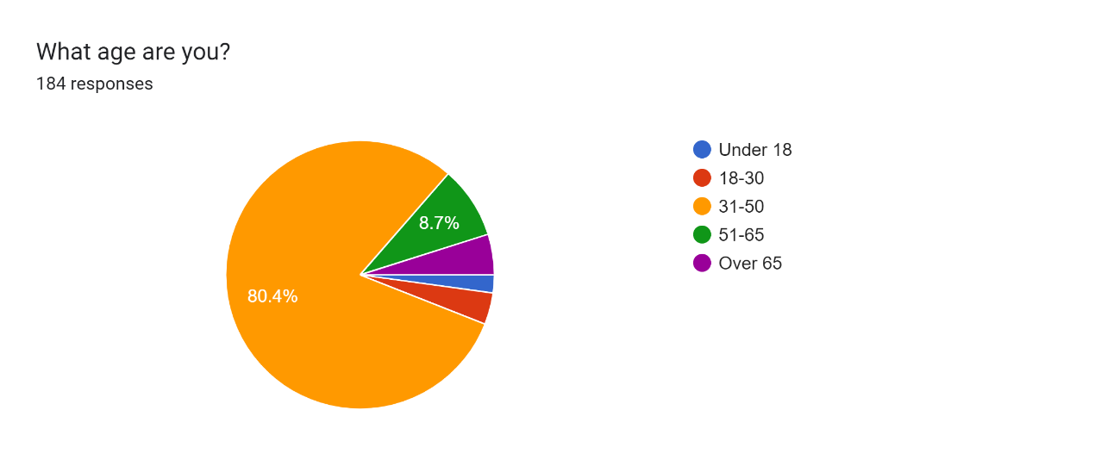

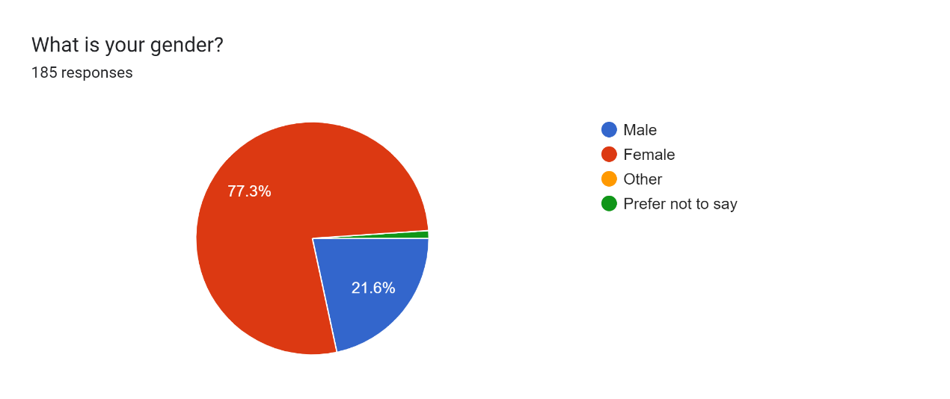

**Favourite existing play pieces**

* 1. Respondents were asked for their favourite item of existing equipment. The responses were (inc. number of mentions):

Zipwire – 121 Tower / bridge – 30

Slide – 55 Climbing wall – 13

Swings / tyre swing – 50 Balancing / obstacle course – 3

* 1. The following should be considered:

1. As a free text response, each respondent could include none or more than one item;
2. As many items of equipment are out of use, they may be underrepresented;
3. Those referring to the tower may also include the slide within that.

**Suggestions for new play pieces**

* 1. Respondents were asked for suggestions for other pieces they would like to see within the playground. Responses were (inc. number of mentions):

Bigger climbing wall – 35 More / better slides – 17

Trampoline – 31 Tunnel slide – 15

More / better swings – 27 Water feature – 10

Monkey bars – 25 Roundabout – 8

Fortress / Pirate ship – 23 Bridges – 8

Obstacle course – 20 Tunnel – 7

* 1. Other suggestions with fewer than five mentions were:

Sensory equipment; fireman’s pole; slopes; table tennis; accessible equipment; basketball; spin seat; see saw; sandpit; and climbing nets.

**Suggestions for non-play equipment improvements**

* 1. Respondents were asked about any other changes they would like to see, other than related to the play equipment. Responses were (inc. number of mentions):

MoreBenches and tables – 95 Coffee / refreshment stand – 9

Different surfacing – 44 Additional access point – 5

More shade – 11 Keep current playbark surface – 5

* 1. Other suggestions with fewer than five mentions were:

Water refill station; more bins; locked at night; better no dogs and max. age signage; better accessibility; scooter / bike parking; free car parking.

**Consultation with councillors and staff**

* 1. At a site visit with town councillors and Parks and Estates staff, the following points were made:

1. It should be kept as timber / natural look;
2. Additional comfortable seating wasn’t included so as to not encourage older teenagers;
3. The age range should follow on from the toddler playground, with a c.12 year old cut off;
4. Play items should be linked together into an assault course;
5. The playbark should be kept but with matting underneath impact zones;
6. More risk / adventure should be encouraged;
7. The existing monolith would need to be felled but could be kept as a play feature;
8. There should be more mounds / tunnels;
9. The entrance way should be resurfaced to take into account desire lines;
10. There should be an additional entrance point;
11. More consideration should be given to accessibility and the Make Space for Girls campaign;
12. The design would need to take into account tree roots and resilience to flooding.

**Consideration of any conflicts**

* 1. **Seating**. Comfortable seating had previously been avoided due to the fears of antisocial behaviour. However, it would appear that this is outweighed by the needs of parents and carers of children using the playground. Therefore, it is recommended that additional comfortable seating is installed and alternative measures to deter antisocial behaviours are investigated.
  2. **Surfacing**. The playbark has been favoured by staff due to its natural appearance and low maintenance, compared with the high cost wetpour surfacing, which is also prone to shrinkage and degrading. However, it is also recognised that playbark can be messy (e.g. getting into shoes and lead to dips in heavily-used areas). It is therefore recommended that contractors be asked to advise on the best solution.
  3. **Water / sand features.** Whilst there were several suggestions for water and sand features, it is highly unlikely that these would be able to be incorporated within the current play area due to lack of space and costs (esp. water feature).
  4. **Coffee / refreshment stand.** There are two cafes / kiosks close to the playground (c.130m and 160m) and an additional kiosk is unlikely to be viable.

**Recommendations for specification**

* 1. Given the outcome of the consultation with both users and councillors / staff, it is recommended that the following is included in the specification for the new playground:

1. Play equipment must include:
2. **Zipwire**;
3. Multiple **slides** including a **tunnel slide** and **wider slide**;
4. Multiple **swings**, including a **tyre swing** or similar;
5. Extensive **themed** high-level **climbing frame** (e.g. pirate ship or fortress) including climbing ropes / nets and possibly a fireman’s pole or similar;
6. An **obstacle course**, perhaps linking to the climbing frame as one large circuit, and including monkey bars;
7. A challenging **climbing wall**, perhaps incorporated into climbing frame;
8. An in-ground **trampoline**;
9. A **tunnel** and **mound**;
10. A **spin / roundabout** feature.
11. Play equipment must:
12. Be **predominantly timber** and as natural in appearance as possible;
13. Be **durable** (including long warrantees) with parts easily maintained and replaced;
14. Be **challenging** for the target age range of 5-12 year olds;
15. Be as **accessible** and **inclusive** as possible, incorporating sensory elements and considering recommendations of the Make Space for Girls campaign;
16. Give consideration to the Council’s immediate **neighbours** to ensure that noise from users is not excessive. This includes no basket swing or similar swing aimed at multiple users is installed;
17. Take into account the felling of the existing **monolith** and **tree roots** around the site, so as to not endanger the **health of existing trees**, as well as take into account the needs of any new tree planting;
18. **Maximise use** of the existing site.
19. Other specification to include:
20. **Comfortable seating**, including **tables**, around the site, especially in the existing shade;
21. Consideration for **alternative surfacing** options such as bonded rubber mulch or matting, to replace or complement existing play bark.
22. Options for **increasing shade** either through planting or artificial shade, with any metal play equipment likely to get hot (e.g. slides) kept out of direct sunlight as much as possible;
23. An area for **bike, scooter, pram parking**;
24. An **additional self-closing access point** towards the east end of the playground.
25. The design should actively respond to the **climate and ecological emergencies** ensuring that any adverse impact on the climate is mitigated and that it leads to a net biodiversity gain at the site.
26. Other works to be carried out by the Council include:
27. **Resurfacing outside entrance** (and any new entrance) to take account of desire lines across grass;
28. Better **signage** stating that **dogs are not permitted** and giving the **recommended age range** for the playground;
29. Look into the possibility of a **water refill station** near to the playground.

**4. Impact assessment**

* 1. The Town Council has a statutory duty to consider the effects of its decisions on biodiversity, and crime and disorder in the area. As the Council has also declared a climate emergency, this should also be considered.

1. **Biodiversity** – the project presents opportunities to improve biodiversity at the site and this will be incorporated within the design. Given that the site is prone to flood, the Council should ensure that this will not lead to any pollution of the river.
2. **Crime and disorder** – the Council should ensure that any changes to the current site do not encourage crime or antisocial behaviour and that, where this is likely, such as the provision of benches and tables, steps are taken to mitigate the effect. This may include increased CCTV coverage; locking the playground at night; and / or improved signage.
3. **Climate emergency** – the Council should give consideration to the entire life cycle of the playground when sourcing materials and considering installation, to ensure the sustainability and durability of materials; and ensuring the carbon footprint of the materials and installation is kept to a minimum.

**5. Recommendation**

5.1. It is recommended that the Working Group **RESOLVES** that the recommended specification in 3.15 of this report be incorporated into the invitation to tender.