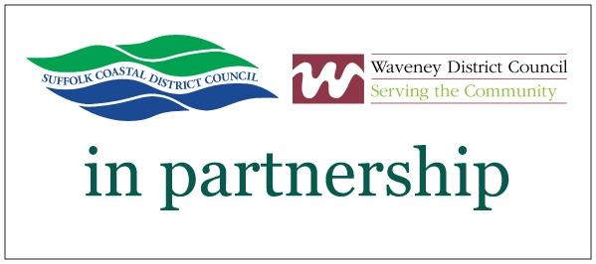

Waveney District Council is seeking suitably qualified contractor(s) to undertake the annual servicing, maintenance and ongoing responsive repair of fire detection systems and fire extinguishers located in their Sheltered Housing Schemes across the Waveney District Council area.

The contract will also cover the ongoing responsive repair of door entry systems and the ongoing responsive repair of warden call systems on an agreed call out charge/hourly rate basis together with the supply of fire extinguishers and fire blankets.

A map of the Waveney District Council area can be viewed by following the link below:

http://www.eastsuffolk.gov.uk/assets/Your-Council/Procurement/Waveney-District-Map.pdf

Design, installation and commissioning of new fire detection systems, design, installation and commissioning of new door entry systems and design, installation and commissioning of new warden call systems do not form part of the requirement and are subject to separate arrangements.

Further information will be found in the Invitation to Bid documents.

Procurement Reference: PROC159

The Invitation to Bid will be conducted via the Delta-eSourcing solution Quick Call; interested parties can view the Invitation to Bid documents once they have expressed an interest, registration has taken place and the procurement open date has been reached..

To respond to this opportunity:
- Please go to the Delta-eSourcing website www.delta-esourcing.com and register as a supplier.
- Please send your expression of interest to Pau.Aldrich@eastsuffolk.gov.uk no later than noon on Wednesday 22nd March 2017
- Please include the email address that you used to register onto the delta-eSourcing system and a contact telephone number in your expression of interest.
- The Delta-eSourcing Quick Call will be open from 14:00 Hours on Wednesday 22nd March 2017 to all those bidders who have registered and expressed an interest before the expression of interest closure date. The registered suppliers will then receive an email from Delta-eSourcing once the Quick Call is live and will then be able to view the Invitation to Bid documents.

The Quick Call will close at noon on Wednesday 12th April 2017, any bids received after this date and time will be rejected.

If you require any further information at this stage please do not hesitate to contact paul.aldrich@eastsuffolk.gov.uk

All rights reserved (15th March 2017). This advert is expressly provided to and solely for the use of Suffolk Coastal District Council and Waveney District Council and must not be used by or distributed to any other party without the prior written consent of Suffolk Coastal District Council and Waveney District Council who accept no liability of whatsoever nature for any use by any other party.

