Hyde Park - Rose Garden Gates
Design Competition
Essential information and Guidance for entrants

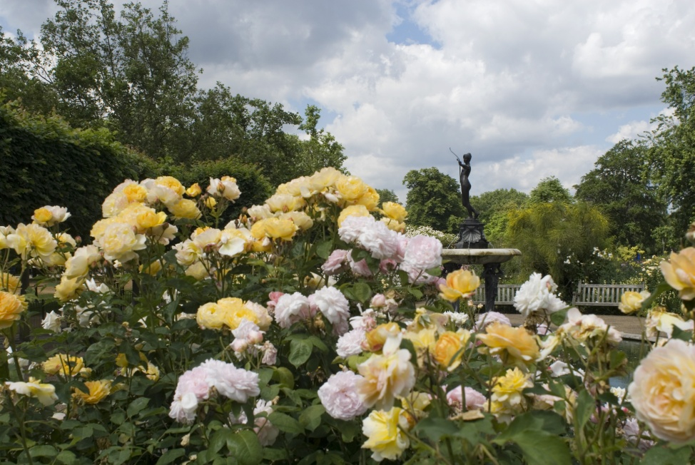

Background

The Hyde Park Rose Garden is located in the south east corner of Hyde Park, south of Serpentine Road, close to Hyde Park Corner.

The Garden was designed by Colvin and Moggridge Landscape Architects and opened in 1994. The design developed from the concept of horns sounding one’s arrival into Hyde Park from Hyde Park Corner. The central circular area enclosed by the yew hedge is imagined to be the mouth of a trumpet or horn and the seasonal flower beds are the flaring notes coming out of the horn.

The rose planting is mixed with herbaceous planting, creating rich seasonal flower beds and strong scents. The spectacular seasonal bedding is a hugely popular feature; the gardens attract high numbers of tourists particularly in the summer months and are still popular throughout the year with local residents and office workers as a quiet contemplative place.

A grand pergola and two fountains are featured in the Rose garden:
- The Boy and Dolphin Fountain by Alexander Munro dates from 1862. It is a pre-raphaelite marble sculpture of a cherub and dolphin on a rock in a basin. Once the centrepiece of the Victorian sunken garden that was demolished to make way for widening of Park Lane in the 1960s, it moved in 1962 to Broad Walk in Regent’s Park and returned to Hyde Park in 1995.
- The fountain statue of Diana the Huntress was sculpted by Lady Feodora Gleichen in 1899. Gleichen was the first female member of the Royal British society of sculptors. It was donated by the owner who commissioned it to Hyde Park in 1906.
- The metal pergola was erected as part of the 1994 works; it is currently overgrown with climbing roses and restoration is planned for this financial year by TRP.

The circular hub to the garden is enclosed by a rose arbour with pillars and chains that will be restored by TRP in the next phase of the refurbishment project.

Renewal of the Rose Garden has been on hold in recent years with the possibility of it being used as a location for an anti slavery memorial. It is now unlikely that this project will go ahead, so TRP are now in a position to look at developing proposals to renew the Rose Garden as a whole.

TRP Objectives

The Rose Garden Gates design competition is part of the first stage of a project to renew and refresh the Hyde Park Rose Garden.

The purpose of the new gates is to:
- signal the arrival into the Rose Garden
- add to the quality of the visitor experience and the anticipation that they feel on arrival
- help to create a destination place and through the design draw people into the site
- help police the garden and improve security at night

Setting for the Gates

In the first stage of the renewal of the Rose Garden, the current low hooped boundary railings are being upgraded to a 1.2m high metal railing with spear head finials. The finished colour will be Royal Parks Green BS 12-B-29. These railings will follow the existing boundary and are due to be installed in January - February 2016.

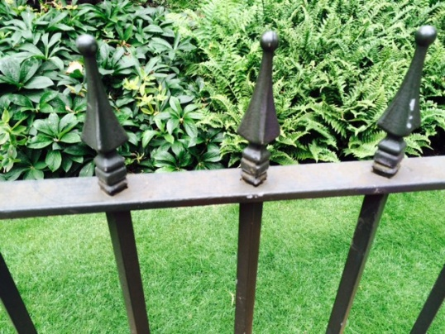
Example of spear head finial

New signage will also be installed to explain the design concept and provide information about the garden design and sculptures. Please refer to Appendix 1 for the Site Layout of the Phase 1 works.

Design Brief

As part of the first stage of the renewal works there is the opportunity to install new bespoke gates that will mark the arrival into the Rose Garden adding to the sense of place and enclosure, at the same time improving security.
There are currently 8 gates into the Rose Garden. The design brief project is to look at the 2 main gates, one at either end of the main east-west path, they could both be the same, or different.

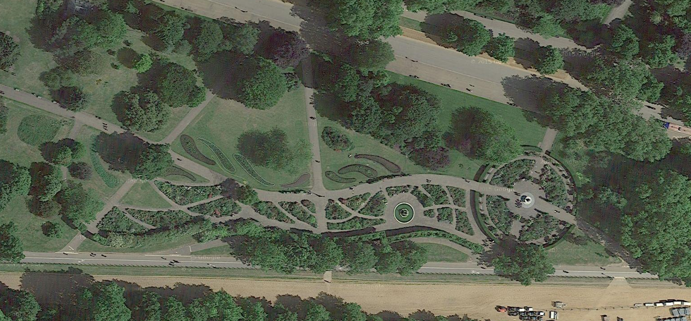
Location of Gates Google ©

The two gates will be two-leaf gates, approximately 3m wide. The gates will remain open in the day and will be locked at night. The designs can be for two gates of the same or different design.

The gates must be sympathetic to the setting in a Grade 1 Listed Landscape, and the traditional railings on either side but could be either modern or traditional in their design. There is a precedent for a modern design to park gates at the nearby Apsley Arch, the Queen Elizabeth Gates (1993) by Giuseppe Lund and the central screen by David Wynne. The theme of the gates is expected to blend in with the garden and its design concept although we are open to your interpretation of this brief.

Design proposals should take into account a budget of £30-35K to fabricate and install the bespoke gates, including VAT. The winning designer(s) only will be able to recuperate the design fees for this phase and must also identify costs for design development and supervision of the works. Please be aware that TRP will not be able to return anyone’s submissions at any stage of this process.

The wining designer(s) will be expected to work closely with the main contractor who will be managing the fabrication and installation of the gates, and oversee the project including completion of full design and installation .

Please note TRP will not be paying for any unsuccessful designs.

Planning

Subject to the design of the gates, planning permission might be required and appropriate fees must be identified to produce the relevant drawings to submit to Westminster Council.

Entry Requirements

The Rose Garden Gates Competition is an open design competition. All designers must provide the information listed in this document. Please note that you should make yourself aware of the Conditions of Contract provided as part of this design competition as these will form part of the contract between TRP and the winning designer.

Design Requirements

The gates must:

- Be three metres in width and fully functioning. They will remain open during the Rose Garden opening hours. With that in mind, we will be looking for the design to also offer interest whilst open. Create a sense of arrival, anticipation, entrance and enclosure.

- Be safe and robust. The proposed materials and fixings must be sustainable and appropriate for an urban setting that attracts daily thousands of visitors.

- Adhere to safety standards for head and finger entrapment to BS EN 1176.

- Reflect the design and compliment the sense of place of the Rose Garden and relate to the TRP objectives.

- Be lockable.

- Provide value of money and have low maintenance requirements over an expected lifespan of 25 years.

- Dovetail with the traditional 1.2m high railings on either side.

Deliverables

The deisgn team should provide a CD or USB memory stick containing:

- A3 concept design drawings, hand drawn or autoCAD of both gates;

- Provide detailed Costs including:
  - Design fees for design development for the competition if appointed the winning designer’s costs for this element will be paid.
  - Design fees for further development to RIBA Stage 4
  - Design fees for drawings if required for planning application
  - Fees for supervision and approval of the fabrication drawings and installation

- Supporting Statement (max 1500 words) explaining your design, materials, maintenance requirements, durability, budget and confirmation of meeting TRP programme for delivery

- A photomontage or sketch view of the Gates in the rose garden setting.

The submission deadline is 17:00 GMT on Monday 23 November 2015. Designers must use the enclosed return label. Submissions should be delivered to:

The Procurement Office
The Old Police House
Hyde Park
London
W2 2UH

E-mail or fax submissions will not be considered.

Please contact procurement@royalparks.gsi.gov.uk for more information, or with any enquiries.

NOTE: couriers sometimes have difficulty locating our offices in the middle of Hyde Park, which must be approached from West Carriage Drive.
Evaluation Criteria

All designers interested in this design competition must complete the attached Suitability Assessment Questionnaire, these are pass or fail questions only, all designers who pass this stage will then go on to have their design reviewed as part of the design competition as follows :

Entries will be judged by a panel of specialists, the quality / price ratio which will be applied to this design competition is a follows :

Quality 90%
Price 10%

Quality

Designers submissions will be evaluated against quality using the following criteria:

- Design response quality Overall quality of the design approach and the design’s ability to fulfil the competition’s aspirations for enhancement of the Rose Garden, functionality and ease of maintenance and the use of appropriate materials etc – 70%
- Evidence of adherence to the budget - 10%
- Ability to meet the programme – 10%

Price

Designers Fees – 10%

There may be a requirement for a presentation but this will be confirmed at a later stage. If a presentation is required please note that we envisage that only the three highest-scoring entries will be invited. In the case of a tie all designers who achieve the three highest scores will be invited.

Post selection, the winner will be required to:

- Detail their winning design to RIBA Plan of Works Stage 4;
- Provide drawings for TRP to submit for planning permission;
- Work closely with the principle contractor through the fabrication process and and supervise the installation of the gates on site.

Judging Panel

A judging panel will include:
- Andrew Scattergood, TRP Chief Executive
- Rob Dowling, TRP Hyde Park Manager
- Dennis Clarke, TRP Head of Park Services,
- Jane Pelly, TRP Head of Landscape,
- Hal Moggridge, Colvin & Moggridge
- Stephen Nice, Burns + Nice

Competition Timeline

Design Competition opens 29 October 2015
Competition closes 23 November 2015
Evaluation of entries 25 November – 05 December 2015
Shortlisting & presentations 7-11 December 2015
Winner announced 15 December 2015
Design Development January 2016
Planning Application January 2016
Installation on site April 2016

Confidentiality of Submissions

Please note the following requirements, any breach of which will invalidate your tender:

You must not tell anyone else, even approximately, what your tender price is or will be, before the time limit for delivery of tenders. The only exception is if you need an insurance quotation to calculate your tender price: you may give your insurance company or brokers any essential information they ask for, so long as you do so in strict confidence.

You must not try to obtain any information about anyone else's tender, or proposed tender, before the tender submission deadline.

You must not make any arrangements with anyone else about whether or not they should tender, or about their or your tender price.

Freedom of Information Act:

we are committed to open government and to meeting our legal responsibilities under the Freedom of Information Act 2000. Accordingly, all information submitted to us may need to be disclosed by us in response to a request under the Act. We may also decide to include certain information in the publication scheme, which we maintain under the Act. If you consider that any of the information included in your tender is commercially sensitive, please identify it and explain (in broad terms) what harm may result from its disclosure if a request is received, and the time period applicable to that sensitivity.

Transparency:

Government has set out the need for greater transparency across its operations to enable the public to hold public bodies and politicians to account. This includes commitments relating to public expenditure, intended to help achieve better value for money. Suppliers and those organisations looking to bid for public sector contracts should be aware that if they are awarded a new government contract, the resulting contract between the supplier and government will be published. In some circumstances, limited redactions will be made to some contracts before they are published in order to comply with existing law and for the protection of national security.

If required
If required, subject to design of gates

