**STATEMENT OF SERVICE REQUIREMENT FOR THE PROVISION OF UP TO THREE CYCLES OF 360° FEEDBACK ASSESSMENTS**

**1 EXECUTIVE SUMMARY**

1.1 The Office for Nuclear Regulation’s (ONR) 2018/19 Corporate Plan under Strategic Theme 3 ‘Getting the best out of our people’ states that we will implement a new Leadership and Management Programme to build the competence of future leaders. Our leaders and managers are a key asset to ONR and consistent leadership and management development is vital to supporting our people to deliver a challenging agenda.

1.2 We see a diagnostic 360° feedback assessment process as providing the opportunity for those in leadership and management roles to receive accurate and helpful feedback in a constructive and confidential manner; helping to align themselves with the requisite competencies for authentic inclusive leadership and greater personal awareness.

2 **BACKGROUND TO ONR and how we work**

2.1 The Office for Nuclear Regulation (ONR) is Great Britain’s independent nuclear regulatory authority.

2.2 ONR was established as a statutory Public Corporation on 1 April 2014 under the Energy Act 2013 to regulate nuclear safety, security and conventional health and safety at licensed nuclear sites in GB.

2.3 The ONR independently regulates safety and security at 36 licensed nuclear sites. These include the existing fleet of operating reactors, fuel cycle facilities, waste management and decommissioning sites and the defence nuclear sector. In addition, we regulate the design and construction of new nuclear facilities and the transport of nuclear and radioactive materials and work with the international inspectorates to ensure that safeguards obligations for the UK are met. We co-operate with international regulators on safety and security issues of common concern, including associated research.

2.4 Although ONR regulates nuclear sites in the UK, the legal responsibility for ensuring nuclear safety rests with the duty holder. The Government is responsible for establishing nuclear policy through a legislative regulatory framework. It does not set regulatory standards or make regulatory decisions. These matters are the responsibility of ONR.

2.5 A combination of ONR’s assessment and inspection functions allows ONR to judge whether licensees are operating with risks reduced to as low as reasonably practicable. In coming to a judgement on whether an acceptable level of safety is being achieved, a significant body of information is typically considered, for example:

* safety cases;
* reports on the licensees’ periodic reviews of safety;
* results of on-site compliance inspections;
* the findings from investigations of incidents and events;
* insights and intelligence gained from the licensees’ senior management and internal regulator; and
* the annual demonstration of emergency exercises at each site.

2.6 Our vision is to be an exemplary regulator that inspires respect, trust and confidence.

2.7 ONR employs over 600 staff, of which 350 of those are in specialist regulatory roles (e.g. nuclear safety, security and safeguards inspectors); the balance being corporate professions (e.g. Finance, IT and Human Resources).

2.8 ONR’s Corporate Office is in Bootle, Merseyside, with two smaller offices in London and Cheltenham.

2.9 During 2017/18 our inspectors; undertook in excess of 1,000 compliance and permissioning inspections and; carried out over 100 permissioning tasks.

2.10 More information about ONR can be found on our website - <http://www.onr.org.uk/>

**3 SCOPE OF THE SERVICES REQUIRED**

3.1 ONR is looking to appoint a single provider for a cycle of 360° feedback assessments, with the possibility of a further two cycles taking place biennially. The first cycle will commence in January 2019 and the latest before the end of April 2025. Each 360° feedback assessment would conclude with formal evaluation and feedback from the provider within four weeks of the close of each assessment.

3.2 As part of our mission to provide efficient and effective regulation of the nuclear industry, holding it to account on behalf of the public; ONR has identified four strategic themes to bring about the business and cultural changes and are enablers to us reaching our mission and vision:

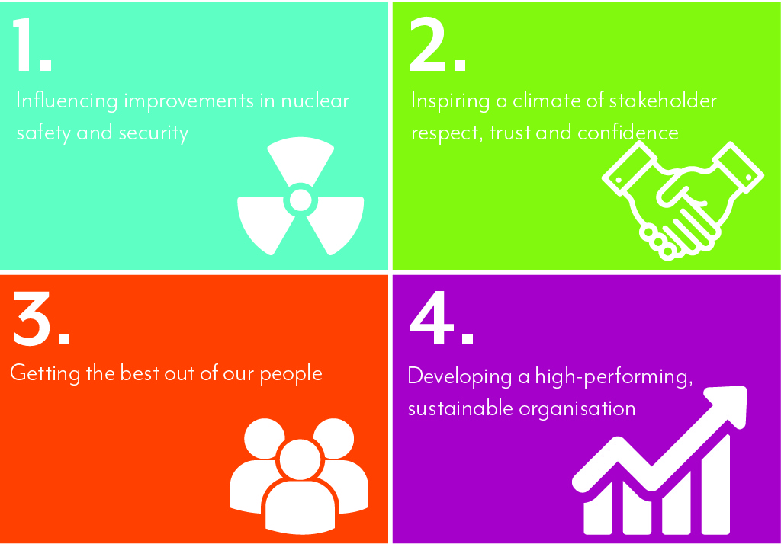

3.3 From these strategic themes for the current financial year 2018/19 top ten priorities have been identified, with a focus on improvements, across four key drivers: feeling valued, leadership and management, behaviours and managing change.

3.4 A 360° feedback assessment process will reflect the expectations outlined in ONR’s top ten priorities and it will be an essential component of measuring outcomes from work relating to improved leadership as identified in the ONR 2017staff survey and the National Equality Standard (NES) Assessment. It will provide an opportunity for those in leadership and management roles to receive accurate and helpful feedback in a constructive and confidential manner.

3.5 The 2017 staff survey, NES Assessment and anecdotal evidence has highlighted that the key leadership issues affecting ONR lie around individuals feeling that leaders and managers do not always display corporate behaviours and are unwilling to accept upward challenge and are not willing to challenge inappropriate and poor behaviours particularly when exhibited by those at a senior level in the organisation. Other key leadership issues were around the lack of personal accountability, staff engagement and clarity of expectations of what success looks like. These are all elements currently reflected within our competency framework and will be key to developing a future leadership framework.

3.6 The Greater Leadership and Management (GLAM) Working Group was established to tackle poor leadership and provide greater support and development opportunities to leaders and managers. It is possible that leaders and managers may not fully understand the contribution of the people they manage. Therefore, there is a strong argument for obtaining wide-ranging information to form an accurate picture of performance. GLAM will be instrumental in approving the question set for the 360° feedback questionnaire.

3.7 An important role for 360° feedback is its capacity to challenge recipients’ perceptions of their skills and performance and to provide the motivation to change. In common with other forms of performance appraisal however, 360° feedback should not bring any great surprises to individuals. Its focus should be on helping them understand how their behaviour is perceived by others and confirming the behaviour that is most likely to get results.

3.8 360° feedback, which will help to inform the development of an inclusive leadership development programme and provide insight into our inclusive leadership potential and help us to identify areas of improvement. Knowing which behaviours we need to strengthen will enable our leaders to focus on self-improvement and lead the change in ONR, delivering performance and wellbeing improvements to all staff.

3.9 Therefore our intention is to offer 360° feedback to all in a leadership and management role from SCS (Senior Leadership Team) to Band 4 (Middle Manager). While exact numbers are not clear at this stage, we expect the numbers to be up to 200 individuals.

3.10 The extent to which the service provider needs to understand ONR and its requirements in advance, in order to project manage the provision of 360° feedback (including establishing the question sets, evaluating data and presenting information to ONR) relevant to ONR and its aims as an exemplary employer**.**

3.11 ONR will require the tenderer to:

* Fully brief the ‘Subjects’ on the purpose of 360° feedback.
* Provide guidance to the ‘Raters’ to provide assurance around the confidentiality of their feedback.
* Following completion of the questionnaires, conduct one to one briefings with the ‘Subjects’ where necessary, should they require assistance in understanding their feedback.
* Complete a composite report following evaluation of questionnaires with both quantative and qualitative data with descriptive comments from ‘Raters’; which will also cover trends in terms of leadership development needs.
* Provide details of how they will evaluate the 360° feedback assessment process at both an individual and organisational level.
* It is expected that the tenderer will work closely with the ONR HR Organisational & Development (OD) Team to successfully deliver 360° feedback to the organisation and fully outline the cost for each stage including: development of the questionnaire and delivery of ‘Subject’ pre-briefings, one to one briefings.

**4 OBJECTIVES**

4.1ONR requires a service provider to work collaboratively to deliver 360° feedback that will support the inclusive leadership development programme and that will help leaders align themselves with the requisite competencies for authentic inclusive leadership and personal awareness.

The key objectives of a 360° feedback assessment process will include:

* full briefing for ‘Subjects’ so that they understand the purpose of 360° feedback and they identify suitable ‘Raters’ who are in a position to comment on their performance and offer credible feedback that enables the recipient to act upon
* subjects undertaking 360° feedback will be required to request feedback from their line manager, peers, direct reports and external stakeholders
* guaranteed anonymity for ‘Raters’ to minimise concern regarding the feedback they provide
* identifying differences between the way individuals see themselves and how they are perceived by others establishing differences between the perceptions of different groups of respondents
* determining which effective leadership behaviours individuals are exhibiting and which behaviours they may need to strengthen further
* with one to one feedback and appropriate support allow individuals to reflect on their performance in leadership and management areas, how they impact on others and provide an opportunity in discussion with their line manager

4.2 Output from the feedback will inform the inclusive leadership and management development programme.

**5 TENDER SUBMISSIONS**

5.1 In order to submit a compliant tender, suppliers are requested to submit the following additional information:

* The CVs and details of the team who will be undertaking the work.
* Tenderers must provide full details with reference to other organisations where they have successfully implemented 360° feedback including: CVs, experience and relevant qualifications directly related to the introduction of 360° feedback.
* Tenderers should also confirm if sub-contractors are to be used to deliver any element of the pilot. If so please provide CVs, experience and relevant qualifications related to 360° feedback.
* Your arrangements for managing delivery of the work and dealing with disputes (including details of who will act as the liaison point between us).
* A financial breakdown of charges for the duration of the service based on accrual accounting techniques, proportioned on a monthly frequency separating detailed revenue and capital costs for delivery. Breakdown of on-going hosting, support and maintenance costs.
* The means of contact - particularly where the service provider or its associates are not local to Bootle. This may include proposals of communications by phone/email, face to face meetings, frequency of contact, travel arrangements.
* The capability of the service provider in all areas of the scope of work and any added value benefits not specified.
* We are seeking a provider who has a proven track record in delivering 360° feedback and understands the importance that this must be well embedded with the organisation to achieve the benefits.
* The tenderer is expected to provide a detailed programme in support of their submission for a 360° feedback process including:
* Evidence of a proven track record of working with other organisations to develop similar programmes, utilising case studies (min. 2 max. 4) on similar projects.
* The capacity to deliver the outline of the programme as outlined in section 5 and how this would be achieved, include a high level milestone plan on a page.
* An example of a well designed questionnaire based upon the effective behaviours outlined in the ONR Behaviour Framework, Civil Service Competency Framework and Inclusive Leadership competencies.

**6 TIMESCALES & CONSTRAINTS**

6.1 The timetable for implementation is short due to the impact on other work around the development of the inclusive leadership development programme. Therefore, tenderers will be asked to provide their submission in time for 360° feedback assessments to be rolled out across ONR week commencing 14th January 2019.

**7** **CONTRACT PERIOD**

7.1The proposed contract start date is expected to be January 2019 and is to run until 30th April 2025 which will enable up to three cycles of assessments to be facilitated during this period.

**8 CONTRACT MANAGEMENT**

8.1ONR will require to be kept updated about progress and delivery of the required work via weekly meetings, which may be conducted by telephone and to include a contract start-up meeting at ONR’s offices at Bootle. Subsequent progress meeting should be arranged with the ONR Project Office and can be held at ONR’s office in Bootle, or the contractor’s premises.