Fleet Pond CS specification 2022

Additional documents:
Request For Quotation (RFQ Fleet Pond Capital)
NE Consent
Fleet Pond Fire Management Plan
Deadline for Quotation Requirement: All quotes to be received by Monday 5th August 2022
1.0 Scope of work
Components of work to include:
- Creation of scrapes within the marshes for habitat creation and water retention
- Scrub management in marshes, reedbeds, ponds and islands
- Installation of features within the main lake for habitat creation and increasing biodiversity.
2.0 Site background information and access
2.1.1 Access to Northeast corner:
Fleet Pond is a SSSI nature reserve with a high volume of daily visitors accessing the site. Access to the north-east area of the site is through the car park (off Cove Road) via lockable bollards, a 2.1m height barrier is in place and can be opened to allow entry. This access point is suitable for most vehicles and machinery, but there are some restrictions within the site (see below). Contractors will need to agree in advance with site ranger, to gain access to site.
Most of the NE area of the site is for suitable for 4x4 vehicles but nothing bigger, except as access along main routes to other parts of the site. The 4.x4 vehicle access is then restricted for crossing streams into marshes – this would require a smaller vehicle.
2.1.2 Access to Boat House Corner (via NE car park):
Main access to the pond for boat launching onto the pond is along a wide hardcore path leading to Boat House Corner, which is suitable for towing vehicles.
2.1.3 Access to Coldstream Marsh (via NE car park):
Access to 1 of the scape locations is along a non-hardcore path, entry onto the marsh is via a 15ft field gate.
2.1.4 Access to Fuglemere Marsh
Via NE car park or residential Westover Road, depending on vehicle size
Access to this scrape location is across 8ft wide bridges and through 12ft field gate. Scrub work along the western edge of the site is only accessible via foot and is not accessible with a 4x4 or any large vehicle.
2.1.5 Boat use
Any boat or vessel brought onto the pond must be steam-cleaned prior to arrival and when taken off site to avoid invasives contamination. Contractors must also be aware of Hart DC’s boating code for Fleet Pond – we strongly advise that contractors use electric motors on the boats for works where possible, particularly when just going out and back to islands to work.
2.2.1 Welfare Facilities
Should welfare facilities be required by the contractor for this project due to the magnitude and duration of these works, contractor to set up a compound – by prior agreement with HDC - at either boat house corner, the car park or on one of the roads that are next to the pond. However, a traffic order maybe required for that or an exemption for all day parking if Wellington or Chestnut grove – to be arranged by contractor and included as part of the project costs.
3.0 Quotation requirements
Contractors to quote for entire project but provide breakdown into following sections. This is to enable timings of works and for agreeing payment schedules, etc. Quote to be separate as follows: -
Part 1 – scrape creation
Part 2 – scrub work using hand tools and small machinery
Part 3 – installation of various lake features

3.1 Scoring for awarding works will be carried out as follows:-
Price (55%)
Quality (45%) consisting of experience and understanding of works (25%), method statement and approach (10%) and references/case studies (10%).
See ‘Request for Quotation’ document for full details of scoring, terms and conditions, deadlines, etc.
3.2 Timings of work
These works are to be complete between September 2022 and Feb 2023. There is potential to move a small part of these works into Sept 2023-Oct 2023, providing there are good reasons for doing so and that the majority of works have been completed before Feb 2023. No additional extensions can be given beyond Oct 2023.
Scrub and scrape works must take place outside the nesting season between September and February. Scrape work will need to take place before the ground conditions become too wet (September-October). Scrub work can take place within the wider winter period (September – end of Feb) as the working conditions will still be favourable. Installation of the lake features and the leaky wooden dam can be completed throughout the year. Contractor MUST provide at least two weeks’ notice prior to commencing works, to enable Hart DC to carry out appropriate visitor engagement and notify stakeholders.

4.0 Health and Safety
- The requirements of health and safety and other current legislation and codes of practice must be observed in all work undertaken.
- All personnel should be adequately trained to perform allocated tasks.
- Suitable PPE must be worn by all operators at all times when on site
- Suitable signage warning the public must be in place, where necessary, when work is underway.
- Contractors must supply Hart District Council with the H&S Working Practices and associated risk assessments before any site works can commence. Contractors must adhere to the council’s Code of Conduct (found within ‘Contractors Procedural Brief’).
4.1 Remediation work
- Remove any temporary signage, barriers and fencing from site
- Make good all damage to adjoining surfaces caused by the works, by access to the works by plant and machinery, by storage of materials and other causes within the contractor’s control
- Compacted soil should be de-compacted and regraded. Contaminated soil (for example accidental spillage of fuel) must be excavated and removed from site to an approved landfill site and replaced with uncontaminated subsoil and topsoil to match existing soil profile
- Make good any damage to retained trees and other woody plants by pruning back damage to healthy growth in accordance with good arboricultural practice
- Leave site clean and tidy. Remove all excess materials from site to the contractor’s store or to an approved tip, unless otherwise agreed in writing
- If bonfires are agreed with the Site Ranger, the contractor must adhere to our ‘Bonfire Procedure’ (found within ‘Contractors Procedural Brief’. This includes removal of all debris from site at the end of the fire and raking over the area

5.0 Map of works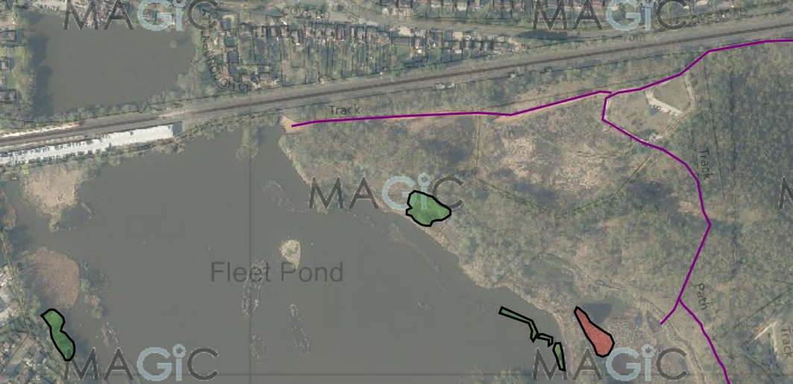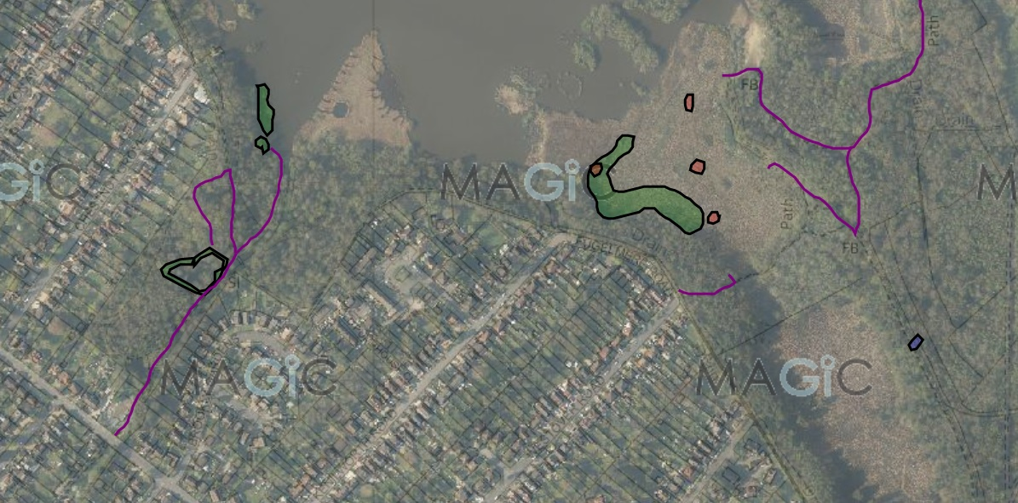
Purple line – access
Green – SB2 scrub clearing
Orange – WN2 scape creation
Blue – RP32 leaky wooden dam
6
5
4
3
2
1

6.0 Scrape creation specification (PART 1 OF 3)
Objective: to help retain water levels across the marshes. Each scrape will need to have an irregular shape with graded sides to aid the establishment of aquatic vegetation.
Location: see map
Parcel ID location: SU8255 0101
Total quantity: 5 (4 small scrapes in Fugelmere marsh, 1 large in Coldstream)
Area: 0.3 hectares in total, see table below for sizes:
Scrape number | Dimensions (m) | Total area (Ha)
1 – 4 (Fuglemere) | 1 x large (50m x 15m) 750  1 x medium (25m x 15m) 375  2 x small (8m x 8m) | 0.1253
5 (Coldstream) | To fit current scrub blueprint | 0.1500

Scrapes should be an irregular shape to maximise the length of its edge, sides will be graded so there is a gentle slope from the shallow margins (3cm – 5cm deep) to a maximum depth of no more than 20cm further into the scrape. Final depths will need to be decided during the course of the works on site with Hart DC staff and the machinery operator, as it will depend on the surface uncovered beneath. For example, ideally scraping to the sand or gravel layer.
Clear off all surface vegetation, to include removal of wooden stumps and root plates, reedmace rhizomes. The surface of the scrape should be left rough, so there is not a uniform depth across the whole area.
Prior to works commencing, the Biodiversity Officer will need to attend a walked survey of the area, to enable us to retain ecologically important species (i.e. mark out and agree with the machinery operator on the ground, which sections to avoid scraping). These areas should then be avoided and not disturbed during the works.
Scraped spoil material to be banked up in off the reedbed/marsh/scrape areas and onto either existing bunds to extend them, or into woodlands as near as possible.
Additional comments:
- Contractor should use a vehicle transport method that avoids damaging the existing good quality marsh habitat. To be discussed and agreed with Site Ranger but examples could include ground plates, temporary tracks or similar. Path of least disturbance can be agreed and then contractors must stick to the agreed route over the rest of the wetland habitat
- Access and operations should avoid machinery contamination by Crassula (unless otherwise agreed in writing with the Site Ranger), to avoid contributing to further spread of this invasive species across the wetland
Coldstream:
- The scrapes in Coldstream should focus on scrub removal as well as creating wet habitat
- Previous work included flail/mulch the scrub and scrape down to sandy soil. This new scrape should replicate previous works
Fuglemere:
- Scrape 4: currently it has a lot of dense scrub, so the works will need to be done in two stages:
1. clear the scrub first
2. scrape the area to create a small pool
- There are already 5 pools in the marsh; new scrapes should sit close to these existing scrapes. Precise locations to be agreed on-site and also with Natural England

7.0 Scrub management specification (PART 2 OF 3)
Objective: to manage encroaching scrub to restore or maintain habitat value. The areas identified for scrub removal are all in difficult to access areas and may require specialist equipment. No scrub should be left on areas cleared and should be either chipped or burnt (or chord wood stacked in woodland/along woodland edges) as pre-determined with Hart District Council.
Parcel ID location: SU8255 0101

Area: 1.3 hectares in total, see below for breakdown
Summary of Scrub Works (see individual scrub areas below for more detailed information):
Scrub Area | Total area (Ha) to be removed | Method of disposal (all areas to be chainsaw works) | Access
1 | 0.1 | Chipped | Small vehicle and chipper
2 | 0.2 | Burn (chipping may be an option depending on access)* | Boat or on foot
3 | 0.2 | Burn or chip | By foot
4 | 0.2 | Burn or chip* | 4x4 vehicle and chipper access
5 | 0.06 | Burn or chip* | Boat access only
6 | 0.6 | Chip | Small vehicle and chipper

7.1 Brookly pond
Objective: Felling trees and reducing scrub around the pond edge to increase the light levels
Operations: Fell up to 20 trees around the pond edge concentrating along the southern edge of the pond. Trees mainly consist of alder, with occasional willow and mature holly, diameters approx. 30- 50cm at breast height. These will be marked on site prior to work commencement. Remove 70-80% of the young willow, alder and sycamore growth from the perimeter of the pond.
Special considerations: use of hand tools around the pond edge, winching will be required to pull cut trees out of the water.
Disposal: Main chord wood to be processed to 2m lengths and stacked into log pile at designated area, within woodland. Brash material can be dragged into the woodland to be chipped onto chord wood. Tracked chipper advisable due to limited access, but contractor to assess and agree with Site Ranger. Contractor is welcome to make alternative suggestions, e.g. removing wood off-site using a small tractor and trailer, however please note that access is limited to small tractor/quad bikes.
Important: Potentially active badger set on the west side of the pond must be demarked and not disturbed. We may well need a specialist ecologist to check it and apply for a licence to work near it, prior to any works commencing. Contractor to confirm this with Hart DC staff prior to commencing any of the Brookly Pond works above.
7.2 Brookly stream including 1 man-made island
Objective: clear scrub on man-made island and scrub leading to island
Operations: Cut, remove and treat all trees and scrub within area shown on map/sketch. This largely consists of young and mature willow/alder trees with diameters no greater than 30cm.
Special considerations: access to island is difficult, so contractor will need to look at either boat or foot access.
Disposal: Cut and burn woody materials on island once it has been cleared to a suitable burn-site. Potential to stack chord wood on site away from cleared area, if suitable area can be identified. If so, cut to 2m lengths and then chip/burn brash.
7.3 Wellington reedbed
Objective: to reconnect Wellington and Chestnut reedbed
Operations: Cut, remove and treat all trees and scrub within area shown on map. This largely consists of mature willow and early mature alder trees with diameters no greater than 30cm. Treat stumps according to details on ‘Fleet Pond SB2 Scrub Specification’.
Special considerations: due to the nature of reedbeds, the ground conditions may make work operations difficult.
Disposal: Brash can be burned on site at or chipped and taken off site (If burning on site, agree location with Site Ranger and adhere to Hart District Council’s Bonfire Protocol (found in ‘Contractors Procedural Brief’).
7.4 North East marsh
Objective: to reconnect North East marsh to Lion’s View by felling willow and alder
Operations: Cut, remove and treat all trees and scrub within area shown on map. This largely consists of mature willow and early mature alder trees with diameters no greater than 30cm.
Special considerations: due to the nature of reedbeds, the ground conditions may make work operations difficult.
Disposal: Brash can be burned on site at or chipped and taken off site (If burning on site, agree location with Site Ranger and adhere to Hart District Council’s Bonfire Protocol.
7.5 Islands
Objective: to clear the scrub growth on the constructed islands to allow reeds and/or aquatic vegetation to establish
Operations: Cut, remove and treat all trees and scrub within area shown on map. This largely consists of young willow/alder scrub.
Special considerations: Access the island via boat, although the water is shallow there is a lot of silt build-up in the bay. This will certainly require chainsaw and burning, as machinery will not be able to access
Disposal: Burn on Clearwater, chip at Sandy Bay or BHC - contractor to decide and confirm with Site Ranger prior to quote.
7.6 Fugelmere marsh
Objective: to clear the encroaching scrub from the marsh, clear up to the woodland edge
Operations: Cut, remove and treat all trees and scrub within area shown on map. This largely consists of young willow/alder scrub.
Special considerations: due to the nature of marshes, the ground conditions may make work operations difficult. Potential to access using ground plates. These can be provided by Hart DC if contractor gives advance notice.
Disposal: Room for burning materials is limited, so chipper is more appropriate in this area. Material can be chipped onto predetermined existing bund on site, in agreement with Hart District Council.
Contractor is responsible for all permit applications and permissions from Environment Agency, relating to pesticide application in and around water. See DEFRA guidance on this: https://www.gov.uk/government/publications/application-to-use-herbicides-in-or-near-water
All scrub management carried out as part of this work should follow the guidance below relating to clearance, disposal and stump treatment.
Scrub clearance
- Cut and treat all scrub within the areas marked on the attached map
- Scrub refers to small trees (willow and alder)
- Scrub or individual trees marked with tape are to be left undamaged
- All scrub should be cut using chainsaws and/or hand tools
- All scrub is to be cut down to ground level, leaving no protruding stumps. Cuts should be made parallel to the ground.
- Under no circumstances is scrub burning to be undertaken
- Biodegradable chain oil must be used
Dispose of cut material
- Dispose of cut material by either chipping or burning
- Bonfire site must be far enough away from trees to avoid causing damage and at least 10m from the crown of any tree
- Where possible, existing fire sites should be utilised. Where there are no burn sites within the area, new burn sites must not be on patches of ground where they can cause damage to species-rich habitat.
- The area used for burning must be agreed in advance between the site ranger and those undertaking the scrub control.
- Corrugated metal sheets to be used for all fires. There are to be supplied by the contractor.
- The use of tyres or other accelerants, including diesel, on fires is not permitted to start or continue the fire that is needed to burn the arisings.
- Burning sites must be prepared, situated, and monitored in such a way that there is a minimal risk of spreading, especially at the end of each day. Preparation may include mowing the surrounding sward around the fire site to reduce fire risk.
- Fires should be taped off at the end of each day.
- If chipping is to occur, brash material should be chipped into small, discrete piles within the woodland area.
- All chord wood will be processed to 2m lengths and stacked into a log pile at designated area within the woodland.
Stump treatment
- Contractors must have an agreed AqHerb01: Agreement to use herbicide in or near water from the Environment Agency before work commences.
- Only those with a valid NPTC PA6AW qualification can apply herbicide.
- All COSHH guidelines, as set out in the manufacturer’s guidelines, should be adhered to in the mixing and transportation of the chemical, to, around and from site.
- All broadleaf cut stumps over a 2.5cm diameter must be treated with a suitable targeted herbicide to ensure efficient control of re-growth.
- Eco plugs should be used on stumps over 10cm, spaced around the edges of each stump and set apart as per the manufacturer’s instructions.
- A horticultural dye must be used to mark which stumps have been treated.
- Stumps can only be treated in weather conditions which will not adversely affect the chemical process, e.g heavy rain or snow.
- Herbicide should be applied with a brush or spot gun to minimise drift onto adjacent vegetation.
- A 90% kill rate of broadleaf stumps is expected.
- A pesticide record form must be completed once the works have been completed.
- A spill kit must be always available on site.

8.0 Lake features specification (PART 3 OF 3)
Contractor note: all translocation and planting must avoid contamination and any spreading of invasive/non-native species across the site.
All the following works will require contractors to access pond via boat. Contractors to provide own boat for duration of the works and to specify type of boat (e.g. powerboat, row boat, size, motor, etc), to be agreed prior to awarding works.
Any works not completed in-line with this specification must be agreed in advance of works and in writing, with Hart District Council. Deviation from this arrangement will likely result in contractor having to return to site and rectify any outstanding issues, within 2 years of installation completion date.
Objective: to increase the diversity and abundance of lake aquatic macrophytes, invertebrates and zooplankton through the use of a range of techniques and features (including protection from grazing fish and birds).
8.1 Map of locations:
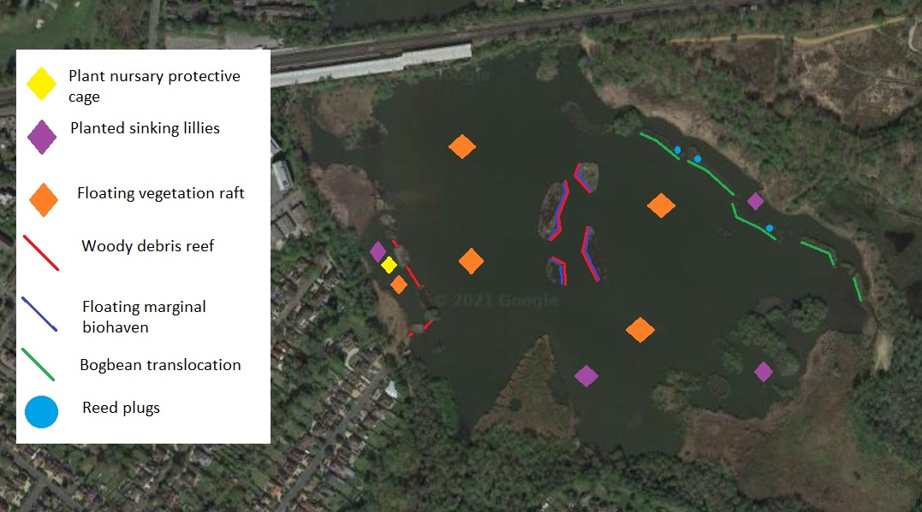
8.2 Bog bean translocation
Contractors to cut existing areas of established bogbean into approx. 1m x 1m sections using hand tools and transported across the lake to the margins of 5 islands (see map for locations). A total of 2m² of bogbean translocation will occur for each of the 5 islands totalling in 10m² across the site (final areas dependent on bogbean available on site).
Access will be via boat, cut using hand tools and tow to other areas of the lake in a suitable secured way, to avoid destabilisation of the bog bean during transport.
Bogbean to be secured to edges of islands using suitable biodegradable material (e.g. coir blanket or similar) and fixed securely to existing timber posts. Materials to be agreed with Hart District Council.

8.3 Planting/Sinking lilies
10 groups of 5 water lilies (50 in total) will be planted at set locations within Fleet Pond (see map for locations). Two groups of lilies will be planted in the more sheltered western area of the pond, the remaining eight groups will be planted in mid-water areas, as marked on map.
- Hart District Council will source and provide lilies for planting: Native white Nymphaea alba and yellow water lilies Nuphar lutea and water fringe Nymphoides peltata species will be planted. All lilies are to be harvested from the Little Pond (adjacent to site) with owner’s permission .
- Contractor responsible for relocating lilies from source to final destination.
- Plants to be anchored in locations using compostable bags with stones in the bottom to weight them down
8.4 Floating Island Rafts
Objective: Increase visual amount of surface vegetation across the pond, which will help reducing surface turbidity as well as increase biodiversity
- Five floating islands will be installed with 4 positioned within the main water body, away from existing islands (see map for locations) and 1 within the sheltered, netted area along the western edge
- Islands to be secured to avoid significant movement across the pond
- Islands to be installed and secured in line with manufacturer specification and guidelines
- The islands should be at least 4x4m² and planted with partly pre-established vegetation. In addition, contractors will be expected to source additional appropriate aquatic vegetation from Fleet Pond (see ‘Vegetation List’ at end of spec). this additional vegetation should cover the remaining ‘gaps’ on the biohaven (we envisage this to be approx. 15-20% of the overall size)
- Floating islands must have submerged roots beneath the floating islands, that cover at least 15% of the area underneath. This will most likely be from the pre-established vegetation, so contractors should utilise suppliers that are able to provide this
- Contractor responsible for collecting, moving and planting existing vegetation from Fleet Pond, onto floating island mat
- Mat should be kept moist and stored/installed in line with manufacturer’s guidance
- All vegetation to be planted to ensure root system is not exposed to the elements
- Following planting of vegetation, water from the pond should be used to ensure vegetation is suitably wet, where necessary
- Refer to NAM advisory sheet re. floating rafts/islands. Suitable suppliers could include Biomatrix Water, Aquatic Engineering, Frog Environmental and Salix. Supplier and product to be agreed with Hart project manager prior to purchasing or installation
- Preference will given for products that have lesser negative impact on natural environment (e.g. use of natural materials and minimal use of plastics, etc). Refer to this as part of the procurement process documents (Section 6.2)
8.5 Island perimeter biohaven
Objective: Increase visual amount of surface vegetation across the pond, around existing islands.
- Four floating biohavens will be secured to the 4 man made mid-lake islands, totalling 180m.
- Split 180m up appropriately (as opposed to evenly), to ensure full coverage across the required length (see map for locations).
- Biohavens to include biodegradable, submerged natural fibre habitat that is suspended to maximise refuge opportunity. Biohavens should have this built into the existing biohaven structure, which is not available with all biohavens. To be sourced by contractor from approved Hart District Council supplier
- Biohavens will be partly pre-established so as per above. Contractors to locate, collect and relocate Fleet Pond existing vegetation into new biohavens, matching spec from above ‘Floating Island’ spec
- Installation of biohavens: To be secured to bank of existing islands using thick natural fibrous rope or similar, that is strong enough to prevent movement away from the island. To be secured to existing posts around perimeter of islands

8.6 Reed habitat expansion
Planting of 100 reed plugs in suitable island/marginal locations (see map for locations). Reed plugs are to be harvested from location within the reserve (location to be confirmed).
Suggested method of stem cutting translocation:
- Harvest stems locally, cut into 20-50cm lengths with retained 2-6 nodes per stem
- Trim the leaves to reduce the need for water whilst the plant roots
- Keep stem bases wet, plant as soon as possible in soil covered by 10-20mm of water. Ensure a node is close to the surface of the soil
- Plant at densities of 10-15 cuttings per metre squared.
- Water levels should not overtop the reed during the winter following planting.
8.7 Protective cage x 1
A protective cage will be installed to support the re-establishment of planted aquatic macrophytes. Initially positioned in the sheltered western area to protect the newly planted water lilies (see map for location). This would comprise of a rectangular frame (1.5m high x 4m long x 4m wide) secured to the bed of the lake with a 0.5cm mesh screen to prevent fish and birds from entering. A equivalent lid will be added to enable inspection of the plant growth.
8.8 Woody debris reef
Objective: To source and supply bundles of coarse woody debris (faggots) and form a protective woody debris reef along indicated locations (see map).
Contractor to:
- Use above materials to construct faggots of 1m width x 1m height x length of at least 2m, each to be constructed using natural strong fibrous twine wrapped around each bundle and secured in at least three places of equal distance apart (e.g. 50cm from centre on either side)
- Transport faggots to reef locations (see map)
- Total length of wood debris reef is 180m in front of the above created biohavens and a further 40m along western sheltered area
- Woody debris faggots to be secured directly to biohavens using a combination of untreated timber posts driven into the base of the pond and using strong natural fibre twine to secure the faggots to the biohaven (all materials to be provided by contractor). Timber posts can be sourced from scrub management/tree works on site, where it is not willow/alder/other water-abled species
- Each faggot section to be adjoined and slight overlap into adjacent faggot, for length of biohaven
- Access must be kept open for boats into the northern most opening of the sheltered area

9.0 Current photos of the area:
Scrape location 1 (Fuglemere marsh): approximate location SU 82361 54755
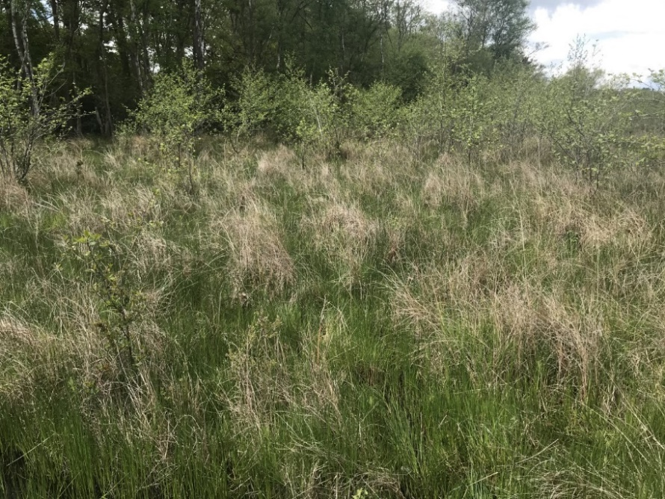

Scrape location 2 (Fugelmere marsh): approximate location SU 82345 54805
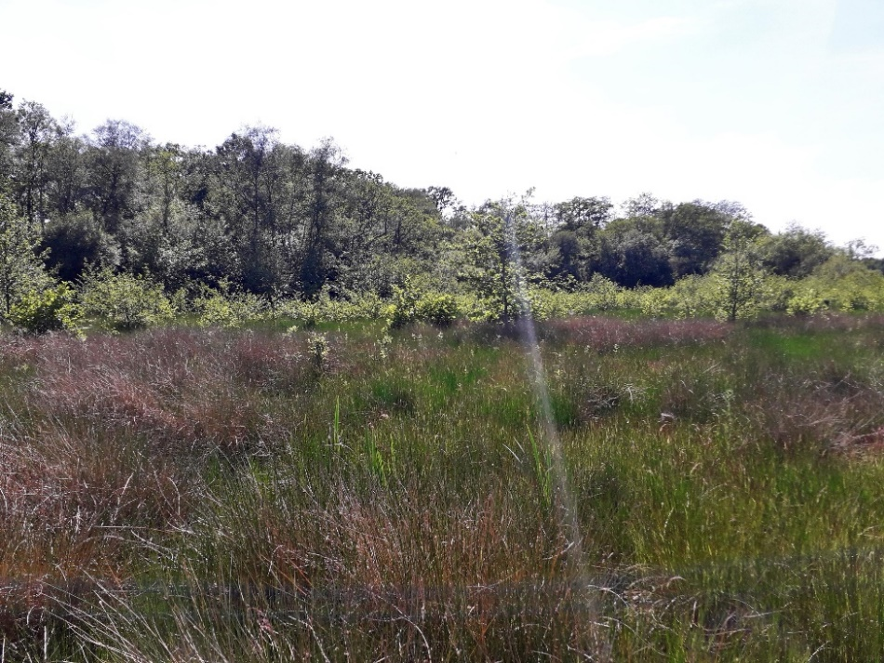

Scrape location 3 (Fugelmere marsh): approximate location SU 82347 54880
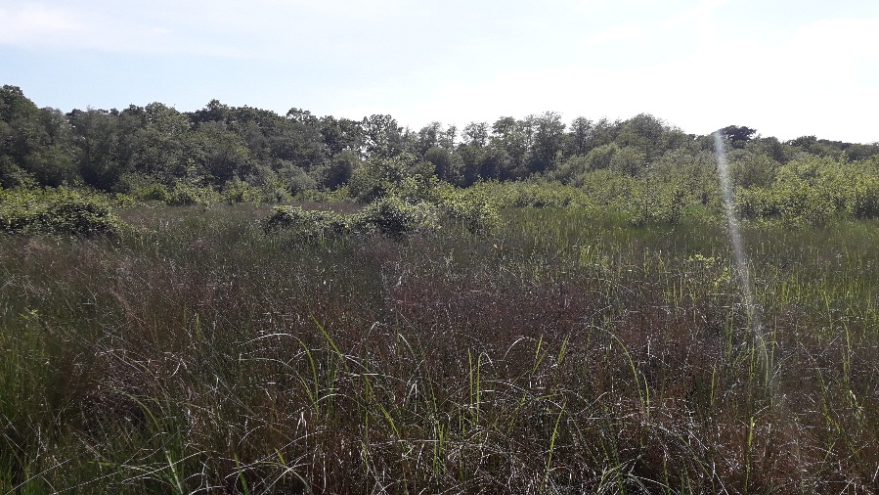

Scrape location 4 (Fugelmere marsh): approximate location SU 82263 54819
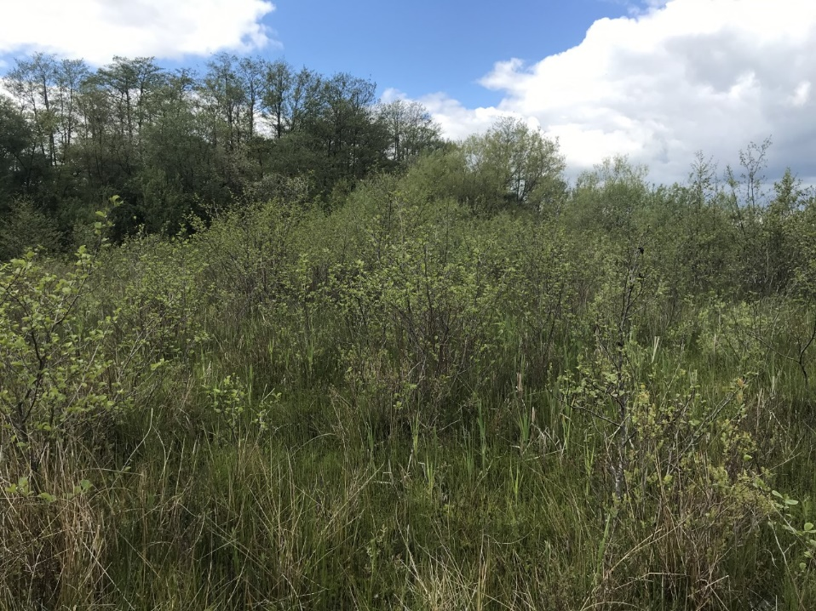
Scrape location 5 (Coldstream marsh) red box indicates location:
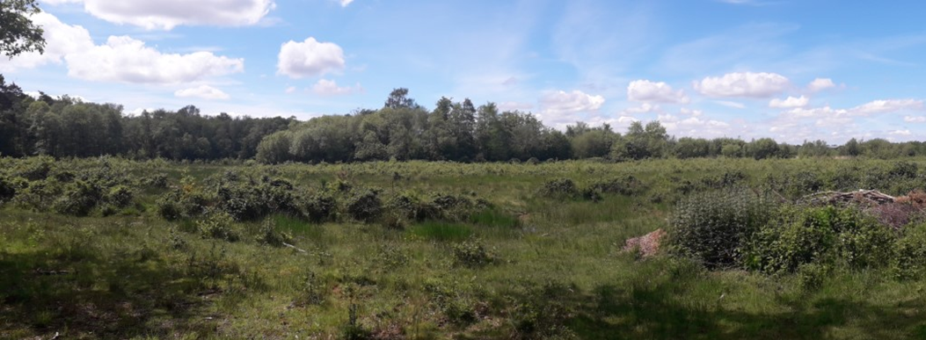
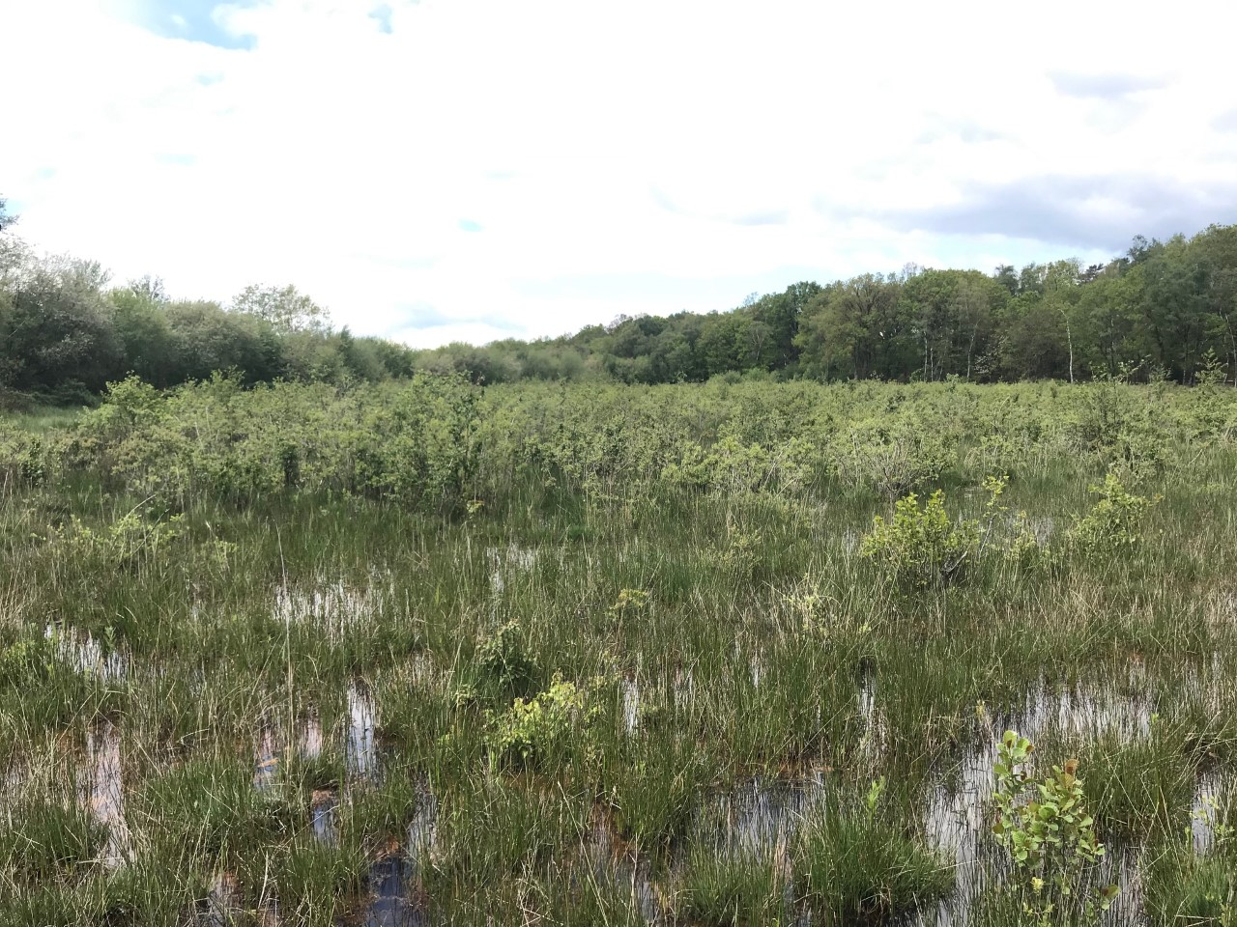
Scrub area 1: Brookly Pond
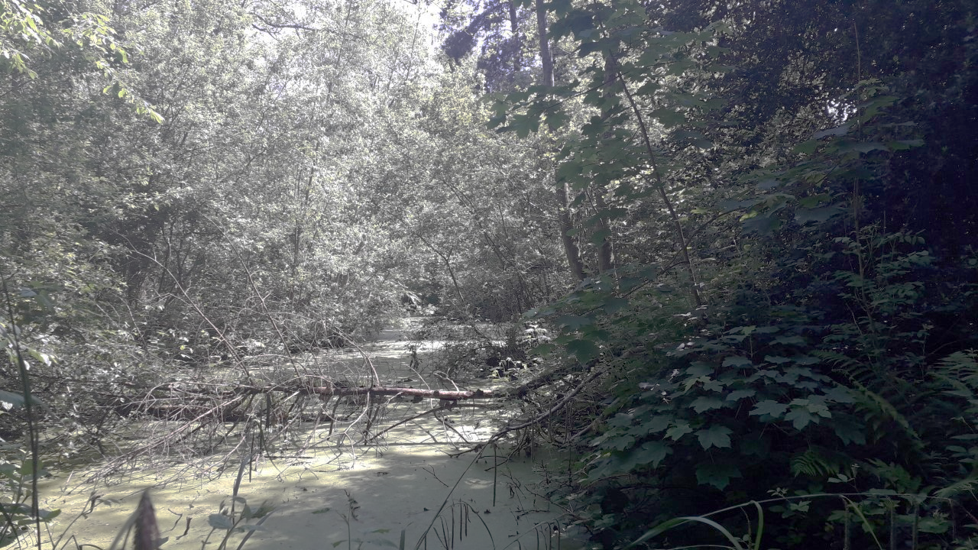 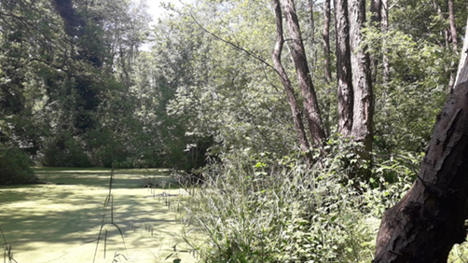
Scrub area 2: Brookly Bay
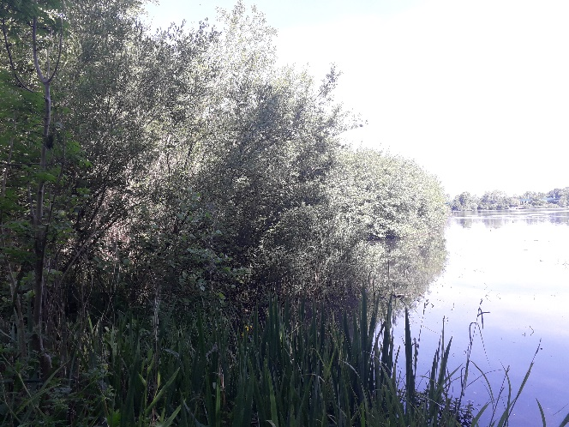
Scrub area 3: Wellington Reedbed
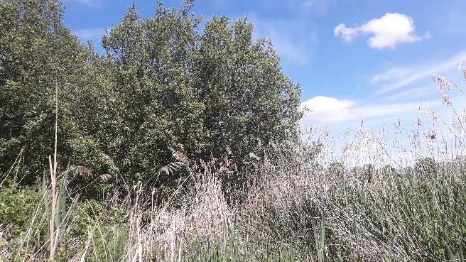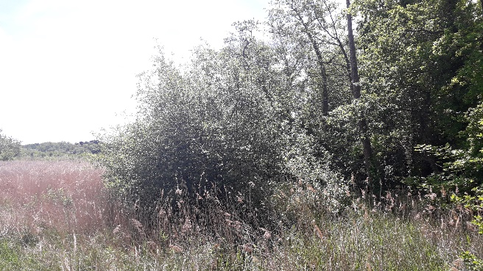
Scrub area 4: North-East marsh/Lion’s View
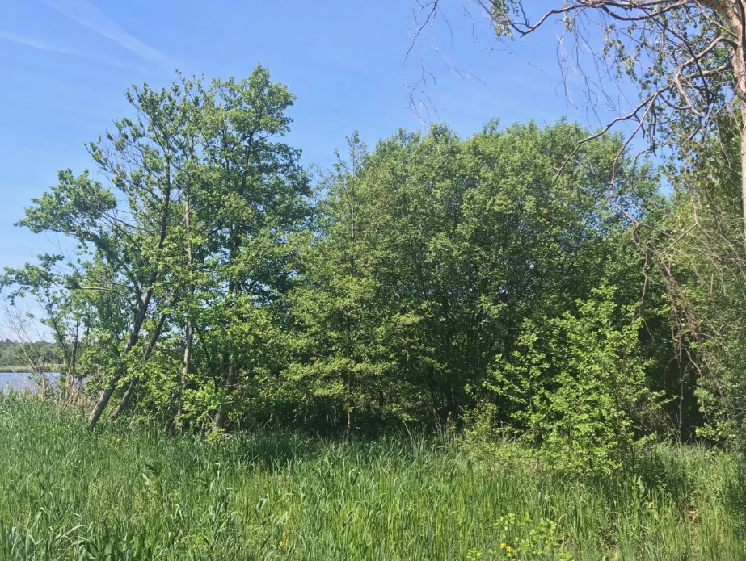
Scrub area 5: Sandy Bay islands (red box indicates island location)
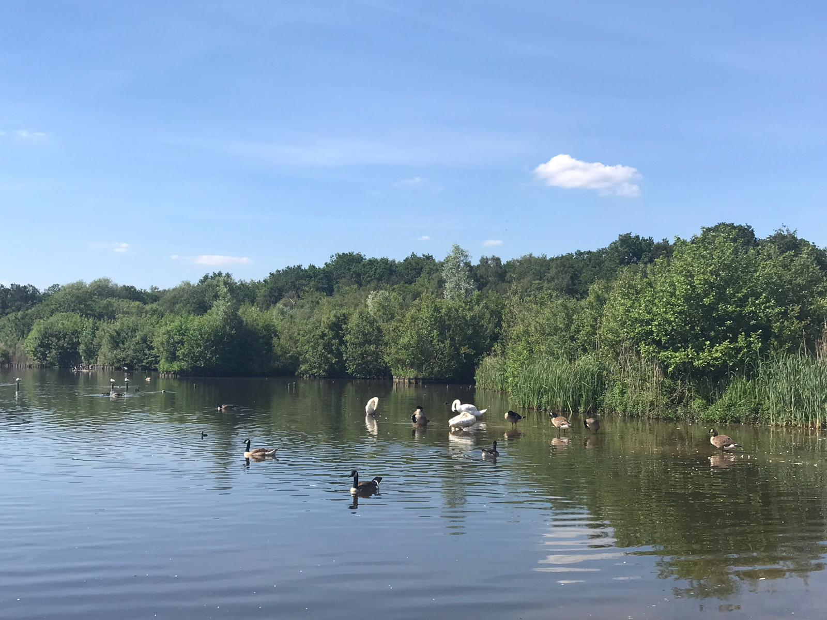
Scrub area 6: Fugelmere marsh
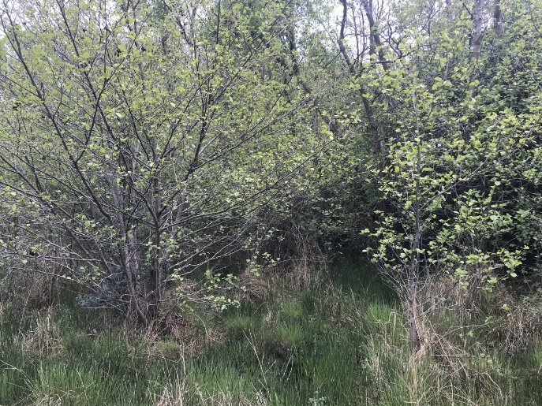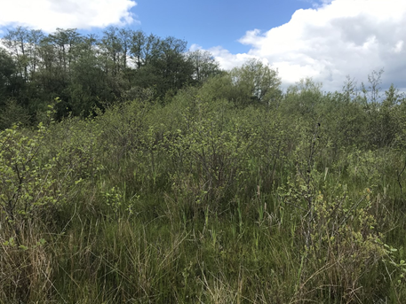
10.0 Vegetation list:
Macrophyte species which were recorded present during a survey conducted in 2019 should be included within the planting mix of the floating islands but other species will also be appropriate if present in Fleet pond. The species include various-leaved water-starwort Callitriche platycarpa, common water star-wort Callitriche helmsii, smooth stonewort, small pondweed Potamogeton berchtoldii, curled pondweed Potamogeton crispus, blunt leaved pondweed Potamogeton obtusifolius, lesser pondweed Potamogeton pusillus, fennel pondweed Stuckenia pectinate, and horned pondweed Zannichellia palustris. Final species selection and sourcing needs to be agreed with Natural England.
Appendices
Appendix 1: Contractors Procedural Brief
CONTRACTORS PROCEDURAL BRIEF
Permits to Work – Contractors must notify sub-contractors of any safety systems in place. Contract of working is between Hart District Council and the Contractor with whom the purchase order has been placed. Contractor takes full responsibility for any sub-contracted works and must obtain prior permissions from Hart Council in writing, when planning to use sub-contractors.
Safety Standards
- All contractors working on site must sign in at reception/office daily.
- Observe all local site rules. e.g. No smoking etc.
- Always notify the Site Manager of any hot works, welding etc.
- The creation of dust and fumes shall be controlled and kept to an absolute minimum.
- Contractor must provide adequate and appropriate signage and set clearly defined work zones that are a safe distance away from members of the public, including closing path sections where appropriate. In the event of path closures, contractor must do so with prior agreement from Hart DC staff.
- Contractor’s electrical tools and other equipment must be suitable for the work and environment in which the work is being performed. Tools and equipment must also be adequately maintained and conform with current regulations.
- Contractors are not permitted to make use of any premises services without the prior approval of the Site Manager.
- Contractors must not operate any dead eye, hoist, lift or any other equipment without the approval of the Site Manager.
- Contractors must maintain safe means of access and egress from every area where the contractors’ employees will be working.
- Contractors are required to use premises roads and gangways to and from the site of operation and are unauthorised to be in any other part of the site.
- All excavations at all times must be securely protected and sign posted with warning lights. Some sites may require trenches to be filled/covered if left overnight.
- Contractors shall report all accidents/incidents to the Site Manager immediately.
- Good housekeeping is to be undertaken at all times by the contractor. All gangways, corridors and roads are to be kept clear of obstruction at all times.
- The premises shall provide a safe place of work. The contractor and sub-contractors have a duty to implement and maintain a safe system of work.
- On completion of work the contractor shall ensure that all materials and waste is removed from site and appropriately disposed of.
- All contractors’ personnel must be competent, adequately trained and equipped to perform the specific task required.

All works to be carried out in accordance with the Code of Safety document below.

Specific site rules:

To be advised by the Site manager where the work is being undertaken.

Countryside Site Works
Due to the very varied sites covered by the Service and varied weather conditions “contractors” must inform the Rangers when and where they are working at all times on council land.
Contractors must be courteous to the general public at all times and communicate any positive or negative feedback from the public back to the Countryside Service.

Any weekend working must be authorized before proceeding.

All fires must be carried out in accordance with the Bonfire Protocol outlined at the end of this document.

CODE OF SAFETY

It is expected that all contractors, sub-contractors and consultants, awarded contracts by Hart District Council shall perform all work with due regard to the Health and Safety at Work etc Act 1974, the Management of Health and Safety Regulations 1992/99, the Construction (Design and Management) Regulations 2015 and all other relevant Regulations, Approved Codes of Practice and HSE guidance. It is also expected that all contractors and their employees will be conversant with any specific safety rules of the premises and the particular area in which they are to work prior to any work commencing.
The contractor shall be responsible for nominating a representative/officer (Site Manager) whose name will be documented in any written contract prior to works proceeding. The contract document shall also name the officer responsible, who will act as the site contact for all matters concerning the works.
The main contractor shall be responsible for notifying all sub-contractors of any factors affecting their health, safety and welfare and the safety of others who could be affected by the work activites being carried out. The main contractor shall ensure that any sub-contractors receive a copy[s] of the site rules and that they are understood. The main contractor shall fully inform the Site Manager of the fact that sub-contractors will be used to perform the works.

Starting work
Appropriate arrangements for health, safety and welfare and safety shall be made and a safe system of work arranged with the Site Manager before the contractor’s operations begin.
Daily, prior to commencing work, the contractor must report to the Site Manager or other previously designated manager in his/her absence.
When contractors’ operations are expected to create special hazards on any particular day(s) e.g. hot works, electrical work, work in confined spaces, demolition work, use of dangerous substances or articles, working at height or any other activity then the attention of the Site Manager must be drawn to these hazards and adequate precautions must be taken. A “permit to work” scheme may be deemed necessary for the given examples dependent upon the findings of any assessment (i.e. serious risk, COSHH, confined spaces or fire).
When Contractors’ employees may be at risk when working in certain areas on the premises, the Contractor will be notified accordingly and will also be provided with all relevant information relating to the identified risk. There will be a joint responsibility on the Site Manager and the Contractor to assess and inform their employees and to advise Hart DC of such hazards. Instruction and training will also need to be considered if the hazard is significant.
Services
Contractors must not connect or interfere with any electrical, gas, water, compressed air or other service on the premises without the expressed written permission of the Site Manager. The connection of portable electrical tools, such as drills, by means of a standard plug top is exempt from this rule provided that the appliances are of the 110volt centre tapped to earth type. The provision of any step-down transformer shall be designated as the responsibility of the Contractor.
Tools & Equipment
All plant, tools, tackle and equipment used by contractors on the premises must be suitable for the work and environment, in which it is being undertaken, must comply with all relevant legal standards and must be maintained in accordance with appropriate safety standards. The personnel using such equipment must be adequately trained and competent in the use of such equipment. Hart DC encourage the use of battery operated wherever possible.
Contractors are expressly forbidden to use any plant, tools, tackle or equipment which belongs to the premises at which the work is being performed.
Electrical Plant & Equipment
The contractor or his employees shall not enter any area of the premises without the expressed permission of the Site Manager or other previously designated manager in his/her absence.
It is recommended that battery powered tools and equipment are used whenever practicable. They have shown to emit lower noise levels and far lesser hand, arm vibration.
Portable electrical tools and equipment must be sufficiently earthed or double insulated. In appropriate cases, i.e. working in a wet environment e.g. swimming pools, such equipment must be of a voltage not exceeding 50volts for lighting and 100volts for portable tools. The electrical supply shall be by means of a double-wound transformer with the secondary circuit being centre tapped to earth.
As further means of protection from excess electrical current all equipment shall be sufficiently fused and the contractor shall use circuit breakers, miniature circuit breakers and residual current devices where possible. All such devices incorporate earth monitoring devices capable of switching off the electrical supply in the event of the earth connection being broken.
Guards, Fences, Barriers, Screens and Enclosures
Guards or fences must not be removed from any machinery or plant except to carry out work on that equipment and then only with the written permission of the Site Manager. Guards or machinery must not be removed while machinery plant is in motion or energized. Guards or Fences must also always be replaced and secured as soon as work is complete and before the machinery/plant is reinstated or energized.
All contractors’ machinery brought onto the premises must comply with the Provision and Use of Work Equipment Regulations 1998 (PUWER) relating to that type of equipment, and must where appropriate, be adequately guarded or fenced. Where a contractor is performing work on the premises which involves the breaking of stone, grinding of metals, sand blasting etc. then the contractor shall be responsible for the installation and maintenance of suitable screening or enclosures to protect persons other than their employees who may be endangered by the activity. Test and examination certificates shall be made available as requested.
Working above ground
When work by a contractor involves the erection and use of any scaffold support, mobile tower scaffolds, mobile elevated work platforms, cradles and/or ladders then the contractor shall be responsible for the safety of such structures. The contractor’s responsibility extends to incorporate features such as scaffold “fans”, ties, walkways, covers, guard rails, toe boards, warning lights etc. as may be deemed necessary for reasons of safety. Daily inspections and precautions must be taken to ensure safety on such structures by the removal of ladders or other means of access when work ceases. Test and examination certificates shall be made available as requested.
Working below ground
Ground on premises may not be broken without the expressed permission of the Site Manager and Hart DC. Nearby underground services must be positively located by the contractor and their presence pointed out to those persons performing the excavations, prior to the work commencing. Excavators and JCB’s should not be used in the vicinity of buried services. A “permit to excavate” may be issued to ensure these precautions are carried out. The excavation must be made safe by means of barriers, stop blocks and suitable warning notices until the ground is restored to its previous state.
All trenches and excavations, particularly those adjacent to roads or existing buildings must be adequately “shored”, and falls of material prevented by “battering back”, caissons, or other effective means in accordance with any guidance and good practice. The safety of other persons on site is to be a continuous priority and excavations boarded over where practicable and/or otherwise suitably protected and signed when work is not actually proceeding.
Confined Space Entry
Contractors employees may not enter any chamber, tank, pit, vat, silo, trench, pipe, sewer, flue, well or other similar confined space where there may be dangerous fumes or lack of oxygen, without the expressed permission of the Site Manager and Hart DC. If permission is given then work in such spaces shall be carried out taking all necessary precautions and using the methods outlined in The Confined Spaces Regulations 1997.
Permits to work
In cases of specifically hazardous work or where contractors operations need to be strictly coordinated with those of the premises to ensure safety, the work shall be governed by means of a formal permit system. The relevance of such a system to the work envisaged must have been discussed and documented wherever possible during the planning stage. The necessity for such a system to be adopted must be noted before work commences and the Site Manager and Hart DC informed.
Control of pollution/waste
Contractors may not deposit any waste, chemical or other substance whatsoever into any drains, skips, bins or any other area on the premises. All waste must be disposed of as agreed in the contract, by an approved and authorised waste disposal contractor(s). Further advice can be obtained from the Environment Agency.
Cartridge operated fixing tools
Cartridge fixing tools may not be used on the premises without prior permission from the Site Manager. If permission has been granted, such tools may only be used in compliance with the standards set out in the PUWER Regulations.
Fire
Smoking, the use of flame lights or the application of heat e.g. welding or burning, is prohibited in most of the premises. When this type of work is essential contractors and their employees must seek prior written approval from the Site Manager and Hart DC.
Contractors are responsible for the provision of a formal Fire Risk Assessment and suitable and sufficient fire fighting equipment appropriate to the work involved and possibly a ‘Fire Watch Person to remain on site until the heat source or embers are made safe. Contractors and their employees must conduct the following checks upon their arrival at the work site:
- The nearest means of escape in case of fire.
- The location, type and method of operation of the nearest fire fighting appliance.
- The location and method of operation of the nearest fire alarm.
Contractors must obey all alarm signals whilst on the premises. Contractors using one or more of the premises’ fire fighting appliances must notify the Site Manager and Hart DC immediately.
Emergency Evacuation of the premises
The Site Manager will inform the Contractors’ Manager of all fire and emergency procedures. The Contractor then has the duty to inform all workers, including sub-contractors of these arrangements.
- Each Council site displays official FIRE INSTRUCTION notices which are generally located adjacent to each fire fighting appliance. These notices are prominently displayed in all corridors and stairways.
- The fire instruction notices state the assembly point for users vacating a building as a result of any EMERGENCY SITUATION and normally incorporates a map identifying the location of the assembly point in relation to the building.
- All contract staff must be made aware of all familiar routes of escape from the building in which they work and fire assembly points.
- The continuous ringing of a bell/siren warning system will indicate that an emergency situation exists which necessitates the evacuation of the building. NO ONE INDIVIDUAL IS EXEMPT FROM EVACUATION.
- Upon hearing the emergency warning it is vital that users evacuate the building in a controlled and orderly fashion. Lifts and paternosters must not be used whilst the emergency alarms are ringing.
- A roll call is to be taken at each assembly point by a nominated person.
Personal Protection
The contractor shall be responsible for providing his own employees with personal protective equipment as may be required for the work in hand. Such equipment may include eye and ear protection, respirators, head protection and breathing apparatus etc.
Reporting an near miss, accident or incident involving a contractors’ employee or other person affected by the contractors’ work
Any accidents of this nature must be reported to the Site Manager immediately. Copies of Reports should also be submitted to the Councils’ Corporate Health and Safety Adviser in the Environmental Health Services department. All accident reports should be presented on an official Council accident/incident report form (ARF1) and completed on the same day as the accident/incident or within 3 days if a weekend.
Reporting an unsafe condition or hazard.
Unsafe conditions or unexpected hazards must be reported to the Site Manager immediately.

Contractor Code of Conduct

Whilst carrying out contracted work for Hart District Council Leisure & Environmental Promotion Department all contractors, their employees and any sub contractors are expected to abide by the following:-

- Be polite, respectful and considerate to others be they Hart DC staff or members of the Public
- Not to discriminate unlawfully against any person for any reason
- Bad language, unnecessarily raised voices and language or behaviour that could be offensive on the grounds of age, physical appearance, gender, sexuality, disability, ethnicity or religion are all forbidden. Examples include –
  - Verbal abuse, or insulting behaviour
  - Sexist jokes, racist jokes, jokes about an individual’s sexual orientation or jokes about disability
  - Unwanted physical contact ranging from touching to serious assault
  - Display or circulation of sexually suggestive or racially abusive material
  - Bullying, coercive or menacing behaviour
  - Ridicule or exclusion of an individual for cultural or religious differences
  - Obscene slogans on T-shirts, other items of clothing, stuck to tool boxes, etc.
- No alcohol or drugs (unless prescription medication) are to be consumed whilst in the work place or brought into the workplace. [Work place can mean a building or out on land owned or controlled by Hart DC]
- All should be in a fit state to work and not under the influence of drink or drugs
- Must observe any relevant national codes of practice and standards for his or her particular area of work
- Be appropriately trained and certificated for what they are doing and / equipment they are operating
- Comply with agreed arrangements relating to where, when and how works are to be completed
- Observe operational regulations, safety rules, regulations and codes of practice, safe working procedures
- Provide copies of all relevant paperwork regarding health & safety for what they are doing, i.e. Risk assessments, hot works certification, etc.
- Be responsible for their personal safety, mindful for that of others working with them, that of staff members of Hart DC and of members of the public

Bonfire Protocol

The number of people required when controlled burning takes place depends on the size of the burn and other resources available, such as water tenders, etc. Adequate numbers of personnel and fire beaters should be available in the event of flare up and/or the burn jumping the brake line. A mobile water supply should be on site and/or a pump from adjacent water source. Back-pack (knap sack) sprayers should be available for spot fires.
Person in charge of daily operational activity is responsible for ensuring there is an adequate Fire Plan in place and accessible, in case of emergencies.
Fire Location
- Fire site to be free from obstructions and well away from buildings, trees and hazards such as overhead cables
- There should be multiple entrance and exit points to the fire site and supervisor should ensure everyone is aware of any loading and fire use procedures
Storage of materials
- Stacking of timber for burning should be a sufficient distance away from the fire site so that it will not catch fire and the pile for burning should be minimal at all times
- Timber should be stacked in the same direction as much as possible, for ease of removal and loading
- All fuel (e.g. matches, dry kindling, newspaper, etc) should be out of the fire break area unless being used to start or reignite the fire
- Sufficient water should be within easy reach to put out any fire issues, such as embers, fire creep, wind carried fires, etc.
Burning procedures
Fire supervisor to carry out appropriate fire risk assessment prior to commencing any fires, to include identifying suitable site location, access, local conditions, emergency plans and contacts.
Controlled burns of vegetation should only be carried out in 0 - light winds with humidity at 50 - 60% and the mean air temperature must be below 50 degrees F.
The area to be burnt should be surrounded by an area clear of vegetation at least 4 metres wide. Burn should be carried out against the wind, where possible.
Bonfires should not be lit if there is a high risk of the surrounding vegetation catching light and / or large embers being dispersed widely. They should not be lit in high winds.
The fire brigade should be informed before controlled burns or bonfires are lit. (Telephone 01329221228)
At least one person should have a mobile phone with them when having a bonfire or carrying out controlled burn,
Fire Issues
If any fire looks to be getting out of control then the fire supervisor should arrange to call the emergency services on 999 as soon as possible. The site manager should also be informed as soon as it is appropriate and safe to do so.
Fire supervisor and all fire users should be aware of appropriate fire safety.

