Refurbished Play Area and Associated Works at
Mount Pleasant Recreation Area, Hamble-le-Rice

9 July 2024
Version 2.0 – Authorised
Hamble Parish Council (HPC)

Invitation to Tender

Background
Mount Pleasant play area is a well-used community asset. Being adjacent to the primary school and within walking distance of the whole village, it is a popular location for parents and children of all ages to meet and play.

Whilst the existing arrangement is very successful in attracting and entertaining young people, there are aspects where it is no longer satisfactory for current needs. For example, a refurbished arrangement would need to be more accessible to a wider range of abilities and ages and equipment may need to be upgraded to meet current material and design specifications.

Project cost
The total project cost shall not exceed £120,000 including VAT.

Site description
A plan of part of Mount Pleasant play area showing the access point and the areas designated for the works is given in Figure 1 below.

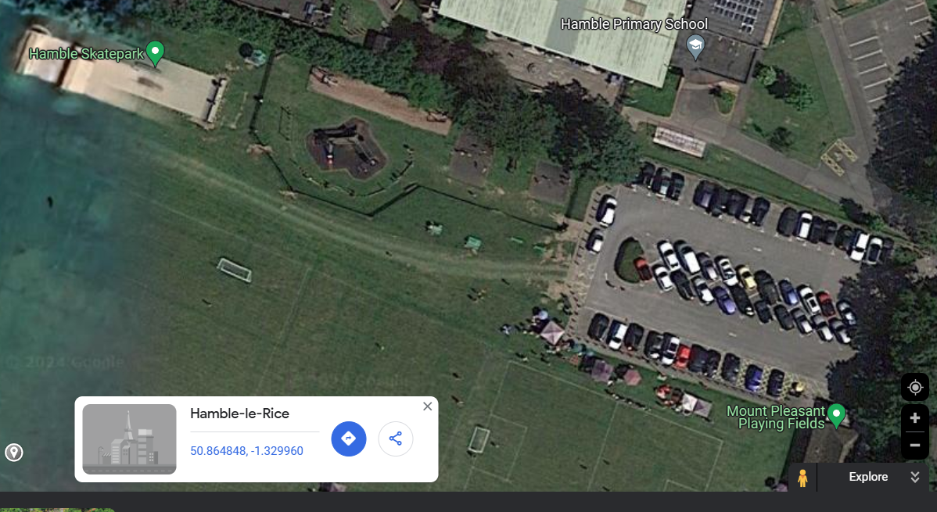

Figure 1
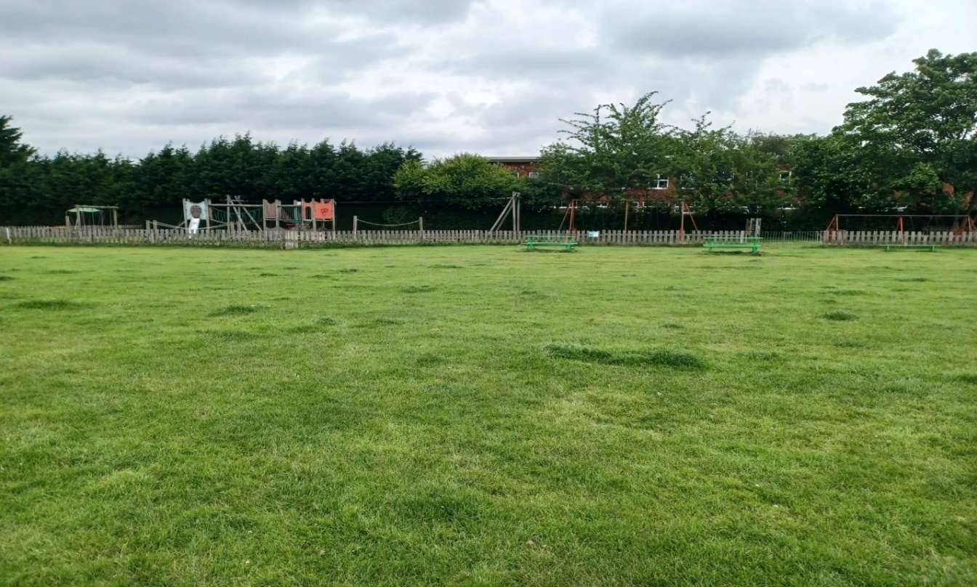
Figure 2

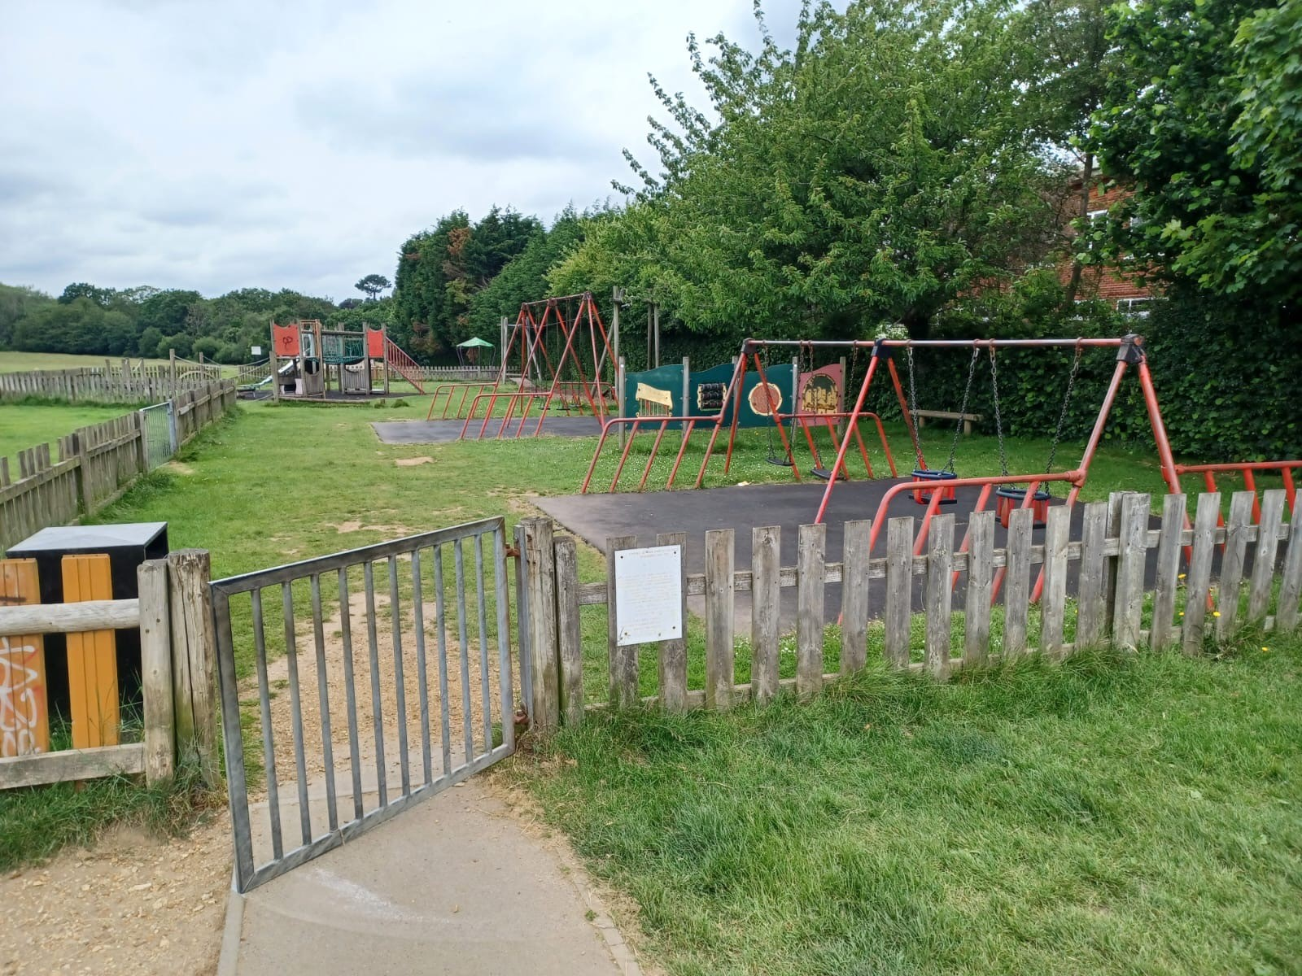
Figure 3

The area is adjacent to the primary school and accessed from Hamble Lane. There is already a parking area on the site, which is heavily used by parents bringing their children to and from school.

There are no services or constraints on access to, or use of the site for equipment or workers, although care should be taken to minimise the impact on the peak drop off and collection times.

Site visits
Bidders are warmly encouraged to visit the site before submitting their tender. Please contact the operations and facilities officer to arrange this. operations@hambleparishcouncil.gov.uk Tel. 023 8045 3422 option 1

Governance
Hamble Parish Council (HPC) has delegated authority to manage the project to the Parish Clerk (Project Director) who will be supported by the operations team with oversight from a small, dedicated subcommittee that can make all decisions relating to the project. The Project Director will take all practical steps to ensure that the financial controls, design authority and program management are clearly established and that necessary matters are escalated to the project subcommittee for timely decision making and reporting.

In accordance with our financial regulations (The Public Contracts Regulations 2015), we are contracting according to the Public Contracts Directive 2014/24/EU.

All works should comply to the British and European Standards for playground equipment BS EN 1176 and surfacing BS EN 1177.

It is expected that all matters relating to the project that are within the delegated scope will be addressed either at routine weekly meetings or, in exceptional circumstances, within 24hrs.

Site work

Confirmation of work hours, storage of materials, access, location of skips, final programme of works, and Risk Assessment Method Statements (RAMS) will be agreed with the Project Director before work begins.

Care should be taken not to damage the field or existing paths. If necessary, heavy vehicles should use ground protection mats.

During installation, the contractor should provide a secure work compound for all equipment and materials.

The contractor will ensure that the public cannot gain access to the work site, by erecting suitable fencing and safety notices around the construction site. The contractor must take all reasonable action to ensure that newly installed apparatus is not used until practical completion is confirmed.

Any machinery left on site overnight must, where possible, be immobilised. The contractor will be held responsible for: any damage caused to or by machinery/materials left on site by the contractor; and any vandalism caused to machinery/materials left on site by the contractor. The contractor will be held responsible for and must make good any damage caused to existing buildings, roads, paths, grassed areas, car parks, fences, drains, sewers, service mains, landscaping, etc. Before the project’s completion, any area that has been damaged during the installation must be made good and returned to new or as a minimum returned to the original condition at the contractor’s expense.

The contractor must protect the whole recreation ground against unauthorised persons, vehicles and encampments by ensuring the access point is locked when not in use. The contractor shall bear the costs incurred in the removal of unauthorised encampments due to the contractor’s negligence.

Works timeline*

Contract published on contact finder | 12 July 2024
Deadline for submissions | 23 August 2024
Tender evaluation completed | 6 September 2024
Tender response due | 13 September 2024
Shortlist conformation | 13 September 2024
Order date and contracts issued | TBD
Agreed completion date | TBD
Work to commence | TBD
Contract awarded pending reference checks | TBD
All snagging/fencing and storage removed | TBD
Invoice or agreed payment schedules | TBD

Planning permission
If the agreed design requires planning permission, the successful bidder will be required to obtain appropriate permission within the scope and funding of the project. This includes a temporary compound.

Equipment maintenance
Submissions must include a separate schedule for the expected maintenance costs for the first 15 years for each item of equipment. The schedule should include annualised costs for all material items in the design. The contractor must be prepared to provide supporting evidence and/or references to support the proposed maintenance programme.

Scoring and evaluation*
Tender submissions will be assessed on whether and to what extent they meet the criteria.

Item | Score | Details
Overall design
Total project cost
Satisfactory references
Satisfactory company and financial checks
Insurance and competency to carry out project

Weighted criteria*

Compliance with work specification
Materials and sustainability
Warranty and durability
Appearance or theme
Inclusivity
Value for money (quantity of items)
References and previous projects

Scoring system *

Quality | Points | Criteria
Superior | 5 | Exceptional demonstration of the relevant ability and understanding experience, skills, resources.
Good | 4 | Comprehensive response in terms of detail. Clearly meets most of the project requirements with no negative indications or inconsistencies.
Adequate | 3 | Reasonable achievement of the requirements specified in the tender offer & presentation. Some errors, risks, weaknesses or omissions which can be corrected or overcome with minimal effort.
Below Expectations | 2 | Minimal achievement of the requirements specified in the tender offer. Several errors, risks or weakness which are possible but will be difficult to overcome and make acceptable.
Poor | 1 | Limited response provided, or a response that is inadequate
Unacceptable | 0 | Totally deficient and non-compliant for the criteria.

Format of submission
In addition to addressing the items above, submissions should include:
- developed scheme with individually costed items, computer-aided designs, and visuals of each item of equipment proposed
- details of warranty and 15-year maintenance costs for each item of equipment
- the most recent set of the bidding company’s audited accounts
- details of any enforcement action under Health & Safety legislation
- brief details of two projects of a similar scale undertaken by the company in the last three years
- contact details of two referees who have contracted the bidding company to complete a project of a similar scale in the last three years
- contact details of one referee who contracted the bidding company to complete a project of a similar scale at least five years ago
- confirmation that should the submission be successful the bidder will be able to meet the timetable (see 8 above)
- details of company insurance (see 14 below)
- evidence of a waste carrier licence
- health & safety policy statement
- equality policy statement
- environmental policy statement

Bidders must ensure they have fully understood this document and the requirements of the work specification. If applicants are unsure of any details, they must contact the Project Director to discuss these before submitting.

Submissions should be clearly marked and sent electronically to:
The Clerk - Hamble Parish Council clerk@hambleparishcouncil.gov.uk

Pricing and payment schedule
All pricing should be listed inclusive of VAT and valid for 5 months from the date of submission.

The quotation must include a distinct amount for the submission of the planning application if this is necessary.

The bidder should propose a schedule of payments with relevant controls and retentions.

Insurance
The bidder must provide confirmation of standard compliance where relevant and evidence within the submission of:
- public liability insurance (minimum £10 million)
- employers’ liability insurance (minimum £5 million)
- professional indemnity insurance (minimum £5 million)

Waste
All waste shall be stored safely while on site and removed from site by the contractor.
Submissions must include evidence that the bidder has an applicable waste carrier licence.

Inspection
All equipment shall be inspected by an RPII accredited inspector upon completion and before the Project Director will accept completion. This shall be arranged by and at the expense of the contractor.

Work specification
The work specification is not exhaustive but stipulates the minimum requirements of the work.

Bidders are encouraged to submit imaginative proposals which differentiate theirs from other applicants’, whilst addressing the specification and not exceeding the stipulated total cost

Proposed locations for items of play equipment are given below, but other locations will be considered if positioning is clearly justified by the design rationale.

Play area
- Location:
  - Generally, the same site as existing.
- Surface:
  - Remove existing and replace with appropriate safety surfacing over whole area within the fence perimeter.
- Materials:
  - All metals to be fully galvanised, not just coated.
  - As far as possible, materials should be fire-resistant, especially bins and benches
- Fencing and Access:
  - Install appropriate perimeter fence and wheelchair accessible gates at entrances.
- The minimum specification must be the direct replacement of the existing facilities. HPC would be keen to discuss any enhancements with the bidder that can be provided within the constraints.
- Adequate supply and groundworks as necessary.
- Inclusivity:
  - Exercise options for users with motor impairments.
  - Points for features that make the space welcoming to teen girls and women.
  - MUGA wheelchair accessible.
- Appearance:
  - In keeping with the surroundings
- ‘Welcome’ signs aligned to face approach paths, branded with Hamble Parish Council.

