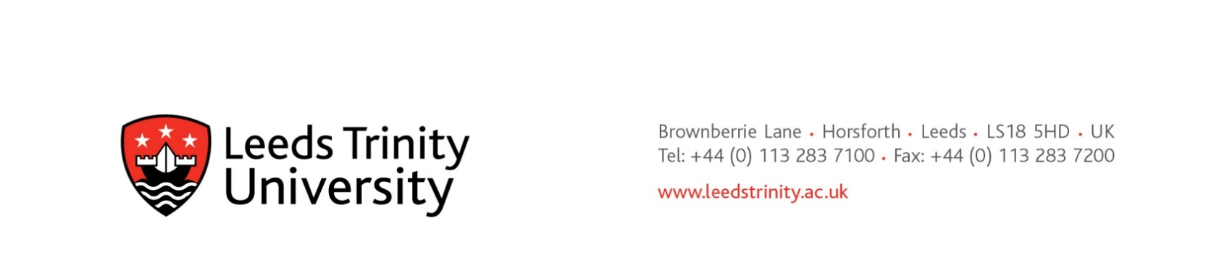

1st December 2022

**INVITATION TO QUOTE**

**Project: ITS080LTU - Medication proficiency e-learning platform**

Dear potential supplier

In respect of the above Leeds Trinity University seeks quotations from market participants.

The information provided in this document presents the university’s current understanding of requirements:

[**“The NMC (2018) Future Nurse: Standards of Proficiency for Registered Nurses”**](https://www.nmc.org.uk/globalassets/sitedocuments/standards-of-proficiency/nurses/future-nurse-proficiencies.pdf) requires that student nurses study and achieve proficiency in medicines management and optimisation.

Within curriculum design and delivery this can be supported by an e-learning solution that uses diagnostic assessments to identify any skill deficits and direct practitioners quickly and accurately to appropriate and self-paced interactive learning that addresses the problem and manages the risks of medication error by supporting the development and assessment of competence for safe medication practice.

The university seeks quotations from market operators for an appropriate ‘off the shelf’ e-learning platform on the following uptake basis:

|  |  |  |  |  |
| --- | --- | --- | --- | --- |
|  |  | **Price excluding VAT** | | |
| **Year** | **No of students** | **Cost per student** | **Cost in year** | **Cumulative cost** |
| standard set up fee / implementation cost | | £ - | £ - | £ - |
| 1 | 100 | £ - | £ - | £ - |
| 2 | 200 | £ - | £ - | £ - |
| 3 | 350 | £ - | £ - | £ - |
| 4 | 350 | £ - | £ - | £ - |
| 5 | 350 | £ - | £ - | £ - |

**Please provide:**

1. your quotation before 1700h Thursday 15th December 2022.
2. a copy of the terms and conditions of contract your quotation relies upon.
3. price information and discounts rewarding longer term contract commitment.

All correspondences to Mark Hayter by e-mail: [m.hayter@leedstrinity.ac.uk](mailto:m.hayter@leedstrinity.ac.uk)

I hope to hear from you soon

With kind regards

Mark Hayter

Head of Procurement