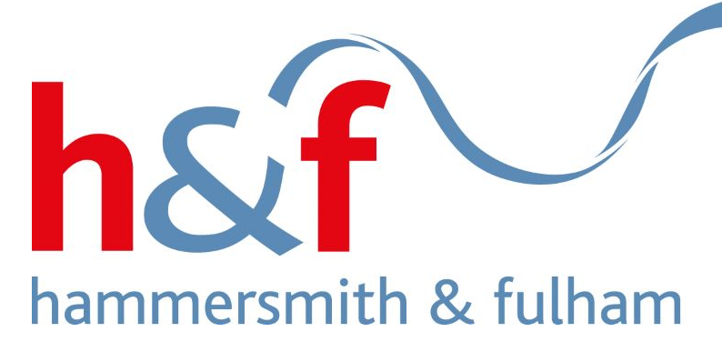

Pre-Market Engagement Questionnaire

Public Realm

This document has been returned by
Click to enter organisation name.

Contents
1. Pre-Market Engagement Questionnaire Response 3

Pre-Market Engagement Questionnaire Response

  - London Borough of Hammersmith and Fulham Council (the “Council”) are keen to understand answers to the following questions from potential Suppliers who are interested in this opportunity.

Table A – Pre-Market Engagement Questionnaire
 | Question
 | Given the diverse nature of Supplies, Services, and/or Works required by the Council, which operating model would you prefer the Council to adopt and how would this affect your offer?
 | Single Provider – Term Maintenance Contract – Single Provider |  |  | Choose an item.
 | Single Provider – Integrated Maintenance and Improvement (TMC +) – Single Provider |  |  | Choose an item.
 | Multiple Providers by Lot – Lot 1 – Bridge and Structure Maintenance: Procurement A – Single Contractor |  |  | Choose an item.
 | Multiple Providers by Lot – Lot 2 – Public Realm Asphalt Surfacing and Road Marking Contract: Procurement A – Single Contractor |  |  | Choose an item.
 | Multiple Providers by Lot – Lot 3 – Public Realm Paving Works: Procurement A – Single Contractor |  |  | Choose an item.
 | Multiple Providers by Lot – Lot 4 – Public Realm Project Works – Multi Contractor Hierarchy |  |  | Choose an item.
 | Multiple Providers by Lot – Lot 5 – Public Realm Street Lighting Maintenance and New Works: Procurement A – Single Contractor |  |  | Choose an item.
 | Multiple Providers by Lot – Lot 6 – Public Realm Drainage Works: Procurement A – Single Contractor |  |  | Choose an item.
 | Multiple Providers by Lot – Lot 7 – Public Realm Ground Maintenance Works: Procurement C |  |  | Choose an item.
 | Multiple Providers by Lot – Lot 8 – Winter Maintenance Works: Procurement A – Single Contractor |  |  | Choose an item.
 | Multiple Providers by Lot – Lot 9 – Tree Maintenance: No procurement |  |  | Choose an item.
 | Multiple Providers by Lot – Lot 10 – Conditions Survey: Procurement B – Multi Consultant |  |  | Choose an item.
 | Multiple Providers by Lot – Lot 11 – Professional Services: Procurement B – Multi Consultant |  |  | Choose an item.
 | Click to enter text.
 | Do you think the bundling of some of these lots would result in additional value being delivered to the Council? |  | Choose an item.
 | If so, what Lots would you like to see bundled together?
 | Click to enter text.
 | The Council are planning to restrict the number of lots that are awarded to a single contractor. Please can you provide your views on how this would potentially impact your offer.
 | Click to enter text.
 | Does the multi lot approach deliver best value service to the Council?  Please add any additional comments below. |  | Choose an item.
 | Click to enter text.
 | What would you consider to be an appropriate / optimal resource level for a contract of this size?
 | Click to enter text.
 | What would be your Preferred Initial Term Contract Duration and any subsequent extension option/s and why?
 | Click to enter text.
 | How would the Contract duration affect your offer?
 | Click to enter text.
 | The Council is minded to use the NEC4 suite of contracts. Do you have any alternative suggestions regarding this proposed approach?
 | Click to enter text.
 | Which form of the NEC4 suite of contracts do you believe would best align to the works/services you would like to provide?
 | Choose an item.
 | Which NEC4 commercial main option(s) would you prefer? e.g. Option A
 | Click to enter text.
 | Would you like to see any specific secondary option X W Y Z clauses included in the contract e.g. X1, etc.
 | Click to enter text.
 | Which pricing structure would enable your company to offer best value to the Council and the optimal method of accounting for inflation?
 | Click to enter text.
 | What do you consider to be the greatest challenges to the Council in the delivery of the works and service required by this procurement?
 | Choose an item.
 | Click to enter text.
 | What do you consider are the barriers to entry within local authority contracts?
 | Click to enter text.
 | Would your company be interested in attending a short online session on practical procurement advice on local government tendering and to answer any questions you may have? |  | Choose an item.
 | What do you consider to be the optimal guarantee period (maintenance period) for maintenance works carried out under the contract and why?
 | Click to enter text.
The Contractor will be required to provide a depot with storage facilities for the operation of the contract as the Council will not provide this facility.
What do you think would be the optimal method of operational contract delivery in terms of materials storage, office, plant, vehicles and welfare facilities whilst maximising sustainable delivery?
 | Material Storage | Click to enter text.
 | Office | Click to enter text.
 | Plant | Click to enter text.
 | Vehicles | Click to enter text.
 | Welfare Facilities | Click to enter text.
 | Which industry specific accreditations and certifications do you think are requisite and/or desirable to fulfil a contract of this size and/or nature?
 | Click to enter text.
 | How could the contract(s) be specified to maximise carbon reduction and environmental benefits delivery in line with the Councils target to be net 0 by 2030?
 | Click to enter text.
 | How could we specify the contracts to maximise social value initiatives and/or outcomes to the community in Hammersmith and Fulham?
 | Click to enter text.
 | Do you believe the incorporation of a dialogue or negotiation stage would be beneficial as part of the procurement process?  Please add any additional comments below. |  | Choose an item.
 | Click to enter text.
 | Are there any other relevant considerations not covered by the previous questions that you feel may assist with shaping the tender and maximising the deliverables?
 | Click to enter text.

