**EXPRESSION OF INTEREST**

**PROVISION OF A DORSET COMMUNITY OUTBREAK RESPONSE SERVICE (CORS)**

**REFERENCE NO: NHSDCORS-EOI-001**

**CONTRACTING AUTHORITY: NHS Dorset**

**START DATE: October 2025**

**DATE RESPONSE REQUIRED: 12TH September 2025**

1. **EXPRESSION OF INTEREST (EOI) SCOPE** 
   1. This EOI seeks information relating to the provision of a Community Outbreak Response Service (CORS)in Dorset to provide a coordinated and timely clinical response to communicable disease outbreaks and or incidents within the Dorset community, ensuring effective management of cases and contacts to minimise transmission and protect public health.
   2. This EOI is being conducted in line with the NHS Dorset ICB Standing Financial Instructions for expected total expenditure between £20,000 and £50,000.
   3. NHS Dorset ICB would like to identify suppliers that may be able to supply the service required as detailed in section 3 & 4 below.
   4. Please advise if you are interested in delivering this service please complete the online form at the following link <https://forms.office.com/e/MFGM06Ap0g>.
   5. Once this EOI procedure has been completed the responses will be presented to the NHS Dorset Executive to understand the next steps. Information shared with the NHS Dorset Executive will be anonymised.

# CURRENT SITUATION

* 1. NHS Dorset are looking to commission a Community Outbreak Response Service (CORS)in Dorset
  2. The UK Health Security Agency (UKHSA) is responsible for managing public health outbreaks, including those in the community. They work with Integrated Care Boards (ICBs) and other partners to detect, investigate, and control outbreaks of infectious diseases and other hazards.

UKHSA works with ICBs to ensure that public health interventions are integrated into local healthcare planning and delivery. This includes ensuring that local health services are prepared to respond to outbreaks and that appropriate resources are available, and the purpose of this Community Outbreak Response Service (CORS) is to meet this aim by providing a point of contact for UKHSA.

# NHS DORSET ICB AIMS – WHAT WE WANT TO ACHIEVE

1. The Community Outbreak Response Service (CORS) will aim to provide a coordinated and timely clinical response to communicable disease outbreaks and or incidents within the Dorset community, ensuring effective management of cases and contacts to minimise transmission and protect public health.

3.2 Desired Outcomes are:

* Reduced time to diagnosis and treatment for confirmed cases.
* Effective prevention response to minimise hospitalisation.
* Improved inter-agency coordination and collaboration.
* Reduced morbidity and mortality associated with the outbreak.

# WHAT NHS DORSET ICB IS LOOKING FOR

* 1. The Dorset Community Outbreak Response Service (CORS) aims to ensure there is one centralised pathway in place for the management of communicable disease outbreaks, seasonal and nonseasonal, outbreaks and or incidents within the Dorset community. This service builds on and is in addition to the responsibilities within the GMS/PMS contract held by GP Practices.
  2. The CORS provisions will support an effective, timely outbreak and or incidents response for the management of communicable diseases within the Dorset community, including education settings, migrant and homeless populations, care home settings and within the patient’s own home.
  3. The service aims to prevent the spread of disease and minimise its impact on local neighbourhood health and the wider healthcare system.
  4. Services to be delivered are:

4.4.1**.** **Inter-Agency Collaboration:**

* **Point of Contact:** provide a point of local contact for the UKHSA Health Protection Team between the hours of 8am – 6pm, Monday to Friday and 8am – 2pm at weekends.
* **Coordination:** Establishing clear lines of communication and coordination between different agencies involved in outbreak response, including public health, healthcare, and emergency services.

## Resource Mobilization: Ensuring adequate resources, including personnel, supplies, and facilities, are available to support outbreak and or incident clinical response efforts.

4.4.2 **Rapid Response:**

* **Testing:** of suspected cases (diagnostic swabbing, Faecal sampling, blood test).
* **Diagnosis:** of diseases (including in school, care home, migrant and asylum-seeking setting or person own home),
* **Clinical assessment and treatment:** of symptomatic individual/s (where applicable),
  + - * **Collection, storage and transport:** of specimens for processing.

4.4.3 **Evaluation and Improvement:**

* **Performance Monitoring:** Tracking key performance indicators to assess the effectiveness of outbreak response efforts.
* **Data Analysis:** Analysing data to identify areas for improvement and refine response strategies.
* **Continuous Improvement:** Implementing a process of continuous improvement to enhance the effectiveness and efficiency of the CORS.
  1. NHS Dorset are considering the following options to deliver the service:

4.5.1 Option 1

The communicable diseases requiring a response under this specification would include **Seasonal Influenza and Scabies**

4.5.2 Option 2

The provider will be commissioned to deliver against option 1 **plus** cover for outbreaks of all other communicable diseases, seasonal and nonseasonal, the most common examples can be seen below. **This is not an exhaustive list:**

* Measles
* Acute Respiratory Infections
* Whooping cough – Pertussis
* IGAS or GAS
* Avian Influenza (HCID)
* Mpox
* All Streptococcus including iGAS.
* Hepatitis A, B and C
* Diphtheria
* Meningococcal infection

4.6. Indicative Budget

* + - A service retainer fee, indicative of 20k. This figure is based on current funding available but NHS Dorset do not have any activity figures to understand if this budget is representative of the cost of this type of service.
    - Additional remuneration will apply against the number of outbreaks presented through the length of the contract
  1. Contract
     1. Contracting terms to be NHS Terms and Conditions for the Provision of Service
     2. Commence Date October 2025
     3. 1-year initial term with an option to extend for a further year

# EOI TIMETABLE

|  |  |
| --- | --- |
| **DATE** | **ACTIVITY** |
| 22/08/2025 | Publication of the Expression of Interest |
| 12/09/2025 | Deadline for submission of a EOI Response |
| 15/09/2025 | Analysis of EOI responses |
| 03/10/2025 | Confirm next steps to EOI Respondents |

1. **RIGHT TO CANCEL OR VARY THIS EXPRESSION OF INTEREST**
   1. NHS Dorset ICB reserves the right to:
      1. Cancel all or part of this EOI at any stage and at any time;
      2. Amend, clarify, add to or withdraw all or part of the EOI at any time
      3. Not proceed with a contract award. Nothing shall constitute a commitment to ordering unless NHS Dorset ICB undertake a procurement process that results in the award of a contract.
2. **GENERAL**
   1. Any and all costs associated with the production of such a response to an EOI must be borne by the Contractor. We will not contribute in any way to meeting production costs of any response.
   2. Information contained within this document is confidential and must not be revealed to any third party without prior written consent from us.
   3. We expect that all responses to this EOI will be provided by Potential Contractor in good faith to the best of their ability in the light of information available at the time of their response.

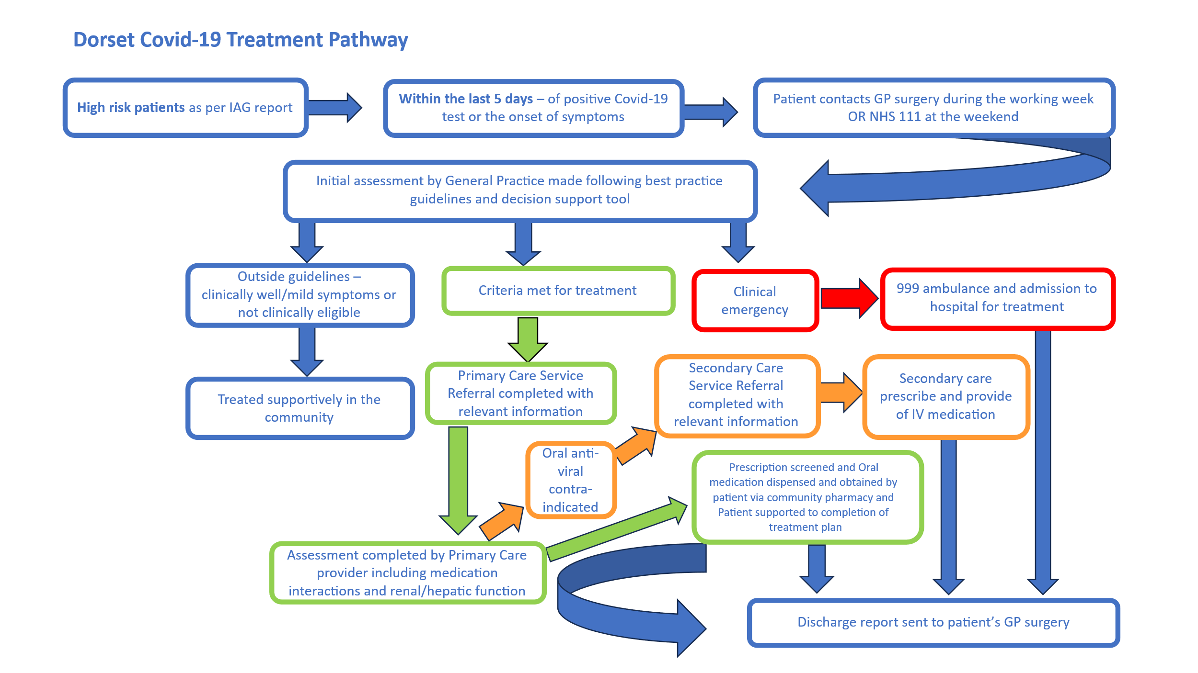**Appendix A**