TENDER FOR ST DENNIS PARISH COUNCIL

St Dennis Parish Council Invitation to Tender
Title: landscaping and groundworks tender
Reference number: 2020/02
Deadline for receipt of tender proposals: 12 noon, 1st October2020

Background
St Dennis Parish Council are responsible for the grass cutting and landscaping for various areas within the Parish. We aim to maintain our assets to a high standard as far as is reasonably practicable, for and on behalf of the residents of the village.

We are separating this contract into three areas as follows:
The Cemetery
The Playing Field
Open spaces (including various verges) and footpaths.

Section 1: Specifications

Introduction
St Dennis Parish Council are seeking a suitably qualified supplier to provide ongoing maintenance to the above areas (maps and further information enclosed Annex A).

The Parish Council wishes to implement this tender to in line with our obligations to ensure that best practices are being observed in the spending of public funds.

The Contracts will run from April 2021. There will be a six-monthly review in the first year and an annual review. Subject to a clause break as detailed in the contract.

Contract 1: Grounds Maintenance Requirements for St Dennis Cemetery:

St Dennis Cemetery is a place of quiet reflection for relatives and the general public and as such all works within its boundaries must be carried out with respect and sensitivity to the location. All contractors must be respectful and sympathetic at all times to visitors and in particular must cease their activities when a burial is taking place.

1 Mowing and Strimming of the Cemetery Grounds
- Fortnightly cuts (weather permitting) between the months of March – October.
- Additional cuts to be authorised by the Parish Clerk.
- The grass around the graves, the tablets in the Garden of Rest, seats, and monuments shall be cut using strimmer’s and the trimmings collected and disposed of by the contractor.
- To ensure all Headstones and Tablets in the Cemetery is clean of grass cuttings.
2. Shrub Maintenance
- Maintenance of shrubbery in the Cemetery.
- The frequency of shrubbery pruning shall be sufficient to prevent the loss of shape due to growth.
- All trimmings resulting from pruning or trimming of the shrubbery shall be collected and disposed of by the contractor.
3. Boundary Maintenance
- Maintenance of the perimeter of the Cemetery twice per annum.
- To cut back growth from the hedgerow’s and maintain adequate access to the public footpath that runs through the Cemetery grounds.
- All trimmings resulting from the strimming / cutting back of the boundary shall be collected and disposed of by the Contractor.
Contract 2: Grounds Maintenance Requirements St Dennis Playing Fields:

1. The following areas are to be cut 18 times per year March - November
All grass areas in St Dennis Playing Fields which include:
- The lower part of the Playing Field
- The Skate Park area
- The banks
- The area above the Skate Park
- The Children’s enclosed area around the play equipment

Contract 3: Grounds Maintenance Requirements for Footpaths, Open Spaces and Trelavour Prazey:
St Dennis has several footpaths that run thought the village and to outlying areas within the Parish. These footpaths need to be stimmed and cut back during different periods throughout the year.

Mowing and Stimming of the Footpaths/ Grass Verges/ Stiles & Gates and Trelavour Prazey
Footpaths
Footpaths are graded into three sections. Gold, Silver and Bronze.
- Gold footpaths are generally cut twice a year between May and September but could be cut more at the discretion of St Dennis Parish Council. The silver paths are only normally cut once a year, but at the discretion of St. Dennis Parish and the bronze paths, stiles and gates at the discretion of St. Dennis parish Council. Additional cuts to be authorised by the Parish Clerk.
- The paths are cut to allow the use of members of the public access on each path, so any branches of trees, shrubs and weeds need to be cut back and maintained, on footpaths that do not have private ownership. However, the removal of trees is not allowed, but the Clerk must be informed of any trees that are blocking any footpath, stile, gate or grass verge.
- The frequency of shrubbery pruning shall be sufficient to prevent the loss of shape due to growth.
- All trimmings resulting from pruning or trimming of the shrubbery shall be collected and disposed of by the contractor.
- Disposal of waste to be removed.
- A map of the paths can be found in Annex A.

Trelavour Prazey
- Price per cut for Trelavour Prazy approx. 0.5 acres.
- To ensure the Sun Dial and Benches at Trelavour Prazey are clean of grass cuttings.
- To prune and maintain the rose bushes and bank twice per year or at the discretion of St Dennis Parish Council and the clerk.
- All cuttings, trimmings and waste to be removed by the contractor.
- Areas to be cut twice monthly thorough out the months of March – October.
- Or at the discretion of St Dennis Parish Council and the Clerk.
Grass Verges
- To be cut monthly throughout the period of March – October.
- Or at the discretion of St Dennis Parish Council and Clerk.
- A map of the grass verges will be supplied in Annex A.
Stiles and Gates
- To be cut and maintained at the discretion of St Dennis Parish Council and Clerk.
- The clerk will request any stile or gate to be cut back at their discretion.
- This will be a trim of any overhanging branches and removal of bushes and grass.
Hendra Prazey Land and Well
- Land to be cut six times between the period of March and October.
- The area of the well to be cut back twice annually.
- Or at the discretion of St Dennis Parish Council and the Clerk.
- Arisings of all cuttings, trimmings and waste to be removed from site by the contractor.

Scope of the Contracts.

A Footpath grass cutting and strimming
A1.1 Footpaths should be cleared to a width of 1.5m (where possible) and to a height of 15 cm
A1.2 General trimming may be left on the site by where large amounts of vegetation result from works, chippings and/or removal from site may be necessary where on-site disposal is not possible.

A2 General Grass Cutting all other areas.
A2.1 The Contractor is required to keep all grassed areas at 50mm or below at all times up to the designated boundary, the contractor is also required to carry out a minimum of two cuts 18 cuts between the months of March – October per annum. Additional cutting may be required in the summer, and further cuts between the months of march and October at the discretion of St Dennis Parish Council.
A2.2 Mowing and strimming shall take place on the full areas of grass as detailed in the attached maps, and all boundaries including the base of all obstacles, tree etc. unless alternative arrangements have been agreed by the Council.
A2.3 The Contractor will clear and dispose all grass clippings arising from mowing operations from paved and tarmac areas, all footpaths, mowing margins, channels, etc
A2.4 During very wet conditions, grass cutting shall cease if damage to the surface, levels and contours of the ground will occur. The Contractor is required to notify the Parish Clerk of the periods when cutting cannot be carried out.
A2.5 The Contractor shall be required to re-cut any area that has not been maintained in accordance with this specification, at his own expense, raking off and clearing from the site any grass that has been cut when growth has reached a height above the upper parameter indicated.
A2.6 The Contractor will confirm to the clerk a regular day of cutting.
A3 Other Ground Maintenance Work.

A3. 1 To quote for additional work required that may occur during the 12 month period.
A4 Mowing Equipment and Machinery.
A4.1 The Contractor shall provide all plant and equipment necessary to cut all grassed areas. All mowing machines shall be well maintained, cutters to all mowers shall be sharp and properly set up so as to cut the grass cleanly at all times.
A4.2 All machinery shall for the duration of each and every cut, be fitted with adequate safety guards.
A4.3 All wheeled grass cutting machinery must be fitted with tyres specifically designed for use on turf.
A4.4 No machinery shall be refuelled or lubricated on the grass areas.
A4.5 In the event of any operation or activity carried out by the Contractor being of detriment to the structure of the facility or area, the Contractor will be responsible for the cost of all remedial works which would be required.
Procurement and Project Timetable

Event | Date/Time
Tender Notice posted | 15th August 2020
Tender response deadline | 12 noon, 1st October 2020
Clarification (if applicable) | w/c
Anticipated contract award | w/c 15th January 2021
Start Date | Tuesday 1st March 2021

*Bidders should raise any queries they have about the requirements with the clerk via email, telephone or site meeting. We will circulate all questions raised (without disclosing the source of the enquiry) and all responses to all bidders unless it considers the information commercially sensitive. Our view on the issue of commercially sensitivity shall be final, the bidder raising the question will be asked to withdraw it if it does not agree with this assessment.

**We reserve the right to carry out clarifications if necessary; these may be carried out via email or by inviting bidders to attend a clarification meeting. In order to ensure that both the Parish Councils and bidders’ resources are used appropriately, we will only invite up to three (the ultimate number will depend on the closeness of scores) highest scoring bidders to attend a clarification meeting. Scores will be moderated based on any clarifications provided during this meeting. You are responsible for all your expenses when attending such meetings. St Dennis Parish Council reserves the right to vary all dates in this Invitation to tender, to terminate this procurement process and/or decide not to award a contract.

Duration of Contract
The contract will be for a 12-month period. This will be renewable annually.

Service Levels
You must propose Service Levels in your tender response for agreement with St Dennis Parish Council. You will be required to comply with the SLAs above and any others suggested and agreed with St Dennis Parish Council as part of the contract.

Escalation Procedures
In the event of a major problem, a list of contacts will be required to manage any problem to a successful conclusion.

Contract Management
In performing the services required under this contract the supplier will report to the Clerk of St Dennis Parish Council.
The Contractor shall provide proof of his Health & Safety policy and where appropriate, copies of Risk Assessments. Copies of Insurance Documents, Safeguarding (Children and Vulnerable Adults) Policy and Environmental Policy shall be provided for Council scrutiny.
All persons operating machinery and equipment must be appropriately trained. The Contractor shall provide adequate proof that all operatives are well trained and conversant with Health & Safety legislation and are competent in their operating methods.
The Contractor is required to notify the Parish Clerk immediately of any accidents, near misses or environmental incidents such as oil or diesel spillages. The Contractor is expected to carry spillage kits.

Please specify in your proposal the named individual who will be responsible for the management of this contract on behalf of your organisation.

Management Reporting/review meetings
Following an initial six-month review with the contractor, the Parish Council shall on an annual basis, carry out a full review of the Contractor’s performance with the successful bidder.

Contract Value
Please note that 35% of the evaluation criteria is allocated to the price. The methodology for scoring price is set out below.

Payment Structure and billing requirements
Payments will be made on a monthly basis, invoices should be received by the office no later than the last day of each month to ensure payment is not delayed. Invoices will include full details of all work undertaken in the period covered by the invoice.

Evaluation Criteria
You are required to respond too ALL of the criteria below. To assist our evaluation of your tender submission, please ensure you clearly cross-refer your response to the assigned numbers. Any relevant supporting tender documentation must also be clearly identifiable by a criteria number.
- Quality Criteria
65 marks will be allocated to your response to the Quality Questions (table 1 below). Each question will be scored using the methodology as outlined in this section.
Your overall score for each question will be calculated by multiplying the quality score you receive with the weighting for that question, set out below. This score will then be divided by the total maximum available score for the Quality Criteria (325) and multiplied by 65% to get your final score for that question.
Example: assume bidder A scores 3 for question 1: the formula is 3 x 15 = 45, 45 ÷ 325 x 65 = 9.00%.
35% of the marks will be available for your price proposal. The methodology for scoring price is set out further below.

Please note – Though criteria are numbered, this does not relate to any order of importance

Table 1

 | Criteria | Weighting
Question 1. | Outline your previous relevant experience of providing similar services including the following information in respect of each example relied on:  Organisation Name:  Length of contract:  Reference contact details.  Please provide references who we may contact to verify the information provided. | 15
Question 2. | Outline your approach to service delivery and detail how you will meet all our requirements in section 1 above. As part of your response you must specifically address the following:  - provide details of similar contracts undertaken  - appendix showing range/scope of qualifications including how frequently these are updated and how the details are maintained  - clarification as to whether you propose to use any third parties to deliver any aspects of the services and detailed information on their experience and role. You should also explain how you will work with these organisations to ensure the services are delivered in accordance with the contract which you will ultimately be responsible for. | 30
Question 3. | Project management and delivery specifically:  Explain your methodology for contract implementation.  Your response must include:  - how you will meet our required service levels and any additional services.  - your proposals for maintaining quality and providing management and reporting information. | 10
Question 4. | Demonstrate the quality and technical skills of the team members including managerial staff who you propose to undertake this contract if successful and explain how those members will have the skills and availability to provide the service to a high standard.  Your response should outline your reporting structure. | 10

- Price criteria (35 marks)

35 marks will be awarded to the lowest priced bid and the remaining bidders will be allocated scores based on their deviation from this figure. Your total costs figure including VAT and expenses in the schedule of charges below will be used to score this question.

For example, if the lowest price is £100 and the second lowest price is £125 then the lowest priced bidder gets 35% (full marks) for price and the second placed bidder gets 32.2% and so on. (25/100 x 35 = 8.75 marks; 35 – 8.75 = 26.25 marks)

The bidder with the highest score when the quality and price marks are added up will be the preferred bidder.

Schedule of Charges
If VAT is chargeable by your company on the services to be provided and this will be taken into account in the overall cost of this procurement contract.

Bidders shall complete the schedule of charges below estimating the travel and subsistence costs associated with their bid. The total fixed price will be inxclusive of VAT and inclusive of expenses and all costs to be incurred.

St Dennis Cemetery | Quantity | Unit costs | Total
Pre contract set up meeting | 1
Mowing & Strimming of Cemetery Grounds | 18
Shrub Maintenance | N/A
Boundary Clearance | 2
Sub-total

VAT
Total Price including VAT and expenses (this figure will be used to calculate your price score)

St Dennis Playing Field | Quantity | Unit costs | Total
Pre contract set up meeting | 1
Mowing and Strimming of the Playing Field Grounds | 18
Boundary Maintenance | 2
Sub-total

VAT
Total Price including VAT and expenses (this figure will be used to calculate your price score)

Footpaths/Verges/stiles & Gates Trelavour Prazey and Hendra Well area. | Quantity | Unit costs | Total
Pre contract set up meeting | 1
Footpaths price per linear metre | 2
Stiles and Gates | 2
Trelavour Prazey | 18
Trelavour Prazey Bank & shrub maintenance | 2
Hendra Prazey | 6
Well Area | 2
Grass Verges | 8
Sub-total

VAT
Total Price including VAT and expenses (this figure will be used to calculate your price score)

The Contractor must provide the following documents as part of the tender submission.
• Detailed costs
• Health & Safety policy including copies of Risk Assessments.
• Safeguarding Policy and Environmental Policy.
• Copies of Insurance Documents.
Notes:
- St Dennis Parish Council reserves the right to reject abnormally low tenders.
- You should not submit additional assumptions with your pricing submission. If you submit assumptions, you will be asked to withdraw them. Failure to withdraw them will lead to your exclusion from further participation in this competition.
The closing time and date for quotations is noon on the 1st October 2020

Section 2: Instructions to tenderers

Please submit your tender offer in accordance with all of the instructions, requirements and specifications set out in the enclosed documentation.

You must treat these documents and any further information provided by St Dennis Parish Council as confidential at all times and only disclose them if necessary, to prepare a compliant response to the tender.

Nothing in the enclosed documentation or appendixes, or any other communication made between St Dennis Parish Council and any other party, can be considered a contract or agreement at this stage.

Compliance
St Dennis Parish Council reserves the right to disqualify or reduce the evaluation score of any tenderers who do not fully comply with the requirements in the tender documentation, in particular the closing time and date.

St Dennis Parish Council reserves the right to evaluate proposals on a variety of criteria. The tender with the lowest price will not automatically be accepted.

Validity of offer
You must offer your tender for acceptance for 60 days from the deadline for tender submission.

Please note that by submitting a tender response for consideration you are confirming that, as an officer for the company/organisation that you represent, you have read and understood the tender documents and that your offer to St Dennis Parish Council is open for acceptance for 60 days from the tender closing date.

Tendering
If we need to amend any tender documents before the closing date, we will write to you with any changes. If we extend the deadline for tender responses, we will advise you.

St Dennis Parish Council reserves the right, in its absolute discretion, to cancel or suspend this tender process at any time and for any reason. If we need to do this we will notify you in writing as soon as reasonably practicably.

St Dennis Parish Council is not responsible and will not pay for any expenses or losses you incur during, but not limited to, the tender preparation, site visits, post-tender negotiations or interviews.

Return of Tender

You must complete and submit your tender response/proposal in a sealed envelope to the Parish Council Office, Claytawc Building, Fore Street, St Dennis, PL26 8AF, by the tender response deadline of 12 noon on the 1st October 2020.

Please ensure that all necessary paperwork is included with your tender documents.

We will not accept any responses submitted by any other method including email. Any tender delivered after the closing date and time for any reason will be discounted.

The Parish Council is not responsible if all or part of your tender is not received.

Appendix 1 Verges

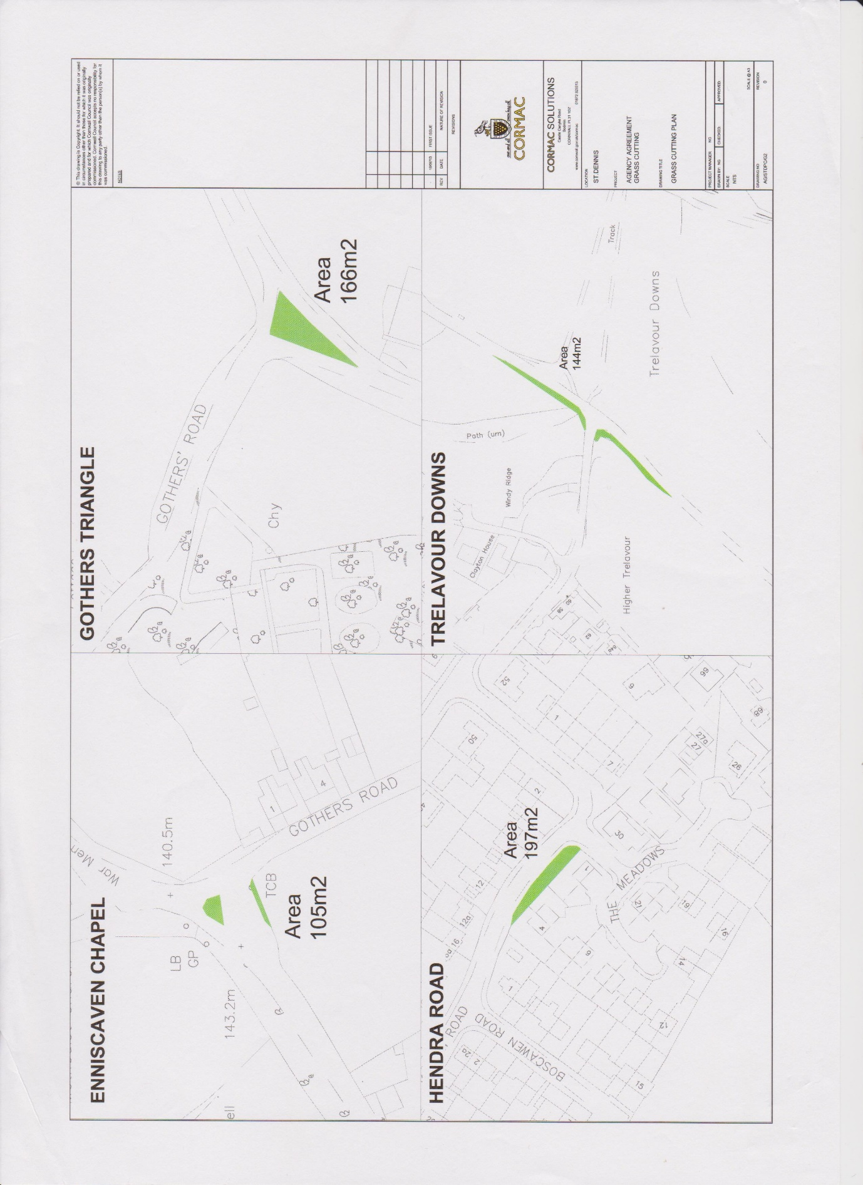

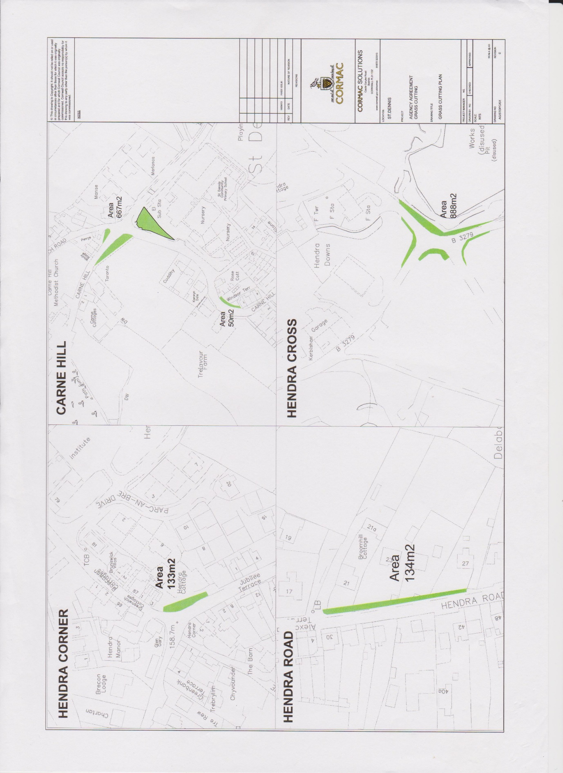

Trelavour Prazey
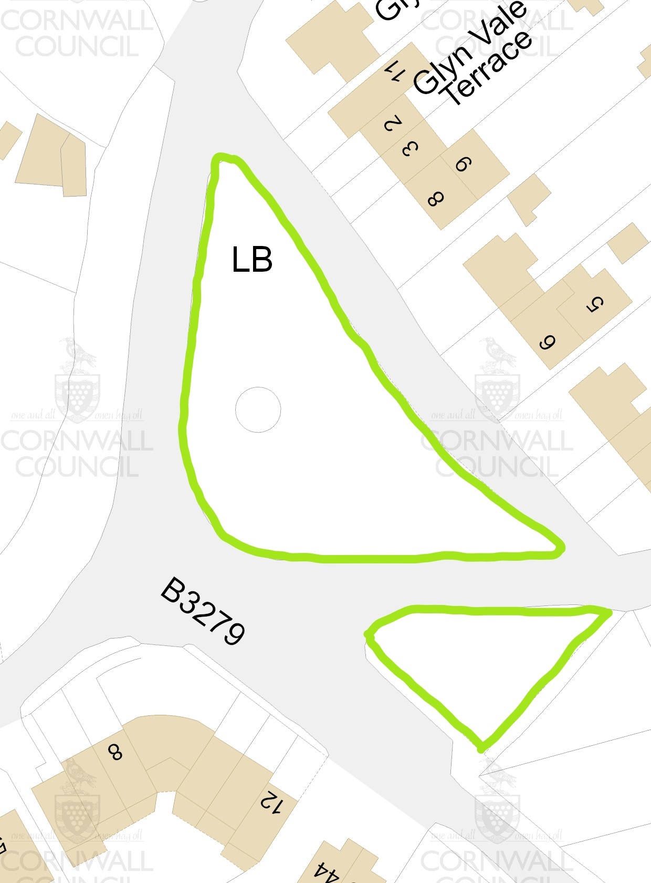

Hendra Prazey
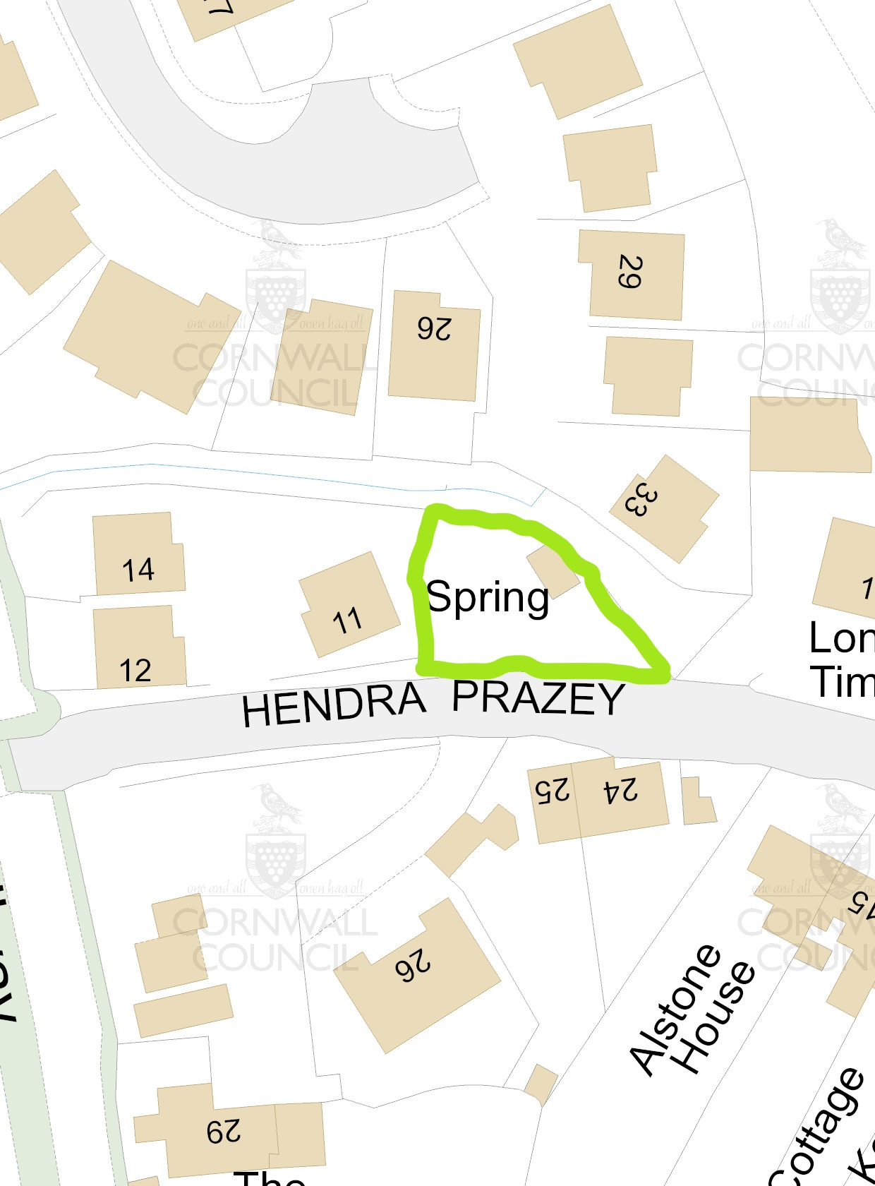

Footpaths: For further information please visit: https://www.cornwall.gov.uk/environment-and-planning/countryside/public-rights-of-way/public-rights-of-way-interactive-mapping/
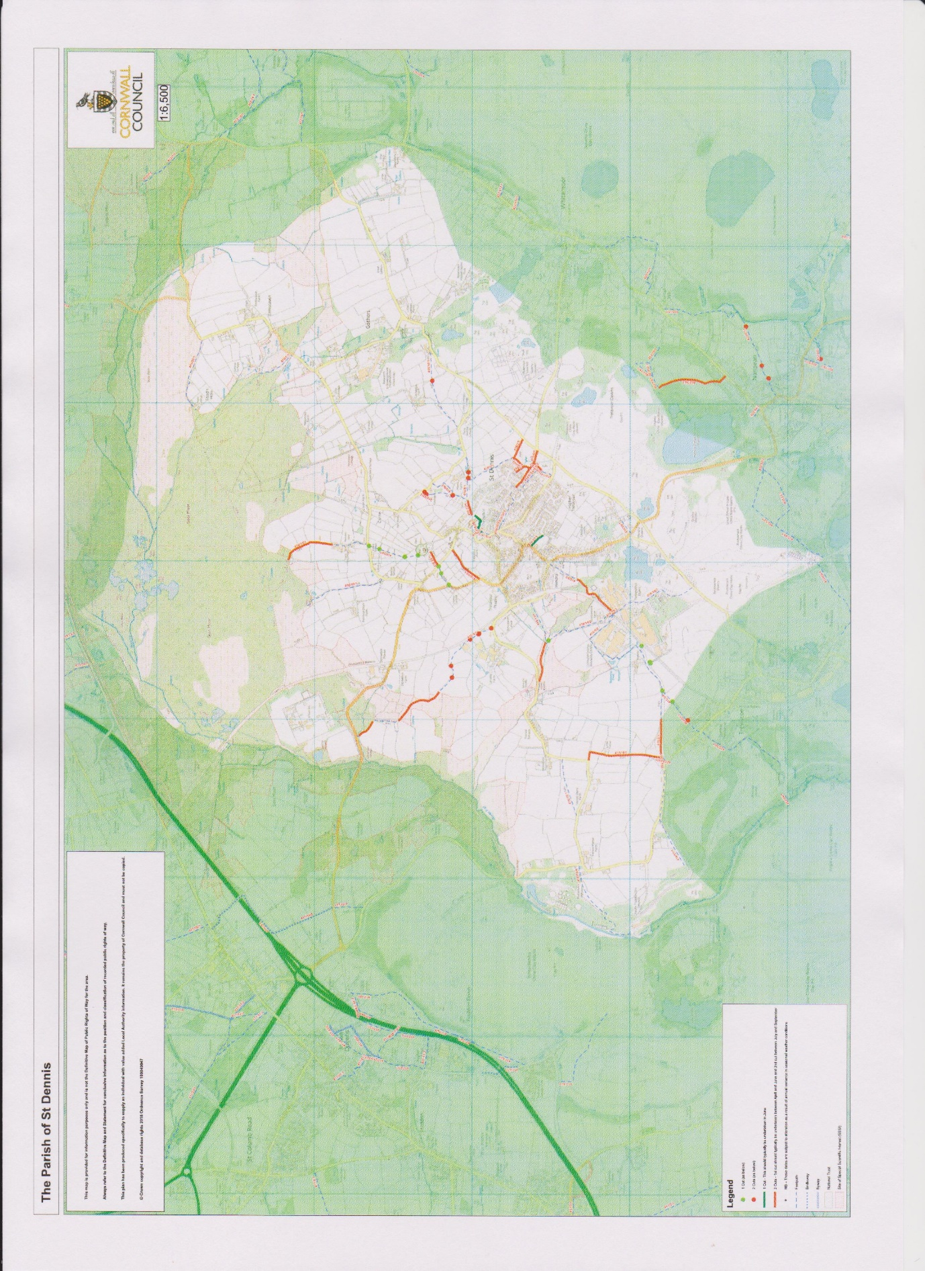

Cemetery Map
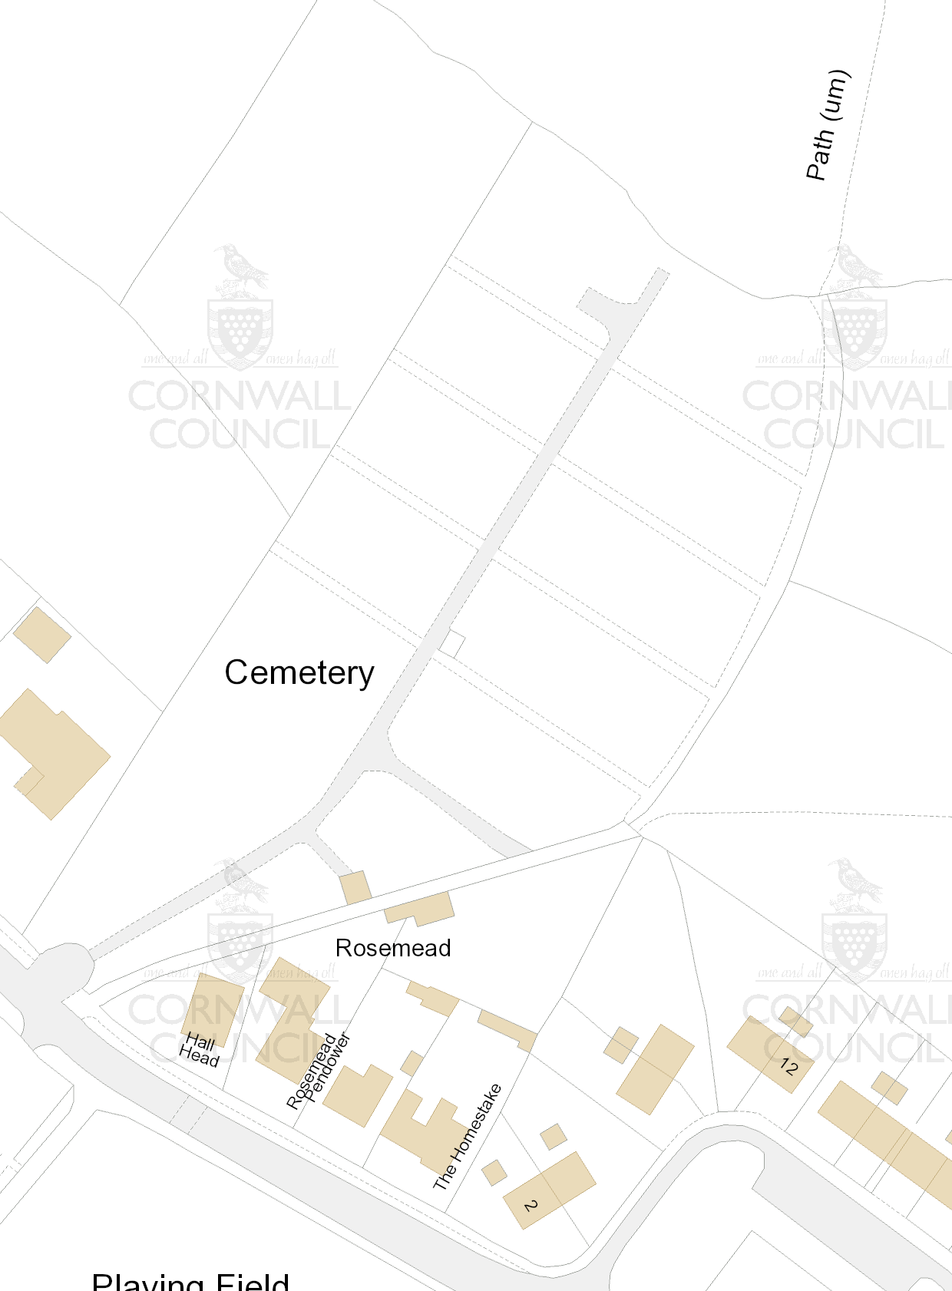

Playing Field Map
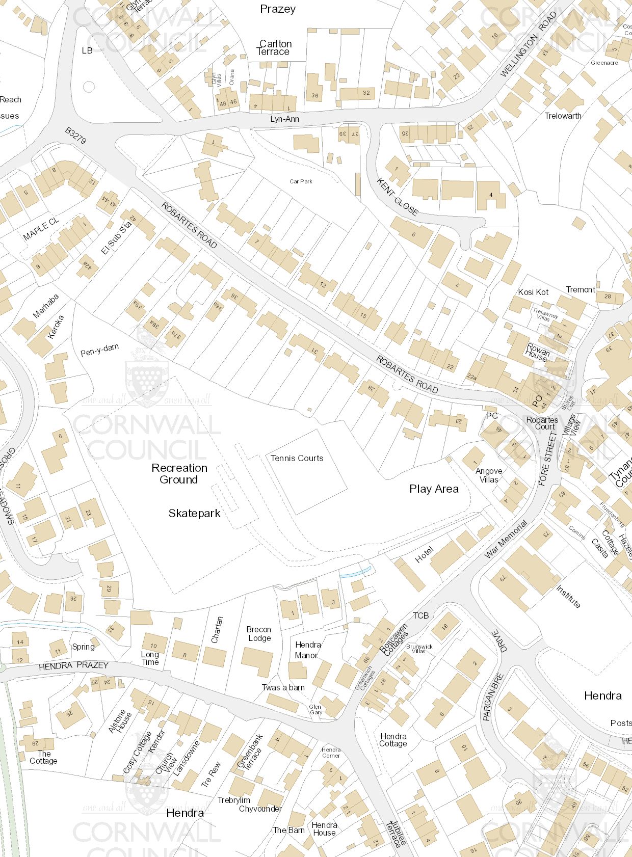

Appendix 2

Acceptance of tender terms and conditions

Name:

Company:

I have read and understand the enclosed documents for the landscaping and maintenance contracts with St Dennis Parish Council.

I accept and agree to the terms and conditions of the tendering process as laid out in the tender documents.

Signed:

Date:

