

www.gov.uk/naturalengland

**Request for Quotation**

**Request for Quotation: Sussex Woods Deer Co-ordinator Role**

You are invited, to submit a quotation for the requirement described in the specification below.

Please confirm, by email, receipt of these documents and whether you intend to submit a quote.

Your response should be returned to the following email address by:

Email: robert.hall@naturalengland.org.uk

Date: **31/05/2023**

Ensure you state the reference number and ‘Final Submission’ in the subject field to make it clear that it is your response.

**Contact Details and Timeline**

Robert Hall will be your contact for any questions linked to the content of the quote pack or the process. Please submit any questions by email and note that, unless commercially sensitive, both the question and the response will be circulated to all tenderers.

|  |  |
| --- | --- |
| Action | Date |
| Date of issue of RFQ | 17/05/2023 |
| Deadline for receipt of Quotation | 31/05/2023 |
| Intended date of Contract Award | w/c 05/06/2023 |
| Inception Meeting | w/c 05/06/2023 |
| Intended Contract Start Date | w/c 05/06/2023 |
| Draft report submitted to Project Officer | na |
| Draft report to be returned to contractor with Natural England comments | na |
| Intended Delivery Date / Contract Duration | 12 months with possible extension |

**Glossary**

Unless the context otherwise requires the following words and expressions used within this Request for Quotation shall have the following meanings (to be interpreted in the singular or plural as the context requires):

|  |  |
| --- | --- |
| “Authority” | Means the Department for Environment, Food and Rural Affairs acting as part of Natural England |
| “RFQ” | Means this Request for Quotation and all related documents published by the Authority and made available to suppliers |
| “Contract” | Means the contract to be entered into by the Authority and the successful supplier. |

**Conditions applying to the RFQ**

You should examine your response to the RFQ and related documents ensuring it is complete prior to submitting your completed quotation.

Your quotation must contain sufficient information to enable the Authority to evaluate it fairly and effectively. You should ensure that you have prepared your quotation fully and accurately and that prices quoted are arithmetically correct for the units stated.

The supplier by submitting a quotation is deemed to accept the terms and conditions in the RFQ. Failure to comply with the instructions set out in the RTQ may result in the supplier’s exclusion from this procurement.

**Acceptance of Quotations**

By issuing this RFQ the Authority does not bind itself to accept any quotation and reserves the right not to award a contract to any supplier who submits a quotation.

**Costs**

The Authority will not reimburse you for any costs and expenses which you incur preparing and submitting your quotation, even if the Authority amends or terminates the procurement process.

**Clarifications**

The Authority reserves the right to discuss, confidentially, any aspect of your quotation with you prior to any award of Contract to clarify matters.

**Amendments**

The Authority may amend the RFQ at any time prior to the deadline for receipt. If it amends the RFQ the Authority will notify you in writing and may extend the deadline for receipt in order to give you a reasonable time in which to take the amendment into account.

**Conditions of Contract**

Natural England’s general Terms and Condition can be found [here](https://assets.publishing.service.gov.uk/government/uploads/system/uploads/attachment_data/file/419961/general_terms_and_conditions.docx).

**Specification**

The Authority is Natural England. The Authority’s priorities are to secure a healthy natural environment; a sustainable, low-carbon economy; a thriving farming sector and a sustainable, healthy and secure food supply. Further information about the Authority can be found at: [Natural England](http://www.naturalengland.org.uk/)

1. **Background**

The Sussex Woods pilot has been set up to address a growing fallow deer population which is having significant impacts on Protected Sites as well as other stakeholders (farmers, foresters, public). Traditional deer management approaches have proved ineffective due to the fallow’s high mobility and the nature of this landscape – a mix of woodland and arable land-use with multiple land ownership and numerous ‘safe havens’. The pilot seeks to engage landowners and other stakeholders to work together to facilitate and incentivise collaborative and sustainable deer management at a landscape scale, leading to an improvement in woodland condition of Protected Sites.

A map of the pilot area is included within Annex 1.

The Deer Co-ordinator role is required to input into a landscape wide strategy to reduce the deer population and help improve the supply chain. The role will be part-time (approx. 35-40 days per annum) depending on how the pilot develops but the successful applicant will be expected to commit at least 35 days to the project.

1. **Key Responsibilities:**
2. Set up and coordinate Deer Management groups (DMGs) – this will require regular communication and engagement with landowners and stalkers within the pilot area as well as other conservation partners. Specific duties include:
   * Provide regular updates to DMG members
   * Provide regular updates to Sussex Woods project team and attend internal team meetings (fortnightly). Occasional attendance at external meetings / workshops may be required.
   * Organise workshops and training (DSC1 / 2 & First Aid)
   * Develop a mentoring programme for new & existing stalkers
   * Set up a programme of collaborative cull days within pilot area
   * Input into quarterly newsletter
3. Support landowners with submission of Night License application – the Sussex Woods pilot is trialling a new ‘contiguous’ Night License approach involving multiple landowners within the pilot area. The co-ordinator will be required to work closely with the Pilot’s Deer Management Advisor to provide all necessary information for this application.
4. To input into other pilot workstreams such as development of local venison supply chain & assisting the external evaluators to review the effectiveness of landowner engagement within DMGs.

This role will report to the Deer Management Advisor and Pilot Co-ordinator (both NE).

1. **Outputs**

The deer co-ordinator should provide the following outputs:

* Regular progress reports on the development of Deer Management Groups and related activities.
* Compiling and analysing end of year cull figures
* Input into Contiguous Night License application (in combination with Pilot Deer Management advisor)
* Identifying training / equipment needs for DMG members
* An end of year report summarising progress of DMG, lessons learnt and future recommendations / needs to improve effectiveness of DM Strategy

An electronic copy of the draft report, in Word format, should be submitted to the Pilot Deer Management Adviser for consideration and comments.

Please note reports should be formatted as per Natural England guidance. Below is an external link to the latest version of the NE Commissioned Report template (which also contains guidance): <http://nepubprod.appspot.com/publication/5790636781600768>

**Prices**

1. Prices must be submitted in £ sterling, inclusive of VAT.
2. Day rates should be provided.
3. The tenderer should demonstrate proven experience of engaging and managing Deer Management Groups with multiple landowners and stalkers.

It is anticipated that this contract will be awarded for a period of 12 months to end no earlier than 30/05/2024. Prices will remain fixed for the duration of the contract award period. We may at our sole discretion extend this contract to include related or further work. Any extension shall be agreed in advance of any work commencing and may be subject to further competition.

Suppliers should email invoices to [APinvoices-NEG-U@gov.sscl.com](mailto:APinvoices-NEG-U@gov.sscl.com) or post them to:

Shared Services Connected Limited    
Natural England    
PO Box 793    
Newport    
NP10 8FZ

Please ensure that the Purchase Order number is included on the invoice

**Quotation Submission**

**Your tender should include the following information**

1. Pricing Template (Annex 5)
2. Deer Management Experience
3. Insurance certificates.
4. Health and Safety Policy.
5. Acceptance of terms and conditions

**Evaluation Criteria**

The contract will be awarded to the tender which best fits the profile of requirements. This will be assessed by the Project Officer in consultation with relevant colleagues using the evaluation criteria detailed below.

As part of the evaluation process a quality threshold will be placed on each scoring criterion identified below. If your tender falls below the threshold then your bid will not be considered.

Your tender should include the following information and supporting evidence.

|  |  |  |  |
| --- | --- | --- | --- |
| **Evaluation Criteria** | **Weighting**  **(%)** | **Threshold score out of 10** | **Tender Information** |
| **Technical expertise and experience –**  Please provide details of your experience in undertaking:   * Deer management and specifically managing DMGs * Working with multiple stakeholder groups including conservation organisations. * Knowledge of Protected Sites or experience of working on relevant conservation projects. * Knowledge of West Sussex and pilot area | 50 | 8 | Qualifications, technical merit that demonstrates best practice deer management experience and highest welfare and safety standards.  Experience of working on deer management projects at a landscape scale including with a range of stakeholders (landowners / stalkers / conservation bodies).  Understanding of relevant legislation such as firearms requirements & deer management tools such as Night License |
| **Financial (value for money)** | 50 | No threshold | Include all costs and VAT clearly itemised. |

The scoring quality criteria are listed in Annex 4

**Contract Management**

This contract shall be managed on behalf of the Authority by:

Robert Hall

Lead Adviser: Sussex Woods PSS Pilot: Deer Management Advisor

Tel: 078106 93537

Email: [robert.hall@naturalengland.org.uk](mailto:robert.hall@naturalengland.org.uk)

Natural England will raise purchase orders to cover the cost of the services and will issue to the awarded supplier following contract award.

Suppliers will be required to invoice after each contract milestone. An invoice schedule will be agreed after the contract is awarded.

Fortnightly updates during the first month then monthly updates thereafter, an e-mail summary of work progress should be sent to the project officer monthly.

**Disclosure**

All Central Government Departments, their Executive Agencies and Non-Departmental Public Bodies are subject to control and reporting within Government. In particular, they report to the Cabinet Office and HM Treasury for all expenditure. Further the Cabinet Office has a cross-Government role delivering overall Government policy on public procurement, including ensuring value for money and related aspects of good procurement practice.

For these purposes, the Authority may disclose within Government any details contained in your quotation. The information will not be disclosed outside Government during the procurement.

In addition, the Authority is subject to the Freedom of Information Act 2000 and the Environmental Information Regulations 2004, which provide a public right of access to information held by public bodies. In accordance with these two statutes, the Authority may be required to disclose information contained in your quotation to any person who submits a request for information pursuant to those statutes.

By submitting a quotation you consent to these terms as part of the procurement.

**Disclaimers**

Whilst the information in this RFQ and any supporting information referred to herein or provided to you by the Authority have been prepared in good faith the Authority does not warrant that this information is comprehensive or that it has been independently verified.

The Authority does not:

* make any representation or warranty (express or implied) as to the accuracy, reasonableness or completeness of the RFQ;
* accept any liability for the information contained in the RFQ or for the fairness, accuracy or completeness of that information; or
* accept any liability for any loss or damage (other than in respect of fraudulent misrepresentation or any other liability which cannot lawfully be excluded) arising as a result of reliance on such information or any subsequent communication.

Any supplier considering entering into contractual relationships with the Authority following receipt of the RFQ should make its own investigations and independent assessment of the Authority and its requirements for the goods and/or services and should seek its own professional financial and legal advice.

**Protection of Personal Data**

In order to comply with the General Data Protection Regulations 2018 the contractor must agree to the following:

* You must only process any personal data in strict accordance with instructions from the Authority
* You must ensure that all the personal data that we disclose to you or you collect on our behalf under this agreement are kept confidential.
* You must take reasonable steps to ensure the reliability of employees who have access to personal data.
* Only employees who may be required to assist in meeting the obligations under this agreement may have access to the personal data.
* Any disclosure of personal data must be made in confidence and extend only so far as that which is specifically necessary for the purposes of this agreement.
* You must ensure that there are appropriate security measures in place to safeguard against any unauthorised access or unlawful processing or accidental loss, destruction or damage or disclosure of the personal data.
* On termination of this agreement, for whatever reason, the personal data must be returned to us promptly and safely, together with all copies in your possession or control.

**General Data Protection Regulations 2018**

For the purposes of the Regulations the Authority is the data processor.

The personal information that we have asked you provide on individuals (data subjects) that will be working for you on this contract will be used in compiling the tender list and in assessing your offer. If you are unsuccessful the information will be **held and destroyed within two years** of the award of contracts. If you are awarded a contract it will be retained for the duration of the contract and destroyed within **seven years** of the contract’s expiry.

We may monitor the performance of the individuals during the execution of the contract, and the results of our monitoring, together with the information that you have provided, will be used in determining what work is allocated under the contract, and in any renewal of the contract or in the award of future contracts of a similar nature. The information will not be disclosed to anyone outside the Authority without the consent of the data subject, unless the Authority is required by law to make such disclosures.

**Annexes**

**Annex 1. Sussex Woods Pilot area**

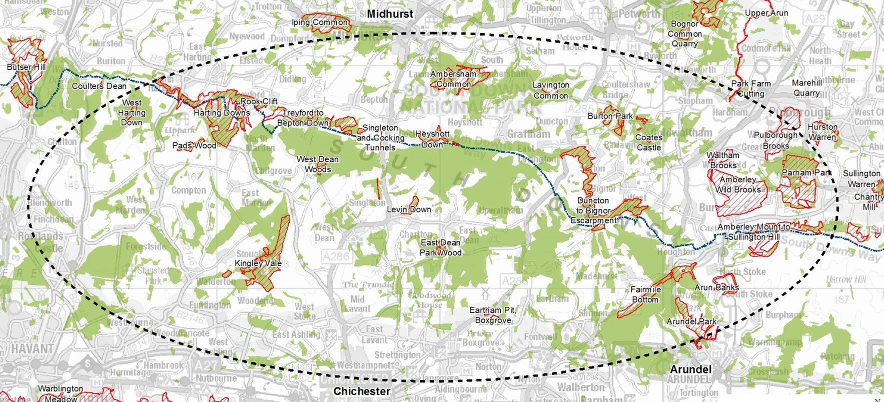

**Annex 2: Scoring Criteria**

|  |  |
| --- | --- |
| **Scoring - Quality Criteria** | |
| **Rating of Response** | **Score** |
| VeryGood or Fully Compliant Submission:  meeting all requirements and is fully explained in comprehensive detail. | 9 - 10 |
| Good or Fully CompliantSubmission:  meeting all the requirements and is explained in reasonable detail. | 7 - 8 |
| Satisfactory or Compliant Submission:  meeting the essential requirements and is explained in adequate detail. | 5 - 6 |
| Weak or Partially Compliant (Minor issues) Submission:  falls short of requirements in some areas and is poorly explained. | 3 - 4 |
| Unacceptable or Non-Compliant (Major issues) Submission:  fails to meet requirements and is not explained. | 1 - 2 |