**Early engagement notice – The distribution of Net Zero co-benefits**

The Climate Change Committee (CCC) is an independent, statutory body established under the Climate Change Act 2008. Our purpose is to advise the UK and devolved governments on emissions targets and to report to Parliament on progress made in reducing greenhouse gas emissions and preparing for and adapting to the impacts of climate change.

The CCC’s Sixth Carbon Budget[1] scenarios imply growing and enduring savings in operating costs, alongside a major investment programme. To 2030, the largest cost increases affecting households are for decarbonising buildings. Large savings are available for households in other areas, most notably in transport from the shift to electric cars. However, even in areas where costs are likely to fall relative to today, the distribution of costs and savings could create both ‘winners’ and ‘losers’ during the transition.

Achieving Net Zero in the UK will also result in significant benefits to human health from better air quality, less noise, more active travel and a shift to healthier diets. Changes to land use and farming practices that cut emissions can also improve air quality and water quality and benefit biodiversity, resilience to climate change and bring recreational benefits. Benefits could partially or fully offset costs.

As set out in the CCC’s Sixth Carbon Budget advice, a key challenge on the path to Net Zero is how to spread the costs and benefits of the transition across the economy: for households, businesses and the Exchequer. The CCC recently commissioned Frontier Economics to develop a set of household archetypes (using Ofgem’s archetypes[2] as a starting point) and a distributional impacts model, to explore the costs faced by households from decarbonising homes and transport. The archetypes developed are shown in Table 1.

This analysis will only tell part of the story, as it does not yet incorporate the co-benefits enjoyed by households alongside any direct financial costs or savings. We are therefore interested in exploring the co-benefits of our Sixth Carbon Budget scenarios that the 15 archetypes developed by Frontier could face.

We are inviting feedback on early procurement ideas for this, to gauge the feasibility of undertaking credible and robust analysis in this space, before deciding whether to put out a project to tender. We are open to suggestions on the appropriate methodology for undertaking this work, but envisage that it could include some (or all) of the following steps:

1. Qualitatively identifying the co-benefits linked to our Sixth Carbon Budget scenarios, particularly from changes occurring in homes and transport, potentially expanding to other sectors (e.g. agriculture and land use). The CCC have highlighted these in our Net Zero[3] and Sixth Carbon Budget reports.
2. Linking co-benefits to particular characteristics of household archetypes which could include whether they live in rural/urban area, income, household size, age, car ownership, cycling/walking. There is also the potential to use data-matching or allocation rules to determine characteristics for the archetypes which we have not explored in our work to date (e.g. health benefits from shifting to healthier, less meat and dairy-intensive diets).
3. Quantifying, and monetising, co-benefits for the pathways and archetypes in question. This could be through standard techniques for valuing costs and benefits (as set out in the Government’s Green Book guidance[4]), or through alternative methods (e.g. reduced costs to the NHS from better health and wellbeing). Work undertaken for the CCC by Ricardo in 2013[5] could be used as a starting point.

**We are inviting suppliers who may be interested in this project, have ideas on how to refine or tighten its scope, or want further information to get in touch with Bianca de Farias Letti (**[**bianca.letti@theccc.org.uk**](mailto:bianca.letti@theccc.org.uk)**) and Chloe Nemo Ramirez (**[**chloe.nemo@theccc.org.uk**](mailto:chloe.nemo@theccc.org.uk)**) by 25th September 2022.**

Table 1 – Summary of archetype starting characteristics

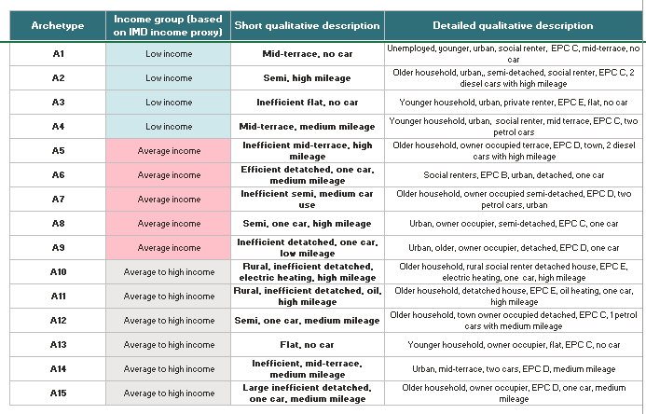

1. CCC (2020) Net Zero – The UK’s contribution to stopping global warming: https://www.theccc.org.uk/publication/net-zero-the-uks-contribution-to-stopping-global-warming/
2. CSE (2020) Ofgem energy consumer archetypes, https://www.ofgem.gov.uk/sites/default/files/docs/2020/05/ofgem_energy_consumer_archetypes_-_final_report_0.pdf
3. CCC (2019) Net Zero – The UK's contribution to stopping global warming, https://www.theccc.org.uk/publication/net-zero-the-uks-contribution-to-stopping-global-warming/
4. HM Treasury (2022) The Green Book, https://www.gov.uk/government/publications/the-green-book-appraisal-and-evaluation-in-central-governent/the-green-book-2020#valuation-of-costs-and-benefits
5. Ricardo AEA (2013) Review of the impacts of carbon budget measures on human health and the environment, https://www.theccc.org.uk/publication/review-of-the-impacts-of-carbon-budget-measures-on-human-health-and-the-environment-by-ricardo-aea/