**NHS TERMS AND CONDITIONS FOR THE PROVISION OF SERVICES (CONTRACT**

**VERSION)**

|  |  |
| --- | --- |
| **The Authority** | **Health Education England** |
| **The Supplier** | **Red Lion Surgery** |
| **Date** | **1st November 2021** |
| **Type of Services** | **Specialist Community Public Health Nursing (Practice Nursing)** |

This Contract is made on the date set out above subject to the terms set out in the schedules listed below (“**Schedules**”). The Authority and the Supplier undertake to comply with the provisions of the Schedules in the performance of this Contract.

The Supplier shall supply to the Authority, and the Authority shall receive and pay for, the Services on the terms of this Contract.

The Definitions in **Error! Reference source not found.** apply to the use of all capitalised terms in this Contract.

**Schedules**

|  |  |
| --- | --- |
| Error! Reference source not found. | Key Provisions |
| Error! Reference source not found. | General Terms and Conditions |
| Error! Reference source not found. | Information and Data Provisions |
| Error! Reference source not found. | Definitions and Interpretations |
| Error! Reference source not found. | Specification and Tender Response Document |
| Error! Reference source not found. | Commercial Schedule |
| Error! Reference source not found. | Staff Transfer |
| Error! Reference source not found. | Expert Determination |
| Error! Reference source not found. | Data Protection Protocol |
| **Schedule 10** | Change Control Process |

*Developed in partnership with*



**Signed by the authorised representative of THE AUTHORITY**

Signature: xxxxxxxxxxxxxx

**Signed by the authorised representative of THE SUPPLIER**

Name:

Position:

Head of Quality and Commissioning

xxxxxxxxxxxxxx

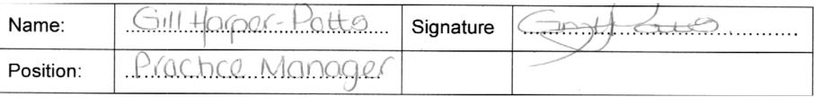

*Developed in partnership with*

