Question 1.

Could you confirm which building(s) you were considering for this project?

Below is a snapshot from Google Earth, if you could indicate on/ from this?

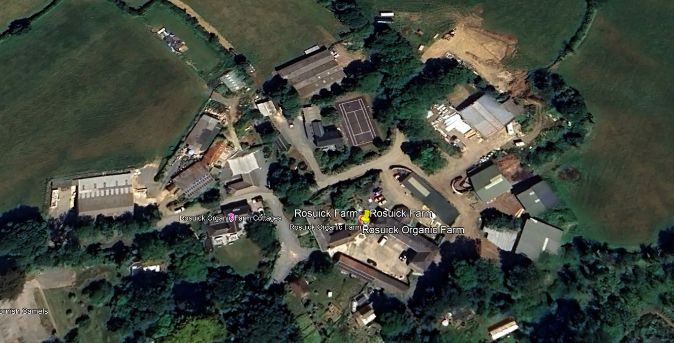

Answer 1.

The 3 phase install is on a new building not shown on the map, the single phase on an old farm building.

what 3 words locations for all.

|  |  |  |
| --- | --- | --- |
| Item | location w3w |  |
| Single phase PV array | ///responses.threaten.binder |  |
| single phase battery | ///uncouth.credit.impresses |  |
| single phase power supply | ///passage.meanwhile.repayment |  |
| 3 phase array | ///wasps.broker.winemaker |  |
| 3 phase battery | ///mediate.clashing.racks |  |
| 3 phase connection point - main supply 150m away in old stone farm buildings | ///crackled.connector.homeward |  |
| LED lighting install | ///wired.sketching.magnum |  |