Appendix H - Digital Map – Film locations

This touchscreen interactive map will be a place for the visitor to learn and discover about many of the popular filming locations across Liverpool. The map will be located within the ‘Stage and Screen’ section of the gallery and will form part of a wider display that is titled the ‘City on Screen’

Objective:
A digital interactive map providing a geographical visualisation of the sites and places where filming has taken place across the Liverpool City Region for a variety of film and TV productions such as Sherlock Holmes, Bulletproof, Cilla and Captain America: The First Avenger. The core content will be provided through images/ video and biographical text linked to film/tv production. The map should reflect the role of the Liverpool’s Film Office.

Technical information:
The map will be located in the corner of the gallery, to the left side of the main gallery entrance. We are proposing that the map will be delivered through a 42” touchscreen, mounted on the wall (see visual MAPV1). We envisage the map to have silent content as the surrounding area will also contain a large digital presentation with an ambient soundtrack. In addition to the map there will also be a mixture of large graphics, open display costume, film props and movie posters in the section (see visual digitalmaplocation.jpg). The overall footprint of this area where the map will be shown is 20sq metres. The area has been designed to have a light colour palette with most walls being white and the flooring a mid-grey tone; the lighting within this space will need to be maintained at a certain level, to meet the required access standards for display. All content will need to adhere to NML’s access guidelines.

Look and Feel:
It should be visually engaging and invite the visitors to interact with the map to find out more about a particular tv/film production and its location on the map. The look and design will engage the user and enhance the core content, through the potential use of moving illustrations, images and pop up text bubbles.

The design of the map will need to tie in closely with the look and feel of the gallery design, so the design will need to follow the graphic approach used within the section. Specific colours and suggested fonts will be supplied by Client.

As such, content could be layered in a dynamic way with text and images. To help/improve searchability, the digital map could provide a set of grouped themes which a visitor could press to highlight particular locations of interest such as top 10 most filmed locations, Hollywood Blockbusters, Local Heroes.

Below are some visual reference examples of multimedia maps to give a look and feel of what NML are looking to produce on the gallery:

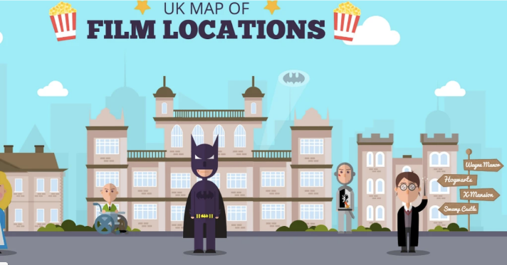
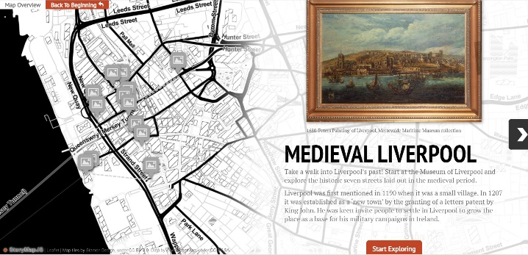
https://uploads.knightlab.com/storymapjs/7604c2e12af415f14ca9aa82682186bd/medieval-liverpool/index.html

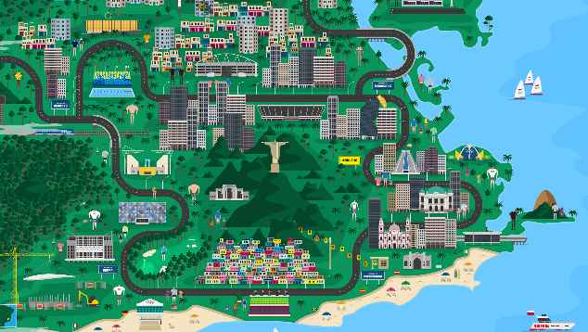
Rio 2016 Interactive Map » From Fiasco Design

Content to be included:
We are looking at telling the wide story of film and TV production and filming across Merseyside and would like the points of interest to range from the more popular city centre sites such as St Georges Hall and the Tobacco warehouse, but also to include wider areas in the Liverpool City Region, such as Formby Beach in the north, the Welsh Streets in Toxteth and Port Sunlight on the Wirral.

We would like to include a quirky mix of film locations, from derelict city centre warehouses to leafy suburban streets. The map should use place as a route into various productions, but also as a means to explore people’s stories and the role of the Liverpool Film Office (through the use of behind-the-scenes images and footage).

We would also like the map to be representative of the different types of genre that are filmed in Liverpool – this includes big screen blockbusters, made for TV one-off productions, (especially costume dramas) and TV series’ that are regularly filmed in the city. This will link to the object displays and graphic content in the adjacent area.

Audience:
Aimed at a general audience but needs to be accessible for visitors on the autism spectrum and dementia.

Copyright:
Footage and imagery are the responsibility of the AV Software provider, to research/source and purchase the copyright licenses/rights, under the guidance of the NML content team. NML requires all copyright license clearance to be at least ten year or a lifetime, nothing less. NML will require copies of the project files and media and the content management system / web platform so the AV presentation can be updated if and when necessary by NML.

Handover:
Once the final version of the software content has been signed off by the client team, the AV Software content producer will be required to deliver/handover final version of the AV files to the AV Hardware contractor. NML will require copies of the project files and media and the content management system / web platform so the AV presentation can be updated if and when necessary by NML.

