

Our Ref: SC210011

Your Ref:

Date: 27th September 2021

Dear Sir/Madam

**Contract Ref: SC210011**

**Contract Title: Water temperature projections in Chalk streams**

You are invited to quote for the above in accordance with the enclosed documents.

Instructions on what information we require you to provide is in Section 4 of the following Request for Quotation document.

Your response should be returned to the following email address by 12:00h Thursday 21st October 2021

[judy.england@environment-agency.gov.uk](mailto:judy.england@environment-agency.gov.uk)

Please confirm, by email, receipt of these documents and whether you intend to submit a quote.

If you have any queries, please do not hesitate to contact me.

Yours sincerely

Dr Judy England

Senior Specialist, Research

E-mail: [judy.england@environment-agency.gov.uk](mailto:judy.england@environment-agency.gov.uk)

Telephone: +44 (0)7836634906

**The Environment Agency**, Horizon House, Bristol BS1 5AH

**Request for Quotation**

**Ref: SC210011**

**Title: Water temperature projections in Chalk streams**

**Section 1**

**Who is the Environment Agency?**

We are an Executive Non-departmental Public Body responsible to the Secretary of State for Environment, Food and Rural Affairs. Our principal aims are to protect and improve the environment, and to promote sustainable development.

Further information on our responsibilities, Corporate Plan and how we are structured can be found on our Website.

<https://www.gov.uk/government/organisations/environment-agency/about>

**What do we spend our money on?**

We are a major procurer of goods and services within the UK, spending circa £600M per annum, our major spend areas are:

* Flood and Coastal Risk Management (design, construction and maintenance)
* ICT and Telecommunications
* Vehicles and Plant
* Environmental Consultancy and Monitoring
* Temporary Staff and Contractors
* Facilities Management, Energy and Utilities
* Flood Management and Water Related Services

**What do we need from our suppliers?**

Suppliers are vital in supporting the delivery of our corporate plan. We aim to support the economy and society whilst delivering more environmental outcomes for every pound we spend. In many areas we are leading the way on environmental and technical developments. It is our role to ensure that suppliers clearly understand our corporate aims and objectives and know that we are committed to delivering the best value most sustainable solutions, taking into account the whole life cost of our procurement decisions. We promote diversity and equality and treat all of our suppliers fairly.

Our procurement strategy may be of interest to you as a potential supplier. It sets out our priorities and key commitments in a range of areas such as delivering our corporate plan, Government policy, supplier management and sustainable procurement:

<https://www.gov.uk/government/organisations/environment-agency/about/procurement#procurement-strategy>

**Government changes and collaboration**

Since 1 April 2013, the Environment Agency is no longer responsible for delivering the environmental priorities of Wales. This is now the remit of Natural Resources Wales (NRW).Further information can be found here:

<http://naturalresources.wales/splash?orig=/>

By bidding for this requirement, you may also be approached by other members of the Defra network, NRW or other government departments that are specifically named in the tender document.

**Further information**

For further information and to see our commitments to Diversity and Equality, please visit our website.

<https://www.gov.uk/government/organisations/environment-agency/about/procurement>

https://www.gov.uk/government/organisations/environment-agency/about/equality-and-diversity

Also, are you up to date on environmental legislation? See links below for further information.

Waste and Environmental Impact - <https://www.gov.uk/browse/business/waste-environment>

Environmental Regulations - <https://www.gov.uk/browse/business/waste-environment/environmental-regulations>’

**Section 2**

**The Customer**

**Summary**

This work is being commissioned by the Research team within the Chief Scientist’s Group. The work of the Environment Agency’s Chief Scientist’s Group is a key ingredient in the partnership between research, guidance and operations that enables the Environment Agency to protect and restore our environment. The team focuses on four main areas of activity:

* Setting the agenda, by providing the evidence for decisions;
* Maintaining scientific credibility, by ensuring that our programmes and projects are fit for purpose and executed according to international standards;
* Carrying out research, either by contracting it out to research organisations and consultancies or by doing it ourselves;
* Delivering information, advice, tools and techniques, by making appropriate products available.

## Contract Length

It is anticipated that this contract will be awarded to one supplier for a period of 5 months to end no later than 31/03/22. Prices will remain fixed for the duration of the contract award period. We may at our sole discretion extend this contract to include related or further work. Any extension shall be agreed in advance of any work commencing and may be subject to further competition. Any amendment to contract prices for the extensions are to be by negotiation.

The Environment Agency Conditions of Contract for Research (Appendix C) shall apply to this contract.

This contract shall be managed on behalf of the Agency by

Dr Judy England,

[judy.england@environment-agency.gov.uk](mailto:judy.england@environment-agency.gov.uk)

+44(0)783634906

## Contact Details and Timeline

Dr Judy England will be your contact for any questions linked to the content of the quote pack or the process. Please submit any questions by email and note that both the question and the response will be circulated to all tenderers.

Key elements of the process have been reviewed. Anticipated dates for planned activities are below:

|  |  |
| --- | --- |
| **Activity** | **Due Date** |
| Supplier responses for Request for Quote | 12:00h Thursday 21 October 2021 |
| Evaluation of Request for Quote submissions | 26 October 2021 |
| Award of contract | 01 November 2021 |
| Project/Contract end date | 31 March 2022 |

It should be noted that these timescales and activities may be subject to change.

**Section 3**

## Evaluation Criteria

We will award this contract in line with the most economically advantageous tender (MEAT) as set out in the following award criteria:

* Price – 60%
* Quality – 40%

The following quality criteria are weighted in accordance with the importance and relevance attached to each one.

* Understanding of project scope and requirements including the proposed methodology – 25%
* Demonstrating relevant personnel, skills and experience for this project – 25%
* Proposed approach – 25%
* Programme of work – 25%

The criteria listed above will be assessed on a 0 to 10 basis and will reflect the following judgements:

|  |  |
| --- | --- |
| **Rating of Response**  **The tenderer provides a response which in the opinion of the evaluators is:** | **Score** |
| **Excellent:** Addresses all of the requirements and provides a response with relevant supporting information which does not contain any weaknesses, giving the Agency complete confidence that the requirements will be met. | 10 |
| **Very Good:** Addresses all of the requirements and provides a response with relevant supporting information, which contains very minor weaknesses, giving the Agency high confidence that the requirements will be met. | 8 |
| **Good:** Addresses all of the requirements and provides a response with relevant supporting information, which contains minor weaknesses, giving the Agency reasonable confidence that the requirements will be met. | 6 |
| **Satisfactory:** Substantially addresses the requirements and provides a response with relevant supporting information which may contain moderate weaknesses, but gives the Agency some confidence that the requirements will be met. | 4 |
| **Weak:** Partially addresses the requirements, or provides supporting information that is of limited relevance or contains significant weaknesses, and therefore gives the Agency low confidence that the requirements will be met. | 2 |
| **Nil:** No response or provides a response that gives the Agency no confidence that the requirements will be met. | 0 |

**Section 4**

**Information to be returned**

**Please note, the following information requested must be provided. Incomplete tender submissions may be discounted.**

Please complete and return the following information:

* Completed Pricing Schedule (Appendix A);
* Completed Prior Rights Schedule (Appendix B);
* Confirmation that terms and conditions are accepted (Appendix C. Please note that the terms cannot be amended later).
* Proposed approach including details of your capability and capacity to undertake the work
* Completed cost proposal
* CVs of proposed members of team, including sub-contractors
* Details of how you propose to manage the consortium (if applicable)
* Details of your experience of carrying out similar contracts over the last 3 years
* Gantt chart of proposed time scales
* Details of how you propose to maintain continuity of personnel
* Details of any conflicts of interest

**Section 5**

**Specification**

# Introduction

The Environment Agency and Defra want to know how potential climate change impacts may affect future water ecosystems. Water temperature has a critical influence on river ecosystems and water quality. Quantifying the amount and timing of future warming in rivers will provide more robust evidence of where to target measures to adapt to these changes. This is needed to increase the pace on action to build ecosystem resilience, create refuges and reduce other pressures. However, there are currently no future national projections of water temperature (cf. availability of future river flows). This limits our understanding of future risks and targeting management choices to improve resilience to the impacts of climate change.

We have scoped how best to model water temperature projections in an earlier project ‘SC200008/R - Scoping a flexible framework for producing river water temperature projections’ so are ready to apply this approach. This project will focus on chalk streams as they are a high priority habitat and of key public focus and provide a useful pilot of the method.

This project will follow the modelling process outlined in SC200008/R to develop water temperature projections for English Chalk streams and one non-Chalk stream example.

The contractors will work in close collaboration with EA staff to deliver the projections and test the modelling approach.

# Background

Climate change is expected to cause a deterioration in water quality and river aquatic ecosystems. To maintain and improve water quality and ensure management responses are resilient to future pressures, it is necessary to identify those areas where intervention is needed. In previous work we assessed the impacts of climate change on eutrophication risk (Environment Agency, 2018) demonstrating the importance of water temperature to developing and managing water quality problems.

River flow regimes shape the river habitats that support biological communities. We have a growing understanding of the role of extreme events (droughts and floods) in shaping these communities. We also know temperature is a critical influence in river ecosystems and for example, that riparian shading can be a really effective resilience building measure in some places. However, there is currently a lack of future water temperature projections to quantify and map this change. We seek to develop a Future River Temperature dataset that could be used alongside projections of river flows and groundwater levels, such as Future Flows (Prudhomme et al., 2012) and the ongoing Met Office / CEH eFLaG project which will provide updated estimates of future river flows.

*Modelling approaches to estimating future water temperature*

In a previous project ‘SC200008/R - Scoping a flexible framework for producing river water temperature projections’ we explored how best to model water temperature projections.

The project reviewed available approaches for modelling river temperature and grouped them into 4 categories: statistical, process-based, machine learning and hybrid. The review included consideration of the data and modelling requirements, and the benefits and limitations of each approach to produce projections of river water temperature for England under climate change scenarios. The most suitable methodology for developing these projections given current data availability was identified.

Decision trees were developed for selecting water temperature models based on methodological approach and data availability over space and time. A potential modelling approach, mixed effect regression, was identified for making English water temperature projections based on constraints in data availability and the scale required for the estimates.

The detailed methodology is provided in Appendix D and the full report is about to be published and is available upon request from Judy England [judy.england@environment-agency.gov.uk](mailto:judy.england@environment-agency.gov.uk). The approach is flexible, involving several steps and analytical choices, which need outlining in the project workflow.

**References:**

ENVIRONMENT AGENCY (2010) Surface Water Temperature Archive for U.K. freshwater and estuarine sites. Science Report SR070035. Bristol: Environment Agency.

# ENVIRONMENT AGENCY (2019) Climate change and eutrophication risk thresholds in English rivers. Report SC140013/R2. Bristol: Environment Agency.

ENVIRONMENT AGENCY (2021) Scoping a flexible framework for producing river water temperature projections.

# PRUDHOMME, C., YOUNG, A., WATTS, G., HAXTON, T., CROOKS, S., WILLIAMSON, J., DAVIES, H., DADSON, S., ALLEN, S. (2012) The drying up of Britain? A national estimate of changes in seasonal river flows from 11 regional climate model simulations. Hydrological processes, 26 (7). 1115-1118. 10.1002/hyp.8434

**3 Scope of Work:**

The work will:

* Follow the flexible framework for producing river water temperature projections for the English Chalk streams and a non-Chalk stream example.

**4 Approach and Method:**

The project will be undertaken in close collaboration with Environment Agency scientists. It will involve the following tasks:

## Task 1 Compile data sets for water temperature projection modelling

Collate, quality assure and infill temperature data for chalk streams and a non-chalk stream example (of a similar size and with sufficient data points - to be determined based on available data). Collate and review the other datasets needed for modelling – e.g. air temperature, discharge, land cover, riparian shading, upstream catchment area, altitude etc.

## Task 2 Appraisal of the modelling method

Appraise the practical application of the approach outlined in “Scoping a flexible framework for producing river water temperature projections” for chalk streams and the data available from Task 1. We welcome suggestions for alternative approaches or refinements to the current approach, along with justification within the tender.

## Task 3 Undertake modelling of water temperature projections.

Following the approach refined in Task 2, develop the code and tools to undertake water temperature projections. Co-develop the specific work flows for applying the methodology specific to this case and more broadly considering potential constraints in applying the approach to different datasets. Apply the models to the chalk stream dataset and non-chalk stream case study separately and together in order to assess consistency in modelling and evaluate the modelling approach between the different the river types.

## Task 4 Present the approach and findings.

Produce a short technical report detailing the modelling approach and findings including comparing the chalk stream and non-chalk stream projections. Include analysis of how chalk stream water temperatures have changed and how they may be expected to change. Compare the results with the non-chalk stream example (both the modelling approach and outcome). The report will be accompanied by computer code/tools and projection data. The datasets from this project will be made available as open data.

Produce a short non-technical summary of the water temperature changes and future projections for chalk streams for ready assimilation into the chalk stream action plan.

Produce a short recorded presentation on the outputs from the project.

**5 Data required:**

* Environment Agency water temperature data (available from the water temperature archive to 2007 (Environment Agency, 2010), water quality archive/WIMS database for 2000 to the present).
* Observed air temperature records (for example UKCP18 observations)
* Future projections of air temperature (for example from UKCP18)
* Additional datasets for model development as necessary (for example catchment characteristics).

## 6 Timescales:

Proposed start date: 1st November 2021

Proposed end date: 31st March 2022

Duration: 5 months

## 7 Undertaking the work:

The contractor should allow enough time and costs for virtual progress meetings to discuss progress and agree future scope. The contractor can expect assistance from various Environment Agency officers to access Environment Agency records.

## 8 Required Knowledge and Expertise:

The skills and experience required include, but are not limited to:

* Project design and management
* Literature review
* Critical methodology evaluation skills / experimental design
* Familiarity with using climate change projections
* Climate change impacts modelling
* Water temperature modelling
* Water quality modelling and GIS
* Data management
* Excellent report writing and presentation skills

The Contractor shall only use people in delivery of the work who are suitably experienced. We recognise the specialist nature of the skills required and we encourage due consideration to the best way of providing the necessary expertise. We would accept proposals from well-balanced consortiums.

**9 Deliverables:**

Key deliverables:

* Quality assured matched chalk stream dataset for water temperature modelling, with summary statistics (observed water temperature data with matched catchment data).
* Water temperature projections for chalk streams dataset.
* Water temperature projections for non-chalk stream example dataset.
* Short science report detailing the process of developing water temperature projections and a review of Chalk stream temperature projections.
* Computer code/tools for producing future projections.
* A short non-technical summary of the water temperature changes and future projections for chalk streams for ready assimilation into the chalk stream action plan.
* A short recorded presentation on the outputs from the project.

All deliverables are to be submitted in draft to the Environment Agency for review and comment, prior to approval. All reports must be produced in accordance with Environment Agency style guides. Reports should be submitted in electronic form in MS Word format.

During the course of the project, the contractor will organise weekly progress virtual meetings with the Environment Agency’s Project Manager and Technical Lead.

After the completion of the project it may be appropriate to disseminate this research via journal papers and/or conference presentations/posters. Preparation of such articles will be subject to review and approval by the Environment Agency in every case and/or co-authorship by the Environment Agency.

|  |  |
| --- | --- |
| **Date** | **Milestone/Deliverable** |
| 01 November 2021 | Contract awarded |
| 01 November 2021 | Start-up meeting (MS Teams) Contractor/Project Team/Advisory Group |
| Weekly | Project manager/technical lead/contractor catch-up meetings (MS Teams) |
| 30 November 2021 | Quality assured chalk stream water temperature dataset |
| 31 January 2022 | Quality assured chalk stream water temperature modelling dataset |
| 1 March 2022 | Draft projections developed  Draft report completed for review (Environment Agency Science report template) |
| 21 March 2022 | Final report, computer script and datasets |
| 31 March 2022 | Project ends |

## 10 Governance:

A Project Board will be set up to steer direction of the project and to provide technical quality review.

|  |  |  |
| --- | --- | --- |
| Role | Name | Responsibility |
| Sponsor | Helen Wakeham | Deputy Director Water Quality |
| Executive | Harriet Orr | Research Manager Climate Change |
| Manager | Judy England | Principal Scientist Hydroecology |
| Delivery Team | Matt Charlton  Stuart Allen  Jon Barrett | Principal Scientist Climate Change  Principal Scientist Climate Change  Research Scientist |
| Advisory Group | Chris Jarvis  Grant McMelin  Mike Dunbar/Drew Constable | Data & Systems Manager  GIS data Team Leader  Hydroecology Team |

**Section 6**

**Contract Management**

This contract shall be managed on behalf of the Agency by Dr Judy England

[judy.england@environment-agency.gov.uk](mailto:judy.england@environment-agency.gov.uk), 07836634906

The contract will be managed by the project manager through regular telephone conversations, emails, review meetings and interim/progress reports.

A small project team and advisory group has been established by the Environment Agency to provide oversight of the work. A project start-up meeting will be held via MS Teams on 1st November and weekly review meetings with the project manager Judy England and the technical lead Matt Charlton. More formal meetings will be scheduled for at the halfway point of the project.

The contractor is expected to maintain regular communication with the project manager; fortnightly telephone calls or MS Teams meetings will be scheduled to facilitate this.

We will raise purchase orders to cover the cost of the services and will issue to the awarded supplier following contract award.

We will pay 25% of the contract costs on completion of each task of the first 3 tasks and the satisfactory receipt of the related deliverables. The remainder of will be paid on receipt and approval of the final report for the project.

Before the invoice is issued, a fee note must be emailed in advance to the contract manager for approval. All invoices must quote the purchase order number in order to be processed. A file copy invoice must be provided to the contract manager, on request. The timescale for payment of invoices will be up to 30 days after we have received a valid invoice.

**Section 7**

**Sustainability Considerations**

We are committed to continually improving our sustainability performance. The Environment Agency has set itself tough objectives as a clear commitment and contribution to sustainable development throughout England. The Agency recognises that this can only be achieved through commitment from all sectors of society and it is intent on raising awareness amongst industry and commerce.

Contractors must adopt a sound proactive environmental approach, designed to minimise harm to the environment.

Environmental criteria should be considered as part of your tender submission with credit given for innovation. Factors to be considered could include areas such as:

* + - Paper use: All documents and reports prepared by consultants and contractors are produced wherever possible on recycled paper containing at least 100% post consumer waste and printed double sided.
    - Travel: use of public transport, reduce face to face meetings by using email and videoconferencing. Meetings to be held in locations to minimise travel and close to public transport links.
    - Packaging: should be kept to a minimum. Re-use and disposal issues must be considered.
    - Efficient Energy and Water Use.
    - Disposal of Waste: Whilst on site the contractor is responsible for the disposal of their own waste and can only use client facilities with express permission from the on site facilities officer.
    - Whilst on site, contractors should comply with the local environmental policy statement which will be made available to you in advance or on arrival.

**Diversity and Equal Opportunities**

We are committed to promoting equality and diversity in all we do and valuing the diversity of our workforce, customers and communities.  As a public body, we publish regular information about what our equality objectives are and how we’re meeting them.

<https://www.gov.uk/government/organisations/environment-agency/about/equality-and-diversity>

**Health and Safety**

Contractors will be responsible for making sure all required health and safety aspects including risk assessments are undertaken and required management measures are in place to protect worker exposure. This includes management of all partners, consortium members and subcontractors.

**IEM2020:**

## Sustainability Objectives

As the Environment Agency, our overarching aim is to protect and improve the environment for people and wildlife. Over the last 10 years we have achieved significant reductions in our environmental impacts that occur through our everyday operations. This included a 40% reduction in our carbon emissions and a 37% reduction in the number of miles we travel. This year we have launched our new Internal Environmental Management strategy to take us through to 2020, building on these successes and widening our ambition.

**Supply chain**

Our 2020 approach will have a very strong emphasis on the indirect impacts of our supply chain.

Our supply chain accounts for over 70% of our total environmental impacts.

Working with our supply chain we want to be world class in the area of environmental management. The environmental impacts of our work and that delivered by and through our supply chain must be reduced; environmental risks must be effectively managed and opportunities for enhancements investigated.

As an organisation, our environmental management system (EMS) is accredited to ISO14001 and EMAS standards. Our procurement activities form part of this system; driving environmental performance improvements across the value chain.

## Section 8

### Additional Information

### Copyright and confidentiality

Unless otherwise indicated, the copyright in all of the documentation belongs to the Environment Agency, and the documentation is to be returned to us with your tender. The contents of the documentation must be held in confidence by you and not disclosed to any third party other than is strictly necessary for the purposes of submitting your quote. You must also ensure that a similar obligation of confidentiality is placed upon any third party to whom you may need to disclose any of the documentation for the purposes of the tender.

### Accuracy of documentation

You should check all documentation; should any part be found to be missing or unclear you should immediately contact us at the address given in the covering letter. No liability will be accepted by the Environment Agency for any omission or errors in the documentation which could have been identified by you.

### Amendments to documentation

Prior to the date for return of tenders, we may clarify, amend or add to the documentation. A copy of each instruction will be issued to every Tenderer and shall form part of the documentation. No amendment shall be made to the documentation unless it is the subject of an instruction. The Tenderer shall promptly acknowledge receipt of such instructions.

### Alternative Offers

Alternative offers may be considered if they constitute a fully priced alternative and are submitted in addition to a quotation complying with the requirements of the Invitation to Quote Documents. If, for any reason you wish to submit an alternative offer without a fully compliant tender please contact us in accordance with the details in the covering letter.

## Continuity of personnel

The Contractor shall employ sufficient staff to ensure that the Services are provided at all times and in all respects to the Project Standard. It shall be the duty of the Contractor to ensure that a sufficient reserve of staff is available to ensure project delivery in the event of staff holidays, sickness or voluntary absence

The Environment Agency will be notified immediately of any changes to personnel associated with the project. The Contractor will ensure that every effort is made to replace outgoing staff with personnel of equal calibre and expertise. All new members of staff undertaking work for the Project will need to be agreed by the Environment Agency prior to commencement.

At all times, the Contractor shall only employ in the execution and superintendence of the Contract persons who are suitable and appropriately skilled and experienced.

## Intellectual property rights

All results, including material and tools produced, developed or paid for under this contract shall be the property of the Environment Agency.

## References

The Environment Agency may request recent and relevant references prior to the award of the project.

**Contract award**

This Request for Quote is issued in good faith but we reserve the right not to award any or all of this work.

### DATA PROTECTION ACT ADDENDUM TO SPECIFICATION

## Protection of personal data

In order to comply with the Data Protection Act 1998 the Contractor must agree to the following:

* You must only process the personal data in strict accordance with instructions from the Environment Agency.
* You must ensure that all the personal data that we disclose to you or you collect on our behalf under this agreement are kept confidential.
* You must take reasonable steps to ensure the reliability of employees who have access to personal data.
* Only employees who may be required to assist in meeting the obligations under this agreement may have access to the personal data.
* Any disclosure of personal data must be made in confidence and extend only so far as that which is specifically necessary for the purposes of this agreement.
* You must ensure that there are appropriate security measures in place to safeguard against any unauthorised access or unlawful processing or accidental loss, destruction or damage or disclosure of the personal data.
* On termination of this agreement, for whatever reason, the personal data must be returned to us promptly and safely, together with all copies in your possession or control.

# APPENDIX A - PRICING SCHEDULE

ALL COSTS QUOTED MUST BE EXCLUSIVE OF VAT

All costs must be quoted on this schedule. Any costs not detailed will not be paid.

**Staff Costs**

Please detail the day rates of your proposed personnel in the table below.

(Please also advise how many hours you constitute a working day)

|  |  |  |  |  |
| --- | --- | --- | --- | --- |
| **Name** | **Title/Grade** | **Phase 1/ Phase 2** | **Day Rate** | **No of Days** |
|  |  |  |  |  |
|  |  |  |  |  |
|  |  |  |  |  |
| **Total** |  |  | £ |  |

**Other costs**

Please state any other costs that will need to be taken into consideration.

|  |  |
| --- | --- |
| **DESCRIPTION** | **COST** £ |
| **1. Other costs (please detail)** |  |
| **2. Other costs (please detail)** |  |
| **3. Other costs (please detail)** |  |
| **TOTAL** |  |

**Discounts, rebates and reductions**

Please detail below any discounts, rebates and other reductions you are prepared to offer and the basis of those incentives

|  |  |
| --- | --- |
| **DESCRIPTION** | **AMOUNT**  £ |
|  |  |
|  |  |
|  |  |
| **TOTAL** |  |

**Total Overall Cost**

Please detail the total fixed cost for the project

|  |  |
| --- | --- |
| **ITEM** | **TOTAL AMOUNT**  £ |
| **Staff Costs** |  |
| **Other Costs** |  |
| **Discounts/reductions** |  |
| **TOTAL Overall Cost** |  |

The following limits will be applicable to all claims for travel and subsistence under this contract:

1. Travel by rail: standard class should be used at all times
2. Travel by car: 45 pence/mile

Hotel bookings should be made through the Environment Agency’s corporate travel contract. Details of this contract are available from the Corporate Contracting Team.

When making reservations you should state that you are a contractor working on Environment Agency business.

Hotel charges must not exceed a maximum limit per night bed and breakfast (VAT included) of: £140 in London; £100 in Bristol; £90 in Warrington; £85 in Reading; £75 in Aberdeen, Birmingham, Belfast, Cardiff, Coventry, Edinburgh, Glasgow, Harlow, Leeds, Manchester, Middlesbrough, Newcastle, Oxford, Portsmouth, Sheffield and York; and £70 in all other destinations. Please note that these hotel ceiling rates are subject to change throughout the life of the contract.

Expenditure on dinner during an overnight stay must not exceed a maximum limit of £25, including a drink.

Receipts for all rail travel, hotel and food expenses will be required as proof of expenditure and will be reimbursed at cost. No profit or additional cost shall be applied by the contractor to such personal expenses.

**APPENDIX B - PRIOR RIGHTS SCHEDULE**

Details of Prior Rights held by the Parties (To be updated as Rights are introduced during the period of the Contract)

Prior Rights owned or lawfully used by a Party, whether under licence or otherwise, which it introduces to the Project for the purposes of fulfilling its obligations under the Contract

Held by the Environment Agency

|  |  |  |
| --- | --- | --- |
| **Name and description of Prior Rights** | **Extent of proposed use in the Project** | **Proprietary owner of the Prior Rights** |
| Water temperature data | Throughout | Environment Agency |
| Catchment environmental data | Throughout | Environment Agency |
|  |  |  |
|  |  |  |
|  |  |  |
|  |  |  |

Held by the Contractor

|  |  |  |
| --- | --- | --- |
| **Name and description of Prior Rights** | **Extent of proposed use in the Project** | **Proprietary owner of the Prior Rights** |
|  |  |  |
|  |  |  |
|  |  |  |

**Explanation of Contractor's Prior Rights**  
All Intellectual Property Rights owned by or lawfully used by the Contractor, whether under licence or otherwise before the date of this Contract. It can also mean any invention and know how or other intellectual property (whether or not patentable) owned by one of the parties prior to the commencement of the Project, or devised or discovered by one of them only in the course of other projects during the Project period and not arising directly from the Project.

**APPENDIX C – ACCEPTANCE OF TERMS AND CONDITIONS**

I/We accept in full the terms and conditions named in Section 2 and appended to this Request for Quote document.

Company ____________________________________________________

Name

Signature ____________________________________________________

Print Name ____________________________________________________

Position ____________________________________________________

Date ____________________________________________________

**APPENDIX D – Development of spatio-temporal river temperature model using "spot" river temperature measurements in the absence of a corrected digital river network**

## Prerequisites

The minimum data requirement for a site-specific (i.e. not distributed across the entire network) regression based river temperature model is water and air temperature records. These can either be paired stations (models may need to be developed to apply transfer functions if the distance is > 2km) or based on gridded temperature products available from the Met Office. The recommended regression based model described here assumes it is unlikely that the Environment Agency will have access to sub-daily water temperature data from enough sites to develop a spatially distributed and temporally dynamic regression model. Hence, it is recommended that sites with long term and sub-monthly water temperature time series based, on spot sampling, are used to develop a mixed effect regression model. This approach provides some potential to predict for new unmonitored sites providing there is no bias in the calibration data, and the new locations are within the environmental range of sites used to calibrate the model. A useful first step before model fitting would be to investigate the consequences of using spot sample data (collected during regular working hours) to characterise daily temperature metrics and investigate to what extent biases could vary between sites and consider the consequences for regression models. This could be based on resampling of existing high-frequency (hourly) records to simulate the spot sampling resolution (weekly – monthly). Other covariates are recommended to improve the model accuracy and also to increase the potential to make predictions for unmonitored sites. It is assumed that all data (particularly water temperature and air temperature) used have undergone quality control procedures to identify and remove spurious values associated with operator or instrument error (see Orr et al. 2015). It is beyond the scope of this document to outline suitable methods for the quality control step in the procedure. Finally, the following method is only appropriate for circumstances where spot samples are collected at random times of day to ensure on temporal biases within or between sites.

## Step by Step Instructions

STEP 1. A thorough assessment of the available water temperature (Tw) data is required. Identification of missing records can be done using the [R software environment](https://www.r-project.org/) which offers useful tools for graphing ([ggplot2](https://ggplot2.tidyverse.org/)) and summarising ([skimr](https://cran.r-project.org/web/packages/skimr/vignettes/skimr.html)) large data sets.

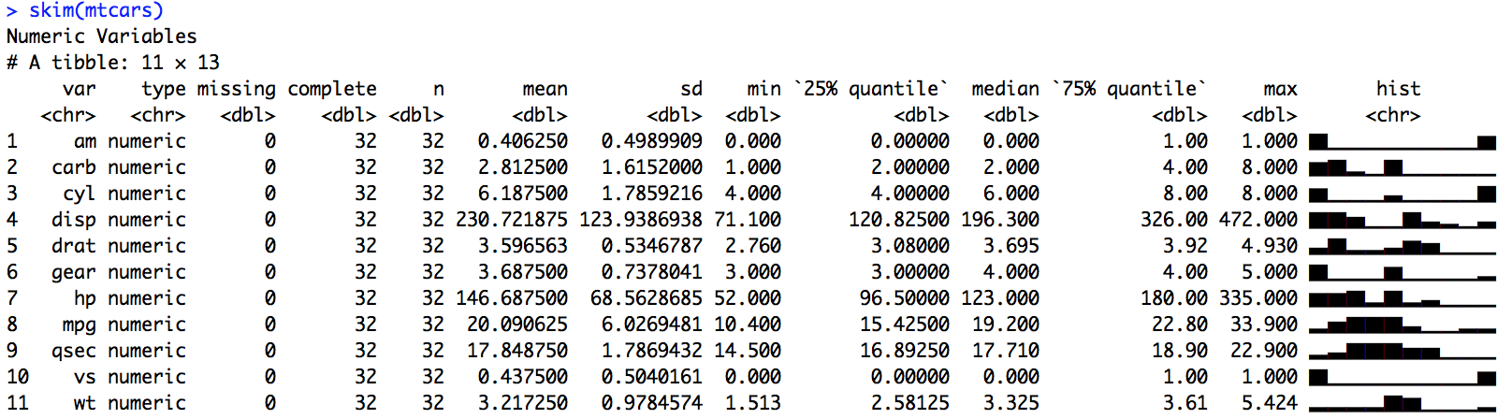

*Figure A1. Example of the summary output that can be generated using Skimr.*

Depending on gap length and timestep, operators must decide if interpolation is a viable option. Linear interpolation is the best option for short gaps while splines or polynomials are better suited to longer gaps (Gnauck 2004, Lepot et al. 2017). More complex methods are available (e.g. machine learning and autoregressive models) but require longer timeseries to be reliably implemented. There are a number of R packages available for univariate time series interpolation, however [ImputeTS](https://cran.r-project.org/web/packages/imputeTS/vignettes/imputeTS-Time-Series-Missing-Value-Imputation-in-R.pdf) is a recommended staring point.

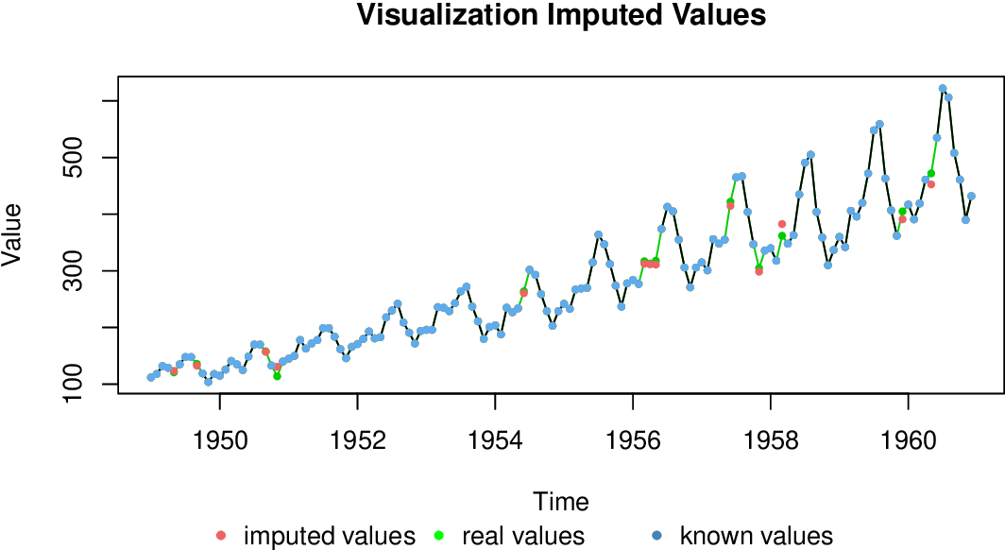

*Figure A2. Example of a test time series (monthly resolution) with missing data filled using ImputeTS. The imputed values are those filled by the statistical function with “real values” representing the actual value for the filled data point. The advantage of ImputeTS is that the fill function performs well even when data are trending.*

An assessment of the number of samples per year/month/week/day is required to decide on feasible model time step. A rough guide is that: i) *daily models* require hourly records, ii) *weekly models* require daily data, iii) *monthly models* require sub-weekly records. The time of day that the measurement was collected is also important as this can bias estimates of maximum or mean due to peak water temperature generally occurring in the afternoon during summer. Advection and site/ catchment specific properties makes it difficult to create models for deriving daily peak water temperature from a spot sample. However, bias in the calculation of weekly/monthly mean Tw is reduced, if sites with >3 year record length and a degree of variability in the time of day that the water temperature was measured are selected for modelling. ***NOTE:***for models at the monthly time step data longer time series are recommended to build robust models. If there is limited variability in the time of measurement and an unbiased mean cannot be generated then a judgment must be made as to whether modelling relative change in water temperature is a suitable compromise.

STEP 2. Water temperature and air temperature need to be available at the same temporal resolution, so a data aggregating may be required if this is not the case. The [xts](https://cran.r-project.org/web/packages/xts/index.html) package in R provides ‘downsampling’ or aggregating functions. Alternatively, if adequate data is available calculation of a water temperature metric (e.g. mean Tw) can be conducted. Interpolation from coarse monitoring time steps (e.g. monthly or weekly) to daily time steps is not advisable as the uncertainty associated can be significant. However, there are promising approaches being developed for hydrographs and groundwater level observations see the tool box for TFN models (multiple site linear transfer function noise) - <http://peterson-tim-j.github.io/HydroSight/>.

STEP 3. The availability of covariates for model fitting needs to be assessed. Following Jackson et al. (2018) the following suite of covariates provide good predictive power: air temperature data (station or gridded), discharge data records ([river flow archive](https://nrfa.ceh.ac.uk/)), land cover data ([CEH land cover map 2019](https://catalogue.ceh.ac.uk/documents/31f4887a-1691-4848-b07c-61cdc468ace7)), riparian shading (e.g. woodland in a 25 m buffer width extending 1000 m upstream), upstream catchment area, Strahler river order, channel orientation, altitude, summer and winter hill shading, channel width, channel gradient, distance to coast and distance to the sea along the river. A decision on the use of [station specific](https://www.ceda.ac.uk/blog/uk-weather-station-records-now-freely-available-to-all-midas-open/) vs [gridded](https://www.metoffice.gov.uk/research/climate/maps-and-data/data/haduk-grid/haduk-grid) air temperature records is required at this stage. Gridded data is recommended as it is directly comparable to climate model outputs. All covariates need to be collated and the quality assessed before including them in the model. In addition all spatial data used must cover the spatial scale to be predicted over as you have matched covariates for all of the prediction locations.

STEP 4. If a water temperature metric (e.g. Mean Tw) was calculated in (2) then the same must be done for covariate time series data (air temperature and discharge). Time steps should be aligned and checked for consistency. It is assumed that all data taken to this stage have been quality controlled. Screening for outliers is advised and missing data should be filled where it is feasible.

STEP 5. Data preparation prior to modelling. An assessment of collinearity between covariates is required. This can be carried out using a combination of visual tools, correlation coefficients and variance inflation factors (vif) - see Zurr et al. (2010) for a detailed guide. Correlation coefficients (r) > 0.8 and vif >3 are reasonably conservative indictors of problematic combinations of variables. To avoid issues later in the model fitting process the variables that are highly correlated need to be carefully considered and removed from the analysis based on either data quality/record length or physical principles*. Following this a visual assessment of data distributions is advised with subsequent transformation if required. This is particularly important if data are highly skewed or non-normal (square-root and log transformations are good starting points the [bestNormalize](https://cran.r-project.org/web/packages/bestNormalize/vignettes/bestNormalize.html) package in R is also a useful tool). An assessment of spatial distribution and spatial structure of sites (e.g. are data clustered in space) is advised.

*An alternative option is to undertake a principal component analysis (PCA) to reduce the dimensionality of the dataset and overcoming any issues associated with collinearity.

STEP 6. To ensure models are robust and not overfitted to the available data it is advisable to conduct model training and model validation on different data fractions (i.e. spatially or temporally). The traditional method requires partitioning data into training and validation sets (training data needs to be continuous and evenly distributed across the year, while validation data need not be temporally continuous). If the time series length is short (<3 years) cross validation approaches represent a more robust alternative and can be applied once the model is specified (Kuhn & Others 2008, Kuhn & Johnson 2013).

STEP 7. A phase of data exploration is required before model fitting and selection. The water temperature time series should be the focus in the first instance. Visualisation of the Tw time series ([ggplot2](https://ggplot2.tidyverse.org/)) can help identify sites/regions with differing thermal regimes. This can be further aided by a statistical assessment of similarity between sites (e.g. Pearson’s correlation coefficient). A GAM smoother should be fitted to assess relationship between time step (e.g. week or month of the year) and water temperature. This can be done using the [mgcv](https://cran.r-project.org/web/packages/mgcv/index.html) package in R. Temporal structure in the residuals can be assessed to identify periods when thermal patterns are most heterogeneous, spatial structure can also be assessed (x-y coordinates, elevation, distance from sea, etc). This information will help guide the operator towards the most important covariates for model building and the need for spatial covariance structure in the final model.

STEP 8. A second phase of data exploration is required to explore the form of the relationship between Tw-Ta. A first step is to asses is the relationship is linear or non-linear fit (e.g. logistic regression) which will then be taken forward for subsequent modelling steps. Note that a seasonally varying linear relationship can look non-linear (e.g. Jackson et al., 2018). Failure to capture seasonal variability would introduce temporal bias in predictions If data are sub-monthly test for breakpoints in relationship between Tw- Ta (see Letcher et al. 2016) and only model for periods when Tw – Ta are synchronised. If predication across the full year is requiredthen assess the monthly variability in intercept and slope of the Tw-Ta relationship. If this is significant then incorporate a term to account for variation (see Jackson et al. 2018). Assess site specific variability in the Tw-Ta relationship and consider adding a random effect to allow the intercept and slope to vary between sites. Assess influence of covariates on Tw-Ta relationship - [coplots](https://www.rdocumentation.org/packages/graphics/versions/3.6.2/topics/coplot) in R are a recommended starting point for this.

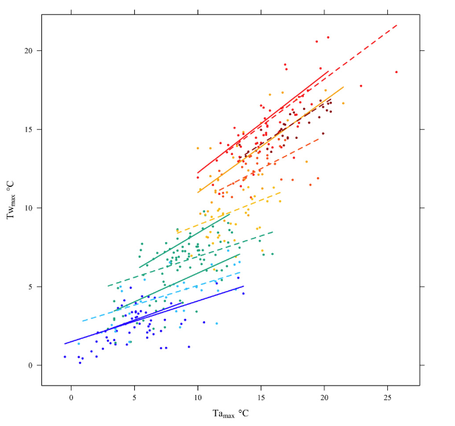

*Figure A3. Example of the seasonal relationship between air and water temperature for an example sites in Scotland. Solid lines represent the first six months of the year (January–June) and dashed lines the second six months (July–December). The colour range is between blue (cool) and red (warm) and vary according to the maximum observed daily temperature in each month. After Jackson et al. (2018).*

STEP 9. The structure of the fixed effects required in the model should be apparent if sufficient time was spent exploring relationships during step (step 8). If the operator is satisfied that no further exploration of the water temperature and covariate relationships is required then the model selection process can be undertaken.

STEP 10. Specify the global model – i.e. the most complex model including all variables and interactions identified in steps (step 5) and (step 8). Fit the model [mgcv](https://cran.r-project.org/web/packages/mgcv/index.html) package in R with smooth terms for non-linear effects. If no no-linear terms are apparent then a linear mixed effect model can be fitted using the [lme4](https://cran.r-project.org/web/packages/lme4/index.html) package. The operator must decide on the random effect structure (e.g. allow intercept and slope for Tw-Ta relationship to vary by site) then test for temporal autocorrelation (incorporating an AR1 structure if necessary – see Jackson et al. (2018). The spatial autocorrelation structure must then be assessed. Ideally this would be done using a variogram based on network distance and “as the crow flies” distance but if a corrected river network is not available then just use Euclidean distance. Detailed information regarding spatial autocorrelation, variograms and fitting appropriate correlation structure to mixed models can be found in Zuur et al. (2009) and Zimmerman & Ver Hoef (2017). Once the random effect structure and temporal/ spatial correlation structure(s) have been specified a stepwise model selection process-based on AIC or BIC can be conducted (see Jackson et al. 2018). The aim is achieve a parsimonious model with normally distributed residuals.

STEP 11. Once the final model has been selected the performance of the model should be assessed using the validation data set or via a suitable cross validation approach (see below). It is generally good practice to assess multiple indicators of model performance – Root mean Square error (RMSE), Coefficient of variation (R2) and percent bias. The [hydroGOF](https://cran.r-project.org/web/packages/hydroGOF/hydroGOF.pdf) package in R provides a variety of functions to facilitate the calculation of these goodness of fit indicators. If the record length was too short for a data partition then 10-fold cross-validation should be used. This is a resampling approach that splits the training/calibration dataset into k-folds, refits the model and predicts for the data left out (Kuhn & Others 2008, Kuhn & Johnson 2013). If the performance is not satisfactory return to (step 8) and refine the model or collect more data. If the performance is good the potential to predict to unmonitored sites can be further explored using new sites not included in the training/validation set.

Alternatively, the operator can decide to return to (step 8) and then fit single station models. This would involve the operator specifying a global model with the temporally dynamic data available for each site (i.e. 9b in Appendix A). Then a regression model can be fitted for each site in the dataset at step 10 (i.e. 10b in Appendix A) and the coefficients generated used to predict or generate projections into the future for that particular site.

STEP 12. Once the final model has been selected and validated it can be used for water temperature projection. The first step required is a decision Global Circulation Model (GCMs) to be used (UKCP 18 is recommended). A useful starting point is the series of factsheets available for [UKCP18](https://www.metoffice.gov.uk/research/approach/collaboration/ukcp/guidance-science-reports). In the first instance users need to decide on the spatio-temporal resolution as this can limit the climate products available - i.e. GCM, RCMs, probabilistic (see Table A1). If a probabilistic projection is chosen then a decision must be made on the Representative Concentration Pathways (RCPs) to be used (See Table A2. Generation of ensembles that sample key uncertainties in the different types of climate models are required for robust future projections. Once the GCMS and RCPs have been selected the required *netcdf* files should be obtained from the Ceda data repository ([www.ceda.ac.uk](http://www.ceda.ac.uk)). The operator will then need to extract relevant grid cells and meteorological data - this can be done using the *ncdf4* package in R. The time series for the particular location must be aggregated/down sampled to match the time step of the water temperature model. Then the outputs from each climate model need to be bias corrected. The delta change approach is well established and has been widely used (see Hay et al. 2000). Briefly, this approach uses the GCM response to climate change to modify observations of Ta. For example if the climate model predicts +3°C, then 3°C is added to all historic observations to construct a new time series for the future climate. There are other delta change methods available including variance scaling, quantile mapping and trend-preserving quantile mapping (See Table A3) If the operator has used an ensemble or a probabilistic product the 5th, 50th and 95th percentiles can then be taken forward to make future Tw projections based on model coefficients obtained in (step 10).

**Table A1** summary of the key characteristics of each of the three strands of information for the UKCP18 land projections. Taken from the [UKCP18 guidance document](https://www.metoffice.gov.uk/binaries/content/assets/metofficegovuk/pdf/research/ukcp/ukcp18-guidance---how-to-use-the-land-projections.pdf)

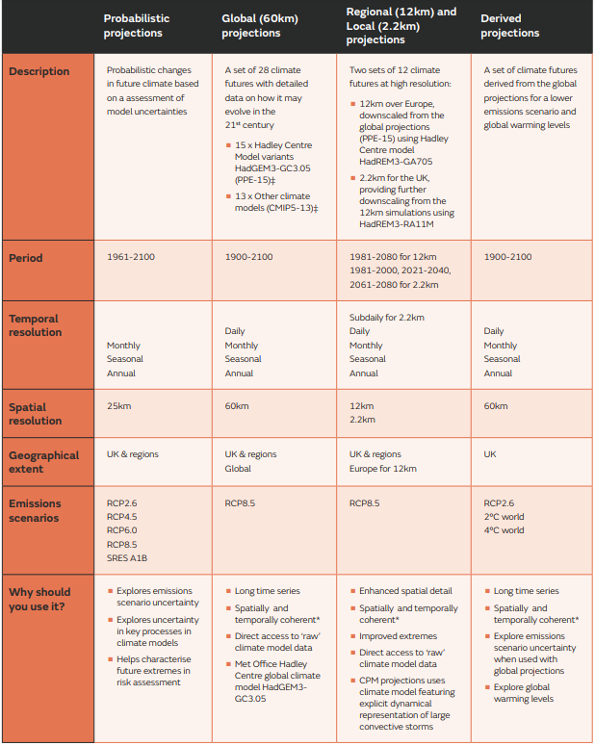

**Table A2** 1 The increase in global mean surface temperature averaged over 2081-2100 compared to the pre-industrial period (average between 1850-1900) for the RCP pathways (best estimate, 5-95% range). From IPCC AR5 WG1.

|  |  |
| --- | --- |
| RCP | Mean change in Ta by 2081-2100 (°C) |
| RCP2.6 | **1.6** |
| RCP4.5 | **2.4** |
| RCP6.0 | **2.8** |
| RCP8.5 | **4.3** |

**Table A3:** Information on some of the most commonly used bias correction methods used for climate data. Taken from the [UKCP18 how to bias correct document](https://www.metoffice.gov.uk/binaries/content/assets/metofficegovuk/pdf/research/ukcp/ukcp18-guidance---how-to-bias-correct.pdf).

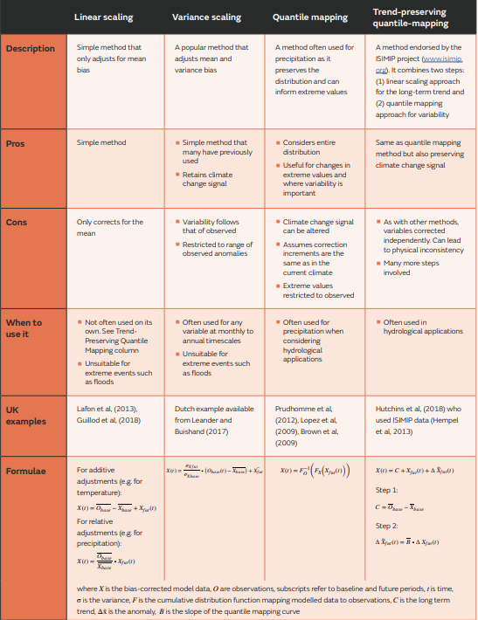

**References:**

GNAUCK, A.2004 Interpolation and approximation of water quality time series and process identification. Analytical and Bioanalalytical Chemisty, 380: 484–492.

HAY, L.E., WILBY, R.L. & LEAVESLEY, G.H. 2000. A comparison of delta change and downscaled gcm scenarios for three mountainous basins in the United States. Journal of the American Water Resources Association 36 (2): 387–397

JACKSON, F. L.,FRYER, R. J.,HANNAH, D. M.,MILLAR, C. P. & MALCOLM, I. A. 2018. A Spatio-Temporal Statistical Model Of Maximum Daily River Temperatures To Inform The Management Of Scotland’s Atlantic Salmon Rivers Under Climate Change. The Science Of The Total Environment 612:1543–1558.

LEPOT, M.,AUBIN, J.-B. & CLEMENS, F. H. L. R. 2017. Interpolation In Time Series: An Introductive Overview Of Existing Methods, Their Performance Criteria And Uncertainty Assessment. Water 9:796.

LETCHER, B. H.,HOCKING, D. J.,O’NEIL, K.,WHITELEY, A. R.,NISLOW, K. H. & O’DONNELL, M. J. 2016. A Hierarchical Model Of Daily Stream Temperature Using Air-Water Temperature Synchronization, Autocorrelation, And Time Lags. PeerJ 4:e1727.

KUHN, M. & JOHNSON, K. 2013. Applied Predictive Modeling. Springer New York, New York. 600 pp.

KUHN, M. & OTHERS. 2008. Building Predictive Models In R Using The Caret Package. Journal Of Statistical Software 28:1–26.

ORR, H. G., SIMPSON, G. L., DES CLERS, S., WATTS, G., HUGHES, M., HANNAFORD, J., DUNBAR, M. J., LAIZEÉ, C. L. R., WILBY, R. L., BATTARBEE, R. W., & EVANS, R. 2015. Detecting changing river temperatures in England and Wales, Hydrological Processes 29:752– 766.

ZIMMERMAN, D. L., & VER HOEF, J. M. (2017). The Torgegram For Fluvial Variography: Characterizing Spatial Dependence On Stream Networks. Journal of Computational And Graphical Statistics 26:253-264.

ZUUR, A. F.,IENO, E. N. & ELPHICK, C. S. 2010. A Protocol For Data Exploration To Avoid Common Statistical Problems. Methods In Ecology And Evolution / British Ecological Society 1:3–14.

ZUUR, A.,IENO, E. N.,WALKER, N.,SAVELIEV, A. A. & SMITH, G. M. 2009. Mixed Effects Models And Extensions In Ecology With R. Springer Science & Business Media. 574 pp.