1 x Toro LTF3000 Stage 5 4WD

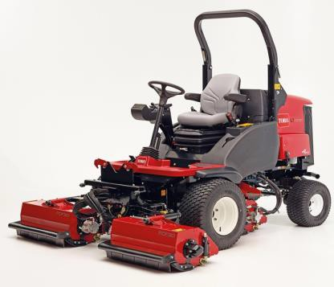
 | KEY SPECIFICATIONS:
• | Fuel Capacity: 60 litres – provides a full day of operation
• | Transport Speed: Forward: 0 to 15.5 mph / Reverse: 0 to 7 mph
• | Cutting Width: 76 cm up to 212 cm
• | Blade Type: Three independent hydraulically driven 27.5 cm diameter, 76 cm wide fine cut flail cutting units
• | Ground Speed: Forward: 0 to 15.5 mph / Reverse: 0 to 7 mph
• | Height of Cut: infinitely variable between 20 to 75 mm
• | ROPS: Two post folding ROPS frame
• | Weight: 1,392 kg (with ROPS), 1,592 kg (with cab) with full tank of fuel
 | KEY MODEL FEATURES:
• | Heavy Duty: Adopting a proven platform, featuring heavy duty rear axle, chassis and lift arms Powerful 33kW (44.2hp) Turbo diesel engine 4WD On Demand transmission Efficient hydraulic systems for maximum power
• | Outstanding Service Access: The LT-F3000 is easy to maintain, service and clean. This helps to reduce downtime, labour and maintenance costs. Easy to access key components Reduced maintenance costs due to robustness and durability of flail units’ design
 | WITH ACCESSORIES:

☑ | LED Flashing Beacon Kit
☑ | LED Kit - Road lighting Kit w/ Brake Lights
☑ | Blower / Tool Carrier Kit

☑ | Rear View Mirrors Kit
☑ | Road Tax & Number Plate
☑ | Differential Lock & 4wd in Reverse

Net Discounted Price: | £ + VAT

