|  |
| --- |
| ***Specification Reference*** |
| FS232001 |
| ***Specification Title*** |
| Support Services in connection with the UK Food Surveillance System |
| **Contract Duration** |
| Up to 3 years (1 year with option to extend) |

This specification, which forms part of the Invitation to Tender (ITT), comprises of three individual sections: -

1. **SPECIFICATION:** An outline of the requirement
2. **PROCUREMENT TIMETABLE:** An estimated timetable for the procurement of the proposed requirement
3. **TENDER REQUIREMENTS AND EVALUATION CRITERIA:** Provides guidance to applicants on the information that should be included within tenders and on the evaluation criteria and weightings used by appraisers when assessing and scoring tenders

Tenders for FSA funded projects must be submitted through the FSA electronic public procurement system, ePPS, using the following link: <https://fsa-esourcing.eurodyn.com/epps/home.do>. Please refer to the ‘Help’ tab on *ePPS’* before completing the application.Failure to do so may result in the tender response not being processed by the system or the response being automatically disqualified during the evaluation stage of the tender process*.*

**THE SPECIFICATION, INCLUDING PROJECT TIMETABLE**

**AND EVALUATION OF TENDERS**

1. **SPECIFICATION**

**GENERAL INTRODUCTION**

The Food Standards Agency is a non-ministerial government department governed by a Board appointed to act in the public interest, with the task of protecting consumers in relation to food. It is a UK-wide body with offices in London, Cardiff, Belfast and York.

The Agency is committed to openness and transparency. As well as the final project report being published on the Food Standards Agency website ([www.food.gov.uk](http://www.food.gov.uk) ), we encourage contractors to publish their work in peer reviewed scientific publications wherever possible. Also, in line with the Government’s Transparency Agenda which aims to encourage more open access to data held by government, the Agency is developing a policy on the release of underpinning data from all of its science- and evidence-gathering projects. Underpinning data should also be published in an open, accessible, and re-usable format, such that the data can be made available to future researchers and the maximum benefit is derived from it. The Agency has established the key principles for release of underpinning data that will be applied to all new science- and evidence-gathering projects which we would expect contractors to comply with. These can be found at <http://www.food.gov.uk/about-us/data-and-policies/underpinning-data>

1. **BACKGROUND & INTENTION**
2. The [Food Standards Agency](http://www.food.gov.uk/) is the UK central competent authority for food safety. One of the objectives of the FSA’s Strategy and Strategic Plan is to make sure that food is safe to eat and what it says it is. To help achieve this, the FSA makes grants to Local Authorities (LAs) and Port Health Authorities (PHAs) to supplement their own sampling, ensuring that official controls on food and feed are effective and therefore consumer protection is maintained and improved.
3. The UK Food Surveillance System (UKFSS) is a national database for recording food sampling in LAs and PHAs. UKFSS links to Public Analyst Laboratories (PAs) and Public Health Laboratories. The UKFSS database is on a FSA server in Foss House, York.
4. UKFSS was first developed and rolled out in Scotland in 2003; administration of the system moved to FSA in London in 2005. The current version available from the incumbent Contractor is version 9 and is referred to as UKFSS Desktop. The Supplier will provide support for this system as specified below.
5. The diagram at Annex 1 shows the data flow between UKFSS, local authority/ laboratory data inputters and FSA staff who interrogate UKFSS. The technical details are in Annex 3.
6. Food Standards Scotland also has access to UKFSS and has a separate contract with the incumbent Contractor for support of UKFSS for Scotland.
7. The short-term need is for technical support of the current database but the longer-term intention is to phase out UKFSS and consider replacing it with a more modern equivalent. The Supplier will provide technical support throughout the transition.
8. **SUPPORT**
9. **First-line support for UKFSS Software on the FSA server**. The support is broader than issues directly related to the software for UKFSS (desk top). It will also include the Centralised Food Analytical Database (CFAD), the postbox database and server maintenance in relation to UKFSS on the FSA Server. The postbox is the initial collection point of all the data input by local authority sampling officers and then the results data input by laboratories. The automatically-generated sample number allows the result to be matched with the initial sample record and, when the data has been validated, the complete record is copied across to the CFAD. The Supplier will ensure that data is copied from the postbox to the CFAD so that at any given time the CFAD does not contain any more than 500 complete (i.e. with laboratory results) records fewer than the postbox. The maintenance of the 'food category tree'[1] is also included in this support.
10. **First-line support for Laboratories.** The Supplier will provide help and guidance as required to identify and resolve issues that affect the functionality of the UKFSS/Laboratory interface and communication between EncExtract and the FSA server. The Supplier will provide support direct to laboratories as necessary. The Supplier will maintain, update and support EncExtract as required. The Supplier will maintain the mapping of determinants (DETS)[2] and enhanced outcomes on the laboratory systems. The Supplier will maintain and support the data validation/communication system for the labs.
11. **General support of FSA server infrastructure and network**. The Supplier will provide support as detailed in Service Levels (see below). Assistance will be provided in the following areas (these will include postbox functions associated with the UKFSS system):

* Internet configuration issues: Assistance will be provided in diagnosing and resolving issues involving hardware and software components related to network communications between the FSS Server and the Internet Hardware and Operating System issues: Assistance will be provided in diagnosing hardware issues. Also, assistance will be provided in facilitating the re-configuration of components and software after a hardware failure has been resolved;
* Interaction between FSA Infrastructure and UKFSS Server software: Assistance will be provided in diagnosing and resolving issues that involve the interaction between the UKFSS Server and existing software or new software written by the Supplier;
* Database infrastructure and configuration: Assistance will be provided in resolving issues with respect to database software related to the UKFSS system on the FSA Server. This includes both the current SQL Server 2005 and Firebird 1.5;
* Security: Assistance and advice will be provided as necessary with regard to the security of the UKFSS System Application Software and the data that is held within it.

1. **First-line support for Local Authorities.** The Supplier will provide help and guidance to Local Authority users as required to identify and resolve issues that affect the function of UKFSS (desk top). This includes the tracking of lost data.
2. **Support for FSA Business.** The Supplier will help with FSA reporting from the CFAD database and postbox as required
3. **Support Costs**. The Financial Proposal should include costs for up to 14 days support a month.
4. **DEVELOPMENT**
5. This specification does not cover any development work. Development work will commence only on acceptance of a signed and costed specification. All development work will be fixed price. For the avoidance of doubt, the price charged to deliver an agreed specification through all stages of testing to its use in a live, production environment will be fixed and will not change regardless of the number of days it actually takes to deliver.
6. **DOCUMENTATION**
7. The Supplier shall, in conjunction with the FSA Representative where appropriate, develop and maintain documentation (whether in hard copy or electronic format) regarding UKFSS and associated systems and any changes thereto, in the use or development of the Deliverables or Services.
8. This documentation shall include but not be limited to: business requirements; functional requirements specifications; interface specifications; help desk logs and resolutions; user manuals or instructions; product information; technical literature; change control documentation; testing process and results; and other related materials.
9. **CONTINUOUS IMPROVEMENT**
10. In conjunction with the Client Representative, the Supplier shall deliver overall improvements in service, for example by:

* establishing procedures to measure and monitor performance;
* identifying ways of improving the effectiveness of what is delivered or the efficiency by which this is achieved;
* suggesting changes within the FSA to accommodate, and further gain from, these improvements;
* monitoring the changes and progress made to record improvements;
* presenting these improvements as part of the regular review sessions (formal and informal) to be held.

1. **PROCUREMENT TIMETABLE**

Table 1 details an **estimated** project timetable for the project. Tenderers should however be aware that the Agency needs to acquire the evidence outlined in this ITT in a timely manner and you should justify your timings in your work plan.

|  |  |
| --- | --- |
| **TABLE 1. ESTIMATED PROJECT TIMETABLE** | |
| **EXPECTED DATE** | **INVITATION TO (ITT) TENDER** |
| 14th April 2016 | Invitation to Tender (ITT) issued by the Agency |
| 14th April 2016 | ITT Clarification period opens |
| 4th May 2016 | ITT Clarification period closes |
| 19th May 2016 | Closing date for submission of ITT responses |
| From 20th May 2016 | Evaluation of ITT responses |
| By 1st June 2016 | Tenderers contacted with points raised by appraisers for clarification on their tender, with 2 weeks to respond |
| Between 6th and 18th June 2016 | Appraisal panel meeting held to consider clarified ITT responses |
| By 30th June 2016 | Tenderers notified of outcome of appraisal and preferred Tenderer (or Tenderers) identified |
| By 8th July 2016 | Contract awarded and signed |
| As soon as possible following contract award | Project initiation meeting takes place and project commences |

**Further Information**

For any technical queries, points of clarification regarding this specification, queries regarding the procurement procedures please submit by e-mail to FSA.procurement@foodstandards.gsi.gov.uk

**Closing Date**

Tenders should be submitted to FSA.procurement@foodstandards.gsi.gov.uk **by the date specified in Table 1.**

**Tenders received after this time will not be considered or evaluated.** **Please allow sufficient time to upload your tender and all supporting evidence before the closing date.**

# EVALUATION OF TENDERS

# The Tenderers Application consists of the:

# Technical envelope (80% of overall value), in which applicants should detail the approach, the work plan and their ability to undertake the work, and

# Financial envelope (20% of overall value), in which applicants should outline all costs to conduct the proposed work, and

# Any other relevant supporting information

# Tenders will be evaluated by FSA internal appraisers and external experts using a numerical system. The table below shows the weightings that have been allocated to each section of the application form and these will be used by the appraisers:

|  |  |
| --- | --- |
| **TABLE 2. EVALUATION CRITERIA FOR SELECTION OF SUCCESSFUL TENDERER** | |
| **CRITERIA** | **PERCENTAGE WEIGHTINGS** |
| TECHNICAL CRITERIA – **80% overall Value** | Made up of |
| 1. Tender summary and objectives | 10% |
| 1. The approach/scope of work | 10% |
| 1. The plan and deliverables | 10% |
| 1. Organisational experience, expertise and staff effort | 20% |
| 1. Project management | 15% |
| 1. Risk management | 5% |
| 1. Quality management, ethics, data protection, dissemination and sustainability | 10% |
| FINANCIAL CRITERIA – **20% overall value** | 20% |

## The Technical Envelope

The Technical envelope is split in to 7 sections for evaluation. Guidance on how to complete each section is provided within the actual application form.

A numerical appraisal scoring system will be used to assess the information given in the Technical envelope of the tender. Appraisers will allocate a score of 0, 30, 60, 80 or 100 to each part of the Technical envelope, depending on the quality and relevance of evidence provided. The scores will then be subjected to the weightings given in Table 2.

All technical criteria will be evaluated as follows:

|  |  |
| --- | --- |
| SCORE | DESCRIPTION FOR SCORE OF EACH CRITERIA |
| 100 | Tender fully meets or exceeds the criteria set |
| 80 | Tender would require minor modification but almost fully meets the criteria with only a few gaps in the evidence remaining |
| 60 | Tender would require some modification but addresses most of the criteria, but may not be detailed enough and/or has several gaps remaining |
| 30 | Tender would require significant modification due to significant gaps |
| 0 | Tender does not meet the specification or policy |

If the applicant does not reach a minimum score of 30 in the technical evaluation they will be automatically eliminated from the process.

## The Financial Envelope

The Financial envelope is split in to 5 sections. Guidance on how to complete each section is provided within the actual application form.

A numerical appraisal scoring system will be used to assess the information given in the financial envelope of the tender. Appraisers will allocate a score of 0, 30, 60, 80 or 100 to the financial envelope, depending on the quality and relevance of evidence provided. The scores will then be subjected to the weighting given in Table 2.

**Requirement for the financial envelope**

Please complete the Finance template provided. Costs should be quoted excluding VAT for the purpose of comparison of tenders. The Agency’s financial year runs from 1 April to 31 March. All costings should be recorded in line with this timescale.

**Evaluation of the financial envelope**

**Financial criteria will be evaluated as follows:**

|  |  |
| --- | --- |
| SCORE | DESCRIPTION FOR SCORE OF THE CRITERIA |
| 100 | There is full justification for the costs and the overall resources are appropriate. The tender is the best value for money for the work proposed to meet the specific evidence requirement advertised |
| 80 | There is some justification for the costs and the overall resources requested. The tender is reasonable value for money for the work proposed to meet the specific evidence requirement advertised. |
| 60 | Limited rational is given for the resources requested and/or the tender does not offer very good value for money, but is not poor value |
| 30 | The tender is relatively poor value for money with little/no justification for costs or resources requested. |
| 0 | The tender costs are not considered value for money and the applicant provided no rationale for costs or resources requested |

**Annex 1 – UKFSS data flow diagram**

**Annex 2 – Specific Obligations**

1. **SUPPLIER’S OBLIGATIONS**

The basis of provision of services under this contract shall be the maintenance and support of a stable and secure system for the FSA which performs to the levels set out below. Further development is not currently planned, but if it takes place it shall be undertaken in a structured and controlled manner, following standard FSA procedures:

The specific Supplier obligations shall include achievement of the following levels of service in the area of Support:

* + Availability of Support service for all lines of support between the hours of 9am and 5pm, Monday to Friday (excluding statutory public holidays) so that all calls are logged immediately;
  + All calls will be logged as the call is received;
  + Support calls from local authorities, laboratories and other UKFSS users shall be handled within the following Response and Resolve timeframes:

Response Times:

The Supplier, on receipt of a call logged from the FSA, or from Capita IT on behalf of the FSA or direct from an enquirer, will provide an immediate response, giving a call reference number.

Resolution Times:

Major - within 24 hours (major incidents include for example tracking samples .as part of set up testing; or providing a Version 9 username and password; DETS table upload)

Moderate - within 1 week (for example offering support to LAs with mapping of MIS systems; Outcomes table upload; category tree upload; investigating technical issues with LA or lab use of the system)

Minor - within 2 weeks (Tracking samples for a local authority to compare with local records; Tracking historic data at labs)

For an Incident the response times shall be as follows:

Table 1: Incident response and resolution times

|  | **Supplier Response** | | |
| --- | --- | --- | --- |
|  | **Respond** | **Update** | **Resolve** |
| Critical incident *affecting all users* | Within 30 minutes of the call | Hourly | Resolution agreed within 2 hours of the call |
| Moderate incident *affecting 20 or more users* | Within 1 hour of the call | Hourly | Resolution agreed within 3 hours of the call |
| Minimal incident *affecting more than one but fewer than 20 users* | Within 2 hours of the call | Hourly | Resolution agreed within 4 hours of the call |
| Minor incident *affecting one user only* | Within 24 hours of the call | Every four hours | Resolution agreed within 36 hours of the call |

In Table 1, the Supplier response actions are defined as follows:

* In responding, the Supplier will acknowledge the problem, the classification of the incident and be able to describe the incident and, where possible, outline possible solutions.
* The update provided by the Supplier will include actions· taken and the outcomes; next steps to be taken and estimated resolution time where this is known; together with advice on if and how the system can continue to be used.
* The Supplier will resolve the incident by agreeing the fix with FSA IT Service Delivery and the Business Owner, and implementing as scheduled with FSA Change Management.

If any form of development is agreed by the FSA, the specific Supplier obligations in the area of Development shall include the following:

* + The Supplier shall work with the FSA to develop and agree a Specification of Requirements
  + The Supplier shall provide a written Proposal to the FSA within five working days of receiving the agreed Specification
  + That Proposal shall estimate the number of days’ effort required (and therefore the price of delivering a solution which meets the requirements) including all time required from the point of receiving ·the specification up to completion of acceptance testing and going live
  + That Proposal shall also include but not be limited to the following:
  + Approach and timescale
  + Commitment and time requirements of FSA staff.

1. **FSA'S OBLIGATIONS**

Notwithstanding the collaboration necessary with the Supplier to enable the provision of Support and Development services, the FSA shall be responsible for:

* + Reporting incidents as soon as possible, and for providing all relevant information to enable the Supplier to progress resolution of the incident;
  + Provision of suitable premises and facilities such as desks, chairs, overhead projectors, where appropriate and essential to the delivery of services;
  + Provision of access to the appropriate equipment and sites to enable the Supplier to undertake specific responsibilities in the supply of Support and Development services.

**Annex 3 – Configuration and user start guides**

**UKFSS Desktop Configuration Guide**

**Introduction**

This guide is aimed at helping UKFSS Desktop Administrators, or Local Authority IT Support to setup UKFSS Desktop within their Local Authority / Council to ensure it works correctly.

The majority of tasks in the configuration process should be carried out during first installation of UKFSS Desktop.

If after referring to this guide you still require any additional assistance, you can contact the UKFSS Helpdesk using the following details

UKFSS Support contacts

Telephone: 0207 276 8282  
email: IT.Servicedesk@foodstandards.gsi.gov.uk

MacLaren West Support

email: support@maclarenwest.co.uk

**Contact Information**

Help Desk email address: [**IT.Servicedesk@foodstandards.gsi.gov.uk**](https://portal.maclarenwest.co.uk/ukfsswebapp/news/IT.Servicedesk@foodstandards.gsi.gov.uk)  
UKFSS Helpdesk telephone number: 0207 276 8282  
[**https://ukfssweb.food.gov.uk**](https://ukfssweb.food.gov.uk/)  
[**http://www.food.gov.uk**](http://www.food.gov.uk/)

**Hardware Technical Specifications**

This specification is the minimum supported technical requirement that UKFSS Desktop can be loaded and operated.

| **Server Minimum** |  |
| --- | --- |
| Operating System: | Windows XP and above. Windows 2000 Server and above. |
| Memory: | 1gb or above |
| Hard Disk: | 400mb or above |
| Processor: | Pentium 233 or above |

| **Client Minimum** |  |
| --- | --- |
| Operating System: | Windows XP or above |
| Memory: | 512mb or above |
| Hard Disk: | 250mb or above |
| Processor: | Pentium 233 or above |

**Software**

The application is written by MacLaren West Ltd using Delphi, a light weight database is used within the application folder and there is no requirement for a database server.

**Connectivity**

UKFSS Desktop synchronises data using an external website, all data communication are initiated by the user on the local system.

The UKFSS Desktop software requires an Internet connection to transfer data to and from the the UKFSS Servers. All data is encrypted before it is uploaded to the UKFSS Server by UKFSS Desktop. The data is passed over HTTP (port 80) as a Encrypted dataset which has been compressed for extra efficiency.

The data encryption used is AES 256.

UKFSS Desktop will require access to the following web locations:

http://ukfss.food.gov.uk  
https://portal.maclarenwest.co.uk

**Local configuration options**

**Enabling proxy login details**

To allow users to enter their proxy details when starting UKFSS Desktop add or set the following setting in the UKFSSDesktop.ini file in the setting section:

The full section should look like this:

[Settings]

LocalDataLocation=%APP%/data

ServerAddress=http://ukfss.food.gov.uk/bin

UseInternetProxy=1

To disable this option you can set the UseInternetProxy=0

**Changing local data storage location**

Once the UKFSS Desktop installation is complete you can configure the data location setting in the UKFSSDesktop.ini file, the options you have are:

| **Location** | **Value in Ini File** |
| --- | --- |
| application dir | %APP% |
| CSIDL_PROGRAMS | %PROGRAMS% |
| CSIDL_MYDOCUMENTS | %MYDOCUMENTS% |
| CSIDL_DESKTOPDIRECTORY | %DESKTOPDIRECTORY% |
| CSIDL_APPDATA | %APPDATA% |
| CSIDL_LOCAL_APPDATA | %LOCAL_APPDATA% |
| CSIDL_COMMON_APPDATA | %COMMON_APPDATA% |
| CSIDL_COMMON_DOCUMENTS | %COMMON_DOCUMENTS% |

To get UKFSS Desktop to use the users My Documents directory, start the path with the prefix %MYDOCUMENTS%.

**Examples:**

| **ini entry** | **Resolved path** |
| --- | --- |
| LocalDataLocation=Z:\data\ukfssdata | Z:\data\ukfssdata |
| LocalDataLocation=%APPDATA% | C:\Users\Mac West\AppData\Roaming\UKFSS Desktop |
| LocalDataLocation=%APPDATA%\UKFSS | C:\Users\Mac West\AppData\Roaming\UKFSS |
| LocalDataLocation=\dataserver\data\ukfssdata\ | \dataserver\data\ukfssdata |

In the first example, UKFSS Desktop will look for user data in the absolute path on the local drive or in a network share mapped to a local drive letter.

The UKFSSDesktop.ini file looks like this:

[Configuration]

Interactive=True

LastUpdateID=

ForceDownload=True

[Directories]

0=$APPLICATION\*.*,Recursive

1=$WINDOWS\SomethingForWindows.txt

[AutoUpdateClient]

DownloadBufferSize=4096

ServiceName=AutoUpdateService

[Message]

Class=TROBINMessage

UseCompression=True

[Settings]

LocalDataLocation=%APP%/data

The only section that contains user configuration settings is the Settings section at the bottom, all other settings can be left as they are.

ServerAddress=http://ukfss.food.gov.uk/bin

**Getting Started with UKFSS Desktop**

**Minimum Requirements**

Supported Operating Systems:

* Windows XP
* Windows 7
* Windows 8
* Windows Server 2003
* Windows Server 2008
* Windows Server 2008 r2

During install.

Normal Usage with multiple users sharing a single install.

* PC Running Windows XP, Windows 7 or Windows 8.
* 250mb Hard Drive Space for system plus 15mb per

**Overview of the installation files options**

You have 3 options for downloading UKFSS Desktop, Standard Windows install file, user based Windows install files and an Archive Zip file.

The archive file is primarily supplied to allow IT departments and technical people to install and distribute UKFSS Desktop as flexibly as possible.

You can download each file from [**here**](https://ukfssweb.food.gov.uk/public/ukfss_desktop/)

We will walk through installing using the standard windows installation file.

**Using Windows Install File**

Download the install file from [**here**](https://ukfssweb.food.gov.uk/public/ukfss_desktop/ukfss_desktop_installer.exe)

Once the download has finished you can run the install file, we download the file to our desktop but it can be run from any location you choose to download it to.

**Install icon**

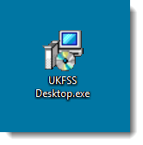

Once you run the install file you will be asked a series of questions regarding the installation options, for example the destination location and also if you would like a desktop short cut. If you choose to install into the program files folder then you will need administrator or read/write privileges. If you install it into your own user space then normal privileges should work fine.

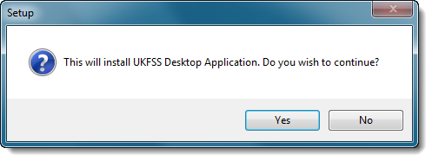

Select yes to start the installation and move through the options.

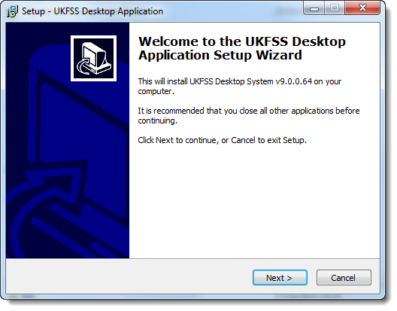

Select next to move on.

**UAC Error**

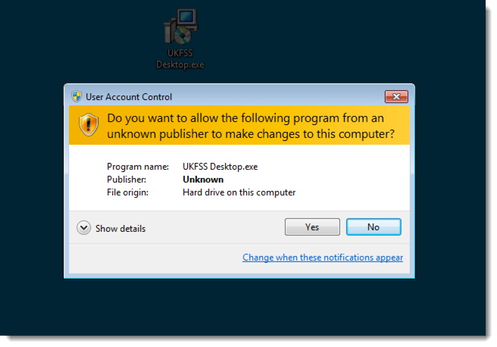

If you see a message like the one above you will need to select Yes to continue with the installation. Please make sure the Program name is UKFSS Desktop.exe before clicking yes.

**Install location**

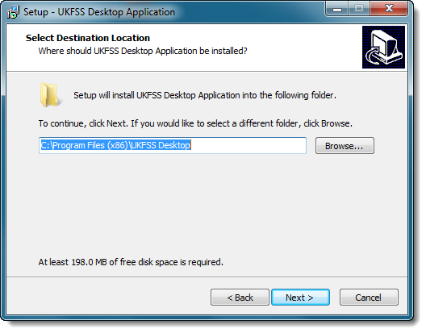

In this option you can change where UKFSS Desktop application will be installed to, this can be any location including an encrypted USB Drive.

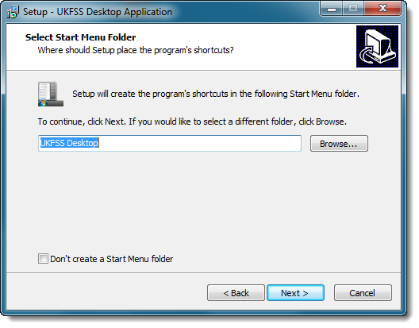

**Application Shortcuts**

This option creates a start menu folder and option, if you are installing to an external location you should tick the option not to create this at the bottom left of the form.

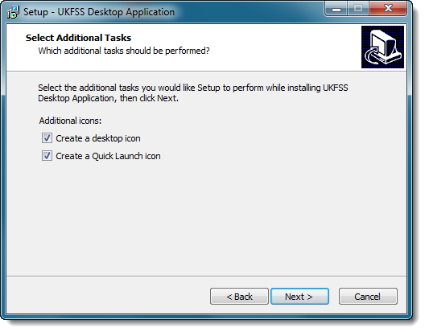

You are also asked if you would like short cut to be create for you in the desktop and also in the quick launch tool bar, again if you are installing to an external location these will not work it the removable drive is not attached.

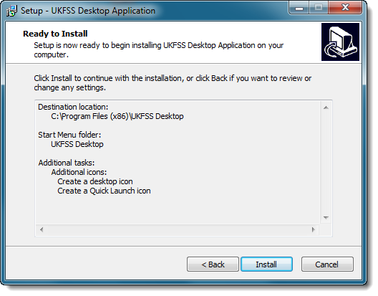

Once you have gone through all the options a summary will be shown for you to check, if you have made any mistakes or would like to change an option just use the back button to return to the option and amend it.

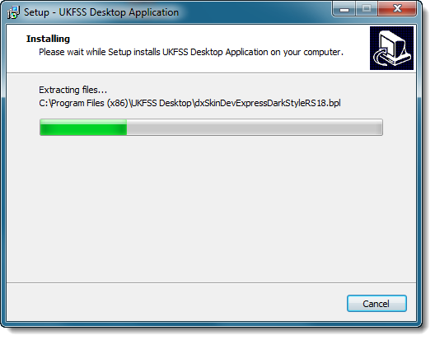

Once you click next the actual install will take place.

**Installation complete**

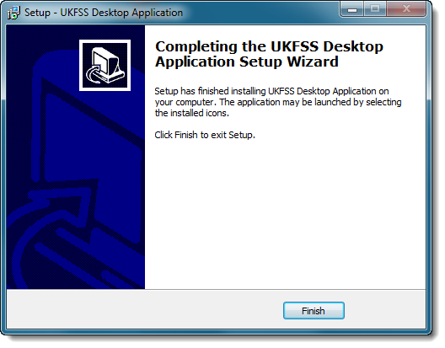

Once the install process completes you can click finish and start using UKFSS Desktop.

**Starting UKFSS Desktop for the first time**

When you start UKFSS Desktop for the first time the system will need to activate the local storage for the users and also possibly check for updates so an active internet connection is required. If you can access the internet from the PC you are installing on you should not encounter any problems. If you do encounter a problem please contact the help desk and inform them that you can't access the web service address for UKFSS and you will be advised on what to do.

For reference the address is: http://ukfss.food.gov.uk

You should have been issued with a username and password by your system admin or by the help desk if this is the first time the local authority has used the system.

If you did not uncheck the create desktop short cut during the install you will have an icon like this on you desktop:

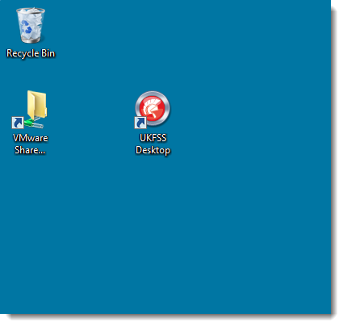

Just double click it to start UKFSS Desktop, you can also right click it and select open. When UKFSS starts it will automatically check for updates. If there are updates available then you will see the following message. You do not need to apply the updates and can click no to continue without applying the update and access the system as normal.

We will go through applying the update as it will show you how to updated the system and also check that we have the privileges to both update the system and for the users to be able to use it.

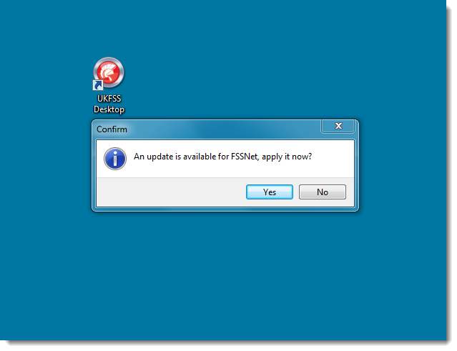

Click yes to apply the update and we will see the following screen apear.

**Checking for updates**

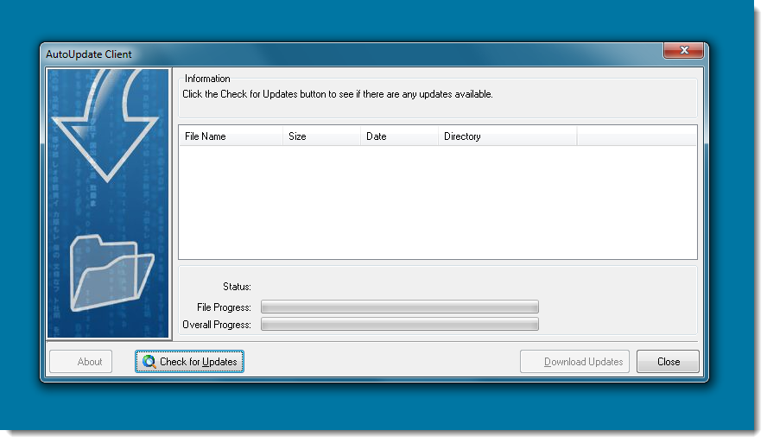

To see what updates are available we use the Check for Updates button on the bottom left of the form, once it has been pressed a list of the updates that are going to be applied will be displayed in the main grid area.

**Applying updates**

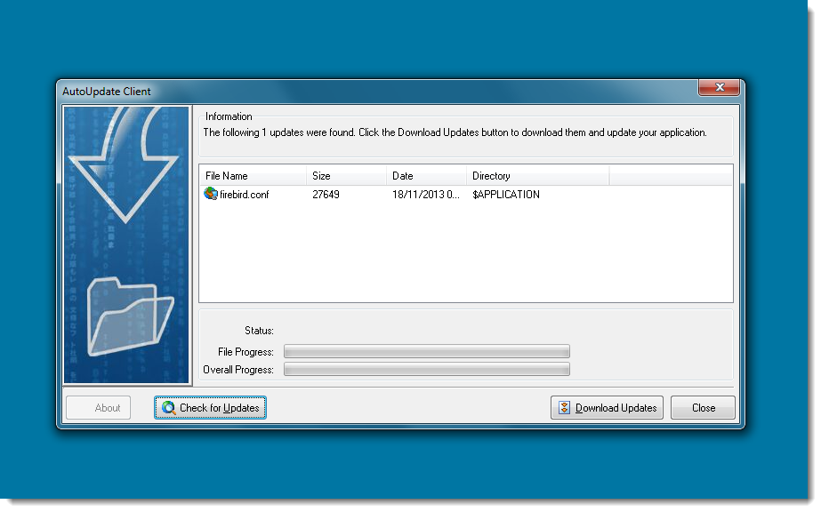

As you can see we have one file that needs to be updated, this is a small text file. Downloading this update will check to see if we have the ability to modify the contents of the application folder of UKFSS Desktop. This will be required as we will need to read report templates and update configuration setting and offline data.

To actually download and apply the update select the Download Updates button on the bottom left of the form next to the close button.

As you can see from the following image we have a problem, our update could not be installed, we can see it has been downloaded because of the green tick but because we are trying to modify a file that is already there we will need the correct permissions. The download file will be saved if possible under a new name and UKFSS Desktop will try to apply the update the next time it runs.

**Update issue**

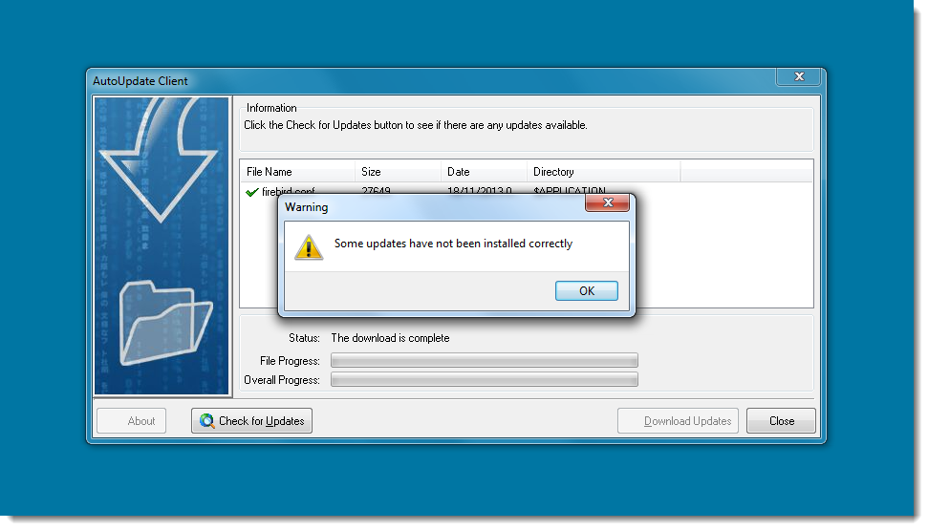

To fix this issue we will need to update the permissions on the UKFSS Desktop folder that was created during the install routine and this will generally only be required if it has been install to a restricted location and not into the users own work area/folder.

The required permissions are:

**Correct file permissions**

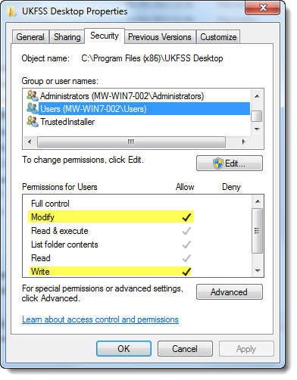

The 2 lines highlighted in yellow have been added and will allow us to use both the auto update feature and the UKFSS System.

If you update the permissions and run the auto update process again you should see the following message.

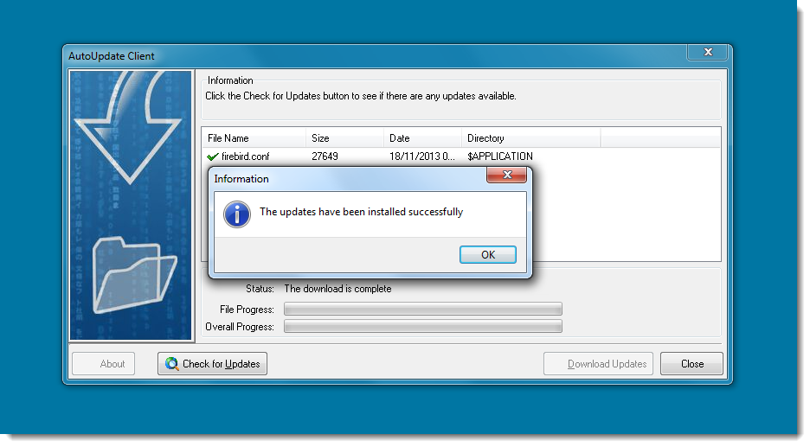

We can now close the auto update application and then start UKFSS Desktop as before, this time we will not be notified about updates and the login screen will open.

**Starting UKFSS Desktop**

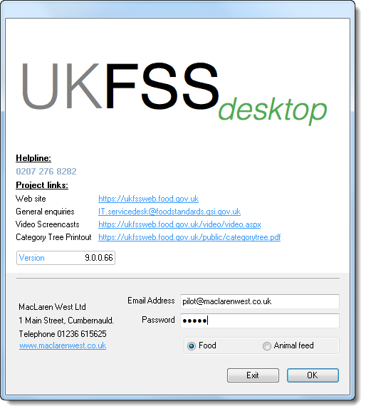

The login screen requires a login email address and a password, if this is the first time you have used UKFSS Desktop then you should have been supplied login details by the help desk. Once you have the admin details you can create accounts user who require access to the system.

To login just enter your details and click ok.

**Invalid User details**

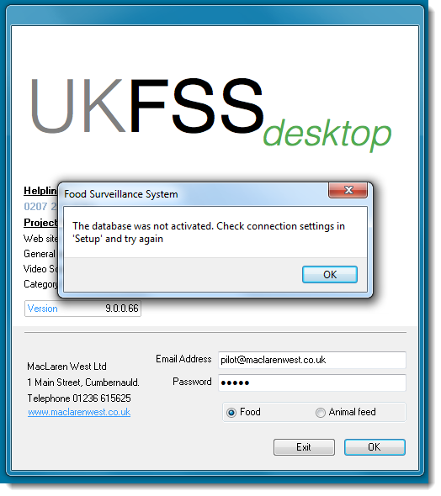

If you see the above message you user details are not valid, you can try again our contact the help desk to check your details.

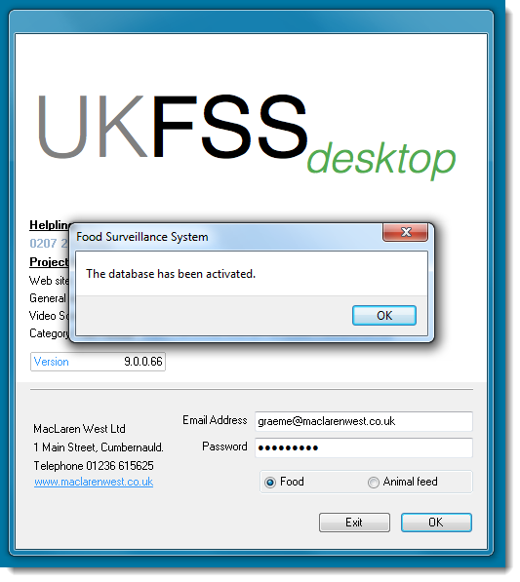

If everything goes well you should see the following message, you can click OK and UKFSS Desktop will start and the next screen you see will be the landing page where the UKFSS news is displayed.

**Login successful**

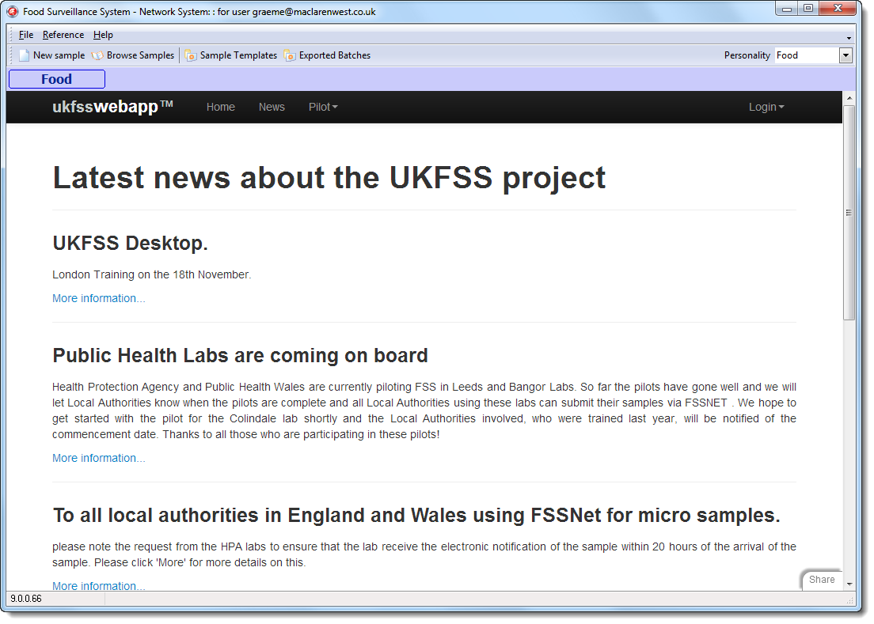

UKFSS has changed quite a lot but most of the changes are under the hood but if you have used old version of the system you will notice these changes as quite a lot of functions have been removed, update data lookup tables, import sample results. You no longer need to do these admin functions manually as they are automatic when UKFSS Desktop has an active network connection.

Some of the other new feature include the ability to update samples even after they have been exported to the Laboratory. You can also attach files, images or certificates to the sample and because of the new update process new features will be added more frequently as we move away for the version system we have at the moment to a more flexible update process

1. The Category Tree classifies food and animal feed products (not samples) so that information on specific types can be obtained from the database. The structure comprises four levels of classification usually referred to as “Clan”, “Family”, “Group” and “Type” (levels 1 to 4).
2. The determination codes used by laboratories to indicate the analyte/units combination of each test carried out on UKFSS samples.