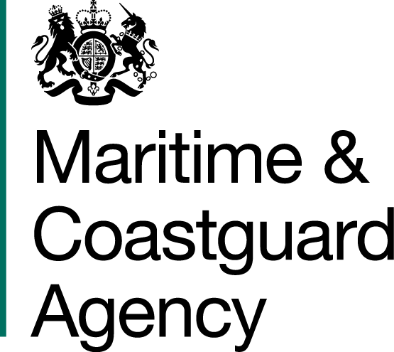

SPECIFICATION

FOR

UK SHIP REGISTER SALES AGENCY (GREECE)

MCA TCA 3/7/1145

The Maritime and Coastguard Agency (MCA) is an Executive Agency of the Department for Transport. The MCA is responsible throughout the UK for implementing and developing the UK Government's maritime safety and environmental protection policy. That includes co-ordinating Search and Rescue (SAR) at sea through Her Majesty’s Coastguard 24 hours a day, and checking that ships meet UK and international safety rules. The MCA work to prevent the loss of lives at the coast and at sea, to ensure that ships are safe, and to prevent coastal pollution: Safer Lives, Safer Ships, Cleaner Seas

The UK Ship Register operates as part of the MCA, providing an international ship register to the global maritime industry. The UK Ship Register’s mission is to become the world’s best performing international flag.

You are invited to submit a tender for the following requirement:

SALES AGENCY (GREECE) CONTRACT

- Background

Further to eligibility changes which took effect in March 2019, and a renewed business plan, the UK Ship Register is looking to grow Gross Tonnage (GT) by expanding its sales capabilities across a wider global footprint.

The first stage in this process is to establish a sales capability in Greece, through a contracted arrangement with a local contractor.

2. Definitions
In this specification the following definitions shall apply:

‘UKSR’ - means the UK Ship Register

‘MCA’ - means the Maritime & Coastguard Agency

‘Sales Agent’ – means the person designated by the contractor to act on behalf of the UK Ship Register in developing new business opportunities with industry representatives

‘Head of Business Development’ – means the person designated by the MCA to manage the contract and the day-to-day relationship with the Sales Agent

3. Requirement

The MCA has a requirement for a contractor to provide a sales agency service based in Greece. This agency will operate on behalf of the UK Ship Register, actively promoting the UK Flag and generating increased Gross Tonnage for the UK Ship Register.

The successful contractor will provide a UK Ship Register sales office in Greece and a suitably qualified sales agent to work on behalf of the UK Ship Register.

The successful contractor must fulfil the following requirements:

Substantial knowledge of global maritime markets and flag administrations

- Must identify a suitably qualified and/or experienced person to represent the UK Ship Register as Sales Agent in sales meetings with maritime industry representatives

- Must demonstrate substantial knowledge of the global maritime market, with suitable experience in global shipping

- Must demonstrate substantial knowledge of global flag administrations and be conversant in the commercial dynamics affecting shipping companies. Specific training on UK Ship Register features and benefits will be provided

Demonstrable business development skills and network in the Greek maritime
industry

- Must have strong representation and presence in Greece with a network of contacts in the Greek maritime industry

The contractor should identify within their tender proposal how the Sales Agent will deliver the following activities;

- Build a pipeline of new business through engagement across the Greek maritime industry and will develop long-term relationships with key prospects and existing UK Ship Register customers

- Actively seek opportunities to sell the benefits of the UK Flag to industry at appropriate and relevant networking events

- Report monthly on the pipeline of new business to the Head of Business Development at the UK Ship Register

- Recommend opportunities for the Head of Business Development at the UK Ship Register to meet with prospective customers where clear sales opportunities exist

- Secure new business for the UK Flag, subject in every case to written approval to proceed from the Head of Business Development UK Ship Register

Additional Requirements

- The contractor will set up suitable office premises in Greece, providing a professional environment commensurate with a UK Ship Register operation. The office space will;
- be located in a commercial setting
- have access to external telephone systems and sufficient broadband/Wi-fi connectivity to communicate effectively with customers and the MCA
- be capable of hosting a formal meeting for up to a maximum of 10 individuals

- Note: the MCA will contribute 50% toward any capital cost of setting up an office. Bidders should only include their proposed share of capital set-up costs in the submission. Any MCA contribution will be paid upon confirmation from a suitably qualified MCA appointed building surveyor that the work undertaken meets the agreed specification and all necessary building control requirements have been met.
- The MCA will provide the Sales Agent with a letter of appointment entitling them to engage in dialogue with customers acting on behalf of the UK Ship Register

- The contractor will provide open-book auditable records of all interactions with prospective and existing customers to the Head of Business Development on a monthly basis

4. Contract Period

The Contract will run for a period of two years, with an option to extend by a further twelve months. There will be an opportunity to break on the first anniversary by either party in writing, providing a minimum of three months-notice.

5. Security Requirements

Refer to General Conditions of Contract for Services Section E.

6. Contract Management

The contractor will be required to attend contract review meetings as required. These will take place on a six-monthly basis; dates to be agreed with the contractor. The MCA reserves the right to call a meeting at any time during normal United Kingdom office hours to resolve any issue relating to the contract.

The contractor should identify their administrative management structure within their tender proposal. This should also include escalation procedures for service delivery management.

Contract review meetings will include the following as a baseline agenda:

6.4.1) Introduction
6.4.2) Progress on pipeline development
6.4.3) Management information review
6.4.4) Issues
i) Commercial
ii) Operational

7. Indemnity and Risk

The Contractor is required to have current and sufficient insurances for carrying out this activity and to indemnify the MCA against any incident which could arise. Reference to our General Conditions of Contract for Services Section G.

