Invitation to Tender
for

Framework for the supply and installation of outdoor digital display signs at Westonbirt National Arboretum

Framework No: FEE/0388

Introduction
The Forestry Commission’s (FC) mission is to protect and expand Britain's forests and woodlands and increase their value to society and the environment.

We take the lead in the development and promotion of sustainable forest management. We deliver the distinct forestry policies of England and Scotland through specific objectives drawn from the country forestry strategies.

We the FC will always consider equality when conducting our procurement activities. We require you to meet your duties under the Equality Act 2010 and may ask for evidence that you are aware of and operate in accordance with those requirements.

More information is available on our website at www.forestry.gov.uk

Specification of Requirements
The Forestry Commission will be awarding a framework agreement for the supply and installation of up to three digital display signs at Westonbirt National Arboretum in Gloucestershire.

Our intention is to award this framework agreement for a period of four years.

Initially we plan to install one digital sign at the Welcome Building; following this we intend to have a 6 month ‘bedding in’ process to allow us to evaluate the success of the sign against our objectives. A break point is available within the framework agreement after the evaluation process is completed on the 1st digital sign, at which time we will decide on whether the framework agreement will continue. The decision on whether to use the break point available will be at our discretion and we will base it on the following factors: performance of the 1st digital sign against key performance indicators and budget availability.

As part of this framework agreement the successful tenderer will
- refine our requirements based on their professional experience;
- procure the agreed digital signage solution;
- advise on our chosen sign locations to ensure maximum effectiveness and cost efficiency;
- oversee the installation process for all signs including compliance with CDM and H&S regulations – this may include selection / management of subcontractors if appropriate;
- provide effective ongoing support to on-site staff to ensure digital signs are fully integrated into our day-to-day work through a Service Level Agreement (SLA) – this will provide ongoing staff training, monitoring, maintenance and technical support for five years initially (with option to extend for a further five years subject to performance (see 2.2.1.1) and budget availability)

Depending on how many digital signs are installed and the length of the SLA agreement the total value of this framework agreement will be in the region of £30,000 – £90,000 (Exc. VAT), split as follows:

- Up to £20,000 – initial procurement and installation of 1st digital sign + up to £10,000 for the SLA agreement for five years
- Up to £50,000 for the procurement and installation of two further digital signs – the decision to install these additional signs depends on performance of first digital display against key performance indicators (see 2.1.1.1) and budget availability
- Should the decision to extend the SLA for a further five years be applied, up to a further £2,000 per annum (maximum £10,000 over the life of the extension period – this is in addition to SLA agreement for 1st sign) will be available.

This budget includes all professional fees, overheads, administration costs, travel and subsistence.

A framework is an agreement with one or several providers. It sets out the general terms and conditions under which we can make specific purchases as and when we need them. The formal contract is formed when the customer places a call-off order against the framework asking for specific delivery of goods, services or works. A bidder can receive a call-off order directly, or we may ask them to take part in a mini-competition with the other bidders on the framework.

This particular Framework Agreement will operate as follows: direct award to a single supplier.

Background information
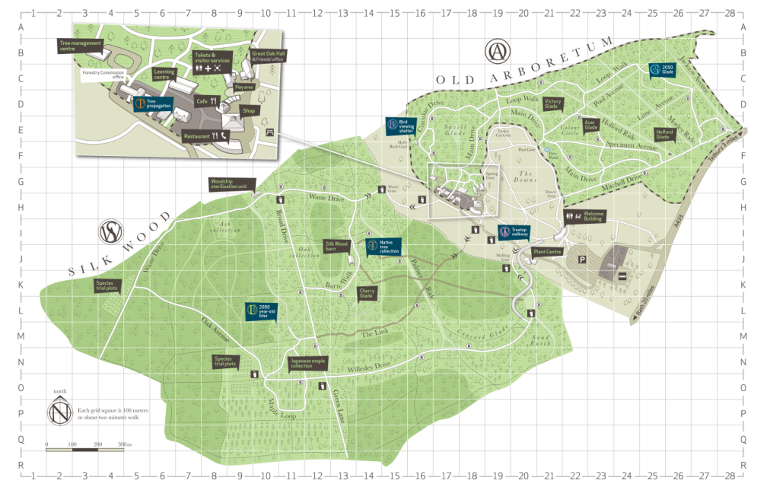
The National Arboretum at Westonbirt is one of Britain’s great botanical treasures. Its 600 acres encompasses an extraordinary collection of around 2,500 different trees and shrubs, including five National Collections, 140 champions and around 100 endangered species. The Westonbirt Estate is also one of the most complete picturesque gardens in Britain and is entered on the English Heritage Register of Parks and Gardens as Grade 1, and therefore of international importance.
1.
2.

Today the arboretum is cared for by the Forestry Commission England (FCE), with support from an associated charity The Friends of Westonbirt Arboretum (FOWA). The site is Gloucestershire’s largest visitor attraction, attracting over 500,000 visits annually, including some 10,000 educational visitors. Approximately half of these visits are made by our 31,000 Friends members.

Westonbirt is committed to providing opportunities for people to connect with trees – physically, mentally and spiritually. This connection is enshrined in its Mission: ‘to connect people with trees to improve the quality of life’. In delivering this Mission we hope all visitors will be inspired by our landscape and the trees within it. We want all visitors to leave with a deeper understanding and appreciation of our four interconnected key messages (overleaf).
- Westonbirt’s landscape is constantly evolving thanks to the vision of custodians past and present
- Trees are essential to life
- Westonbirt is an internationally important tree collection
- Our ongoing management is exemplary; protecting Westonbirt for the future
Westonbirt has recently reorganised its physical landscape through the Westonbirt Project. This developed a cohesive welcome and arrival experience, as well as new interpretative experiences (the Stihl treetop Walkway) and facilities for our tree collection team. This digital signage project is part of the next stage in the site development to further develop a cohesive orientation and interpretative experience across the whole site.

Background to the digital signage project and its aims
At present visitors arriving at the Welcome Building (Point 1. Map pg4) are faced with a variety of temporary signage, including ‘A’ boards, banner flags and posters. To date the greatest number of A-frames we have counted at the Welcome Building has been 14. Yet even with all these signs, we still don’t always have the signs to highlight the full range of site information. Many visitors also spend time at our central facilities (Point 2. Map pg4), which house our retail / catering offer as well as exhibition space, learning centre and other interpretation hotspots. This area does not currently have a Forestry Commission staff / volunteer presence. We would like to have a digital sign located within this area to re-orientate visitors during their visit and highlight some of these additional interpretative elements.

Key project aims are to:
- Provide a robust outdoor digital signage solution that welcomes visitors; providing them with a warm, interactive experience that enables them to understand the full Westonbirt ‘offer’. A full breakdown of the types of information we hope to provide on each sign is provided in Section 2.1.3.
- Provide a software system that allows for quick, easy, regular and remote updating of content by onsite operational staff
- Rationalise existing temporary signage into a professional digital solution that reflects the high quality Westonbirt brand and ensures better consistency
- Support day-to-day site management of site by enabling scheduling of messages (daily and seasonally) to highlight promotions, what’s looking good etc. – as well as enabling provision of emergency information quickly
- Provide a future proof digital solution that will enable us to take advantage of new media – in particular although we do not initially intend to enable visitors to interact with the screens through touchscreen technology, we would like explore a solution that has this as a potential future option

2.1.1.1 Key performance indicators
We will be evaluating the success of the project against agreed KPIs; in particular these will guide our decision as to whether to use the break point in the framework agreement. Although the exact indicators will be agreed with the successful tenderer on award of the framework agreement possible measures are highlighted below.

Indicator | Measures
Ease of use | - Happy front-of-house staff – staff feedback  - Number of uploading ‘issues’ e.g. crashes, glitches in software  - Responsiveness of contractor in relation to ongoing SLA
Improved visitor engagement with site | - Observations – visitor stopping / holding power of screen  - Visitor surveys – where do they learn about Westonbirt offer  - Feedback from franchise holders e.g. do they get increased visibility to offers / visitor take up offers  - Membership data  - Number of visits to other locations in arboretum
Supporting a quality experience | - Staff / visitor feedback on look and feel  - Satisfaction levels from visitors  - Screen tests under different environmental conditions; number of screen failures, readability

Target audiences
The digital signage aims to engage with our different audience groups. These broad categories are briefly outlined.

Friends of Westonbirt members
Members often have a clear understanding of what Westonbirt affords them and use the site on a daily/weekly basis. Members are vital for our long-term sustainability, but they can also be among our most vocal critics if they feel that they do not understand our decisions / work. This can be exacerbated by the fact that many members do not take full advantage of our current interpretative offer because they feel that either it is not ‘aimed’ at them or that they already ‘know’ it. On the flip side many members feel great personal ownership of the arboretum and enjoy sharing their photographs, stories and anecdotes. We hope that the digital signage will:
- Encourage members to broaden their understanding of what takes place on site
- Encourage members to take advantage of special member offers
- Increase their appreciation of how their membership supports the arboretum
- Provide further opportunity for co-curated content

First time ‘experience seekers’
Westonbirt is especially well known for certain seasons (autumn) and events (such as Enchanted Christmas). At these times we receive a higher proportion of first time or very infrequent visitors, who are attracted by our world-renowned reputation and marketing. These visitors have limited understanding of what Westonbirt is and therefore need greater orientation and support. Often their understanding is limited to the single offer that prompted their visit. We hope that the digital signage will:
- Provide clear orientation and ‘nuts and bolts’ guidance e.g. facilities, rules
- Ensure these visitors understand the full scope of the ‘offer’
- Promote future seasons / events thereby encouraging repeat visits and membership

Discovery families
Between 30 – 40% of our visitors come in family groups; often containing multiple generations. We have an extensive family offer that includes trails, play features and discovery / craft events. We hope that the digital signage will:
- Heighten expectation and provide a call to action
- Ensure these visitors understand the full scope of the ‘family offer’
- Promote future seasons / events thereby encouraging repeat visits and membership
- Ensure groups understand the ‘rules’

Enthusiasts
Westonbirt has a range of visitors with special interests including; trees (obviously), wildlife and gardening. Photography is also a keen interest for many visitors; 32% indicate that it is a primary reason for their visit. These audiences often have a greater understanding of specific topics and want to learn more. We hope that the digital signage will:
- Signpost these visitors to other interpretative hotspots
- Promote future seasons / events thereby encouraging repeat visits and membership

Signage locations
We have identified three preferred locations for digital signs. As part of the project delivery the successful contractor will help us to confirm specific locations for each sign. NB: As part of the installation process the successful tenderer will need to ‘make good’ surrounding surfaces to the level of the current finishes. These include pennant stone and resin-bond.

Location 1: Approach to Welcome Building

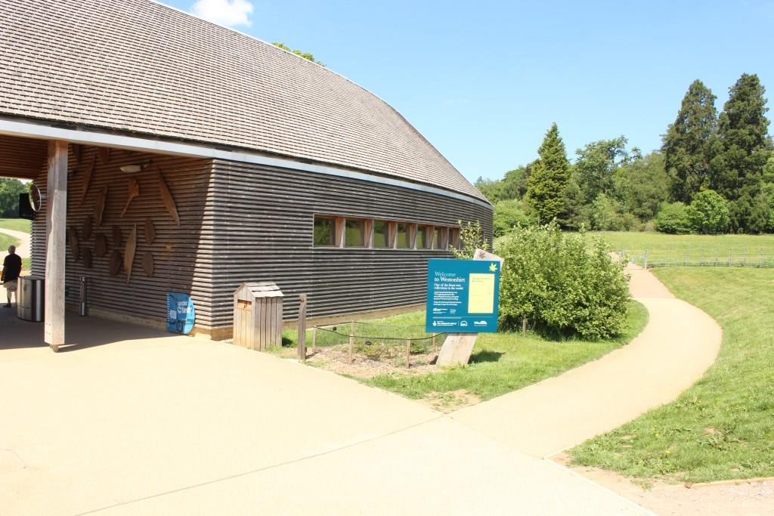 | NB: This will be the 1st sign installed. Our preferred location is on the right-hand side as visitors approach from the car park as we believe this will be less impacted by queuing. The new digital sign will replace the current static price board. During install we are keen to ensure that additional power / data cables are installed to allow us to install a self-service ticket machine alongside the sign at a later date. This position will mean the sign is in full sun for extended periods – the successful contractor will advise on this.
Location 2: Welcome Building plaza

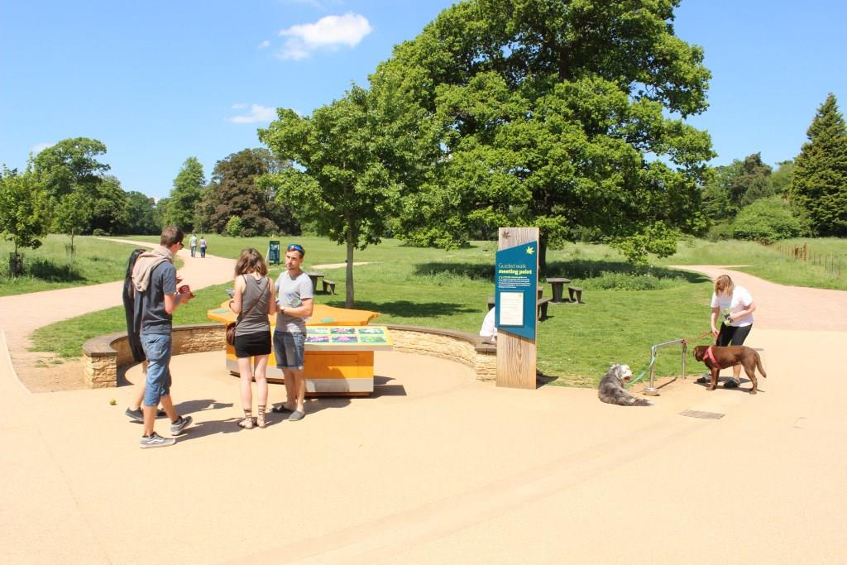 | Our preferred location is on the right-hand side as visitors enter through the access gates. We feel this is better than the left hand side as there is more space.  The new digital sign will replace the current static Guided walk Meeting Point sign – which we intend to move further along the path.
Location 3: Central facilities
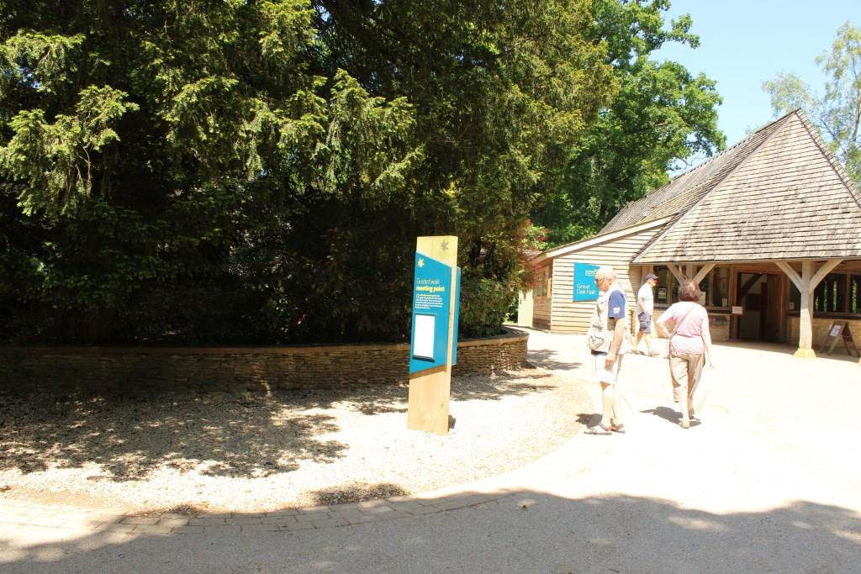 | Our preferred location is on the path side between the café and visitor toilets, close to the entrance to Exploratree play area.  The new digital sign will replace the current static Guided walk Meeting Point sign.
Specific queries that we have (to be addressed by successful contractor):
- Are these locations appropriate in terms of ensuring good visibility?
- Do these locations pose issues in terms of possible congestion – if so how do we minimise this?
- Do we need to consider the position of the sun through the day?
- LOCATION 3: How can we minimise installation impact on tree roots?

Core information to be provided
The digital signs will inform visitors of admission times and prices, membership, daily / forthcoming events / offers, onsite interpretative ‘hotspots’ and introduce deeper interpretive stories. We envisage the digital system will allow a flexible approach to how these messages are distributed across the signs; the table below gives our initial thoughts on this, although we would hope the successful contractor will be able to advise further. We expect the digital solution will enable messages to be scheduled on a daily / weekly / monthly basis and possibly to allow screens to be split into different areas containing different messages.

Sign location | Information
WB – car park side | - Admission times and prices (including membership)  - Brief site overview – what’s so special about Westonbirt?  - Key daily events and facilities; guided walks, seasonal trails, family activities  - Emergency information  - After hours information
WB – arboretum side | - Arboretum areas and ‘what’s looking good today’ information – more in-depth interpretation  - Emergency information  - Upcoming events  - Become a member call to action  - Franchise offers  - Link to our twitter / Facebook feed?
Central hub | - Interpretation – link to key onsite ‘hotspots’  - Emergency information  - Upcoming events  - Membership information  - Franchise offers

Scope of work
We are looking for a contractor to oversee the whole project from inception to completion; providing a high quality product on time, within budget and to the required quality standards.

Technical specification
The list below provides a description of our requirements for the digital signage. We will expect the successful contractor to advise on the most appropriate model to deliver to this specification.
- Freestanding ‘totem’ solution, housing a single-sided portrait screen at least 47” in size
- Be able to operate 24/7 x 364 days per year (we close Christmas day!)
- Ensure good readability regardless of ambient light conditions (including coping with angled / direct sunlight) and viewing angle (+/- 60 degrees);
  - Full HD resolution
  - Minimum screen brightness of 2,000 nits
  - Use of ambient light sensors to automatically adjust screen brightness based on light levels
  - Provide high contrast ratio (min. 5,000:1) and colour saturation
  - Include use of anti-reflective treatment on glass (not anti-glare film)
  - Include active screen temperature management to prevent solar clearing / blackening
  - Operating temperature range from -40ºC to +55 ºC
- Include appropriate heating / cooling to ensure internal housing environment remains within screen manufacturer’s guidelines (typically 20 – 25ºC) to ensure optimal screen performance and screen lifespan
  - Inclusion of temperature sensors, automatic heat/cooling regulation and emergency power-off
- Be fully sealed (rating IP66) to withstand changing weather and other outdoor environmental factors; wind, rain, humidity, dust, insects, dog urine etc.
- Be robust to withstand interaction with visitors, including possible vandalism and risk of mobility scooters being driven into them (IK rating of 10) e.g.
  - Use of thermally toughened laminated glass to protect screen
  - Ensure data security – closed system so cannot be hacked into
- Be guaranteed for the following periods;
  - Screen performance guaranteed for a minimum of 50,000 operational hours based on 24hrs/7day week operation
  - 3 years – associated cooling/heating system
  - 10 years - screen housing
- Enable flexible, attractive display of information including different media formats including images, text, film, audio etc.
- Use an appropriate CMS system that is compatible with Forestry Commission IT systems to manage content. This system will include the ability to
  - Enable screens to run same / different content
  - Update new content quickly / effectively – both remotely through network and at the display point
  - Schedule different content at different times of day / season
  - Schedule power off/on
  - Adjust display parameters e.g. brightness, contrast, backlight etc.
  - Show more than one piece of information at a time through split screen
  - Make appropriate use of new and emerging technologies where appropriate e.g. Twitter, Facebook, web, rolling feeds etc.
  - Potential for touchscreen in future
- Enable easy maintenance including
  - remote monitoring / troubleshooting of all components / software – ability to make necessary adjustments without visiting site
  - servicing in the installed location
  - modular system to enable replacement of different parts without need to replace whole unit e.g. screen / glass cover etc.
- Be energy efficient e.g. through power saving, use of LED etc.
- Steel powder-coated totem housing to fit with branding e.g. use of standard signage Pantone 309 / Leaf motif + possible HLF acknowledgement
- Housing to be structurally sound and non-corrosive
- Product complies with relevant H&S standards
- Ensure ongoing technical support through development of Service Level Agreement – see 2.2.1.1

Ongoing support (through Service Level Agreement)
The successful contractor will provide ongoing support through a Service Level Agreement (SLA) agreement for five years from completion (with option to extend for a further five years).

The level of support expected will include:
- Ongoing monitoring of screen performance through built-in functionality (e.g. temperature sensors) including automatic correction – provision of quarterly report to feedback any significant factors
- Responding to technical problems related to hardware or software within 48 hours, Monday – Friday.
- Where technical problems cannot be resolved immediately through remote support, if necessary an engineer will visit site within 5 working days to assess and agree a clear time frame to ensure minimal downtime.
- Where the screen needs to be removed a temporary replacement should be fitted
- Annual onsite check / service of hardware including computer and associated cooling / heating systems – and check of external casing
- Support ongoing staff training through provision of an annual ½ day refresher training session
- Carrying out upgrades to keep up with operating systems if/when these become available

At the end of the initial five year support period we will review the agreement, with the option to extend for a further five years. It is not necessarily our intention to move the support of our digital signage to another provider, but we reserve the right to do so. Should we choose to do this the contractor will ensure a smooth transition through provision of full service records / notes etc.

Project phases
The successful contractor will have full responsibility for the project management of all aspects of the delivery of the identified digital signage outlined in this tender. This includes initial research & development, installation and on-site initiation. The specific duties at each stage of the process are outlined in the following sections; at all stages the successful contractor will be expected to liaise with relevant Forestry Commission staff and seek approval.

Phase 1: Research and development
This phase aims to lay the groundwork for successful delivery of the project. The successful contractor will
- Sense check our plans; check location sites, technical specifications and agree final positions / sign orientation
- Confirm the project budget through discussions with suppliers / groundworks contractors
- Carry out site surveys that may be required e.g. services
- Liaise with Forestry Commission IT team to clarify systems requirements / feasibility
- Provide us with suitable plans etc. to enable us to obtain necessary consents required for installation e.g. planning permission
- Identify digital signage options (for both hardware / software) that meet the technical requirements outlined in Section 2.2.1 and present fully costed options to Forestry Commission team for agreement. Options will outline
  - Initial purchase cost
  - Lifetime costs of each solution (taking into account running costs / service level agreement etc.)
  - Where decisions on system are required to meet the budget
  - Specific installation requirements for each option
  - Proposals for maintenance and renewal, including any necessary contractual arrangements
- Apply for planning permission
- Procure agreed digital signage system from supplier

Phase 2: Installation and initial content development
Following selection of the digital signage package the contractor will oversee its successful installation onsite, including works to provide electrical power / networking to the signs. This will include
- Development of agreed installation plan including method statements and associated risk assessments
- Provision of insurance details / training records detailing competence
- Supervision / monitoring during installation to ensure compliance
- Commissioning of subcontractors as required (ensuring quotations offer genuine value for money)
- Inspecting works to ensure compliance with quality standards
- Early notification of any variations and requests for extensions of time, providing detailed justifications for review and determination by Client

The contractor will also develop a suite of content templates in line with the Westonbirt brand – to include:
- Admission information (including membership)
- What’s looking good today – seasonal / plant information
- Family / adult events including guided walks
- Key offers;

  - Mobility scooter hire
  - Membership advert
  - Upcoming seasons
  - Tree works alert
  - Exhibitions

Franchise templates - catering / shop offers / Westonbirt WoodWorks / Learning with Nature

Emergency information template

Onsite initiation

Following installation the digital signage the contractor will provide an intensive three month initiation phase. This will include
- Sign off of signage based on (a) quality of finish, materials and workmanship and (b) digital hardware / software working as specified: if any part of the signage fails to pass this assessment the contractor will take whatever steps may be necessary to enable the signs pass the Acceptance Tests.
- Enabling staff to develop initial campaigns using developed templates through provision of onsite training day and accompanying ‘how to’ manual for 10 Westonbirt staff in use of CMS system to create and manage campaigns
- Provision of Health & Safety file including all ‘as built’ information operation and maintenance manuals
- Confirmation of maintenance agreements and/or call-off contracts with appropriate suppliers
- Details of warranties
- Support onsite staff to develop suitable onsite evaluation process to ensure that the digital signage is meeting visitor / staff expectations and inform future campaigns / digital signage developments. Specifically this evaluation will assess whether the signs;
- meet our visitors’ needs – provoke their curiosity and interest
- have the desired learning outcomes
We will retain 10% of the initial budget (excluding SLA) until we have successfully completed the initiation phase.
Should we decided to install the additional two signs in locations 2 / 3 we would expect to follow a similar phased delivery process (albeit some elements outlined above will already have been completed).

Other key considerations

Health and safety
Westonbirt receives over 500,000 visits per year and installation work will need to be carefully planned to ensure the safety of our visitors and minimise disruption to them. The successful tenderer will be responsible for managing all installation work to ensure compliance with all relevant H&S legislation:
- Carry out relevant surveys to accurately map underground services (Appendix 1 contains constraint maps for information)
- Plan when work is carried out to tie in with quiet seasons/times of day – this is especially important when moving machinery onto site
- Erect and maintain appropriate safety barriers and warning signage

Inclusive access
Visitor surveys indicate that around 20% of groups visiting Westonbirt include someone with a disability. Digital signage must be compliant with the requirements of the Equality Act 2010, demonstrating best practice in accessibility for a wide range of users. We will be looking for innovative solutions to accessibility in all media and interpretation, for engaging the widest possible audience, including all strands of diversity.

Brand
All new interpretation should adhere to our design guidance and branding requirements and should meet an exemplary high quality standard to match our visitor’s expectations of the first impression of the National Arboretum. Our brand manual has been supplied with this tender.

Environmental sustainability
The design, build and installation of this project should follow the principles of the Forestry Commission’s environmental policy: http://www.forestry.gov.uk/website/forestry.nsf/byunique/infd-6z2jzm

Particular emphasis should be on sourcing a digital solution that minimizes ongoing energy usage.
The project must protect our tree collection. In particular installation works must consider the British Standard ‘Trees in relation to design, demolition and construction – Recommendations’ (BS5837) and in particular its guidance on
- root protection area (RPA) in sections 3.7 and 4.6 and annex D
- proximity of structures to trees in section 5.3
As a Grade One Historic Landscape of international significance great care must be taken on choosing final locations for each sign. We have been advised that these signs will require planning permission – the contractor will provide support in preparing applications to enable us to meet planning conditions.
This list of requirements is not exhaustive and contractors are expected to incorporate sustainability into their solutions wherever possible.

Note: Tenderers must include details of any areas where they will not be able to comply with these requirements. If your Tender does not meet these requirements we reserve the right to reject it completely.

Notes for Completion and Conditions

Definitions and purpose
The “authority” or “we” means the Forestry Commission, or anyone acting on behalf of the Forestry Commission, that is seeking to invite suitable Suppliers to participate in this procurement process.

“You”/”Your” or “Supplier” or “Bidder” means the body responding to this Invitation to Tender (ITT) i.e. the legal entity submitting a tender. The ‘Supplier’ or ‘Bidder’ is intended to cover any economic operator as defined by the Public Contracts Regulations 2015 and could be a registered company; charitable organisation; Voluntary Community and Social Enterprise (VCSE); Special Purpose Vehicle; or other form of entity.

This Invitation to Tender (ITT) has been designed to assess both the suitability of a Supplier to deliver the authority’s contract requirement(s); and to determine of those suitable, which supplier(s) have provided the most economically advantageous tender.

Timetable
Set out below is the procurement timetable. While we do not intend to depart from the timetable, we reserve the right to do so and if this is required, we will inform Suppliers in writing of any changes.

Stages | Dates
Bidder Briefing Day | 27th July, 10am – 1pm
Closing date for further questions | 17th August, 3pm
Closing Date and Time for Tender Returns | 25th August, 1pm
Expected Notification of Award | Week commencing 11 September
Expected Start Date | Week commencing 18th September

Bidder briefing day
Bidders are invited to attend a Bidder Briefing Day to help them understand more about the requirements of this framework agreement. The Briefing will take place on the date specified in the timetable above and bidders should contact the person named at 3.3 to confirm their attendance and receive further details.

Enquiries
Please send all enquiries by email, by the deadline stated at Section 3.2 quoting the reference number printed at the front of this document to:

Ben Oliver
Learning and Participation Manager

ben.oliver@forestry.gsi.gov.uk

If we consider any question or request for clarification is relevant to all interested parties, we will circulate both the query and the response to all prospective bidders, although your identity will remain confidential.

If you want to tender, and have not yet registered interest in the framework agreement you must do so before the closing date for expressing interest to make sure you are told about any questions and answers.

Responses and supporting documents
Please ensure that all questions are completed in full, and in the format requested. Failure to do so may result in your submission being disqualified. If the question does not apply to you, please state clearly ‘N/A’.

Should you need to provide additional Appendices in response to the questions, these should be numbered clearly and listed as part of you declaration. A template for providing additional information is provided at the end of this document, which should be used unless, due to formatting, this is not possible.

To make the process straightforward, you do not need to provide supporting documents with your tender unless specifically requested to do so. However, we may ask you for this later.

Your organisation will only be evaluated based on the information in your tender. If you do not mention any applicable previous experience of working with us in your reply we cannot take this into account.

Please do not send any information that is general company or promotional literature, as this will not form part of our evaluation. Any additional documents you provide must refer to a question within the ITT and be easily identifiable as the answer.

Return arrangements
Please return your completed tender submission inclusive of any relevant appendices as:

Two paper copies by post or hand delivered, and

One copy on disk or USB type storage device in a read only format

Please note that we do not accept fax or email copies. We must receive your completed tender before the closing date and time shown in the Timetable at section 3.2. We will keep tenders received before this deadline unopened until after this time. We reserve the right to not consider any tenders received after the deadline. Please be aware that tenders may be copied for our use.

Mark your envelopes with the words ‘Tender for Digital Signage, FEE/0388 – Not to be opened until 25th August at 1pm’.

Submissions may be excluded if you do not mark the envelope in this way.

Send completed tender documents to the following address:

Ben Oliver
Westonbirt National Arboretum
Tetbury
Glos
GL8 8QS

Clarification
During our evaluation process, we may need to seek clarification on aspects of your tender return. If required we will contact you using the contact details you have provided. Clarification may require you to submit, supplement, clarify or complete the relevant information or documentation within an appropriate time limit. The purpose of any such clarification is to provide us with the information we require to score your submission; it will not be an opportunity for you to improve or substantially change the information you have already submitted.

Verification of information provided
Whilst reserving the right to request information at any time throughout the procurement process, the authority may enable the Supplier to self-certify that there are no mandatory/discretionary grounds for excluding their organisation. When requesting evidence that the Supplier can meet the specified requirements (such as the questions within the sub-sections of 4.6 of this ITT relating to Technical and Professional Ability) the authority may only obtain such evidence after the final tender evaluation decision i.e. from the winning Supplier only.

Sub-contracting arrangements
Where the supplier proposes to use one or more sub-contractors to deliver some or all of the requirements, a separate Appendix should be used to provide details of the proposed bidding model that includes members of the supply chain, the percentage of work being delivered by each sub-contractor and the key deliverables each sub-contractor will be responsible for.

The authority recognises that arrangements in relation to sub-contracting may be subject to future change, and may not be finalised until a later date. However Suppliers should be aware that where information provided to the authority indicates that sub-contractors are to play a significant role in delivering key requirements, any changes to those sub-contracting arrangements may affect the ability of the Supplier to proceed with the procurement process or to provide the supplies and/or services required. Suppliers should therefore notify the authority immediately of any change in the proposed sub-contractor arrangements. The authority reserves the right to deselect the Supplier prior to any award, based on an assessment of the updated information.

Consortia arrangements
If the Supplier completing this ITT is doing so as part of a proposed consortium, the following information must be provided:-

- Names of all consortium members;
- The lead member of the consortium who will be contractually responsible for delivery of the contract (if a separate legal entity is not being created); and
- If the consortium is not proposing to form a legal entity, full details of proposed arrangements within a separate Appendix.

Please note that the authority may require the consortium to assume a specific legal form if awarded the work, to the extent that a specific legal form is deemed by the authority as being necessary for the satisfactory performance of the framework agreement.

All members of the consortium will be required to provide the information required in all sections of the ITT as part of a single composite response to the authority i.e. each member of the consortium is required to complete the form.

Where you are proposing to create a separate legal entity, such as a Special Purpose Vehicle (SPV), you should provide details of the actual or proposed percentage shareholding of the constituent members within the new legal entity in a separate Appendix.

The authority recognises that arrangements in relation to a consortium bid may be subject to future change. Suppliers should therefore respond on the basis of the arrangements as currently envisaged. Suppliers are reminded that the authority must be immediately notified of any changes, or proposed changes, in relation to the bidding model so that a further assessment can be carried out by applying the selection criteria to the new information provided. The authority reserves the right to deselect the Supplier prior to any award of contract, based on an assessment of the updated information.

Confidentiality
When providing details of contracts in answering section 4.6 of this ITT (Technical and Professional Ability), the Supplier agrees to waive any contractual or other confidentiality rights and obligations associated with these contracts.

The authority reserves the right to contact the named customer contact in section 4.6 regarding the contracts included in section 4.6. The named customer contact does not owe the authority any duty of care or have any legal liability, except for any deceitful or maliciously false statements of fact.

The authority confirms that it will keep confidential and will not disclose to any third parties any information obtained from a named customer contact, other than to the Cabinet Office and/or contracting authorities defined by the Public Contracts Regulations.

The Supplier must treat all information supplied to it by the authority in confidence and must not disclose it to third parties other than to obtain sureties or quotations for submitting its response.

As part of the tendering process, the Supplier must identify any parts of its tender submission which it designates as confidential and would not want published; such information may include technical or trade secrets or other confidential information. The authority will then assess this information (along with the rest of the contract), taking account of Regulation 21 of the Public Contracts Regulations, when considering which contractual information should or should not be published or released on request.

Tender validity
All details of the tender, including prices and rates, must be valid for 90 days from receipt of tender.

Language
The completed tender and all accompanying documents must be in English.

Applicable Law
Any framework agreement concluded as a result of this ITT will be governed by English law.

Pricing
All prices will be in sterling and exclusive of VAT.

Additional costs
Once we have awarded the framework agreement, we will not pay any additional costs incurred which are not reflected in your tender submission.

Evaluation
A Tender Panel will evaluate responses to the tender objectively using the criteria and evaluation matrix’ defined within Section 4.

Gateways
Some questions in the tender are known as gateways and are fundamental requirements of the framework agreement. These are marked on a ‘pass/fail’ basis and if you do not answer these sections appropriately, we may reject your submission in full and cease to evaluate any more questions.

Weighted questions
Some sections of this ITT include questions that are weighted. The weightings applied to each question ensure the relative importance of each is correctly reflected in the overall scores applied.
For these questions, the marks out of 4 that are achieved for each question will be subsequently weighted to provide a total number of marks out of 100.

Award
Once we have carried out the evaluation and identified the successful tenderer(s), we will tell all tenderers in writing by email of our award decision.

Debriefing
We will give all bidders the opportunity of a debriefing. Please tell us in writing as soon as possible if you want a debriefing.

Contract management
If we award a framework agreement, you will have to co-operate in managing it and comply with the contract management requirements, as detailed in the Specification of Requirements at Section 2.

Costs
Unless otherwise stated in this ITT, all costs associated with taking part in this process remain your responsibility and we will not return any part of your completed tender to you.

Right to cancel or vary the process
We reserve the right to cancel or withdraw from the tendering process at any stage.

Inducements
Offering an inducement of any kind in relation to obtaining this or any other contract with us will disqualify you from being considered and may constitute a criminal offence.

Disclaimer
While the information in this ITT and supporting documents has been prepared in good faith by us, it may not be comprehensive nor has it been independently verified.
Neither the FC, nor their advisors, nor their respective directors, officers, members, partners, employees, other staff or agents:
- makes any representation or warranty (express or implied) as to the accuracy, reasonableness or completeness of this ITT; or
- accepts any responsibility for the information contained in the ITT or for the fairness, accuracy or completeness of that information nor shall any of them be liable for any loss or damage (other than in respect of fraudulent misrepresentation) arising as a result of relying on such information or any subsequent communication.

Your response
In order to submit a tender for this requirement you must complete and return the relevant sections, detailed in the table below, in compliance with Section 3 above. If we have decided that certain sections are not relevant for this particular ITT, we have indicated this by stating ‘N/A’ next to the title heading at the relevant section and by indicating ‘Not Applicable’ within the table below. Unless otherwise indicated in this way, all sections must be completed and returned.

The table below provides a summary of the evaluation method for each section, however full details of how we will evaluate your submission can be found in the individual Evaluation Matrix’ within each section.

Section | Title | Evaluation Method
4.1 | Supplier Information | For information only but must be completed
4.2 | Grounds for mandatory exclusion | Pass / Fail
4.3 | Grounds for discretionary exclusion – Part 1 | Pass / Fail
4.4 | Grounds for discretionary exclusion – Part 2
Selection Criteria
4.5 | Economic and Financial Standing | Not applicable
4.6 | Technical and Professional Ability | Pass / Fail
4.7 | Additional Selection Modules
4.7.1 | Project Specific Questions to assess Technical and Professional Ability | Pass / Fail
4.7.2 | Insurance | Pass / Fail
4.7.3 | Compliance with equality legislation | Pass / Fail
4.7.4 | Environmental Management | Pass / Fail
4.7.5 | Health and Safety | Pass / Fail
Award Criteria
4.8 | Requirement Specific Questions | Scored and Weighted
4.9 | Pricing Schedule | Scored and Weighted
4.10 | ITT Template Appendices | Template Only – Use where required
4.11 | Terms and Conditions of Contract | Pass / Fail
4.12 | Declaration | Pass / Fail

Supplier Information
Supplier details |  | Answer
Full name of the Supplier completing the ITT
Registered company address
Registered company number
Registered charity number

Registered VAT number
Name of immediate parent company
Name of ultimate parent company
Please mark ‘X’ in the relevant box to indicate your trading status |  | i) a public limited company
 |  | ii) a limited company
 |  | iii) a limited liability partnership
 |  | iv) other partnership
 |  | v) sole trader
 |  | vi) other (please specify)
Please mark ‘X’ in the relevant boxes to indicate whether any of the following classifications apply to you |  | i)Voluntary, Community and Social Enterprise (VCSE)
 |  | ii) Small or Medium Enterprise (SME)
 |  | iii) Sheltered workshop
 |  | iv) Public service mutual
Bidding model
Please mark ‘X’ in the relevant box to indicate whether you are:
a) Bidding as a Prime Contractor and will deliver 100% of the key framework deliverables yourself
b) Bidding as a Prime Contractor and will use third parties to deliver some of the services

If yes, please provide details of your proposed bidding model that includes members of the supply chain, the percentage of work being delivered by each sub-contractor and the key framework deliverables each sub-contractor will be responsible for.
c) Bidding as Prime Contractor but will operate as a Managing Agent and will use third parties to deliver all of the services

If yes, please provide details of your proposed bidding model that includes members of the supply chain, the percentage of work being delivered by each sub-contractor and the key framework deliverables each sub-contractor will be responsible for.
d) Bidding as a consortium but not proposing to create a new legal entity.  If yes, please include details of your consortium in the next column and use a separate Appendix to explain the alternative arrangements i.e. why a new legal entity is not being created.  Please note that the authority may require the consortium to assume a specific legal form if awarded the framework to the extent that it is necessary for the satisfactory performance of the framework |  |  | Consortium members:  Lead member:
e) Bidding as a consortium and intend to create a Special Purpose Vehicle (SPV).  If yes, please include details of your consortium, current lead member and intended SPV in the next column and provide full details of the bidding model using a separate Appendix. |  |  | Consortium members:  Current lead member:  Name of Special Purpose Vehicle:
Contact details
Supplier contact details for enquiries about this ITT
Name
Postal address
Country
Phone
Mobile
E-mail

Licensing and registration (please delete the option which doesn’t apply)
Registration with a professional body  If applicable, is your business registered with the appropriate trade or professional register(s) in the EU member state where it is established (as set out in Annex XI of directive 2014/24/EU) under the conditions laid down by that member state). | Yes / No  If Yes, please provide the registration number in this box.
Is it a legal requirement in the state where you are established for you to be licensed or a member of a relevant organisation in order to provide the requirement in this procurement? | Yes / No  If Yes, please provide additional details within this box of what is required and confirmation that you have complied with this.

Grounds for mandatory exclusion
You will be excluded from the procurement process if there is evidence of convictions relating to specific criminal offences including, but not limited to, bribery, corruption, conspiracy, terrorism, fraud and money laundering, or if you have been the subject of a binding legal decision which found a breach of legal obligations to pay tax or social security obligations (except where this is disproportionate e.g. only minor amounts involved).

If you have answered “yes” to question 4.2.2 on the non-payment of taxes or social security contributions, and have not paid or entered into a binding arrangement to pay the full amount, you may still avoid exclusion if only minor tax or social security contributions are unpaid or if you have not yet had time to fulfil your obligations since learning of the exact amount due. If your organisation is in that position please provide details using a separate Appendix. You may contact the authority for advice before completing this form.

4.2.1 Within the past five years, has your organisation (or any member of your proposed consortium, if applicable), Directors or partner or any other person who has powers of representation, decision or control been convicted of any of the following offences? | Please indicate your answer by marking ‘X’ in the relevant box.
 | Yes | No
- conspiracy within the meaning of section 1 or 1A of the Criminal Law Act 1977 or article 9 or 9A of the Criminal Attempts and Conspiracy (Northern Ireland) Order 1983 where that conspiracy relates to participation in a criminal organisation as defined in Article 2 of Council Framework Decision 2008/841/JHA on the fight against organised crime;
- corruption within the meaning of section 1(2) of the Public Bodies Corrupt Practices Act 1889 or section 1 of the Prevention of Corruption Act 1906;
- the common law offence of bribery;
- bribery within the meaning of sections 1, 2 or 6 of the Bribery Act 2010; or section 113 of the Representation of the People Act 1983;
- any of the following offences, where the offence relates to fraud affecting the European Communities’ financial interests as defined by Article 1 of the Convention on the protection of the financial interests of the European Communities:
(i) the offence of cheating the Revenue;
(ii) the offence of conspiracy to defraud;
(iii) fraud or theft within the meaning of the Theft Act 1968, the Theft Act (Northern Ireland) 1969, the Theft Act 1978 or the Theft (Northern Ireland) Order 1978;
(iv) fraudulent trading within the meaning of section 458 of the Companies Act 1985, article 451 of the Companies (Northern Ireland) Order 1986 or section 993 of the Companies Act 2006;
(v) fraudulent evasion within the meaning of section 170 of the Customs and Excise Management Act 1979 or section 72 of the Value Added Tax Act 1994;
(vi) an offence in connection with taxation in the European Union within the meaning of section 71 of the Criminal Justice Act 1993;
(vii) destroying, defacing or concealing of documents or procuring the execution of a valuable security within the meaning of section 20 of the Theft Act 1968 or section 19 of the Theft Act (Northern Ireland) 1969;
(viii) fraud within the meaning of section 2, 3 or 4 of the Fraud Act 2006; or
(ix) the possession of articles for use in frauds within the meaning of section 6 of the Fraud Act 2006, or the making, adapting, supplying or offering to supply articles for use in frauds within the meaning of section 7 of that Act;
- any offence listed—
(i) in section 41 of the Counter Terrorism Act 2008; or
(ii) in Schedule 2 to that Act where the court has determined that there is a terrorist connection;
- any offence under sections 44 to 46 of the Serious Crime Act 2007 which relates to an offence covered by subparagraph (f);
- money laundering within the meaning of sections 340(11) and 415 of the Proceeds of Crime Act 2002;
- an offence in connection with the proceeds of criminal conduct within the meaning of section 93A, 93B or 93C of the Criminal Justice Act 1988 or article 45, 46 or 47 of the Proceeds of Crime (Northern Ireland) Order 1996;
- an offence under section 4 of the Asylum and Immigration (Treatment of Claimants etc.) Act 2004;
- an offence under section 59A of the Sexual Offences Act 2003;
- an offence under section 71 of the Coroners and Justice Act 2009
- an offence in connection with the proceeds of drug trafficking within the meaning of section 49, 50 or 51 of the Drug Trafficking Act 1994; or
- any other offence within the meaning of Article 57(1) of the Public Contracts Directive—
(i) as defined by the law of any jurisdiction outside England and Wales and Northern Ireland; or
(ii) created, after the day on which these Regulations were made, in the law of England and Wales or Northern Ireland.
Non-payment of taxes

4.2.2 Has it been established by a judicial or administrative decision having final and binding effect in accordance with the legal provisions of any part of the United Kingdom or the legal provisions of the country in which your organisation is established (if outside the UK), that your organisation is in breach of obligations related to the payment of tax or social security contributions?

If you have answered Yes to this question, please use a separate Appendix to provide further details. Please also use this Appendix to confirm whether you have paid, or have entered into a binding arrangement with a view to paying, including, where applicable, any accrued interest and/or fines?

Grounds for discretionary exclusion – Part 1
The authority may exclude any Supplier who answers ‘Yes’ in any of the following situations set out in paragraphs (a) to (i);

4.3.1 Within the past three years, please indicate if any of the following situations have applied, or currently apply, to your organisation. | Please indicate your answer by marking ‘X’ in the relevant box.
 | Yes | No
- your organisation has violated applicable obligations referred to in regulation 56 (2) of the Public Contracts Regulations 2015 in the fields of environmental, social and labour law established by EU law, national law, collective agreements or by the international environmental, social and labour law provisions listed in Annex X to the Public Contracts Directive as amended from time to time;
- your organisation is bankrupt or is the subject of insolvency or winding-up proceedings, where your assets are being administered by a liquidator or by the court, where it is in an arrangement with creditors, where its business activities are suspended or it is in any analogous situation arising from a similar procedure under the laws and regulations of any State;
- your organisation is guilty of grave professional misconduct, which renders its integrity questionable;
- your organisation has entered into agreements with other economic operators aimed at distorting competition;
- *your organisation has a conflict of interest within the meaning of regulation 24 of the Public Contracts Regulations 2015 that cannot be effectively remedied by other, less intrusive, measures;
- the prior involvement of your organisation in the preparation of the procurement procedure has resulted in a distortion of competition, as referred to in regulation 41, that cannot be remedied by other, less intrusive, measures;
- **your organisation has shown significant or persistent deficiencies in the performance of a substantive requirement under a prior public contract, a prior contract with a contracting entity, or a prior concession contract, which led to early termination of that prior contract, damages or other comparable sanctions;
- Your organisation –
- has been guilty of serious misrepresentation in supplying the information required for the verification of the absence of grounds for exclusion or the fulfilment of the selection criteria; or
- has withheld such information or is not able to submit supporting documents required under regulation 59 of the Public Contracts Regulations 2015; or
- your organisation has undertaken to
(aa) unduly influence the decision-making process of the contracting authority, or
(bb) obtain confidential information that may confer upon your organisation undue advantages in the procurement procedure; or
- your organisation has negligently provided misleading information that may have a material influence on decisions concerning exclusion, selection or award.

* Conflicts of interest

In accordance with question 4.3.1 (e), the authority may exclude the Supplier if there is a conflict of interest which cannot be effectively remedied. The concept of a conflict of interest includes any situation where relevant staff members have, directly or indirectly, a financial, economic or other personal interest which might be perceived to compromise their impartiality and independence in the context of the procurement procedure.

Where there is any indication that a conflict of interest exists or may arise then it is the responsibility of the Supplier to inform the authority, detailing the conflict in a separate Appendix. Provided that it has been carried out in a transparent manner, routine pre-market engagement carried out by the authority should not represent a conflict of interest for the Supplier.

** Taking Account of Bidders’ Past Performance

In accordance with question (g), the authority may assess the past performance of a Supplier (through a Certificate of Performance provided by a Customer or other means of evidence). The authority may take into account any failure to discharge obligations under the previous principal relevant contracts of the Supplier completing this ITT. The authority may also assess whether specified minimum standards for reliability for such contracts are met.

In addition, the authority may re-assess reliability based on past performance at key stages in the procurement process (i.e. Supplier selection, tender evaluation, contract award stage etc.). Suppliers may also be asked to update the evidence they provide in this section to reflect more recent performance on new or existing contracts (or to confirm that nothing has changed).

‘Self-cleaning’

Any Supplier that answers ‘Yes’ to questions 4.2.1, 4.2.2 and 4.3.1 should provide sufficient evidence, in a separate Appendix, that provides a summary of the circumstances and any remedial action that has taken place subsequently and effectively “self cleans” the situation referred to in that question. The Supplier has to demonstrate it has taken such remedial action, to the satisfaction of the authority in each case.

If such evidence is considered by the authority (whose decision will be final) as sufficient, the economic operator concerned shall be allowed to continue in the procurement process.

In order for the evidence referred to above to be sufficient, the Supplier shall, as a minimum, prove that it has;
- paid or undertaken to pay compensation in respect of any damage caused by the criminal offence or misconduct;
- clarified the facts and circumstances in a comprehensive manner by actively collaborating with the investigating authorities; and
- taken concrete technical, organisational and personnel measures that are appropriate to prevent further criminal offences or misconduct.

The measures taken by the Supplier shall be evaluated taking into account the gravity and particular circumstances of the criminal offence or misconduct. Where the measures are considered by the authority to be insufficient, the Supplier shall be given a statement of the reasons for that decision.

Grounds for discretionary exclusion – Part 2 – N/A

Selection Criteria

Economic and Financial Standing – N/A

Technical and Professional Ability
The Government has developed an approach to ensuring that previous poor performance by suppliers can be taken into account and robustly assessed prior to entering into certain new contracts (as described in “Procurement Policy Note 04/15 Taking Account of Suppliers’ Past Performance”. This will give the Government confidence, based on past performance, in the reliability of suppliers.

The policy is that, as part of any assessment of a supplier’s Technical and Professional ability, contracting authorities should ensure that any failure by the supplier to provide satisfactory performance of previous principal contracts is taken into account in the assessment of whether specified minimum standards for reliability for such contracts are met.

Evidence will be collected from suppliers to enable this assessment to be made (and a random sample of the evidence collected may be verified).

In addition, under the policy, authorities will re-assess reliability based on past performance before key points in the procurement process (i.e. short listing, preferred bidder status, conclusion of contract etc). Suppliers will accordingly be asked to update the evidence they provide in relation to past performance to reflect more recent performance on new or existing contracts (or to confirm that nothing has changed).

4.6 | Relevant experience and contract examples
4.6 | Please provide details of up to three contracts, in any combination from either the public or private sector, that are relevant to the authority’s requirement. Contracts for supplies or services should have been performed during the past three years. Works contracts may be from the past five years, and VCSEs may include samples of grant funded work.  The named customer contact provided should be prepared to provide written evidence to the authority to confirm the accuracy of the information provided below.  Consortia bids should provide relevant examples of where the consortium has delivered similar requirements; if this is not possible (e.g. the consortium is newly formed or a Special Purpose Vehicle will be created for this contract) then three separate examples should be provided between the principal member(s) of the proposed consortium or Special Purpose Vehicle (three examples are not required from each member).  Where the Supplier is a Special Purpose Vehicle, or a managing agent not intending to be the main provider of the supplies or services, the information requested should be provided in respect of the principal intended provider(s) or sub-contractor(s) who will deliver the supplies and services. (If required you may provide this information in the form of a referenced Appendix).
 |  | Contract 1 | Contract 2 | Contract 3
4.6.1 | Name of customer organisation
4.6.2 | Point of contact in customer organisation  Position in the organisation  E-mail address
4.6.3 | Contract start date  Contract completion date  Estimated Contract Value
4.6.4 | In no more than 500 words, please provide a brief description of the contract delivered including evidence as to your technical capability in this market.
4.6.5 If you cannot provide at least one example for questions 4.6.1 to 4.6.4, in no more than 500 words please provide an explanation for this e.g. your organisation is a new start-up.

Evaluation Matrix for Section 4.6
Responses to the questions in this section will be scored on the basis of the marking criteria detailed in the table below.
Weight | Agreed Marking Criteria
Pass/Fail | Pass – Three references relevant to the subject matter of this ITT have been provided and the authority is content that the minimum standards for reliability have been met. We will consider accepting a lower number of references depending on how long you have been in business.  Fail – References are not relevant OR a satisfactory number of references have not been provided OR the authority has evidence of the suppliers’ failure to discharge their obligations under previous principal relevant contract(s) which may include minimum standards for reliability in performing such contracts having not been met.

Additional Selection modules
Suppliers who self-certify that they meet the requirements for these additional modules will be required to provide evidence of this if they are successful at award stage.

Project specific questions to assess Technical and Professional Ability

No. | Question | Pass / Fail or weighting
1 | Please provide details of your recommended digital signage solution (make/model etc.) and confirm that it meets the following essential requirements:  - Freestanding ‘totem’ solution, housing a single-sided portrait screen, 47” in size  - Be able to operate 24/7 x 364 days per year  - Screen:  - Full HD resolution  - Minimum screen brightness of 2,000 nits  - Includes ambient light sensors to automatically adjust screen brightness  - High contrast ratio (min. 5,000:1) and colour saturation  - Has anti-reflective treatment (not anti-glare film)  - Operating temperature range from -40ºC to +55 ºC  - Has adjustable display parameters e.g. brightness, contrast, backlight etc.  - Includes appropriate heating / cooling to ensure internal housing environment remains within screen manufacturer’s guidelines for optimal screen performance and lifespan  - Active screen temperature management to prevent solar clearing / blackening  - Temperature sensors, automatic heat/cooling regulation  - Housing:  - IP66 rating – please confirm independent testing  - IK10 rating – please confirm independent testing  - Is guaranteed for the following periods;  - Screen performance guaranteed for a minimum of 50,000 operational hours based on 24hrs/7day week operation  - 3 years – associated cooling/heating system  - 10 years - screen housing  - Is fully compliant with EU regulations and is permitted to be operated in public places within the EU  - Allows all components and software to be monitored / adjusted remotely without visiting site  - Is a modular system that enables replacement of different parts without need to replace whole unit  - Includes measures to reduce energy use | Pass / Fail
Answer:

Evaluation Matrix for Section 4.7.1
Responses to the questions in this section will be evaluated on the basis of the marking criteria detailed in the table below.

No. | Pass/Fail or Weighting | Marking Criteria
4.7.1 | Pass/Fail | Pass – Bidder’s solution meets these requirements  Fail – Bidder’s solution does not meet these requirements

Insurance

Please self-certify (by deleting the option which doesn’t apply) whether you already have, or can commit to obtain, prior to the commencement of the framework the levels of insurance cover indicated below.  Employer’s (Compulsory) Liability Insurance = £5million  Note: It is a legal requirement that all companies hold Employer’s (Compulsory) Liability Insurance of £5 million as a minimum. Please note this requirement is not applicable to Sole Traders.  Public Liability Insurance = £5 million  Professional Indemnity Insurance = £5 million  Product Liability Insurance = £2 million | Yes / No

Evaluation Matrix for Section 4.7.2
Responses to the questions in this section will be scored on the basis of the marking criteria detailed in the table below.
Weight | Agreed Marking Criteria
Pass/Fail | Pass – You must either confirm that you have the required levels of insurance in place for each and every claim rather than on an aggregate basis or, alternatively, undertake that should you be successful, that such levels of insurance will be available to you and that you undertake to maintain these levels of insurance for the duration of the requirement.  Fail – If you cannot make such a commitment, your bid will fail in its entirety.

Compliance with Equality Legislation – N/A

Environmental Management – N/A

Health and Safety
This section allows us to assess your competency for health and safety. We have provided some guidance to help you understand the requirements for each area. You may also find it useful to refer to the Health and Safety Executive (HSE) website for some guidance before completing this section. You can find this here: http://www.hse.gov.uk/.

1 | - Does your organisation have a written health and safety policy? AND  - If yes, please provide details of when it was last reviewed and updated.  Note: If your organisation has less than 5 employees, the Forestry Commission still requires you to have a written Health and Safety Policy
Answer:

2a) | The FC requires confirmation that this contract will be carried out by personnel (individuals, staff or sub-contractors) with the pre-requisite Health and Safety certifications / qualifications. Bidders are required to complete the table below with reference to their delivery team for this contract.
Certification / Qualification |  |  | Number of personnel with certification / qualification | Qualification Provider | Frequency of Update training
First Aid at work (3 day course)
Certified for street works
- Machine operators have CPCS (Construction Plant Competence Scheme) certification.
NICEIC Registration and can confirm that they are compliant with 17th Edition, BS7671
2b) |  | If the appropriate personnel who will deliver the contract do not currently hold any or all of the above qualifications or certifications, explain any plans (including dates) you have in place to secure the necessary certifications/qualifications in advance of contract commencement.  Please state ‘not applicable’ in the box below where this does not apply.
Answer:

* Please see our First Aid Policy for those that work on our land for further details. Note: if your current certification does not cover these aspects, you will be required to undertake the necessary training prior to commencing any work.

3) | Briefly describe your selection process for sub-contractors. The selection process should include assessment and review of sub-contractors’ approach to risk assessment; competence and qualifications; and accident/near miss reporting & recording.  If you intend to carry out all work using your own direct employees, you need only provide a short statement to this effect.
Answer:

4a) | Briefly describe your process for ensuring personnel are competent and up to date on general and site specific health and safety requirements. This should include your plans for supervision and monitoring. Provide evidence of examples to support your response.
Answer:

4b) |  | Provide an example of a site specific risk assessment you have applied in a previous contract which demonstrates that the risks identified have been controlled.  OR  Where an example from a previous contract cannot be produced, please explain how you would risk assess a job; please support this response with a generic or hypothetical risk assessment relevant to the subject of the contract/framework.
Answer:

4c) |  | In relation to your risk assessment process, describe how you monitor to ensure the controls remain in place for the duration of the work. Where available, supply any relevant evidence to support your response such as completed checklists or other similar evidence.
Answer:

4d) | Explain your approach to Lone Working; and where this is carried out provide details of your process, methods and frequency of checking for contracts of this nature.
Answer:

4e) | Briefly explain how your organisation obtains competent health and safety advice (either within the organisation or externally). Please show us you have the following or equivalent: Internal health and safety personnel, consultants, appointed person in the organisation responsible for health and safety.
Answer:

4f) | - Describe your accident / near miss reporting system including any actions taken post incident to prevent recurrence;  - Support your response with one example where this is available;  - Describe your understanding of the requirements under the Reporting of Injuries, Diseases and Dangerous Occurrences Regulations 2013 (RIDDOR).
Answer:

5) | Provide a short explanation of your process for Inspection and Testing of Machinery and Equipment providing certificates and completed checklists to support your response.  Your answer should show an understanding of the Provision and Use of Work Equipment Regulations 1998 (PUWER).
Answer:

Evaluation Matrix for Section 4.7.5
Responses to the questions in this section will be scored on the basis of the marking criteria detailed in the table below. Any bidder that receives a ‘Fail’ against any of the health and safety questions will not be considered further in relation to this ITT.

Question | Description | Marking Method |  | Marking Criteria
1) | Health & Safety Policy | Pass or Fail |  | Pass – Organisation has a health and safety policy which has been reviewed in the last two years.  Fail – Organisation does not have a health and safety policy OR Organisation does have a health and safety policy but bidder has provided no evidence of policy being reviewed in last two years.
2a) & b) | Certifications / Qualifications | Pass or Fail |  | Pass – Bidder has stated they have all the certifications/qualifications required to undertake the work in response to part a of the question; OR Bidder has not confirmed that all certifications/qualifications are currently held in response to part a), but has provided a response to part b of the question which gives assurance that the necessary certifications/qualifications will be secured in advance of contract commencement.  Fail – Bidder has not provided the necessary assurance that all certifications/qualifications will be secured in advance of contract commencement in response to either part a) and/or part b) of the question.
3 | Sub-contractor Selection Process | Pass or Fail |  | Pass – Bidder has described their process for sub-contractor selection. The process explains all the aspects requested in the question and provides assurance that sub-contractors will be assessed thoroughly in this respect to meet the minimum health and safety requirements of the contract.  Fail – The requirement to sub-contract has been identified in the bid, but the process for assessing sub-contractors does not cover the required aspects of the question and/or does not provide the necessary assurance that sub-contractors will be assessed thoroughly in line with requirements.
Responses to the component parts of question 4 will be scored as detailed in the marking criteria column below. In order to pass this question, bidders will need to achieve a pass mark which is equal to or greater than 11 out of 17. Any bidder scoring below 11 will fail this section. Note: bidders can also automatically fail certain sections of question 4 if their responses are inadequate as detailed below; in such cases, failure of one component part would constitute an overall failure of the section and their entire bid.
4a) | Updating of H&S |  | Scored Question |  | Score of 2 – Response provides confidence that personnel are updated on relevant health and safety matters at appropriate times and that adequate supervision/monitoring is undertaken – relevant actions may include use of site inductions, training, newsletters, meetings, site visits etc.  Score of 1 – Response leaves reservations about whether personnel are provided with the relevant health and safety updates or provides limited evidence of updates being carried out. There is limited evidence to demonstrate adequate supervision or monitoring takes place.  Score of 0 – No response provided or inadequate response provided.
4b) | Risk Assessment Process – Part i |  | Scored Question |  | Scoring Part i)  Score of 4 – Relevant site specific risk assessment from previous contract has been provided in response to Part i). This shows appropriate hazards and controls, demonstrating competence in application of this process.  Score of 3 – Description of risk assessment process has been provided along with generic or hypothetical risk assessment in response to Part i). This shows an understanding of the process and provides confidence that the bidder would be able to apply the principles in a real situation.  Score of 2 – Description of risk assessment process has been provided without any examples in response to Part i) OR generic or hypothetical risk assessment in response to Part i) has been provided, with no further information of the process applied.  Fail – Inadequate process or no response provided
4c) | Risk Assessment Process – Part ii |  | Scored Question |  | Score of 3 – Process description provides confidence that sufficient monitoring takes place throughout contract duration to ensure controls remain on site. Response is supported by appropriate evidence such as completed checklists, records of toolbox talks, evidence of supervisory visits or other appropriate evidence.  Score of 1 – Process description provided without further appropriate supporting evidence – this gives some confidence that controls remain on site through the duration of the contract. OR, Some evidence supplied such as completed checklists, records of toolbox talks, supervisory visits or similar without a description of the process applied.  Score of 0 – No response provided or response does provide confidence that an adequate process exists to ensure controls will remain on site for the duration of the contract.
4d) | Lone Working Process |  | Scored Question |  | Score of 4 - Supplier does not allow lone working.  Score of 3 - Lone working is restricted and the approach and system described gives confidence that the risk of lone working is being adequately controlled. Frequency of checking is appropriate to the risks associated with the work.  Score of 1 - Lone working is carried out but explanation of process gives limited confidence of risks being controlled to an acceptable level.  Fail - Response is completely inadequate or process described does not provide any confidence that Lone Working process will be managed to ensure safety of personnel.
4e) | Health & Safety Advice |  | Scored Question |  | Score of 1 - Response identifies competent responsible person.  Score of 0 - Response not provided or inadequate.
4f) | Accidents / Near Misses and RIDDOR |  | Scored Question |  | 1 point allocated for each of the following (maximum score achievable is 3):  - Relevant accident reporting process described along with any post-accident actions to prevent recurrence – Score 1 point  - Examples provided are relevant and demonstrate process being put into practice – Score 1 point  - RIDDOR description, categories, timescales and understanding of responsibilities reflect current legislative requirements – Score 1 point
5 | Inspection and Testing of Machinery and Equipment |  | Pass or Fail |  | Pass - Sufficient explanation of process provided along with evidence of internal and external checks being carried out. Response demonstrates an understanding of PUWER and LOLER (where relevant).  Fail - Lack of evidence or understanding provided and or inadequate checking process demonstrated

Award Criteria

Requirement Specific Questions
No. | Question | Weight
1 | Question: Quality  Please explain how the features of your proposed digital signage solution meet our project aims and how they will add value to our visitor offer and help support our staff to provide information in a timely and efficient manner that recognises and responses to the different needs of our identified audiences.  Your response should make specific reference to how your proposal  - enables attractive display of information including its use of different media formats including images, text, film, audio and social media  - enables staff to create / manage / schedule content easily through a cms system  - would support our Westonbirt brand (including the housing) | 20%
Response:

2 | Question: Ongoing support  Please provide a detailed outline of how you would provide ongoing support after installation and how this meets our requirements outlined within the SLA section of our brief. In particular you should address  - Warranties for different aspects of signage solution; screen / housing etc.  - Ongoing staff support and training  - Monitoring of day-to-day system functioning – support reporting against our KPIs  - Response to technical issues / breakdowns etc. including your response times  - Your system security accreditation and the ongoing security measures within your system to protect against unauthorised access | Weight 20%
Response:

2 | Question: Organisation and project delivery  Please outline how you propose to deliver this project to meet our brief. Your response should evidence successful deployment of this signage in similar situations, outline the key members of your team that will help deliver this project should you be successful and what their role will be. You should provide a clear detailed delivery timetable that identifies key milestones and individual responsibilities. You should also outline how you intend to manage the proposed installation safely and include evidence of risk assessment / method statements to evidence your approach. | Weight 10%
Response:

Evaluation Matrix for Section 4.8
Responses to the questions in this section will be scored on the basis of the marking criteria detailed in the table below.

No. | Weighting | Marking Criteria
1 | 20% | The following evaluation system will be applied to this section:  0 – No response or totally inadequate  No response or an inadequate response.  1 – Major Reservations / Constraints  The response simply states that the supplier can meet some of the requirements set out in the question or Specification of Requirements, but have not given information or detail on how they will do this.  2 – Some Reservations/Constraints  Bidder has provided some information about how they propose to meet most of the requirements as set out in the question or Specification of Requirements. There is some doubt in their ability to consistently meet the full range of requirements.  3 – Fully Compliant  Bidder has provided detailed information covering all elements of the question, detailing how they propose to meet all the requirements as set out in the question or Specification of Requirements. This gives full confidence in their ability to meet the full range of our requirements.  4 – Exceeds Requirements  Bidder meets the required standard in all respects and exceeds some or all of the major requirements, which in turn leads to added value within the framework.
2 | 20%
3 | 10%

Pricing Schedule
The overall weighting for pricing is 50% - split between two:
- Initial costs to procure and install signage (25% weighting)
- Ongoing cost to maintain / support digital signage through the Service Level Agreement (25% weighting)

All bidders must provide pricing schedules to deliver the digital signage project using the following tables. All prices must be exclusive of VAT.

- Initial procurement and installation of digital signs – this must provide us with all costs associated with the purchase and installation of the digital signs

Ref | Description |  | Price (£)
Price of one digital sign based on your proposed signage solution to meet our specification. This cost should be for the total cost for the whole unit i.e. housing, screen and associated hardware, cms software. NB: we will multiply this cost by three to work out the total cost for all three signs.
Where feasible please breakdown the total cost into constituent elements.
 | Installation cost for each location specified within the brief. Each price should be given as a total price and should cover all aspects of installation process. Please also split this price into the following elements:  - Laying power / data to each location – price per metre  - Preparing base for digital sign according to requirements – state base specification priced on  - Delivery of digital sign to site  - Installation of each digital sign  - Making good any paths / surfacing impacted by the installation of each sign | Location 1 – Welcome Building Approach
 |  | Location 2 – Welcome Building plaza
 |  | Location 3 – Central hub
 | Professional fees to manage procurement and installation process as outlined in brief
Total cost for initial procurement / installation of digital signage [NB – THIS IS THE FIGURE THAT YOU WILL BE EVALUATED ON]

- Ongoing running costs of digital signs
Ref | Description | Price  (£)
 | Total cost of 5 year SLA in accordance with our brief.
Please indicate the approximate annual power consumption (kW) of a single sign. Please outline how this calculation has been formulated.

Please note this is for information only. We may seek clarification on this prior to award if it seems unreasonably high.

Evaluation Matrix for Section 4.9
Responses to this section will be scored on the basis of the marking criteria detailed in the table below.

Weight | Agreed Marking Criteria
50% | Price will be evaluated using the ‘standard differential method’ – each bidder receives 100% of the available marks less the percentage by which their tender is more expensive than the lowest; with 4 being the maximum score achievable.

ITT – Template for Appendices
Please use the following form for each appendix you are providing. If, for formatting purposes you are not able to use this appendix form, please ensure you clearly number the appendix, along with the section and question it relates to.

Appendix Number -
ITT Section -
Question Number -

Terms and Conditions
This ITT, and any contract arising from it, will be subject to the latest version our terms and conditions for Goods (and any related services).
The successful Tenderer’s usual terms and conditions are not, and will not, become terms and conditions of any contract that we may award as a result of this ITT.

a) | Do you accept the FC’s Terms and Conditions of Contract as detailed above? (delete the option that doesn’t apply) | Yes / No
b) | If no, please provide details of any specific areas that you have an issue with. Please note that failure to agree to our Terms and Conditions of Contract may invalidate your tender submission.

Evaluation Matrix for Section 4.11
Responses to the questions in this section will be scored on the basis of the marking criteria detailed in the table below.
Weight | Agreed Marking Criteria
Pass/Fail | Pass: Terms and Conditions have been accepted without any exceptions, or exceptions are minor and can be accommodated.  Fail: Exceptions noted have been discussed and are unable to be accommodated.

Declaration
I declare that to the best of my knowledge the answers submitted to these questions are correct. I understand that the information will be used in the selection and evaluation process to assess my organisation’s suitability to participate in this procurement, and to determine which supplier(s) provide the most economically advantageous tender in accordance with the criteria set out in this ITT. I am signing on behalf of ………………………………………………………………… (insert name of supplier).

I understand that the authority may reject my submission if there is a failure to answer all relevant questions fully or if I provide false/misleading information. I have provided a full list of any Appendices used to provide additional information in response to questions.

The essence of selective tendering is that the authority will receive bona fide competitive tenders from all those tendering. In recognition of this principle, I certify that this is a bona fide tender, intended to be competitive, and that ‘we’ (I or any other person acting for on behalf of my organisation) have not fixed or adjusted the amount of the tender by or under or in accordance with any agreement or arrangement with any other person. I also certify that we have not done and we undertake that we will not do so at any time before the hour and date specified for the return of this tender any of the following acts:
- communicate to a person other than the person calling for those tenders the amount or approximate amount of the proposed tender, except where the disclosure, in confidence, of the approximate amount of the tender was necessary to obtain premium insurance quotations required for preparing the tender;
- enter any agreement with any other person whereby they will refrain from tendering or as to the amount of any tender to be submitted;
- offer or pay or give or agree to pay any sum of money or valuable consideration directly or indirectly to any person for doing or having done or causing or having caused to be done in relation to any other tender or proposed tender for this work any act or thing of the sort described above.

In this certificate, the word “’person” includes any individual, partnership, association, or body either corporate or unincorporated; and “’any agreement or arrangement” includes any such transaction, formal or informal, and whether legally binding or not.

I also declare that there is no conflict of interest in relation to the authority’s requirement.

The following appendices form part of our submission;

Section of ITT | Appendix Number

ITT COMPLETED BY
Name:

Role in Organisation:

Date:

Signature:

Evaluation Matrix for Section 4.12
Responses to this section will be evaluated on the basis of the marking criteria detailed in the table below.
Weight | Agreed Marking Criteria
Pass/Fail | Pass: Completed, signed declaration has been provided with all relevant appendices listed.  Fail: Declaration has not been signed or provided, or exceptions have been noted which cannot be accepted.

See EU definition of SME: http://ec.europa.eu/enterprise/policies/sme/facts-figures-analysis/sme-definition/

