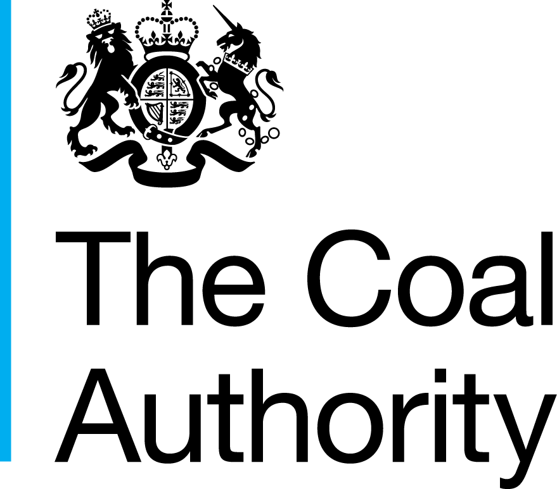
Resolving the impacts of mining
 |  | Coal Authority  200 Lichfield Lane  Mansfield  Nottinghamshire  NG18 4RG | T 0345 762 6848  T +44(0)1623 637000  www.gov.uk/coalauthority
Reference: CA18/2493

Requirements

Cost Benefit Analysis studies

For

Coal mine water discharges

17th December 2015

Introduction
The Coal Authority have the requirement for the the completion of cost benefit assessments on a number of sites, the detals of which are described within this documentation.

Background
The Coal Authority require 4 cost benefit assessments to be completed by March 31st 2016 in respect of coal mine water discharges.

The assessments are required to determine the benefits for implementing mine water treatment schemes for coal discharge sites. The assessments will be undertaken using the Coal Authority’s methodology for cost benefits assessments, which is provided in appendix 1. The Coal Authority are currently focusing on the preventative mine water treatment schems. These are sites where mine water currently is not impacting a water course but is believed that there could be an impact in the future.

Sites
The coal mine water discharges required for assessment are:
• Bilston Glen (Scotland),
• Cefn Coed (South Wales),
• Strafford, and
• Hauxley

Requirement
The cost benefit analyses must follow the Authority’s approved methodology provided in appendix 1, to allow for cross comparisons to previous analyses.

The aim of undertaking this task is to determine whether the benefits of developing a mine water treatment scheme (MWTS) to improve the receiving watercourse is significant compared to the cost of treatment.

A site visit, once contact has been awarded, may be required. The sites are not owned by the Coal Authority and public access or land owner permission will need to be arranged prior to any site visit. The Coal Authority will assist with this if required.

Health, safety and environment management including compliance with the Coal Authority guidance for consultancy (attached). This will include preparation of risk assessment and health and safety plan that must be approved by the Coal Authority prior to undertaking any fieldwork.

The Coal Authority can provide scoping studies or relevant reports and data if required.

The scope of the studies are outlined below:

- Project Team and Resources
  - An economist that has undertaken cost benefit analyses before is required.
  - The project team proposed to undertake this research study must be suitably qualified and able to demonstrate experience of similar projects. Note that the project team should not be changed from that proposed in your quotation during the project without the express written permission of the Coal Authority.

- Preparation of reports
- Draft report – submitted 3 weeks before the project end date to allow for review and comments
- Final report – to be submitted 1 week after comments have been issued by the Authority to the Consultant.
- All of the assessments need to be fully completed and invoiced by 31st March 2016 for the assessments. Where this is not feasible please provide dates for the earliest completion.

- Project management
- Start-up meeting (telephone meeting is preferred) this will be to clarify and confirm the delivereables. Identification of further information which can be shared.
- Health, safety and environment management including compliance with the Coal Authority guidance for consultancy (attached). This will include preparation of risk assessment and health and safelty plan that must be approved by the Coal Authority prior to undertaking any fieldwork
- A project plan must be submitted as part of the tender submission to include timings of when works are to be undertaken and this will be agreed at the start up meeting for the delivery of the Services.

The assessments must be completed and the final report submitted no later than 31st March 2016 for the coal project, however, should this not be achievable the Consultant is required to provide details of the plan that it can deliver to.

Coal Site Information

Bilston Glen
Bilston Glen is a preventative site located in Dalkeith Scotland, National Grid Reference (NGR) NT 336 671 (Figure 1). This preventative site is not currently discharging mine water. The Bilston Glen mine water discharge is currently recovering and is predicted to reach the surface in 2020. The mine water from the Bilston Glen workings once fully recovered will discharge to the River South Esk via the Old Fordell Junkies Day Level. There is already a mine water discharge from the Old Fordell Level, impacting 0.1 km of watercourse. It is predicted that the proposed mine water discharge from Bilston Glen will add to the current discharge.

Treatment options are being considered, a minimum of 2 scenarios will be required for this assessment. More details will be provided upon award of tender.

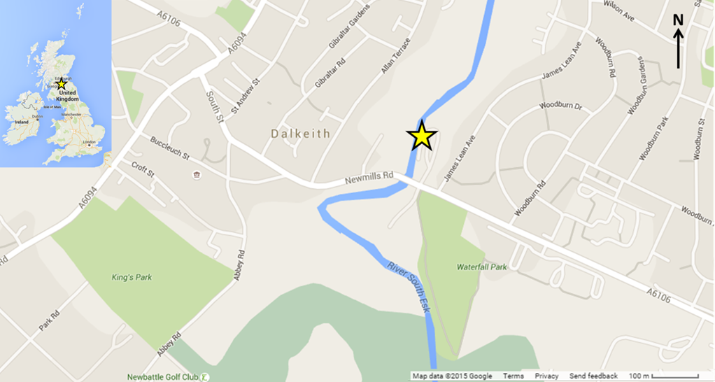
Figure 1. Bilston Glen/Old Fordell location plan

Cefn Coed
Cefn Coed is a preventative site located near Crynant, South Wales, NGR SN 785 032 (Figure 2). Water began to outbreak intermittently on site during 2011 and has been progressively worsening. Currently the mine water does not reach the water course but it is predicted to discharge to the Afon Dulais. The mine water is being discharged from a surface inset to a shaft with a current intermittent maximum flow rate of 15 L/s (although this is expected to increase and become continuous) and iron concentrations of around 15 mg/l.

Treatment options are being considered, a minimum of 3 scenarios will be required for this assesment. More details will be provided upon award of tender.
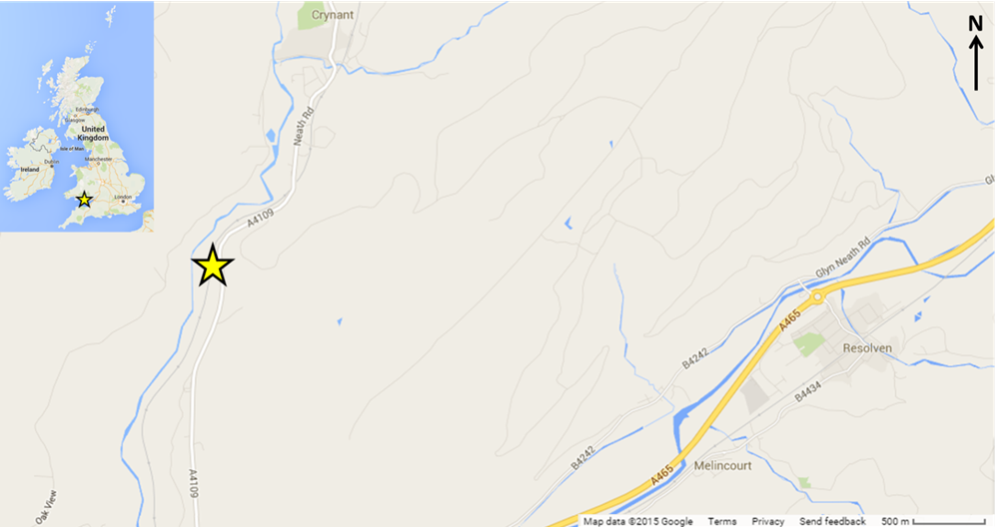
Figure 2. Cefn Coed location plan

Strafford
Strafford MWTS is located near Dodworth, South Yorkshire, England NGR SE 319 040 (Figure 3). Phase one of the scheme is designed to treat a flow of 20 L/s and an average iron concentration of 7.25 mg/l. A phase 2 for the scheme is proposed to increase the flow rate to 60 L/s with iron concentrations remaining the same.
The original scheme was impleneted to prevent mine water discharging to the Stainbrough Dike. It is propsed that Phase 2 of the scheme will allow grater control of the mine water across a larger area of the coalfield.

Treatment options are being considered and more details will be provided upon award of tender.

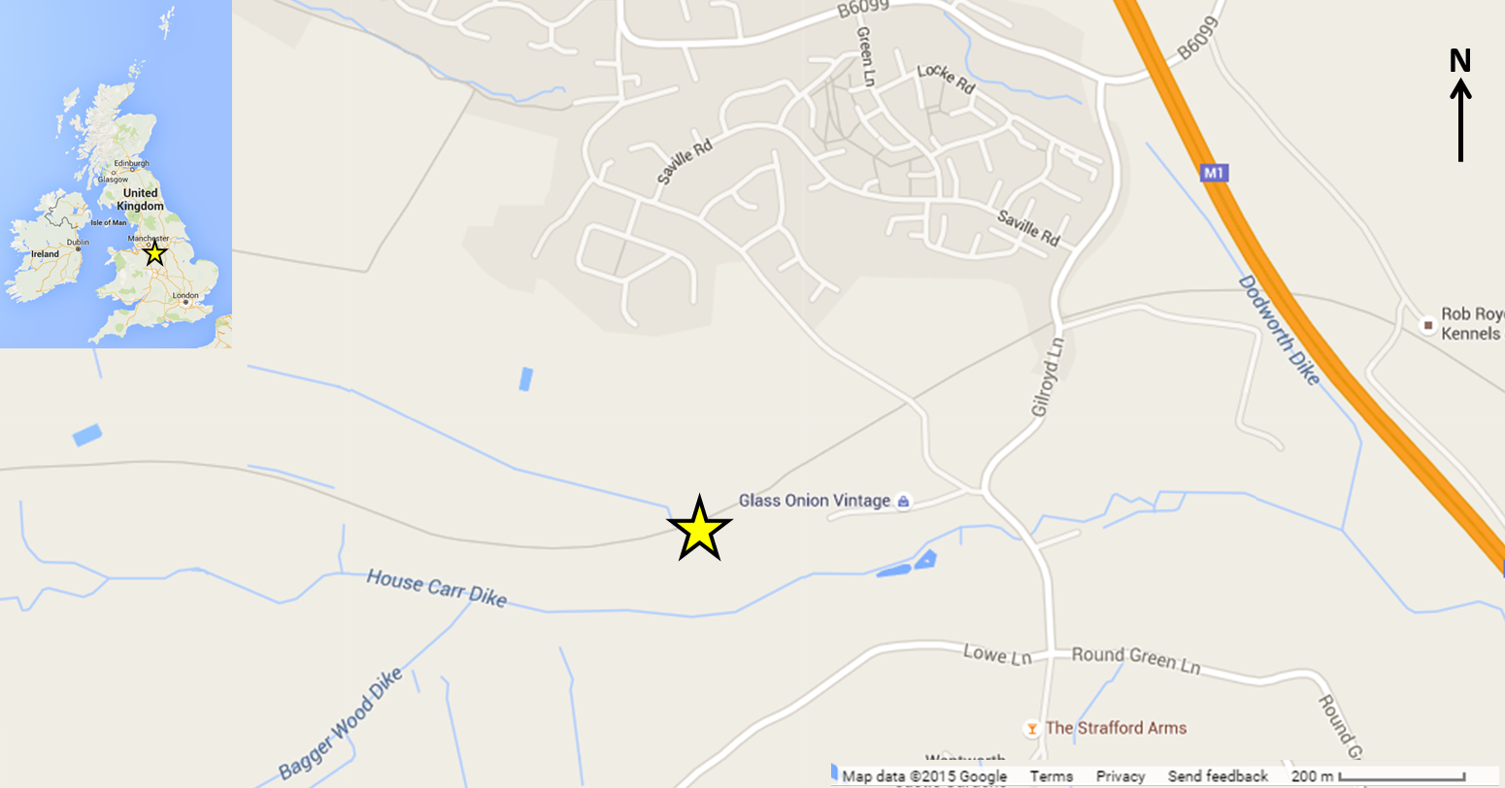
Figure 3. Strafford MWTS location plan.

Hauxley
Hauxley is a preventative site, the Hauxley coalfield is centered around the village of Broomhill, Northumbria, England NGR NU 250 000 (Figure 4). The area has been undergoing mine water rebound since pumping ceased in 2007. The mine water is expected to reach surface level during summer 2016.

Treatment options are being considered, a minimum of 3 scenarios will be required for this assessment. More details will be provided upon award of tender.
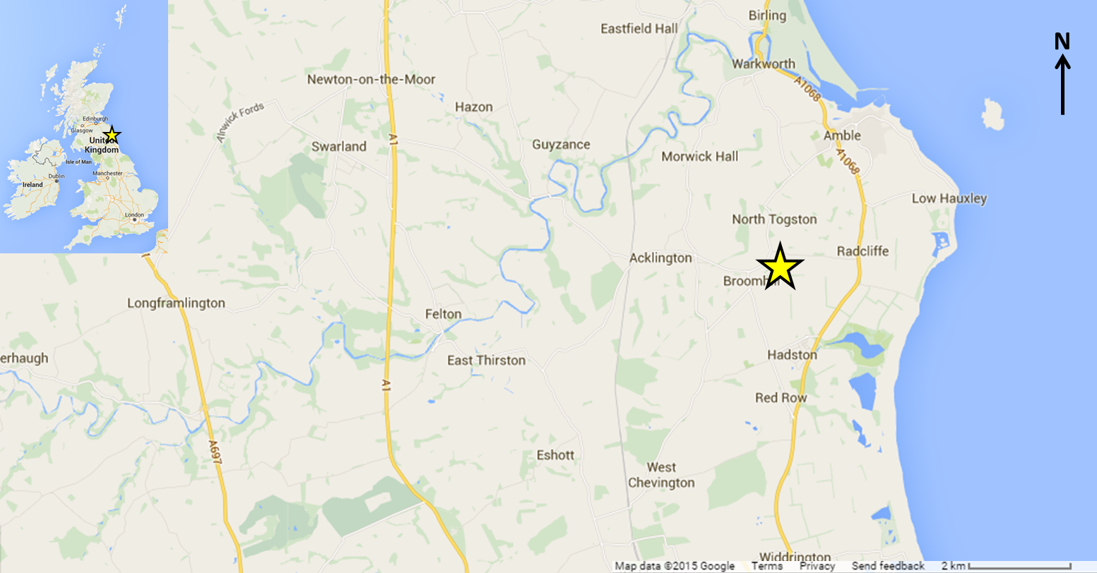
Figure 4. Hauxley location plan

