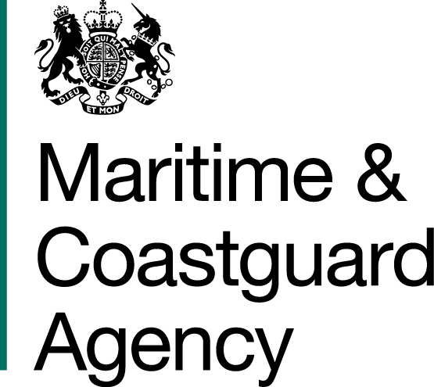 |  |  | Bay 3/21  Spring Place  105 Commercial Road  Southampton  SO15 1EG
 | To whom it may  Concern, |  | Tel:  E-mail: | +44 (0)20 381 72173  contracts@mcga.gov.uk
 |  |  | Your ref:  Our ref: |  | TCA 3/7/1065
First issued 21st September 2018
Last reviewed 25th September 2018
Dear Sirs

QUESTIONS AND ANSWERS - A STUDY TO REVIEW THE RISKS PRESENTED BY, AND TO, SHIPPING WITHIN THE UNITED KINGDOM EXCLUSIVE ECONOMIC ZONE (UK EEZ) AND TO ASSESS THE AVAILABILITY AND ADEQUACY OF EMERGENCY TOWAGE ARRANGEMENTS.

We have received questions for the above-mentioned tender, and to ensure that all tenderers have access to the same information, we have copied the questions and our answers to you:

Question 1

We note that the format of the response should be two physical copies and a digital copy on a USB 3.0 flash drive or equivalent. To ensure confidentiality is maintained it is standard practice to protect digital information with a password. Can this password be transmitted to the recipient via email? Is so, where should it be sent?

Response

The email address for all correspondence regarding this tender should be submitted to Contracts@mcga.gov.uk

Question 2

Can the authority advise whether the Technical and Commercial volumes of the proposal have to be separate documents or can they be combined?

Response

Technical and Commercial proposals can be supplied (and will be accepted) as either a combined or as separate documents. Presentation is left to the discretion of the supplier.

Question 3

Given the statements regarding the requirement to sign the Official Secrets Act, will a Security Aspects letter be issued?

Response

There is not a need to sign the Official Secrets Act for this requirement. MCA may request a supplier to sign a Non-Disclosure Agreement.

Question 4

Are there any limits for the word count or page count of the submitted response?

Response
There is no word or page limit for submitted responses.

Question 5

The MCA has identified the types of vessels that should be considered for study into towage provision (e.g. AHT’s, AHTS’s, OSRV’s and ERRV’s). Are there any limitations on Flag State; should we be investigating only those vessels that fly the UK flag?

Response

In terms of the current commercial availability of emergency towage, the study should not be restricted to UK flagged vessels.

Any future procurement activity for UK Government emergency towage provision may require the proposed vessel(s) of the successful tenderer(s) be re-flagged to the UK flag, if they are not already UK flagged.

Question 5

Would the MCA support, and therefore accelerate, the sourcing of data from MAIB on accidents that “include mechanical failure leading to a vessel being not under command, collisions between ships or offshore objects, loss of cargo, sinkings, listings, groundings and fires/explosions” in UK waters for the time period in question of 2013 to 2017?"

Response

MAIB have confirmed that they can provide this data.

Question 6

We understand that a significant amount of AIS data will be required, which could increase the costs of the project as a result. Will the MCA allow access to, or will it be able to transmit to the successful bidder data such as AIS data for the relevant shipping areas of global fleet data?

Response

The MCA will be able to provide AIS data pertinent to the study. Its format and detail will be discussed at the kick-off meeting after selection of the successful consultant

Question 7

Can you can confirm whether the MCA hold data on ship types which can be linked to the vessel’s unique MMSI number, or whether the MCA hold a licence with a commercial provider which allows them to share that data with their contractors?”

Response

The MCA has access to data through its AIS data contractor. This data can be shared however, the scope of the data needed will be discussed at the kick-off meeting after selection of the successful consultant

Question 8

Clause A1- Please could you circulate a copy of the “Staff Vetting Procedures”.

Response

Please see attached link - https://www.gov.uk/guidance/security-vetting-and-clearance

Question 9

Clauses E6.2 - Please could you circulate a copy of the “Authority’s Security Policy”.

Response

Please see attached link - https://www.gov.uk/government/publications/security-policy-for-contractors-consultants-and-suppliers

Question 10

Clauses E 7.2 and E 7.11 - It is feasible that the Contractor’s reports will include the Contractor’s pre-existing IP. E7.11 suggests that such pre-existing Intellectual Property would remain vested in the Contractor and a licence would be granted to the Authority.
Are we therefore correct in interpreting E7.2 as applying to new Intellectual Property Rights only?

Response

Correct

Question 11

Clause F1.3 - If the Authority request copies of sub-contracts, would these be priced or un-priced?

Response

Please provide priced copies

Question 12

Clause F1.8 Is a transfer of rights or obligations of all or part of the Contract likely for this opportunity? Can you clarify what options are available to the Contractor if the transfer of rights and obligations is to a private sector body which is against the commercial interests of the Contractor?

For example, would you consider qualifying F 1.8 (c ) as being subject to the prior written consent of the Contractor (not to be unreasonably withheld or delayed)?

Response

Yes, MCA is not looking to deviate away from the overarching principles of the standard terms but will mutually agree amendments to the terms. Proposed amendments should be marked up on your tender submission and clearly identified.

Question 13

Clause G1.2 - The indemnity includes losses caused indirectly as well as those caused directly by any act or omission of the Contractor. This increases the Contractor’s risk significantly beyond the common law position.

Can you clarify if you could consider the deletion of “indirectly”?

Response

Yes, MCA is not looking to deviate away from the overarching principles of the standard terms but will mutually agree amendments to the terms. Proposed amendments should be marked up on your tender submission and clearly identified.

Question 14

Clause G1.2 - Ignoring the uncapped liabilities in G1.1, we note that with the exception of those liabilities that would fall under the limit in G1.4 (Defaults), the indemnity in G1.2 is uncapped.

Can you clarify if you would consider (a) capping the indemnity (subject always to G1.1); and (b) introducing an obligation on the Authority to take “all reasonable steps to mitigate its losses”?

Response

MCA is not looking to deviate away from the overarching principles of the standard terms but will mutually agree amendments to the terms. Proposed amendments should be marked up on your tender submission and clearly identified.

Question 15

Clause G1.4 - Can you clarify the anticipated “unless otherwise agreed” figure in (a) and (b) noting the relatively modest contract value?

Response

MCA is not looking to deviate away from the overarching principles of the standard terms but will mutually agree amendments to the terms. Proposed amendments should be marked up on your tender submission and clearly identified. Tenderers should propose liability values that are proportionate to the contract value and that do not build in additional cost to the requirement.

Question 16

Clause G2 - Can you clarify if you would consider an insurance limit of £5 million per event AND in the annual aggregate?

Response

Yes, MCA is not looking to deviate away from the overarching principles of the standard terms but will mutually agree amendments to the terms. Proposed amendments should be marked up on your tender submission and clearly identified.

Question 17

Clause G2 - Given that the Contractor is responsible for the acts and omissions of its sub-contractors can you clarify if you would consent to lower PI cover for a subcontractor?

Response

MCA is not looking to deviate away from the overarching principles of the standard terms but will mutually agree amendments to the terms. Proposed amendments should be marked up on your tender submission and clearly identified.

Question 18

Clause H6 - With the exception of Personal Data, could you clarify if you would consider the Contractor retaining (in confidence) one copy in order to demonstrate that he had performed his obligations under the Contract?

Response

MCA would expect suppliers to comply with GDPR requirements and agree to the non disclosure of information to third parties. The expectation is that a supplier would retain a copy in order to demonstrate that he had performed its obligation and to assist with any points of clarity.

Question 19

Please can the Authority advise if, in the case we insert our proposed amendments to the Terms and Conditions within the Commercial section of our Tender, we would still be compliant and therefore able to negotiate those terms later on, should you identify us as your preferred supplier?

Response

Your tender would be compliant but it will be noted that it is qualified. MCA is not looking to deviate away from the overarching principles of the standard terms but will mutually agree amendments to the terms. Proposed amendments should be marked up on your tender submission and clearly identified.

Yours faithfully,

Richard Skeats MCIPS
MCA Procurement Team

