
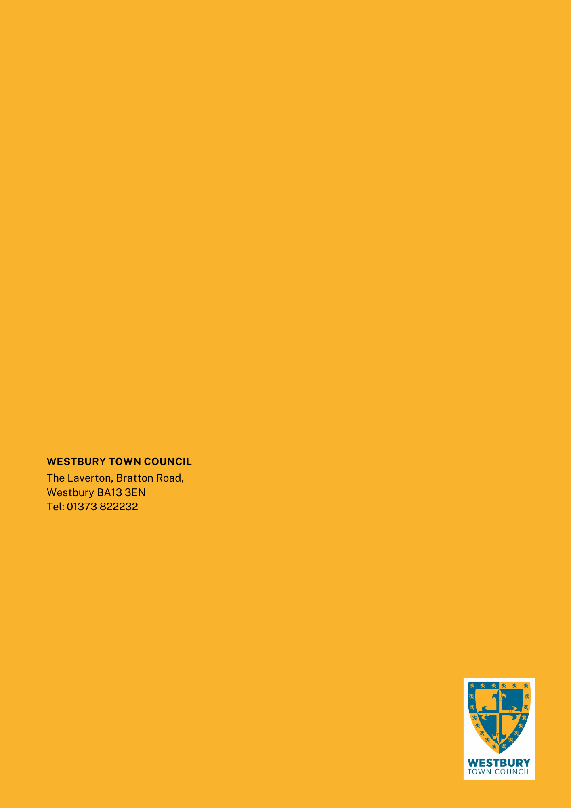


WTC 02 / 2024-25
Date 16/12/2024
Westbury Town Council:
Tender for grounds maintenance and Streetscene contract
METHOD STATEMENT
Westbury Town Council
The Laverton, Bratton Road
Westbury, Wiltshire BA13 3EN
www.westburytowncouncil.gov.uk
info@westburytowncouncil.gov.uk
01373 822232

DOCUMENT 5

Structure of Submission
The table below sets out the Technical Submission criteria and Weighting.

Core Contract
Technical Submission Criteria |  | Tender Weighting
1 | Delivering the Service | 10%
2 | Mobilisation and logistical readiness | 10%
3 | Customer Focus | 20%
4 | Efficiency and savings | 10%
5 | Agility | 5%
6 | Technology | 5%
 | Total | 60%

Delivering the Core Contract
WTC must be confident the standards, reliability and professionalism of your organisation will always meet WTC’s expectations and values. More details about WTC’s vision and priorities can be found www.westburytowncouncil.gov.uk

Please proceed to question 1

Question 1
Describe how your organisation’s methodology for delivering the works and services as set out in WTC’s specification to ensure WTC’s objectives are met.
What additional staff resources will be required to deliver this contract, taking into consideration the TUPE Element?
Please consider the following:
- How your organisation’s structure will ensure high quality in delivering the service.
- How your organisations delivery will promote growth in the Westbury Community
- How your organisation will work in collaboration with WTC and key stakeholders.
- How the culture in your organisation will encourage high standards of performance and pride within your workforce.
- How the investment in staff (training & development) will benefit WTC and its community.
- How you will deploy staff and resources to improve efficiencies when delivering the service.
Bidder Response- Max 1000 words

Question 2
Describe how your organisation will be ready to deliver the full requirements of the contract on the commencement date.
Please consider the following:
- Plant and machinery
- Supplies and provisions
- Staff rotas and team management
- Storage and compounds
- Technology.
Bidder Response Max 1000 words

Question 3
Describe how your organisation will promote a customer focused approach.
Please consider the following:
- How you will manage clear and effective communications with WTC
- How you will manage clear and effective communication with the Westbury community (public, local businesses and organisations).
- How you will enhance and improve the community’s perception of the service
- How will you ensure your workforce demonstrates the behaviours expected by WTC when working in the community. Especially in a sensitive environment, such as a cemetery.
- How will you manage communications and complaints from the community arising from your service.
  - How will you bring this to a successful outcome (give an example)

Please note the town council may seek feedback and customer reviews from a number of local customers – please provide details.
Bidder Response Max 2000 words

Customer Name | Location & Service delivered | Contact Number

Question 4
Describe how your organisation will identify and deliver efficiencies and savings within the contract.
Please consider the following:
- Your system for managing resource availability.
- How you identify continuous and consistent service improvement
- Example of where you have achieved service improvement. What financial or other benefits have been realised (please provide contact details).
Bidder Response Max 1000 words

Question 5
Describe how your organisation will develop and adjust to meet the challenges during the contract life.
Please consider the following:
- How your organisation will manage any changes in the specification of the contract. For example, additional or removal of land resulting from Wiltshire Council Policy (new development).
- How your organisation preserves business continuity.
- How your organisation prepares for government or legislative police. For example, inflation, employment or other impacts on your industry.
Bidder Response Max 1000 words

Question 6
Describe how your organisation will identify and incorporate technology that will support service delivery and provide an example where you have improved outcomes with the use of new technology.
Please consider the following:
- How your organisation will help to develop or seek out new technology including Artificial Intelligence (AI) and equipment to improve the service delivery.
- How you will engage the Client in testing or developing new technology that may be of use to WTC
- How your organisation will integrate WTC’s systems such as Abavus.
Bidder Response- Max 1000 words

