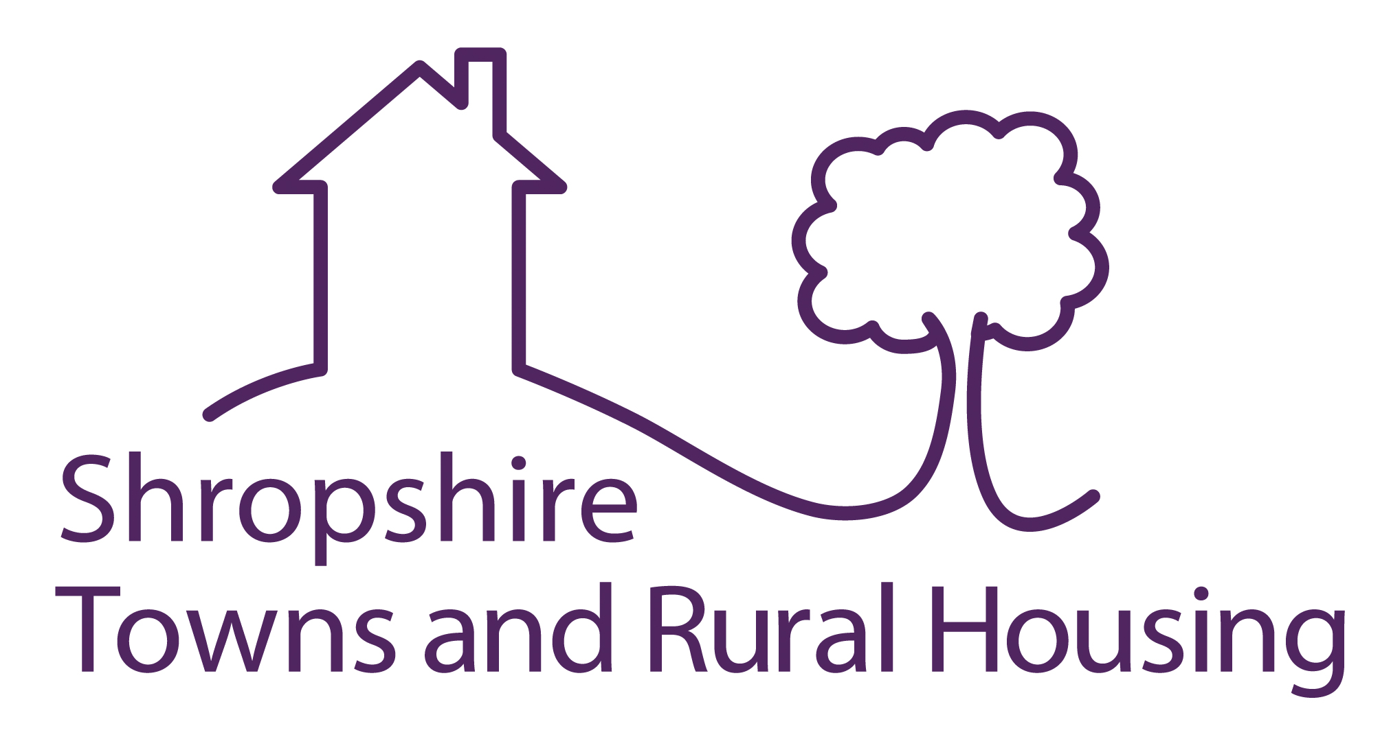

Expression of Interest to Tender for Kitchen & Bathroom Replacement Works

Applicants are invited to express an interest in tendering for Kitchen and Bathroom replacement works to Shropshire Council owned properties in the North and West of Shropshire for an initial period of three years, with the potential to extend for a further year, commencing in April 2020.

Shropshire Towns and Rural Housing manage a stock of approx. 4100 dwellings for Shropshire Council. Properties are tenanted, sheltered and supported housing stock throughout the rural towns and villages in and around Bridgnorth and Oswestry.

This contract will comprise kitchen & bathroom replacements. Works will include:

- Kitchens designed by a named supplier (which will be managed by the successful kitchen appointed contractor)
- Bathrooms designed and installed by the appointed contractor
- All associated builders work, including plastering etc
- Electrical and plumbing installations
- Replacement anti-slip vinyl flooring
- Tiling and decoration works
- The management and calling off of asbestos removal orders to suit the .programme

There may be an option for the contract to be split into the Oswestry and Bridgnorth areas and accordingly applicants should state their preference if this option appeals. There are equal numbers of properties in each area.

This will be a single stage tender process. Following the closing date of the Expression of Interest, Tender packs will be sent to contractors which will include a Pre- Qualification Questionaire and Specification / Schedule of Rates. We will utilise the JCT Measured Term Contract with the successful tender to achieve the initial 3 +1 year period of works to an estimated value up to £850,000 per annum.

If you wish to express your interest please apply for a Tender pack by email to:
Steve Gray MRICS, Procurement and Contracts Officer steve.gray@starhousing.org.uk
Quoting the reference SG.2019 – K&BR or in writing to the above at:
Shropshire Towns and Rural Housing. The Spruce Building. Sitka Drive. Shrewsbury Business Park. Shrewsbury. SY2 6LG.

The deadline for expressions of interest to be received at Shropshire Towns and Rural Housing office is Thursday 12th December 2019

