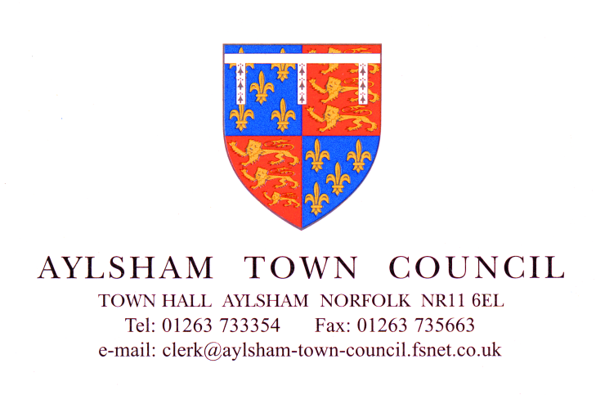

**Invitation to Tender**

**To Undertake Kitchen Refurbishment**

**at Aylsham Town Hall, Aylsham Market Place, NR11 6EL**

**Introduction:**

Aylsham Town Council is the owner and manager of Aylsham Town Hall, a Grade II listed building situated in the Market Place of the historical Norfolk town of Aylsham. Since it was built in the 1850’s it has had numerous uses but for several years now it has provided a venue for meetings in the centre of town. The hall consists of three floors, storage cellars in the basement, Town Council offices on the first floor and a large meeting hall with associated facilities on the ground floor.

Aylsham is a growing town and the call on the usage of the Town Hall is growing with it. To enable the Town Council to maximise the use of the Town Hall for a variety of functions upgrading work is needed to the existing kitchens.

**Requirements**

The Town Hall kitchen is used for a variety of functions from teas and coffees to full sit-down meals for 150 covers. The existing equipment is not suitable for the larger uses and is very close to not meeting hygiene and safety standards.

The Town Council have agreed that the kitchen needs replacing to bring it up to a commercial standard and are inviting tenders for the following work.

**Preparation**

To remove and dispose of:

Existing flooring and Wall covering

LEC Under counter Fridge

Blue Seal Commercial 6 Burner Oven

Gas Hot Cupboards

Existing storage Cupboards

**Building Work**

To create servery area where hot cupboards are removed

To supply and lay altro flooring

To supply and install wall cladding

To ensure electric and gas connections are to standard

To install extraction system for cooking area

To supply and replace existing lighting

All building work carried out must meet food safety regulations.

**Equipment**

To supply and install:

Stainless steel Tableting including sink

Lincat Opus 800 Induction Hob

Pedestal for above

Lincat EC09 electric oven

Stand for Above

Grill electric

wall brackets for above

Lincat Hot cupboard

Gantry for above

Microwave

Upright Fridge

Under counter Freezer

Silverlink top 600m

Silverlink Cupboard

Stainless Steel Shelving

**Finishing**

To ensure the kitchen is completed for use at the end of the works

To visit the site please contact Natasha Carver 01263 733354 or email [info@aylsham-tc.gov.uk](mailto:info@aylsham-tc.gov.uk) to make an appointment

The Town Hall is very well used and not all dates will be available. Once dates have been set they must be adhered to.

All work must be completed no later than 31st May 2018.

An indication as to the duration of the work and anticipated commencement date is required

**Closing date for tenders 5pm Wednesday 8th November 2017**