JAMES VICKERS – SENIOR CONTRACTS MANAGER
Telephone Number: 07385 460030
Email: james.vickers@swyt.nhs.uk

Supply of Online Surveys

Supplier name and address: |  | Address of Trust Headquarters: -  Fieldhead Hospital  Ouchthorpe Lane  Wakefield West Yorkshire  WF1 3SP
Supplier name and address: |  | Authorised signature:  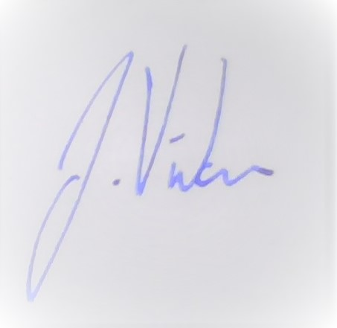

 | Date:  07/11/2024 | Quotation Number:  Q2835
REQUEST FOR QUOTATION  MUST BE STRICTLY RETURNED VIA UPLOAD TO THE SWYPFT IN-TEND SUPPLIER PORTAL  FAILURE TO DO SO WILL RESULT IN YOUR QUOTATION SUBMISSION BEING DISQUALIFIED | Date:  07/11/2024 | Quotation Number:  Q2835
 | Buyer Name:  James Vickers | Buyer Contact Details:  James.vickers@swyt.nhs.uk

THIS IS NOT AN ORDER

INSTRUCTIONS:

1. NHS Conditions of Contract will apply – copies are available on request

2. Please return Quotations via upload to the In-tend portal by:
12:00 Noon on 14 November 2024

3. Quotations other than on this form will not receive consideration.

4. The South West Yorkshire Partnership NHS Foundation Trust recognises the importance of good corporate citizenship and maintaining high standards of social, ethical and environmental conduct.
We are also committed to ensuring that our suppliers and contractors throughout the supply chain adopt a similar approach and have developed a supplier code of conduct to which we expect all our suppliers to adhere which is embedded below: -

Therefore, as part of their bid suppliers are requested and encouraged to provide details of their company’s involvement in this initiative or demonstrate where possible a range of more sustainable procurement options.

5. WE HEREBY OFFER TO SUPPLY GOODS/SERVICES AT THE PRICES STATED ON THIS AND ANY
ATTACHED FORMS IN ACCORDANCE WITH NHS CONDITIONS OF CONTRACT.

Areas highlighted in yellow require information

Company Name: | Company Address:
Signed: | Position:
Date: | Position:
Contact Information:

Telephone:
Fax:
Mobile:
Email address:

Website address:
Prices quoted on this quotation remain fixed for: days/weeks from the date of signature
6. Specification of Requirements

The Trust is looking to receive quotations for a service based against the accompanying specification.

Please detail all requirements with relevant cost element below.

Product Code | Qty Required | Item Description | Item Price | Total Price | Total Price  Inc VAT
 |  |  | £  £  £  £  £ | £  £  £  £  £ | £  £  £  £  £

- Discounts

Discounts | % Discount
Please state any additional discount offered for early or prompt payment within the stated number of days of the date of delivery or the submission of an invoice whichever is the later.  Net 7 Days  Net 14 Days  Net 21 Days  Net 30 Days  Please list any other discounts that are available against the service provision that you are proposing. | %  %  %  %  %

- Payment Terms & Schedules

Payment Profile
It is the intention of the Trust to make payment following full delivery of the required goods. Please acknowledge your acceptance of this condition.  If you have answered No to the above please provide below an indication of your preferred payment options/schedule which may be considered. | Yes/No  (Please delete as appropriate)

- Further Information

Please Provide any Further Information relevant to your offer in the section below

