1. Procurement specification

Supplier notice
Please note that responses need to be submitted electronically through the BRAVO Solution E Tendering Portal. All communications must be via the message board for this ITT. It is not appropriate to contact any of the Project Team directly with queries about this ITT. This will ensure a clear audit trail and a consistent approach to enquires and information clarity. Please be aware that questions and responses may be shared with all bidders in this process.
Reference | ITT 30239
Title | To manage the Adoption Support Fund (ASF) (to be the ‘fund manager’)
Procurement lead
Contract manager

2. Introduction/Requirement background

- Adoption support services play a vital role in supporting adoptive families to meet the needs of their adoptive children. Over 70% of children adopted enter care due to abuse or neglect. Many adopted children have specific needs or disabilities, which require additional support.
- While recent research has shown that only around 3% of adoptions disrupt, a quarter of parents report major challenges, and a further third describe life as generally good with some challenge.
- Adopted children are also less likely than their non-adopted peers to reach expected educational attainment levels. Around half of adopted children (self-declared) reached expected levels at Key Stage 2, compared with three-quarters of non-adopted children.
- The Adoption and Children Act (2002) places a duty on local authorities to maintain an appropriate service for adoption support. The Adoption Support Services Regulations (2005) require authorities to assess adoption support needs when requested by an adoptive child, their parents, natural parents and former guardians. The provision of support to meet these needs is at the discretion of the local authority, taking into account the individual case and local resources.
- Despite the increase in funding to local authorities through the ASF, we are aware that there still remain challenges around adoption support services e.g. parental awareness of entitlement to an assessment of their adoption support needs; the timeliness and quality of adoption support assessments; an underdeveloped evidence base on the effectiveness of specialist therapeutic interventions and availability and quality of services across the country.

- The ASF is part of the government’s reforms to adoption. Further information on which can be found here: https://www.gov.uk/government/publications/further-action-on-adoption-finding-more-loving-homes.

- The Fund was successfully trialled in ten prototype local authorities in England in 2014-15 and rolled out across England on 1 May 2015. The Fund provides therapeutic support to:
- improve relationships with friends, family members, teachers and school staff
- improve engagement with learning
- improve emotional regulation and behaviour management
- improve confidence and ability to enjoy a positive family life and social relationships

- In April 2016, the scope of the Fund was extended to children, living in England, who were previously in care (LAC) immediately prior to being cared for under a Special Guardianship Order (SGO) and children living in England and were adopted from countries other than England (known as overseas and inter-country adoptions).

- Support from the Fund is available pre and post the Adoption Order (from the point the child is placed with the adoptive parents), and can be used to purchase services from the private and voluntary sectors as well as local authorities and NHS mental health services.

- The diagram below sets out the process for accessing the Adoption Support Fund. To access the ASF, the responsible local authority must have conducted an assessment of the adoptive/eligible special guardian family’s support needs. The local authority is required by law to conduct one. If the assessment identifies that therapeutic services would be beneficial to the family, the local authority, in discussion with the family, can apply to the ASF on the family’s behalf. The contractor managing the ASF will assess the application against published scope and criteria. Where necessary, clarification may be sought from the local authority. Incomplete applications or applications containing identifiable information e.g. child’s name are returned. Satisfactory applications under the fair access limits (£5k for therapy and £2.5k for specialist assessment) are expected be approved by the contractor within 5 working days and funding will be released to the local authority to commission the approved support services. Applications above the fair access limits or if over £20k in total will be initially assessed by the contractor and sent to the Department for approval.

- Diagram A. ASF High Level Process

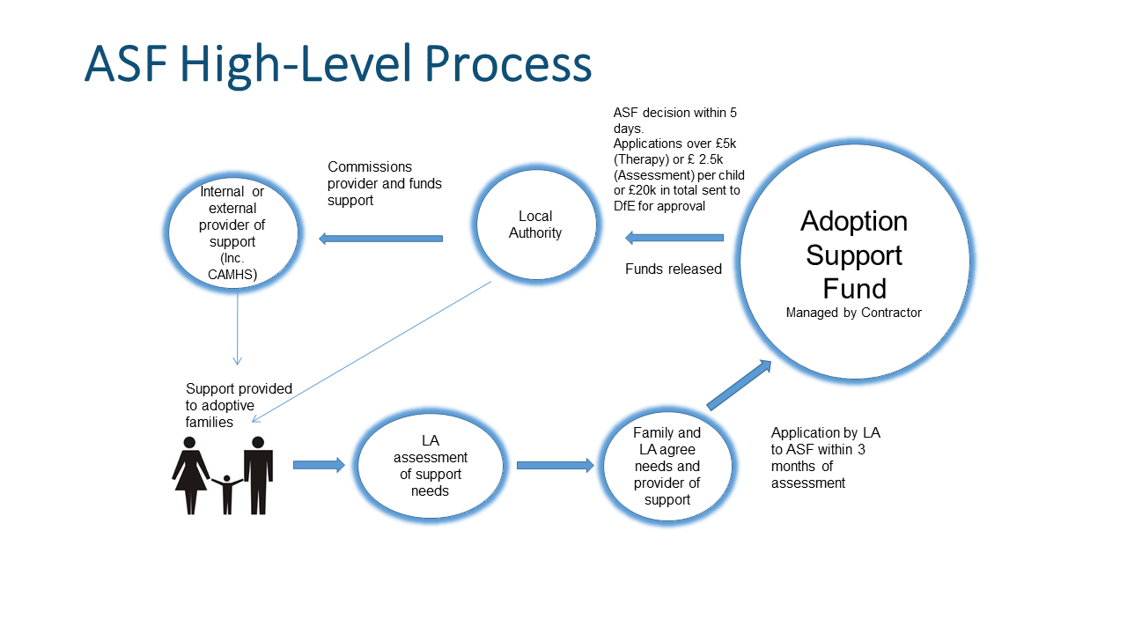

- The diagram below provides a detailed process map for the application process.

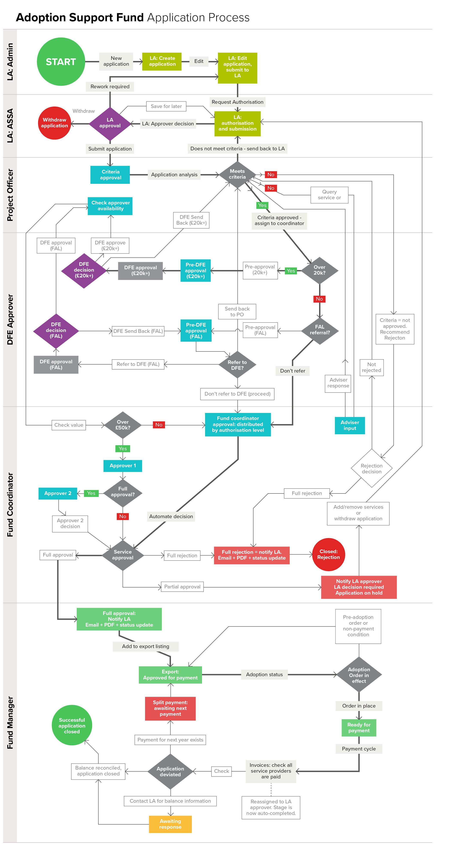

- In 2015-16, the Adoption Support Fund totalled £19m. For 2016-17, the budget was increased to over £23m. For 2017-18 the budget is £28m. Further increases are planned for the next two financial years (2018-20).

- On 6 October 2016, due to budgetary pressures, we introduced a Fair Access Limit (FAL) of £5k per child, per year and a matched funding approach whereby local authorities were asked to match fund costs above the £5k annual limit. For the financial year, 2017-18, we introduced a new, separate, £2.5k FAL for specialist assessments in addition to the existing £5k FAL for therapy. The match funding approach applies to both FALs. We are currently consulting on the fair access limits for 2018-19 and 2019-20.

- We published an evaluation of the Fund in August 2017, which showed that parents believe access to the Fund has improved their lives, including through improved child behaviour and mental health. A copy of the evaluation is available here www.gov.uk/government/publications/adoption-support-fund-evaluation. A further evaluation, building on this evaluation, is currently being commissioned.

- We are delivering new adoption service models through Regional Adoption Agencies that see local authorities and voluntary adoption agencies working together to deliver excellent adoption services everywhere, with a strong focus on innovation and practice. The first four regional adoption agencies have gone live. We are working towards all local authorities being part of a regional adoption agency by 2020. We are supporting three regional adoption agency pilots, who are testing the implementation of the Fund at a regional level and three regional adoption agency adoption support centres of excellence , which will bring together social care, health and education experts to provide a co-ordinated assessment and support offer for families. The ASF regionalisation pilots are Adoption Counts, Adopt South West and One Adoption. Each of the pilots will be exploring areas such as the integration of ASF as part of the wider adoption support offer available to all adopted families; modelling regional approaches to commissioning of adoption support services; regional decision making of adoption support funding.

- As at the end of September 2017, the ASF had provided over £57m towards supporting 20,000 families across all local authority areas. The ASF fund manager processes around 200 applications, totalling on average £500k, per week.

- The current contract to deliver the ASF expires at the end of March 2018. We wish to procure a delivery partner to manage the ASF for two years (from 1 April 2018 to 31 March 2020), with the option to extend for a further two year’s subject to Spending Review decisions about the future of the Fund beyond 2020.

- The delivery partner’s role will be to:
- set up and manage a digital platform to process up to 10,000 applications per year including a successful transition from the current platform;
- provide ongoing helpline support and other relevant guidance on making applications to the Fund to local authorities/regional adoption agencies;
- assess and approve up to 10,000 applications a year according to published scope and criteria;
- refer applications above the fair access limits to the Department for approval;
- manage payments to local authorities and funds returned by local authorities;
- respond to complaints;
- develop and implement ideas to make best use of the learning from the take up of ASF to date;
- provide detailed management information to the Department on a weekly, monthly, annual and ad-hoc basis;
- provide targeted support to local authorities and regional adoption agencies on a range of policy areas including developing the provider market and piloting the regionalisation of the ASF;
- work effectively with any contractor appointed to carry out the evaluation of the implementation of the Fund; and
- ensure there is a smooth transition or closure at the end of the contract.

3. Mandatory requirements

- The successful bidder must demonstrate the following mandatory requirements:

- the skills to run an efficient national fund processing up to 10,000 applications per year through a simple, secure and efficient digital system;
- a clear understanding of the purpose of the Fund;
- excellent stakeholder management skills to support local authorities/regional adoption agencies to access the Fund;
- expertise in the development of evidence based policy solutions;
- excellent project management expertise including project planning, project implementation, project review, risk management; and
- the ability to provide value for money solutions.

4. Detailed requirements (THE SERVICES)

- Purpose

To manage the Department’s Adoption Support Fund (www.adoptionsupportfund.co.uk)

- Scope

- develop the online application portal for the processing of applications from local authorities/regional adoption agencies in line with government departmental IT standards (see Technical Specification Annex 4) and the terms and conditions of the Fund: (www.adoptionsupportfund.co.uk/Portals/0/Adoption%20Support%20Fund%20Terms%20and%20Conditions%20of%20Funding.pdf?ver=2017-03-08-154522-847 ). The applicant journey is detailed in paras 10-12 above.
- provide ongoing helpline support and other relevant guidance on making applications to the Fund to local authorities/regional adoption agencies;
- assess and approve up to 10,000 applications a year according to published scope and criteria (www.adoptionsupportfund.co.uk/Portals/0/Service%20Categorisation%20Guidance_22%20April%202016_V2.pdf );
- refer applications above the Fair Access Limits (currently £5k for therapy and £2.5k for specialist assessments per child per financial year) to the Department for approval;
- manage payments to local authorities/regional adoption agencies for successful applications including facilitating the return of unspent funds;
- respond to and manage complaints;
- develop and support the implementation of ideas to make best use of the learning from the take up of ASF to date;
- provide detailed management information to the Department on a weekly, monthly, annual and ad-hoc basis;
- provide targeted support to local authorities and regional adoption agencies on a range of policy areas including developing the provider market and piloting the regionalisation of the ASF;
- work effectively with any contractor appointed to carry out the evaluation of the implementation of the Fund; and
- ensure there is a smooth transition or closure at the end of the contract.

- Volume of work

3.1 Since the introduction of the Fund in May 2015, application rates have increased significantly. A comparison of annual trends shows that there were 1185 approved applications between May and September 2015 (Fund commenced in May 2015); 3333 approved applications between April to September 2016 and 4558 approved applications April to September 2017.

3.2 We expect volumes to continue to increase over the next two years and envisage the portal handling up to 10,000 applications per year. Monthly rates are likely to be constant during the year with minor dips in school holiday periods.

3.3 We expect there to be helpline support to all local authorities/regional adoption agencies during weekdays from 09:00-17:00 excluding Bank Holidays. Currently the helpline deals with around 150 calls a week. Around 95% are from local authorities with the remainder from parents or providers.

3.4 Local authorities/ Regional adoption agencies and key Department users will require training in the use of the proposed solution. All training will need to take place prior to the launch of the new service on 1 April 2018 and must lead to confidence in users’ interaction and use of the solution. The training is likely to be a mixture of face-to-face and virtual. It is expected that most of the training will be in group format, with one–to-one training in exceptional circumstances.

3.5 A minimum of 60 days per year to support local authorities/regional adoption agencies with the effective running of the Fund, e.g. developing the provider market across the country, identifying good practice case studies, gaps and trends in provision in particular areas.

3.6 Provision of management data (see Section 4 below and Section 2.6 of the Technical Specification).

3.7 Up to 10 days per month support for the implementation of government policy on the ASF including support for the three regional adoption agencies piloting the regionalisation of the ASF.

4 Management information

4.1 The successful bidder will be required to provide the Department with weekly, monthly, annual reporting on Fund performance. Such data will cover numbers of applications received, processed, costs, spend summary, local and regional variations, numbers of families and children supported.

4.2 The successful bidder will also be expected to respond to ad-hoc requests for information from the Department in relation to support the Department’s work, e.g. ministerial submissions, Freedom of Information requests, parliamentary questions and other ad-hoc requests. We envisage this to equate to around 2-5 additional days a month.

5 Outputs and deliverables

5.1 An online system to process applications and administer payments for up 10,000 applications from local authorities/Regional Adoption Agencies.

5.2. Training of all users in the system i.e. local authorities, Regional Adoption Agencies and Departmental Users.

5.3 Management data reports on the Fund on a weekly, monthly and annual basis. Minimum content to include data on application volumes, spend, numbers of children supported, families supported, historical trends, local authority performance.

5.4. Implementation of agreed plan to deliver support to local authorities/regional adoption agencies to ensure delivery of requirements set out in 3.5 and 3.7 above

- Quality Standards (KPI’s, Service levels etc.)

6.1 Ensure that the Fund is fully distributed in each financial year in line with government accounting rules.

6.2 99% of all applications under the current Fair Access Limits ( £5k for therapy and £2.5k for specialist assessment), correctly completed by local authority/regional adoption agencies, are processed within 5 working days

6.3 All correctly completed applications above the Fair Access Limits are assessed and sent to the Department for approval within 3 working days

6.4 Local authority/regional adoption agency feedback demonstrates high level of satisfaction rates i.e. 98% of authorities rate the service provided as excellent or good.

6.5 All reporting requirements are met within agreed deadlines.

- Quality Assurance measures/processes

7.1 A clear complaints process in place setting out how complaints will be handled, timescales for response, escalation criteria and appeals procedure.

- ASF Independent Evaluation

8.1 In August 2017, we published an independent evaluation of the Fund’s early implementation covering its launch in May 2015 to February 2017 www.gov.uk/government/publications/adoption-support-fund-evaluation. The report covered findings from the baseline survey undertaken at the point families first signed up to the Fund, and a follow up survey 7 months later to capture changes. A third wave of the longitudinal survey to deepen our understanding of the longer term effects of receiving support through the Fund is currently in progress and is expected to report in December 2018. To build on this a further evaluation is being commissioned. This new evaluation will provide an up-to-date assessment of the impact on family and child outcomes, include an assessment of recent changes to the Fund, as well as the changes in the adoption market.

8.2 The ASF Fund manager will be required to ensure that the system records information on applications who have consented to be contacted for research purposes. The successful bidder will be expected to work co-operatively with any appointed evaluation contractor by providing them information such as the contact details of families who have consented to take part in the research; simple reports from the applications data and anonymised records containing any free text data relating to supporting evidence to the application.

8.3 We would estimate this work to equate to a maximum of 10 days per year.

- Financial Details

9.1 As with all government contracts, we expect to see value for money in bidders’ estimate of their costs. Fully costed bids are expected. Bidders must complete the attached cost matrix in full to demonstrate how the costs have been arrived at.

9.2 Bidders are asked to set out separately the number of days, rates and costs for activity above the minimum requirements requested in this specification

10 Transfer of Undertaking (Protection of Employment) Regulations 2006

10.1 The attention of bidders is drawn to the Transfer of Undertakings (Protection of Employment) Regulations 2006 (TUPE). Whilst it is the responsibility of the bidder to consider whether or not TUPE applies in the circumstances of this contract, and to tender accordingly, it is the view of the Department that TUPE may apply as a consequence of any change in the provider of the services under this contract. Based on information provided by the incumbent provider of services, the Department understands that there are currently 8 employees who would potentially be within the scope of TUPE, although the Department makes no representations or warranties as to the accuracy of this information. Anonymised information on these employees is available via BRAVO subject to the completion of a Non-Disclosure Agreement.

- Technical Requirements

11.1 The Department’s technical requirements for this tender are set out in detail in Annex 4. Bidders are asked to complete this Annex in full.

5 Timescales

5.1 The current contract to manage the ASF expires on 31 March 2018. There cannot be a break in continuity of service between the expiry of the current contract and the new contract. There will be a need for a transition period to ensure that the current system transfers to the new system. This will take place from January to March 2018. Collaboration between the existing and new contractor will be required during that time.

5.2 Bidders should provide a separate costed plan setting out how they would manage this transition period. The costed plan should include set up/develop costs for the service prior to 1 April 2018.

5.3 The contract will be for a period covering January 2018 to 31 March 2020, with the possibility of an extension of a further two year’s subject to Spending Review decisions.

6 Security of Data
6.1 The Data Handling clauses for this requirement is set out in Annex 4 – Technical Specifications.

6.2 Bidders are required to complete those sections explaining how they will ensure that departmental or personal data will be protected.

Attachments

The following documents should be read in conjunction with this Requirement:
- READ ME FIRST (RMF) – Instructions and Information on Tendering Procedures
- DOCUMENT 2 – ITT Specification
- DOCUMENT 3 – Evaluation Criteria
- DOCUMENT 4 – Draft Agreement
- Annex 1 – Standard Questionnaire (SQ) Declaration Form
- Annex 2 – Tender Declaration Forms
- Annex 3 – Cost Matrix
- Annex 4 - Departmental Technical Specifications

These can be downloaded via BRAVO from The Supplier attachment section .

Indicative timeline

Prior Information Notice Issued | 22 September 2017
Advert published | 2 November
ITT issued | 2 November
Bidder Event | 9 November
Last day for submission of queries from bidders (5pm) | 21 November
Last day for Department to respond to queries | 27 November
Last day for submission of bids (12pm) | 4 December
Tender evaluation | w/c 4 December
Bidder clarification meetings (if required) | w/c 11 December 2017
Successful bidder notified | January 2018
Standstill period/ Finalisation of contract | December 2017/January 2018
Contract award to carry out transition work | January 2018
Transition planning and implementation | January to March 2018
ASF contractor begins delivery | 1 April 2018

Potential suppliers should be advised that the timescales shown in the requirements documents should be regarded as intended final dates, however, in this case the contract start date may be affected by any final budgetary approvals processes required to complete this project. Any amendments will be clarified and agreed before the intended service start date.

Terms and Conditions

Please see the draft contract (Document 4)

Additional Information

Payment
Payments will be made by BACS transfer following receipt of a valid invoice.
The successful tenderer should provide details of discounts for prompt payment.
VAT
Bidders are required to indicate whether VAT will be charged.
Where the contract price agreed between the Department and contractor is inclusive of any VAT, further amounts will not be paid by the Department should a vatable supply claim be made at any later stage.
Where the overall contract price is exclusive of VAT, the Department will pay any VAT incurred at the prevailing rate (currently 20%). If the VAT rate changes the Department will pay any VAT incurred at the new rate.
It is the responsibility of tenderers to check their VAT position with HMRC before submitting a bid.
Child Sex Abuse
The Internet Watch Foundation (IWF) was established in 1996 by the UK internet industry to provide the UK internet Hotline for public and IT professionals to report potentially illegal online content and to be the 'notice and take-down' body for this content. IWF works in partnership with the online industry, law enforcement, Government, the education sector, charities, international partners and the public to minimise the availability of this content, specifically, child sexual abuse content hosted anywhere in the world.

Access to the IWF URL list is available to ISPs, mobile operators, search providers and filtering companies only. All organisations that require access must sign a licence, which sets out how the data can be used.

It is a contract conditions that the successful supplier must block access to those Uniform Resource Locators (URLs) specified on the IWF’s list.

Queries and Guidance

Queries
Any queries in respect of this Specification should be raised via BRAVO message board.

Guidance

Responses to this Specification need to be submitted electronically through BRAVO by completing evaluation sections and questions. Further guidance on this process can be found by downloading them from BRAVO.

Bidders experiencing technical difficulties should e mail help@bravosolution.co.uk supplying details and screenshots if applicable, BEFORE the closing date for this tender opportunity,

https://www.gov.uk/government/uploads/system/uploads/attachment_data/file/301889/Final_Report_-_3rd_April_2014v2.pdf

