**Technology Services 2 Agreement RM3804**

**Framework Schedule 4 - Annex 1**

**Order Form**

**701551645 - TP 1359 Project MOUNTBATTEN classrooms FY 21/22.**

In this Order Form, capitalised expressions shall have the meanings set out in Call Off Schedule 1 (Definitions), Framework Schedule 1 or the relevant Call Off Schedule in which that capitalised expression appears.

The Supplier shall provide the Services specified in this Order Form to the Customer on and subject to the terms of the Call Off Contract for the duration of the Call Off Period.

This Order Form should be used by Customers ordering Services under the Technology Services 2 Framework Agreement ref. RM3804 in accordance with the provisions of Framework Schedule 5.

The Call Off Terms, referred to throughout this document, are available from the Crown Commercial Service website <http://ccs-agreements.cabinetoffice.gov.uk/contracts/rm3804>

**The Customer must provide a draft Order Form as part of the Further Competition Procedure.**

**Section A**

**General information**

This Order Form is issued in accordance with the provisions of the Technology Services 2 Framework Agreement RM3804.

|  |
| --- |
| **Customer details** |
| **Customer organisation name**  Ministry of Defence |

|  |
| --- |
| **Billing address**  Your organisation’s billing address - please ensure you include a postcode  MP1.1 NCHQ, Leach Bldg, Whale Island, HMS EXCELLENT, Portsmouth. Hants. PO2 8BY |

|  |
| --- |
| **Customer representative name**  The name of your point of contact for this Order  Elizabeth Meatyard |

|  |
| --- |
| **Customer representative contact details**  Email and telephone contact details for the Customer’s representative  Elizabeth.meatyard100@mod.gov.uk |

|  |
| --- |
| **Supplier details** |
| **Supplier name**  The Supplier organisation name, as it appears in the Framework Agreement  Click here to enter text. |

|  |
| --- |
| **Supplier address**  Supplier’s registered address  Click here to enter text. |

|  |
| --- |
| **Supplier representative name**  The name of the Supplier point of contact for this Order  Click here to enter text. |

|  |
| --- |
| **Supplier representative contact details**  Email and telephone contact details of the supplier’s representative  Click here to enter text. |

|  |
| --- |
| **Order reference number or the Supplier’s Catalogue Service Offer Reference Number**  A unique number provided by the supplier at the time of the Further Competition Procedure  Please provide the order reference number, this will be used in management information provided by suppliers to assist CCS with framework management. If a Direct Award, please refer to the Supplier’s Catalogue Service Offer Reference Number  **701551645** |

**Section B**

**Overview of the requirement**

|  |  |  |  |
| --- | --- | --- | --- |
| **Framework Lot under which this Order is being placed**  *Tick one box below as applicable (unless a cross-Lot Further Competition)* | | **Customer project reference**  *Please provide the customer project reference number.* | |
| 1. TECHNOLOGY STRATEGY & SERVICES DESIGN |  | 701551645 |
| 1. TRANSITION & TRANSFORMATION |  | **Call Off Commencement Date** |
| 1. OPERATIONAL SERVICES |  | *The date on which the Call Off Contract is formed – this should be the date of the last signature on Section E of this Order Form*  **14 May 2021** |
| a: End User Services |  |
| b: Operational Management |  |
| c: Technical Management |  |
| d: Application and Data Management |  |
| 1. PROGRAMMES & LARGE PROJECTS |  |
| 1. OFFICIAL |  |  |
| * + - * 1. SECRET (& above) |  |  |

|  |  |  |  |  |  |  |  |  |  |  |  |  |  |  |  |  |  |  |  |  |  |  |
| --- | --- | --- | --- | --- | --- | --- | --- | --- | --- | --- | --- | --- | --- | --- | --- | --- | --- | --- | --- | --- | --- | --- |
| **Call Off Contract Period (Term)**  *A period which does not exceed the maximum durations specified per Lot below:*   |  |  |  |  | | --- | --- | --- | --- | | **Lot** | **Maximum Initial Term – Months (Years)** | **Extension Options – Months (Years)** | **Maximum permissible overall duration – Years (composition)** | | **1** | 24 (2) | - | 2 | | **2** | 36 (3) | - | 3 | | **3** | 60 (5) | - | 5 | | **4** | 60 (5) * | 12 + 12 = 24 (1 + 1 = 2) | 7 (5+1+1) * | | | |
| **\*** *There is a minimum 5 year term for this Lot*  **Call Off Initial Period** Months  **6 weeks** | **Call Off Extension Period (Optional)** Months  **NA** | |
| **Minimum Notice Period for exercise of Termination Without Cause**  (Calendar days) *Insert right (see Call Off Clause 30.7)* | | **30 days** |

|  |
| --- |
| **Additional specific standards or compliance requirements**  *Include any conformance or compliance requirements over and above the Standards (including those listed at paragraph 2.3 of Framework Schedule 2) which the Services must meet.*  *List below if applicable*  **As detailed in Statement of Requirement** |
| **Customer’s ICT and Security Policy**  *Where the Supplier is required to comply with the Customer’s ICT Policy and Security Policy then append to this Order Form as a clearly marked document*  **As detailed in Statement of Requirement** |
| **Security Management Plan**  *Where the Supplier is required to provide the Customer with the Security Management Plan then append to this Order Form as a clearly marked document*  **As detailed in Statement of Requirement** |

**Section C**

**Customer Core Services Requirements**

Please provide details of all Services required including the locations where the Supplier is required to provide the Services Ordered.

|  |
| --- |
| **Services**  *List below or append as a clearly marked document to confirm the Services which the Supplier shall provide to the Customer (which could include the Customer’s requirement and the Supplier’s response to the Further Competition Procedure). If a Direct Award, please append the Supplier’s Catalogue Service Offer.*  **As per Statement of Requirement** |

|  |
| --- |
| **Location/Site(s) for provision of the Services**  **As per Statement of Requirement.** |

|  |  |  |  |
| --- | --- | --- | --- |
| **Additional Clauses** *(see Annex 3 of Framework Schedule 4)*  *This Annex can be found on the RM3804 CCS webpage. The document is titled RM3804 Alternative and additional t&c’s v4.*  *Those Additional Clauses selected below shall be incorporated into this Call Off Contract* | | | |
| **Applicable Call Off Contract Terms**  **Additional Clauses and Schedules** |  | **Optional Clauses**  *Can be selected to apply to any Order* |  |
| *Tick any applicable boxes below* |  | *Tick any applicable boxes below* |  |
| **A: SERVICES – Mandatory**  **The following clauses will automatically apply where Lot 3 services are provided (this includes Lot 4a & 4b where Lot 3 services are included).**  A3: Staff Transfer  A4: Exit Management |  | C: Call Off Guarantee |  |
| D: Relevant Convictions |  |
| E: Security Requirements |  |
| F: Collaboration Agreement  Where required please complete and append to this Order Form as a clearly marked document (see Call Off Schedule F) |  |
| **A: PROJECTS - Optional** |  |
| A1: Testing |  |
| A2: Key Personnel |  | G: Security Measures |  |
| **B: SERVICES - Optional**  *Only applies to Lots 3 and 4a and 4b* |  |
| B1: Business Continuity and Disaster Recovery |  | H: MOD Additional Clauses |  |
| B2: Continuous Improvement & Benchmarking |  | **Alternative Clauses** |  |
| B3: Supplier Equipment |  | *To replace default English & Welsh Law, Crown Body and FOIA subject base Call Off Clauses* |  |
| B4: Maintenance of the ICT Environment |  | *Tick any applicable boxes below* |  |
| B5: Supplier Request for Increase of the Call Off Contract Charges |  | Scots Law  Or |  |
| B6: Indexation |  | Northern Ireland Law |  |
| B7: Additional Performance Monitoring Requirements |  | Non-Crown Bodies |  |
|  |  | Non-FOIA Public Bodies |  |

|  |  |  |  |  |  |  |  |  |  |
| --- | --- | --- | --- | --- | --- | --- | --- | --- | --- |
| **Collaboration Agreement** *(see Call Off Schedule F) This Schedule can be found on the RM3804 CCS webpage. The document is titled RM3804 Collaboration agreement call off schedule F v1.* | | | | | | | | | |
| **Organisations required to collaborate** (Collaboration Suppliers)  Click here to enter text. | An executed Collaboration Agreement shall be delivered from the Supplier to the Customer within the stated number of Working Days from the Call Off Commencement Date *insert right*  **OR** | | | | | | | Click here to enter text. | |
| An executed Collaboration Agreement from the Supplier has been provided to the Customer and is attached to this Order Form.  *tick box (right) and append as a clearly marked complete document* | | | | | | |  | |
| |  |  | | --- | --- | | Licensed Software Where Software owned by a party other than the Customer is used in the delivery of the Services list product details under each relevant heading below | | | Supplier Software  NA. | Third Party Software  NA | | | | | | | | | | |
| **Customer Property** *(see Call Off Clause 21)*  Items licensed by the Customer to the Supplier (including any Customer Software, Customer Assets, Customer System, Customer Background IPR and Customer Data)  *List below if applicable*  NA. | | | | | | | | | |
| **Call Off Contract Charges and Payment Profile** *(see Call Off Schedule 2)*  Include Charges payable by the Customer to the Supplier (including any applicable Milestone Payments and/or discount(s), but excluding VAT) and payment terms/profile including method of payment (e.g. Government Procurement Card (GPC) or BACS)  *List below or append as a clearly marked document. If a Direct Award, please append the Price Card attached to the Supplier’s Catalogue Service Offer.*  **£86,881.82 to be paid on completion of work via CP&F/ Exostar.** | | | | | | | | | |
| **Undisputed Sums Limit (£)**  *Insert right (see Call Off Clause 31.1.1)* | | | | | NA. | | | | |
| **Delay Period Limit (calendar days)**  *Insert right (see Call Off Clause 5.4.1(b)(ii))* | | | | | NA. | | | | |
| **Estimated Year 1 Call Off Contract Charges (£)**  For Call Off Contract Periods of over 12 Months | | | | | **£86,881.82** | | | | |
| **Enhanced Insurance Cover**  Where a specific Call Off Contract requires a higher level of insurance cover than the £1m default in Framework Schedule 14 please specify below | | | | | | | | | |
| Third Party Public Liability Insurance (£) | | | | | **£5m** | | | | |
| Professional Indemnity Insurance (£) | | | | | Click here to enter text. | | | | |
| **Transparency Reports** *(see Call Off Schedule 6)*  *If required by the Customer populate the table below to describe the detail (titles are suggested examples)*   |  |  |  |  | | --- | --- | --- | --- | | **Title** | **Content** | **Format** | **Frequency** | | [Performance] |  |  |  | | [Call Off Contract Charges] |  |  |  | | [Key Sub-Contractors] |  |  |  | | [Technical] |  |  |  | | [Performance management] |  |  |  | | | | | | | | | | |
| **Quality Plans** *(see Call Off Clause 7.2)* | | | | | | | | | |
| Time frame for delivery of draft Quality Plans from the Supplier to the Customer – from the Call Off Commencement Date (Working Days)  *Where applicable* *insert right* | | | | | | | NA | | |
| **Implementation Plan** *(see Call Off Clause 5.1.1)* | | | | | | | | | |
| Time frame for delivery of a draft Implementation Plan from the Supplier to the Customer – from the Call Off Commencement Date (Working Days)  *Where applicable* *insert right. If a Direct Award, please append the Implementation Plan attached to the Supplier’s Catalogue Service Offer.* | | | | | | | NA | | |
| **BCDR** *(see Call Off Schedule B1)*  *This can be found on the CCS RM3804 webpage. The document is titled RM3804 Alternative and additional t&c’s v4.*  An executed BCDR Plan from the Supplier is required prior to entry into the Call Off Contract *tick box (right) and append as a clearly marked complete document*  **OR** | | | | | | | | |  |
| Time frame for delivery of a BCDR Plan from the Supplier to the Customer – from the Call Off Commencement Date (Working Days)  *Where applicable* *insert right* | | | | | | | NA | | |
| Disaster Period (calendar days) | | | | | | | NA | | |
| **GDPR** (see Call Off Clause 23.6)  *Where a specific Call Off Contract requires the inclusion of GDPR data processing provisions, please complete and append Call Off Schedule 7 to this order form. This Schedule can be found in the Call Off Contract on the RM3804 CCS webpage*  ____________________________________________________________________________  **Supplier Equipment** *(see Call Off Clause B3)*  *This can be found on the RM3804 CCS webpage. The document is titled RM3804 Alternative and additional t&c’s v4.* | | | | | | | | | |
| X - Service Failures (number)  *Where applicable* *insert right* | | NA. | | Y – Period (Months)  *Where applicable* *insert right* | | NA | | | |
| **Key Personnel & Customer Responsibilities** *(see Call Off Clause A2)*  *List below or append as a clearly marked document to include Key Roles* | | | | | | | | | |
| **Key Personnel**  *List below or append as a clearly marked document to include Key Roles* | | | **Customer Responsibilities**  *List below or append as a clearly marked document* | | | | | | |
| NA | | | NA | | | | | | |
| **Relevant Conviction(s)**  Where applicable the Customer to include details of Conviction(s) it considers relevant to the nature of the Services.  *List below or append as a clearly marked document (see Call Off Clause D where used)*  NA | | | | | | | | | |
| **Appointment as Agent** *(see Call Off Clause 19.5.4)*  *Insert details below or append as a clearly marked document* | | | | | | | | | |
| Specific requirement and its relation to the Services | | | | Other CCS framework agreement(s) to be used | | | | | |
| NA | | | | NA | | | | | |

**Section D**

**Supplier response**

Suppliers - use this section to provide any details that may be relevant in the fulfilment of the Customer Order

|  |
| --- |
| **Commercially Sensitive information**  Any information that the Supplier considers sensitive for the duration of an awarded Call Off Contract  **NA** |

|  |
| --- |
| **Total contract value**  Please provide the total contract value (for the Call Off Initial Period) as detailed in your response to the Customer’s statement of requirements. If a Direct Award, please refer to the Price Card as attached to the Supplier’s Catalogue Service Offer.  **£86,881.82** |

**Section E**

**Call Off Contract award**

This Call Off Contract is awarded in accordance with the provisions of the Technology Services 2 Framework Agreement RM3804.

The Supplier shall provide the Services specified in this Order Form to the Customer on and subject to the terms of this Order Form and the Call Off Terms (together referred to as “the Call Off Contract”) for the duration of the Call Off Contract Period.

|  |
| --- |
| **SIGNATURES** |

**For and on behalf of the Supplier**

|  |  |
| --- | --- |
| Name |  |
| Job role/title |  |
| Signature |  |
| Date |  |

**For and on behalf of the Customer**

|  |  |
| --- | --- |
| Name |  |
| Job role/title |  |
| Signature |  |
| Date |  |

**Call-Off Schedule 5 (Pricing Details)**

**Pricing Table**

|  |  |  |  |  |  |  |  |  |  |  |  |  |  |  |  |  |
| --- | --- | --- | --- | --- | --- | --- | --- | --- | --- | --- | --- | --- | --- | --- | --- | --- |
|  | **Item Number** | | **Specification** | | | **Delivery Date**  **(estimated dates to be confirmed on contract award)** | | | **Total Qty** | | **Firm Price (£) Ex VAT** | | | | |  |
|  | **Per Item** | | | **Total**  **(including packaging, delivery and any applicable import charges)** | |  |
|  | **1** | | Provision of works completed and accepted as per statement of requirement. | | | 14 May until 14 June 2021 | | | 1 | | £86,881.82 | | | £86,881.82 | |  |
|  | |  | |  |  | |  |  | |  | |  | **Total Firm Price** | | **£86,881.82** | |

|  |  |
| --- | --- |
| **Item Number** | **Consignee Address (XY code only)** |
| **All** | MWS Collingwood, Newgate Lane Fareham |

|  |  |
| --- | --- |
| **Item Number** | **Payment Schedule** |
| **1** | Payment to be made following delivery and installation |

**Call-Off Schedule 20 – Call-Off Specification**

Navy Command Commercial

**TP1357 – MOUNTBATTEN CISTU IS Career Course Classrooms FY2122**

**Introduction**

A requirement has been identified to develop 2 in number X-LAN classrooms and 2 in number Collingwood Training Local Area Network (TLAN) classroom in Marlborough (662/663) building HMS Collingwood.

* 1. The fit-to-receive works must be complete and presented to SCIDA week commencing 14 Jun.

To ensure submission of a complete and comprehensive quote, a full survey of the project equipment fits will be conducted prior to the agreed tender submission date. An industry day will take place on Tues 20 April 2021. Requests to attend the industry day should be made to the Commercial Officer no later than 16:00hrs on Friday 16 April 2021.

**Engineering Change Request (ECR) process**

Strict adherence to JSP 440 and JSP 604 Part 2 Volume 2 must be followed. The contractor is responsible for the ECR process forms 1, 2 and 4 and will act as the Design Authority for the installation of the LANs and associated equipment in these rooms. The Navy Command Site Coordinating Installation Design Authority (SCIDA) pack at annex B contains the information and document templates needed to complete an ECR submission.

**Requirement**

This Statement of Requirement (SoR) covers classroom reconfigurations in Marlborough Building, room G56, G58, G39 and G41. A summary of requirements is detailed in table 1:

|  |  |  |
| --- | --- | --- |
| 1. **Requirement** | 1. **Description** | 1. **Annex** |
| 1. 1 | Convert rooms G56 into an X-LAN classroom. | 1. B |
| 1. 2 | 1. Convert room G58 into an X-LAN classroom. | 1. C |
| 1. 3 | Convert room G39 into a TLAN classroom. | 1. D |
| 1. 4 | Convert room G41 into a TLAN classroom. | 1. E |

1. **Table 1 – outline of requirements**

**Installation**

The contractors are reminded that an ECR 3 from SCIDA is required before commencing any Information Technology (IT) infrastructure installations associated with this project. The installation is not to commence until the Authority to Proceed is obtained from the Training Equipment Project Management Team (TEPMT) Project Manager (PM).

Cables and materials for MOD installations are to be Cat 6 Low Halogen Smoke Free (LHSF) and used only if they comply with EURO CLASS STANDARD 305/2011. All cables will be marked with the CE mark and the Euro Class category for the cable marked on the cable sheath. Contractors shall make available a Declaration of Performance (DOP) certificate available to the TEPMT PM (and Atlas for room G43 as the authority undertaking the ECR process).

**Quotation**

Quote must include a scheme of works which must detail installation time frames. The principle requirements must be met as detailed in tables 3 to 6.

The principle requirements to convert room G56 into an X-LAN classroom can be found in table 2:

|  |  |  |
| --- | --- | --- |
| **Req. No** | **Requirement** | **Remarks** |
| **1** | **Installation works – as per figure B-1** |  |
| 1.1 | Remove redundant training aids. | Including but not limited to:  Roller board, projector screen, ceiling-mounted projector, redundant fibre optic cabling passing through partition wall to laptops in G58. |
| 1.2 | Install interactive screen solution (supplied by TEPMT) and connect to switched fused spur. | Contractor to supply and install USB and HDMI cabling and ensure presented at instructor’s position. |
| **2** | **LAN work – as per figures B-1, B-2 and B-3** |  |
| 2.1 | Act as the Design Authority by providing a design solution for the LAN work and undertake the ECR process with SCIDA. | TEMPT to be included on all correspondence. |
| 2.2 | Supply and install 2 x 19” server racks (E.g 2x 24U 600x600 floor standing cabinets) to support training equipment. | Each cabinet will be fitted with the following as shown in figure B-2:  • 3x 6-way UK 3 pin PDUs.  • 1x 19” horizontal earth bar and management tray.  • 1x 24 port Cat6 UTP copper patch panel  • Install inter-cabinets links (cat6 UTP Cca or B2ca cable) between each cabinet utilising ports 24 & 24 and 23 & 23 from the new patch panels. |
| 2.3 | Supply and install compliant 3-compartment containment for network and power around the workstation area to the Distribution Board and LAN cabinets. | The centre compartment must be a minimum of 100 mm high; this is to maintain the 100 mm regulatory gap between power cables and Cat 6 data cables.  Cabling is to run through the top compartment. Network Access Points (NAPs) will be installed into the centre compartment of the containment.  This containment is to be installed around the rooms above the workstation locations. |
| 2.4 | Supply and install 1 x dual NAP per PC position. | A total of 17 x dual NAPs to be installed and configured IAW figure B-3. |
| 2.5 | Connect each dual NAP to relevant CISTU IS training equipment server rack in-room. | NAPs split between the two training networks in room IAW figure B-1. |
| 2.6 | Supply and install 1 x single NAP per PC position. | A total of 17 x single NAPs to be installed and configured IAW figure B-3. |
| 2.7 | Connect each single NAP to X-LAN switch in room F63 and room F75 via the in-room server cabinet. | Appropriate fibre optic connections to be identified in the contractor provided design and approved by the Customer. |
| 2.8 | Supply and install compliant containment for the network cabling from the classroom to the switch cabinets in room F63 and room F75. | Location and route identified in contractor defined design solution and to be approved by the customer. Existing containment to be used where appropriate. |
| **3** | **Workbench installation – as per figure B-1** |  |
| 3.1 | Supply and position* workstation bench around the room 800mm deep with a rolled front edge.  *Securing benches to the wall is considered to be infrastructure work and must be done by others. | The work benches shall be supported by fully welded steel square frames (H700mm x D700mm) using 25 mm x 25 mm, 3mm mild Steel Square, hollow section and powder coated admiralty grey and positioned approx. every meter.  All routed joints shall be placed above the steel frames for additional support.  Courtesy boards shall also be used where radiators or radiator housing prevent positioning workstations directly against any wall.  A gap of 100 mm shall be left between the radiator housing and the courtesy boards and 500 mm between the floor and courtesy boards.  The support frames shall be fitted with adjustable rubber feet to allow for any unevenness in the floor.  The workbenches shall not be higher than 760 mm when fitted.  75mm cable management holes with suitable grey plastic surround are to be entered at the rear right of each workstation position.  Suitable caged trays are to be supplied and installed at the rear underside of the work benches for cable management. |

**Table 2 – Principle requirements to convert room G56 into an X-LAN classroom**

The principle requirements to convert room G58 into an X-LAN classroom can be found in table 3.

|  |  |  |
| --- | --- | --- |
| **Req. No** | **Requirement** | **Remarks** |
| **1** | **Installation works – as per figure C-1** |  |
| 1.1 | Remove redundant training aids. | Including but not limited to:  Roller board, projector screen, ceiling-mounted projector, 1 x NAP back to source.  NB. Removal of fibre cabling passing to G56 captured in requirements table for G56. |
| 1.2 | Install interactive screen solution (supplied by TEPMT) and connect to switched fused spur. | Contractor to supply and install USB and HDMI cabling and ensure presented at instructor’s position. |
| **2** | **LAN work – as per figures C-1, C-2 and C-3** |  |
| 2.1 | Act as the Design Authority by providing a design solution for the LAN work and undertake the ECR process with SCIDA. | TEMPT to be included on all correspondence. |
| 2.2 | Supply and install 2 x 19” server racks (E.g 2x 24U 600x600 floor standing cabinets) to support training equipment. | Each cabinet will be fitted with the following as shown in figure C-2:  • 3x 6-way UK 3 pin PDUs.  • 1x 19” horizontal earth bar and management tray.  • 1x 24 port Cat6 UTP copper patch panel  • Install inter-cabinets links (cat6 UTP Cca or B2ca cable) between each cabinet utilising ports 24 & 24 and 23 & 23 from the new patch panels. |
| 2.3 | Supply and install compliant 3-compartment containment for network and power around the workstation area to the Distribution Board and LAN cabinets. | The centre compartment must be a minimum of 100 mm high; this is to maintain the 100 mm regulatory gap between power cables and Cat 6 data cables.  Cabling is to run through the top compartment. Network Access Points (NAPs) will be installed into the centre compartment of the containment.  This containment is to be installed around the rooms above the workstation locations. |
| 2.4 | Supply and install 1 x dual NAP per PC position. | A total of 17 x dual NAPs to be installed and configured IAW figure C-3. |
| 2.5 | Connect each dual NAP to relevant CISTU IS training equipment server rack in-room. | NAPs split between the two training networks in room IAW figure C-1. |
| 2.6 | Supply and install 1 x single NAP per PC position. | A total of 17 x single NAPs to be installed and configured IAW figure C-3. |
| 2.7 | Connect each single NAP to X-LAN switch in room F63 and room F75 via the in-room server cabinet. | Appropriate fibre optic connections to be identified in the contractor provided design and approved by the Customer. |
| 2.8 | Supply and install compliant containment for the network cabling from the classroom to the switch cabinets in room F63 and room F75. | Location and route identified in contractor defined design solution and to be approved by the customer. Existing containment to be used where appropriate. |
| **3** | **Workbench installation – as per figure C-1** |  |
| 3.1 | Supply and position* workstation bench around the room 800mm deep with a rolled front edge.  *Securing benches to the wall is considered to be infrastructure work and must be done by others. | The work benches shall be supported by fully welded steel square frames (H700mm x D700mm) using 25 mm x 25 mm, 3mm mild Steel Square, hollow section and powder coated admiralty grey and positioned approx. every meter.  All routed joints shall be placed above the steel frames for additional support.  Courtesy boards shall also be used where radiators or radiator housing prevent positioning workstations directly against any wall.  A gap of 100 mm shall be left between the radiator housing and the courtesy boards and 500 mm between the floor and courtesy boards.  The support frames shall be fitted with adjustable rubber feet to allow for any unevenness in the floor.  The workbenches shall not be higher than 760 mm when fitted.  75mm cable management holes with suitable grey plastic surround are to be entered at the rear right of each workstation position.  Suitable caged trays are to be supplied and installed at the rear underside of the work benches for cable management. |

**Table 3 – Principle requirements to convert rooms G58 into an X-LAN classroom**

The principle requirements to convert room G39 into a TLAN classroom can be found in table 4.

|  |  |  |
| --- | --- | --- |
| **Req. No** | **Requirement** | **Remarks** |
| **1** | **Audio Visual (AV) equipment – as per figure D-1** |  |
| 1.1 | Remove redundant training aids. | Including but not limited to:  Roller board, projector, screen. |
| 1.2 | Install interactive screen solution (supplied by TEPMT) and connect to switched fused spur. | Contractor to supply and install USB and HDMI cabling and ensure presented at instructor’s position. |
| **2** | **LAN work – as per figures D-1 and D-2** |  |
| 2.1 | Act as the Design Authority by providing a design solution for the LAN work and undertake the ECR process with SCIDA. | TEMPT to be included on all correspondence. |
| 2.2 | Supply and install compliant 3-compartment containment for network and power around the workstation area to the DB and LAN cabinet. | The centre compartment must be a minimum of 100 mm high; this is to maintain the 100 mm regulatory gap between power cables and Cat 6 data cables.  Cabling is to run through the top compartment. Network Access Points (NAPs) will be installed into the centre compartment of the containment.  This containment is to be installed around the rooms above the workstation locations. |
| 2.3 | Supply and install compliant containment for the network cabling from the classroom to the switch cabinet in G40. | Location and route previously identified by the Collingwood TLAN Design Authority (ATLAS) at figure D-2 to be used as required. Existing containment to be used where appropriate. |
| 2.4 | Supply and install 1 x single NAP per PC position. | A total of 17 x single NAPs to be installed and configured IAW figure D-3. |
| 2.5 | Supply and install 1 x single NAP per printer position. | A total of 1 x single printer NAPs to be installed and configured IAW figure D-3. |
| 2.6 | Supply and install LAN infrastructure to connect 16 student PCs,1 instructor PC and 1 printer to Collingwood TLAN network in G40 via copper links. | IAW JSP604 PT2 VOL2.  Passive Infrastructure cables are to run through the **top compartment** of the containment entering the centre section when required to supply NAP’s. |
| **3** | **Workbench installation – as per figure D-1** |  |
| 3.1 | Supply and position* workstation bench 800mm deep with a rolled front edge to extend existing desk arrangement by 300mm.  *Securing benches to the wall is considered to be infrastructure work and must be done by others. | The work benches shall be supported by fully welded steel square frames (H700mm x D700mm) using 25 mm x 25 mm, 3mm mild Steel Square, hollow section and powder coated admiralty grey and positioned approx. every meter.  All routed joints shall be placed above the steel frames for additional support.  Courtesy boards shall also be used where radiators or radiator housing prevent positioning workstations directly against any wall.  A gap of 100 mm shall be left between the radiator housing and the courtesy boards and 500 mm between the floor and courtesy boards.  The support frames shall be fitted with adjustable rubber feet to allow for any unevenness in the floor.  The workbenches shall not be higher than 760 mm when fitted.  75mm cable management holes with suitable grey plastic surround are to be entered at the rear right of each workstation position.  Suitable caged trays are to be supplied and installed at the rear underside of the work benches for cable management. |

**Table 4 – Principle requirements to convert room G39 into a TLAN classroom**

The principle requirements to convert room G41 into a TLAN classroom can be found in table 5.

|  |  |  |
| --- | --- | --- |
| **Req. No** | **Requirement** | **Remarks** |
| **1** | **Audio Visual (AV) equipment – as per figure E-1** |  |
| 1.1 | Remove redundant training aids. | Including but not limited to:  Roller board, projector, screen. |
| 1.2 | Install interactive screen solution (supplied by TEPMT) and connect to switched fused spur. | Contractor to supply and install USB and HDMI cabling and ensure presented at instructor’s position. |
| **2** | **LAN work – as per figures E-1 and E-2** |  |
| 2.1 | Act as the Design Authority by providing a design solution for the LAN work and undertake the ECR process with SCIDA. | TEMPT to be included on all correspondence. |
| 2.2 | Supply and install compliant 3-compartment containment for network and power around the workstation area to the DB and LAN cabinet. | The centre compartment must be a minimum of 100 mm high; this is to maintain the 100 mm regulatory gap between power cables and Cat 6 data cables.  Cabling is to run through the top compartment. Network Access Points (NAPs) will be installed into the centre compartment of the containment.  This containment is to be installed around the rooms above the workstation locations. |
| 2.3 | Supply and install compliant containment for the network cabling from the classroom to the switch cabinet in G40. | Location and route previously identified by the Collingwood TLAN Design Authority (ATLAS) at figure E-2 to be used as required. Existing containment to be used where appropriate. |
| 2.4 | Supply and install 1 x single NAP per PC position. | A total of 17 x single NAPs to be installed and configured IAW figure E-3. |
| 2.5 | Supply and install 1 x single NAP per printer position. | A total of 1 x single printer NAPs to be installed and configured IAW figure E-3. |
| 2.6 | Supply and install LAN infrastructure to connect 16 student PCs,1 instructor PC and 1 printer to Collingwood TLAN network in G40 via copper links. | IAW JSP604 PT2 VOL2.  Passive Infrastructure cables are to run through the **top compartment** of the containment entering the centre section when required to supply NAP’s. |
| **3** | **Workbench installation – as per figure E-1** |  |
| 3.1 | Supply and position* workstation bench 800mm deep with a rolled front edge to extend existing desk arrangement by 300mm.  *Securing benches to the wall is considered to be infrastructure work and must be done by others. | The work benches shall be supported by fully welded steel square frames (H700mm x D700mm) using 25 mm x 25 mm, 3mm mild Steel Square, hollow section and powder coated admiralty grey and positioned approx. every meter.  All routed joints shall be placed above the steel frames for additional support.  Courtesy boards shall also be used where radiators or radiator housing prevent positioning workstations directly against any wall.  A gap of 100 mm shall be left between the radiator housing and the courtesy boards and 500 mm between the floor and courtesy boards.  The support frames shall be fitted with adjustable rubber feet to allow for any unevenness in the floor.  The workbenches shall not be higher than 760 mm when fitted.  75mm cable management holes with suitable grey plastic surround are to be entered at the rear right of each workstation position.  Suitable caged trays are to be supplied and installed at the rear underside of the work benches for cable management. |

**Table 5 – Principle requirements to convert room G41 into a TLAN classroom**

Additional requirements:

* 1. Contractor shall have both ISO 9001 and NICEIC accreditations with a suitable scope for the work required.
  2. All work shall be carried out in accordance with current regulations & standards appertaining to the type of work undertaken.
  3. The contractor shall supply all tools and lifting equipment (with current certification) and any other equipment as necessary to complete this task.
  4. The whole of the work covered by this specification shall be undertaken without MoD assistance unless otherwise stated.
  5. All materials required to carry out the task shall be supplied by the contractor unless otherwise stated.
  6. Where CIS is being installed the contractor is to comply with the Navy Command Engineering Change Request (ECR) process.
  7. Contractors are to be available at installation inspections that are conducted by external authorities, (eg SCIDA, MCTA).
  8. Contractors are to be able to work unescorted within the establishment either through having the appropriate security clearance (SC) or providing their own escorts that have the appropriate security clearance (SC), unless otherwise stated.
  9. Prior to commencement of any work by contractors on site they must conduct a site induction brief (4 Cs) with the Training Equipment Installation Coordinator (TEIC). The safety brief is site generic and the brief is valid for a period of up to 12 months. The contractor must carry the 4Cs card issued by TEIC at all times when working on site and be able to produce the card upon request. A site (building) specific brief must be obtained from the building manager or TU prior to work commencing.
  10. TEPMT TEIC and contractors shall consult the onsite asbestos register to identify any possible issues with the proposed work schedule and on asbestos materials in the vicinity of the work to be undertaken.

**Health and safety**

Prior to starting work, the contractor will be required to forward the following:

1. Risk Assessment that includes:
   * 1. The tasks should be identified.
     2. All hazards should be identified, including COVID-19.
     3. Hazards should be eliminated where possible.
     4. Persons at risk should be identified.
     5. All risks should be evaluated.
     6. Controls should be developed for these risks.
     7. The Assessment should be recorded.
     8. Controls should be implemented.
     9. The Assessment should be reviewed and monitored as necessary.
2. Proposed Safe System of Work / Method Statement that should include:
3. Details of work to be done.
4. Method of doing this work.
5. Location of the worksite.
6. Project timing and phasing.
7. Details of Personnel, their skills, training and competence.
8. Details of equipment to be used including Maintenance procedures and records.
9. Additional precautions due to COVID-19 requirements
10. Copy of the company’s Health and Safety Policy.
11. History of the company’s safety performance.
12. Certification and Tests of Plant and Equipment being employed.
13. COSHH assessments for any hazardous materials being brought and used on site.
14. The company is responsible for ensuring that all employees are compliant with the H&S requirements detailed in their RAMS, eg use of PPE.
15. Waste management certification as required.
16. The company shall provide evidence that they have current 3rd party liability insurance with a minimum value of £5M.

Recently there has been reports concerning the lack of PPE worn by contractors in HMS Collingwood. Contractors are reminded that the wearing of all PPE is mandatory for the specific task as detailed iaw the risk assessment. In particular:

1. Hard hats are to be worn when necessary and where there is a danger of knocks and falling items.
2. High Visibility jackets ***must be worn*** when working outside of buildings and inside as necessary.
3. Safety shoes/boots are always to be worn when working on site. Plimsolls are never acceptable.
4. Risk Assessment and Method statement are always to be on hand for the task in progress.
5. All workers are to be in date for the 4C’s Induction with TEIC before commencing any work.
6. ‘Lone man’ working’ is not allowed within TEPMT controlled projects.
7. Contractors must ‘sign in/out’ of the building before and on completion of the working period.
8. Contractors not abiding with the ethos of the induction training and H&S regulation will be escorted off site. Repeated transgressions may result in breach of contract.

**Working hours**

The contractor will normally be required to contain work within the routine working hours of the Establishment i.e. 0800 – 1600 Monday to Thurs, 0800 – 15.30 Fri. Work outside of routine working hours must be agreed and authorised with the TEPMT Senior Project Manager (SPM) a minimum of 24hrs in advance.

**Worksite**

The worksite is always to be kept clean and tidy. All waste to be removed and disposed of iaw current legislation and the site cleaned before handover to TEPMT.

Annexes:

1. Navy Command SCIDA ECR pack
2. Requirement 1 – Convert room G56 into an X-LAN classroom
3. Requirement 2 – Convert room G56 into an X-LAN classroom
4. Requirement 3 – Convert room G39 into a TLAN classroom
5. Requirement 4 – Convert room G41 into a TLAN classroom

**Annex A to**

**File reference 20210316-TP 1359 - Mountbatten CISTU IS Classrooms FY2122- SOR - V5**

**16 March 2021**

**Navy Command SCIDA ECR pack**

The Navy Command SCIDA pack contains the information and document templates needed to complete an ECR submission.

*\*These documents have been inserted individually within the ITT documents section for ease of access.*

**Annex B to**

**File reference 20210316-TP 1359 - Mountbatten CISTU IS Classrooms FY2122- SOR - V5**

**16 March 2021**

**Requirement 1 – Convert room G56 into an X-LAN classroom**

An illustrative example of the conversion of G56 into an X-LAN classroom can be seen at figure B-1.

An illustrative example of the 19” training equipment cabinets can be seen at figure B-2.

An illustrative example of socket configuration for each PC Can be found at figure B-3.

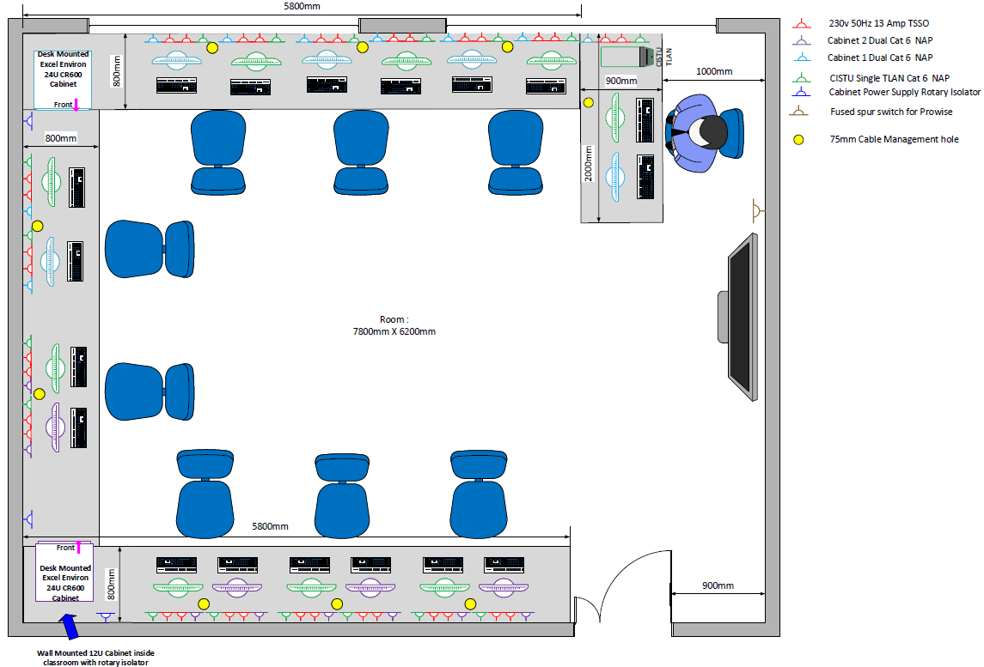

**Figure B-1 – Illustrative example of G56 conversion into an X-LAN classroom**

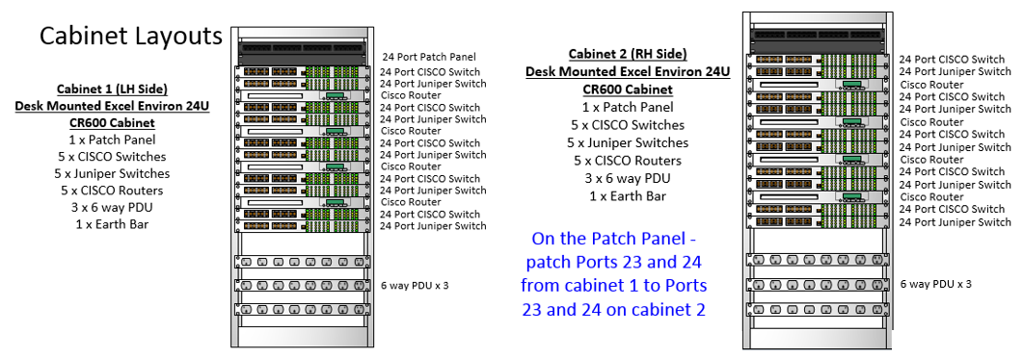

**Figure B-2 – Illustrative example of 19” server racks supporting CISTU IS training equipment**

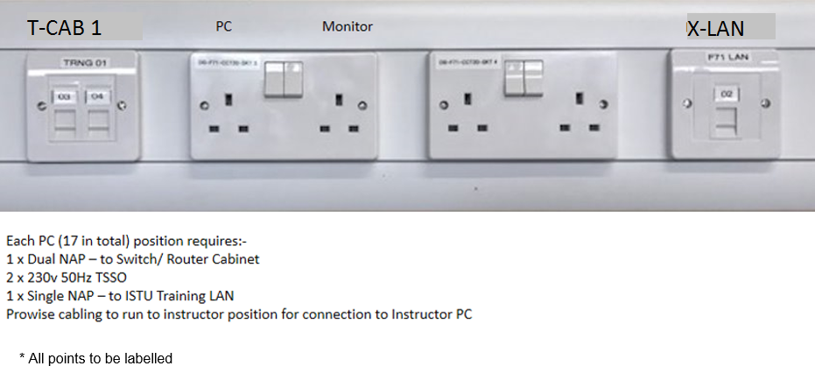

**Figure B-3 – Illustrative example of socket configuration for each PC**

**Annex C to**

**File reference 20210316-TP 1359 - Mountbatten CISTU IS Classrooms FY2122- SOR - V5**

**16 March 2021**

**Requirement 2 – Convert room G58 into an X-LAN classroom**

An illustrative example of the conversion of G58 into an X-LAN classroom can be seen at figure C-1.

An illustrative example of the 19” training equipment cabinets can be seen at figure C-2.

An illustrative example of socket configuration for each PC Can be found at figure C-3.



**Figure C-1 – Illustrative example of G58 conversion into an X-LAN classroom**



**Figure C-2 – Illustrative example of 19” server racks supporting CISTU IS training equipment**



**Figure C-3 – Illustrative example of socket configuration for each PC**

**Annex D to**

**File reference 20210316-TP 1359 - Mountbatten CISTU IS Classrooms FY2122- SOR - V5**

**16 March 2021**

**Requirement 3 – Convert room G39 into a TLAN classroom**

An illustrative example of the conversion of G39 into a TLAN classroom can be seen at figure D-1.

The network cabling route defined by the network Design Authority can be seen at figure D-2.

An illustrative example of socket configuration for each PC Can be found at figure D-3.

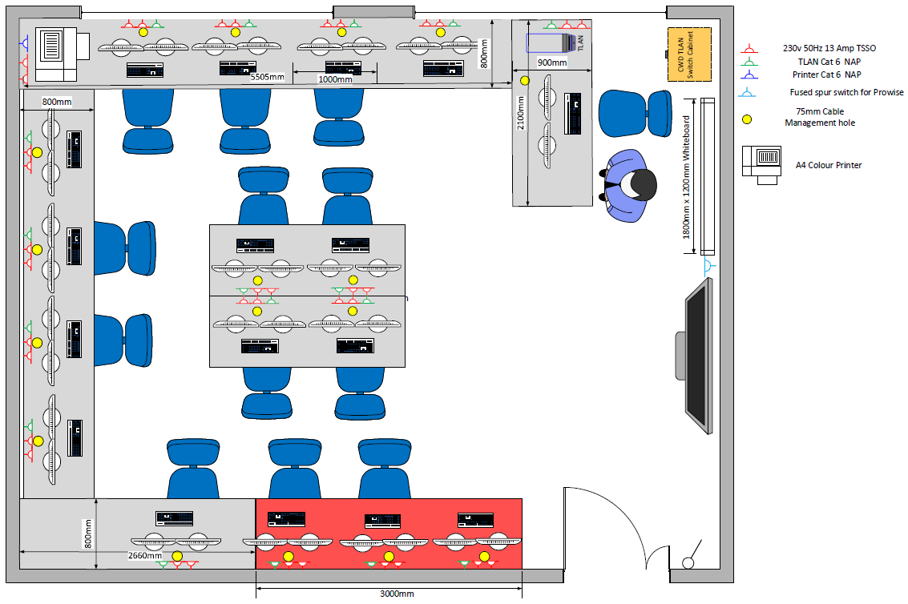

**Figure D-1 – Illustrative example of G39 conversion into a TLAN classroom**

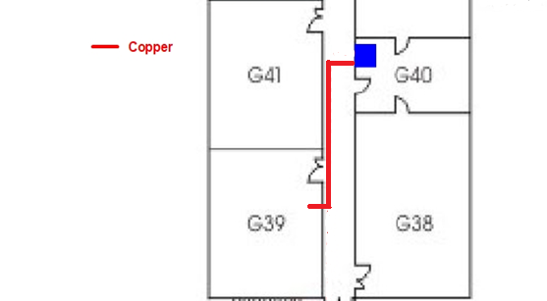

**Figure D-2 – Illustrative example of G39 networking**

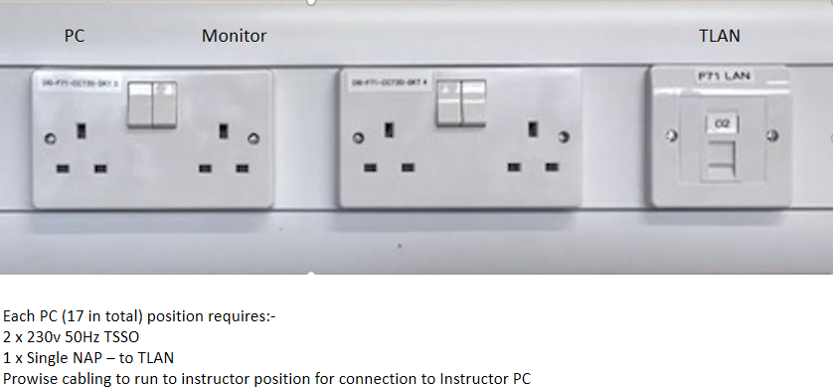

* All points to be labelled

**Figure D-3 – Illustrative example of socket configuration for each PC**

**Annex E to**

**File reference 20210316-TP 1359 - Mountbatten CISTU IS Classrooms FY2122- SOR - V5**

**16 March 2021**

**Requirement 3 – Convert room G41 into a TLAN classroom**

An illustrative example of the conversion of G41 into a TLAN classroom can be seen at figure E-1.

The network cabling route defined by the network Design Authority can be seen at figure E-2.

An illustrative example of socket configuration for each PC Can be found at figure E-3.

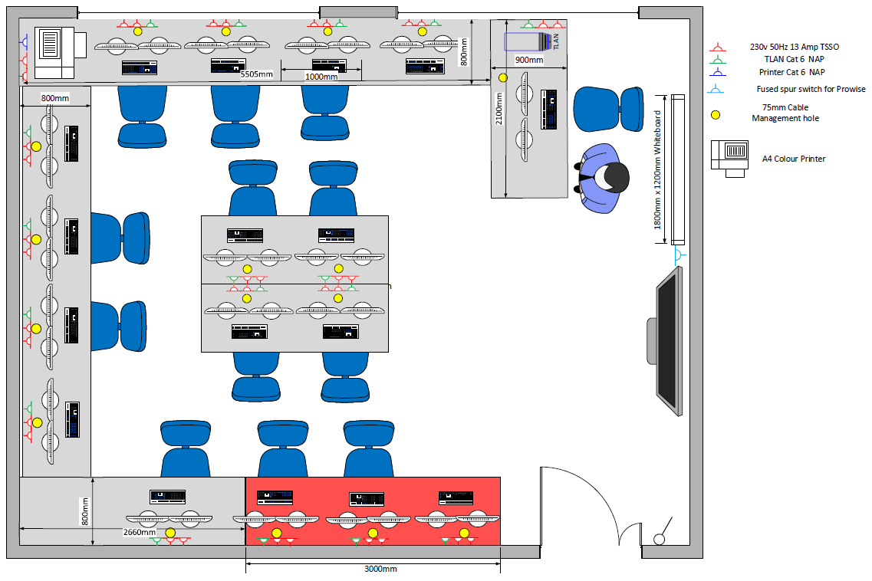

**Figure E-1 – Illustrative example of G41 conversion into a TLAN classroom**

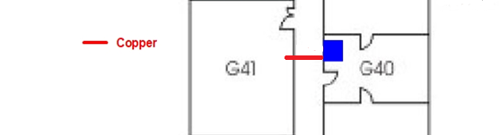

**Figure E-2 – Illustrative example of G41 networking**



* All points to be labelled

**Figure E-3 – Illustrative example of socket configuration for each PC**